Supplementary Figures
Suplementary Methods

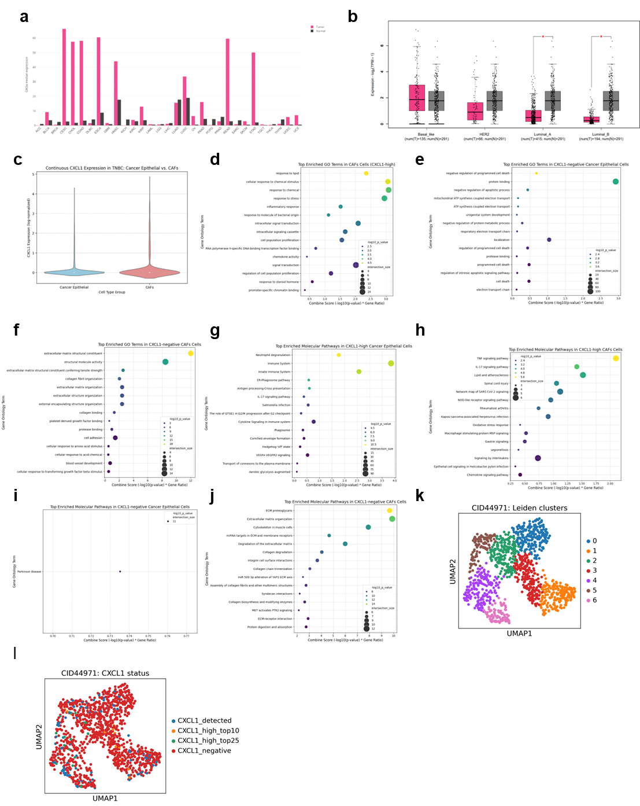
Supplementary figure 1: Complementary data to figure 1 related to GROa median expression in different cancer types. (A) GROa expression in all cancer types analysed in GEPIA2 database. GROa expression in the tumour tissue is presented in pink-coloured bars and the others relate to the expression in normal tissue. Expression is presented in transcript per million (TPM). (B) GROa expression in different breast cancer subtypes retrieved from GEPIA2. Samples from tumour tissue are in colour purple while samples from normal tissue are in grey. (C) Distribution of the CXCL1 expression through the cancer epithelial and CAF cell types in single cell analysis. (D) Biological process GO analysis for the CXCL1 positive cells in CAFs cell type. The size of the dot represents the percentage of genes in the set. (E) Biological process GO analysis for the CXCL1 negative cells in cancer epithelial cell type. The size of the dot represents the percentage of genes in the set. (F) Biological process GO analysis for the CXCL1 negative cells in CAFs cell type. The size of the dot represents the percentage of genes in the set. (G) Molecular function GO analysis for the CXCL1 positive cells in cancer epithelial cell type. The size of the dot represents the percentage of genes in the set. (H) Molecular function GO analysis for the CXCL1 positive cells in CAFs cell type. The size of the dot represents the percentage of genes in the set. (I) Molecular function GO analysis for the CXCL1 negative cells in cancer epithelial cell type. The size of the dot represents the percentage of genes in the set. (J) Molecular function GO analysis for the CXCL1 negative cells in CAFs cell type. The size of the dot represents the percentage of genes in the set. (K) UMAP plot showing the distribution of the different leiden clusters from spatial transcriptomics analysis. (L) UMAP plot showing the distribution of CXCL1 levels in the different leiden clusters.

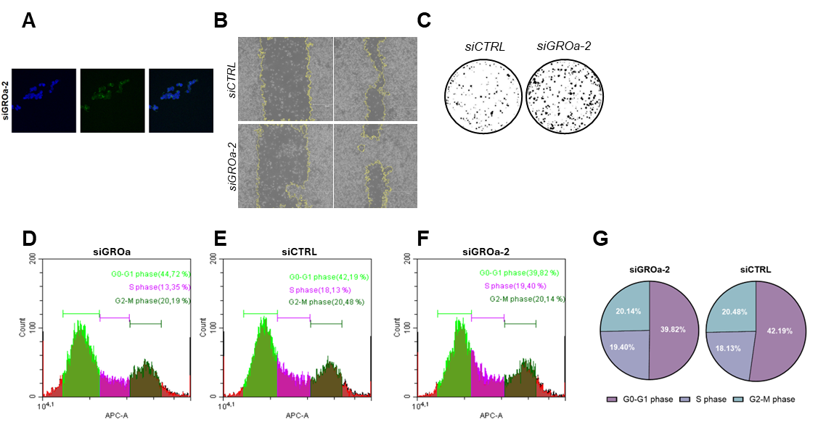
Supplementary figure 2: Complementary data to figure 2 phenotypic assays. (A) Immunofluorescence images from MDA-MB-231 GROa KD cells quantified in figure 2. (B,C) Images of the percentage of closed gap in 48h in an scratch assay and colony formation capacity comparing GROa knock-down with control conditions with siGROa-2. (D-F) Raw plots retrieved from CytoFlex Software when determining the effect of the silencing in the control and both siRNA conditions. (G) Processed data on the effect of the silencing using the siRNA 2 in the cell cycle.

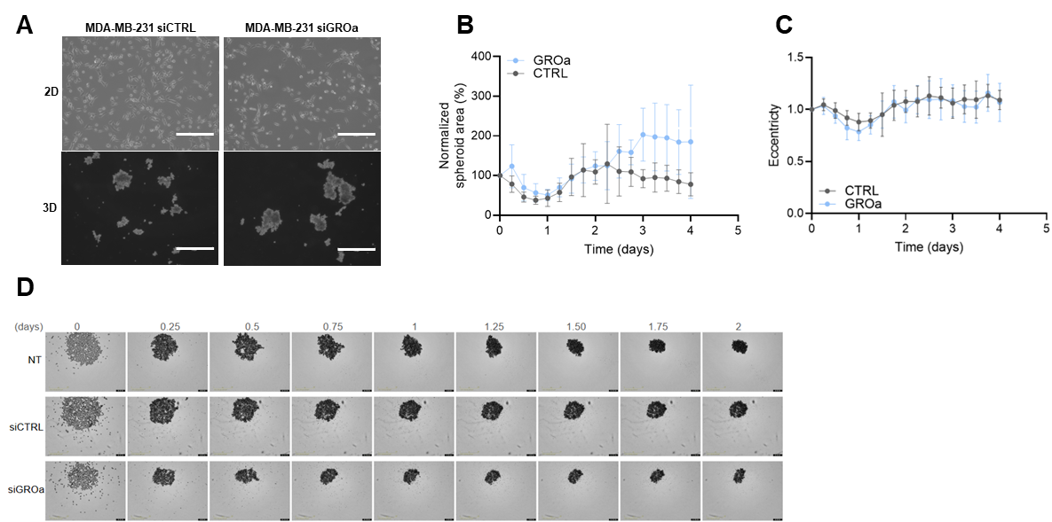
Supplementary figure 3: Complementary data to figure 3 spheroid analysis. (A) Representative images showing morphological differences between the 2D and 3D cultures in transfected cells compared to the transfection control. Scale = 300 μm. (B) Normalized spheroid area in percentage analysis obtained from Incucyte SXS (Sartorius). Images were obtained every 6 hours for 4 days. (C) Eccentricity measured in spheroids from different transfection conditions obtained from Incucyte SX5 (Sartorius). Images captured every 6 hours for 4 days. (D) Brightfield images captured by Incucyte SX5 (Satrorius) from day 0 to day 2 for the different transfection conditions. Scale = 400 μm.

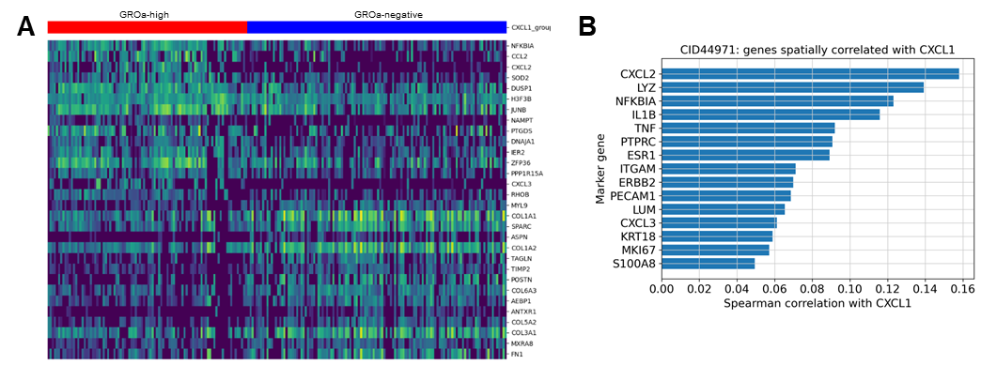
Supplementary figure 4: Complementary data to figure 4 single cell and spatial transcriptomics analysis. (A) Heatmap comparing the genetic signature in GROa-high or GROa-negative cells in CAFs cell type. (B) Genes spatially correlated with GROa expression in spatial transcriptomics. Correlation is represented using Spearman correlation considering a weak correlation from 0-0.39, 0.4-0.59 moderate and 0.6-1 strong.

Supplementary methods
Single Cell Analysis
Analysis was performed in Python environment using the packages Scanpy, AnnData, pandas, NumPy, seaborn,Matplotlib and gseapy. Expression matrix was loaded from Matrix Market format together with the corresponding gene and barcode identifiers. Apart from the ones established on the metadata, there was no new cell-type annotation in this work-flow. Gene symbols were standardised to uppercase to ensure consistent gene matching across the expression matrix and marker sets. Count values were normalised to a total of 10000 counts per cell and log-transformed using log1p. Log-normalised values were used for GROa detection, visualization, correlation-style summaries, differential expression analysis and heatmap generation.
Determination of GROa levels in different breast cancer subtypes and cell type
GROa expression was extracted from the log-normalised expression matrix. Cells were classified as GROa⁺ when the log-normalised expression value was greater than zero. Binary metadata was generated to indicate GROa⁺ and GROa⁻ cells. This threshold was used as a detection criteria and should be interpreted as detectable transcript abundance after normalisation rather than as a biological expression cutoff.
In order to determine patient-level aggregation across breast cancer subtypes, bias caused by unequal number of cells per patient was reduced by performing subtype comparisons at the patient level. For each patient, GROa⁺ cells were calculated within each major cell type category by averaging the binary GROa⁺ variable across cells grouped by patient identifier, tumor subtype and major cell type. In this analysis, the patient was treated as the unit of comparison for subtype-level summaries. Main cell populations selected for comparison were cancer epithelial cells, cancer-associated fibroblasts and myeloid cells. Patient-level GROa⁺ fractions were visualized using boxplots. Breast cancer subtype was plotted on the x-axis, and the patient-level GROa⁺ fraction was plotted on the y-axis. Major cell types were included as a grouping variable to compare GROa detection across different compartments. Subtypes were consistently named across plots and outliers were optionally suppressed for graphical clarity affecting only visualization and did not alter the patient-level values.

GROa⁺ distribution and differential expression in TNBC cancer epithelial cells and CAFs
Further analysis was performed in TNBC samples to compare GROa behaviour in CAFs and cancer epithelial cells. Cells were first filtered to only maintain TNBC subtype and then splitted in the two cell populations of interest. Distribution of total GROa or positive expression was inspected using violin plots by cell type. In the TNBC subset, cells were classified according to GROa expression. GROa⁻ cells were defined as cells with zero expression of GROa. GROa positive cells were subclassified in GROa-high and GROa-low. GROa-high corresponded to those whose expression levels were above the 90th percentile while GROa-low were the rest. Because GROa-negative cells were predominant in the sample, for each cell-type specific comparison, the GROa-negative group was limited to approximately five times the number of GROa-high cells. This was performed in order to reduce group imbalance while retaining broader biological variability.
Differential expression analysis was performed separately for TNBC CAFs and TNBC cancer epithelial cells. In each population, GROa-high cells were compared with the GROa⁻ reference group using the Wilcoxon rank-sum test implemented in Scanpy. Genes were considered differentially expressed when adjusted P value was less than 0.05 and the absolute log fold change was greater than 0.25. In order to focus on biologically relevant genetic signatures, GROa was excluded from the analysis as well as mitochondrial and ribosomal protein genes. Mitochondrial genes were identified by the MT-prefix and ribosomal genes by RPS or RPL prefixes. Differential expression was plotted in a heatmap. The top upregulated and downregulated genes were filtered from the gene list and both top 15 ranked by adjusted P value were used to generate heatmaps comparing GROa-high and GROa- cells. Heatmaps were generated with seaborn clustermap and cells were annotated by GROa expression groups to facilitate the interpretation of the different groups.
Gene Ontology enrichment analysis was performed using gseapy with the Enrichr interface. Enrichment was assessed for the GO Biological Process 2021 and GO Molecular Functions 2021 gene-set libraries. Separate enrichment analyses were performed for genes enriched in GROa-high or GROa- subsets, checking the CAFs and the cancer epithelial subgroups separately. For each analysis, terms were ranked by adjusted P value, and the top enriched terms were visualized using bubble plots.
Spatial Transcriptomic Analysis
Analysis was performed in Python using Scanpy, AnnData, Squidpy, pandas, NumPy, SciPy and Matplotlib. Filtered 10x Genomics Matrix Market expression files corresponding to CID44971 were loaded into AnnData object. Spot-level spatial coordinates, tissue-position information, image scale factors and available metadata were matched to the expression matrix using the corresponding barcode identifiers. Quality control metrics were calculated for each Visium spot, including total UMI counts, number of detected genes and percentage of mitochondrial transcripts. Mitochondrial genes were identified by gene symbols labelled as MT-. Since the analysis used filtered count matrices, additional filtering was conservative. Spots were retained if they were located within tissue and satisfied all of the following criteria: at least 500 UMI counts, 200 detected genes and no more than 30% mitochondrial counts. The original UMI count matrix was preserved prior to normalisation. Counts were library-size normalised to 10000 counts per spot and log-transformed using log1p. The full log-normalised expression matrix was stored before highly variable gene selection to allow posterior extraction of genes that might not be retained among highly variable genes. Highly variable genes were selected using the Seurat method implemented in Scanpy, retaining the top 3000 genes. Expression values for highly variable genes were scaled with a maximum value of 10. Principal component analysis was performed using 30 components. A nearest-neighbor graph was constructed using 15 neighbors and 30 principal components. Uniform manifold approximation and projection was used for visualization of transcriptional similarity between spots. Expression-defined spatial domains were identified using Leiden clustering at a resolution of 0.6.

Determination of the architecture linked to GROa expression
GROa expression was extracted from the full log-normalised expression matrix rather than from the highly variable gene-filtered matrix to ensure that GROa was retained for analysis. For each spot, the log-normalised GROa value was stored as a spot-level metadata variable. Spots with log-normalised GROa expression higher than zero were classified as GROa-detected. To identify regions with stronger GROa signal, thresholds were defined among GROa-detected spots. Spots in the upper 25% of GROa expression were labelled as GROa-high top 25%, and spots in the upper 10% were classified as GROa-high top 10%. The upper 10% group was used as the stringent GROa-high category for differential expression analysis. These thresholds were defined within CID44971 and were therefore interpreted as sample-relative categories rather than universal biological cutoffs.
GROa expression was visualized on the corresponding hematoxylin and eosin tissue image using Visium spatial coordinates. Log-normalised GROa expression was plotted to assess the spatial intensity and distribution of GROa across the tissue section. A categorical GROa status map was also generated in order to distinguish between GROa-negative, GROa-detected, GROa-high top 25% and GROa-high top 10% spots. Leiden clusters were projected onto the tissue image to compare GROa-rich regions with expression-defined spatial domains.

Transcriptional analysis of GROa⁺ spatial regions
To evaluate transcriptional features associated with GROa-positive spatial regions maker expression was assessed in three predefined gene panels. The immune marker panel included CD68, CD163, S100A8, S100A9, CD8A and GZMB. The stemness-associated panel included CD44, ALDH1A, VIM, ITGA6 and KRT14. The epithelial-to-mesenchymal transition marker panel included EPCAM, CDH1, VIM and GROa. Prior to visualization, marker lists were filtered to retain only genes detected in spatial transcriptomics dataset. Dot blots were generated comparing GROa-negative and GROa-high spatial regions, the dot size represents the number of Visium spots while the dot color represents the mean expression level of that marker. Expression values were standard scaled by gene to facilitate the comparison of relative expression patterns across the two GROa-defined spatial groups. Marker expression patterns were interpreted as spot-level enrichment profiles rather than single-cell identity assignments.

