Graph 1: Overall prevalence of lingual cortex types (C, P, U-I, U-II, and U-III) across the 504 evaluated tooth regions.
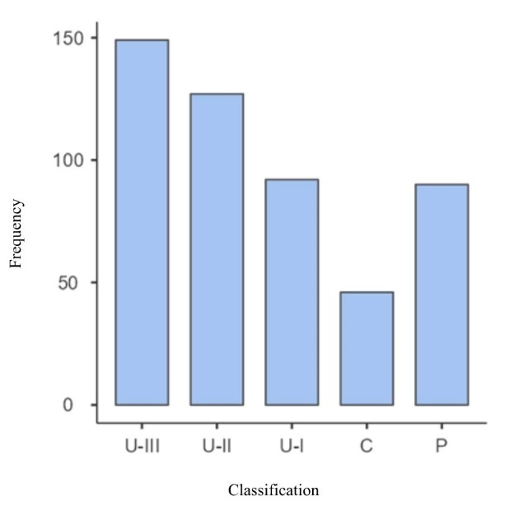
Source: Research data.

