Electronic Supporting Information of

Photophysical Insights of Blue–Green Emitting Oxadiazole: Efficient Energy Transfer in Core–Shell Quantum Dot Hybrids

Sushma Katti^{[a]}, Amith Yadav H J*^{[a]}, G.H. Pujar^{[b]}, S.R. Inamdar^{[c]}, Narahari Deshapande^{[d]}, Vinay Parol^{[e]} , Vinuta J B^{[e,f]}, R Vijay Kumar^{[a]}, Veena V S^{[a]}

ªDepartment of Studies in Physics, Davangere University, Davangere 577007, Karnataka, India.
^{b}Department of Physics, Govt. First Grade College, Harapanahalli, Vijayanagara 583137, Karnataka, India.
^{c}Laser Spectroscopy Programme, Department of Physics and UGC-CPEPA, Karnatak University, Dharwad 580003, Karnataka, India.
^{d} Department of Chemistry, Karnatak University, Dharwad 580003, Karnataka, India.
^{e}Department of Physics, Bapuji Institute of Engineering and Technology, Davangere 577004, Karnataka, India.
^{f}Department of Physics, K.L.E Society’s R. L. Science Institute (Autonomous), Belagavi 590001, Karnataka, India.
Corresponding author: amithyadavhj@gmail.com

Table of Contents:
Section | Contents | Page. No
1 | 1.1 Synthesis and Characterization of Novel Fluorescent AVBO Derivative:  (i) General procedure for the synthesis of 2-(4-tert-butylphenyl)-5-p-tolyl-1,3,4-oxadiazole (OXD).  (ii) General procedure for the synthesis of 2-(4-(bromomethyl)phenyl)-5-(4-tertbutylphenyl)-1,3,4-oxadiazole (1)  (iii) General procedure for the synthesis of Wittig salt (2).  (iv) General procedure for the synthesis of AVBO.  1.2 Physical Measurements | 2-4
2 | Scheme: Synthetic route for the compound AVBO | 5
3 | Fig. S1: ¹H & ¹³C NMR of intermediate OXD | 6
3 | Fig. S2: ¹H & ¹³C NMR of intermediate 1 | 7
3 | Fig. S3: ¹H & ¹³C NMR of intermediate 2 | 8
3 | Fig. S4: ¹H & ¹³C NMR of AVBO | 9
4 | Fig. S5: FT-IR Spectra for intermediate compound OXD | 10
4 | Fig. S6: FT-IR Spectra of intermediate compound 1 | 10
4 | Fig. S7: FT-IR Spectra of intermediate compound 2 | 11
4 | Fig. S7: FT-IR Spectra of AVBO. | 11
5 | Fig. S8: LC-MS mass spectra of intermediate compound OXD (m/z 292.36491) | 12
5 | Fig. S9: LC-MS mass spectra of intermediate compound 1 (m/z 371.27610) | 12
5 | Fig. S10: LC-MS mass spectra of intermediate compound 2 (m/z 553.55242) | 12
5 | Fig. S11: LC-MS mass spectra of compound AVBO (m/z 480.08803) | 13
6 | Theory of FRET measurements | 14
7 | Stern-Volmer and Perrin Models | 15
8 | Table S1: Calculated Solvent Polarity Functions and other Parameters | 17
9 | Table S2: Calculated Solvent Polarity Functions and other Parameters | 18
9 | References | 19

1. Experimental Section:
1.1. Synthesis and Characterization of Novel Fluorescent AVBO Derivative: All solvents were freshly distilled over appropriate drying reagents prior to use. All
starting materials were purchased from Sigma Aldrich and were used without further
purification. The required intermediates and final compounds were synthesized according to
following procedure.
(i) General procedure for the synthesis of 2-(4-tert-butylphenyl)-5-p-tolyl-1,3,4-oxadiazole (OXD): A mixture of 4-methylbenzohydrazide (5.0 g, 3.32 mmol) and 4-tert-butylbenzoic acid (7.0g, 3.92 mmol) in POCl3 (70 mL) was refluxed for about 12 h at 100 oC. The progress of the reaction mixture was monitored by TLC. The reaction mixture was allowed to reach room temperature (RT) and the quenching of reaction mixture in crushed ice was carefully carried out under efficient fume hood. The solid that separated was collected by filtration, washed with excess of water followed by saturated NaHCO3 solution to remove excess of carboxylic acid. The collected solid was dried and recrystallized from ethanol to obtain the desired oxadiazole in 80-90% yield.
White solid; Yield 90 %; Mp: 150-155 °C; FT-IR (KBr, cm⁻¹,): 3031 (C-H aromatic), 2954, 2907 (C-H aliphatic), 1615, 1551, 1493, 1412 (C=C and C=N Aromatic), 1017, 963 (1,3,4-oxadiazole ring), 843 (tert-Butylbenzene); ¹H NMR (500 MHz, CDCl₃) δ 8.06 (d, J = 8.5 Hz, 4H, Ar-CH), 8.03 (d, J = 8.1 Hz, 2H, Ar-CH), 7.55 (d, J = 8.4 Hz, 2H, Ar-CH), 7.34 (d, J = 7.8 Hz, 3H, Ar-CH₃), 1.35 (s, 9H, Ar-C(CH₃)₃); ¹³C NMR (101 MHz, CDCl₃) δ 164.42, 150.95, 138.07, 129.64, 127.43, 127.16, 125.61, 123.40, 123.00, 40.59, 31.78, 24.26; HRMS: m/z [M + H]⁺ calc’d for C₁₉H₂₀N₂O 292.3749, found 292.3649.
(ii) General procedure for the synthesis of 2-(4-(bromomethyl)phenyl)-5-(4-tertbutylphenyl)-1,3,4-oxadiazole (1). A mixture of compound 2-(4-tert-butylphenyl)-5-p-tolyl-1,3,4-oxadiazole (OXD) (5.0 g, 1.17 mmol) and NBS (3.0 g, 1 equ) were taken in CCl4 (50 mL), to this catalytic amount of DBP (0.414, 0.1 equ) was added and refluxed the reaction mixture for about 6-8 h at 80 0C. The progress of the reaction was monitored by TLC. After the completion of reaction solvent was removed by applying reduced pressure, separated solid was thoroughly washed with water to remove water soluble succinamide. Resulting solid was dried and recrystallized from ethanol to obtain pure brominated product in 85-90% yield.
White solid; Yield 88 %; m.p.146-147 °C; FT-IR (KBr, cm⁻¹): 3001 (C-H aromatic), 2923, 2903 (C-H aliphatic), 1615, 1551, 1493, 1412 (C=C and C=N Aromatic), 1019, 966 (1,3,4-oxadiazole ring), 849 (tert-Butylbenzene), 599 (C-Br Stretch); ¹H NMR (500 MHz, CDCl₃) δ 8.14 (d, J = 8.2 Hz, 2H, Ar-CH), 8.10-8.08 (d, 2H, Ar-CH), 7.60-7.57 (d, 4H, Ar-CH), 4.56 (s, 2H, -CH₂-), 1.40 (s, 9H, Ar-C(CH₃)₃); ¹³C NMR (126 MHz, CDCl₃) δ 164.79, 163.88, 155.48, 141.34, 129.75, 127.31, 126.82, 126.10, 123.95, 120.98, 39.70, 35.13, 32.35, 31.14; HRMS: m/z [M + H]⁺ calc’d for C₁₉H₁₉BrN₂O 371.2709, found 371.2761..
(iii) General procedure for the synthesis of Wittig salt (2): A mixture of 2-(4-(bromomethyl)phenyl)-5-(4-tert-butylphenyl)-1,3,4-oxadiazole (1) (4.0 g, 1.07 mmol) and triphenyl phosphine (2.82, 1.07 mmol) in DMF (50 mL) was refluxed for about 6 h at 80 oC, the reaction progress was monitored by TLC. After the completion of reaction, the solvent was removed by applying reduced pressure. Separated Phosphonium salt was washed using ethyl acetate to remove excess of triphenyl phosphine. The collected solid was in about 95 % yield.
White solid; Yield: 87 %; FT-IR (KBr, cm⁻¹): 3039 (C-H aromatic), 2960, 2924 (C-H aliphatic), 2852, 2760 (-CH₂-) 1612, 1582, 1548, 1492 (C=C and C=N Aromatic), 1437, 1111, 1070, 718 (-P-CH₂ Aromatic), 1021, 959 (1,3,4-oxadiazole ring), 846 (tert-Butylbenzene); ¹H NMR (500 MHz, CDCl₃) δ 7.95 (d, J = 8.4 Hz, 4H, Ar-CH), 7.82 (m, 15H, P-Ar-CH), 7.52 (d, J = 8.4 Hz, 2H, -CH₂-), 7.39 (d, J = 8.3, 2.3 Hz, 2H, Ar-CH), 5.80 (d, J = 15.2 Hz, 2H, Ar-CH), 1.38 (s, 9H, Ar-C(CH₃)₃); ¹³C NMR (126 MHz, CDCl₃) δ 164.66, 163.69, 163.67, 155.34, 134.98, 134.95, 134.61, 134.53, 132.57, 132.52, 131.65, 131.58, 130.17, 130.07, 126.75, 126.72, 126.68, 125.98, 123.55, 123.52, 120.72, 117.95, 117.26, 35.07, 31.11, 30.50, 30.13; HRMS: m/z [M + H]+ calc’d for [C₃₇H₃₄N₂OP⁺] Br- 553.6524, found 553.5524.
(iv) General procedure for the synthesis of 2-(4-(2-(anthracen-10-yl)vinyl)phenyl)-5-(4-tert-butylphenyl)-1,3,4-oxadiazole (AVBO): A mixture of Phosphonium salt (2) (0.5 g, 0.00078 mol) and aldehyde (0.162 g, 1 equ) were taken in Water:DCM (40:60) mixture under vigorous stirring. Sodium hydroxide solution (50%, 0.65 ml) was added to the mixture by syringe and stirred for 5-6 h at room temperature. Completion of reaction was confirmed by TLC. The reaction mixture was diluted with dichloromethane and water. The organic layer was separated and the solvent was removed under reduced pressure. The resulting solid was dried and recrystallized from ethanol to get the desired product in 60-70% yield. The synthetic approach is highly convenient and provides AVBO compound in the trans configuration across the double bond. This all-trans configuration is evidenced by 1H-NMR spectroscopy. AVBO displayed a doublet signal around 6.5-7.5 ppm with a typical coupling of ca. 16.00- 16.60 Hz. This value corresponds with the expected value for a 3Jtrans Coupling of the vinylic protons. Further evidence concerning the structures of AVBO were confirmed by 1H-NMR, FTIR, and mass spectrometry (MS). The good accordance between calculated and expected values for microanalysis gives a proof of the purity of the material.
Yellow amorphous solid, yield: 65 %. Mp = 240-247 °C. FT-IR: 3300-3150 (C-H aromatic-anthracene, phenyl and vinylene), 3100 (C-H aliphatic), 1610-1560 (Oxadiazole ring C=C and C=N Strecthing with aromatic rings), 1460-1360 (tert-Butyl), 1070-1010 (C-O-C), 700-900 (out of plane C-H bends-phenyl ring and anthracene); ¹H NMR (500 MHz, CDCl3) δ: 8.45 (s, 1H), 8.37 (dd, J = 6.4, 3.3 Hz, 2H), 8.24 (d, J = 8.1 Hz, 2H), 8.15-8.04 (m, 5H), 7.83 (d, J = 8.1 Hz, 2H), 7.60 (d, J = 8.4 Hz, 2H), 7.52 (dd, J = 6.7, 3.1 Hz, 4H), 7.04 (d, Jtrans = 16.6 Hz, 1H), 1.42 (s, 9H); ¹³C NMR (126 MHz, CDCl3) δ: 164.5, 164.10, 150.0, 138.7, 135.2, 132.4, 127.7, 127.4, 127.1, 126.3, 125.1, 123.1, 123.42, 123.20, 32.4, 31.4; MS m/z calculated for C34H28N2O 480.60, Found 480.08803 (M+); Anal. Calcd (%) for C34H28N2O: C, 84.97; H, 5. 83; N,5.83. Found: C, 84.95; H, 5. 87; N, 5.87.
1.2 Physical Measurements: FT-IR spectra were recorded as KBr pellets on a ThermoFisher Nicolet 6700 FT-IR spectrometer at 2 cm⁻¹ resolution with 100 scans over the range of 4000-400 cm⁻¹. ¹H and ¹³C NMR were measured by using TMS as internal standard on Bruker 400-MHz FT NMR spectrometer in CDCl₃. Chemical shifts are reported in ppm downfield (δ) from TMS. Melting points were obtained by open capillary method and are uncorrected. High resolution mass spectra (HRMS) were obtained on Agilent Technologies 6538 UHD Accurate-Mass Q-TOF LC/MS spectrometer.

2. Scheme: Synthetic route for the compound AVBO
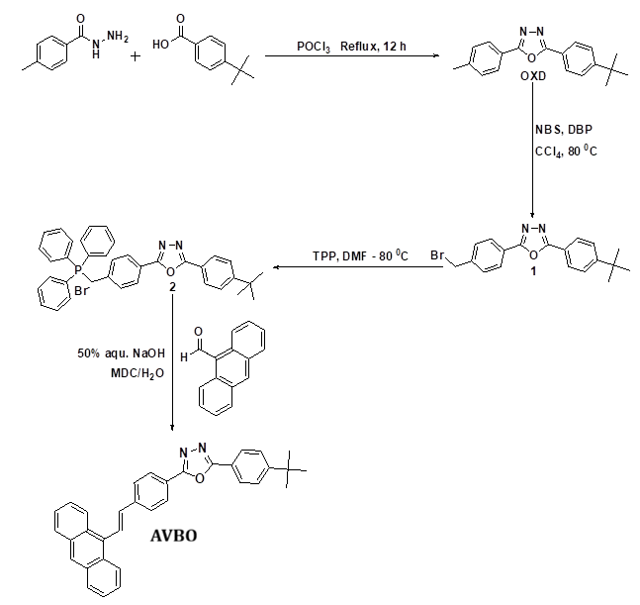
Scheme: Synthetic route for the compound AVBO.

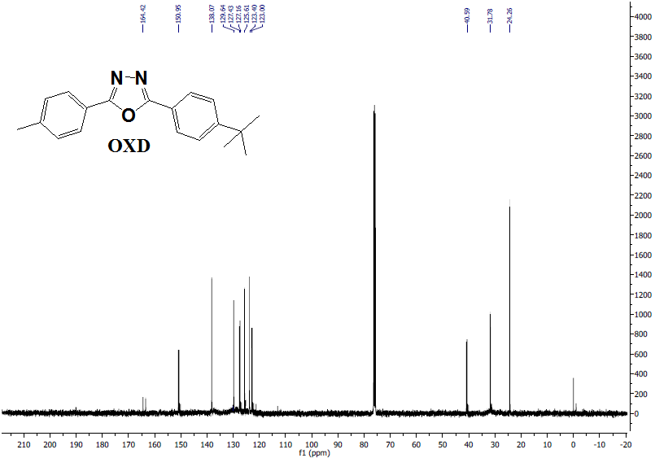
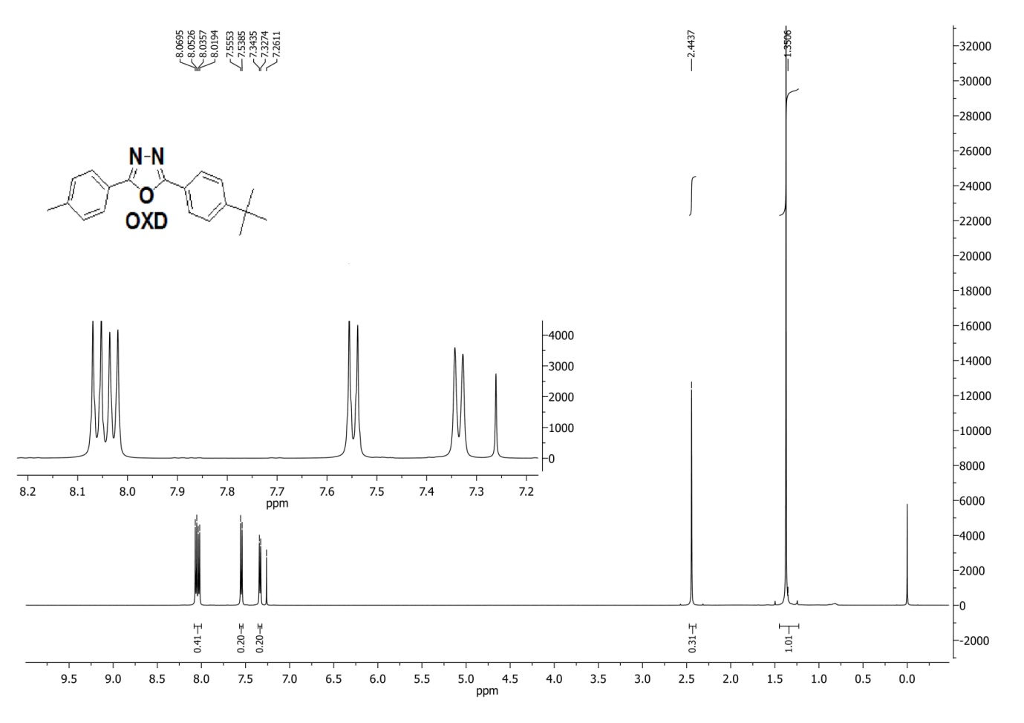
Fig. S1: ¹H & ¹³C NMR of intermediate OXD.

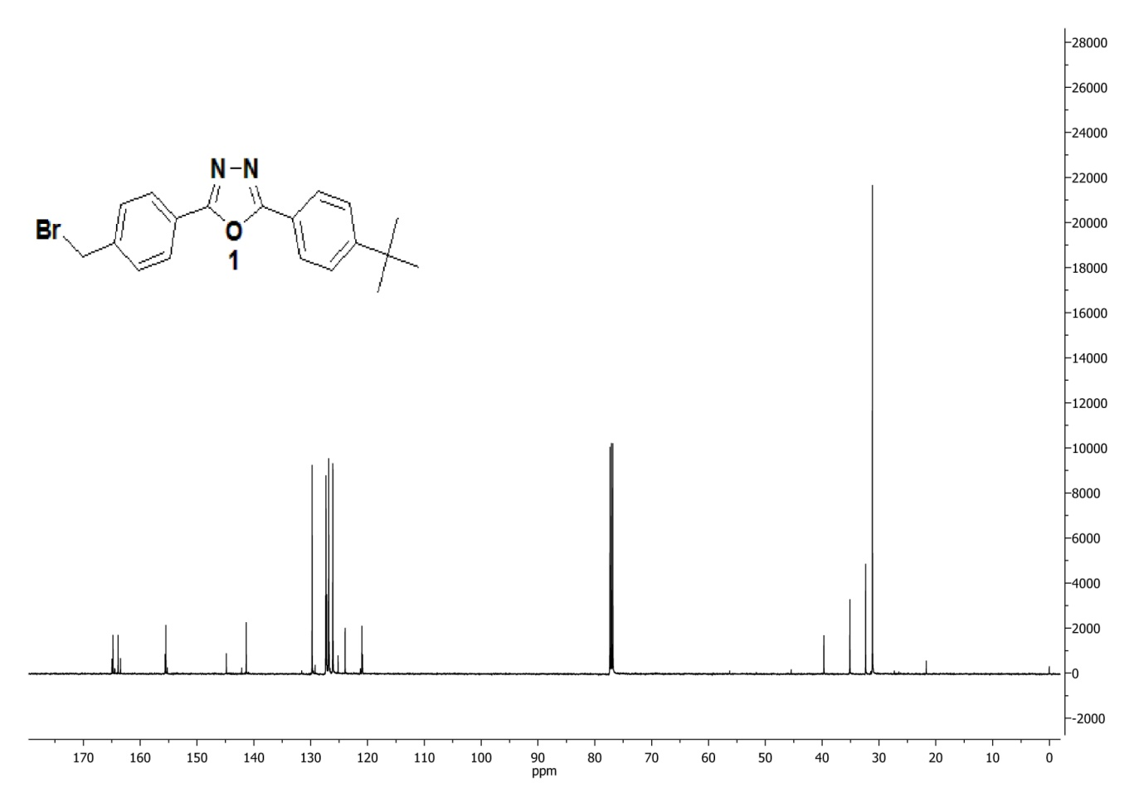
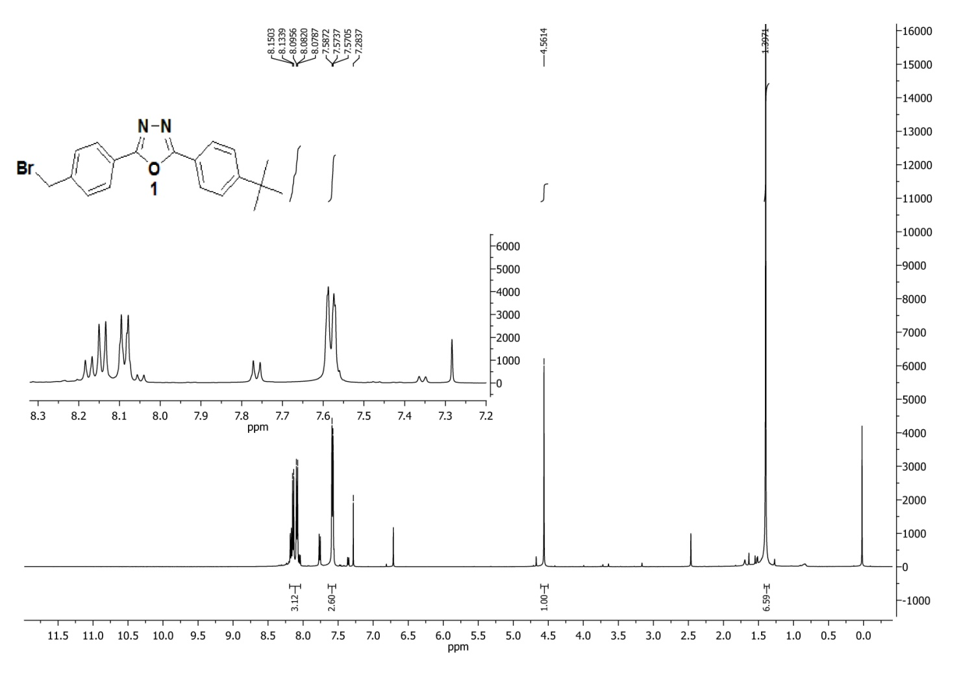
Fig. S2: ¹H & ¹³C NMR of intermediate 1.
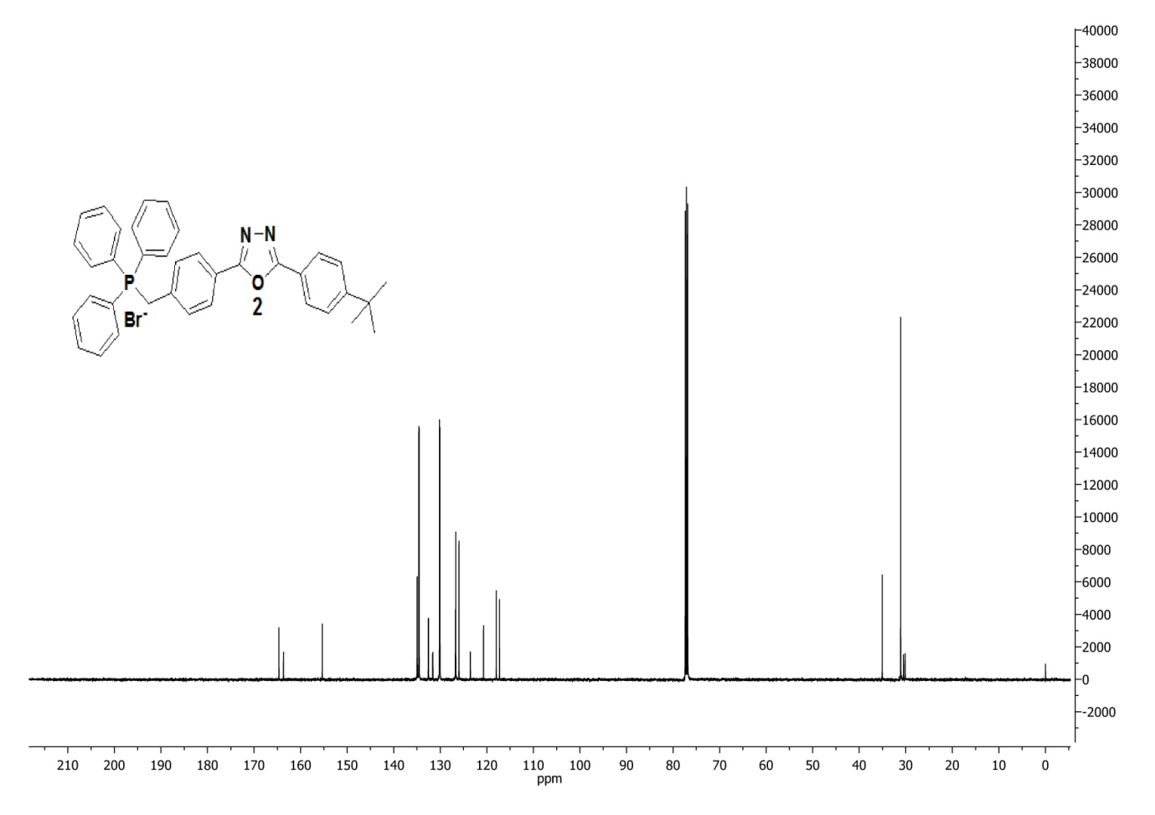
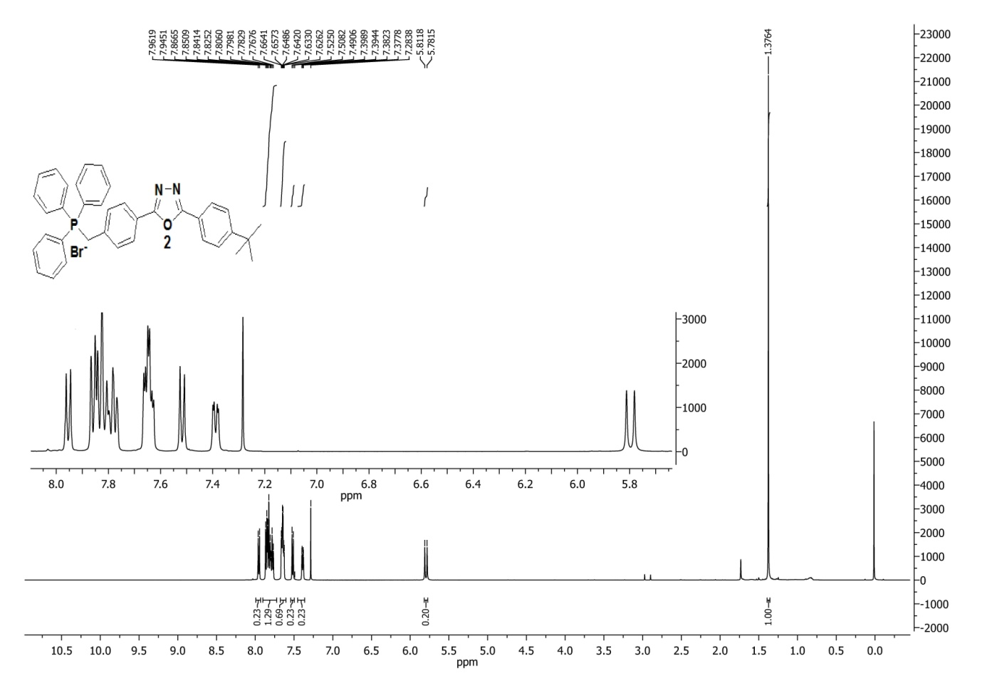
Fig. S3: ¹H & ¹³C NMR of intermediate 2.
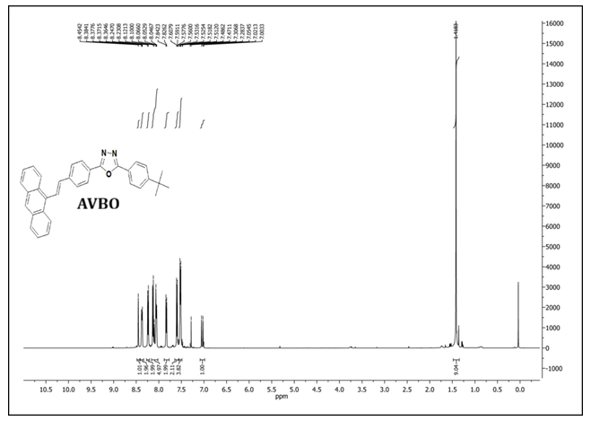
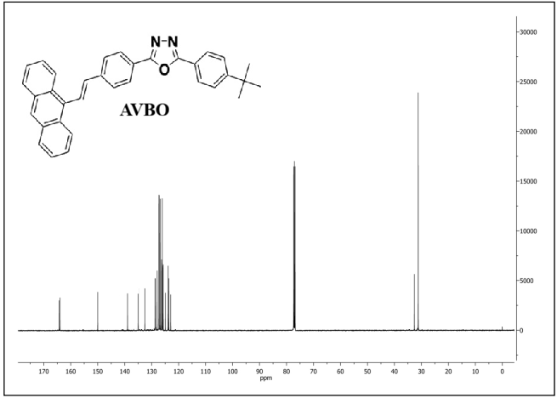
Fig. S4: ¹H and ¹³C NMR of AVBO.
Fig. S5: FT-IR Spectra for intermediate compound OXD

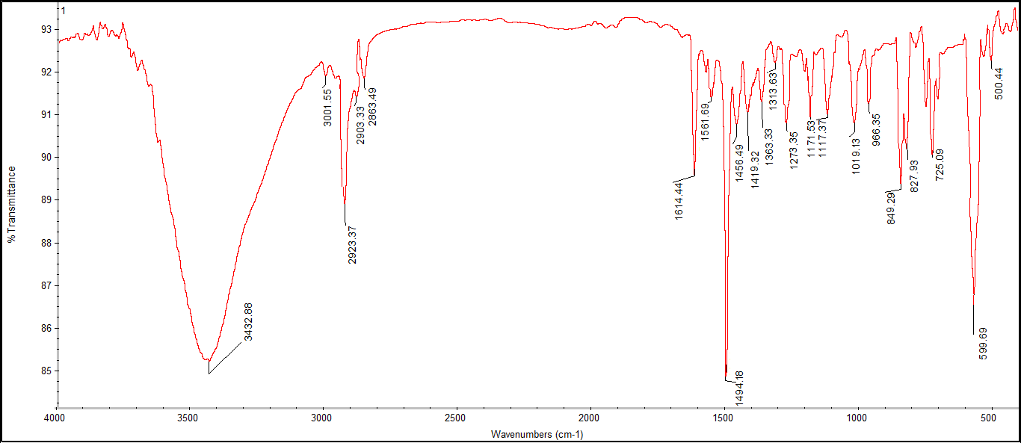

Fig. S6: FT-IR Spectra of intermediate compound 1
Fig. S7: FT-IR Spectra of intermediate compound 2
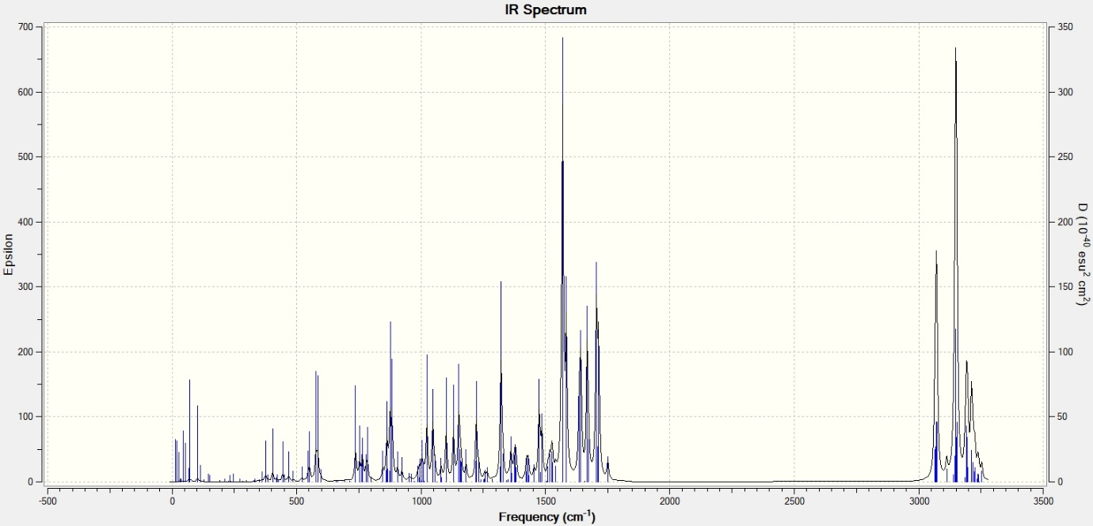
Fig. S7: FT-IR Spectra of AVBO.
(*Obtained using Gaussian 09W at DFT/ cam-b3lyp/6-31g(d,p) level)

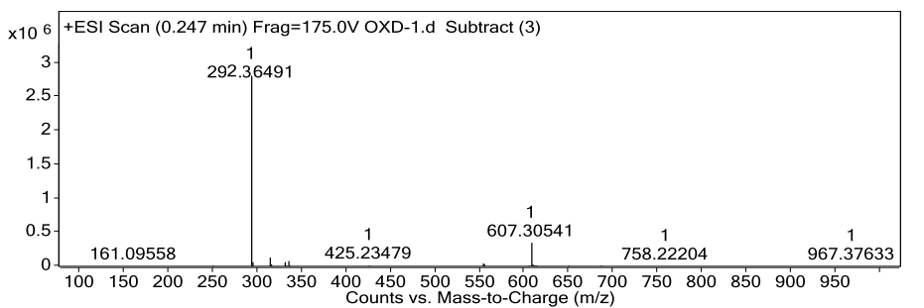
Fig. S8: LC-MS mass spectra of intermediate compound OXD (m/z 292.36491)

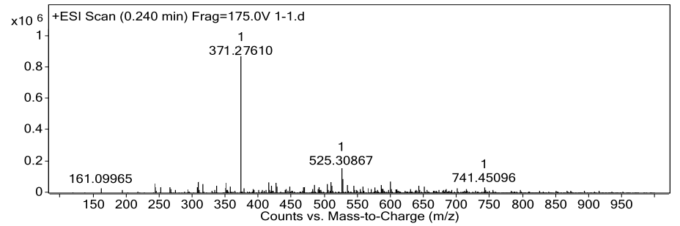
Fig. S9: LC-MS mass spectra of intermediate compound 1 (m/z 371.27610)

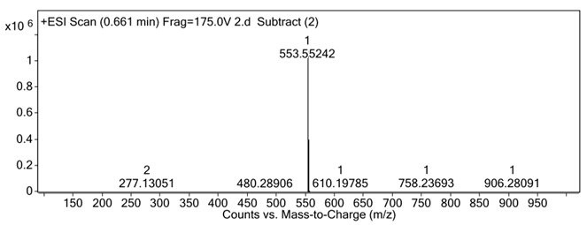
Fig. S10: LC-MS mass spectra of intermediate compound 2 (m/z 553.55242)

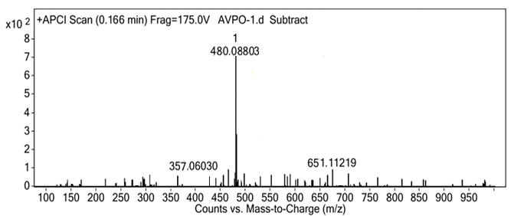

Fig. S11: LC-MS mass spectra of compound AVBO (m/z 480.08803)

6. Theory of FRET measurements
The first theoretical formulation of FRET that successfully identified the
inverse sixth power distance dependence was made by Theodor Förster [1] which provided a quantitative explanation for the non-radiative energy transfer in terms of his famous expression given by
(S1)
where, is the rate of energy transfer from donor to acceptor, is the lifetime of donor in absence of acceptor, r is the donor to acceptor distance and R₀ is the well-known Förster radius given by the spectral overlap between the fluorescence spectrum of the donor and the absorption spectrum of the acceptor. The distance of separation at which resonance energy transfer is 50% efficient, is called the Förster distance (R₀). To understand molecular interaction it is usually important to consider the distances than transfer rate. The value of R₀ can be defined by the following expression [1-3],
(S2)
where, is the orientation factor of transition dipole moment between donor and acceptor usually assumed to be equal to 2/3 for random orientation [2,4], is the fluorescence quantum yield of the donor, N is the Avogadro number, n is the refractive index of the medium and is known as the spectral overlap integral, expressed as,
(S3)
where, is the normalized fluorescence intensity of the donor, is the extinction coefficient of the acceptor. Although equation (S2) looks complex, many of the terms are physical constants, and therefore the above definition of R₀ in Å can be rewritten as,
(S4)
i.e.,
(S5)
The energy transfer efficiency (E) is the fraction of photons absorbed by the donor which is transferred to acceptor and is given by [2-4]
(S6)
Using equation (S1) and (S6), E can be expressed as
(S7)
Hence, the efficiency of FRET depends on the distance of separation between donor and acceptor molecules. The average energy-transfer efficiency (E) can also be estimated from either steady-state [5] or time-resolved fluorescence data [6] for FRET pairs using the expression
(S8)
where, F_{D} and F_{DA} are the relative fluorescence intensities of the donor in absence and presence of acceptor and and designate the excited-state lifetime of donor without and with the acceptor.
7. Stern-Volmer and Perrin Models:
Stern-Volmer Model: Stern–Volmer (SV) plots from both steady-state and time-resolved measurements offered deeper insights into the quenching mechanism underlying FRET [2]. The SV equation [Eqn. (S9)] connects quencher concentration to excited-state quenching as follows:
(S9)
where I₀ and I represent the PL intensity of the donor QDs without and with AVBO quencher, respectively; K_{D} is the Stern-Volmer quenching constant; kq denotes the bimolecular quenching rate constant; [Q] is the quencher concentration; and τ₀ and τ are the average donor lifetimes in the absence and presence of quencher.​ Chromophores may undergo either static or dynamic quenching. Static quenching involves ground-state complexation between fluorophore and quencher, reducing PL intensity without affecting lifetimes. Dynamic quenching, conversely, requires collisions between excited chromophore and quencher, resulting in shortened excited-state lifetimes.
Perrin Model: From the SV plot of the ZnSe/ZnS QDs-AVBO complex in toluene solution, it is found that the relative PL intensity of the QDs varies non-linearly with the concentration of AVBO dye. In general, the non-linear Stern-Volmer plot (I₀/I vs. [Conc.]) indicates that both static and dynamic effects are present in the PL quenching process. The exponential variation in the relative PL intensity can be explained in accordance with the Perrin model, as discussed below [2, 7-9].
$\frac{I_{0}}{I}=e^{∝[C]}=e^{λ}$ (S10)
In this case, α represents the quenching constant, [C] represents the concentration of the acceptor, and λ represents the number of acceptor molecules present within the quenching sphere. Consequently, a plot of log (I₀/I) vs. [C] will be linear, and the quenching constant (α) will be obtained from the plot. In the Perrin model, the quenching constant (α) is directly proportional to the quenching volume (V) of the D-A system, as indicated by the following relation.
$∝ =\frac{N_{A}V}{1000}$ (S10)
Here, $V =\frac{4}{3}r_{q}^{3}$ (S10)
Here, r_{q} represents the quenching radius of the donor–acceptor system, and N_{A} denotes Avogadro’s number (6.023×10²³ mol⁻¹). The quenching constant (α) for the QDs–AVBO donor–acceptor system. Based on this value of α, the corresponding quenching volume and quenching radius were calculated. In this context, the term “quenching volume” is used to refer to the “effective area,” which is often termed the “sphere of action,” of the QDs. In a randomly distributed system, instantaneous quenching is possible if the location of the quencher is within the “sphere of action,” which is of volume.

Table S1: Absorption & fluorescence wave numbers ($\overline{v}$ in cm⁻¹), other spectral shift data of AVBO and solvent polarity functions measured in solvents at room temperature.
Solvent No. | Solvent | $${\overline{v}}_{A}$$ | $${\overline{v}}_{F}$$ | $${\overline{v}}_{A}-{\overline{v}}_{F}$$ | $${\overline{v}}_{A}+{\overline{v}}_{F}$$ | (${\overline{v}}_{A}+{\overline{v}}_{F}$) /2 | $$f_{1}$$ | $$f_{2}$$ | $$f_{3}$$ | $$E_{T}$$
1 | DMSO | 25445 | 19724 | 5721 | 45169 | 22585 | 0.2634 | 0.8414 | 0.7445 | 0.444
2 | N,N-DMF | 25510 | 19608 | 5902 | 45118 | 22559 | 0.2754 | 0.8395 | 0.7114 | 0.386
3 | Chloroform | 25575 | 20161 | 5414 | 45737 | 22868 | 0.1482 | 0.3709 | 0.4877 | 0.259
4 | DCM | 25641 | 20284 | 5357 | 45925 | 22963 | 0.2172 | 0.5904 | 0.5829 | 0.309
5 | Toluene | 25445 | 20367 | 5079 | 45812 | 22906 | 0.0132 | 0.0290 | 0.3499 | 0.099
6 | Methanol | 25773 | 19881 | 5892 | 45654 | 22827 | 0.3090 | 0.8575 | 0.6529 | 0.762
7 | Ethanol | 25840 | 19960 | 5880 | 45800 | 22900 | 0.2886 | 0.8117 | 0.6516 | 0.654
8 | Propanal | 25773 | 19920 | 5853 | 45694 | 22847 | 0.2746 | 0.7812 | 0.6524 | 0.617
9 | Butanol | 25707 | 20000 | 5707 | 45707 | 22853 | 0.2633 | 0.7494 | 0.6459 | 0.586
10 | Pentanol | 25575 | 20080 | 5495 | 45656 | 22828 | 0.2524 | 0.7158 | 0.6364 | 0.568
11 | Hexanol | 25641 | 20040 | 5601 | 45681 | 22841 | 0.2432 | 0.6861 | 0.6268 | 0.559
12 | Heptanol | 25641 | 20325 | 5316 | 45966 | 22983 | 0.2331 | 0.6518 | 0.6136 | 0.549
13 | Nonanol | 25575 | 20161 | 5414 | 45737 | 22868 | 0.2144 | 0.5884 | 0.5885 | 0.528
14 | Decanol | 25510 | 20284 | 5226 | 45794 | 22897 | 0.2042 | 0.5528 | 0.5727 | 0.525

Table S2: Time-resolved photoluminescence measurements for solvatochromic analysis.
Solvent No. | Solvent | Lifetime components (ns) |  | Relative Amplitudes |  |  | Average Lifetime  <τ> (ns)
Solvent No. | Solvent | τ₁ | τ₂ | A₁ | A₂
1 | DMSO | 0.38 | 1.44 | 18.12 | 81.88 | 1.25
2 | N,N-DMF | 0.29 | 1.17 | 17.82 | 82.18 | 1.01
3 | Chloroform | 0.15 | 2.25 | 5.35 | 94.65 | 2.13
4 | DCM | 1.20 | 2.39 | 22.18 | 77.82 | 2.13
5 | Toluene | 0.13 | 2.63 | 4.68 | 95.32 | 2.51
6 | Methanol | 0.12 | 0.75 | 14.58 | 85.42 | 0.66
7 | Ethanol | 0.21 | 1.14 | 13.55 | 86.45 | 1.02
8 | Propanal | 0.34 | 1.42 | 15.38 | 84.62 | 1.25
9 | Butanol | 0.46 | 1.65 | 16.68 | 83.32 | 1.45
10 | Pentanol | 0.53 | 1.80 | 16.51 | 83.49 | 1.59
11 | Hexanol | 0.69 | 1.97 | 19.19 | 80.81 | 1.73
12 | Heptanol | 0.86 | 2.15 | 21.70 | 78.3 | 1.87
13 | Nonanol | 0.96 | 2.31 | 23.56 | 76.44 | 1.99
14 | Decanol | 1.20 | 2.39 | 22.18 | 77.82 | 2.13

References:
- Förster Th. Modern Quantum Chemistry (Part 2). Action of Light and Organic Molecules. 1965.
- a) Lakowicz JR. Principles of fluorescence spectroscopy 2006; b) Nicholas JT. Modern Molecular Photochemistry 1991; c) Sha J, Tong C, Zhang H, Feng L, Liu B, Lü C., Dye Pigment 2015, 113, 102–9; d) Dong L, Wang L, Wang X, Liu Y, Liu H, Xie M., Dye Pigment 2016, 128, 170–8.
- Förster Th. Modern Quantum Chemistry (Part 2). Action of Light and Organic Molecules. 1965.
- a) Sadhu S, Haldar KK, Patra A., J Phys Chem C 2010, 114, 3891–7; b) Dey D, Bhattacharjee D, Chakraborty S, Hussain SA., Sensors Actuators, B Chem 2013, 184, 268–73.
- Chen G, Jin Y, Wang L, Deng J, Zhang C., Chem Commun 2011, 47, 12500–2.
- Seth D, Chakrabarty D, Chakraborty A, Sarkar N., Chem Phys Lett 2005, 401, 546–52.
- Thomas, A., Sandeep, K., Somasundaran, S. M., & Thomas, K. G. (2018). How trap states affect charge carrier dynamics of CdSe and InP quantum dots: visualization through complexation with viologen. ACS Energy Letters, 3(10), 2368-2375.
- Funston, A. M., Jasieniak, J. J., & Mulvaney, P. (2008). Complete quenching of CdSe nanocrystal photoluminescence by single dye molecules. Advanced Materials, 20(22), 4274-4280.
- Laferrière, M., Galian, R. E., Maurel, V., & Scaiano, J. C. (2006). Non-linear effects in the quenching of fluorescent quantum dots by nitroxyl free radicals. Chemical communications, (3), 257-259.

