Whole-genome sequencing of Pseudomonas sihuiensis F3 and analysis of its genes related to lignin degradation

Xiaohan Li ¹, Shijie Zou ², Jinghong Wang ², Lin Zhang ², Aman Khan ¹, Lei Lu ¹, Weidong Wang ^{1,2}*
1. Key Laboratory of Saline-Alkali Land Restoration and Re-vegetation in Northeast China, Ministry of Education, College of Life Sciences, Northeast Forestry University, Harbin, 150400
2. Key Laboratory of Green and Low-Carbon Agriculture in Northeast Plain, Ministry of Agriculture and Rural Affairs, Daqing, 163319

*Corresponding author
Prof. Weidong Wang
- mail address: wdwang@nefu.edu.cn

Table S1 Genome assembly results for Pseudomonas sihuiensis
Feature | Value
Genome size (bp) | 5,163,010
Number of genes | 4764
Gene total length (bp) | 4,626,524
Gene length relative to genome (%) | 89.61
GC% | 62.75
Read length N50 | 7102
Mean read length | 6793.63
Number of reads | 256,767
sRNA  23S rRNA  5S rRNA  16S rRNA  tRNA | 16  4  4  4  65

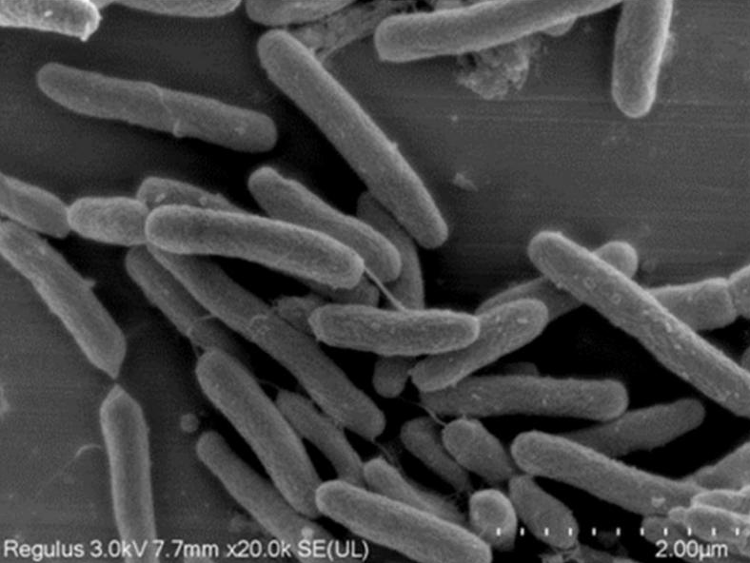
Fig. S1 Morphology of strain F3 under scanning electron microscopy
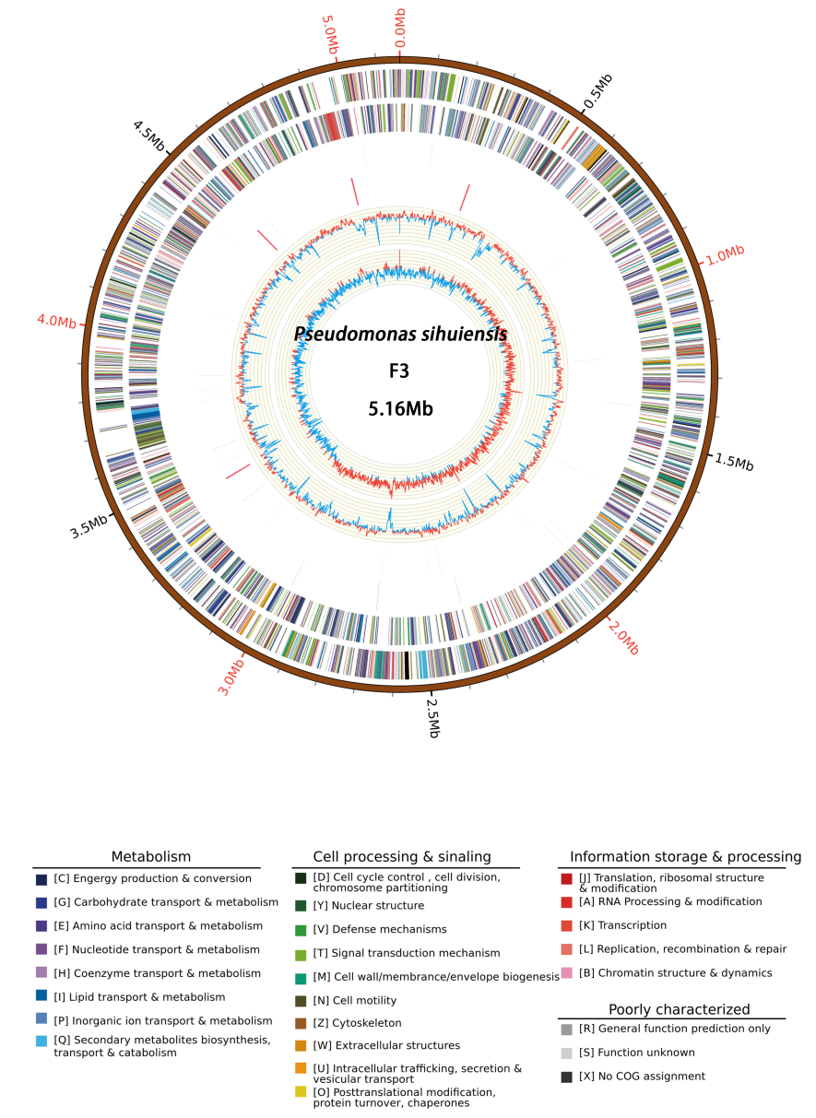
Figure S2 Whole-genome map of strain F3

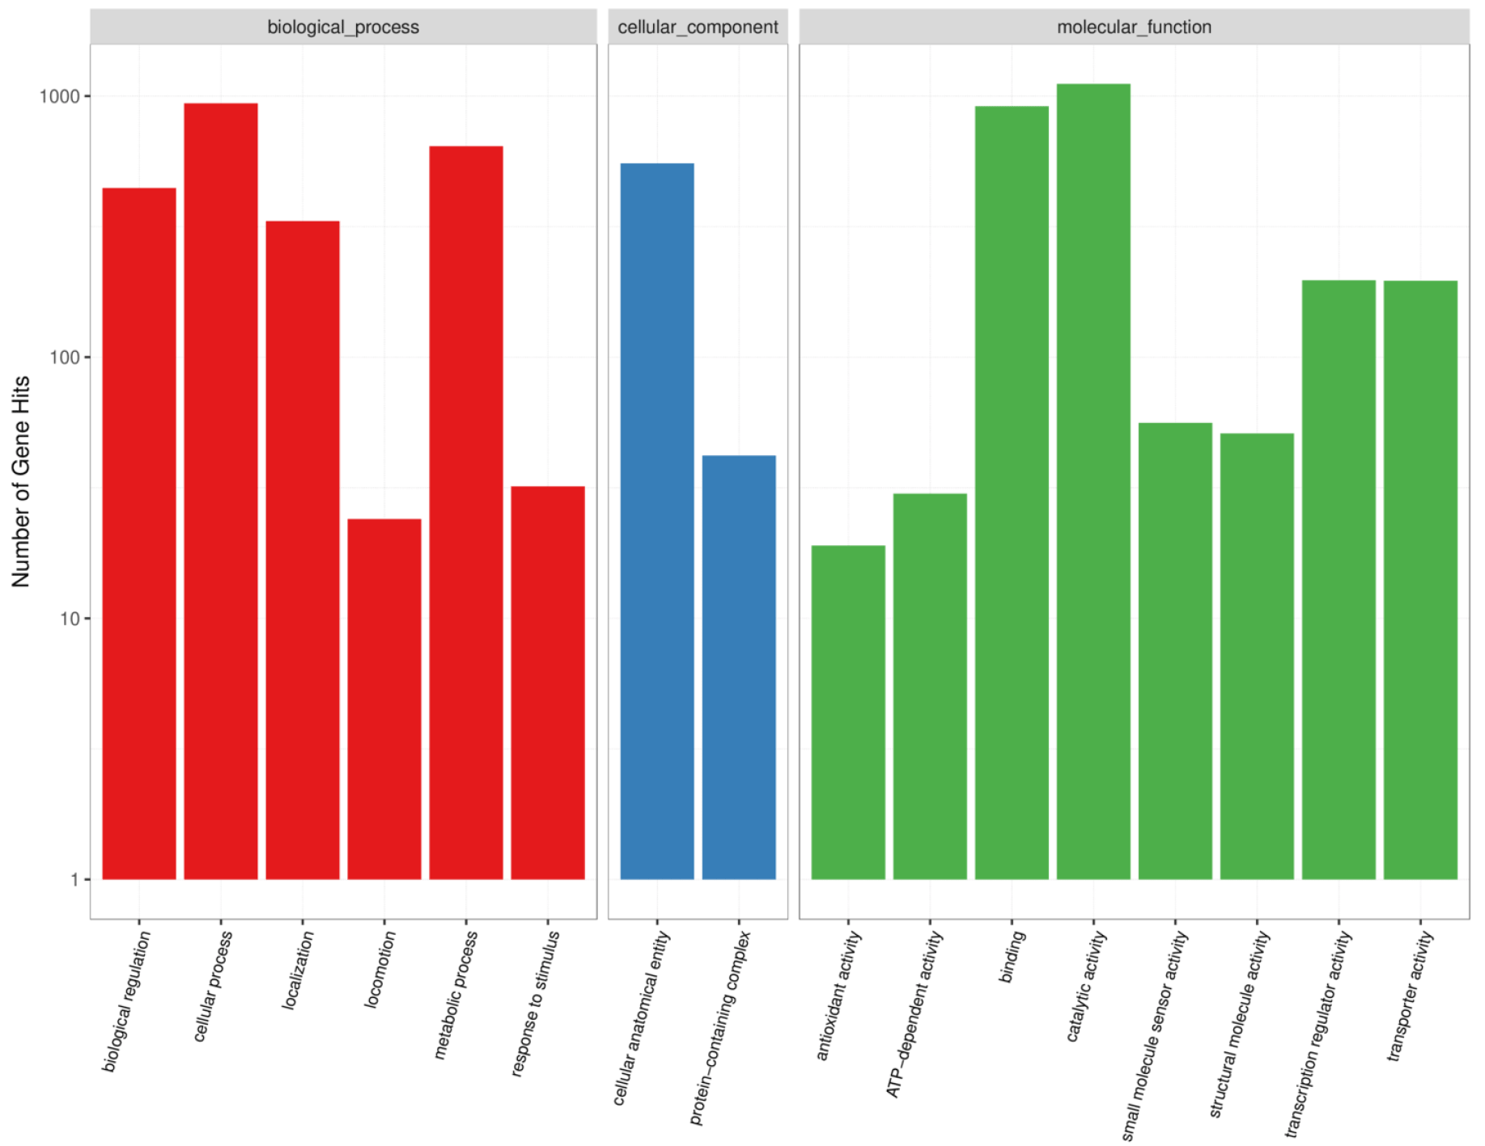
Fig S3 Genome GO database annotation analysis of strain F3

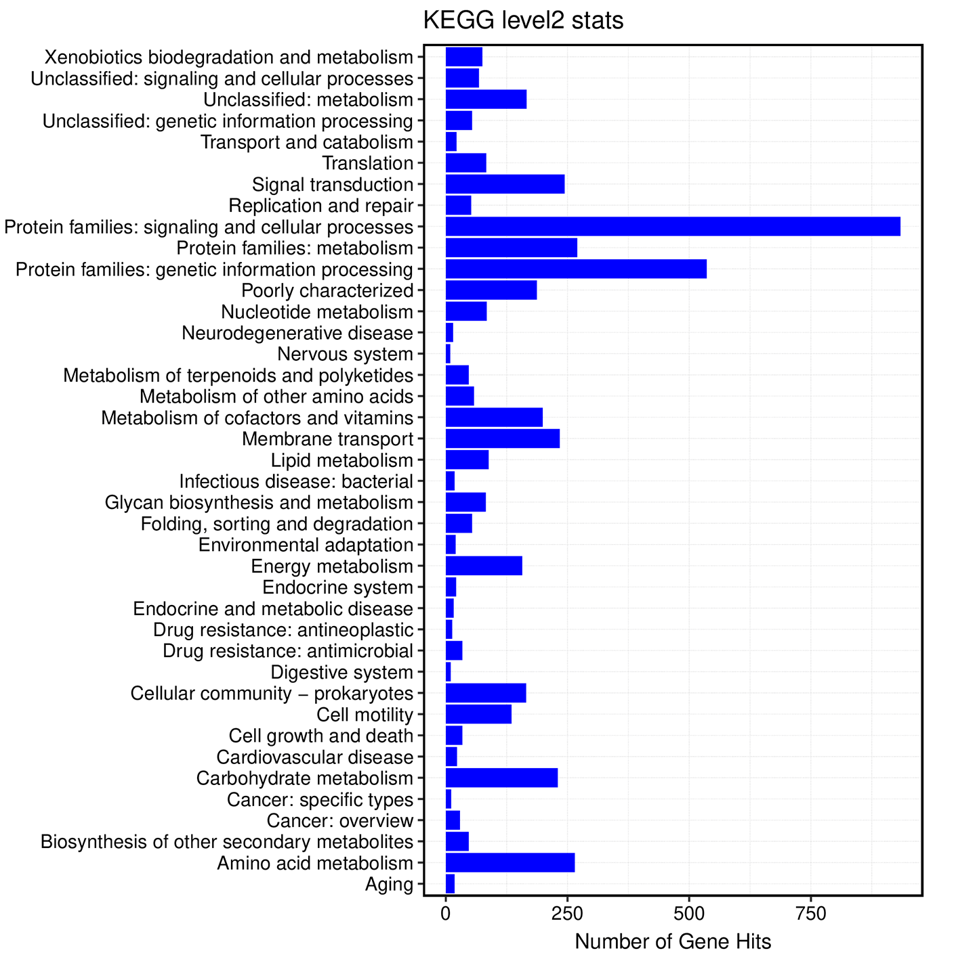
Fig S4 Genome annotation analysis of strain F3 in the KEGG database

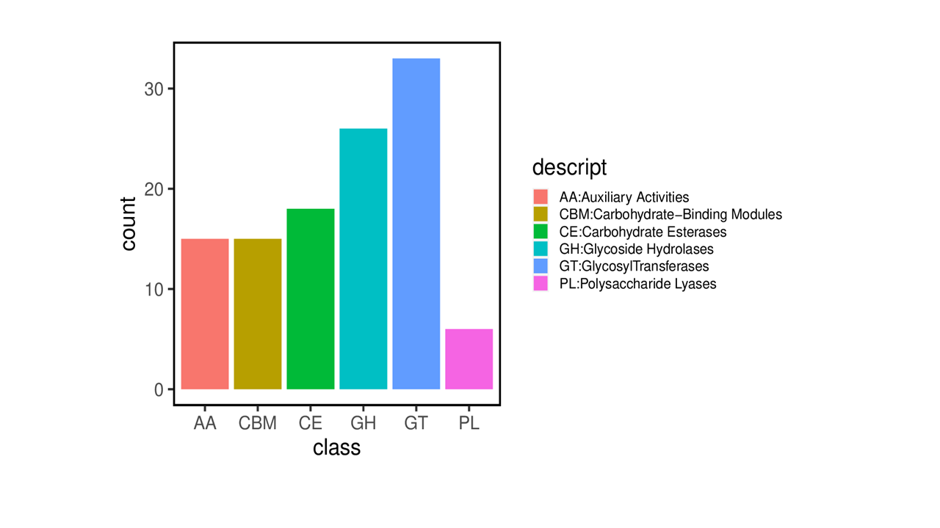
Fig S5 Functional classification of the CAZy database for the F3 genome strain

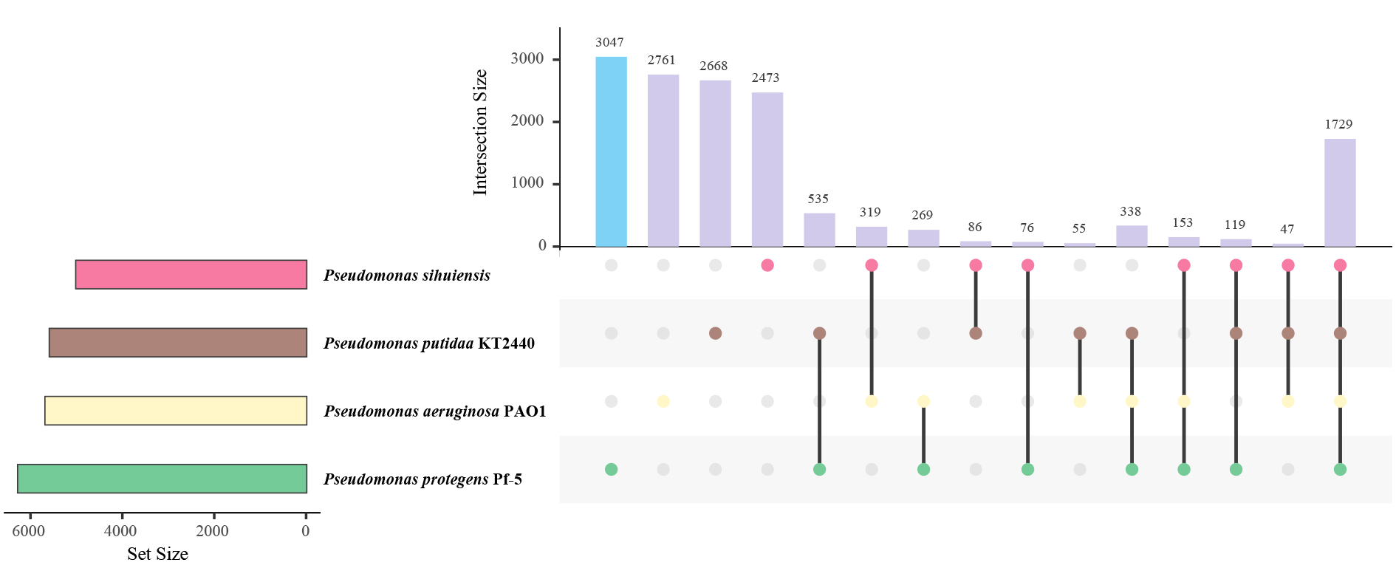
Figure S6 Gene set intersection analysis of Pseudomonas species

