Supplementary materials
Fractionation of the Peptide signal into 10 peptide classes of calibrated MW
Table 1 Characteristics of the 10 custom peptides classes defined specifying their MW ranges, expected number of peptidic AAs in the peptide chain, and elution time ranges
Classes | Class 1 | Class 2 | Class 3 | Class 4 | Class 5 | Class 6 | Class 7 | Class 8 | Class 9 | Class 10 | -
$MW$ (g/mol) | 8270 | 5789 | 4054 | 2834 | 1985 | 1388 | 972 | 680 | 476 | 333 | 233
$${nb}_{aa}$$ | 67.9 | 46.4 | 32.4 | 22.6 | 15.8 | 11.0 | 7.7 | 5.3 | 3.7 | 2.5 | 1.8
Elution time  (min) | 13,0 | 15,5 | 18,0 | 20,5 | 23,0 | 25,5 | 28,0 | 30,5 | 33,0 | 35,5 | 38,0

MW distribution of keratin hydrolysates
Fig. 1 Peptides MW distribution of hydrolysates from experiment E12 as determined by the proposed SE-HPLC methodology

Results of the calibration of the Superdex Increase column – Peptides
Table 2 The retention times, MWs and sequences of all 26 peptide standards
Peptide standards | Molecular weights MWs (g/mol) | Retention  times (min)
CHIIITTPPS | 1081.30 | 24.113
CEHPTTGPQPPS | 1364.46 | 24.499
CGHHHNP | 800.85 | 25.561
HPPTWYHWGHSGHS | 1685.76 | 26.702
LLLNQTVGHS | 1081.25 | 27.992
HHLPPTV | 799.94 | 28.481
RAERKAKE | 987.12 | 28.663
NHMMMGHS | 1082.24 | 28.875
FFFGPWGPQ | 1082.24 | 29.347
FGGHPTWGHS | 1082.15 | 29.790
KRTLR | 627.83 | 30.410
FGPPPTW | 800.92 | 31.204
AAGHMQW | 799.42 | 31.634
RIY | 450.54 | 33.802
RIY | 450.53 | 34.063
EHNT | 499.48 | 34.265
IF | 278.35 | 34.742
TL | 232.28 | 35.115
LY | 294.35 | 35.949
AM | 220.29 | 36.127
DF | 280.28 | 36.769
KW | 332.40 | 36.845
GGG | 189.17 | 37.556
DY | 296.28 | 38.325
SY | 268.27 | 38.394
GG | 132.12 | 38.591

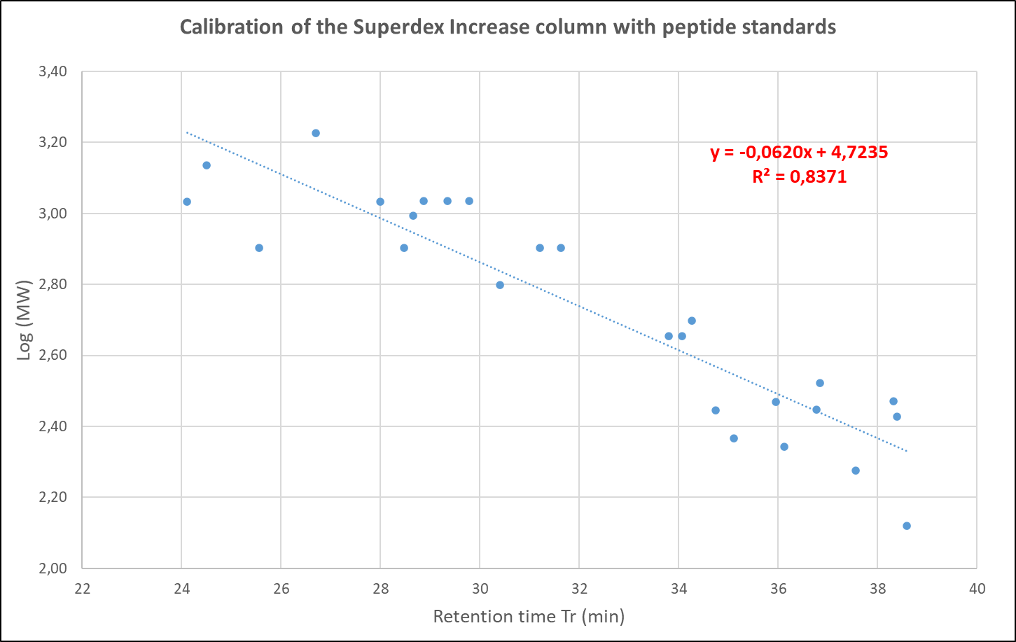
Fig. 2 Calibration of the Superdex Increase column with peptide standards

Results of the calibration of the Superdex Increase column – Free Amino Acids
Table 3 The retention times and MWs of all 18 free AAs standards
Free AAs standards | Molecular weights  MWs (g/mol) | Retention times (min)
Leucine (Leu) | 131.18 | 36.367
Isoleucine (Ile) | 131.18 | 36.565
Proline (Pro) | 115.13 | 36.727
Valine (Val) | 117.15 | 36.941
Lysine (Lys) | 146.19 | 37.510
Methionine (Met) | 149.21 | 37.582
Glutamic acid (Glu) | 147.13 | 38.174
Phenylalanine (Phe) | 165.19 | 38.262
Alanine (Ala) | 89.10 | 38.339
Arginine (Arg) | 174.20 | 38.421
Histidine (His) | 155.16 | 38.640
Threonine (Thr) | 119.12 | 38.655
Aspartic acid (Asp) | 133.11 | 39.389
Serine (Ser) | 105.09 | 39.821
Glycine (Gly) | 75.07 | 40.030
Tyrosine (Tyr) | 181.19 | 40.297
Cysteine (C) | 121.16 | 40.807
Cystine (Cys) | 240.30 | 41.991
Tryptophan (W) | 204.23 | 47.087

The boundary retention time between Peptides and FAA ($t_{delim}$), and the lower ($t_{lower}$) and upper ($t_{upper}$) retention time boundaries delimiting the elution range of the two main fractions of all the 28 investigated keratin protein hydrolysates
Table 4 Hydrolysates from experiments E11 - Elution range of their constitutive Peptide and FAA fractions
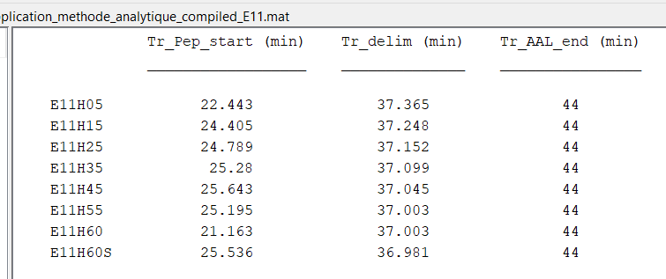
Table 5 Hydrolysates from experiments E12 - Elution range of their constitutive Peptide and FAA fractions
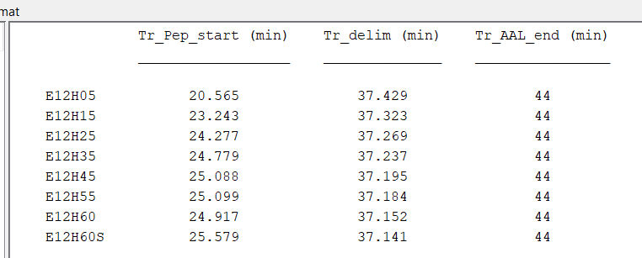

Table 6 Hydrolysates from experiments E31 - Elution range of their constitutive Peptide and FAA fractions
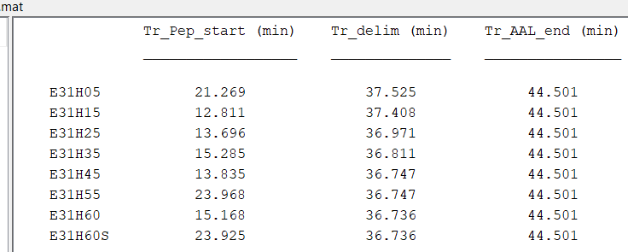
Table 7 Hydrolysates from experiments E32 - Elution range of their constitutive Peptide and FAA fractions
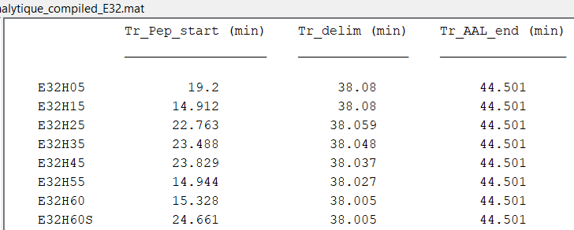

Aminograms of hydrolysates produced in experiments E31 and E32 showing the total concentrations of free AA, total AA and Peptides, and the key parameter ${\overline{M}}_{aa}$deduced from these compositions
Table 8 Aminograms of hydrolysates produced in experiments E31 and E32 showing the total concentrations of free AA, total AA and Peptides, and the key parameter ${\overline{M}}_{aa}$ deduced from these compositions using Eq. (4)
 | E31 - Concentrations (g/L) |  |  |  |  |  |  |  |  |  |  |  |  |  | E32 - Concentrations (g/L)
 | H05 |  | H15 |  | H25 |  | H35 |  | H45 |  | H55 |  | H60 |  | H05 |  | H15 |  | H25 |  | H35 |  | H45 |  | H55 |  | H60
 | Free AA | Total AA | Free AA | Total AA | Free AA | Total AA | Free AA | Total AA | Free AA | Total AA | Free AA | Total AA | Free AA | Total AA | Free AA | Total AA | Free AA | Total AA | Free AA | Total AA | Free AA | Total AA | Free AA | Total AA | Free AA | Total AA | Free AA | Total AA
Aspartic acid | 7.7 | 13.0 | 10.6 | 13.2 | 11.9 | 13.1 | 12.6 | 12.9 | 12.8 | 12.9 | 12.9 | 12.9 | 13.1 | 13.1 | 4.6 | 13.6 | 6.9 | 13.0 | 9.2 | 14.3 | 9.2 | 13.3 | 9.9 | 13.3 | 11.3 | 13.7 | 11.4 | 11.4
Threonine | 1.7 | 7.7 | 3.5 | 7.9 | 4.8 | 7.8 | 5.7 | 7.7 | 6.2 | 7.7 | 6.5 | 7.4 | 6.7 | 7.3 | 0.8 | 7.9 | 1.5 | 7.7 | 2.4 | 8.4 | 2.9 | 7.9 | 2.8 | 7.8 | 3.8 | 8.5 | 4.2 | 8.1
Serine | 12.1 | 21.4 | 17.1 | 21.6 | 19.4 | 21.4 | 20.7 | 20.8 | 20.9 | 21.0 | 20.6 | 20.6 | 20.5 | 20.5 | 7.6 | 21.6 | 11.0 | 21.0 | 14.7 | 22.9 | 14.7 | 21.3 | 15.6 | 18.4 | 17.8 | 22.3 | 18.3 | 21.4
Glutamic acid | 7.5 | 17.1 | 11.3 | 17.1 | 13.4 | 16.7 | 14.6 | 16.5 | 15.2 | 16.5 | 15.5 | 15.5 | 15.7 | 15.8 | 3.9 | 17.7 | 6.4 | 16.9 | 9.0 | 18.4 | 9.6 | 17.0 | 10.1 | 12.4 | 12.0 | 17.9 | 12.7 | 16.7
Glycine | 13.0 | 20.1 | 16.3 | 20.4 | 17.7 | 20.3 | 17.7 | 19.1 | 18.0 | 19.2 | 17.9 | 18.9 | 18.3 | 19.0 | 8.6 | 20.0 | 11.9 | 19.5 | 14.9 | 21.5 | 13.7 | 19.9 | 14.9 | 18.5 | 16.0 | 18.5 | 16.6 | 19.4
Alanine | 5.5 | 10.9 | 7.9 | 11.0 | 9.2 | 10.7 | 9.7 | 10.4 | 9.9 | 10.3 | 10.3 | 10.6 | 10.4 | 10.7 | 2.6 | 11.0 | 4.8 | 10.5 | 6.7 | 11.4 | 6.7 | 10.8 | 7.1 | 12.3 | 7.7 | 11.0 | 8.4 | 10.7
Valine | 2.6 | 13.5 | 3.7 | 13.5 | 4.8 | 13.5 | 5.8 | 13.2 | 6.7 | 13.1 | 7.2 | 13.0 | 7.5 | 13.0 | 2.2 | 13.8 | 2.6 | 13.5 | 3.1 | 14.9 | 3.0 | 13.8 | 3.1 | 13.5 | 4.0 | 13.6 | 4.2 | 13.3
Cystine | 2.0 | 21.4 | 5.0 | 21.2 | 7.5 | 21.1 | 9.2 | 20.3 | 10.1 | 20.2 | 11.4 | 20.6 | 11.7 | 21.3 | 0.0 | 23.6 | 1.7 | 22.5 | 2.7 | 24.2 | 3.9 | 21.4 | 3.8 | 26.0 | 5.7 | 24.6 | 6.3 | 21.2
Methionine | 0.6 | 0.7 | 0.7 | 0.7 | 0.7 | 0.7 | 0.6 | 0.6 | 0.6 | 0.6 | 0.7 | 0.7 | 0.8 | 0.8 | 1.1 | 1.1 | 1.1 | 1.1 | 1.0 | 1.0 | 0.6 | 0.8 | 0.8 | 0.8 | 0.8 | 0.8 | 0.9 | 0.9
Isoleucine | 1.1 | 8.0 | 2.3 | 8.1 | 2.9 | 8.1 | 3.6 | 7.8 | 4.0 | 7.7 | 4.3 | 7.2 | 4.6 | 7.3 | 0.3 | 8.1 | 0.8 | 7.9 | 1.2 | 8.7 | 1.8 | 8.2 | 1.8 | 8.1 | 2.2 | 8.1 | 2.2 | 8.0
Leucine | 4.6 | 16.5 | 7.9 | 16.5 | 10.1 | 16.4 | 11.3 | 15.7 | 12.2 | 15.5 | 13.1 | 15.1 | 13.3 | 15.2 | 2.4 | 16.8 | 3.9 | 16.2 | 5.8 | 17.7 | 6.5 | 16.4 | 6.6 | 16.5 | 8.7 | 16.4 | 9.2 | 16.3
Tyrosine | 3.8 | 10.0 | 5.8 | 10.2 | 6.9 | 10.2 | 7.8 | 10.2 | 8.2 | 10.0 | 4.6 | 11.6 | 4.5 | 10.6 | 2.5 | 9.9 | 3.7 | 10.0 | 4.9 | 10.9 | 5.0 | 10.0 | 5.1 | 10.1 | 6.1 | 10.4 | 6.5 | 10.5
Phenylalanine | 3.8 | 10.0 | 5.4 | 10.1 | 6.7 | 9.8 | 7.5 | 9.6 | 8.2 | 9.6 | 8.2 | 9.6 | 8.5 | 9.2 | 2.9 | 10.2 | 3.7 | 9.9 | 4.8 | 10.7 | 5.0 | 10.0 | 5.0 | 10.1 | 5.9 | 10.2 | 6.5 | 9.9
Lysine | 1.0 | 3.1 | 1.5 | 3.0 | 2.0 | 2.9 | 2.1 | 2.8 | 2.3 | 2.9 | 2.2 | 2.5 | 2.4 | 2.6 | 0.6 | 3.2 | 0.9 | 3.2 | 1.3 | 3.4 | 1.4 | 3.1 | 1.5 | 2.5 | 1.7 | 2.4 | 1.7 | 2.8
Histidine | 0.5 | 1.5 | 0.8 | 1.4 | 1.0 | 1.3 | 1.1 | 1.2 | 1.2 | 1.2 | 1.0 | 1.0 | 1.0 | 1.0 | 0.0 | 1.8 | 0.7 | 1.8 | 0.8 | 1.8 | 0.7 | 1.5 | 0.7 | 1.4 | 0.9 | 1.6 | 1.1 | 1.5
Arginine | 3.0 | 10.9 | 5.4 | 11.1 | 6.7 | 10.8 | 7.9 | 10.5 | 8.4 | 10.3 | 8.8 | 9.8 | 8.4 | 10.0 | 1.8 | 11.6 | 2.9 | 11.1 | 4.2 | 12.1 | 4.3 | 10.8 | 4.4 | 10.8 | 5.9 | 11.5 | 5.9 | 10.9
Proline | 6.4 | 17.4 | 10.1 | 18.4 | 14.9 | 18.3 | 13.4 | 15.9 | 15.0 | 16.3 | 17.0 | 18.1 | 17.7 | 18.3 | 3.6 | 19.5 | 6.1 | 18.7 | 9.2 | 20.1 | 10.3 | 18.1 | 10.1 | 19.2 | 10.9 | 19.1 | 10.8 | 19.1
Total (g/L) | 77 | 203 | 115 | 205 | 140 | 203 | 151 | 195 | 160 | 195 | 162 | 195 | 165 | 196 | 46 | 211 | 71 | 204 | 96 | 222 | 100 | 204 | 103 | 202 | 122 | 211 | 127 | 202
Peptides (g/L) | 126 |  | 90 |  | 63 |  | 44 |  | 35 |  | 33 |  | 31 |  | 166 |  | 134 |  | 127 |  | 105 |  | 99 |  | 89 |  | 75
${\overline{M}}_{aa} (g.mol^{-1})$ | 123 | 138 | 127 | 137 | 129 | 137 | 131 | 138 | 132 | 138 | 131 | 138 | 131 | 138 | 120 | 139 | 124 | 139 | 125 | 138 | 127 | 138 | 126 | 140 | 129 | 140 | 129 | 138

