RGS@home: Supplementary material

Additional file 1: 2
Table S1 2
Table S2 3
Table S3 4
Table S4 5
Additional file 2: 6
Figure S1 6
Figure S2 7

Additional file 1:

Table S1. Extended baseline characteristics and clinical scales of the modified intention-to-treat (mITT) sample (N = 41).
Values are presented as mean (SD), median [IQR], or n (%). One influential observation identified during longitudinal modeling was excluded from the final longitudinal analytic models (analytic cohort N = 40).
Characteristic | Control (N = 11) | RGS (N = 30)
Demographics
Age (years), mean (SD) | 63.1 (12.0) | 60.8 (13.1)
Female, n (%) | 4 (36.4) | 9 (30.0)
BMI, mean (SD) | 27.0 (6.7) | 25.9 (4.4)
Country, n (%)
France | 8 (72.7) | 16 (53.3)
Spain | 1 (9.1) | 8 (26.7)
Sweden | 2 (18.2) | 6 (20.0)
Clinical Characteristics
Patient status, n (%)
- Inpatient | 6 (54.5) | 7 (23.3)
- Outpatient | 5 (45.5) | 23 (76.7)
Paretic side, n (%)
- Left | 9 (81.8) | 16 (53.3)
- Right | 2 (18.2) | 12 (40.0)
- Both | 0 (0.0) | 1 (3.3)
Education level, n (%)
- Illiterate | 0 (0.0) | 1 (3.3)
- Primary | 1 (9.1) | 9 (30.0)
- Secondary | 4 (36.4) | 15 (50.0)
- University | 6 (54.5) | 5 (16.7)
Time since stroke (months), median [IQR] | 4.1 [1.5-4.6] | 6.8 [2.3-39.7]
Chronic (>6 months), n (%) | 2 (18.2) | 16 (53.3)
Barthel Index (BI), median [IQR] | 85.0 [67.5-90.0] | 92.5 [85.0-100.0]
BI ≥95, n (%) | 2 (18.2) | 15 (50.0)
BI =100, n (%) | 2 (18.2) | 10 (33.3)
FM-UE (0-66), mean (SD) | 46.5 (14.0) | 49.9 (14.9)
CAHAI, mean (SD) | 50.8 (31.7), n = 9 | 69.2 (25.6), n = 24
Grip force, mean (SD) | 30.4 (43.3) | 35.4 (43.7)
SIS, mean (SD) | 65.0 (15.9) | 63.2 (16.9)
FSS, mean (SD) | 38.5 (14.7) | 39.2 (14.1)
HDRS, mean (SD) | 7.7 (7.1) | 7.4 (6.8)
Pain VAS, mean (SD) | 3.0 (2.8) | 1.3 (2.3)
MAS, median [IQR] | 0 [0-2] | 0 [0-1]
MRC, median [IQR] | 3 [3-4] | 4 [3-4]
MoCA, mean (SD) | 25.6 (3.1) | 24.4 (3.6)

Table S2. Sensitivity analyses adjusting for baseline imbalances (N = 40).
Between-group differences (Group × Time interaction) from linear mixed-effects models adjusted for chronicity (months post-stroke) and patient status (inpatient vs outpatient). Values represent the adjusted difference in change from baseline between RGS and Control (Δ RGS minus Δ Control), with 95% confidence intervals (N = 40). Positive values favor RGS for BI, FM-UE, CAHAI, Grip Force, and SIS, whereas negative values favor RGS for FSS, HDRS, VAS, and MAS. Results are consistent with the primary analysis.
Statistically significant results (p < 0,05) are highlighted in bold.
Outcome | Time | Adjusted difference (95% CI) | p-value
Barthel Index (BI) | 3M | -5.42 (-11.21 to 0.37) | 0.066
 | 12M | -2.51 (-8.45 to 3.43) | 0.401
Fugl-Meyer UE (FM-UE) | 3M | -0.12 (-5.81 to 5.57) | 0.967
 | 12M | 0.48 (-5.15 to 6.11) | 0.868
CAHAI | 3M | -1.82 (-11.62 to 7.98) | 0.715
 | 12M | 0.11 (-9.75 to 9.97) | 0.983
MAS (spasticity) | 3M | -0.07 (-0.33 to 0.19) | 0.612
 | 12M | -0.23 (-0.49 to 0.03) | 0.84
Grip force | 3M | 4.63 (-0.32 to 9.58) | 0.67
 | 12M | 1.22 (-3.81 to 6.25) | 0.634
Stroke Impact Scale (SIS) | 3M | -2.68 (-9.35 to 3.99) | 0.431
 | 12M | -0.15 (-6.82 to 6.52) | 0.965
Fatigue Severity Scale (FSS) | 3M | -7.78 (-17.58 to 2.02) | 0.119
 | 12M | -11.86 (-21.95 to -1.77) | 0.023
Hamilton Depression Rating Scale (HDRS-17) | 3M | 1.15 (-2.02 to 4.32) | 0.476
 | 12M | 0.92 (-2.25 to 4.09) | 0.568
Pain VAS | 3M | 1.02 (-0.55 to 2.59) | 0.201
 | 12M | 1.18 (-0.39 to 2.75) | 0.141

Table S3. Quality of Life outcomes: adjusted change from baseline and between-group differences (N = 40).
Values represent the adjusted mean change (Δ) from the Linear Mixed-Effects Model (LMM). Differences represent the interaction contrast (RGS Δ minus Control Δ). For outcomes where higher scores indicate improvement, positive values favor RGS; for outcomes where lower scores indicate improvement, negative values favor RGS.
Outcome | Time | RGS adj Δ | Control adj Δ | Adj diff (95% CI) | p-value
SF-36 Emotional well-being | 3M | +1.6 | +2.5 | -0.9 (-16.9 to +15.1) | 0.945
 | 12M | +4.8 | -1.9 | +6.7 (-9.5 to +22.9) | 0.412
SF-36 Energy/fatigue | 3M | +3.1 | +1.2 | +1.9 (-13.1 to +16.9) | 0.801
 | 12M | +8.6 | +3.0 | +5.6 (-9.5 to +20.7) | 0.465
SF-36 General health | 3M | -8.6 | -3.2 | -5.4 (-21.4 to +10.6) | 0.501
 | 12M | -5.7 | -9.1 | +3.4 (-12.7 to +19.5) | 0.678
SF-36 Pain | 3M | -0.7 | -4.7 | +4.0 (-13.8 to +21.8) | 0.655
 | 12M | +4.3 | +7.4 | -3.1 (-20.9 to +14.7) | 0.732
SF-36 Physical functioning | 3M | +5.8 | +6.0 | -0.2 (-15.6 to +15.2) | 0.985
 | 12M | +13.6 | +13.2 | +0.4 (-15.1 to +15.9) | 0.958
SF-36 Role physical | 3M | +7.4 | +9.2 | -1.8 (-27.5 to +23.9) | 0.891
 | 12M | +20.2 | +20.5 | -0.3 (-26.1 to +25.5) | 0.982
SS-QoL  (Total Score) | 3M | +0.9 | +6.0 | -5.1 (-25.4 to +15.2) | 0.621
 | 12M | +6.2 | +2.8 | +3.4 (-16.9 to +23.7) | 0.741

Table S4. QoL outcomes: adjusted within-group change from baseline (LMM).
The SF-36 Role Emotional and Social Functioning subscales were excluded due to data singularity from extreme ceiling/floor effects. Values represent the Adjusted Mean Change (Δ) and p-values derived from the within-group contrasts of the Linear Mixed-Effects Model. Positive values indicate improvement for all scales except for General Health and the early phases of Energy/fatigue, where baseline adjustments reflect the complexity of chronic recovery trajectories. Consistent with previous analysis, the RGS group shows more frequent sustained improvements at 12 months. Significant p-values (p < 0.05) are bolded.
Outcome | Time | RGS Within-Group Adj Δ | p-value (RGS) | Control Within-Group Adj Δ | p-value (Control)
SF-36 Emotional well-being | 3M | +1.6 | 0.712 | +2.5 | 0.721
 | 12M | +4.8 | 0.265 | -1.9 | 0.786
SF-36 Energy/fatigue | 3M | +3.1 | 0.442 | +1.2 | 0.860
 | 12M | +8.6 | 0.034 | +3.0 | 0.649
SF-36 General health | 3M | -8.6 | 0.042 | -3.2 | 0.641
 | 12M | -5.7 | 0.181 | -9.1 | 0.185
SF-36 Pain | 3M | -0.7 | 0.891 | -4.7 | 0.540
 | 12M | +4.3 | 0.361 | +7.4 | 0.337
SF-36 Physical functioning | 3M | +5.8 | 0.152 | +6.0 | 0.368
 | 12M | +13.6 | < 0.001 | +13.2 | 0.046
SF-36 Role physical | 3M | +7.4 | 0.278 | +9.2 | 0.407
 | 12M | +20.2 | 0.004 | +20.5 | 0.063
SS-QoL (Total Score) | 3M | +0.9 | 0.865 | +6.0 | 0.492
 | 12M | +6.2 | 0.251 | +2.8 | 0.747

Additional file 2:

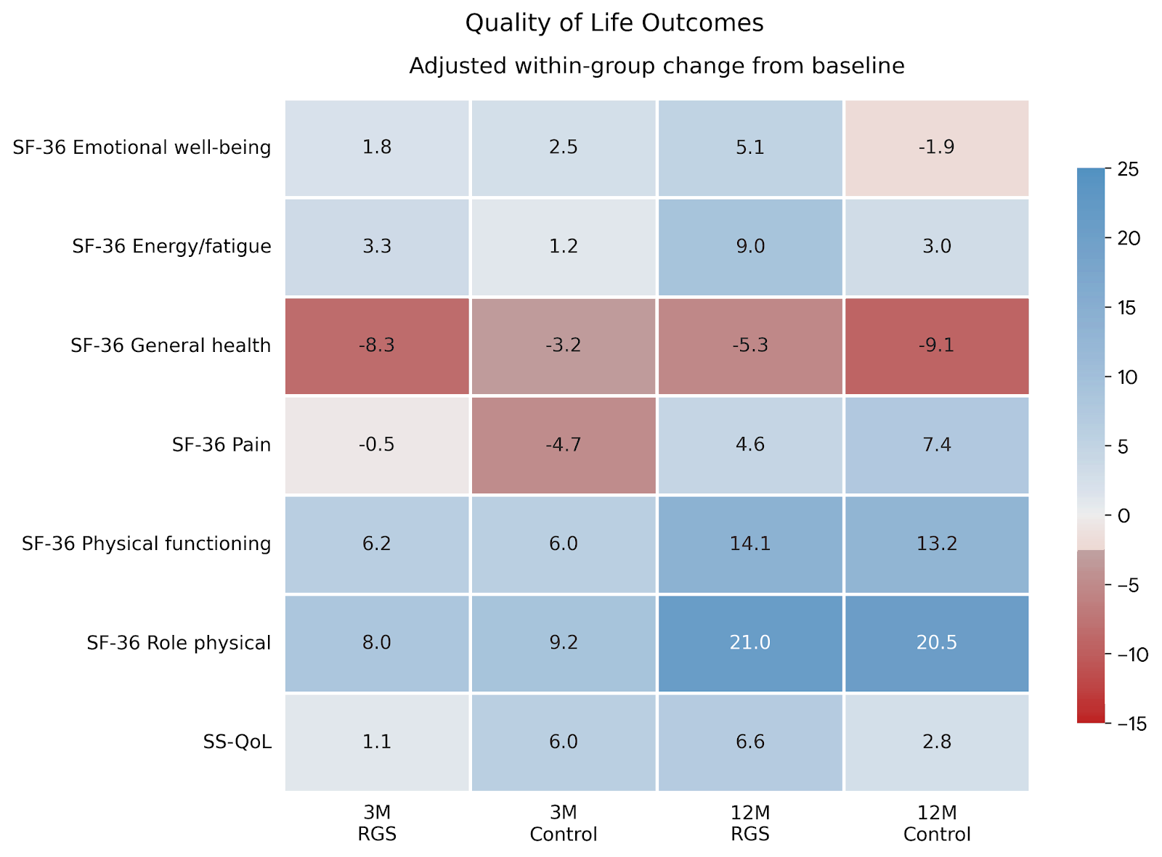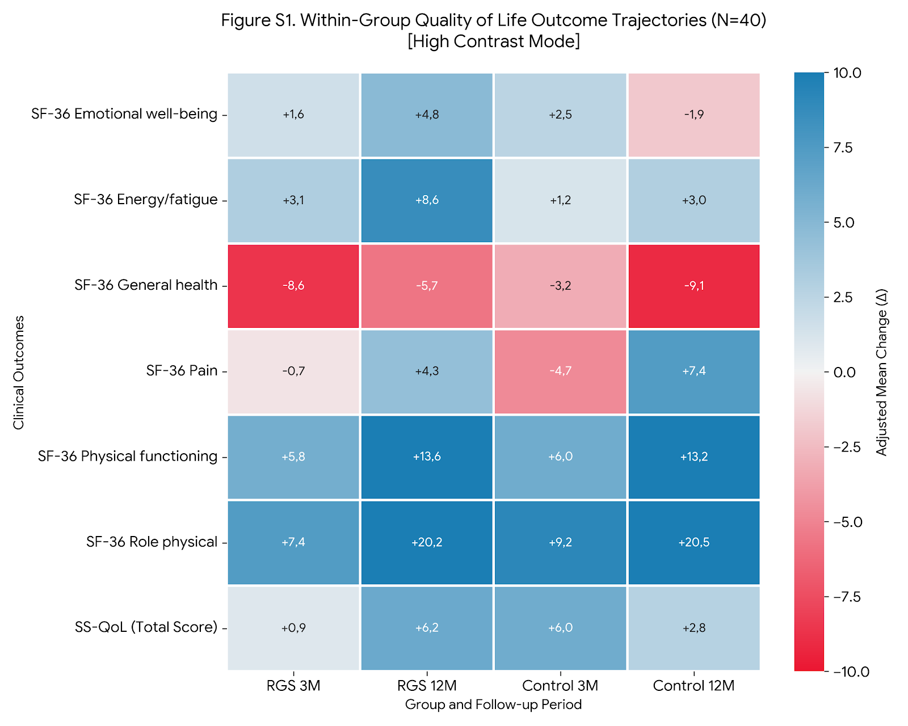

Figure S1. Quality of Life outcomes adjusted within-group changes.
Heatmap displaying the longitudinal adjusted mean change (Δ) from baseline for the N = 40 cohort. The diverging color scale represents the clinical trajectory: blue shading indicates improvement (positive change from baseline), while red shading indicates worsening (negative change from baseline), with darker intensities reflecting a greater magnitude of change.
Sustained RGS Recovery: The first two columns show that the RGS intervention not only triggers early gains (+5.8 in Physical Functioning at 3M) but also maintains and accelerates them through the 12-month follow-up (+13.6).
Control Divergence: The final column (Control 12M) highlights a "functional decay" with a drop in Emotional Well-being (-1.9) and a significant worsening in General Health (-9.1).
Physical Strength: Both groups show strong gains in Role Physical at 12 months, but the RGS group maintains a more balanced improvement across the mental and physical subscales.

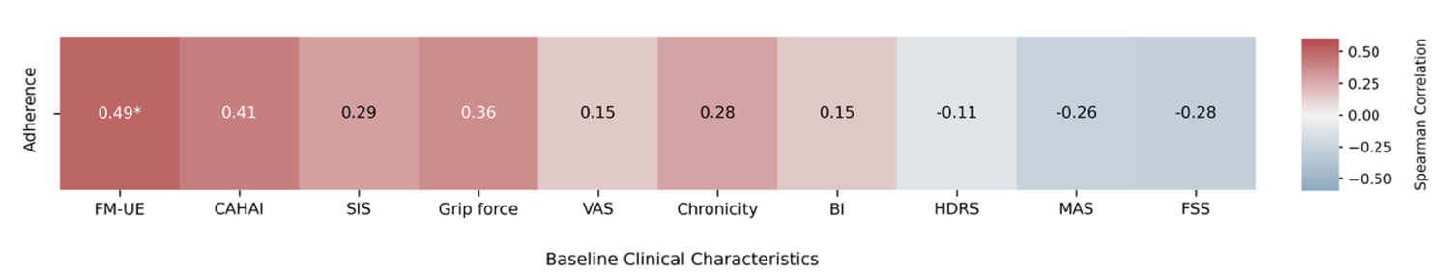

Figure S2. Exploratory association between baseline characteristics and intervention adherence.
Heatmap displaying Spearman rank correlation coefficients (ρ) between total training hours and baseline clinical metrics. The analysis included participants with complete training logs (N = 21-22, depending on variable completeness). Cell values represent the correlation coefficient (ρ), with color intensity and hue indicating the strength and direction of the association (red = positive, blue = negative). Baseline motor capacity showed the strongest positive association with training dose for FM-UE (ρ = 0.49, p = 0.023). Positive but non-significant trends were observed for CAHAI (ρ = 0.41), Grip force (ρ = 0.36), and chronicity (ρ = 0.28), whereas fatigue (FSS) showed a negative trend (ρ = -0.28). Statistically significant correlations (p < 0.05) are denoted with an asterisk.

