Evaluation of the anti-SARS-CoV-2 properties of essential oils and aromatic extracts
Daniel Jan Strub^{1,2,*}, Michał Talma³, Maria Strub², Wioletta Rut¹, Mikolaj Zmudzinski¹, Władysław Brud⁴, Dirk Jochmans⁵, Laura Vangeel⁵, Linlin Zhang⁶, Xinyuanyuan Sun⁶, Zongyang Lv^{7,8}, Digant Nayak^{7,8}, Shaun K. Olsen^{7,8}, Rolf Hilgenfeld^{6,9}, Johan Neyts⁵, Marcin Drąg^{1*}
¹Department of Chemical Biology and Bioimaging, Wrocław University of Science and Technology, Wyb. Wyspiańskiego 27, 50-370 Wrocław, Poland
² Liquid Technologies sp. z o.o., Gdańska 13, 50-344 Wrocław, Poland
³ Department of Bioorganic Chemistry, Wrocław University of Science and Technology, Wyb. Wyspiańskiego 27, 50-370 Wrocław, Poland
⁴ Scientific Committee of the International Federation of Essential Oils and Aroma Trades (IFEAT), c/o TC Group, Level 1, Devonshire House, One Mayfair Place, London W1J 8AJ, UK
⁵ Laboratory of Virology and Chemotherapy, Department of Microbiology, Immunology and Transplantation, Rega Institute, KU Leuven, Leuven, Belgium
⁶ Institute of Molecular Medicine, University of Lübeck, Ratzeburger Allee 160, 23562 Lübeck, Germany
⁷ Department of Biochemistry and Molecular Biology and Hollings Cancer Center, Medical University of South Carolina, Charleston, SC 29425, USA.
⁸ Department of Biochemistry and Structural Biology University of Texas Health Science Center at San Antonio, San Antonio, TX 78229, USA.
⁹ German Center for Infection Research (DZIF), Hamburg-Lübeck-Borstel-Riems Site, University of Lübeck, 23562 Lübeck, Germany

corresponding authors: daniel.strub@pwr.edu.pl, marcin.drag@pwr.edu.pl

S1. Inhibition assay of selected F&F materials 2
S2. IC₅₀ graphs for PL^{pro} 29
S3. IC₅₀ graphs for M^{pro} 30
S4. Antiviral assay of selected F&F materials 32

S1. Inhibition assay of selected F&F materials

Table S1. Inhibition activity of selected F&F materials against SARS-CoV-2 cysteine proteases. * Inhibitory activity for the concentration of 50 µg/mL of each F&F material. Numbers represent the mean value from two experiments (inhibition < 50%) or five experiments (inhibition > 50%).
No. | English common name | Botanical name | Country of origin | M^{pro *}  [%] inh. | PL^{pro} *  [%] inh.
Achariaceae
1 | Chaulmoogra seed oil (exp.) | Hydnocarpus wightianus | India | 0 | 22
Acoraceae
2 | Sweet flag  Calamus EO | Acorus calamus | India | 1 | 0
Altingiaceae
3 | Storax EO | Liquidambar styraciflua | Honduras | 17 | 15
4 | Storax gum | Liquidambar styraciflua | Honduras | 90.5±3.6 | 8
5 | Storax gum | Liquidambar styraciflua | Guatemala | 68.8±5.9 | 9
6 | Storax gum raw | Liquidambar styraciflua | Guatemala | 68.7±4.4 | 15
7 | Storax resinoid | Liquidambar styraciflua | Honduras | 93.1±0.7 | 13
8 | Storax resinoid | Liquidambar orientalis | Turkey | 49 | 2
Amaranthaceae
9 | Spinach absolute | Spinacia oleracea | Egypt | 76.6±5.9 | 15
Amaryllidaceae
10 | Garlic EO | Allium sativum | China | 47 | 34
11 | Leek EO | Allium porum | Egypt | 46 | 23
12 | Onion EO | Allium cepa | Egypt | 40 | 15
Anacardiaceae
13 | Mango leaf absolute | Mangifera indica | Egypt | 22 | 14
14 | Mastic EO | Pistacia lentiscus | Greece | 22 | 0
15 | Mastic EO | Pistacia lentiscus | Morocco | 18 | 19
16 | Pepper pink CO₂ | Schinus terebinthifolia Raddi | Madagascar | 13 | 6
17 | Schinus molle EO | Schinus molle | Peru | 0 | 5
Annonaceae
18 | Cananga EO | Cananga odorata (Lam.)  Hook. f. & Thomson  forma macrophylla | Indonesia | 39 | 6
19 | Ylang-Ylang complete EO | Cananga odorata Hook. f. & Thomson forma genuina | Madagascar | 0 | 6
20 | Ylang-Ylang Extra EO | Cananga odorata Hook. f. & Thomson forma genuina | Madagascar | 28 | 22
21 | Ylang-Ylang I EO | Cananga odorata Hook. f. & Thomson forma genuina | Comoros | 0 | 23
22 | Ylang-Ylang I EO | Cananga odorata Hook. f. & Thomson forma genuina | Madagascar | 5 | 23
23 | Ylang-Ylang II EO | Cananga odorata Hook. f. & Thomson forma genuina | Comoros | 6 | 20
24 | Ylang-Ylang II EO | Cananga odorata Hook. f. & Thomson forma genuina | Madagascar | 24 | 4
25 | Ylang-Ylang III EO | Cananga odorata Hook. f. & Thomson forma genuina | Comoros | 7 | 13
26 | Ylang-Ylang III EO | Cananga odorata Hook. f. & Thomson forma genuina | Madagascar | 47 | 25
Apiaceae
27 | Ajowan EO | Trachyspermum ammi  (L.) Sprague ex Turill | India | 0 | 0
28 | Angelica root EO | Angelica archangelica | Hungary | 1 | 4
29 | Angelica root EO | Angelica archangelica | India | 56.6±5.7 | 76.9±3.4
30 | Angelica seed EO | Angelica archangelica | USA | 8 | 3
31 | Anise seed EO | Pimpinella anisum | Egypt | 12 | 5
32 | Anise seed EO | Pimpinella anisum | Greece | 4 | 2
33 | Asafoetida EO | Ferula assa-foetida | India | 0 | 14
34 | Caraway seed EO | Carum carvi | Hungary | 0 | 1
35 | Caraway seed EO | Carum carvi | Egypt | 0 | 14
36 | Caraway seed absolute | Carum carvi | Egypt | 0 | 25
37 | Carrot leaf absolute | Daucus carota | Egypt | 0 | 10
38 | Carrot seed EO | Daucus carota | Greece | 14 | 0
39 | Carrot seed EO | Daucus carota | France | 38 | 0
40 | Carrot seed EO | Daucus carota | India | 29 | 12
41 | Carrot seed EO | Daucus carota | Egypt | 35 | 0
42 | Carrot seed absolute | Daucus carota | Egypt | 28 | 26
43 | Celery herb EO | Apium graveolens | Egypt | 0 | 0
44 | Celery herb EO | Apium graveolens | France | 18 | 0
45 | Celery herb EO | Apium graveolens | India | 0 | 6
46 | Celery herb EO | Apium graveolens | Egypt | 0 | 0
47 | Coriander leaves EO | Coriandrum sativum | Russia | 0 | 14
48 | Coriander leaves EO | Coriandrum sativum | Egypt | 1 | 0
49 | Coriander leaves absolute | Coriandrum sativum | Egypt | 33 | 24
50 | Coriander fruits EO | Coriandrum sativum | Egypt | 0 | 0
51 | Coriander fruits EO | Coriandrum sativum | Greece | 13 | 0
52 | Coriander fruits EO | Coriandrum sativum | Russia | 2 | 11
53 | Cumin EO | Cuminum cyminum | Egypt | 0 | 20
54 | Cumin absolute | Cuminum cyminum | Egypt | 1 | 21
55 | Cumin EO | Cuminum cyminum | Egypt | 20 | 21
56 | Cumin oleoresin | Cuminum cyminum | Spain | 0 | 12
57 | Dill seed EO | Anethum graveolens | South Africa | 2 | 0
58 | Dill seed EO | Anethum graveolens | Greece | 22 | 5
59 | Dill weed EO | Anethum graveolens | Austria | 0 | 5
60 | Dill weed EO | Anethum graveolens | Egypt | 0 | 5
61 | Dill weed EO | Anethum graveolens | USA | 16 | 11
62 | Fennel bitter EO | Foeniculum vulgare  Mill. subsp. vulgare var.  vulgare | Australia | 18 | 0
63 | Fennel bitter 70% fenchone EO | Foeniculum vulgare  Mill. subsp. vulgare var.  vulgare | Australia | 27 | 7
64 | Fennel bitter EO | Foeniculum vulgare  Mill. subsp. vulgare var.  vulgare | Spain | 0 | 0
65 | Fennel bitter EO | Foeniculum vulgare  Mill. subsp. vulgare var.  vulgare | Egypt | 0 | 18
66 | Fennel sweet EO | Foeniculum vulgare Mill.  subsp. vulgare var. dulce  (Mill.) Batt | Australia | 24 | 24
67 | Fennel sweet EO |  | Greece | 17 | 0
68 | Fennel sweet EO |  | Hungary | 14 | 10
69 | Fennel sweet EO |  | Egypt | 0 | 15
70 | Galbanum EO | Ferula gummosa Boiss.  syn. Ferula galbaniflua  Boiss. et Buhse | Iran | 11 | 9
71 | Galbanum resinoid | Ferula gummosa Boiss.  syn. Ferula galbaniflua  Boiss. et Buhse | Iran | 78.2±0.8 | 11
72 | Lovage leaf EO | Levisticum officinale Koch | Hungary | 16 | 0
73 | Lovage root EO | Levisticum officinale Koch | Hungary | 76.5±1.9 | 39
74 | Parsley herb EO | Petroselinum crispum  (Mill.) Fuss  syn. Petroselinum sativum Hoffm | Australia | 42 | 0
75 | Parsley herb EO |  | Egypt | 49 | 18
76 | Parsley fruit EO |  | Australia | 26 | 28
77 | Parsley fruit EO |  | Egypt | 11 | 5
78 | Parsley fruit EO |  | Romania | 0 | 15
79 | Sea fennel EO | Crithmum maritimum | Greece | 49 | 0
Aquifoliaceae
80 | Mate absolute | Ilex Paraguariensis | Brazil | 0 | 5
Asparagaceae
81 | Tuberose absolute | Polianthes tuberosa | India | 0 | 18
Asteraceae
82 | Armoise EO | Artemisia herba-alba Asso. | North Africa | 0 | 14
83 | Artichoke absolute | Cynara cardunculus | Egypt | 39 | 41
84 | Blue tansy EO | Tanacetum annuum | Morocco | 7 | 0
85 | Calendula absolute | Calendula officinalis | Egypt | 21 | 41
86 | Calendula concrete | Calendula officinalis | Egypt | 49 | 28
87 | Chamomile blue EO | Matricaria chamomilla L.  syn. Chamomilla recutita  (L.) Rauschert | Egypt | 2 | 0
88 | Chamomile blue EO |  | Hungary | 18 | 0
89 | Chamomile blue EO |  | Greece | 31 | 0
90 | Chamomile blue absolute |  | Egypt | 0 | 31
91 | Chamomile blue concrete |  | Egypt | 4 | 31
92 | Chamomile Roman EO | Chamaemelum nobile  (L.) All.  syn. Anthemis nobilis L.  syn. Ormenis nobilis (L.)  J. Gay ex Coss. & Germ. | France | 0 | 0
93 | Chamomile Roman EO |  | Greece | 9 | 0
94 | Chamomile wild EO | Cladanthus mixtus (L.)  Chevall.  syn. Chamaemelum mixtum (L.) All. | Morocco | 8 | 2
95 | Cotula EO | Cotula cinerea | Egypt | 21 | 29
96 | Davana EO | Artemisia pallens Wall.  ex DC. | India | 25 | 15
97 | Everlasting EO | Helichrysum italicum  (Roth) G. Don  syn. Helichrysum angustifolium (Lam.) DC. | Spain | 24 | 9
98 | Everlasting EO |  | Greece | 18 | 2
99 | Goldenrod EO | Solidago canadensis | Canada | 4 | 8
100 | Helichrysum EO | Helichrysum gymnocephalum | Madagascar | 14 | 23
101 | Helichrysum EO | Helichrysum bracteiferum | Madagascar | 31 | 20
102 | Iary EO | Psiadia altissima | Madagascar | 31 | 0
103 | Inula EO | Inula graveolens | France | 20 | 0
104 | Irish lace (anis del monte) EO | Tagetes filifolia | Ecuador | 26 | 50
105 | Milfoil (yarrow) EO, 3% chamazulene | Achillea millefolium | Austria | 43 | 17
106 | Milfoil (yarrow) EO, 15% chamazulene | Achillea millefolium | Austria | 40 | 16
107 | Milfoil (yarrow) EO | Achillea millefolium | Bulgaria | 41 | 27
108 | Milfoil (yarrow) EO | Achillea millefolium | Greece | 11 | 3
109 | Milfoil (yarrow) EO | Achillea millefolium | Spain | 28 | 0
110 | Tagete EO | Tagetes minuta L.  syn. Tagetes glandulifera Schrank | Egypt | 48 | 28
111 | Tagete absolute | Tagetes minuta L.  syn. Tagetes glandulifera Schrank | Egypt | 39 | 24
112 | Tagete EO | Tagetes minuta L.  syn. Tagetes glandulifera Schrank | Madagascar | 16 | 19
113 | Tagete EO | Tagetes minuta L.  syn. Tagetes glandulifera Schrank | Mexico | 14 | 0
114 | Tagete EO | Tagetes minuta L.  syn. Tagetes glandulifera Schrank | South Africa | 1 | 0
115 | Tagete EO | Tagetes minuta L.  syn. Tagetes glandulifera Schrank | Zimbabwe | 59.1±1.7 | 0
116 | Tarragon EO | Artemisia dracunculus | USA | 0 | 15
117 | Tarragon EO | Artemisia dracunculus | Spain | 0 | 8
118 | Wormwood herb EO | Artemisia absinthium | Russia | 0 | 0
119 | Wormwood herb EO | Artemisia absinthium | USA | 0 | 16
Betulaceae
120 | Birch tar EO | Betula pendula Roth | France | 45 | 7
Brassicaceae
121 | Rocket absolute | Eruca vesicaria | Egypt | 100±0.1 | 26
122 | Rocket concrete | Eruca vesicaria | Egypt | 94 | 33
Burseraceae
123 | Copal EO | Protium amazonicum | Ecuador | 18 | 21
124 | Elemi EO | Canarium luzonicum  (Blume) A. Gray | Phillipines | 33 | 31
125 | Elemi gum | Canarium luzonicum  (Blume) A. Gray | Phillipines | 97.1±1.9 | 17
126 | Myrrh EO | Commiphora myrrha  (Nees) Engl.  syn. C. molmol (Engl.)  Engl. ex Tschirch | Somalia | 68.2±0.9 | 19
127 | Myrrh resinoid |  | Somalia | 2 | 15
128 | Myrrh resin |  | Somalia | 23 | 31
129 | Olibanum (frankincense) EO | Boswellia sacra Flueck.  syn. Boswellia carteri  Birdw. | Somalia | 21 | 20
130 | Olibanum (emerald frankincense) EO | Boswellia sacra Flueck.  syn. Boswellia carteri  Birdw. | Somalia | 27 | 0
131 | Olibanum (frankincense) EO | Boswellia sacra Flueck.  syn. Boswellia carteri  Birdw. | Ethiopia | 31 | 0
132 | Olibanum (frankincense) EO | Boswellia sacra Flueck.  syn. Boswellia carteri  Birdw. | India | 10 | 0
133 | Olibanum (frankincense) EO | Boswellia sacra Flueck.  syn. Boswellia carteri  Birdw. | Oman | 26 | 0
134 | Olibanum (frankincense) resinoid | Boswellia sacra Flueck.  syn. Boswellia carteri  Birdw. | Somalia | 14 | 5
135 | Opopanax EO | Commiphora erythraea  (Ehrenb.) Engl. | Somalia | 0 | 11
136 | Opopanax absolute | Commiphora erythraea  (Ehrenb.) Engl. | Somalia | 0 | 9
137 | Opopanax resinoid | Commiphora erythraea  (Ehrenb.) Engl. | Somalia | 0 | 15
138 | Palo Santo EO | Bursera graveolens | Ecuador | 27 | 34
Cannabaceae
139 | Hops EO | Humulus lupulus | Austria | 26 | 11
140 | Hops EO | Humulus lupulus | Canada | 14 | 15
Caprifoliaceae
141 | Honeysuckle absolute | Lonicera caprifolium | Egypt | 0 | 14
142 | Spikenard EO | Nardostachys grandiflora DC.  syn. Nardostachys jatamansi (D.Don) DC. | India | 30 | 5
Caryophyllales
143 | Carnation absolute | Dianthus caryophyllus | Egypt | 0 | 8
144 | Carnation concrete | Dianthus caryophyllus | Egypt | 3 | 12
Cistaceae
145 | Cistus complete EO | Cistus ladanifer | Spain | 34 | 22
146 | Cistus EO | Cistus ladanifer | Spain | 24 | 13
147 | Cistus EO | Cistus ladanifer | Greece | 3 | 2
148 | Cistus absolute | Cistus ladanifer | Spain | 0 | 20
149 | Cistus SEV absolute | Cistus ladanifer | Spain | 42 | 11
150 | Labdacistus EO | Cistus ladanifer | Spain | 0 | 0
151 | Labdanum absolute | Cistus ladanifer | Spain | 48 | 20
152 | Labdanum gum refined | Cistus ladanifer | Spain | 73.7±2.2 | 0
153 | Labdanum resinoid | Cistus ladanifer | Spain | 33 | 12
Cupressaceae
154 | Amber solid | Juniperus Virginiana | USA | 59.4±2.9 | 53.9±1.9
155 | Blue cypress EO | Callitris intratropica | Australia | 73.1±2.7 | 0
156 | Cade crude ex-sabine EO | Juniperus phoenicea | Spain | 94.0±0.6 | 31
157 | Cade, rectified EO | Juniperus oxycedrus | India | 34 | 4
158 | Cedarleaf EO | Thuja occidentalis | Canada | 0 | 10
159 | Cedarwood EO | Cupressus funebris | China | 56.7±4.5 | 0
160 | Cedarwood Texas EO | Juniperus ashei J. Buchholz | USA | 38 | 18
161 | Cedarwood Virginian EO | Juniperus virginiana | USA | 60.4±2.9 | 0
162 | Cypress EO | Cupressus sempervirens | Italy | 17 | 14
163 | Cypress EO | Cupressus sempervirens | Greece | 27 | 2
164 | Cypress absolute | Cupressus sempervirens | Italy | 39 | 12
165 | Hinoki EO | Chamaecyparis obtusa | Japan | 0 | 18
166 | Juniper berry EO | Juniperus communis | North Macedonia | 0 | 6
167 | Juniper berry EO | Juniperus communis | Greece | 14 | 7
168 | Juniper Berry CO₂ | Juniperus communis | India | 35 | 0
169 | Siam wood EO | Fokienia hodginsii | Vietnam | 83.8±1.5 | 3
170 | Thuja EO | Thuja plicata | Central/East Europe | 0 | 7
Cyperaceae
171 | Cypriol (Nagarmotha) EO | Cyperus scariosus R. Br. | India | 59.3±1.6 | 21
Dipterocarpaceae
172 | Gurjun Balsam rectified (Copaene) | Dipterocarpus spp | Indonesia | 0 | 13
Ericaceae
173 | Anthopogon EO | Rhododendron anthopogon | Nepal | 36 | 0
174 | Labrador tea EO | Rhododendron groenlandicum | Canada | 15 | 17
175 | Wintergreen EO | Gaultheria procumbens | Nepal | 0 | 26
Euphorbiaceae
176 | Cascarilla bark EO | Croton eluteria (L.)  W. Wright  syn. Clutia eluteria L. | El Salvador | 30 | 2
Fabaceae
177 | Broom absolute | Spartium junceum | Italy | 0 | 36
178 | Cabreuva red EO | Myrocarpus fastigiatus Allemao | Paraguay | 78.6±0.9 | 19
179 | Cassie absolute | Acacia farnesiana | Egypt | 0 | 7
180 | Copaiba balsam | Copaifera officinalis | Brazil | 10 | 8
181 | Fenugreek absolute | Trigonella foenum graecum | Egypt | 0 | 25
182 | Fenugreek absolute | Trigonella foenum graecum | India | 0 | 2
183 | Licorice hydroalcoholic extract | Glycyrrhiza glabra | Egypt | 0 | 23
184 | Mimosa absolute | Acacia decurrens var. dealbata | France | 38 | 5
185 | Paramela EO | Adesmia Boronioides Hook. F. | Argentina | 34 | 8
186 | Peru balsam | Myroxylon balsamum var.  pereirae | El Salvador | 64.4±2.2 | 36
187 | Peru balsam | Myroxylon balsamum var.  pereirae | Guatemala | 44 | 0
188 | Peru balsam raw | Myroxylon balsamum var.  pereirae | Guatemala | 20 | 15
189 | Peru resinoid | Myroxylon balsamum var.  pereirae | El Salvador | 57.9±1.5 | 9
190 | Tolu resinoid | Myroxylon balsamum (L.) Harms | Venezuela | 77.3±4.6 | 15
191 | Tonka bean absolute | Dipteryx odorata | Brazil | 0 | 21
Geraniaceae
192 | Geranium EO | Pelargonium graveolens | China | 0 | 0
193 | Geranium EO | Pelargonium graveolens | Greece | 27 | 0
194 | Geranium EO | Pelargonium graveolens | Egypt | 29 | 23
195 | Geranium EO | Pelargonium graveolens | Madagascar | 0 | 5
196 | Geranium EO | Pelargonium graveolens | South Africa | 0 | 0
197 | Geranium Bourbon EO | Pelargonium graveolens | Madagascar | 0 | 4
198 | Geranium absolute | Pelargonium graveolens | Egypt | 27 | 22
199 | Geranium concrete | Pelargonium graveolens | Egypt | 30 | 13
200 | Geranium hydrolate absolute | Pelargonium graveolens | Egypt | 29 | 35
Grossulariaceae
201 | Blackcurrant buds absolute | Ribes nigrum | France | 44 | 16
Iridaceae
202 | Orris root absolute | Iris pallida | Italy | 13 | 0
203 | Orris root concentrate | Iris pallida | France | 0 | 26
Lamiaceae
204 | Basil cinnamon EO | Ocimum basilicum ‘Cinnamon’ | Egypt | 7 | 3
205 | Basil holy EO | Ocimum tenuiflorum L.  syn. Ocimum sanctum L. | India | 19 | 7
206 | Basil lemon EO | Ocimum x africanum | Egypt | 32 | 0
207 | Basil lemon absolute | Ocimum x africanum | Egypt | 25 | 42
208 | Basil lemon concrete | Ocimum x africanum | Egypt | 26 | 30
209 | Basil oleoresin | Ocimum basilicum | India | 0 | 27
210 | Basil sweet (linalool) EO | Ocimum basilicum | Egypt | 23 | 0
211 | Basil sweet (linalool) EO | Ocimum basilicum | Greece | 22 | 8
212 | Basil sweet (linalool) EO | Ocimum basilicum | Thailand | 2 | 0
213 | Basil sweet (linalool) EO | Ocimum basilicum | Egypt | 34 | 33
214 | Basil sweet (linalool) EO | Ocimum basilicum | Egypt | 30 | 31
215 | Basil tropical (estragol) EO | Ocimum basilicum | Egypt | 11 | 18
216 | Basil tropical (estragol) EO | Ocimum basilicum | India | 0 | 15
217 | Basil tropical (estragol) EO | Ocimum basilicum | Thailand | 3 | 8
218 | Basil tropical (estragol) absolute | Ocimum basilicum | Egypt | 17 | 29
219 | Basil tropical (estragol) concrete | Ocimum basilicum | Egypt | 17 | 29
220 | Basil tropical (estragol) hydrolate absolute | Ocimum basilicum | Egypt | 8 | 32
221 | Catnip (catmint) EO | Nepeta cataria | Canada | 21 | 0
222 | Hyssop EO | Hyssopus officinalis | Austria | 17 | 14
223 | Hyssop EO | Hyssopus officinalis | Bulgaria | 3 | 18
224 | Lavandin EO | Lavandula angustifolia Mill. × Lavandula latifolia Medik. | France | 3 | 16
225 | Lavandin abrialis EO | Lavandula angustifolia Mill. × Lavandula latifolia Medik. | France | 2 | 0
226 | Lavandin absolute | Lavandula angustifolia Mill. × Lavandula latifolia Medik. | France | 0 | 8
227 | Lavandin grosso EO | Lavandula angustifolia Mill. × Lavandula latifolia Medik. | France | 1 | 2
228 | Lavandin super EO | Lavandula angustifolia Mill. × Lavandula latifolia Medik. | France | 0 | 0
229 | Lavandin EO | Lavandula angustifolia Mill. × Lavandula latifolia Medik. | Greece | 17 | 3
230 | Lavender EO | Lavandula angustifolia Mill. | Australia | 16 | 9
231 | Lavender EO | Lavandula angustifolia Mill. | France | 15 | 5
232 | Lavender EO | Lavandula angustifolia Mill. | Greece | 21 | 8
233 | Lavender EO | Lavandula angustifolia Mill. | Spain | 4 | 9
234 | Lavender fresh EO | Lavandula angustifolia Mill. | Bulgaria | 2 | 13
235 | Lavender green absolute | Lavandula angustifolia Mill. | France | 0 | 8
236 | Lavender organic EO | Lavandula angustifolia Mill. | France | 0 | 7
237 | Lavender spike EO | Lavandula latifolia Medik. | France | 0 | 10
238 | Lavender spike absolute | Lavandula latifolia Medik. | France | 33 | 10
239 | Spanish wild marjoram EO | Thymus mastichina | Spain | 0 | 16
240 | Marjoram sweet EO | Origanum majorana | Greece | 15 | 0
241 | Marjoram sweet EO | Origanum majorana | Morocco | 0 | 12
242 | Marjoram sweet EO | Origanum majorana | Egypt | 3 | 17
243 | Marjoram sweet absolute | Origanum majorana | Egypt | 39 | 30
244 | Lemon balm EO | Melissa officinalis | Bulgaria | 47 | 14
245 | Lemon balm EO | Melissa officinalis | Greece | 43 | 0
246 | Mentha citrata EO | Mentha aquatica L. var. citrata (Ehrh.) Fresen.  syn. Mentha citrata Ehrh. | India | 0 | 0
247 | Mentha arvensis EO | Mentha canadensis L.  syn. Mentha arvensis var. piperascens Malinv. ex Holmes  syn. Mentha arvensis var. glabrata (Benth.) Fernald | China | 0 | 9
248 | Mentha arvensis EO |  | India | 0 | 12
249 | Mentha arvensis partially dementholized EO |  | India | 0 | 17
250 | Oregano EO | Origanum vulgare  L. subsp. hirtum (Link)  letsw. | Greece | 23 | 11
251 | Oregano EO, carvacrol 91.7% | Origanum vulgare  L. subsp. hirtum (Link)  letsw. | Greece | 17 | 8
252 | Pennyroyal EO | Mentha pulegium | Morocco | 7 | 13
253 | Peppermint EO | Mentha x piperita | Australia | 16 | 1
254 | Peppermint EO | Mentha x piperita | China | 0 | 22
255 | Peppermint Yakima EO | Mentha x piperita | USA | 18 | 0
256 | Peppermint | Mentha x piperita | Greece | 9 | 0
257 | Perilla EO | Perilla frutescens | China | 32 | 0
258 | Spearmint EO | Mentha spicata L.  syn. Mentha viridis L. var. crispa Benth. | China | 0 | 2
259 | Spearmint EO | Mentha spicata L.  syn. Mentha viridis L. var. crispa Benth. | Greece | 19 | 0
260 | Spearmint EO | Mentha spicata L.  syn. Mentha viridis L. var. crispa Benth. | Egypt | 13 | 12
261 | Origanum Spanish type EO | Thymbra capitata  (L.) Cav.  syn. Thymus capitatus (L.) Hoffmanns. & Link | Spain | 22 | 8
262 | Patchouli EO | Pogostemon cablin (Blanco) Benth.  syn. Mentha cablin Blanco | Indonesia | 63.5±2.0 | 12
263 | Patchouli DM Sulawesi Iron free EO | Pogostemon cablin (Blanco) Benth.  syn. Mentha cablin Blanco | Indonesia | 11 | 10
264 | Patchouli light EO | Pogostemon cablin (Blanco) Benth.  syn. Mentha cablin Blanco | Indonesia | 27 | 4
265 | Patchouli molecular distillation EO | Pogostemon cablin (Blanco) Benth.  syn. Mentha cablin Blanco | Indonesia | 11 | 11
266 | Patchouli Super Dark EO | Pogostemon cablin (Blanco) Benth.  syn. Mentha cablin Blanco | Indonesia | 45 | 26
267 | Rosemary EO | Rosmarinus officinalis | Australia | 19 | 11
268 | Rosemary EO | Rosmarinus officinalis | Spain | 0 | 11
269 | Rosemary EO | Rosmarinus officinalis | Greece | 37 | 4
270 | Rosemary EO | Rosmarinus officinalis | Egypt | 26 | 27
271 | Rosemary absolute | Rosmarinus officinalis | Egypt | 46 | 29
272 | Sage clary EO | Salvia sclarea L.  syn. Salvia sclarea var. turkestaniana (Noter) Mottet | Egypt | 33 | 0
273 | Sage clary EO |  | Greece | 26 | 0
274 | Sage clary EO |  | Spain | 0 | 3
275 | Sage clary absolute |  | Egypt | 2 | 22
276 | Sage clary concrete |  | Egypt | 0 | 7
277 | Sage Dalmatian EO | Salvia officinalis | Hungary | 0 | 7
278 | Sage Dalmatian EO | Salvia officinalis | Greece | 23 | 0
279 | Sage, Spanish type EO | Salvia officinalis subsp. lavandulifolia (Vahl) Gams  syn. Salvia lavandulifolia Vahl | Spain | 0 | 4
280 | Savory summer EO | Satureja hortensis | Egypt | 23 | 0
281 | Savory summer EO | Satureja hortensis | Hungary | 19 | 7
282 | Savory winter EO | Satureja montana | Egypt | 15 | 0
283 | Thyme grey absolute | Thymus zygis | Spain | 13 | 8
284 | Thyme var thymol EO | Thymus zygis | Hungary | 16 | 5
285 | Thyme red EO | Thymus vulgaris | Spain | 10 | 8
286 | Thyme EO | Thymus vulgaris | Greece | 10 | 0
287 | Thyme red absolute | Thymus vulgaris | Spain | 0 | 13
288 | Thyme common absolute | Thymus vulgaris | Egypt | 37 | 47
289 | Thyme red oleoresin | Thymus vulgaris | Turkey | 0 | 28
290 | Thyme white EO | Thymus vulgaris | France | 2 | 4
Lauraceae
291 | Camphor tree (camphor laurel) EO | Cinnamomum camphora (L.) J. Presl  syn. Laurus camphora L. | Japan | 0 | 0
292 | Cassia, Chinese type EO | Cinnamomum cassia (L.) J. Presl  syn. Cinnamomum aromaticum Nees | China | 35 | 8
293 | Cassia, Chinese type CO₂ |  | Indonesia | 43 | 8
294 | Cinnamon bark, Sri Lanka type EO | Cinnamomum verum  J. Presl  syn. Cinnamomum zeylanicum Blume | Indonesia | 15 | 0
295 | Cinnamon leaf, Sri Lanka type EO | Cinnamomum verum  J. Presl  syn. Cinnamomum zeylanicum Blume | Indonesia | 0 | 0
296 | Ho (Shiu) wood EO | Cinnamomum camphora linaloliferum | China | 0 | 19
297 | Ishpingo EO | Ocotea quixos | Ecuador | 39 | 38
298 | Litsea cubeba EO | Litsea cubeba (Lour.) Pers. | China | 16 | 12
299 | Massoia bark EO | Cryptocarya massoy (Oken) Kosterm. | Indonesia | 6 | 4
300 | Ocotea cymbarum EO | Ocotea cymbarum | China | 11 | 0
301 | Ravintsara EO | Cinnamomum camphora | Madagascar | 11 | 30
302 | Rosewood, Brazilian type EO | Aniba rosaeodora Ducke  Aniba parviflora (Meissn.) Mez. | Brazil | 23 | 1
303 | Sassafras EO | Sassafras albidum | Taiwan | 14 | 0
304 | Sugandha kokila EO | Cinnamomum glaucescens | India | 17 | 1
305 | Sweet bay EO | Laurus nobilis | Spain | 0 | 11
306 | Sweet bay EO | Laurus nobilis | Greece | 26 | 0
307 | Sweet bay oleoresin | Laurus nobilis | Turkey | 15 | 13
Magnoliaceae
308 | Magnolia champaca flower EO | Michelia × alba DC | Thailand | 39 | 0
309 | Magnolia champaca leaf EO | Michelia × alba DC | Thailand | 17 | 1
Malvaceae
310 | Cocoa seed absolute | Theobroma cacao | Tanzania | 0 | 30
311 | Cocoa butter CO₂ | Theobroma cacao | Indonesia | 0 | 36
Meliaceae
312 | Neem oil (exp.) | Azadirachta indica | India | 6 | 18
Myristicaceae
313 | Mace EO | Myristica fragrans Houtt. | Indonesia | 0 | 0
314 | Nutmeg EO | Myristica fragrans Houtt. | India | 0 | 7
315 | Nutmeg EO | Myristica fragrans Houtt. | Indonesia | 0 | 11
Myrtaceae
316 | Bay EO | Pimenta racemosa (Mill.) J.W. Moore | India | 34 | 1
317 | Big Badja gum EO | Eucalyptus badjensis | Australia | 10 | 0
318 | Blue mallee EO | Eucalyptus polybractea R. T. Baker | Australia | 4 | 17
319 | Cajeput EO | Melaleuca leucadendra | Indonesia | 0 | 2
320 | Clove bud CO₂ | Syzygium aromaticum (L.) Merr. & L. M. Perry  syn. Eugenia caryophyllus (Spreng.) Bullock & S. G. Harrison | Indonesia | 25 | 14
321 | Clove bud EO |  | Madagascar | 40 | 20
322 | Clove leaf EO |  | Madagascar | 46 | 24
323 | Clove stem MD 85% EO |  | Indonesia | 25 | 14
324 | Clove stem dark 85% EO |  | Indonesia | 33 | 31
325 | Coastal tea tree EO | Leptospermum laevigatum | Australia | 44 | 35
326 | Eucalyptus citriodiora (lemon-scented gum) EO | Corymbia citriodora (Hook.) K.D. Hill & L.A.S. Johnson  syn. Eucalyptus citriodora Hook. | Brazil | 50.0±2.5 | 5
327 | Eucalyptus citriodiora (lemon-scented gum) EO |  | Madagascar | 19 | 21
328 | Eucalyptus globulus EO | Eucalyptus globulus Labill. | Australia | 23 | 4
329 | Eucalyptus globulus EO | Eucalyptus globulus Labill. | China | 0 | 5
330 | Eucalyptus kochii EO | Eucalyptus kochii | Australia | 0 | 1
331 | Eucalyptus radiata EO | Eucalyptus radiata Sieber ex DC | South Africa | 0 | 0
332 | Eucalyptus smithii EO | Eucalyptus smithii | South Africa | 0 | 10
333 | Kānuka EO | Kunzea ericoides  (A. Rich.) Joy Thomps.  syn. Leptospermum ericoides A. Rich. | New Zealand | 0 | 7
334 | Lemon Myrtle EO | Backhousia citriodora F. Muell. | Australia | 0 | 25
335 | Lemon scented tea tree EO | Leptospermum petersonii F. M. Bailey  syn. Leptospermum citratum Challinor, Cheel & Penfold | South Africa | 0 | 1
336 | Mānuka EO | Leptospermum scoparium J. R. Forst et G. Forst | Australia | 17 | 15
337 | Mānuka (MBTK 5+) EO | Leptospermum scoparium J. R. Forst et G. Forst | New Zealand | 16 | 5
338 | Mānuka (MBTK 20+) EO | Leptospermum scoparium J. R. Forst et G. Forst | New Zealand | 9 | 6
339 | Mānuka (MBTK 25+) EO | Leptospermum scoparium J. R. Forst et G. Forst | New Zealand | 7 | 33
340 | Melaleuca,  terpinen-4-ol type (tea tree) EO | Melaleuca alternifolia (Maiden & Betche) Cheel  syn. Melaleuca linariifolia Sm. | Australia | 0 | 0
341 | Melaleuca,  terpinen-4-ol type (tea tree) EO |  | South Africa | 0 | 5
342 | Melaleuca,  terpinen-4-ol type (tea tree) EO |  | China | 5 | 26
343 | Myrtle EO | Myrtus communis | Tunisia | 0 | 25
344 | Niaouli EO | Melaleuca quinquenervia (Cav.) S.T. Blake | Madagascar | 0 | 10
345 | Pimento berry EO | Pimenta dioica (L.) Merr. | Jamaica | 0 | 11
346 | Pimento leaf EO | Pimenta dioica (L.) Merr. | Jamaica | 0 | 6
347 | Rosalina EO | Melaleuca ericifolia | Australia | 30 | 17
348 | Smoky tea tree EO | Leptospermum glaucescens | Australia | 37 | 31
349 | Sweet fern EO | Comptonia peregrina | Canada | 32 | 0
350 | Tick Bush EO | Kunzea ambigua (Sm.) Druce  syn. Leptospermum ambiguum Sm. | Australia | 16 | 4
Nymphaeaceae
351 | Water lily absolute | Nymphaea caerulea | Sri Lanka | 0 | 13
Oleaceae
352 | Jasmine EO | Jasminum grandiflorum | Egypt | 1 | 17
353 | Jasmine absolute | Jasminum grandiflorum | Egypt | 0 | 25
354 | Jasmine absolute | Jasminum grandiflorum | India | 0 | 16
355 | Jasmine concrete | Jasminum grandiflorum | Egypt | 0 | 28
356 | Olive leaf absolute | Olea europea | Egypt | 0 | 10
357 | Osmanthus absolute | Osmanthus fragrans | China | 0 | 7
Parmeliaceae
358 | Oakmoss absolute | Evernia Prunastri | North Macedonia | 71.4±3.1 | 16
359 | Oakmoss resinoid | Evernia Prunastri | France | 28 | 11
360 | Treemoss absolute | Pseudevernia furfuracea | France | 12 | 18
Pinaceae
361 | Black pine EO | Pinus nigra | Austria | 37 | 10
362 | Cedarwood atlas EO | Cedrus atlantica (Endl.) G. Manetti ex Carrière | Morocco | 54.4±4.6 | 1
363 | Cedarwood Himalaya EO | Cedrus deodara (Roxb. ex D. Don) G. Don | India | 5 | 15
364 | Fir needle Canadian EO | Abies balsamea (L.) Mill. | Canada | 3 | 21
365 | Fir needle Canadian EO | Abies balsamea (L.) Mill. | China | 0 | 0
366 | Fir balsam Canadian absolute | Abies balsamea (L.) Mill. | Canada | 37 | 0
367 | Fir balsam Canadian concrete | Abies balsamea (L.) Mill. | Canada | 35 | 0
368 | Fir Douglas | Pseudotsuga menziesii | Argentina | 23 | 14
369 | Fir needle Siberian EO | Abies sibrica Ledeb. | Russia | 21 | 26
370 | Hemlock, spruce EO | Tsuga canadensis L. Carriere | Canada | 0 | 7
371 | Jack pine twigs and leaves EO | Pinus banksiana | Canada | 14 | 9
372 | Jack pine wood EO | Pinus banksiana | Canada | 8 | 7
373 | Larch tamarack | Larix laricina | Canada | 12 | 0
374 | Longleaf pine EO | Pinus palustris | Canada | 0 | 22
375 | Pine pumilio EO | Pinus pumilio | Germany | 31 | 0
376 | Scots pine EO | Pinus sylvestris | Bulgaria | 0 | 5
377 | Scots pine EO | Pinus sylvestris | Greece | 10 | 0
378 | Silver fir cones EO | Abies alba Mill. | Austria | 37 | 16
379 | Silver fir needles & twigs EO | Abies alba Mill. | Greece | 37 | 0
380 | Spruce black twigs and leaves EO | Picea mariana | Canada | 4 | 8
381 | Spruce black bark EO | Picea mariana | Canada | 8 | 5
382 | Spruce black wood EO | Picea mariana | Canada | 19 | 8
383 | Spruce white twigs and needles EO | Picea glauca | Canada | 14 | 0
384 | Spruce absolute | Picea glauca/Picea mariana | Canada | 52.8±1.8 | 0
385 | Swiss pine EO | Pinus cembra | Austria | 0 | 2
386 | Turpentine EO | Pinus pinaster Aiton | Austria | 40 | 14
387 | Venice turpentine I | Pinus pinaster Aiton | Austria | 56.3±2.8 | 30
388 | Yellow pine needles EO | Pinus ponderosa | Argentina | 24 | 7
Piperaceae
389 | Betel leaf EO | Piper betle | India | 29 | 16
390 | Cubeb EO | Piper cubeba L.f. | Singapore | 43 | 0
391 | Cubeb CO₂ | Piper cubeba L.f. | Indonesia | 47 | 24
392 | Pepper black oleoresin 40/20 | Piper nigrum | India | 16 | 46
393 | Pepper black EO | Piper nigrum | India | 0 | 5
394 | Pepper black EO | Piper nigrum | Madagascar | 24 | 17
395 | Pepper black CO₂ | Piper nigrum | India | 0 | 36
396 | Pepper black CO₂ | Piper nigrum | Indonesia | 38 | 26
397 | Spiked pepper (matico) EO | Piper aduncum | Ecuador | 18 | 9
Poaceae
398 | Bran absolute | Triticum vulgare | France | 0 | 25
399 | Bran concrete | Triticum vulgare | Morocco | 0 | 26
400 | Citronella, Sri Lanka type EO | Cymbopogon nardus (L.) W. Watson var. lenabatu Stapf. | Sri Lanka | 51.3±1.4 | 11
401 | Citronella, Java type EO | Cymbopogon winterianus Jowitt | Java Indonesia | 29 | 14
402 | Citronella organic, Java type EO | Cymbopogon winterianus Jowitt | Paraguay | 31 | 16
403 | Citronella, Java type EO | Cymbopogon winterianus Jowitt | China | 38 | 8
404 | Gingergrass EO | Cymbopogon martinii (Roxb.) W. Watson var. sofia | Indonesia | 21 | 33
405 | Hay absolute | Lolium perenne | France | 1 | 13
406 | Lemongrass West Indian EO | Cymbopogon citratus (DC.) Stapf. | China | 2 | 6
407 | Lemongrass EO | Cymbopogon flexuosus (Nees ex Steud.) W. Watson | India | 3 | 4
408 | Palmarosa EO | Cymbopogon martini (Roxb.) W. Watson var.  motia | Indonesia | 22 | 9
409 | Vetiver EO | Chrysopogon zizanioides (L.) Roberty  syn. Vetiveria zizanioides (L.) Nash | Brazil | 66.0±7.2 | 7
410 | Vetiver EO |  | Haiti | 74.2±4.3 | 0
411 | Vetiver EO |  | Java Indonesia | 65.9±4.4 | 35
412 | Vetiver EO |  | India | 45 | 16
413 | Vetiver CO₂ |  | India | 0 | 3
Ranunculaceae
414 | Black cumin seed oil (exp.) | Nigella sativa | India | 0 | 0
415 | Black cumin CO₂ | Nigella sativa | India | 2 | 25
Rosaceae
416 | Rose EO | Rosa x damascena Mill. | Bulgaria | 26 | 0
417 | Rose EO | Rosa x damascena Mill. | Greece | 34 | 0
418 | Rose EO | Rosa x damascena Mill. | Turkey | 25 | 0
419 | Rose absolute | Rosa x damascena Mill. | Bulgaria | 43 | 0
420 | Rose absolute | Rosa x damascena Mill. | Egypt | 31 | 9
421 | Rose absolute | Rosa x damascena Mill. | Morocco | 26 | 0
422 | Rose cabbage EO | Rosa centifolia | Egypt | 6 | 17
423 | Rose cabbage absolute | Rosa centifolia | Egypt | 0 | 13
424 | Rose cabbage leaves absolute | Rosa centifolia | Egypt | 0 | 19
425 | Rose cabbage concrete | Rosa centifolia | Egypt | 0 | 6
426 | Strawberry leaf absolute | Fragaria x ananassa | Egypt | 11 | 6
Rubiaceae
427 | Coffee arabica absolute | Coffea arabica | Indonesia | 0 | 3
428 | Coffee arabica CO₂ | Coffea arabica | India | 0 | 19
429 | Coffee Robusta CO₂ | Coffea canephora | India | 0 | 1
Rutaceae
430 | Amyris EO | Amyris balsamifera | Haiti | 57.9±4.9 | 16
431 | Bergamot EO | Citrus bergamia Risso & Poit.  syn. Citrus aurantium L. subsp. bergamia (Risso & Poit.) Wight & Arn. ex Engl. | Italy | 8 | 0
432 | Boronia absolute | Boronia megastigma | Australia | 24 | 33
433 | Boronia leaf absolute | Boronia megastigma | Australia | 21 | 27
434 | Buchu leaf EO | Agathosma betulina (P.J. Bergius) Pillans | South Africa | 0 | 0
435 | Buchu leaf EO | Agathosma crenulata | South Africa | 4 | 0
436 | Citrus hystrix (kaffir lime) EO | Citrus hystrix DC.  syn. Citrus torosa Blanco | China | 0 | 0
437 | Clementine mandarin EO | Citrus clementina hort. ex Tanaca  syn. Citrus deliciosa Ten. x Citrus sinensis (L.) Osbeck | Spain | 0 | 16
438 | Grapefruit Pink EO | Citrus x paradisi Macfad. | USA | 0 | 5
439 | Grapefruit red EO | Citrus x paradisi Macfad. | USA | 4 | 20
440 | Grapefruit White  EO | Citrus x paradisi Macfad. | USA | 4 | 7
441 | Grapefruit White  EO | Citrus x paradisi Macfad. | Greece | 6 | 0
442 | Lemon EO | Citrus limon (L.) Osbeck | Italy | 0 | 12
443 | Lemon EO | Citrus limon (L.) Osbeck | California USA | 0 | 0
444 | Lemon EO | Citrus limon (L.) Osbeck | Argentina | 0 | 0
445 | Lemon EO | Citrus limon (L.) Osbeck | Greece | 0 | 0
446 | Lemon EO | Citrus limon (L.) Osbeck | Spain | 3 | 12
447 | Lemon sfumatrice EO | Citrus limon (L.) Osbeck | Italy | 0 | 1
448 | Lime EO | Citrus aurantifolia (Christm.) Swingle | India | 0 | 0
449 | Lime distilled EO | Citrus aurantifolia (Christm.) Swingle | Mexico | 0 | 9
450 | Lime expressed EO | Citrus aurantifolia (Christm.) Swingle | Mexico | 0 | 25
451 | Mandarin EO | Citrus reticulata Blanco  syn. Citrus nobilis Andrews | Italy | 0 | 10
452 | Mandarin EO | Citrus reticulata Blanco  syn. Citrus nobilis Andrews | Greece | 0 | 0
453 | Mandarin green EO | Citrus reticulata Blanco  syn. Citrus nobilis Andrews | Brazil | 0 | 1
454 | Mandarin red EO | Citrus reticulata Blanco  syn. Citrus nobilis Andrews | Argentina | 0 | 0
455 | Neroli EO | Citrus aurantium L.  syn. Citrus amara Link  syn. Citrus bigaradia Loisel  syn. Citrus vulgaris Risso | Morocco | 24 | 2
456 | Neroli EO |  | Egypt | 14 | 12
457 | Neroli BdN EO |  | Egypt | 15 | 0
458 | Orange bitter, blossom hydrolate absolute |  | Egypt | 27 | 22
459 | Orange bitter, blossom hydrolate absolute |  | Morocco | 29 | 22
460 | Orange bitter, distilled EO |  | Egypt | 0 | 0
461 | Orange bitter EO |  | Brazil | 0 | 9
462 | Orange bitter "Red" (mature) EO, cold pressed |  | Egypt | 23 | 20
463 | Orange bitter "Green" (immature) EO, cold pressed |  | Egypt | 9 | 24
464 | Orange blood EO | Citrus sinensis (L.) Osbeck | Italy | 0 | 5
465 | Orange flower absolute | Citrus aurantium L.  syn. Citrus amara Link  syn. Citrus bigaradia Loisel  syn. Citrus vulgaris Risso | Tunisia | 13 | 5
466 | Orange flower concrete |  | Morocco | 47 | 35
467 | Orange sweet (high aldehyde) EO | Citrus sinensis (L.) Osbeck | Brazil | 0 | 5
468 | Orange sweet EO | Citrus sinensis (L.) Osbeck | Brazil | 3 | 14
469 | Orange sweet EO | Citrus sinensis (L.) Osbeck | USA | 0 | 20
470 | Orange sweet EO | Citrus sinensis (L.) Osbeck | Valencia Spain | 0 | 7
471 | Orange sweet EO | Citrus sinensis (L.) Osbeck | Greece | 12 | 4
472 | Orange sweet 5-fold EO | Citrus sinensis (L.) Osbeck | Brazil | 0 | 10
473 | Petitgrain bigarade EO | Citrus aurantium L.  syn. Citrus amara Link  syn. Citrus bigaradia Loisel  syn. Citrus vulgaris Risso | Egypt | 15 | 9
474 | Petitgrain bigarade EO |  | Greece | 6 | 0
475 | Petitgrain bigarade sur fleurs EO |  | Egypt | 0 | 14
476 | Petitgrain bigarade EO |  | Paraguay | 5 | 15
477 | Petitgrain bigarade EO |  | Tunisia | 0 | 4
478 | Petitgrain bigarade absolute |  | Egypt | 8 | 33
479 | Petitgrain citrus hystrix (kaffir lime) EO | Citrus hystrix DC.  syn. Citrus torosa Blanco | China | 50 | 0
480 | Petitgrain key lime EO | Citrus aurantifolia (Christm.) Swingle | Egypt | 34 | 8
481 | Petitgrain lemon EO | Citrus limon (L.) Osbeck | Spain | 0 | 10
482 | Petitgrain mandarin EO | Citrus reticulata Blanco  syn. Citrus nobilis Andrews | Egypt, Spain | 85.3±6.2 | 100
483 | Petitgrain mandarin light fraction EO | Citrus reticulata Blanco  syn. Citrus nobilis Andrews | Egypt | 69.7±4.5 | 100
484 | Petitgrain mandarin heavy fraction EO | Citrus reticulata Blanco  syn. Citrus nobilis Andrews | Egypt | 87.3±4.4 | 100
485 | Rue EO | Ruta graveolens | Spain | 0 | 20
486 | Sichuan pepper (Limonella) EO | Zanthoxylum limonella Alston  syn. Zanthoxylum rhetsa (Roxb.) DC. | Mexico | 19 | 3
487 | Tangerine EO | Citrus tangerina | USA | 0 | 4
488 | Tangerine EO | Citrus tangerina | Spain | 0 | 12
489 | Winged prickly ash EO | Zanthoxylum armatum | India | 2 | 13
490 | Yuzu EO | Citrus junos | Japan | 8 | 9
Salicaceae
491 | Balsam poplar buds EO | Populus balsamifera | Canada | 41 | 6
Santalaceae
492 | Australian sandalwood EO | Santalum spicatum (R.Br.) A. DC  syn. Eucarya spicata (R.Br.) Sprag et Summ. | Australia | 67.0±5.0 | 25
493 | Sandalwood EO | Santalum album | India | 1 | 7
494 | Sandalwood EO | Santalum austro-caledonicum | New Caledonia | 70.9±3.3 | 4
Schisandraceae
495 | Star anise, Chinese type EO | Illicium verum Hook. f. | China | 8 | 0
496 | Star anise, Chinese type CO₂ | Illicium verum Hook. f. | India | 0 | 7
Scrophulariaceae
497 | False sandalwood (buddawood) EO | Eremophila mitchellii Benth. | Australia | 40 | 17
Solanaceae
498 | Capsicum CO₂ | Capsicum annuum var. annuum | India | 16 | 28
499 | Capsicum oleoresin 1.000.000 SHU | Capsicum annuum var. annuum | India | 0 | 16
500 | Fabiana EO | Fabiana imbricata | Argentina | 33 | 14
501 | Paprika oleoresin 40.000 CU | Capsicum annuum | India | 3 | 49
502 | Paprika oleoresin 60.000 CU | Capsicum annuum | India | 12 | 55.5±2.8
503 | Paprika oleoresin 80.000 CU | Capsicum annuum | India | 19 | 45
504 | Tobacco absolute | Nicotiana tabacum | France | 0 | 20
505 | Tomato leaf abs | Lycopersicum esculentum | Egypt | 0 | 19
Styracaceae
506 | Benzoin Siam resinoid | Styrax tonkinensis | Laos | 99.7±0.4 | 17
507 | Benzoin Sumatra resinoid | Styrax benzoin | Indonesia | 72.9±2.5 | 9
Tropaeolaceae
508 | Nasturtium absolute | Tropaeolum nasturtium | Egypt | 67.8±2.0 | 25
Urticaceae
509 | Nettle abs | Urtica urens | Egypt | 67.1±5.8 | 25
Valerianaceae
510 | Valerian EO | Valeriana officinalis | China | 24 | 0
Verbenaceae
511 | Lantana EO | Lantana camara | Egypt | 34 | 32
512 | Lemon verbena EO | Aloysia citriodora Palau  syn. Aloysia triphylla (L'Hér.) Britton  syn. Lippia triphylla (L'Hér.) Kuntze  syn. Verbena triphylla L'Hér.  syn. Lippia citriodora (Palau) Kunth | Morocco | 6 | 18
Violaceae
513 | Violet leaf absolute | Viola odorata | France | 29 | 26
514 | Violet leaf absolute | Viola odorata | Egypt | 56.2±9.5 | 23
515 | Violet leaf concrete | Viola odorata | Egypt | 49 | 20
Vitaceae
516 | Cognac green EO | Vitis vinifera | Austria | 0 | 10
517 | Cognac white EO | Vitis vinifera | USA | 0 | 0
Winteraceae
518 | Tasmanian pepperberry absolute | Tasmannia lanceolata | Australia | 62.3±3.5 | 16
519 | Tasmanian pepperberry extract | Tasmannia lanceolata | Australia | 64.7±2.5 | 16
Zingiberaceae
520 | Cardamom EO | Elettaria cardamomum (L.) Maton | Guatemala | 25 | 12
521 | Cardamom EO | Elettaria cardamomum (L.) Maton | India | 2 | 0
522 | Cardamom EO | Elettaria cardamomum (L.) Maton | Indonesia | 12 | 22
523 | Cardamom green CO₂ | Elettaria cardamomum (L.) Maton | India | 0 | 14
524 | Ginger CO₂ | Zingiber officinale Roscoe | India | 14 | 15
525 | Ginger CO₂ | Zingiber officinale Roscoe | Indonesia | 38 | 0
526 | Ginger CO₂ | Zingiber officinale Roscoe | China | 22 | 2
527 | Ginger EO | Zingiber officinale Roscoe | India | 39 | 35
528 | Ginger EO | Zingiber officinale Roscoe | Jamaica | 20 | 10
529 | Ginger EO | Zingiber officinale Roscoe | China | 23 | 16
530 | Ginger EO | Zingiber officinale Roscoe | Nigeria | 21 | 16
531 | Ginger fresh EO | Zingiber officinale Roscoe | Madagascar | 39 | 30
532 | Lesser galangal EO | Alpinia officinarum | China | 0 | 16
533 | Phlai EO | Zingiber montanum (J. König) Theilade  syn. Zingiber cassumunar Roxb. | Thailand | 4 | 6
534 | Turmeric EO | Curcuma longa | China | 63.8±2.1 | 6
535 | Turmeric CO₂ | Curcuma longa | India | 33 | 5
536 | Turmeric CO₂ | Curcuma longa | Indonesia | 28 | 10
537 | Turmeric oleoresin | Curcuma longa | India | 89.0±0.7 | 64.3±1.6
Zygophyllaceae
538 | Guaiacwood EO | Bulnesia sarmientoi | Paraguay | 72.0±5.1 | 15

S2. IC₅₀ graphs for PL^{pro}
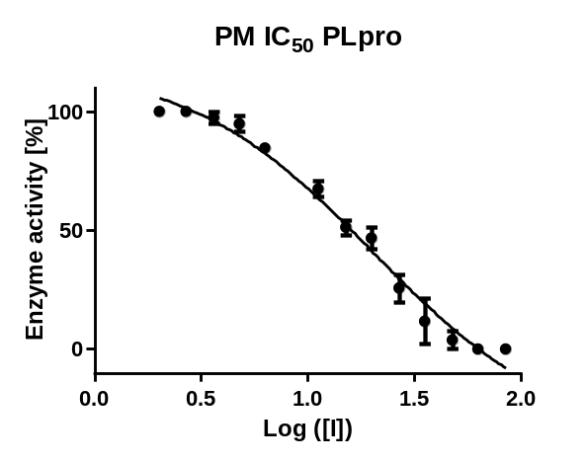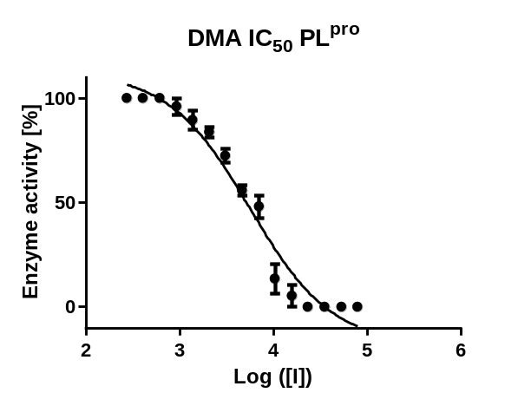
Fig. S2.1. IC₅₀ graphs (PL^{pro}) for petitgrain mandarin (PM) essential oil and dimethyl anthranilate (DMA)
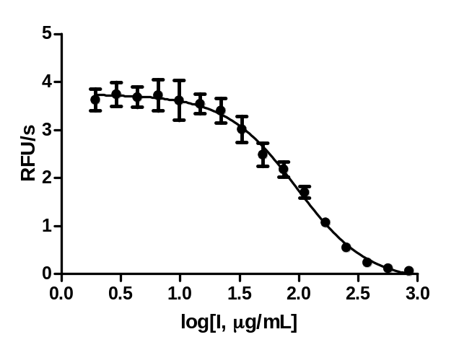
Fig. S2.2. IC₅₀ graph (PL^{pro}) for turmeric oleoresin.

S3. IC₅₀ graphs for M^{pro}
Essential Oils
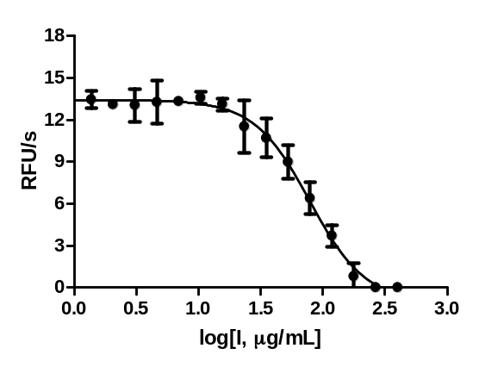  Fig. S3.1. IC₅₀ graph (M^{pro}) for lovage root EO. | 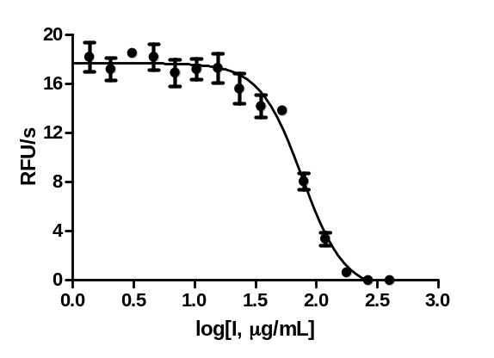  Fig. S3.2. IC₅₀ graph (M^{pro}) for Siam wood EO.
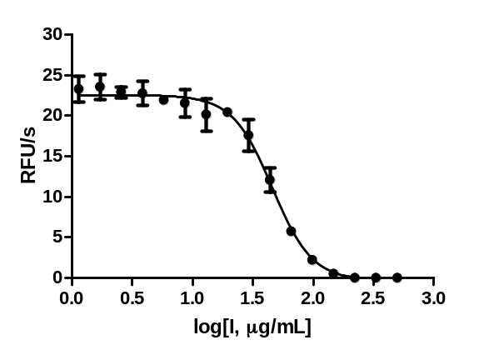  Fig. S3.3. IC₅₀ graph (M^{pro}) for blue cypress EO. | 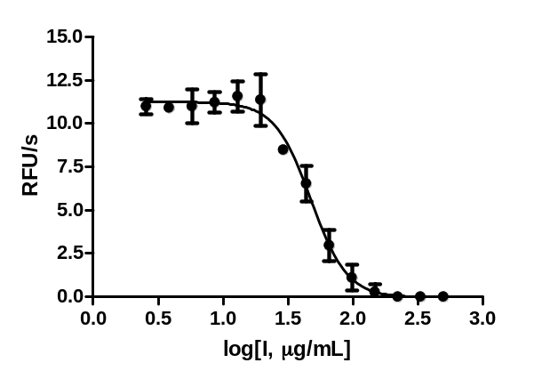  Fig. S3.4. IC₅₀ graph (M^{pro}) for guaiacwood EO.
Extracts
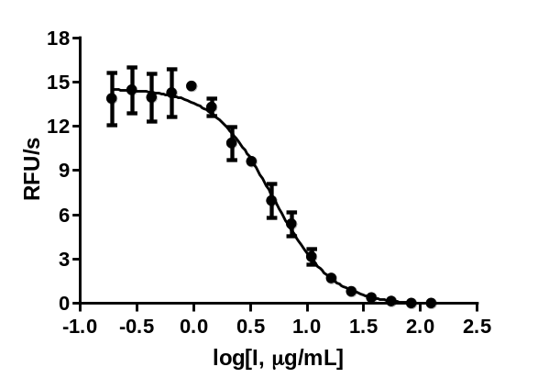  Fig. S3.5. IC₅₀ graph (M^{pro}) for benzoin Siam resinoid. | 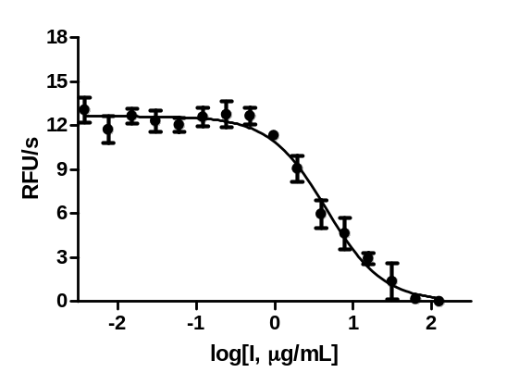  Fig. S3.6. IC₅₀ graph (M^{pro}) for benzoin Sumatra resinoid.
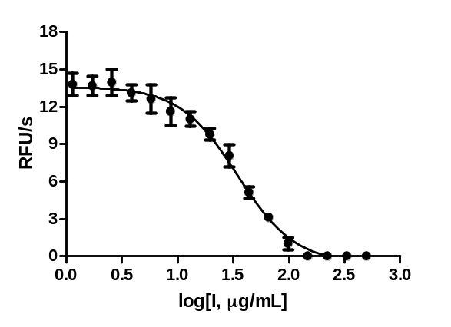  Fig. S3.7. IC₅₀ graph (M^{pro}) for galbanum resinoid. | 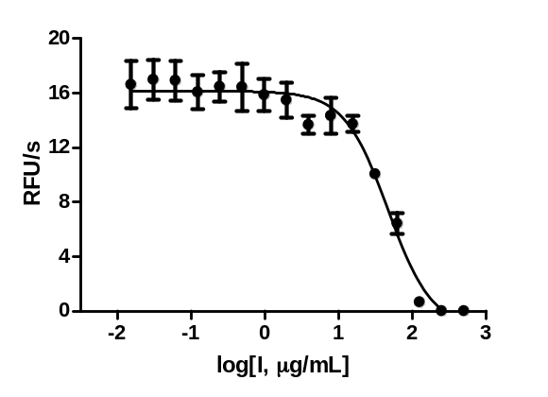  Fig. S3.8. IC₅₀ graph (M^{pro}) for storax resinoid.
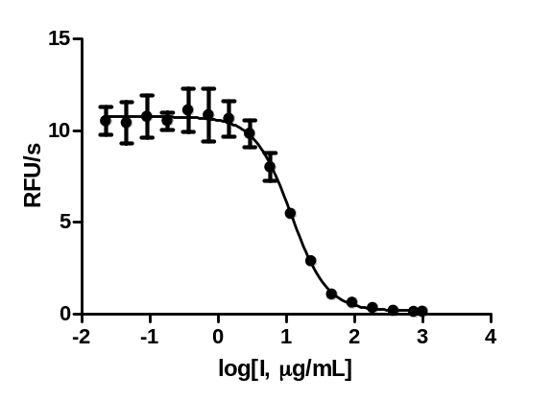  Fig. S3.9. IC₅₀ graph (M^{pro}) for turmeric oleoresin. | 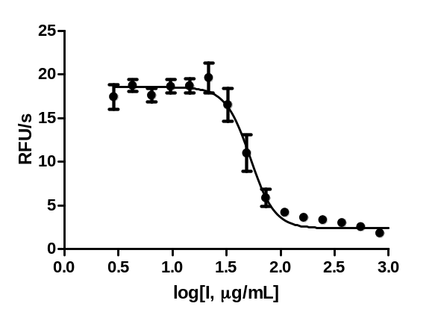  Fig. S3.10. IC₅₀ graph (M^{pro}) for labdanum gum refined.
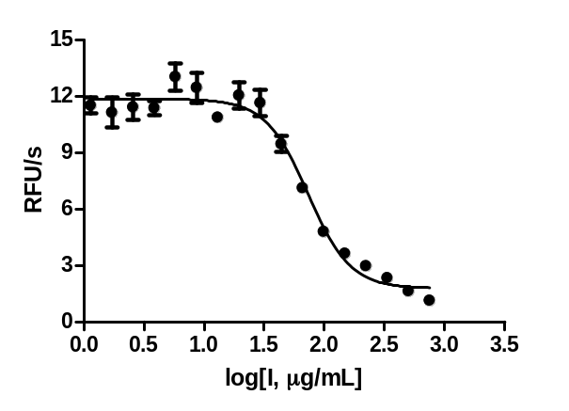  Fig. S3.11. IC₅₀ graph (M^{pro}) for nasturtium absolute. | 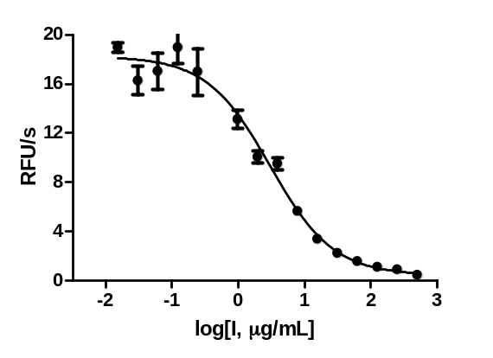  Fig. S3.12. IC₅₀ graph (M^{pro}) for rocket absolute.
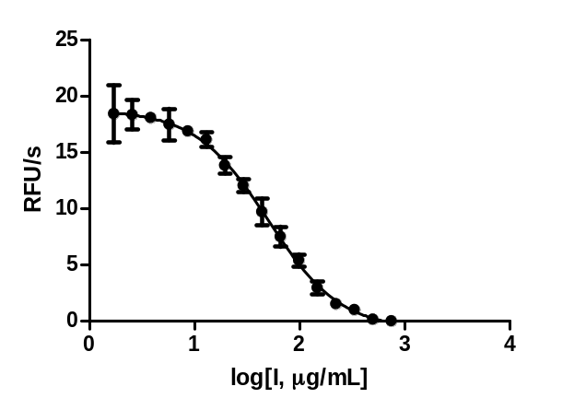Fig. S3.13. IC₅₀ graph (M^{pro}) for Tasmania lanceolata extract. | 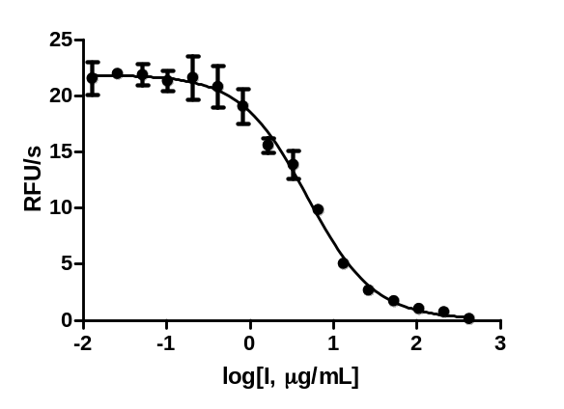Fig. S3.14. IC₅₀ graph (M^{pro}) for rocket concrete.

S4. Antiviral assay of selected F&F materials

Table S2. Antiviral properties of the most active natural SARS-CoV-2 proteases inhibitors.
Natural material | SARS-CoV-2 EC₅₀ [µg/mL] | Toxicity CC₅₀ [µg/mL]
Essential oils
Angelica root India EO | >100 | 47.3±7.1
Blue cypress EO | >100 | 28.5±1.1
Cabreuva Red EO | >100 | 17.2±2.1
Cade crude EO | >100 | 71.2±19.7
Guaiacwood EO | >100 | 25.4±3.9
Koron EOs* | >100 | >100
Lovage root EO | >100 | 34.2±2.6
Petitgrain mandarin EO | >100 | >100
DMA | >100 µM | >100
Sandalwood spicatum EO | >100 | 27.5±0.1
Siam wood EO | >100 | 17.6±0.8
Extracts
Amber solid | >100 | >100
Benzoin Siam resinoid | 78.8±3.3 | >100
Benzoin Sumatra resinoid | 31.5±2.4 | 85.5±1.9
Galbanum resinoid | >100 | 9.2±0.1
Nasturtium absolute | >100 | 58.2±5.5
Nettle absolute | 94.9±4.1 | 94.9±4.1
Oakmoss absolute | >100 | 83.4±1.8
Paprika oleoresin 60 000 CU | >50 | >100
Rocket absolute | >100 | 28.4±1.3
Spinach absolute | >100 | 88.3±1.7
Storax resinoid | >100 | 85.6±1.8
Tasmania lanceolata extract | >100 | 28.3±0.6
Tolu resinoid | >100 | >100
Turmeric oleoresin | >100 | 28.1±0.1
*Mixture of essential oils used by the indigenous people of the Amazon to fight COVID-19.

