Fertilization-driven coupling of soil dissolved organic matter chemodiversity and microbial communities reveals molecular mechanisms of carbon stabilization in arid agroecosystems
Hongxian Qianª, Bin Xue^{b*}, Lina Zhou^{c, d}, Yangxiu Mu^{c, d}, Lingtong Du^{b}, Kun Ma^{b}, Qi Zhou^{e}, Lin Chen^{b}, Ruili Gaoª, Man Zhang ^{b}, Zhizhong Mu^{b}, Xiaolong Ma^{b}, George Martial Ndzana^{f}
ª School of Agriculture, Ningxia University, Yinchuan, Ningxia, China
^{b} School of Ecology and Environment, Ningxia University, Yinchuan, Ningxia, China
^{c} Institute of Agricultural Resources and Environment, Ningxia Academy of Agriculture and Forestry Sciences, Yinchuan, Ningxia, China
^{d} Yinchuan Field Scientific Observation and Research Station of the Ministry of Agriculture and Rural Affairs, Yinchuan, Ningxia, China
^{e} Gansu Academy of Agri-engineering Technology, Lanzhou, Gansu, China
^{f} Faculty of Agronomy and Agricultural Sciences, University of Dschang, PO. Box 222, Dschang, Cameroon
* Corresponding Author.
E-mail: xuebin0606@nxu.edu.cn; 13477035453@163.com
Phone: +86-0951-2062133
Fax: +86-0951-2062133

Table S1 Fertilizer inputs under different fertilizer application
Treatments | Chemical fertilizer (kg ha⁻¹) |  |  | Organic fertilizer (kg ha⁻¹)
Treatments | N | P₂O5 | K₂O | Organic fertilizer (kg ha⁻¹)
CK | 0 | 0 | 0 | 0
NPK | 375 | 150 | 75 | 0
M | 0 | 0 | 0 | 3000
0.5NPKM | 187.5 | 75 | 37.5 | 3000
NPKM | 375 | 150 | 75 | 3000
1.5NPKM | 562.5 | 225 | 112.5 | 3000

Table S2 The number and proportion of total PMTs related to each elemental combination classes under different fertilization treatments
Soil layers | Total PMTs | CK | NPK | M | 0.5NPKM | NPKM | 1.5NPKM
Surface | CHO | 111286  (66.75%) | 108645  (61.31%) | 100735  (57.12%) | 105124  (59.44%) | 100554  (57.05%) | 81875  (70.70%)
Surface | CHON | 54070  (32.43%) | 66881  (37.74%) | 72963  (41.37%) | 69997  (39.58%) | 73234  (41.55%) | 33629  (29.04%)
Surface | CHOS | 1335  (0.80%) | 1601  (0.90%) | 2196  (1.25%) | 1394  (0.79%) | 1913  (1.09%) | 276  (0.24%)
Surface | CHONS | 41  (0.02%) | 75  (0.04%) | 454  (0.26%) | 339  (0.19%) | 542  (0.31%) | 25  (0.02%)
Subsurface | CHO | 133609  (69.24%) | 116263  (61.42%) | 111391  (64.54%) | 102584  (69.62%) | 42859  (47.91%) | 46081  (46.27%)
Subsurface | CHON | 58532  (30.33%) | 71909  (37.99%) | 59403  (34.42%) | 43839  (29.75%) | 42780  (47.82%) | 49381  (49.58%)
Subsurface | CHOS | 803  (0.42%) | 1022  (0.54%) | 1553  (0.90%) | 873  (0.59%) | 2233  (2.50%) | 2104  (2.11%)
Subsurface | CHONS | 33  (0.02%) | 84  (0.04%) | 253  (0.15%) | 53  (0.04%) | 1588  (1.78%) | 2032  (2.04%)

Table S3 The number and proportion of total PMTs related to each compound classes under different fertilization treatments
Soil layers | Total PMTs | CK | NPK | M | 0.5NPKM | NPKM | 1.5NPKM
Surface | Lignins/CRAM-like structures | 112676  (67.58%) | 119186  (67.26%) | 118499  (67.20%) | 121416  (68.65%) | 115590  (65.59%) | 82199  (70.98%)
Surface | Tannin | 12034  (7.22%) | 12361  (6.98%) | 12145  (6.89%) | 11613  (6.57%) | 11320  (6.42%) | 4026  (3.48%)
Surface | Aliphatic/Peptide-like | 15909  (9.54%) | 16298  (9.20%) | 14323  (8.12%) | 13564  (7.67%) | 14454  (8.20%) | 11939  (10.31%)
Surface | Aromatic structures | 14772  (8.86%) | 17354  (9.79%) | 21347  (12.11%) | 20563  (11.63%) | 22781  (12.93%) | 7042  (6.08%)
Surface | Lipids | 5601  (3.36%) | 6168  (3.48%) | 5152  (2.92%) | 4584  (2.59%) | 6183  (3.51%) | 6495  (5.61%)
Surface | Carbohydrates | 443  (0.27%) | 463  (0.26%) | 429  (0.24%) | 395  (0.22%) | 683  (0.39%) | 68  (0.06%)
Surface | Unsaturated hydrocarbon | 14  (0.01%) | 15  (0.01%) | 43  (0.02%) | 11  (0.01%) | 19  (0.01%) | 9  (0.01%)
Surface | Others | 5283  (3.17%) | 5357  (3.02%) | 4410  (2.50%) | 4708  (2.66%) | 5213  (2.96%) | 4027  (3.48%)
Subsurface | Lignins/CRAM-like structures | 129146  (66.92%) | 125310  (66.20%) | 118583  (68.70%) | 101732  (69.04%) | 56501  (63.16%) | 63179  (63.43%)
Subsurface | Tannin | 9741  (5.05%) | 11190  (5.91%) | 11682  (6.77%) | 9027  (6.13%) | 8399  (9.39%) | 9101  (9.14%)
Subsurface | Aliphatic/Peptide-like | 22051  (11.43%) | 19374  (10.24%) | 14090  (8.16%) | 12945  (8.79%) | 6668  (7.45%) | 7024  (7.05%)
Subsurface | Aromatic structures | 15803  (8.19%) | 19658  (10.39%) | 18017  (10.44%) | 13628  (9.25%) | 13836  (15.47%) | 15585  (15.65%)
Subsurface | Lipids | 8709  (4.51%) | 7231  (3.82%) | 4928  (2.86%) | 5203  (3.53%) | 1447  (1.62%) | 1516  (1.52%)
Subsurface | Carbohydrates | 900  (0.47%) | 543  (0.29%) | 425  (0.25%) | 144  (0.10%) | 356  (0.40%) | 362  (0.36%)
Subsurface | Unsaturated hydrocarbon | 21  (0.01%) | 24  (0.01%) | 10  (0.01%) | 9  (0.01%) | 12  (0.01%) | 5  (0.01%)
Subsurface | Others | 6606  (3.42%) | 5948  (3.14%) | 4865  (2.82%) | 4661  (3.16%) | 2241  (2.51%) | 2826  (2.84%)

Fig. S1. UV–Vis absorption spectra of soil DOM at the surface (A) and subsurface (B) soil layers under different fertilization treatments. CK, no fertilization; NPK, chemical fertilizer; M, organic fertilizer; 0.5NPKM, half‑rate chemical fertilizer plus organic fertilizer; NPKM, chemical fertilizer plus organic fertilizer; 1.5NPKM, 1.5‑fold chemical fertilizer plus organic fertilizer.
Fig. S2. Fluorescence spectra (A) and loadings (B) of distinct soil DOM components analyzed by EEM spectroscopy and PARAFAC under different fertilization treatments.

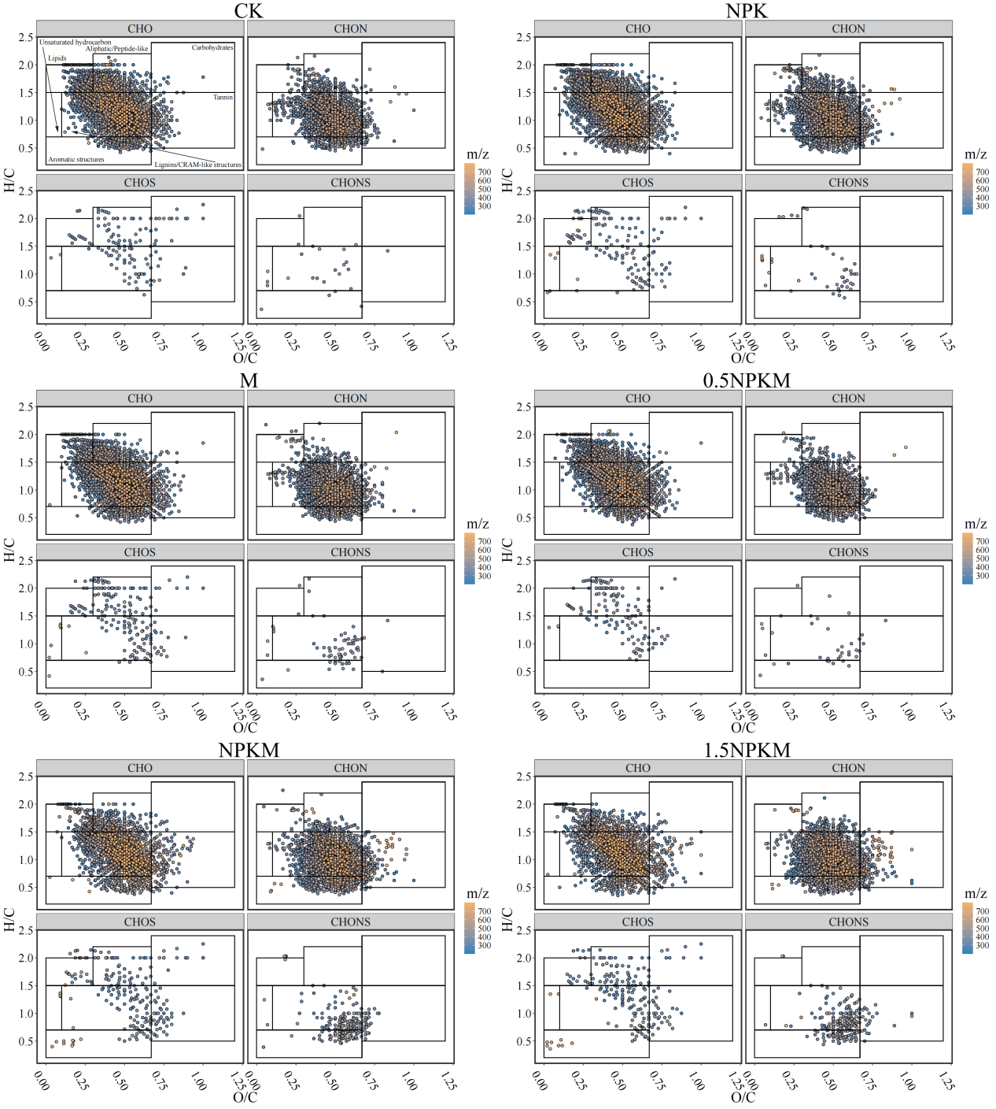
Fig. S3. Van Krevelen diagram of anthropogenic-alluvial soil DOM at the subsurface soil layer under different fertilization treatments.

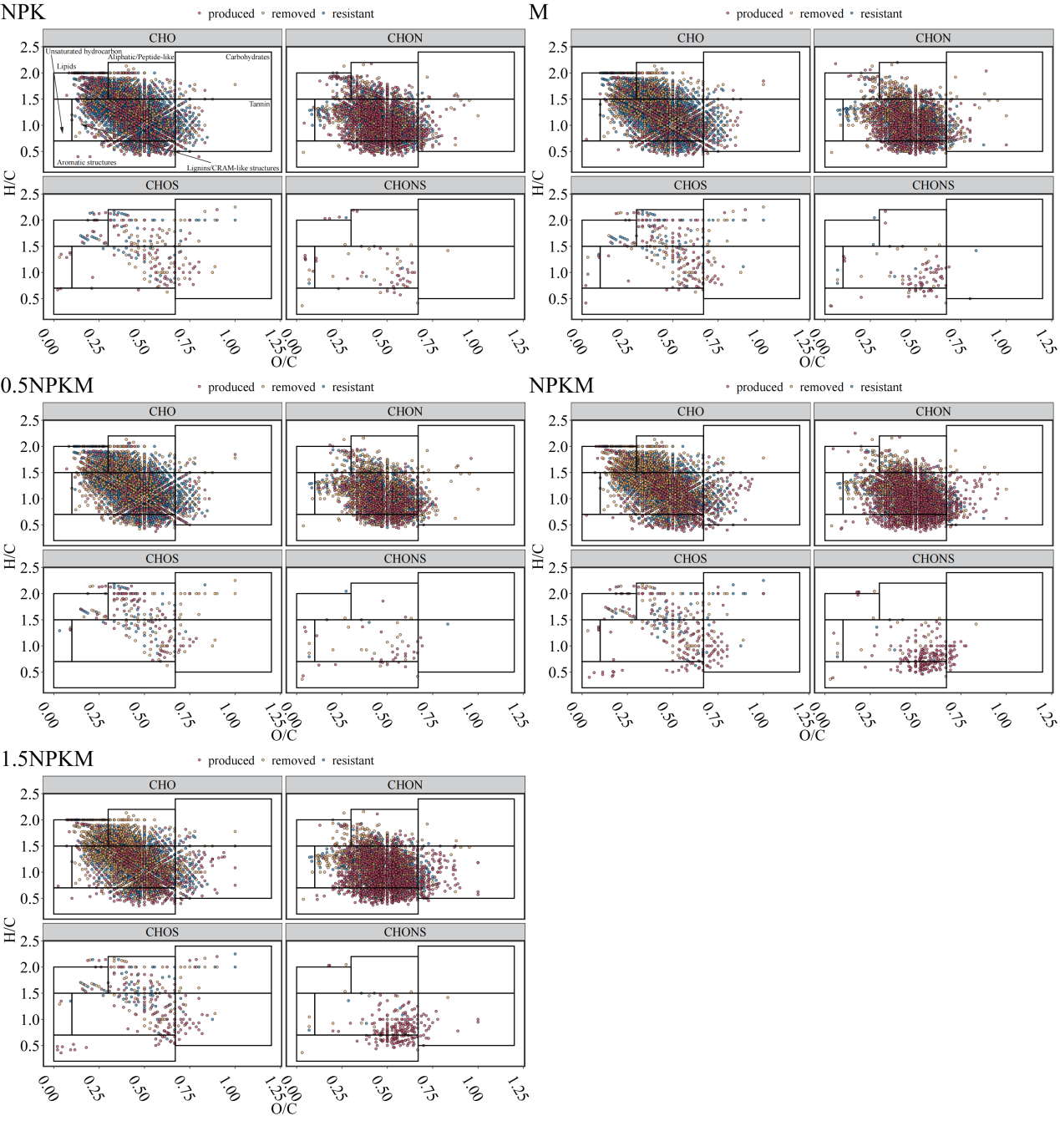
Fig. S4. Van Krevelen diagram of changes anthropogenic-alluvial soil DOM compounds at the subsurface soil layer under different fertilization treatments.

Fig. S5. The net PMTs of eight compound groups for intergroup and intragroup pathways at the subsurface soil layer under different fertilization treatments.

Fig. S6. The net PMTs of all compounds for intergroup and intragroup pathways at the surface (A) and subsurface (B) soil layers under different fertilization treatments.

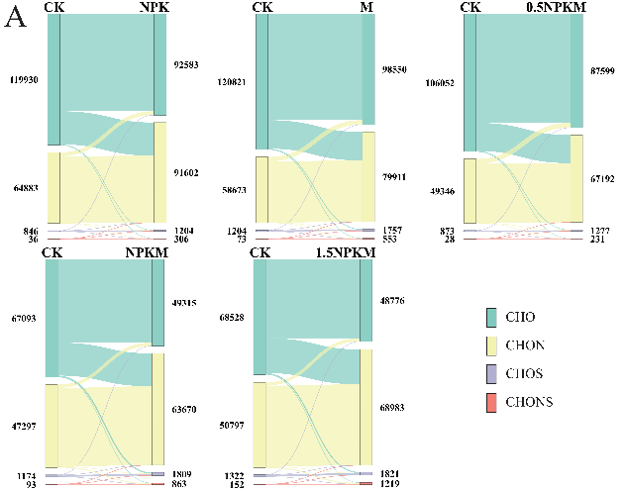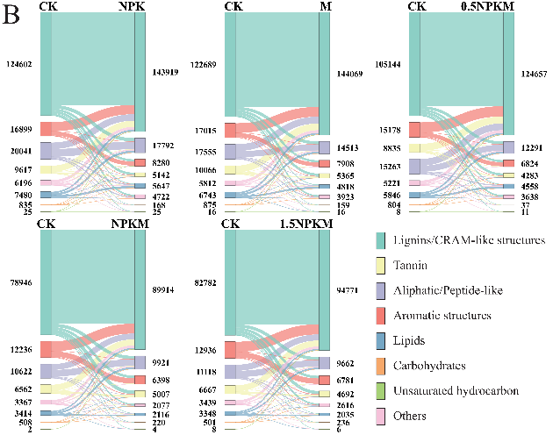
Fig. S7. Sankey diagram illustrating the values of molecular transformations of elemental combination (A) and compound classes (B) in the subsurface soil layer between unfertilized control and fertilization treatment.

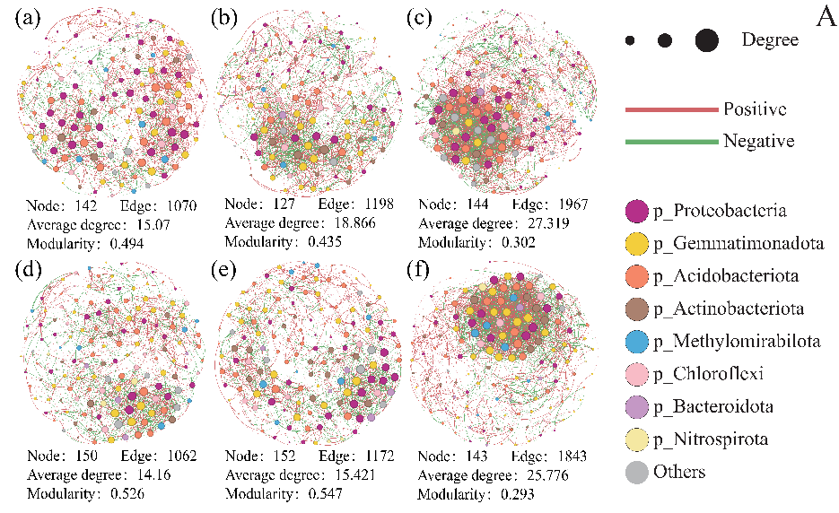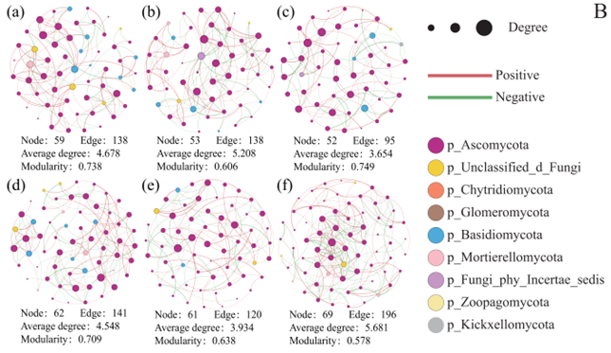
Fig. S8. Interspecies network co-occurrence plots at the bacterial (A) and fungal (B) phylum level at the subsurface soil layer under different fertilization treatments. (a) CK, (b) NPK, (c) M, (d) 0.5 NPKM, (e) NPKM, (f) 1.5NPKM.

