Supplementary Materials for

Tailoring coordination geometry in cobalt single-atom catalysts for thermocatalytic aerobic esterification
Yingzhuang Xu¹, Pengcong Pan¹, Bingbing Fan¹, Zhiqiang Ge¹*, Xia Tian¹, Jianrong Han¹, Wei Su¹*, Zhen Liu²*, Longlu Wang³*
*Corresponding authors. Email: 045359@hebust.edu.cn, weisu@hebust.edu.cn, zhenliu68@hnu.edu, wanglonglu@njupt.edu.cn

Table of Contents

Experimental Procedures 2
Flame synthesis 2
Aspen Plus simulations 2
Technical and economic analysis 2
Theoretical calculation 4
Supplementary Figs 1–48 5
Supplementary Tables 1–2 54
Supplementary References 1–4 56

Experimental Procedures
Flame synthesis
Premixing: Metal acetylacetonates were mixed with paraffin wax to prepare candle precursor solutions. Specifically, metal acetylacetonates were first dissolved in tetrahydrofuran (THF; minimum volume required for complete dissolution), either individually or as a mixed solution depending on the number of metal species to be incorporated. The resulting precursor solution was then added dropwise into molten paraffin wax at 100 °C under continuous stirring, followed by further heating for 30 min to completely remove the solvent. The final total metal concentration in the molten paraffin wax was maintained at 0.06 mM.
Burning and collection: The as-prepared candle was ignited, and a stainless-steel collector was positioned approximately 20 mm above the wick in the outer flame region. The resulting candle soot (CS)-based samples were subsequently scraped from the collector surface using a stainless-steel blade for further characterization and use. During combustion, the candle flame generates both ultrahigh temperatures and steep temperature gradients along and perpendicular to the flame direction. The local high-temperature zone promotes the evaporation, decomposition, and/or reaction of paraffin molecules (long-chain alkanes) and metal precursors, enabling the formation of soot clusters and their subsequent growth through sintering and coalescence. Meanwhile, the surrounding temperature gradient facilitates the condensation and deposition of CS-based nanoparticles onto the collector². More specifically, vaporized and/or decomposed metal precursors interact with reactive oxygen and/or carbon species in the flame, forming gaseous and/or liquid metal oxides that subsequently undergo condensation, nucleation, and solidification on the CS support.
Determination of flame temperatures: To determine the temperature of the candle flame, we used an infrared thermal camera (PT850) installed with a high-temperature lens with an operating range of −40 to 2500 °C. The camera was equipped with a vanadium oxide microbolometer detector (7.5–14 µm), generating high-resolution thermal images up to 1280 × 1024 pixels. The distance to the flame during measurement was 0.7 m, and the data accuracy was ±10 K. During operation, the imaging system scans and detects target objects sequentially from left to right and from top to bottom, decomposes the target objects into individual pixels, converts the radiant energy through the infrared detector, and generates a signal current corresponding to changes in the radiant energy of the flame. The temperatures are finally displayed digitally in color and analyzed using ThermoTools Infrared Analysis software.

Aspen Plus simulations
Process simulation. The process begins by blending the fresh reactants—benzyl alcohol, methanol, and oxygen—with the recycled stream in MIXER-1, which is then preheated to the reaction temperature via heat exchanger EX-1. The mixture enters the CATALYTIC REACTOR to undergo esterification at 60°C. The resulting crude product is routed to TOWER-1 to remove the water by-product, followed by TOWER-2, where the bulk of the solvent is stripped off. The bottom stream then feeds into the final distillation column, TOWER-3, which isolates methyl benzoate at the bottom with a molar purity of 99.99% and a mass flow rate of 2010.96 kg/day. Concurrently, the unreacted raw materials and solvents recovered from the overheads of TOWER-2 and TOWER-3 are combined and pressurized via a pump to achieve a 99% mass recovery rate, recycling back to the reactor inlet to close the loop.

Technical and economic analysis
Assumptions. To evaluate the industrial feasibility of electrically heated thermocatalytic oxidative esterification, a techno-economic analysis (TEA) was conducted using conservative and literature-grounded assumptions. All costs were normalized to a basis of 1 tonne methyl benzoate production per day unless otherwise specified. The reaction was assumed to operate continuously with a capacity factor of 0.9 (21.6 h operation per day). Experimentally relevant catalytic parameters including a methyl benzoate selectivity of 99%, product yield of 98%, and reaction temperature of 60 °C were directly adopted from experimentally accessible conditions rather than theoretical optima. Thermal energy required for the catalytic reaction was assumed to be entirely supplied by electric heating and therefore converted into electricity consumption. The TEA includes reactor capital investment, electric heating systems, separation units, electricity consumption, auxiliary equipment, and maintenance costs. Parameters were selected according to commonly reported industrial electrified chemical processes.
The following assumptions were used:.
- eactor capital cost: US$150,000 for a 1 tonne day⁻¹ plant with a lifetime of 30 years..
- Separation equipment capital cost: 35% of reactor cost.
- Electricity price: US$0.1 kWh⁻¹.
- Separation costs (distillation + methanol recycling): 30% of electricity costs.
- Operation cost: 20% of capital costs.
- Maintenance cost: 10% of capital cost.
- Installation cost: 10% of capital cost.
- Balance of plant: 50% of capital cost.
- Capacity factor: 0.9.
- Auxiliary electricity consumption: 50% of reaction electricity.
- Methanol recovery efficiency: 90%.
- Oxygen utilization efficiency: 90%.

Material Cost
Molecular weights

Compound | Molecular weight (g mol⁻¹)
Benzyl alcohol | 108.14
Methanol  Oxygen | 32.04  32.00
Methyl benzoate | 136.15

Production basis. Target production: 1 tonne methyl benzoate:
$$\frac{1000}{136.15}=7.344 kmol$$
Benzyl alcohol consumption. Considering 98% yield:
$$n_{BA}= \frac{7.344}{0.98}=7.494 kmol$$
Required mass: $7.497 ×108.14=810.4 kg$
Cost: $0.8104 ×2720=US\$2204.3$
Methanol consumption. Stoichiometric requirement:
$$7.497 ×32.04=240.1 kg$$
Industrial excess methanol (3× stoichiometric): $240.1 ×3=720.3 kg$
Assuming 90% recovery: $720.3 ×0.1=72.0 kg$
Cost: $0.072 ×400=US\$28.8$
Oxygen consumption. Theoretical oxygen requirement:
$$7.497 ×0.5 ×32.00=119.9 kg$$
Assuming 90% oxygen utilization: $\frac{119.9}{0.9} =133.2 kg$
Cost: $0.1332 ×50=US\$6.66$
Total material cost: $2204.3+28.8+6.66=US\$2239.8$
Electricity cost. Because the reaction is operated at a relatively mild temperature of 60 °C, the thermal energy requirement is substantially reduced compared with conventional gas-phase oxidation systems.
A conservative thermal energy demand of:
0.8 GJ tonne⁻¹
Converting thermal energy into electricity: $0.8 ×277.8=222.2 kWh {tonne}^{-1}$
Auxiliary electricity demand (pumps, stirring, control systems, separation assistance):
$$222.2×0.5=111.1 kWh {tonne}^{-1}$$
Total electricity consumption: $222.2×111.1=333.3 kWh {tonne}^{-1}$
Electricity cost: $333.3×0.1=US\$33.3 {tonne}^{-1}$
Separation cost. The separation process includes:
- Methanol recycling
- Water removal
- Distillation purification of methyl benzoate
Following the methyl benzoate TEA framework, the separation cost was estimated as 30% of electricity cost: $33.3×0.3=US\$10$
Capital cost. Reactor and electric heating system.
Assumed capital cost: US$150000
Separation equipment cost: $150000×0.35=US\$52500$
Total installed capital: $150000+52500=US\$202500$
Levelized capital cost. Plant lifetime: 30 years
Annual production: $365 ×0.9=328.5 tonnes {year}^{-1}$
Total lifetime production: $328.5 ×30=9855 tonnes$
Cost: $\frac{202500}{9855} =US\$20.55$

Operation cost: $20.55 ×0.2 =US\$4.11 per tonne MB$
Maintenance cost: $20.55 ×0.1 =US\$2.06 per tonne MB$
Installation cost: $20.55 ×0.1 =US\$2.06 per tonne MB$
Balance of plant: $20.55 ×0.5 =US\$10.28 per tonne MB$
Total Production Cost
Cost component | USD tonne⁻¹
Materials | 2239.8
Electricity  Separation | 33.3  10.00
Capital  Operation  Maintenance  Installation  Balance of plant | 20.55  4.11  2.06  2.06  10.28
Total production cost:
$$2239.8+33.3+10.0+20.55+4.11+2.06+ 2.06+10.28 =US\$2322.2 per tonne MB$$

Theoretical calculation
All density functional theory (DFT) calculations were performed using the ORCA quantum chemistry program package (version 5.0.3) [1]. The B3LYP density functional was employed in conjunction with the def2-SVP basis set [2]. Relaxed potential energy surface scans were conducted with no constraints other than specifying the spin multiplicity. To accelerate the calculations, the RIJCOSX approximation was applied with the auxiliary basis set def2/J. Atom-pairwise dispersion corrections with Becke-Johnson damping (D3BJ) were included in the DFT energy [3-4].

Supplementary Figs. 1–49

Supplementary Fig. 1.
Aberration-corrected HAADF-STEM image and corresponding elemental mapping of the Co_{SA}-N₃ catalyst. (a) Aberration-corrected HAADF-STEM image showing isolated Co single atoms uniformly dispersed throughout the carbon matrix (representative single-atom Co sites are highlighted with white circles). (b) Corresponding elemental maps revealing the spatial distributions of C, N, O, and Co in the Co_{SA}-N₃ catalyst.

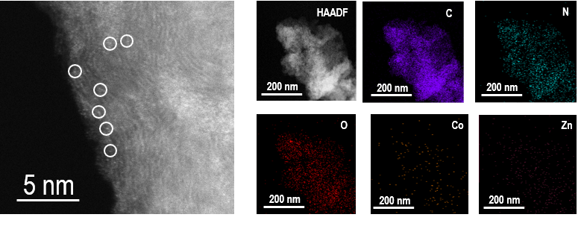

Supplementary Fig. 2.
Aberration-corrected HAADF-STEM image and corresponding elemental mapping of the Co_{SA}-N₄ catalyst. (a) Aberration-corrected HAADF-STEM image showing isolated Co single atoms uniformly dispersed throughout the carbon matrix (representative single-atom Co sites are highlighted with white circles). (b) Corresponding elemental maps revealing the spatial distributions of C, N, O, and Co in the Co_{SA}-N₄ catalyst.

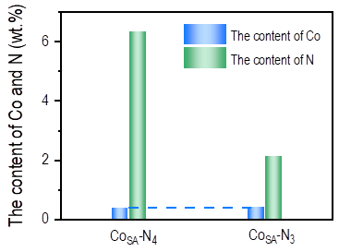

Supplementary Fig. 3.
Cobalt and nitrogen contents in Co_{SA}-N₄ and Co_{SA}-N₃ catalysts determined by inductively coupled plasma mass spectrometry (ICP-MS) and elemental analysis. ICP-MS analysis shows that the cobalt contents of Co_{SA}-N₄ and Co_{SA}-N₃ are 0.391 wt% and 0.412 wt%, respectively, while the zinc content is below the detection limit, consistent with its complete volatilization at high temperature. Elemental analysis reveals nitrogen contents of 6.41 wt% for Co_{SA}-N₄ and 2.08 wt% for Co_{SA}-N₃.
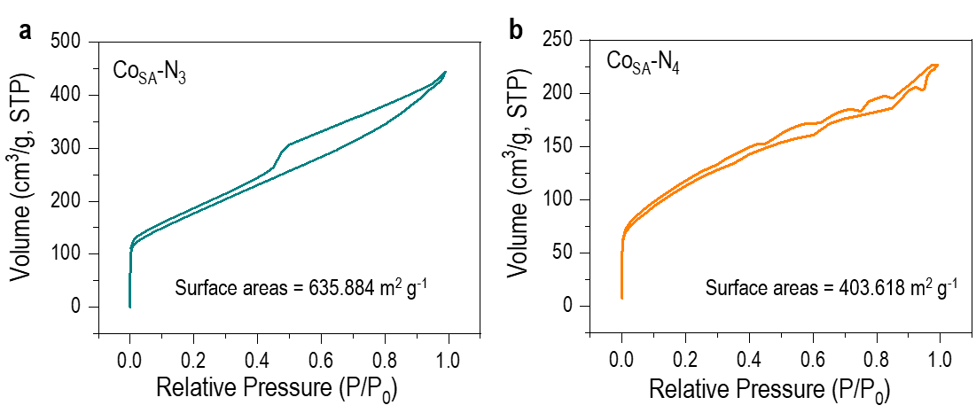

Supplementary Fig. 4.
N₂ adsorption-desorption isotherms of Co_{SA}-N₃ and Co_{SA}-N₄ catalysts. (a) N₂ adsorption-desorption isotherm of Co_{SA}-N₃. (b) N₂ adsorption-desorption isotherm of Co_{SA}-N₄. Both catalysts indicate the presence of hierarchical pore structures.

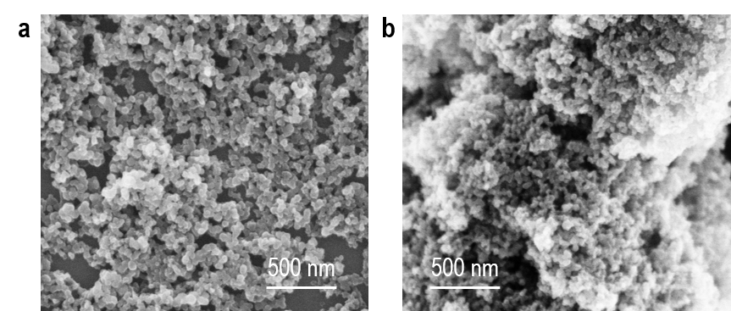

Supplementary Fig. 5.
Transmission electron microscopy images of Co_{SA}-N₃ (a) and Co_{SA}-N₄ (b).

Supplementary Fig. 6.
Raman spectra of NC, Co_{SA}-N₃, and Co_{SA}-N₄. The spectra exhibit characteristic D and G bands at approximately 1350 cm⁻¹ and 1580 cm⁻¹, respectively. The intensity ratios (Iᴅ/Iɢ) are 1.04 for Co_{SA}-N₄ and 1.06 for Co_{SA}-N₃, indicating increased structural defects and disorder in the three-coordinate Co_{SA}-N₃ catalyst.

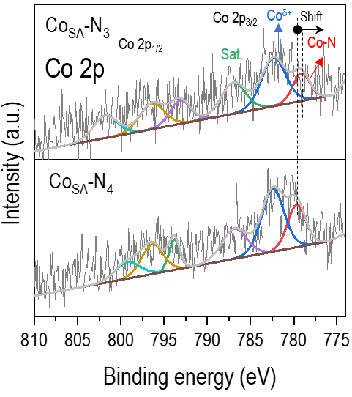

Supplementary Fig. 7.
High-resolution X-ray photoelectron spectroscopy (XPS) Co 2p core-level spectra of Co_{SA}-N₃ and Co_{SA}-N₄ catalysts. Both spectra exhibit two prominent peaks at ~782.4 eV and ~797.2 eV, corresponding to Co 2p_{3/2} and Co 2p_{1/2}, respectively. Notably, the Co-N peaks in Co_{SA}-N₃ are negatively shifted relative to those in Co_{SA}-N₄, indicating increased electron density at the cobalt center due to the reduced coordination numbe

Supplementary Fig. 8.
X-ray photoelectron spectroscopy (XPS) core-level spectra of the Co_{SA}-N₃ and Co_{SA}-N₄ of Zn 2p. No detectable Zn 2p signal is observed in either catalyst, confirming that zinc is completely volatilized during the high-temperature calcination process, consistent with the ICP-MS results.

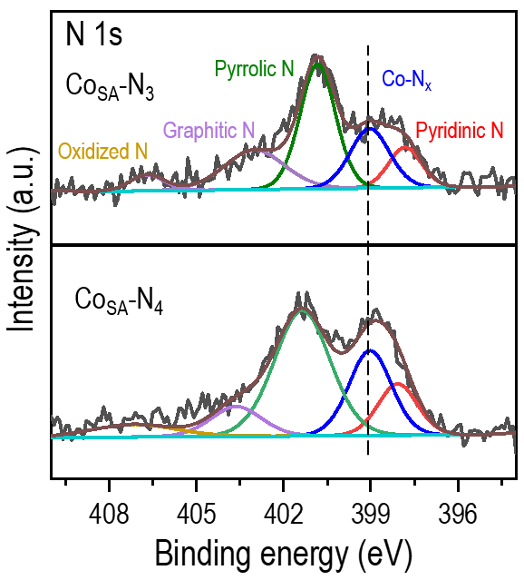

Supplementary Fig. 9.
High-resolution X-ray photoelectron spectroscopy (XPS) N 1s core-level spectra of Co_{SA}-N₃ and Co_{SA}-N₄ catalysts. The spectra are deconvoluted into five distinct nitrogen species: pyridinic N (398.1 eV), Co-N_{x} (399.1 eV), pyrrolic N (401.3 eV), graphitic N (403.7 eV), and oxidized N (407.1 eV). The decrease in the Co-N_{x} content in Co_{SA}-N₃ is related to the reduced coordination number of Co and N.

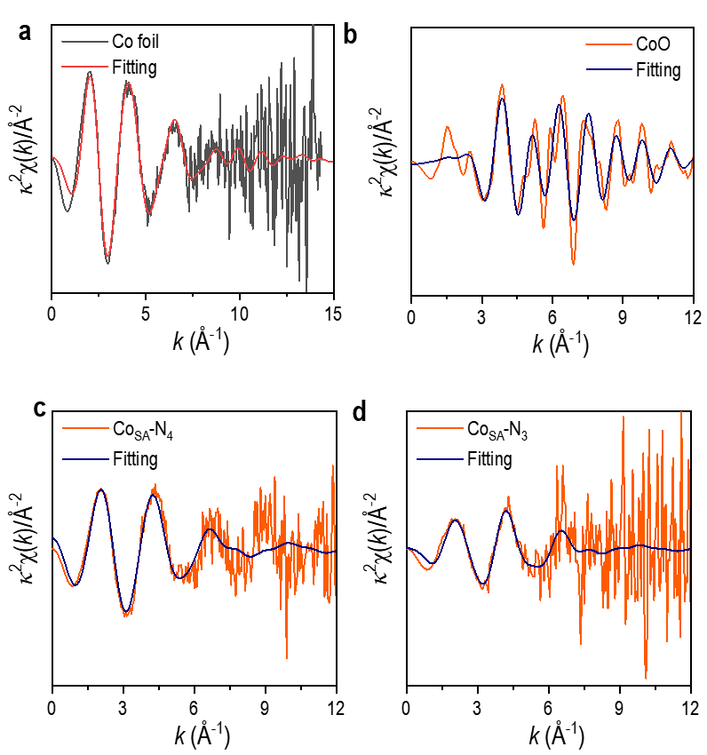

Supplementary Fig. 10.
Fourier-transformed magnitudes of Co K-edge EXAFS spectra for reference samples and catalysts. (a) Co foil, (b) CoO, (c) Co_{SA}-N₄, and (d) Co_{SA}-N₃. A pronounced peak at ~1.50 Å corresponds to the Co‒N scattering path in both Co_{SA}-N₄ and Co_{SA}-N₃, while no Co‒Co scattering signal is detected around 2.20 Å, confirming the absence of Co clusters or nanoparticles and demonstrating atomic dispersion of Co species.

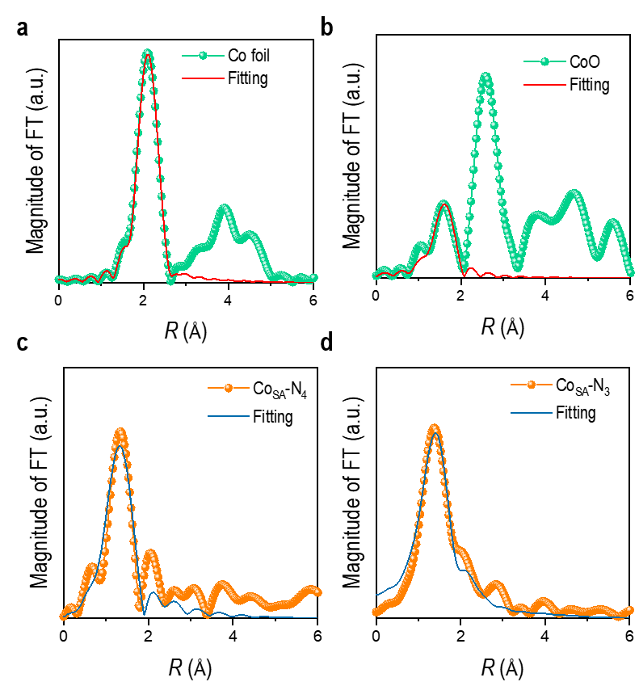

Supplementary Fig. 11.
Quantitative EXAFS R-space fitting curves for Co foil, CoO, Co_{SA}-N₄, and Co_{SA}-N₃. (a) Co foil: fitting of the Co‒Co scattering path at ~2.20 Å. (b) CoO: fitting including Co‒O and Co‒Co contributions. (c) Co_{SA}-N₄ and (d) Co_{SA}-N₃: fitting of the Co‒N first-shell scattering path at ~1.50 Å. The excellent agreement between experimental and fitted data across all samples validates the reliability of the structural models. The quantitative fitting results (summarized in Supplementary Table 2) yield average coordination numbers of 4.01 ± 0.08 for Co_{SA}-N₄ and 3.05 ± 0.10 for Co_{SA}-N₃, bond lengths of approximately 1.89 Å for Co‒N in both catalysts, and low Debye‒Waller factors, indicating well-defined local coordination environments.

Supplementary Fig. 12.
Wavelet transform (WT) EXAFS analysis of reference samples. (a) Co foil and (b) CoO. The WT-EXAFS analysis provides k-space and R-space resolution, enabling differentiation of backscattering atoms. Co foil exhibits a characteristic Co‒Co coordination feature, while CoO shows distinct Co‒O and Co‒Co contributions. These reference WT patterns serve as benchmarks for confirming the absence of Co‒Co scattering in the single-atom catalysts.

Supplementary Fig. 13.
Catalytic performance comparison between Co_{SA}-N₃ and Co-free Zn/CN catalysts for the aerobic oxidative esterification of benzyl alcohol. The Co-free Zn/CN support exhibits negligible catalytic activity, while Co_{SA}-N₃ achieves a near-quantitative yield of methyl benzoate under identical reaction conditions. This result demonstrates that the carbon matrix alone is insufficient to drive the oxidation reaction and confirms the essential role of cobalt single-atom sites.

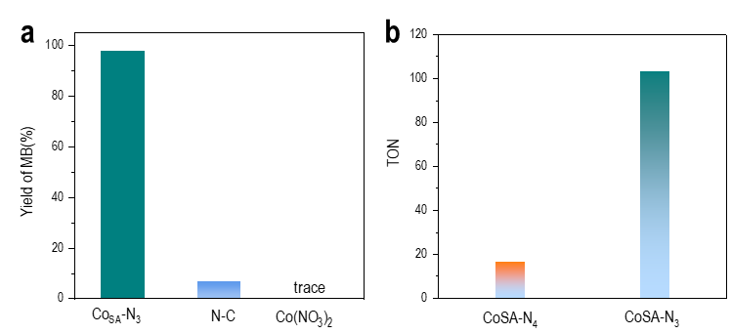

Supplementary Fig. 14.
Control experiments and turnover number (TON) comparison of Co_{SA}-N₃ and Co_{SA}-N₄ catalysts. (a) Catalytic performance comparison between Co_{SA}-N₃, Co-free Zn/CN, and homogeneous Co(NO₃)₂ catalysts for the aerobic oxidative esterification of benzyl alcohol. (b) Turnover numbers (TON) of Co_{SA}-N₃ and Co_{SA}-N₄ catalysts, calculated based on the total Co content determined by ICP-MS.

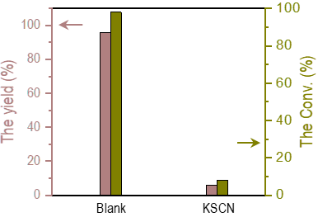

Supplementary Fig. 15.
Catalytic performance comparison between Co_{SA}-N₃ and Co-free Zn/CN catalysts. The addition of KSCN, a well-known metal-site poison, leads to near-complete suppression of catalytic activity, demonstrating that exposed Co single-atom sites are responsible for the observed catalytic transformation.

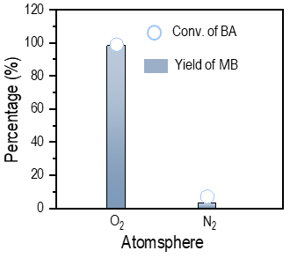

Supplementary Fig. 16.
Control experiment demonstrating the essential role of molecular oxygen in the aerobic oxidative esterification of benzyl alcohol. Catalytic performance of Co_{SA}-N₃ under O₂ atmosphere (0.1 MPa) versus O₂-free (inert gas, e.g., Ar or N₂) conditions. No product formation is observed in the absence of O₂, confirming that molecular oxygen is indispensable for the oxidative esterification reaction.

Supplementary Fig. 17.
Recycling stability tests of the Co_{SA}-N₃ catalyst for the aerobic oxidative esterification of benzyl alcohol over five consecutive reaction cycles. The catalyst retains most of its initial activity over five cycles without noticeable deactivation, demonstrating excellent operational stability and reusability.

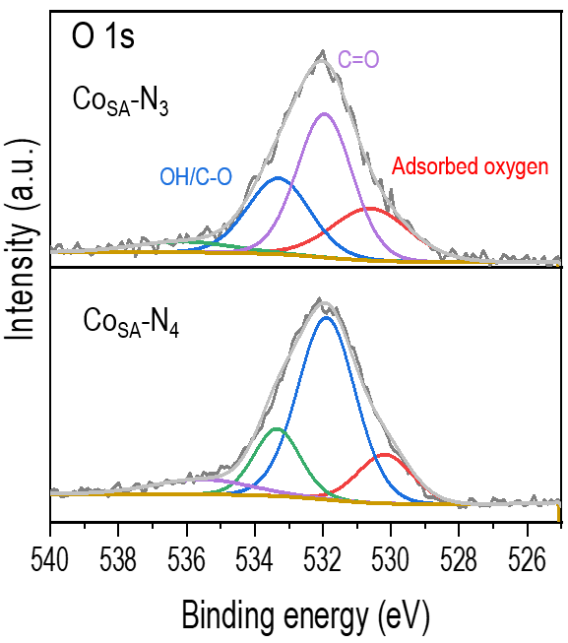

Supplementary Fig. 18.
X-ray photoelectron spectroscopy (XPS) O 1s core-level spectra of Co_{SA}-N₃ and Co_{SA}-N₄ catalysts after the aerobic oxidative esterification of benzyl alcohol. The three-coordinate Co_{SA}-N₃ catalyst exhibits a markedly stronger signal at 533.3 eV attributed to C–O/OH functionalities compared to its four-coordinate counterpart, indicating enhanced adsorption of oxygen-containing species on the low-coordinate Co site

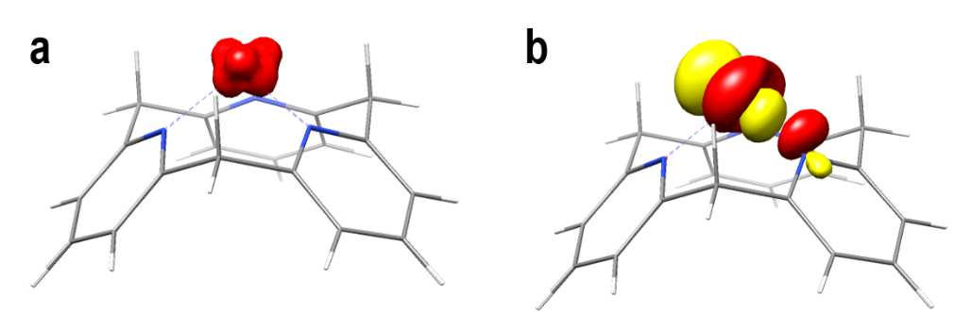

Supplementary Fig. 19.
(a) Calculated spin density of low-spin Co_{SA}-N₃. (b) Unrestricted corresponding orbitals (with overlap coefficient equals 0) of low-spin Co_{SA}-N₃, illustrating the orbital interactions and electron distribution in the low-spin state.

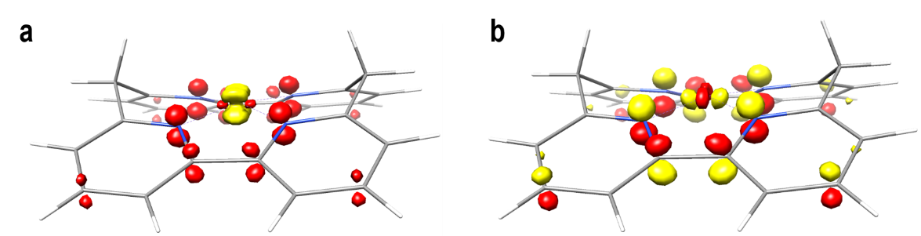

Supplementary Fig. 20.
(a) Calculated spin density of low-spin Co_{SA}-N₄. (b) Unrestricted corresponding orbitals (with overlap coefficient equals 0) of low-spin Co_{SA}-N₄, illustrating the orbital interactions and electron distribution in the low-spin state of the four-coordinate Co site.

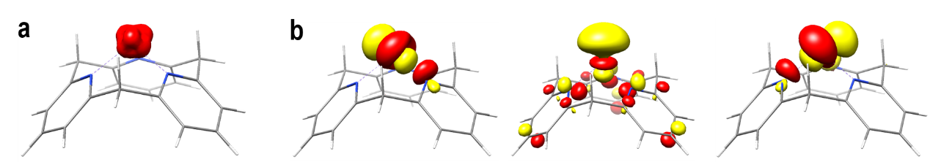

Supplementary Fig. 21.
(a) Calculated spin density distribution of high-spin Co_{SA}-N₃ (S = 3/2). (b) Unrestricted corresponding orbitals (with overlap coefficient equals 0) of high-spin Co_{SA}-N₃, illustrating the orbital interactions and delocalized electron distribution that govern O₂ activation.

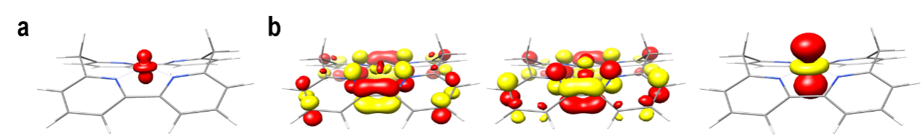

Supplementary Fig. 22.
(a) Calculated spin density distribution of high-spin Co_{SA}-N₄ (S = 3/2). (b) Unrestricted corresponding orbitals (with overlap coefficient equals 0) of high-spin Co_{SA}-N₄, illustrating the orbital interactions and electron distribution in the high-spin state of the four-coordinate Co site.

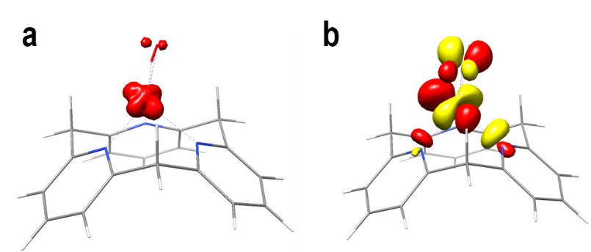

Supplementary Fig. 23.
(a) Calculated spin density distribution of low-spin Co_{SA}-N₃-O₂. (b) Unrestricted corresponding orbitals (with overlap coefficient equals 0) of low-spin Co_{SA}-N₃-O₂, illustrating the orbital interactions between the low-spin Co center and the adsorbed O₂ molecule.

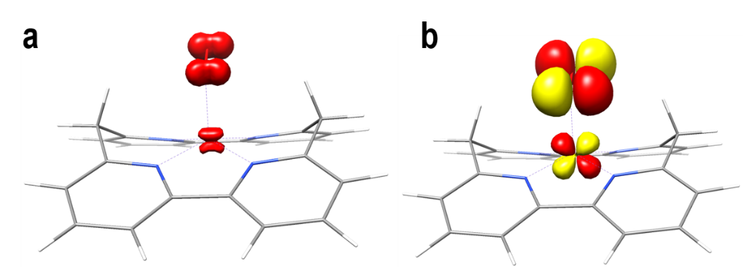

Supplementary Fig. 24.
(a) Calculated spin density distribution of low-spin Co_{SA}-N₄-O₂. (b) Unrestricted corresponding orbitals (with overlap coefficient equals 0) of low-spin Co_{SA}-N₄-O₂, illustrating the orbital interactions between the low-spin Co center and the adsorbed O₂ molecule.

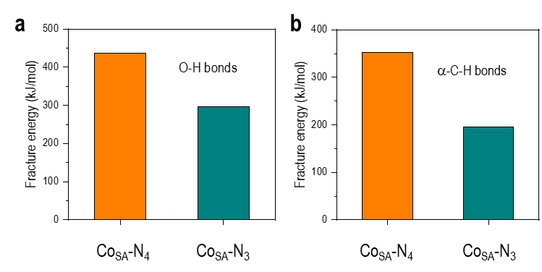

Supplementary Fig. 25.
(a) Energy profile for the O–H bond cleavage of benzyl alcohol. (b) Energy profile for the α-C–H bond cleavage of the benzyl alkoxide intermediate. The three-coordinate Co_{SA}-N₃ exhibits significantly lower activation barriers for both steps compared to the four-coordinate Co_{SA}-N₄, consistent with its superior catalytic performance.

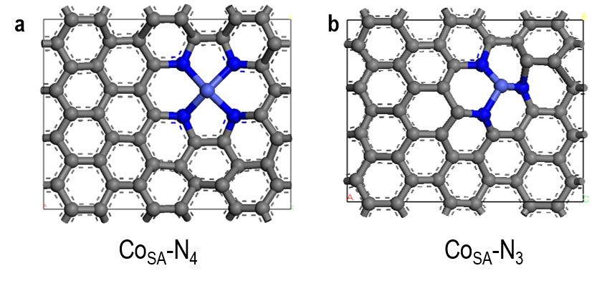

Supplementary Fig. 26.
Optimized model structures of Co_{SA}-N₄ and Co_{SA}-N₃ used in DFT calculations. The four-coordinate Co_{SA}-N₄ model features a square-planar Co–N₄ configuration embedded in a graphene-like carbon matrix, while the three-coordinate Co_{SA}-N₃ model adopts a distorted Co–N₃ geometry with an open coordination site, consistent with the EXAFS fitting results.

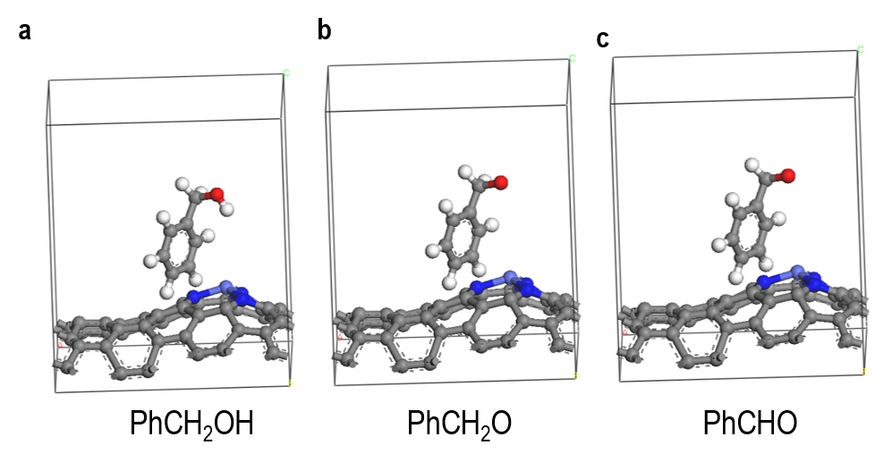

Supplementary Fig. 27.
Optimized adsorption configurations of key reaction intermediates on Co_{SA}-N₃. (a) Adsorption of benzyl alcohol (PhCH₂OH) on Co_{SA}-N₃. (b) Adsorption of benzyl alkoxide (PhCH₂O⁻) on Co_{SA}-N₃. (c) Adsorption of benzaldehyde (PhCHO) on Co_{SA}-N₃. The three-coordinate Co site provides an open coordination environment for effective binding of these oxygen-containing intermediates, facilitating the sequential dehydrogenation and esterification steps.

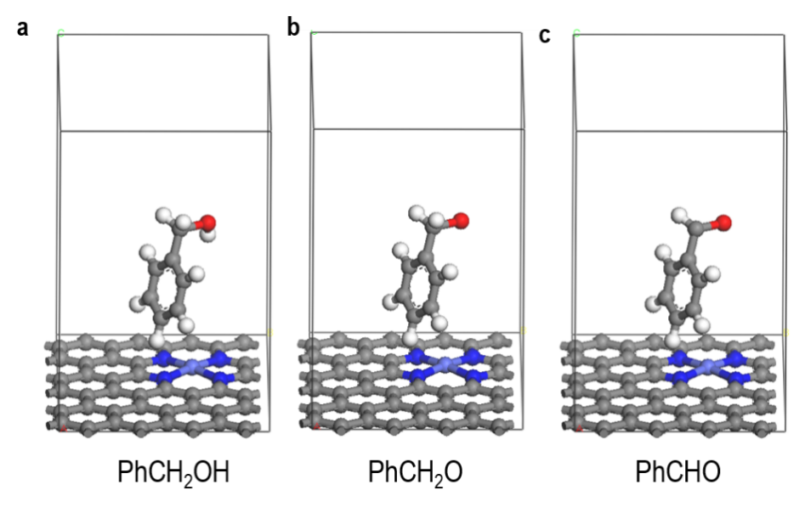

Supplementary Fig. 28.
Optimized adsorption configurations of key reaction intermediates on Co_{SA}-N₄. (a) Adsorption of benzyl alcohol (PhCH₂OH) on Co_{SA}-N₄. (b) Adsorption of benzyl alkoxide (PhCH₂O⁻) on Co_{SA}-N₄. (c) Adsorption of benzaldehyde (PhCHO) on Co_{SA}-N₄. Compared to Co_{SA}-N₃ (Supplementary Fig. 27), the four-coordinate Co site exhibits weaker binding affinities for all intermediates, consistent with its lower catalytic activity.

Supplementary Fig. 29.
Density of states (DOS) analysis of Co_{SA}-N₄ and Co_{SA}-N₃. (a) Projected density of states (PDOS) of Co d-orbitals and N p-orbitals for Co_{SA}-N₄. (b) PDOS of Co d-orbitals and N p-orbitals for Co_{SA}-N₃. The three-coordinate Co_{SA}-N₃ exhibits an upshifted d-band center relative to the four-coordinate Co_{SA}-N₄, indicating enhanced orbital hybridization and electron back-donation capability for O₂ activation.
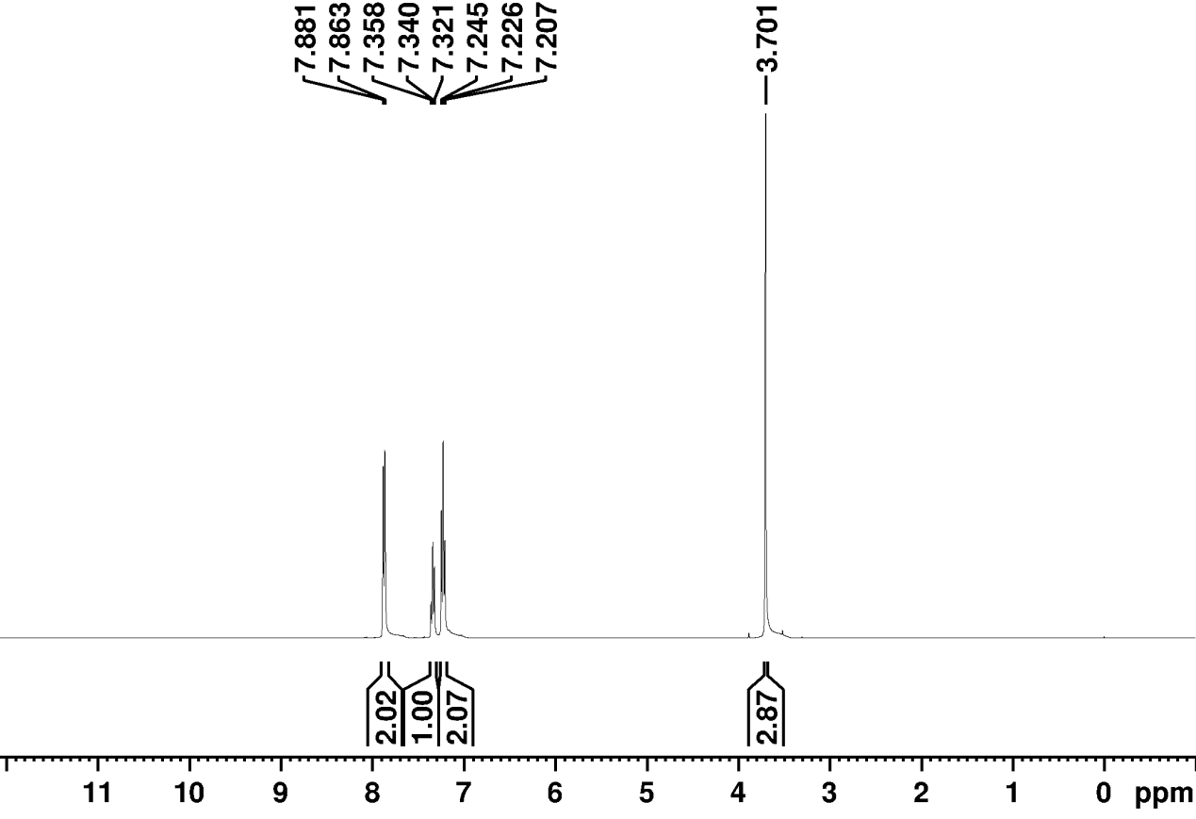

Supplementary Fig. 30.
¹H NMR spectrum of the reaction product of the benzoic acid product in CDCl₃.

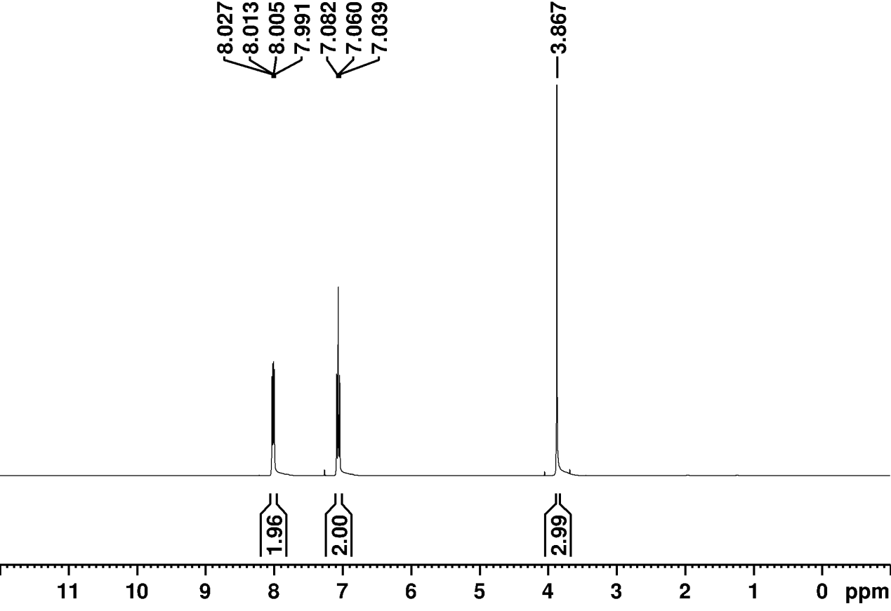

Supplementary Fig. 31.
¹H NMR spectrum of the reaction product of methyl 4-fluorobenzoate in CDCl₃.

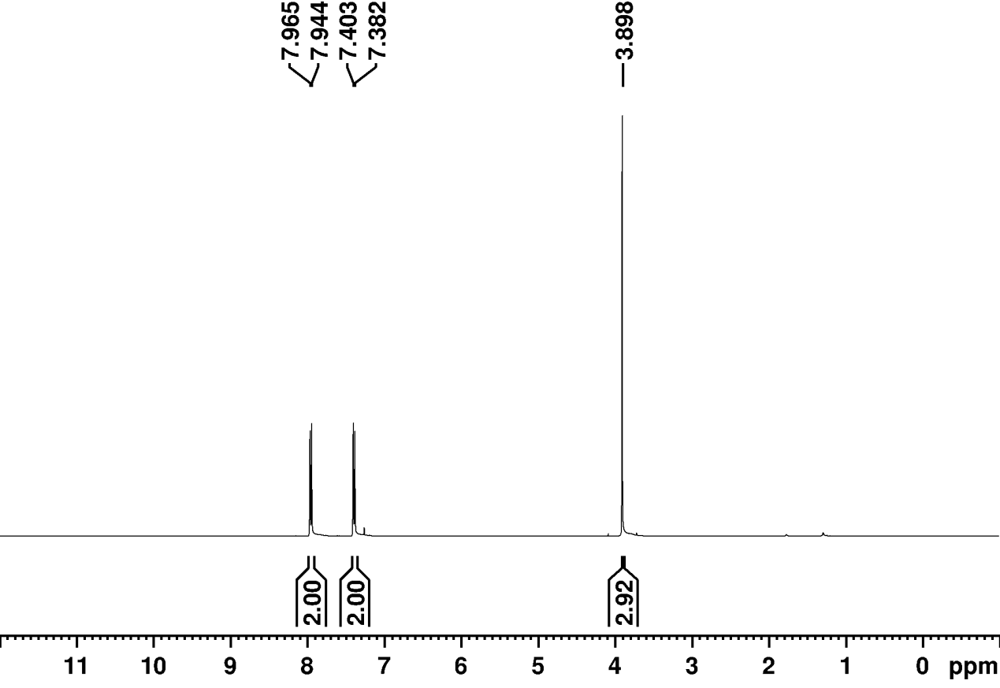

Supplementary Fig. 32.
¹H NMR spectrum of the reaction product of methyl 4-chlorobenzoate in CDCl₃.

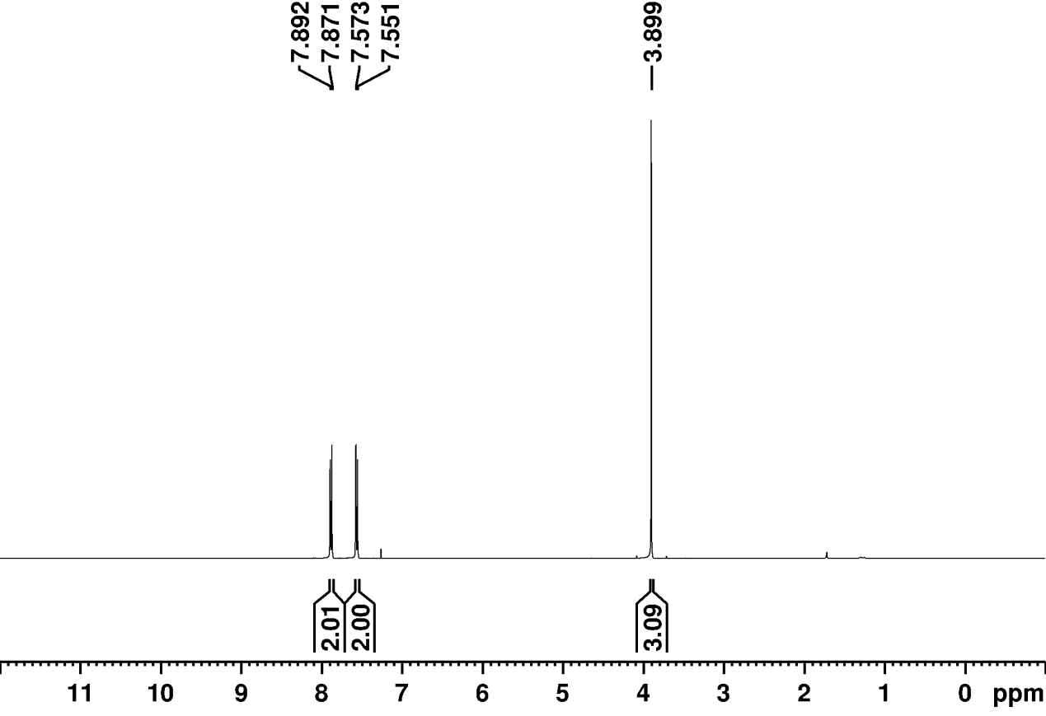

Supplementary Fig. 33.
¹H NMR spectrum of the reaction product of methyl 4-bromobenzoate in CDCl₃.

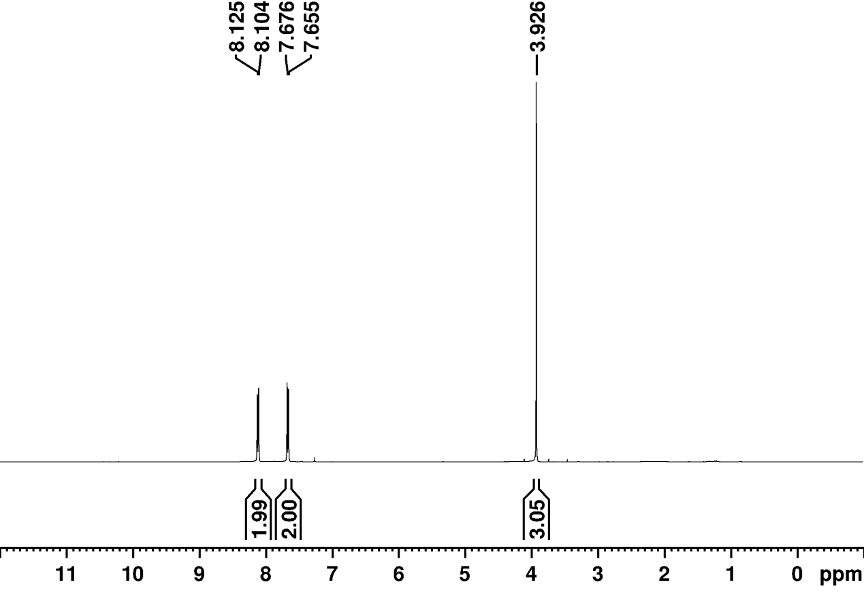

Supplementary Fig. 34.
¹H NMR spectrum of the reaction product of methyl 4-(trifluoromethyl)benzoate in CDCl₃.

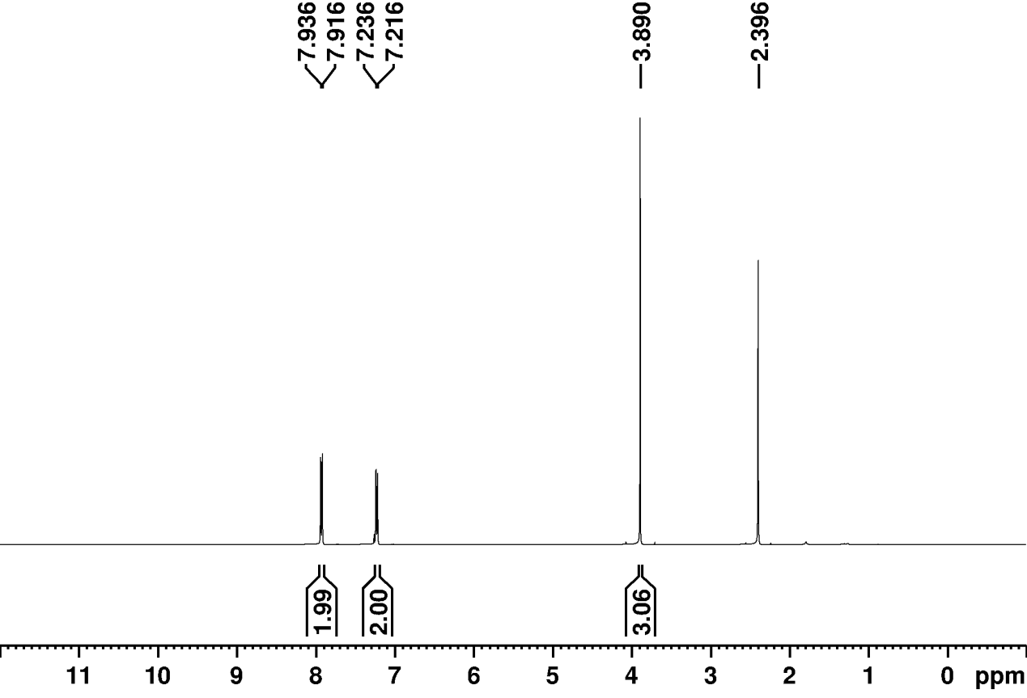

Supplementary Fig. 35.
¹H NMR spectrum of the reaction product of methyl 4-methylbenzoate in CDCl₃.

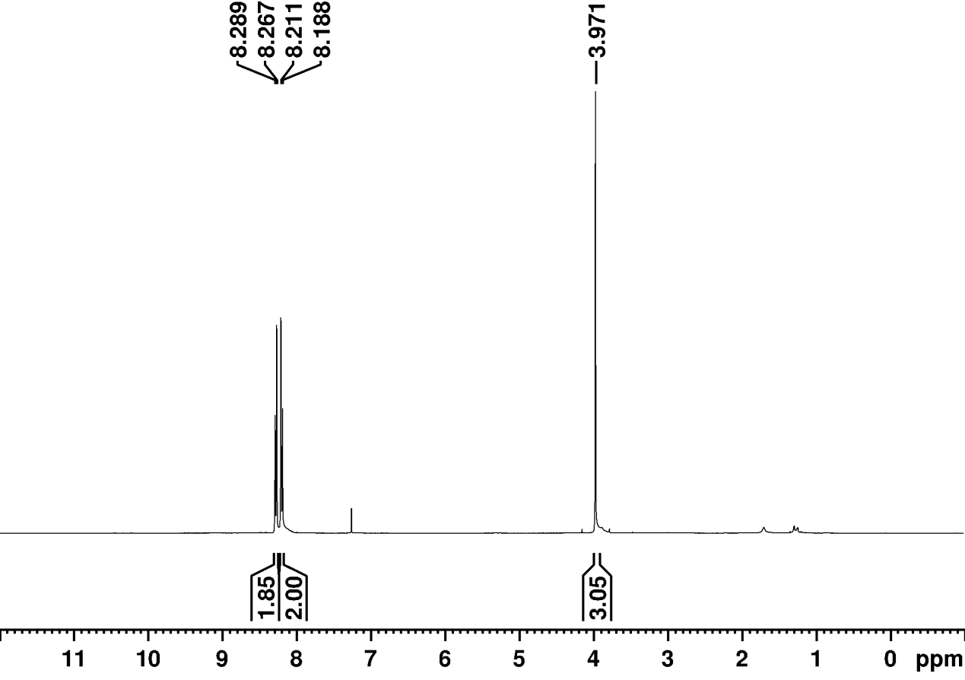

Supplementary Fig. 36.
¹H NMR spectrum of the reaction product of methyl 4-nitrobenzoate in CDCl₃.

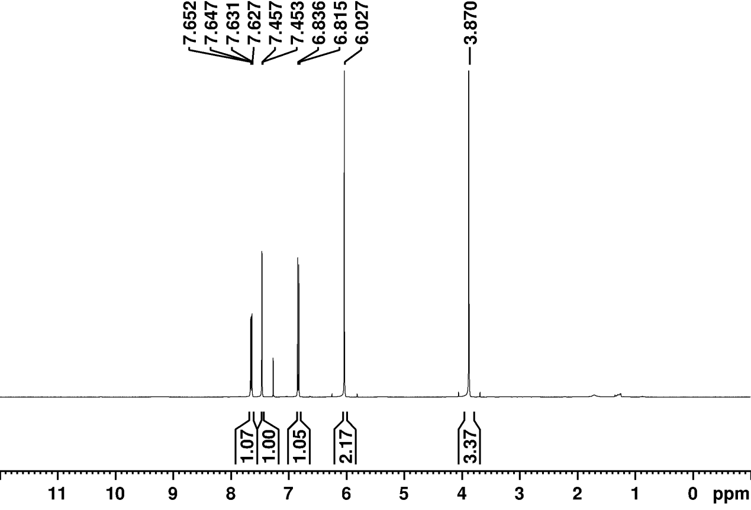

Supplementary Fig. 37.
¹H NMR spectrum of the reaction product of methyl 1,3-benzodioxole-5-carboxylate in CDCl₃.

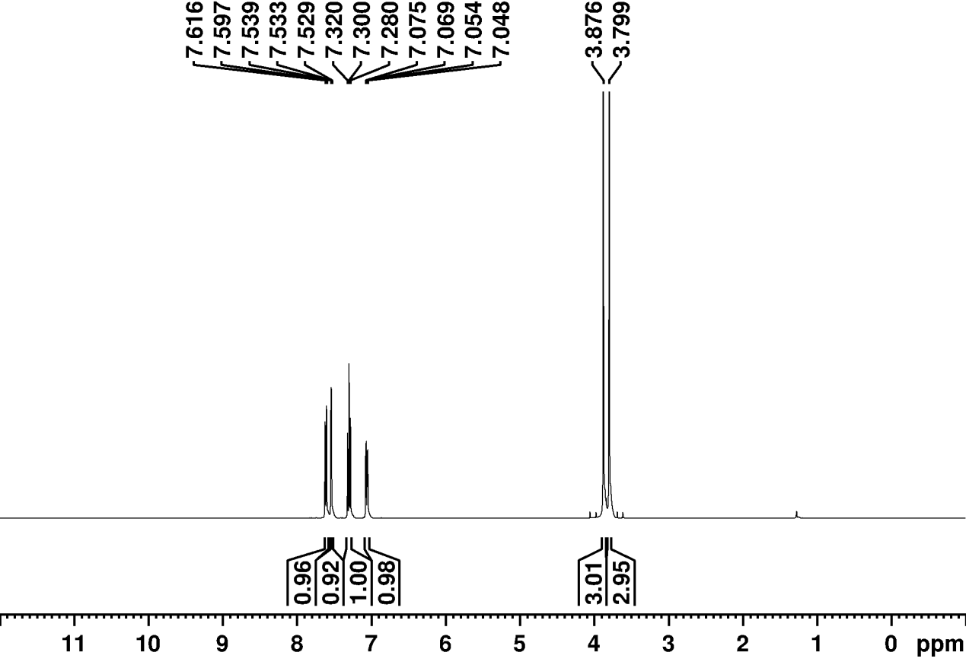

Supplementary Fig. 38.
¹H NMR spectrum of the reaction product of methyl 3-methoxybenzoate in CDCl₃.

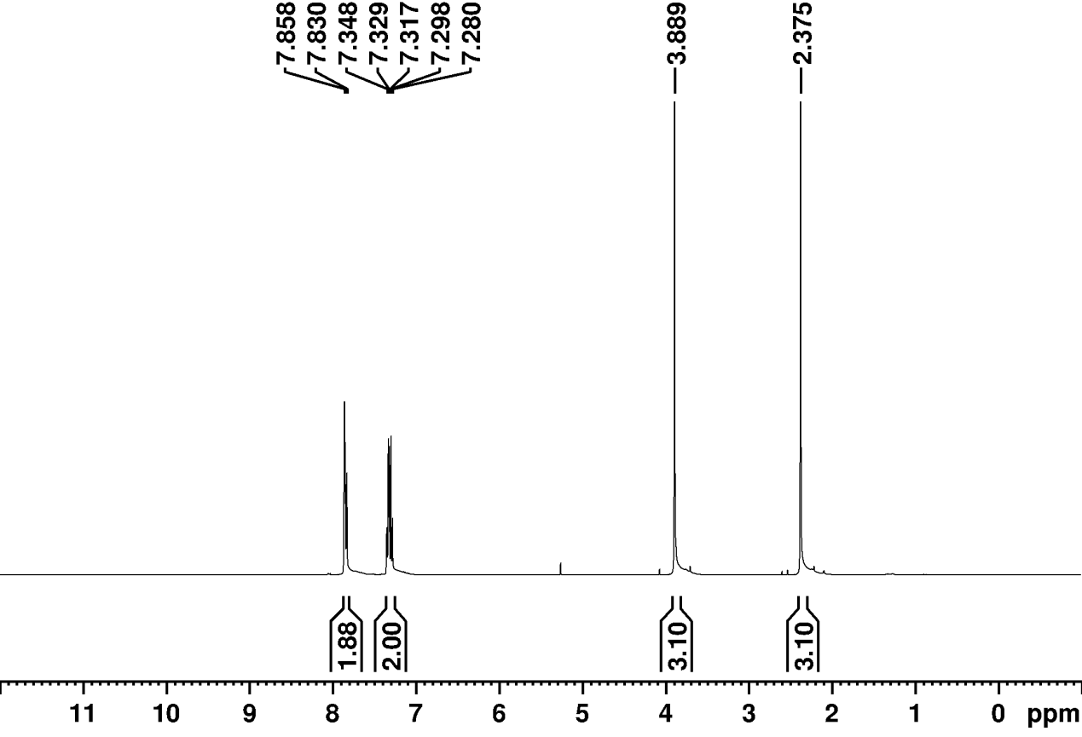

Supplementary Fig. 39.
¹H NMR spectrum of the reaction product of methyl 3-methylbenzoate in CDCl₃.

Supplementary Fig. 40.

GC-MS analysis of the reaction product of 2-phenylquinoline.

Supplementary Fig. 41.

GC-MS analysis of the reaction product of 2-(4-fluorophenyl)quinoline.

Supplementary Fig. 42.

GC-MS analysis of the reaction product of 2-(4-chlorophenyl)quinoline.

Supplementary Fig. 43.

GC-MS analysis of the reaction product of 2-(4-bromophenyl)quinoline.

Supplementary Fig. 44.

GC-MS analysis of the reaction product of 4-(quinolin-2-yl)benzonitrile.

Supplementary Fig. 45.

GC-MS analysis of the reaction product of 2-(quinolin-2-yl)aniline.

Supplementary Fig. 46.

GC-MS analysis of the reaction product of 2-(4-methoxyphenyl)quinoline.

Supplementary Fig. 47.

GC-MS analysis of the reaction product of 2-(4-trifluoromethyl-phenyl)-quinoline.

Supplementary Fig. 48.

GC-MS analysis of the reaction product of 2-phenyl-8-methylquinoline.

Supplementary Tables 1–2

Supplementary Table 1.
Elemental composition of the catalysts determined by ICP-MS and elemental analysis.
Catalysts | ICP-MS |  |  | Elemental analysis
 | Co(wt.%) | Zn(wt.%) | N(wt.%)
Co_{SA}-N₃ | 0.412 | 0.001 | 2.08
Co_{SA-}N₄ | 0.391 | 0.002 | 6.41

Supplementary Table 2.
Fitted results of Co K-edge EXAFS curves.

Sample | Shell | Nª | R^{b} | σ²(Å²)^{c} | R factor (%)^{d}
Co foil^{e} | Co–Co | 12* | 2.489±0.015 | 0.0082±0.00189 | 0.008
CoO^{f}  Co_{SA}-N₄^{g} | Co–O  Co-N | 3.43  4.01 | 2.096±0.029  1.874±0.174 | 0.0079±0.00499  0.0264±0.01062 | 0.014  0.013
CoSA-N₃^{h} | Co-N | 3.05 | 1.992±0.047 | 0.0169±0.00986 | 0.014
ªN is the coordination number; ^{b}R is the distance between the absorber and the backscatter atoms; ^{c}σ² is Debye-Waller factor to account for both thermal and structural disorders; ^{d}R factor indicates the goodness of the fitting; ^{e}Fitting range: 3.000 ≤ k(Å) ≤ 12.000 and 2.00 ≤ R(Å) ≤ 3.00; ^{f}Fitting range: 2.000 ≤ k(Å) ≤ 10.000and 1.00 ≤ R(Å) ≤ 2.00; ^{g}Fitting range: 3.00 ≤ k(Å) ≤ 9.000 and 1.00 ≤ R(Å) ≤ 2.10; ^{h}Fitting range: 2.00 ≤ k(Å) ≤ 9.00 and 1.00 ≤ R(Å) ≤ 2.00.

References

- Neese, F. WIREs Comput Mol Sci., Software update: The ORCA program system—Version 5.0. 12, e1606 (2022).
- Becke, A. D. Density‐functional thermochemistry. III. The role of exact exchange, J.Chem. Phys., 98, 5648 (1993).
- Becke, A. D. & Johnson, E. R. A density-functional model of the dispersion interaction, J. Chem. Phys. 123, 154101 (2005).
- Johnson, E. R & Becke, A. D. A post-Hartree-Fock model of intermolecular interactions: inclusion of higher-order corrections, J. Chem. Phys., 123, 024101 (2005).

