Figure S1
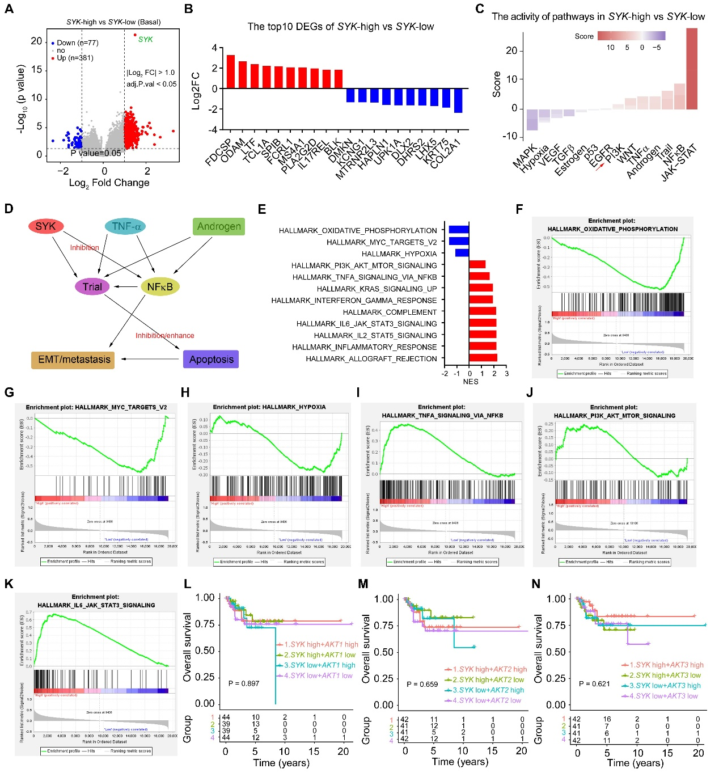
Figure S1. Integrated functional profiling of SYK expression strata in the Basal-like breast cancer (TCGA-BRCA). (A) Volcano plot identifying differentially expressed genes (DEGs; |log₂ FC| > 1.0, FDR < 0.05) in SYK-high vs. SYK-low tumors. (B) Top 10 most significantly dysregulated DEGs (FDR < 0.05). (C) Single-sample GSEA-derived pathway activity z-scores across SYK strata; (D) Integrative SYK-centered signaling model in the Basal-like breast cancer, synthesizing transcriptomic dysregulation, pathway activation, and clinical outcome associations. (E-K) Gene Set Enrichment Analysis (GSEA) demonstrating pathway-level enrichment in SYK-high vs. SYK-low tumors. (L-N) Kaplan-Meier analyses of overall survival (OS) stratified by SYK expression and AKT1/2/3 mRNA levels (median dichotomization).

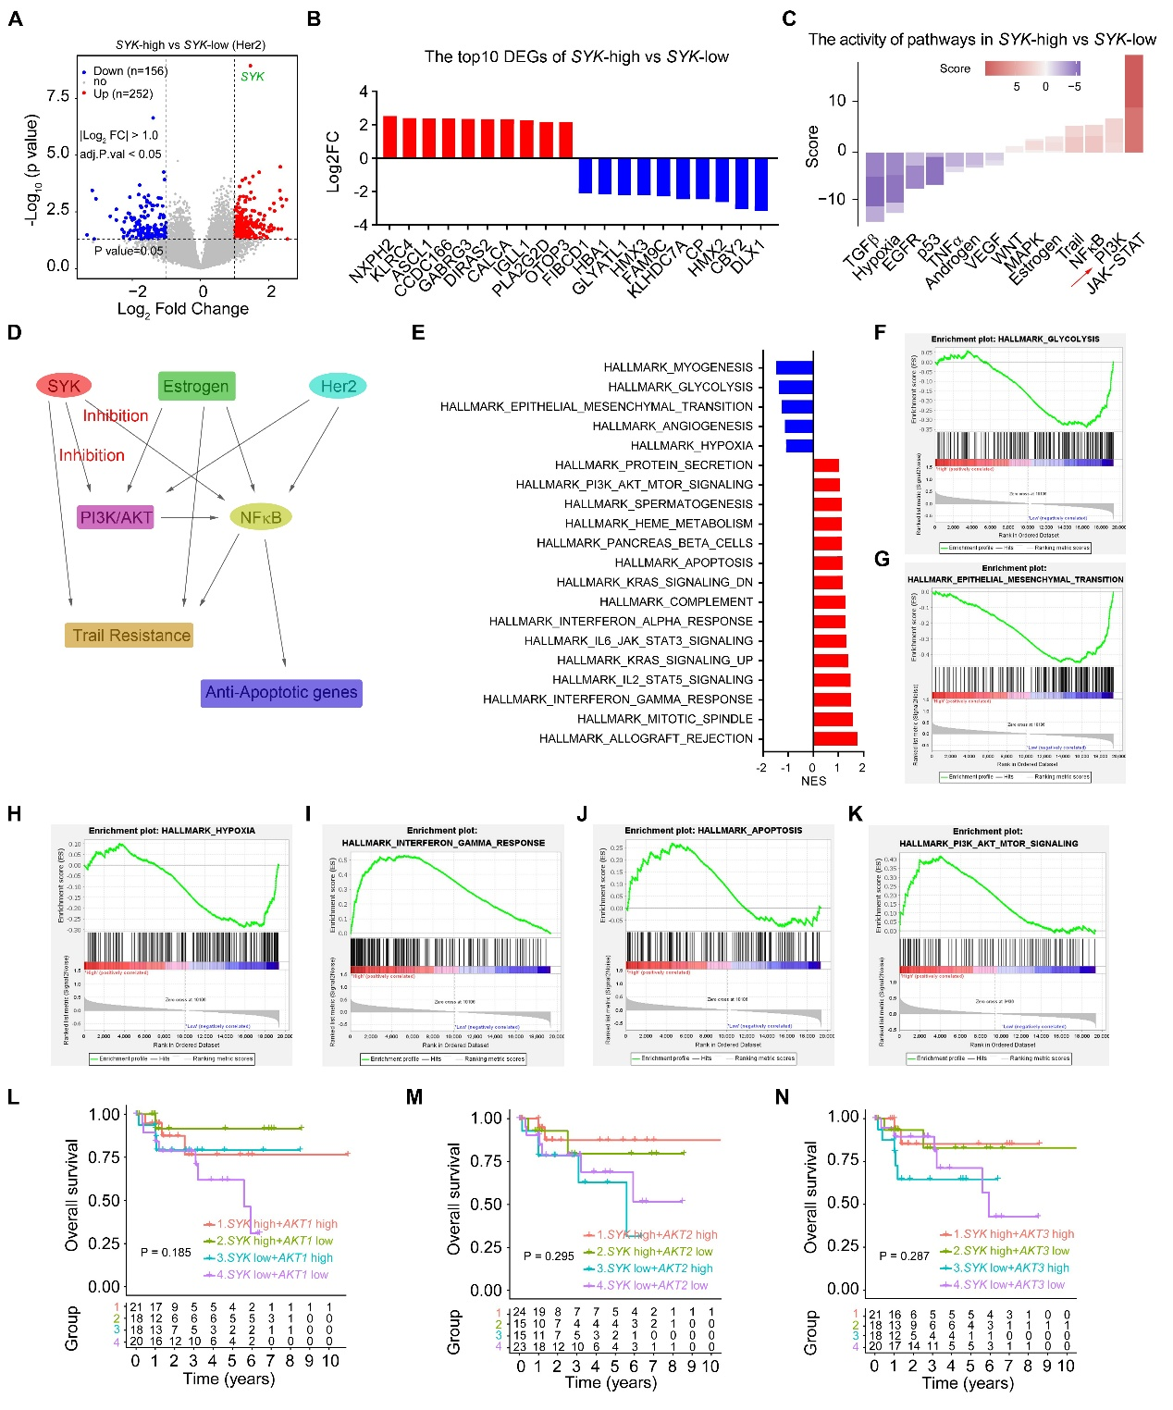

Figure S2. Integrated functional profiling of SYK expression strata in the Her2-riched breast cancer (TCGA-BRCA). (A) Volcano plot identifying differentially expressed genes (DEGs; |log₂ FC| > 1.0, FDR < 0.05) in SYK-high vs. SYK-low tumors. (B) Top 10 most significantly dysregulated DEGs (FDR < 0.05). (C) Single-sample GSEA-derived pathway activity z-scores across SYK strata. (D) Integrative SYK-centered signaling model in the Her2-enriched breast cancer, synthesizing transcriptomic dysregulation, pathway activation, and clinical outcome associations. (E-K) Gene Set Enrichment Analysis (GSEA) demonstrating pathway-level enrichment in SYK-high vs. SYK-low tumors. (L-N) Kaplan-Meier analyses of OS stratified by SYK expression and AKT1/2/3 mRNA levels (median dichotomization).
Figure S3. Integrated functional profiling of SYK expression strata in the Luminal B breast cancer (TCGA-BRCA). (A) Volcano plot identifying differentially expressed genes (DEGs; |log₂ FC| > 1.0, FDR < 0.05) in SYK-high vs. SYK-low tumors. (B) Top 10 most significantly dysregulated DEGs (FDR < 0.05). (C) Single-sample GSEA-derived pathway activity z-scores across SYK strata. (D) Integrative SYK-centered signaling model in the Luminal B breast cancer, synthesizing transcriptomic dysregulation, pathway activation, and clinical outcome associations. (E-K) Gene Set Enrichment Analysis (GSEA) demonstrating pathway-level enrichment in SYK-high vs. SYK-low tumors. (L-N) Kaplan-Meier analyses of OS stratified by SYK expression and AKT1/2/3 mRNA levels (median dichotomization).

Table S1. The primer sequences of target genes for qRT-PCR.
Gene name | Sequences (5’-3’)
Human-SYK | sense - CATCAGTCAGAAGCCTCAG
Human-SYK | antisense -TAGGAGCCGTTGTTGTCT
Human-AKT1 | sense -ACGCTACTTCCTCCTCAA
Human-AKT1 | antisense -CTCCTCCTCCTGCTTCTT
Human-GAPDH | sense -ACAGCCTCAAGATCATCAG
Human-GAPDH | antisense -AGTCCTTCCACGATACCA

Table S2. siRNA sequences targeting the SYK gene in human breast cancer cell lines.
Gene name | Sequences (5’-3’)
Human-siSYK-299 | Sense- GCAUGAGUGAUGGGCUUUAUUTT
Human-siSYK-299 | Antisense- AAUAAAGCCCAUCACUCAUGCTT
Human-siSYK-1058 | Sense- CGGGUGGAAUAAUCUCAAGAATT
Human-siSYK-1058 | Antisense- UUCUUGAGAUUAUUCCACCCGTT
Human-siSYK-2079 | Sense- GCGCAAUUACUACUAUGACGUTT
Human-siSYK-2079 | Antisense- ACGUCAUAGUAGUAAUUGCGCTT
Human-siRNA-NC | Sense- UUC UCC GAA CGU GUC ACG UTT
Human-siRNA-NC | Antisense- ACG UGA CAC GUU CGG AGA ATT

