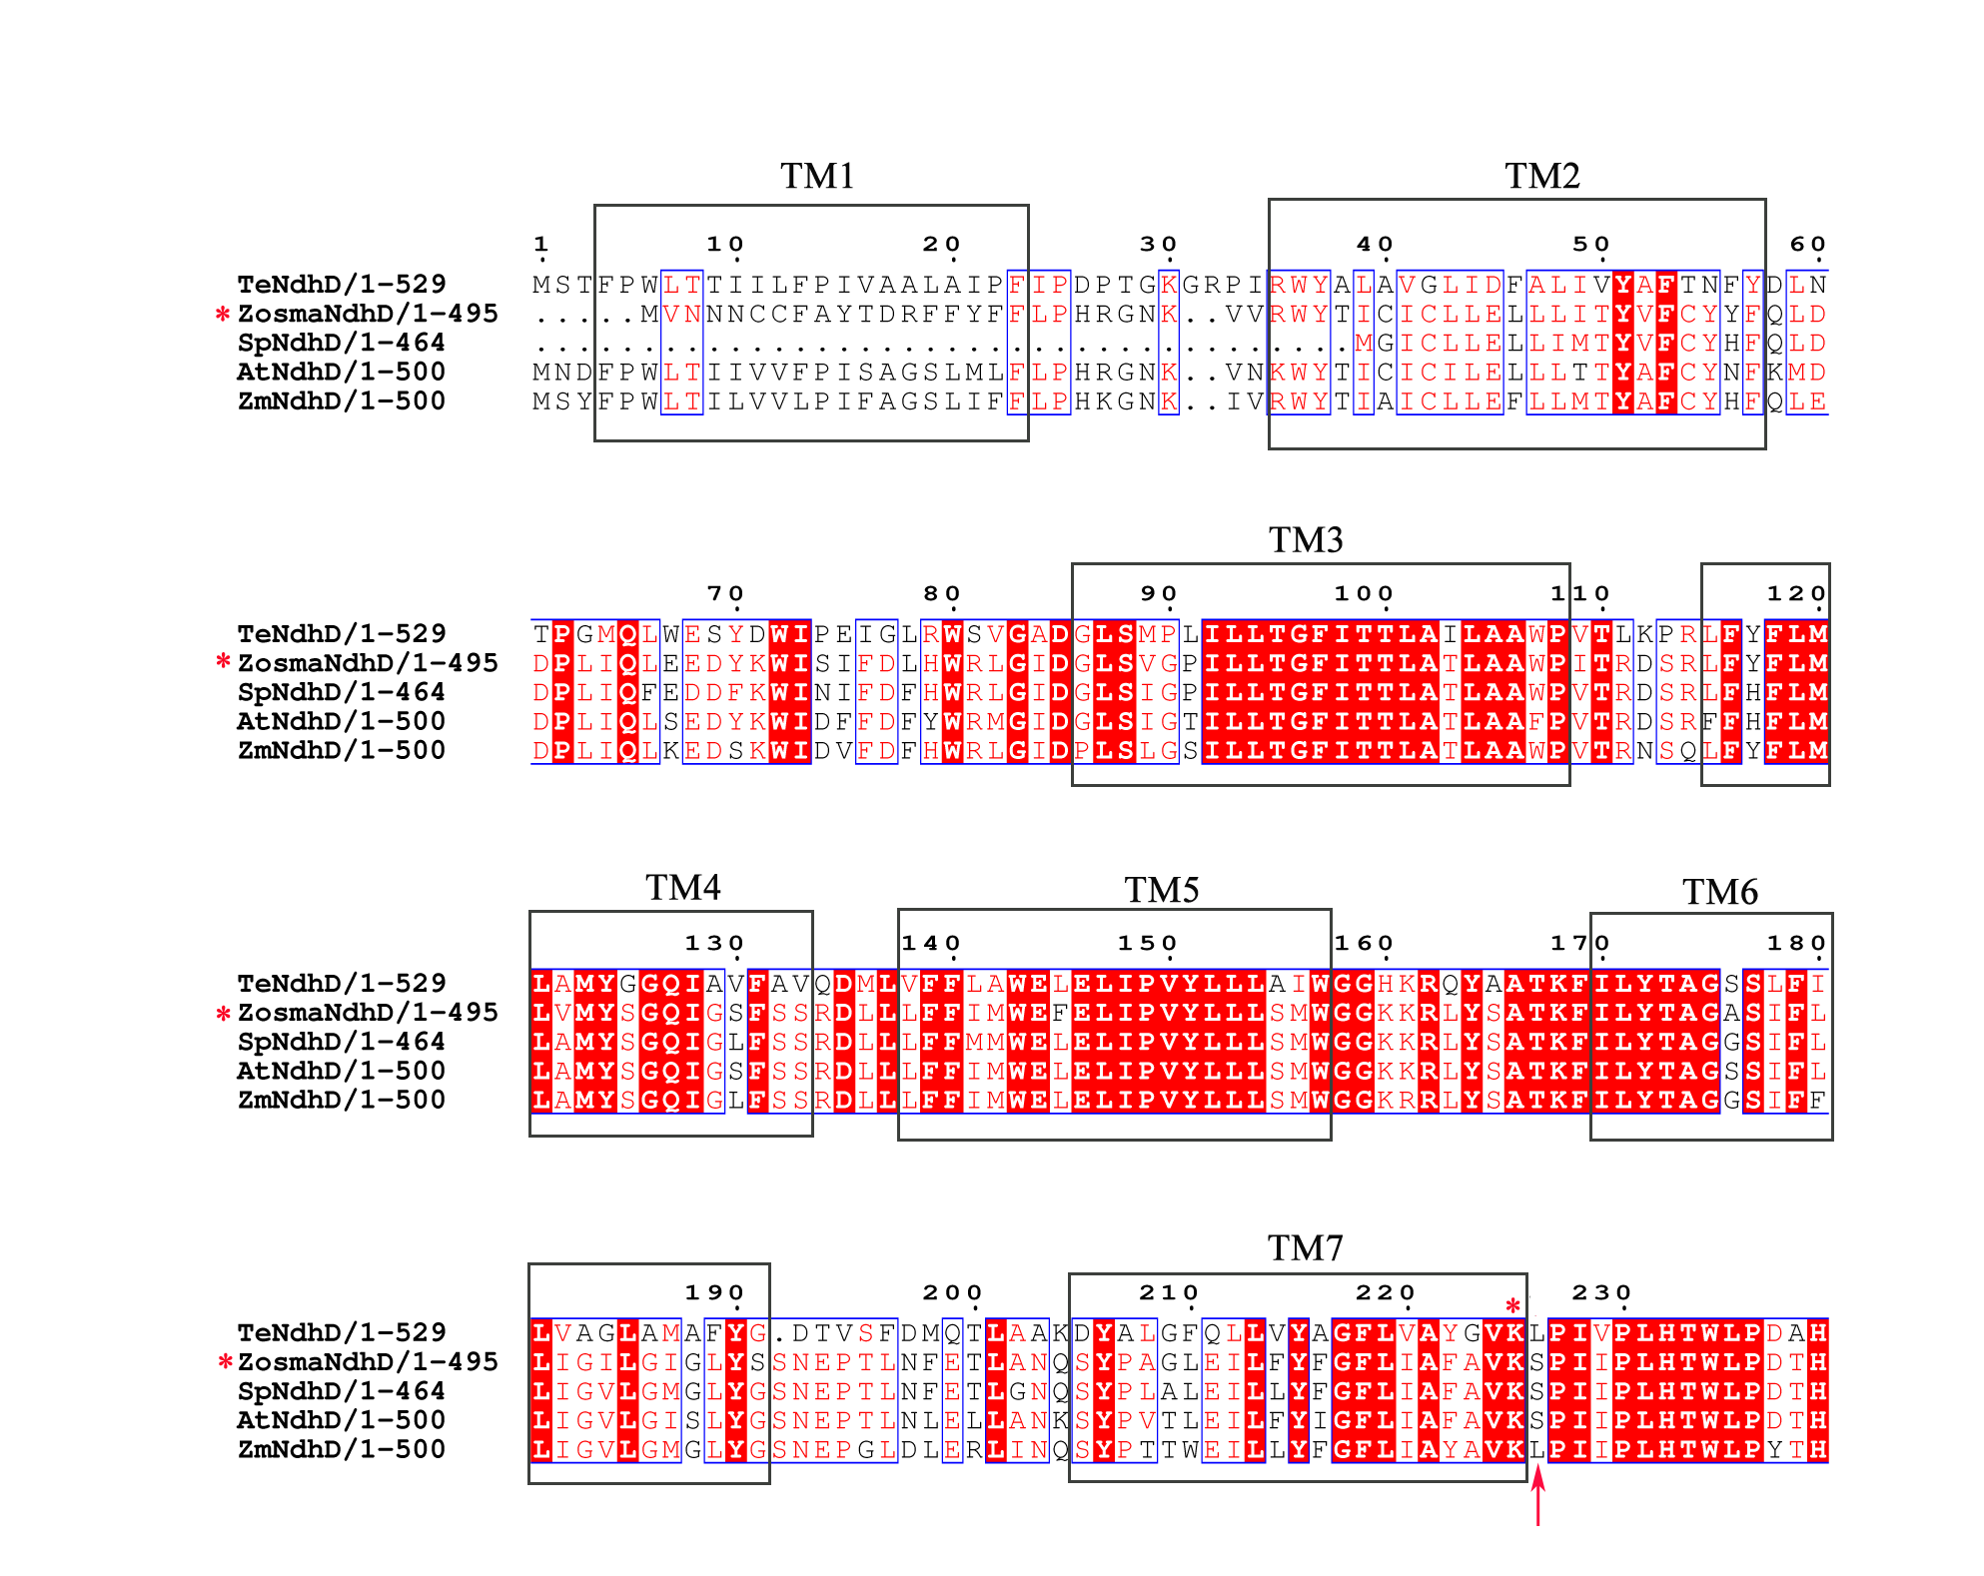
(A)
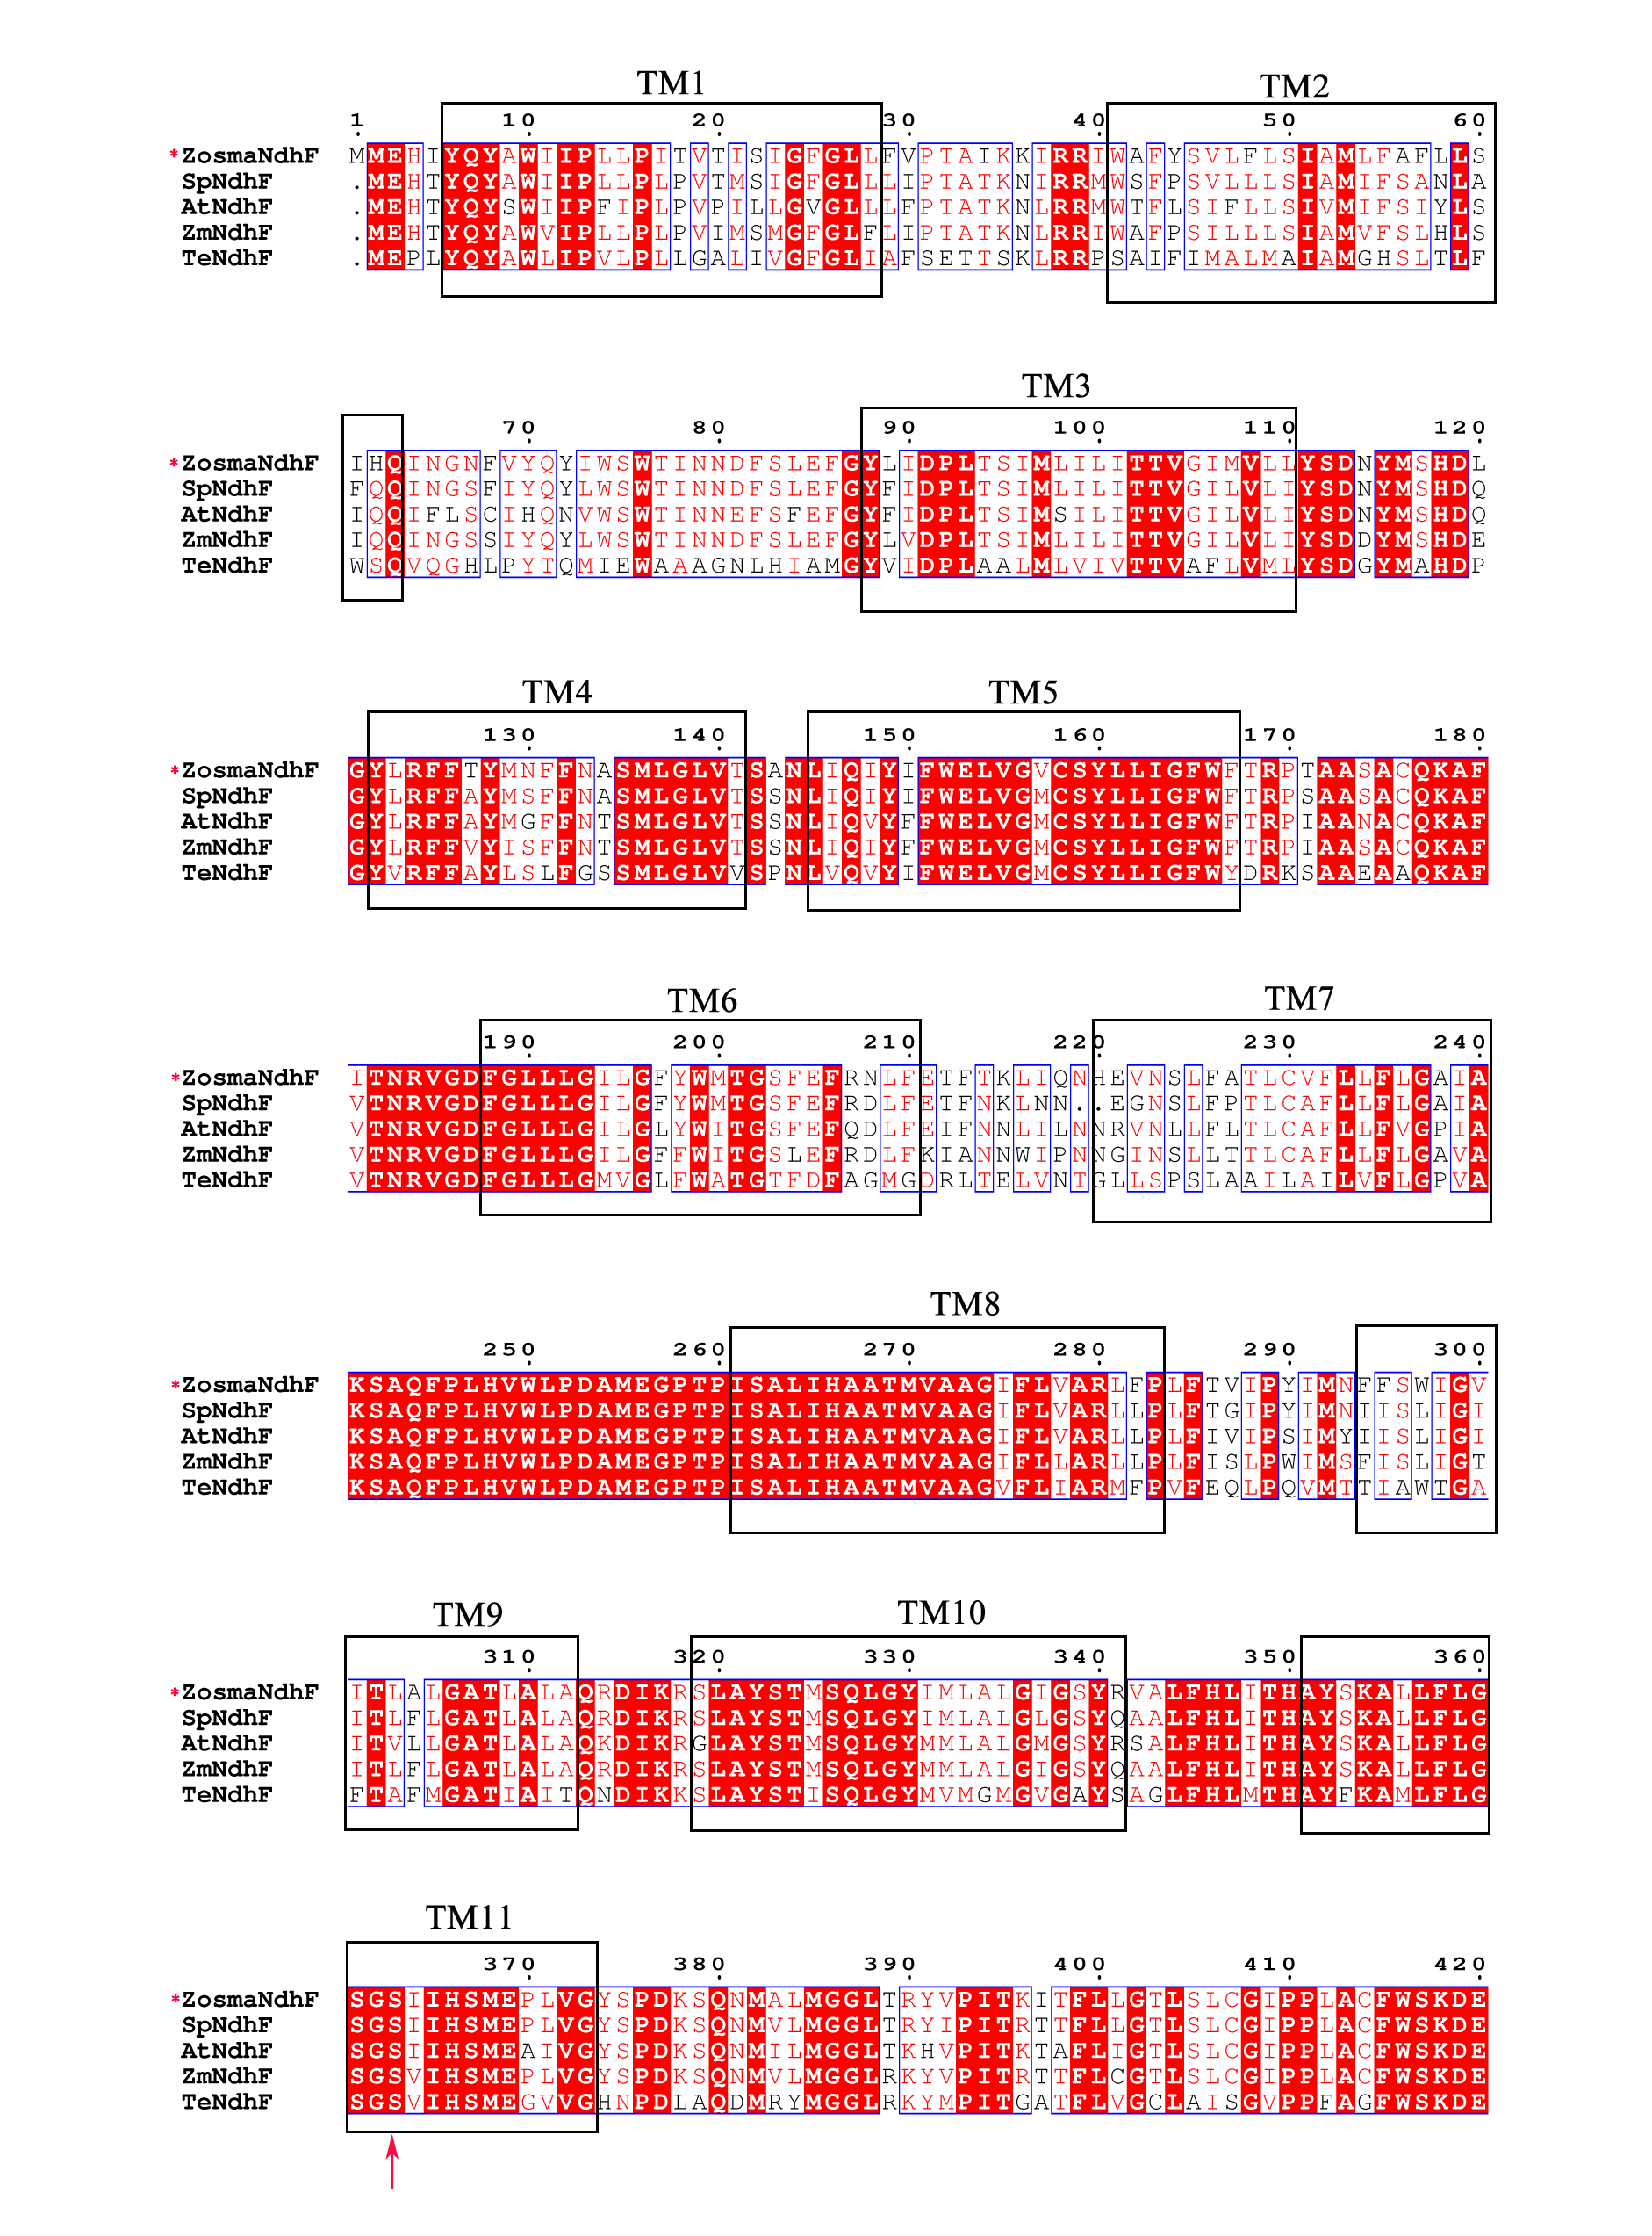
(B)
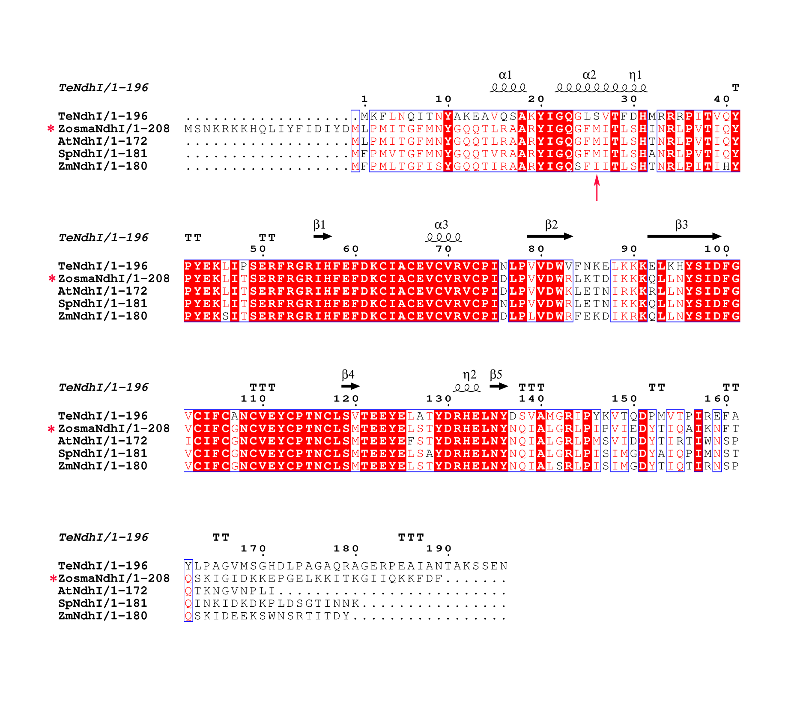
(C)
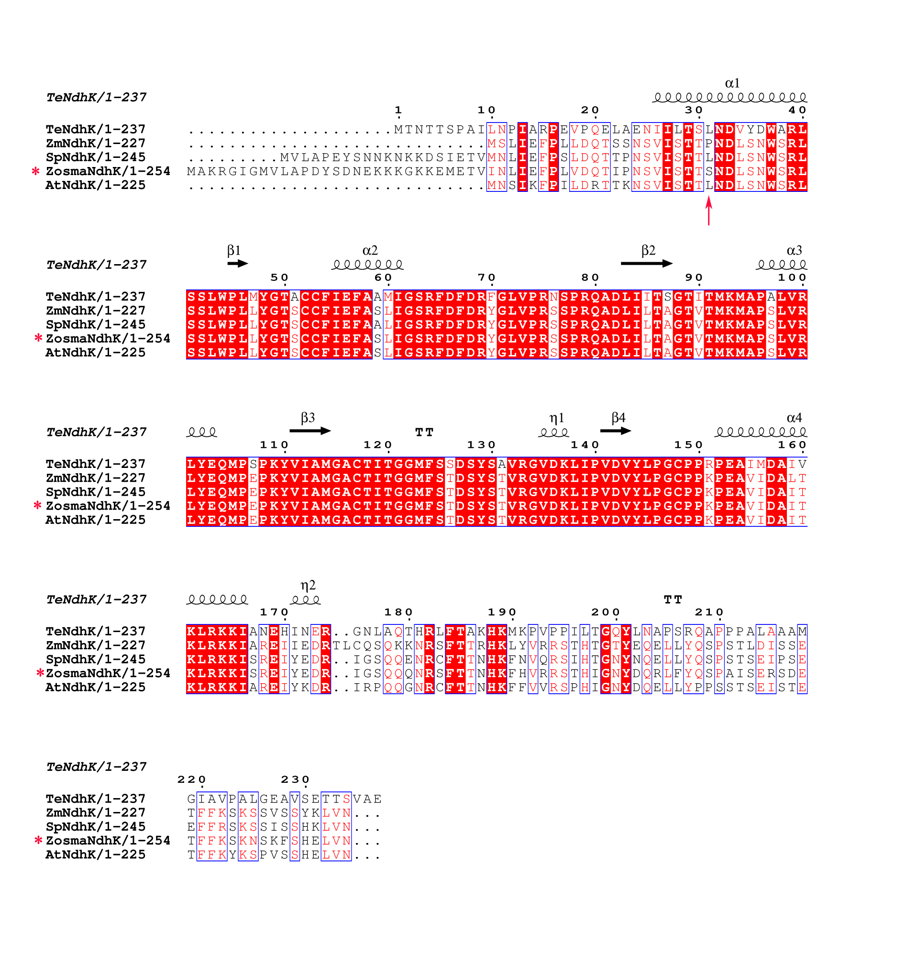
(D)

Additional file 5: ClustalW amino acid alignment of the amino acid sequence of NdhD (A), NdhF (B), NdhI (C) and NdhK (D) from Z. marina with other four species. At, A. thaliana; Sp, S. polyrhiza; Te, T. elongatus BP-1; Zm, Z. mays. The conserved charged lysine residue is indicated by asterisk. The editing sites are indicated by arrows.

