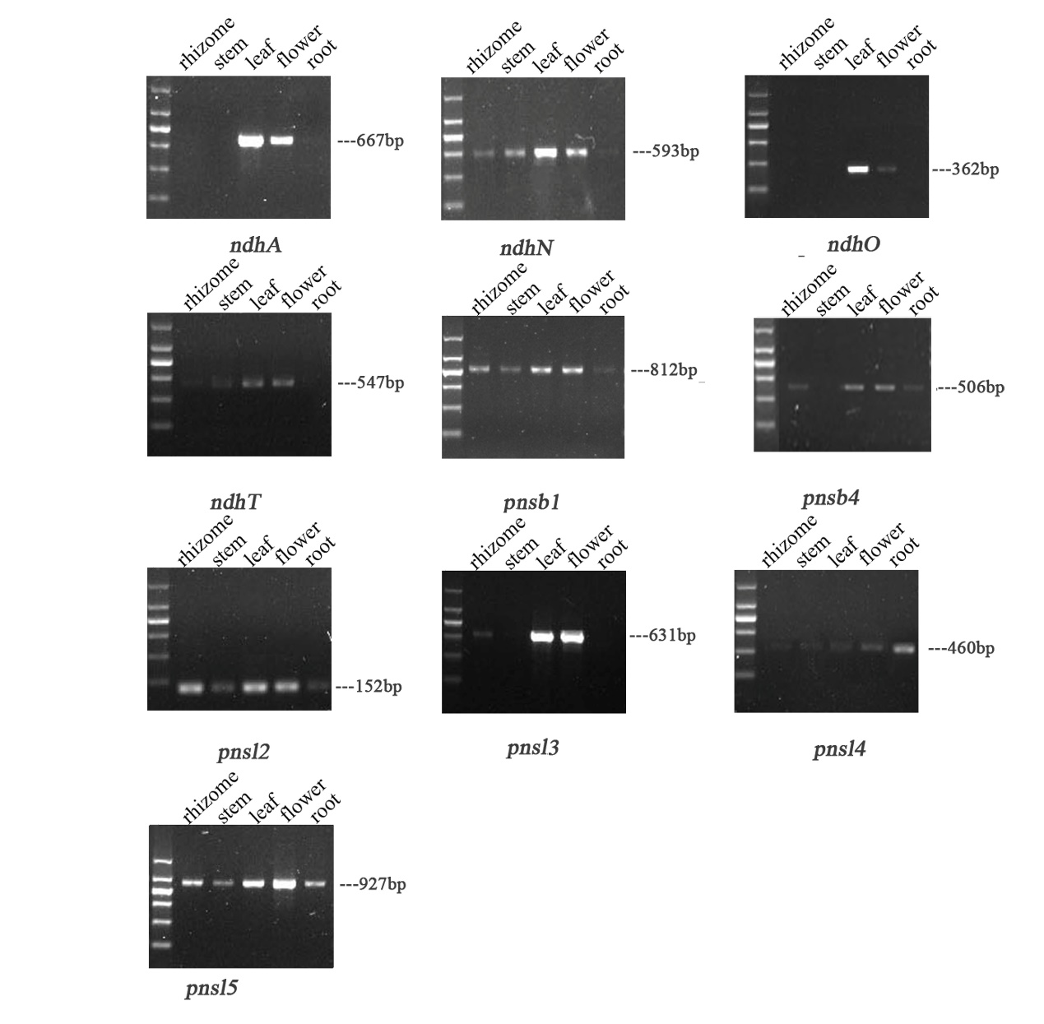
(A)
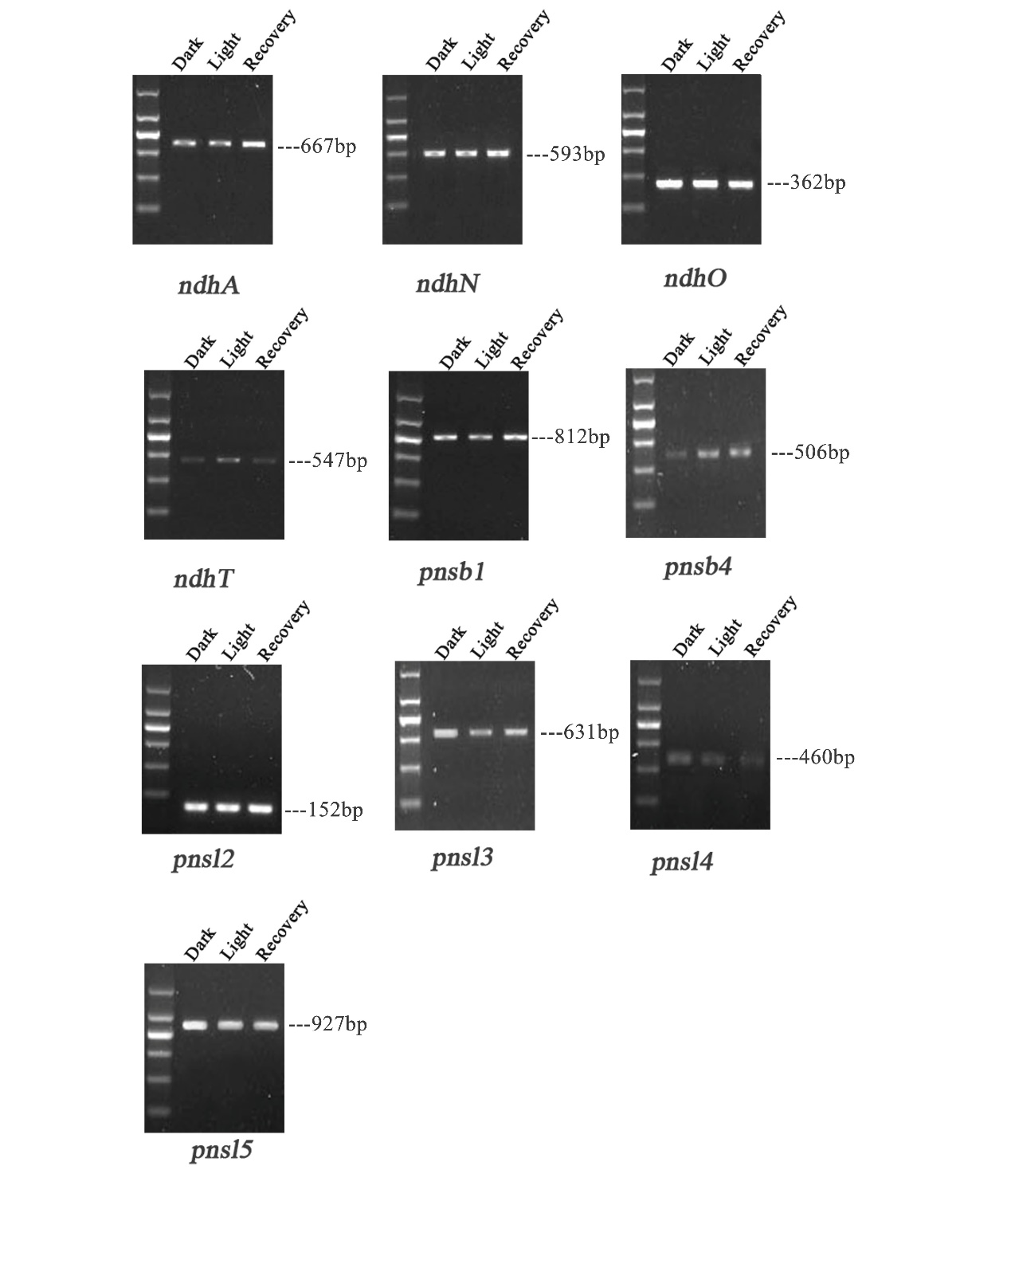
(B)

Additional file 3: Ndh gene without alternative splicing events. The transcripts of ndh gene in five tissues including rhizome, stem, leaf, flower and root (A). The transcripts of ndh gene in the period of light exposure and the subsequent dark recovery (B). The first lane left is 200-bp ladder (200bp, 400bp, 600bp, 800bp, 1000bp, 1500bp). AS transcripts are highlighted in red. The fundamental transcripts are labeled in black.

