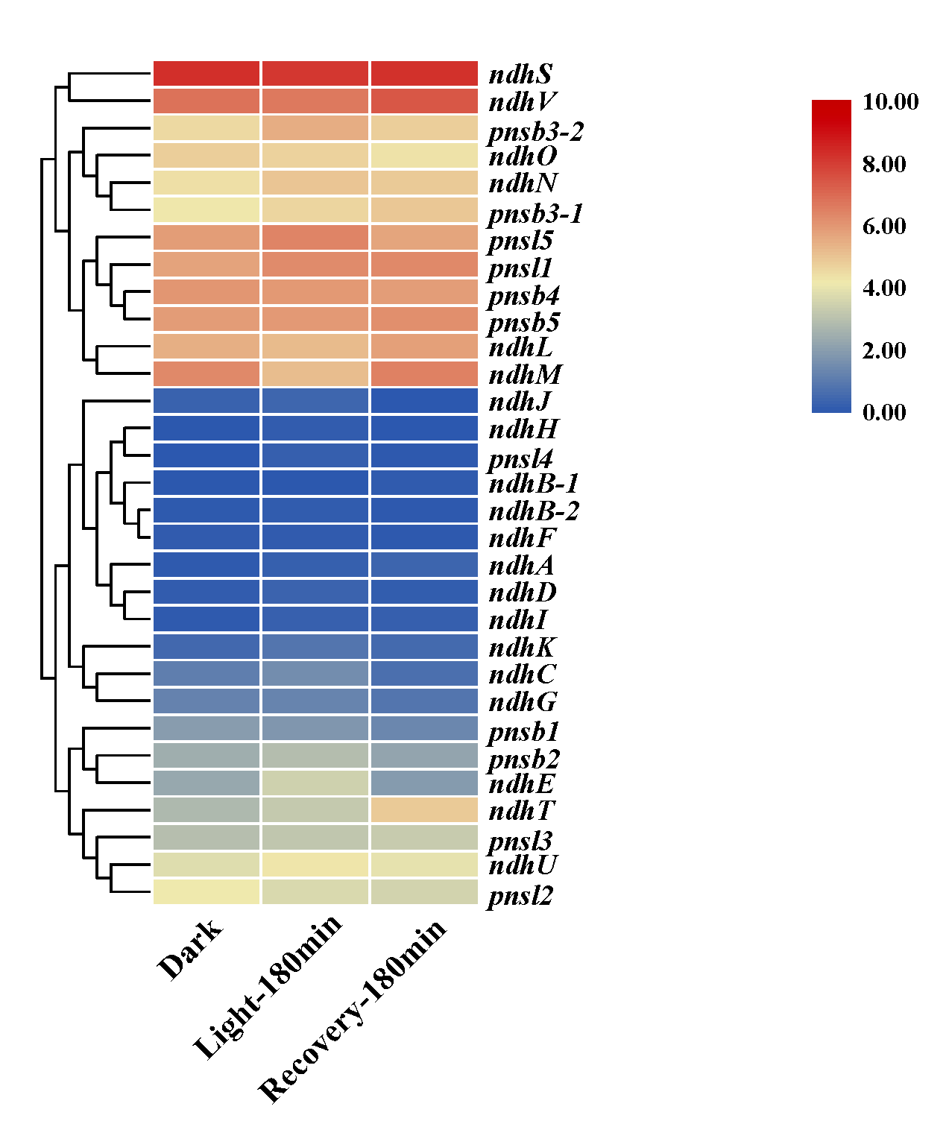

Additional file 7: Expression profiles of ndh genes in the period of light exposure and the following recovery detected by transcriptome. FPKM values of ndh genes were transformed by log2 and the heatmap was drawn using TBtool.

