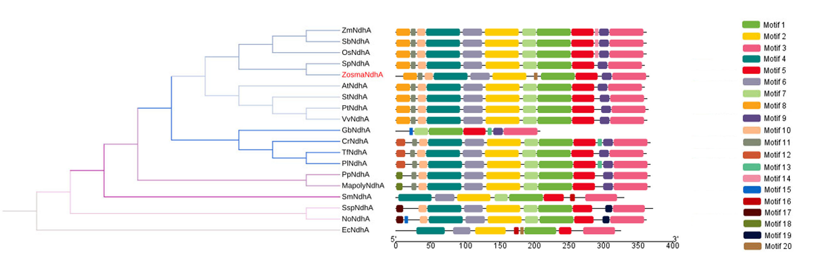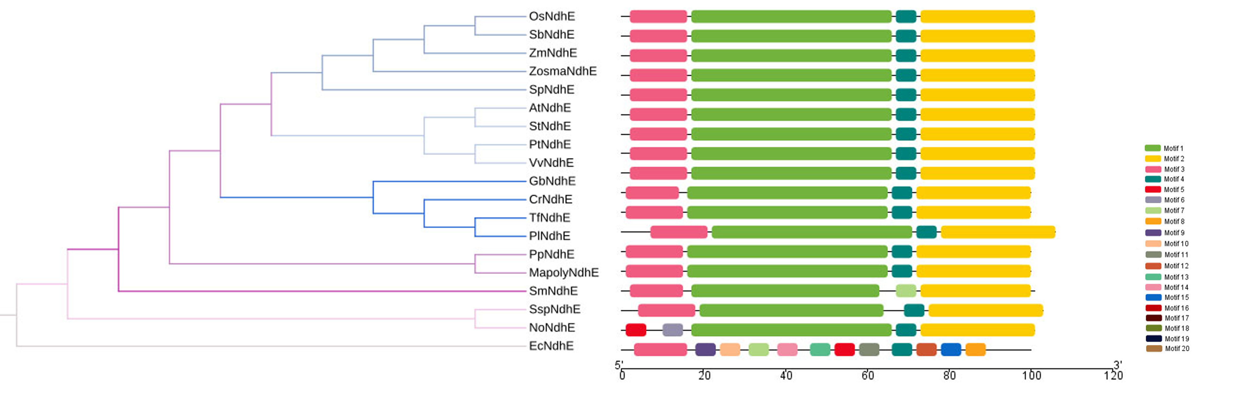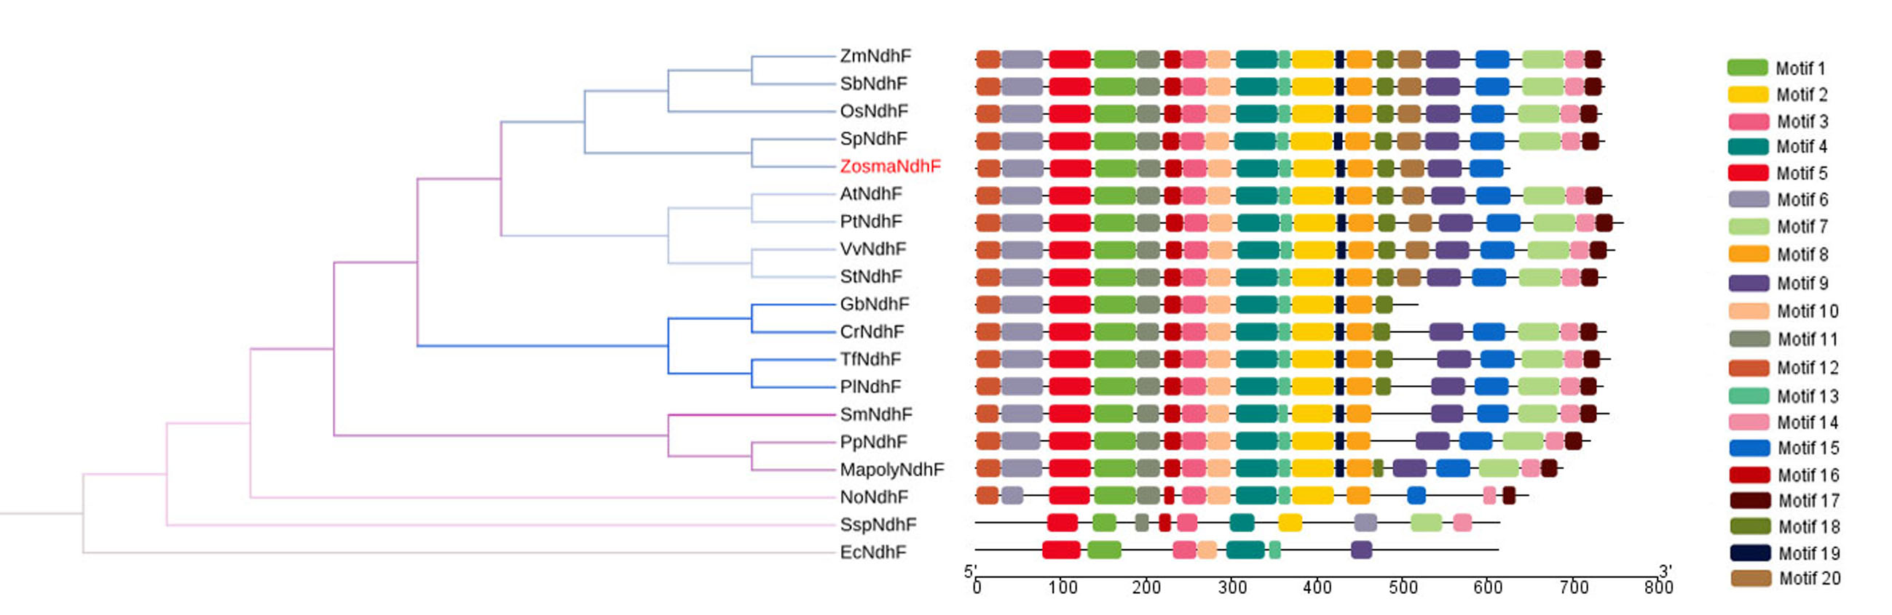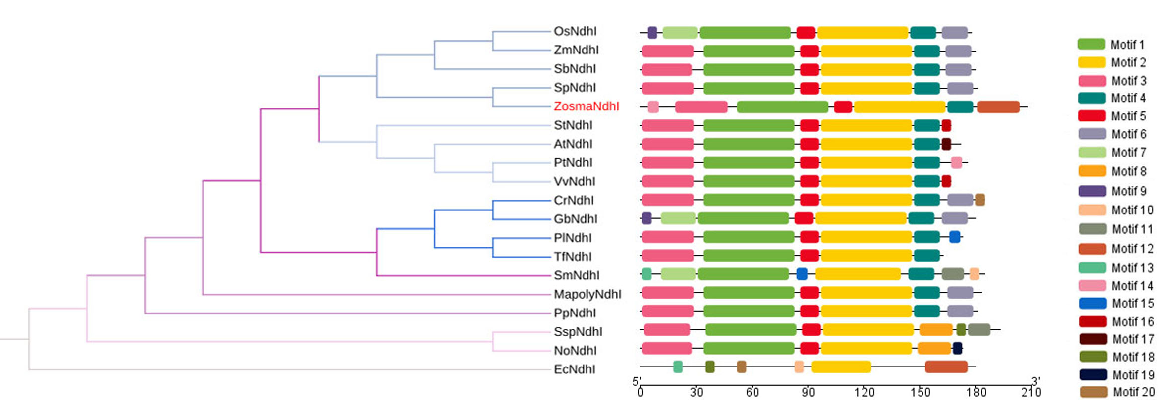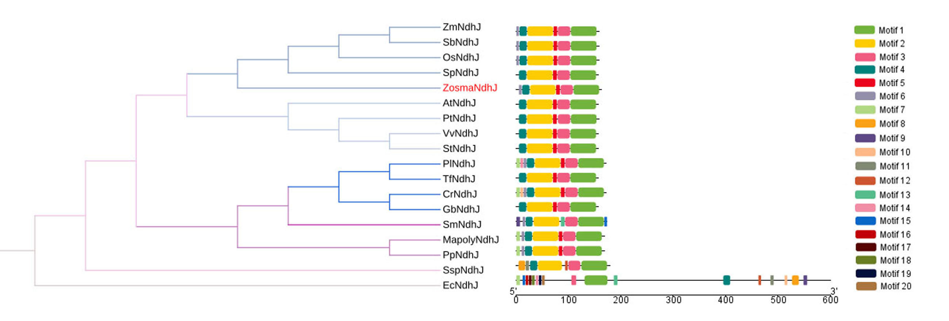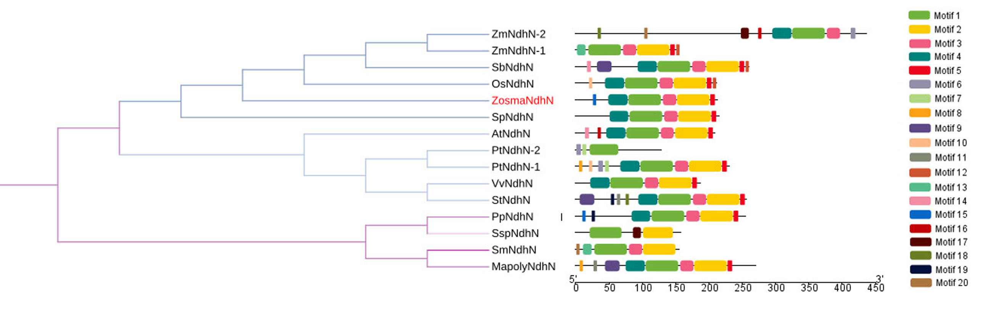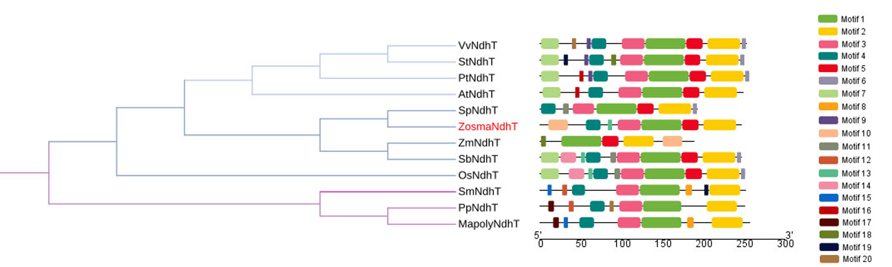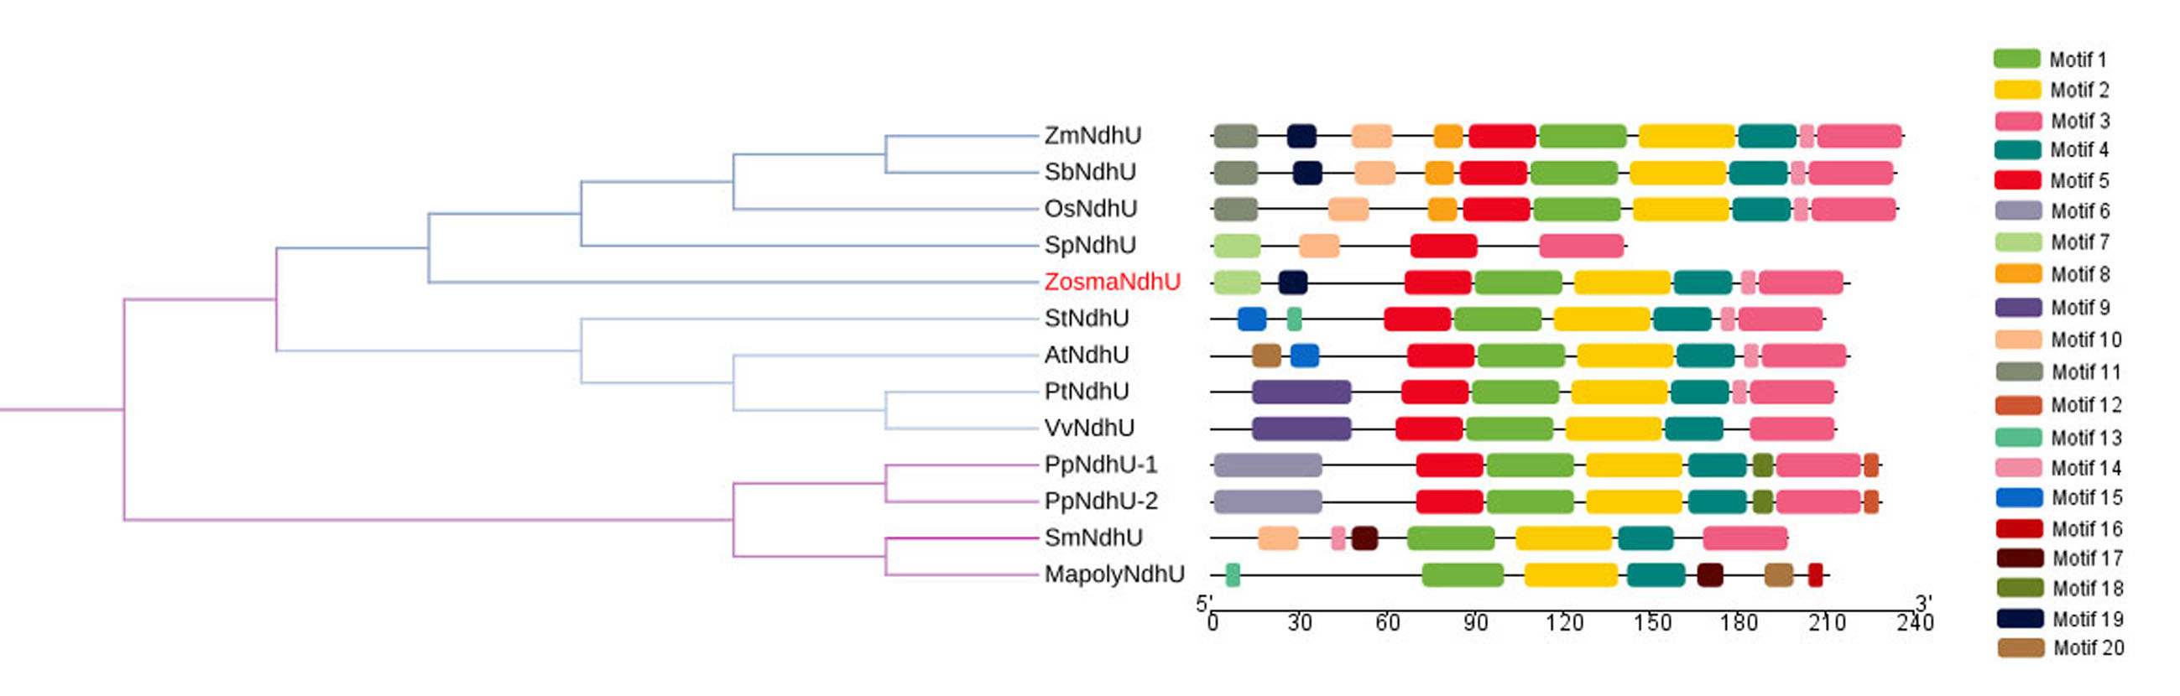
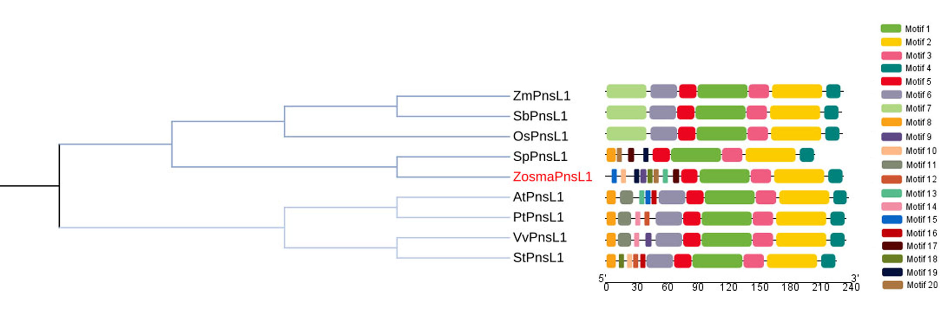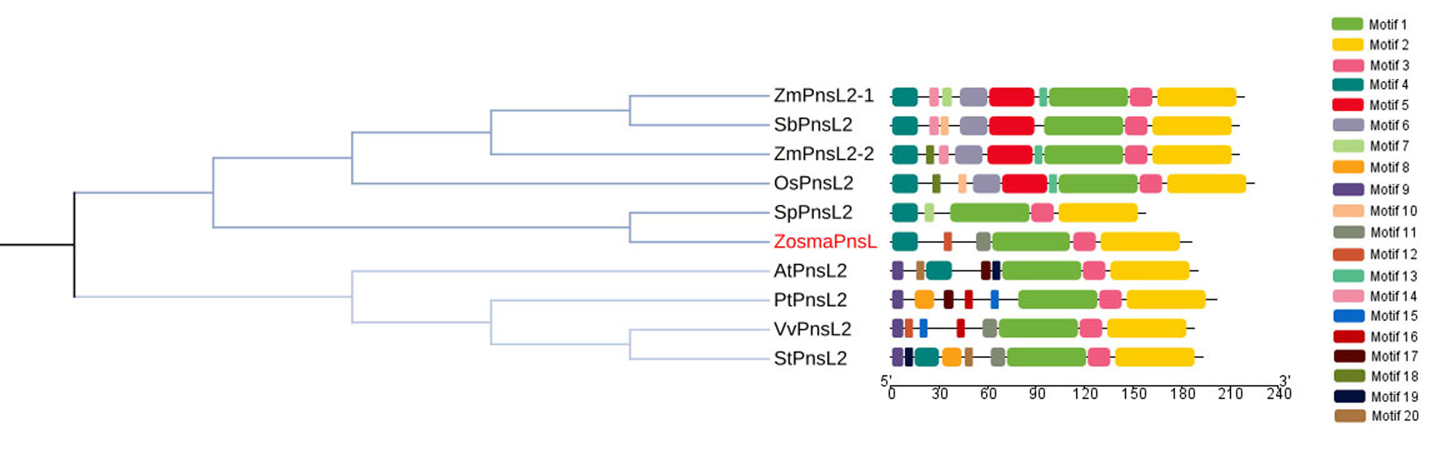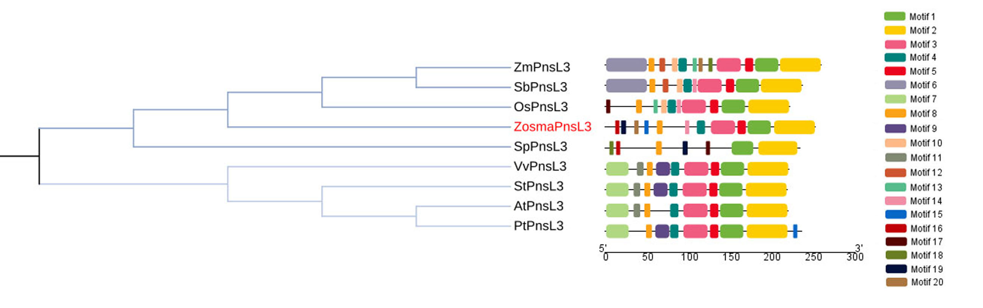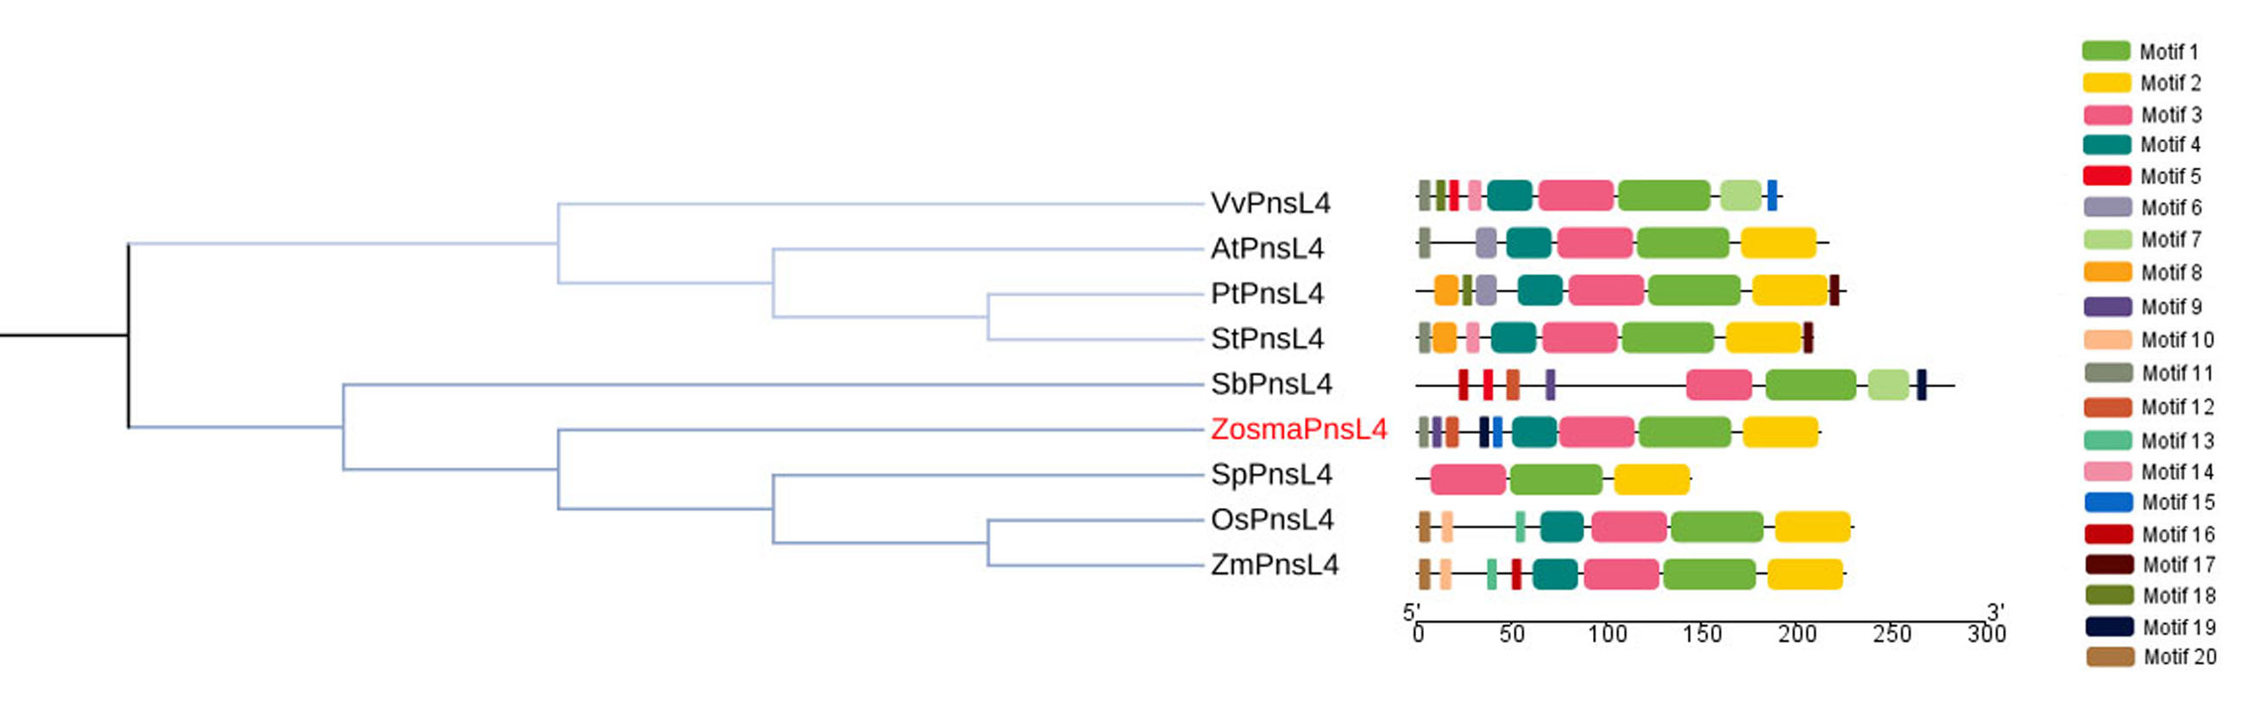
(A)
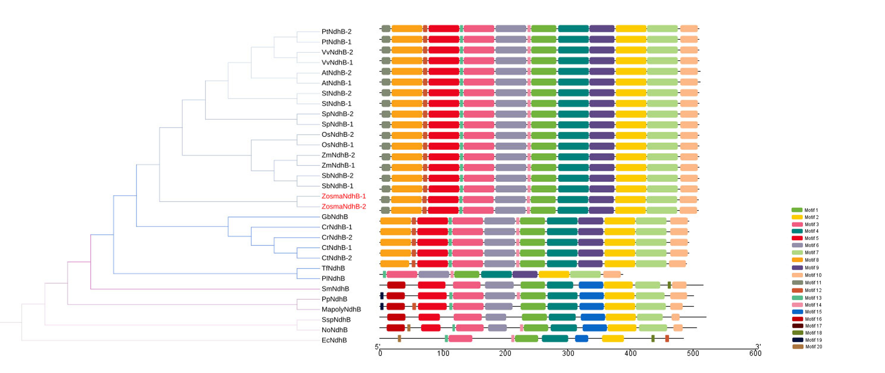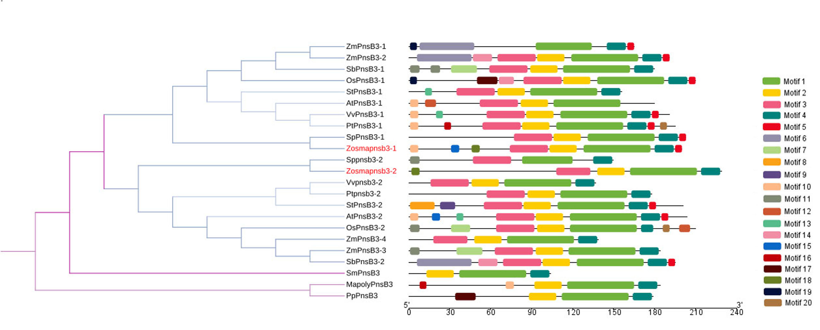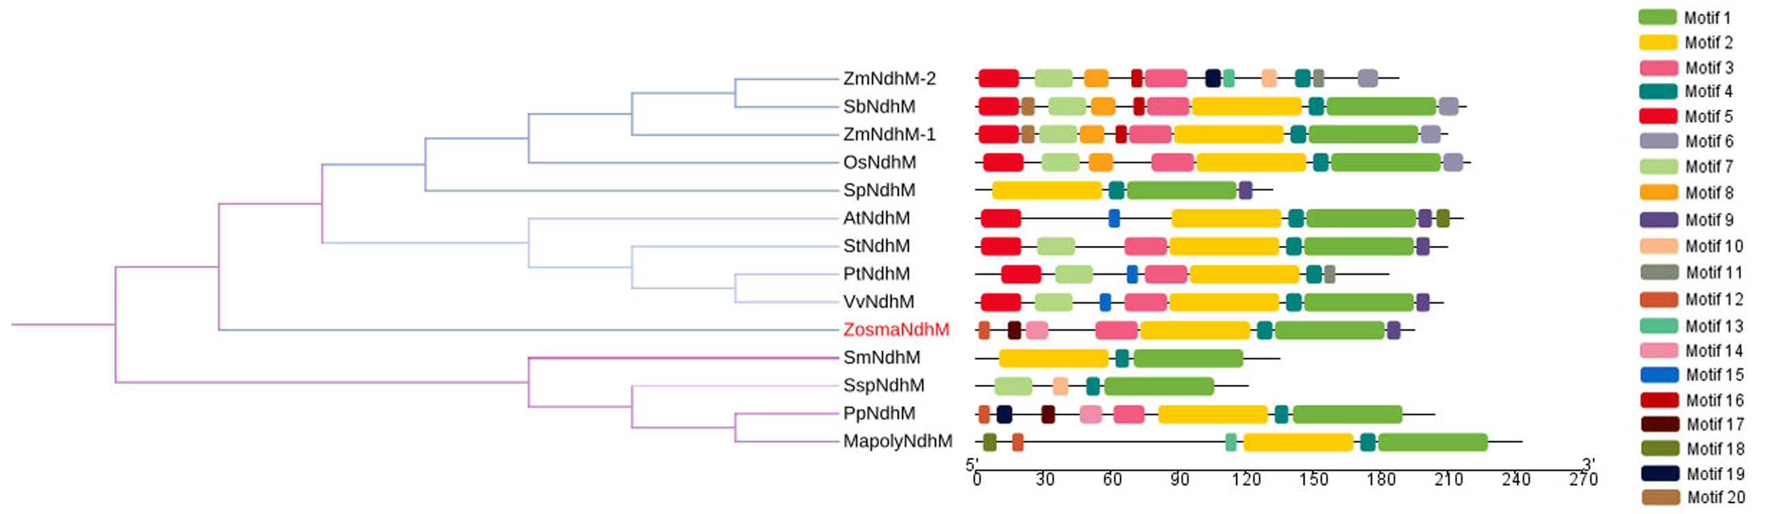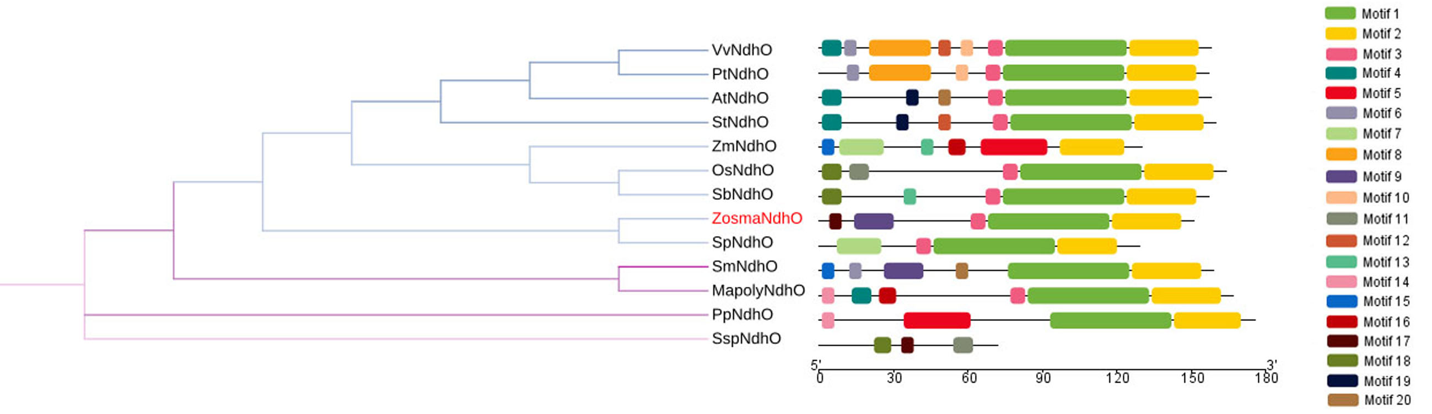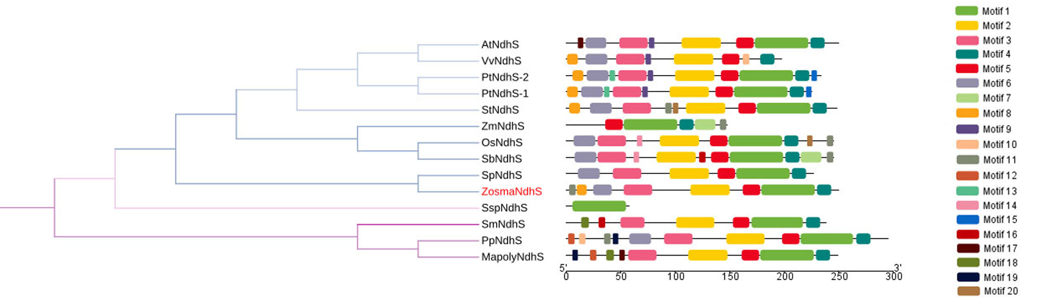
(B)

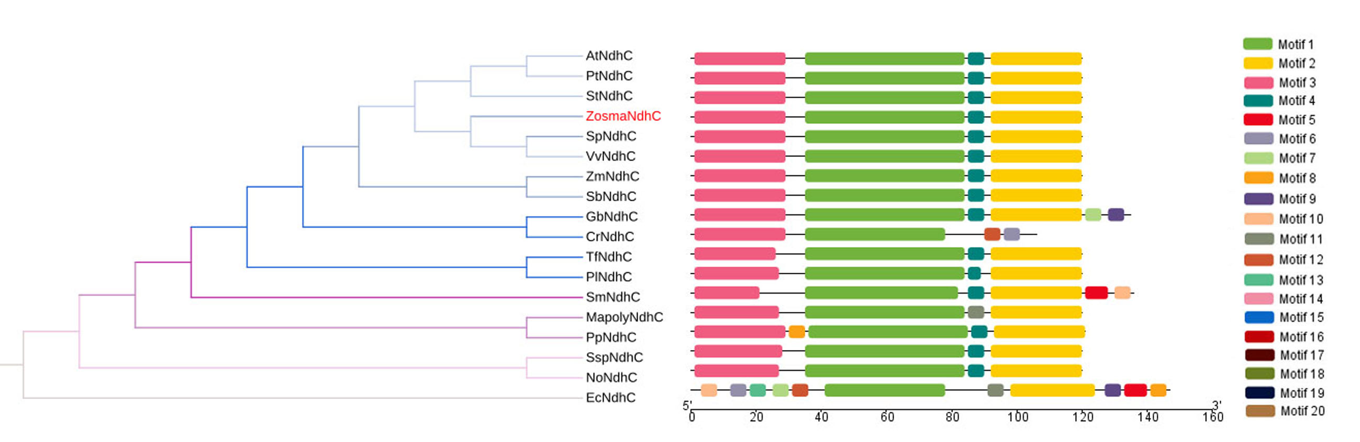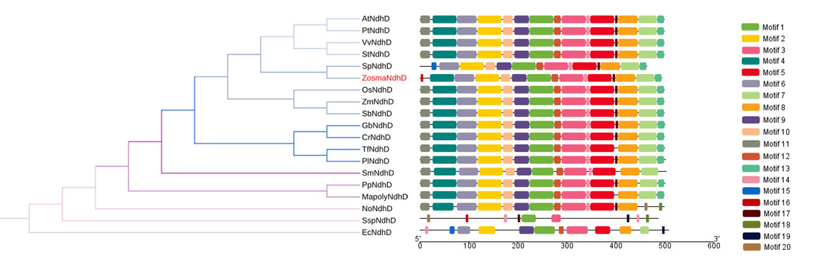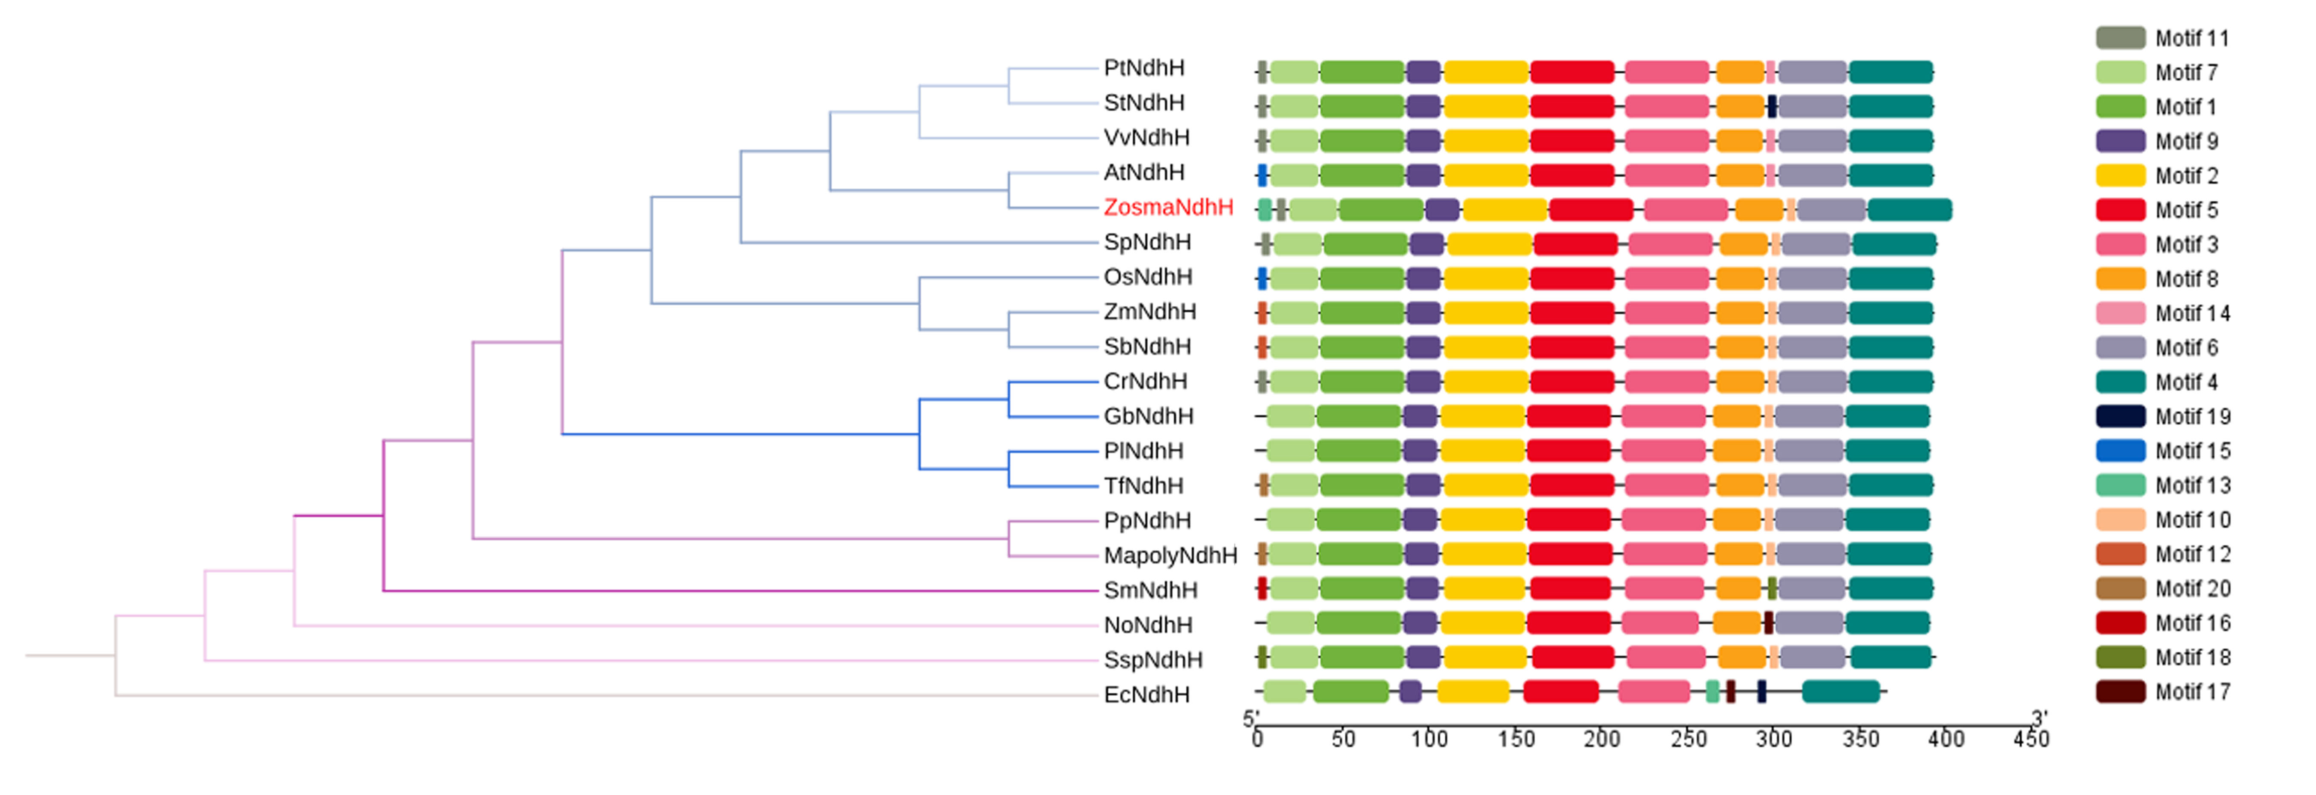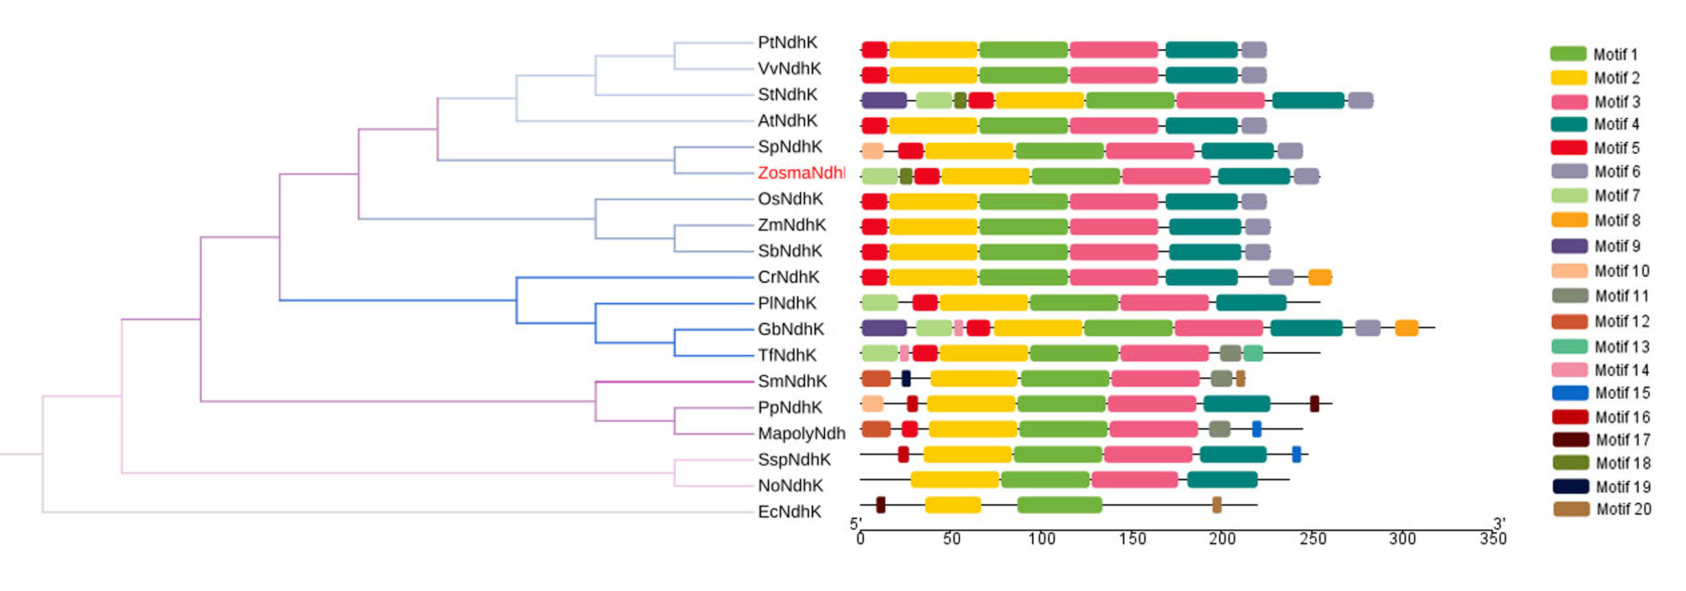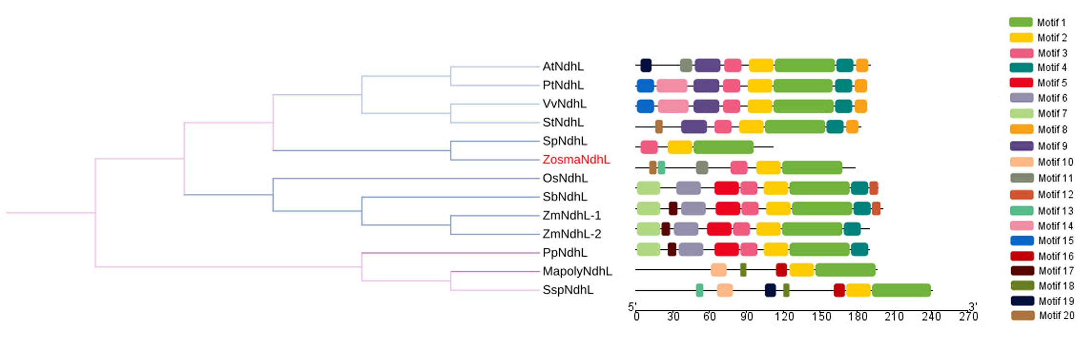
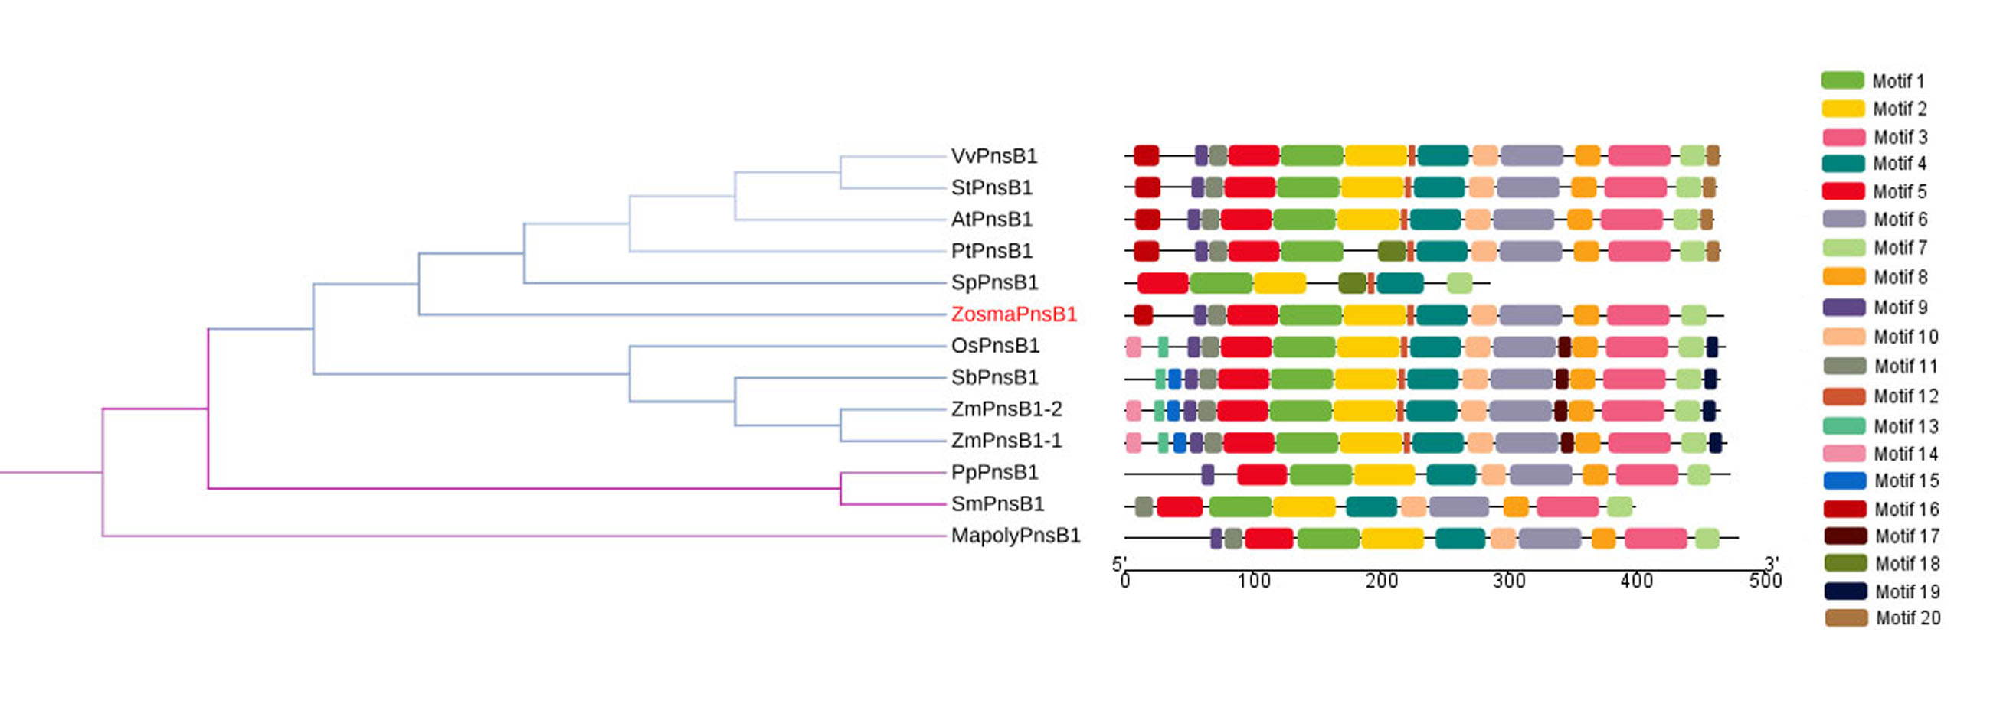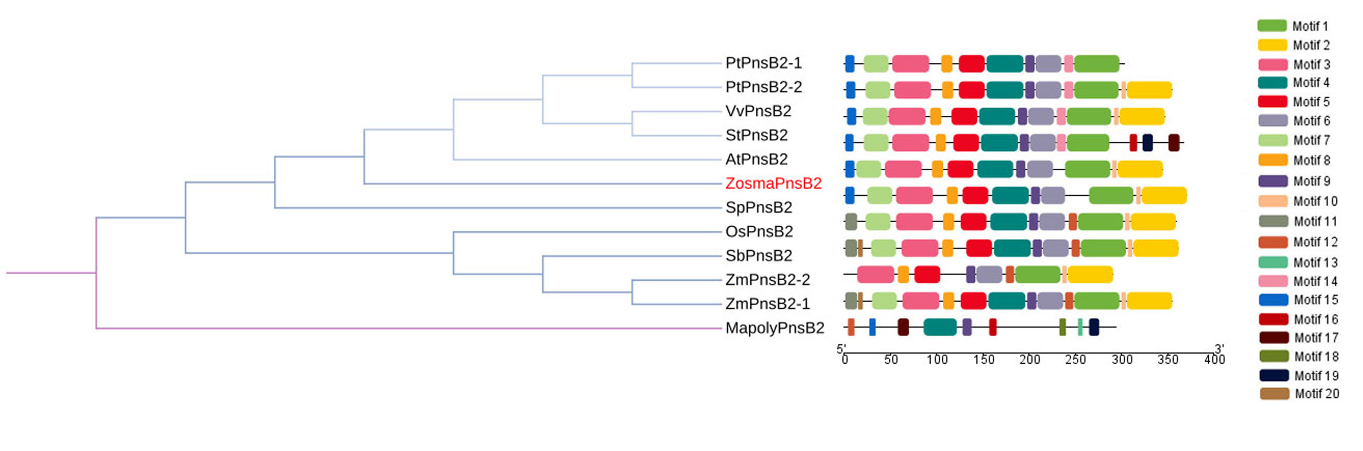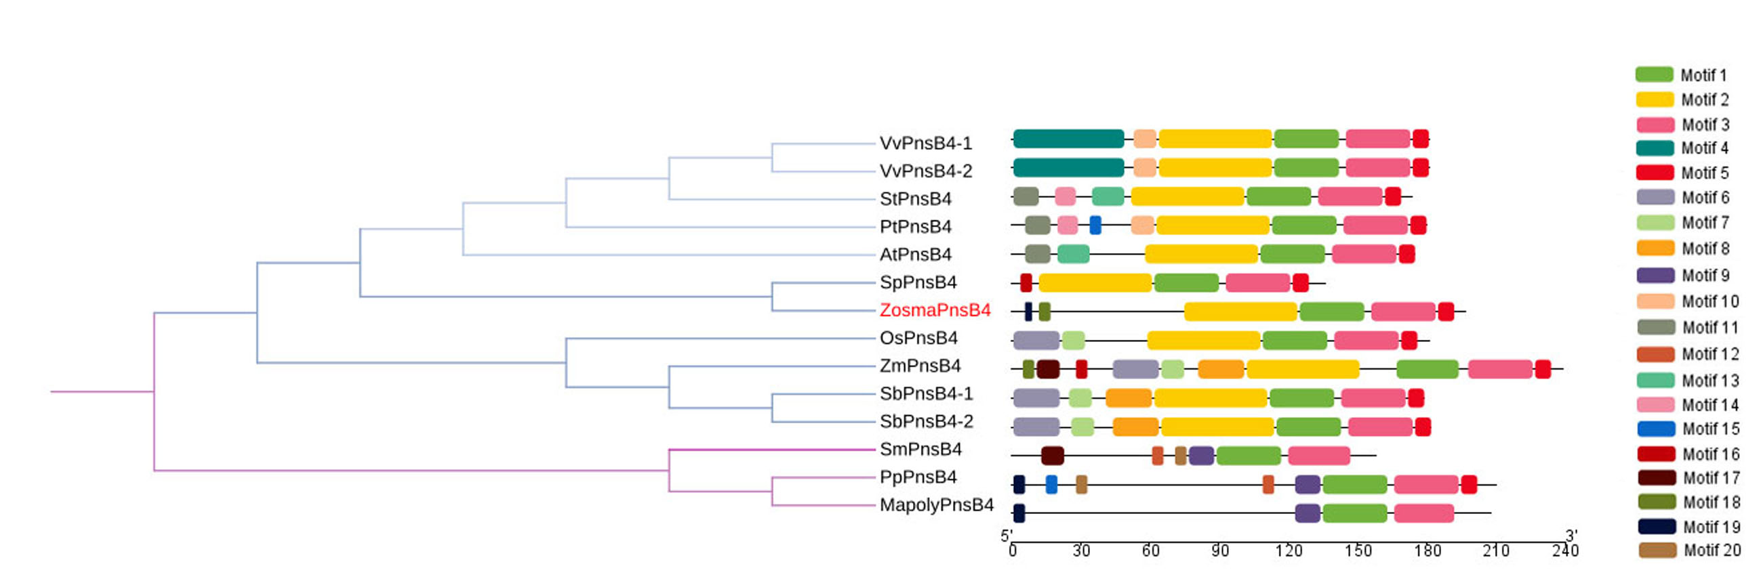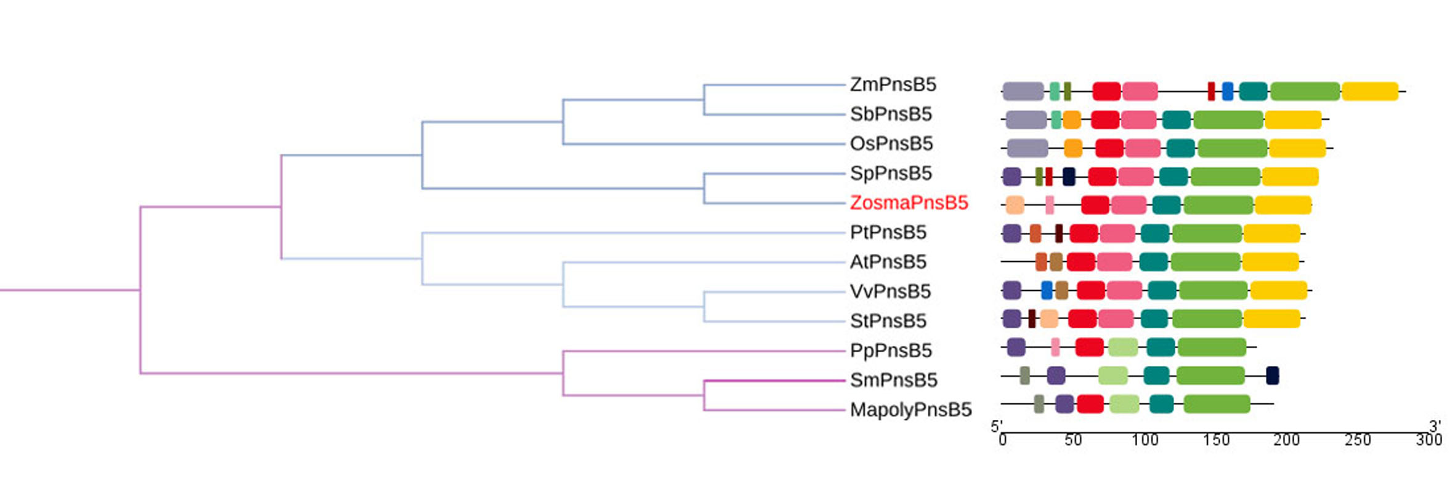
(C)

Additional file 1: Phylogenetic trees and motif compositions of individual Ndh subunits from nineteen different species. At, Arabidopsis thaliana; Cr, Cycas revoluta; Ec, Escherichia coli.; Gb, Ginkgo biloba; Mapoly, Marchantia polymorpha L.; No, Nephroselmis olivacea; Os, Oryza sativa Japonica; Pl, Podocarpus latifolius; Pp, Physcomitrella patens; Pt, Populus trichocarpa; Sb, Sorghum bicolor; Sm, Selaginella moellendorffii; Sp, Spirodela polyrhiza; Ssp, Synechocystis sp. PCC 6803; St, Solanum tuberosum; Tf, Taxus floridana; Vv, Vitis vinifera; Zm, Zea mays; Zosma, Zostera marina. Individual Ndh subunits share the evolutionary history with NADH dehydrogenase-like (NDH) complex (A). Individual Ndh subunits evolved independently (B). Individual Ndh subunits exhibit similar evolutionary history with Ndh complex (C). The phylogenetic tree was constructed using amino acid sequences of individual Ndh proteins. The motifs numbered 1-20 indicate the motif composition of Ndh proteins, the scale at the bottom can be used as a reference of protein length.

