Supplemental Materials
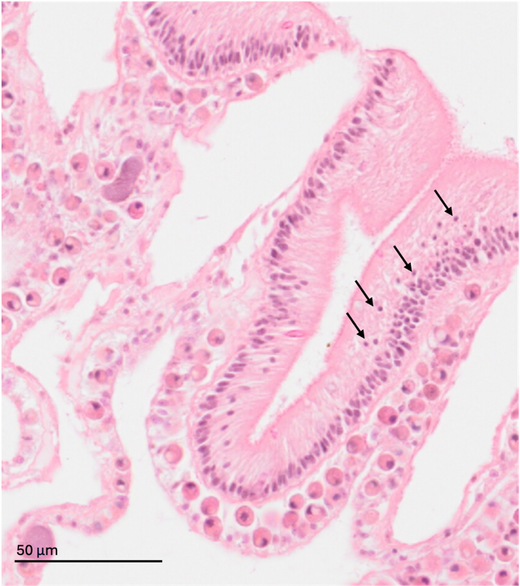
Figure S1. Example of necrotic tissue as evidenced by pyknotic nuclei. Black arrows point to pyknotic nuclei (shrinkage or condensation of a cell with increased nuclear compactness and/or density).
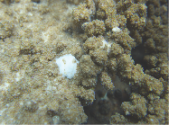
Figure S2. Non-symbiotic Growth Anomaly.
Figure S3. Acropora cover in the lagoon over time. Points is average benthic cover across six transects at each site at each time point, and lines are standard errors.

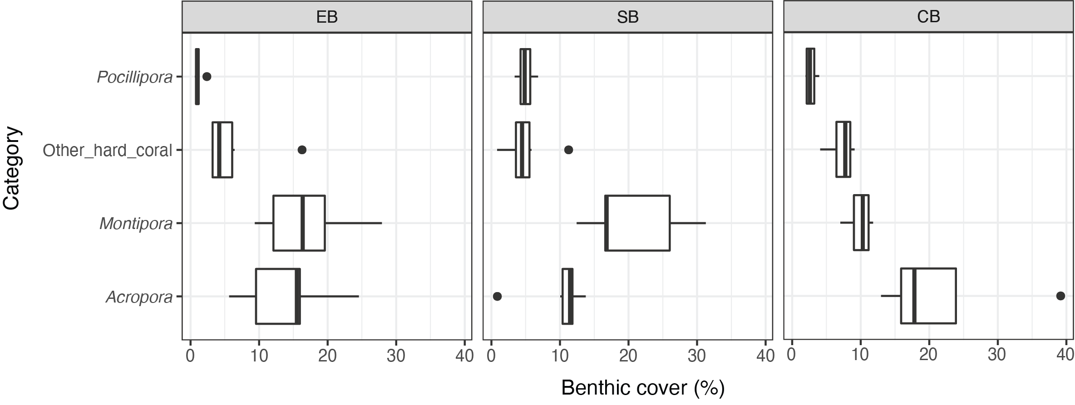
Figure S4. Hard coral cover at sites over time.
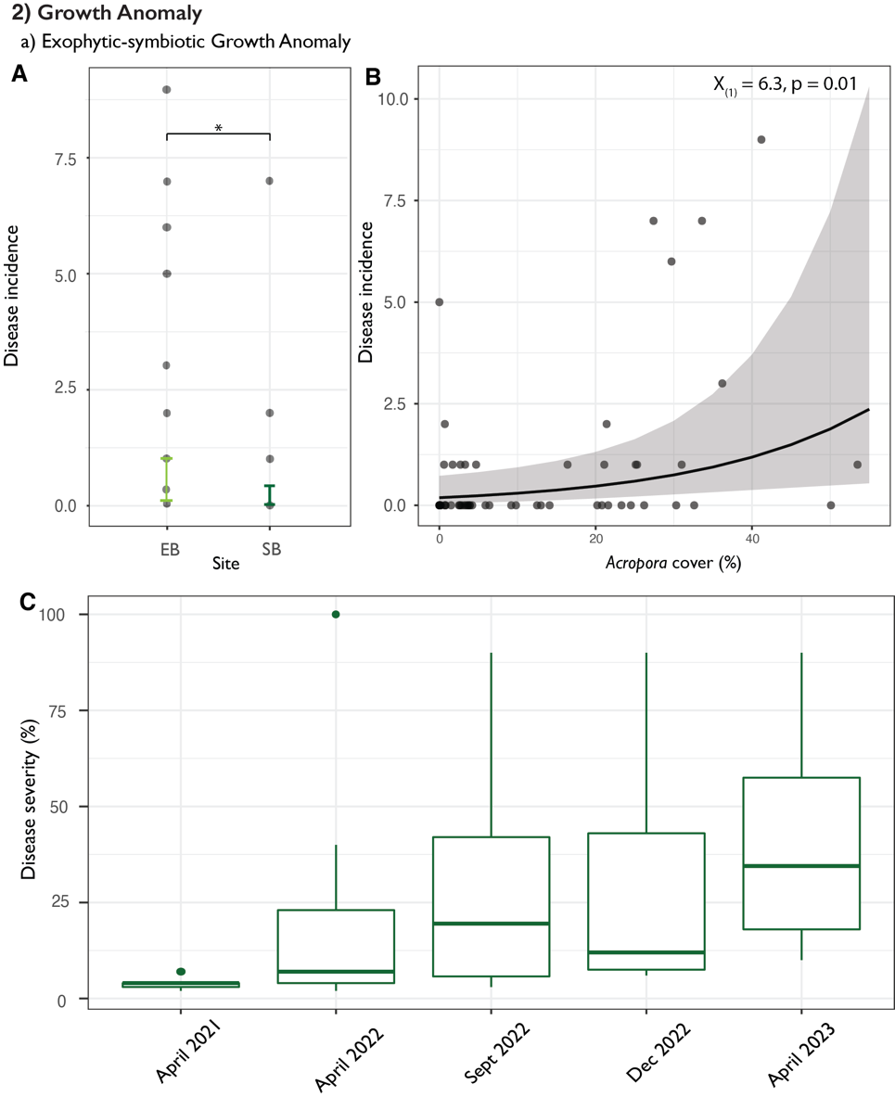
Figure S5. A. Prevalence of GAs over the monitoring period in EB and SB. B. Modelled relationship between site and disease incidence. C. Modelled relationship between Acropora cover and predicted counts of Growth Anomalies.

Table S1. Total colonies surveyed over study period in the lagoon and CB.
Time point | Lagoon (EB and SB) | CB
April 2021 | 51 | NA
April 2022 | 107 | 41
September 2022 | 119 | 44
December 2022 | 86 | 46
April 2023 | 119 | 62

Table S2. Paling prevalence glm, modelled with modelled with binomial family and counts specified as a weights argument. Pseudo R2 (delta) = 0.73
Covariate | Chisq | Df | Pr(>Chisq)
Site | 1.16 | 1 | 0.28
Month | 39.28 | 4 | < 0.001
Acropora_cover | 0.51 | 1 | 0.47
Site:Month | 3.96 | 4 | 0.41

Table S3. Acute sub-acute WS prevalence glm, modelled with binomial family and counts specified as a weights argument. Pseudo R2 (delta) = 0.84.
Covariate | Chisq | Df | Pr(>Chisq)
Site | 1.29 | 1 | 0.26
Month | 8.58 | 4 | 0.07
Acropora_cover | 0.88 | 1 | 0.35
Site:Month | 22.12 | 4 | < 0.001

Table S4. Acute sub-acute WS severity glmm, linear model transect ID specified as random effects. R2 = 0.3
Covariate | Chisq | Df | Pr(>Chisq)
Site | 1.32 | 1 | 0.25
Month | 13.84 | 4 | 0.01
Site:Month | 12.90 | 3 | < 0.01

Table S5. Paling WS with tissue loss prevalence glm, modelled with binomial family and counts specified as a weights argument. Pseudo R2 (delta) = 0.70.
Covariate | Chisq | Df | Pr(>Chisq)
Site | 2.65 | 1 | 0.10
Month | 6.54 | 4 | 0.16
Acropora_cover | 1.74 | 1 | 0.19
Site:Month | 12.97 | 4 | 0.01

Table S6. Paling WS with tissue loss log(severity) glmm, linear model transect ID specified as random effects. R2 = 0.42
Covariate | Chisq | Df | Pr(>Chisq)
Site | 0.38 | 1 | 0.54
Month | 4.52 | 4 | 0.34
Site:Month | 4.1 | 1 | 0.04

Table S7. Growth anomalies prevalence glm, modelled with negative binomial family and log(counts) specified as an offset.
Covariate | Chisq | Df | Pr(>Chisq)
Site | 4.68 | 1 | 0.03
Month | 3.09 | 4 | 0.54
Acropora_cover | 6.33 | 1 | 0.01

Table S8. Growth Anomaly log(severity) glmm, linear model transect ID specified as random effects. R2 = 0.37
Covariate | Chisq | Df | Pr(>Chisq)
Site | 1.91 | 1 | 0.16
Month | 12.14 | 4 | 0.02
Site:Month | 2.50 | 2 | 0.29

