Table S1 Sample size and distribution of the dataset
Data ID | Total number of samples | Number of Samples per Disease Group | Number of samples in the control group | Platform | Organization Type | Published Literature [PMID]
GSE4707 | 14 | 10 | 4 | GPL1708 | placenta | 16860862
GSE10588 | 43 | 17 | 26 | GPL2986 | placenta | 19249095
GSE25906 | 60 | 23 | 37 | GPL6102 | placenta | 21183218
GSE24129 | 16 | 8 | 8 | GPL6244 | placenta | 21810232
GSE30186 | 12 | 6 | 6 | GPL10558 | placenta | 22702245
GSE43942 | 12 | 5 | 7 | GPL10191 | placenta | 23544093
GSE44711 | 16 | 8 | 8 | GPL10558 | placenta | 23770704
GSE75010 | 157 | 80 | 77 | GPL6244 | placenta | 30312585
GSE114691 | 41 | 20 | 21 | GPL11154 | placenta | 31248403

Table S2 Fcell1-Dcell18 and Mcell1-Mcell8 Cell control table
Cell control table
Fetal_B_Cells | Fcell1
Fetal_CD14+__Monocytes | Fcell2
Fetal_CD8+__Cytotoxic_T_Cells | Fcell3
Fetal_Cytotrophoblasts | Fcell4
Fetal_Endothelial_Cells | Fcell5
Fetal_Fibroblasts | Fcell6
Fetal_GZMB+__Natural_Killer | Fcell7
Fetal_GZMK+__Natural Killer | Fcell8
Fetal_Hofbauer_Cells | Fcell9
Fetal_Memory_CD4+__T_Cells | Fcell10
Fetal_Mesenchymal_Stem_Cells | Fcell11
Fetal_Naive_CD4+__T_Cells | Fcell12
Fetal_Naive_CD8+__T_Cells | Fcell13
Fetal_Natural_Killer_T_Cells | Fcell14
Fetal_Nucleated_Red_Blood_Cells | Fcell15
Fetal_Plasmacytoid_Dendritic_Cells | Fcell16
Fetal_Proliferative_Cytotrophoblasts | Fcell17
Fetal_Syncytiotrophoblast | Fcell18
Maternal_B_Cells | Mcell1
Maternal_CD14+__Monocytes | Mcell2
Maternal_CD8+__Cytotoxic_T_Cells | Mcell3
Maternal_FCGR3A__Monocytes | Mcell4
Maternal_Naive_CD4+__T_Cells | Mcell5
Maternal_Naive_CD8+__T_Cells | Mcell6
Maternal_Natural_Killer_Cells | Mcell7
Maternal_Plasma_Cells | Mcell8

Table 3 F_DEGs_up_ratio_summary
Dataset_Method | Total_Genes | Up_Genes | Down_Genes | Up_Ratio
GSE10588CIBERSOFTx | 1751 | 767 | 984 | 0.438
GSE10588NNLS | 7194 | 3242 | 3951 | 0.4507
GSE114691_NNLS | 570 | 251 | 319 | 0.4404
GSE114691CIBERSOFTx | 2837 | 834 | 2003 | 0.294
GSE24129CIBERSOFTx | 2914 | 1545 | 1369 | 0.5302
GSE24129NNLS | 4516 | 2439 | 2077 | 0.5401
GSE25906_CIBERSOFTx | 359 | 172 | 186 | 0.4791
GSE25906NNLS | 977 | 507 | 469 | 0.5189
GSE30186CIBERSOFTx | 8525 | 4520 | 4005 | 0.5302
GSE30186NNLS | 755 | 331 | 424 | 0.4384
GSE43942CIBERSOFTx | 93 | 52 | 41 | 0.5591
GSE43942NNLS | 102 | 45 | 57 | 0.4412
GSE44711CIBERSOFTx | 79 | 33 | 46 | 0.4177
GSE44711NNLS | 48 | 21 | 27 | 0.4375
GSE4707_CIBERSOFTx | 4854 | 2700 | 2154 | 0.5562
GSE4707_NNLS | 1003 | 527 | 476 | 0.5254
GSE75010CIBERSOFTx | 3364 | 1935 | 1429 | 0.5752
GSE75010NNLS | 11256 | 6103 | 5153 | 0.5422

Table 4 M_DEGs_up_ratio_summary
Dataset_Method | Total_Genes | Up_Genes | Down_Genes | Up_Ratio
GSE10588CIBERSOFTx | 1001 | 509 | 492 | 0.5085
GSE114691_NNLS | 570 | 251 | 319 | 0.4404
GSE114691CIBERSOFTx | 274 | 113 | 161 | 0.4124
GSE24129CIBERSOFTx | 1830 | 1014 | 816 | 0.5541
GSE25906_CIBERSOFTx | 1475 | 758 | 717 | 0.5139
GSE25906NNLS | 1091 | 553 | 538 | 0.5069
GSE30186CIBERSOFTx | 1311 | 713 | 598 | 0.5439
GSE43942CIBERSOFTx | 20 | 12 | 8 | 0.6
GSE44711CIBERSOFTx | 19 | 4 | 15 | 0.2105
GSE4707_CIBERSOFTx | 1273 | 564 | 709 | 0.443
GSE4707_NNLS | 104 | 48 | 56 | 0.4615
GSE75010CIBERSOFTx | 1223 | 541 | 682 | 0.4424
GSE75010NNLS | 272 | 157 | 115 | 0.5772

Table 5 MF_DEGs_up_ratio_summary
Dataset_Method | Total_Genes | Up_Genes | Down_Genes | Up_Ratio
GSE10588CIBERSOFTx | 5382 | 2322 | 3060 | 0.4314
GSE114691_NNLS | 5799 | 413 | 5386 | 0.0712
GSE114691CIBERSOFTx | 10312 | 1293 | 9019 | 0.1254
GSE24129CIBERSOFTx | 4261 | 2199 | 2062 | 0.5161
GSE25906_CIBERSOFTx | 5872 | 2884 | 2988 | 0.4911
GSE25906NNLS | 4394 | 2044 | 2350 | 0.4652
GSE30186CIBERSOFTx | 4668 | 2452 | 2216 | 0.5253
GSE43942CIBERSOFTx | 127 | 57 | 70 | 0.4488
GSE44711CIBERSOFTx | 75 | 34 | 41 | 0.4533
GSE4707_CIBERSOFTx | 3198 | 1731 | 1467 | 0.5413
GSE4707_NNLS | 5449 | 3342 | 2107 | 0.6133
GSE75010CIBERSOFTx | 9241 | 5008 | 4233 | 0.5419
GSE75010NNLS | 1253 | 622 | 631 | 0.4964

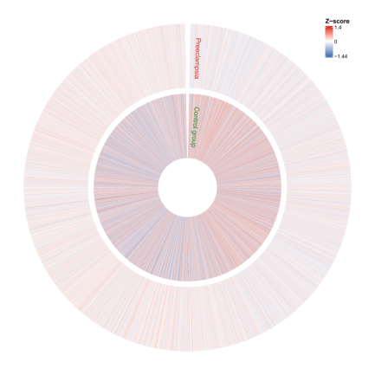Fig 1(a) GSE4707 Standardized Data Overview | 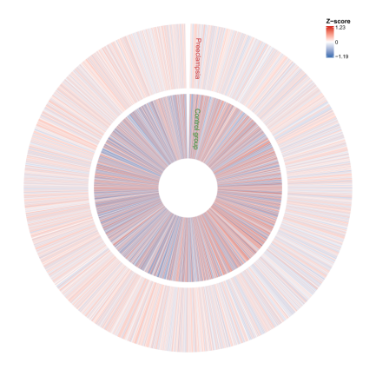Fig 1(b) GSE4707 CIBERSOFTx_Fetal_DEG | 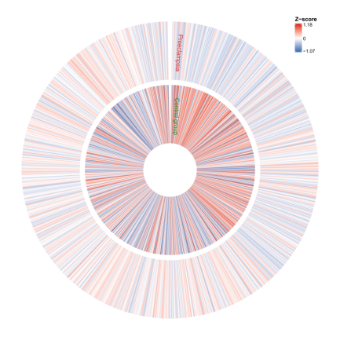Fig 1(c) GSE4707 CIBERSOFTx_Maternal_DEG
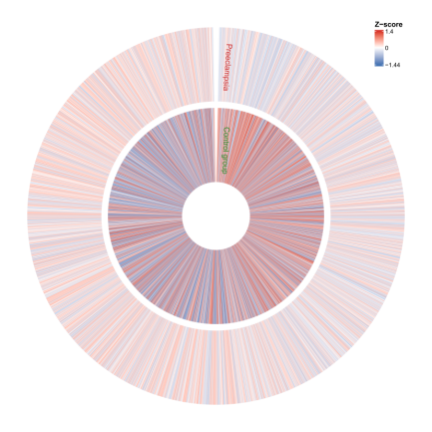  Fig 1(d) GSE4707 CIBERSOFTx_Maternal_Fetal_DEG | 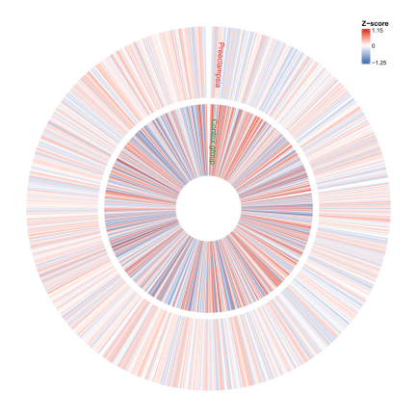  Fig 1(e) GSE4707 NNLS_Fetal_DEG | 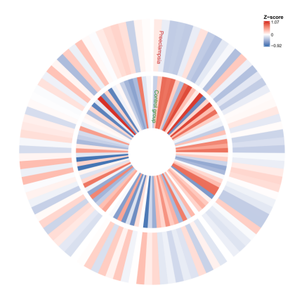  Fig 1(f) GSE4707 NNLS_Maternal_DEG
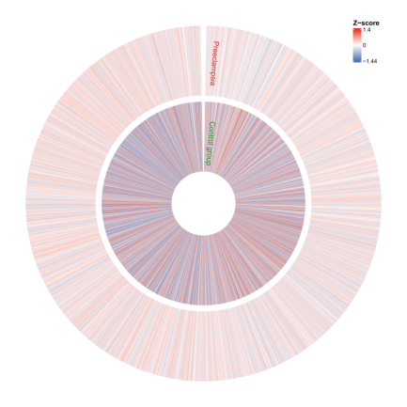  Fig 1(g) GSE4707 NNLS_Maternal_Fetal_DEG | Fig 2(a) GSE10588 Standardized Data Overview | Fig 2(b) GSE10588 CIBERSOFTx_Fetal_DEG
Fig 2(c) GSE10588 CIBERSOFTx_Maternal_DEG | Fig 2(d) GSE10588 CIBERSOFTx_Maternal_Fetal_DEG | Fig 2(e) GSE10588 NNLS_Fetal_DEG
Fig 3(a) GSE24129 Standardized Data Overview | Fig 3(b) GSE24129 CIBERSOFTx_Fetal_DEG | Fig 3(c) GSE24129 CIBERSOFTx_Maternal_DEG
Fig 3(d) GSE24129 CIBERSOFTx_Maternal_Fetal_DEG | Fig 3(d) GSE24129 NNLS_Fetal_DEG | Fig 4(a) GSE25906 Standardized Data Overview
Fig 4(b) GSE25906 CIBERSOFTx_Fetal_DEG | Fig 4(c) GSE25906 CIBERSOFTx_Maternal_DEG | Fig 4(d) GSE25906 NNLS_Fetal_DEG
Fig 4(e) GSE25906 NNLS_Maternal_DEG | Fig 5(a) GSE30186 Standardized Data Overview | Fig 5(b) GSE30186 CIBERSOFTx_Fetal_DEG
Fig 5(c) GSE30186 CIBERSOFTx_Maternal_DEG | 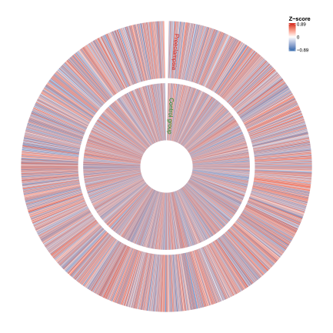Fig 5(d) GSE30186 CIBERSOFTx_Maternal_Fetal_DEG | Fig 5(e) GSE30186 NNLS_Fetal_DEG
Fig 6(a) GSE43942 Standardized Data Overview | Fig 6(b) GSE43942 CIBERSOFTx_Fetal_DEG | Fig 6(c) GSE43942 CIBERSOFTx_Maternal_DEG
Fig 6(d) GSE43942 CIBERSOFTx_Maternal_Fetal_DEG | Fig 6(e) GSE43942 NNLS_Fetal_DEG | Fig 7(a) GSE44711 Standardized Data Overview
Fig 7(b) GSE44711 CIBERSOFTx_Fetal_DEG | Fig 7(c) GSE44711 CIBERSOFTx_Maternal_DEG | Fig 7(d) GSE44711 CIBERSOFTx_Maternal_Fetal_DEG
Fig 7(e) GSE44711 NNLS_Fetal_DEG | Fig 8(a) GSE75010 Standardized Data Overview | Fig 8(b) GSE75010 CIBERSOFTx_Fetal_DEG
Fig 8(c) GSE75010 CIBERSOFTx_Maternal_DEG | Fig 8(d) GSE75010 CIBERSOFTx_Maternal_Fetal_DEG | Fig 8(e) GSE75010 NNLS_Fetal_DEG
Fig 8(f) GSE75010 NNLS_Maternal_DEG | Fig 8(g) GSE75010 NNLS_Maternal_Fetal_DEG | Fig 9(a) GSE114691 Standardized Data Overview
Fig 9(b) GSE114691 CIBERSOFTx_Fetal_DEG | Fig 9(c) GSE114691 CIBERSOFTx_Maternal_DEG | Fig 9(d) GSE114691 CIBERSOFTx_Maternal_Fetal_DEG
Fig 9(e) GSE114691 NNLS_Fetal_DEG | Fig 9(f) GSE114691 NNLS_Maternal_DEG | Fig 9(g) GSE114691 NNLS_Maternal_Fetal_DEG

