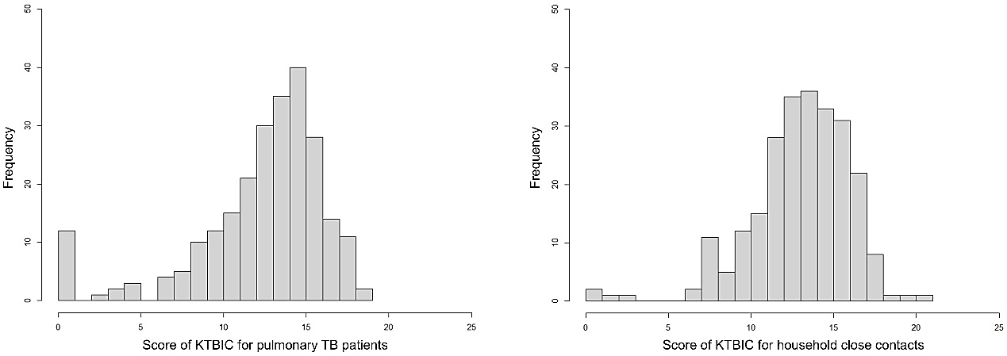
Supplementary Figure 1. Distribution of scores of KTBIC for pulmonary TB patients and household close contacts.
Abbreviations: KTBIC, knowledge of tuberculosis infection control; TB, tuberculosis.

