Supporting material
A Pre-Enrichment-Free Colorimetric Biosensor Based on Immunomagnetic Separation and G-Quadruplex DNAzyme Signal Amplification for Ultrasensitive Detection of Vibrio parahaemolyticus in Seafood

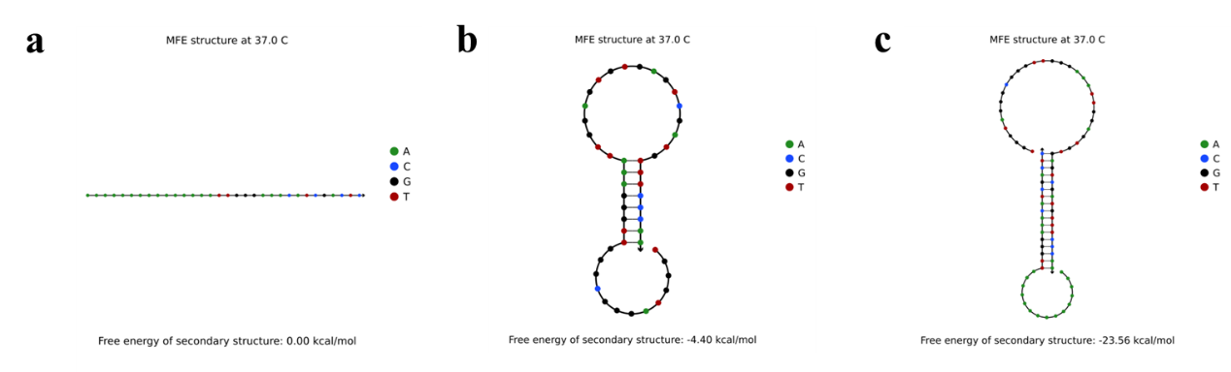

Figure S1. Structural analysis diagram.(a)ssDNA. (b) Hairpin. (c) Hybrid duplex formed by ssDNA and Hairpin.

Name | Sequence
Apt | 5'-SH-TCTAAAAATGGGCAAAGAAACAGTGACTCGTTGAGATACT-3'
ssDNA | 5'-AAAAAAAAAAAAAAATTGGGAAACATCGACTC-3'
CatG4 | 5'-TGGGTAGGGCGGGTTGGGAAA-3'
Hairpin | 5'-TGGGTAGGGCGGGTTGGGAAATTGGAGTGTGAGTCGATGTTTCCCAA-3'
Table. S1 The DNA sequences used in this work.

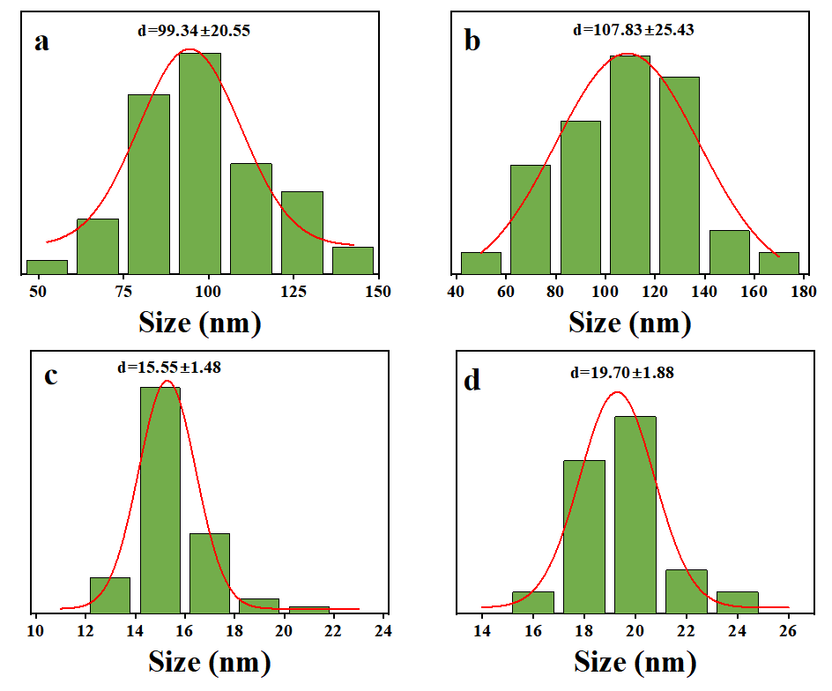
Figure S2. Particle size distribution diagram: (a) Fe@Ag; (b) Fe@Ag - apt; (c) AuNPs; (d) AuNPs - IgY.

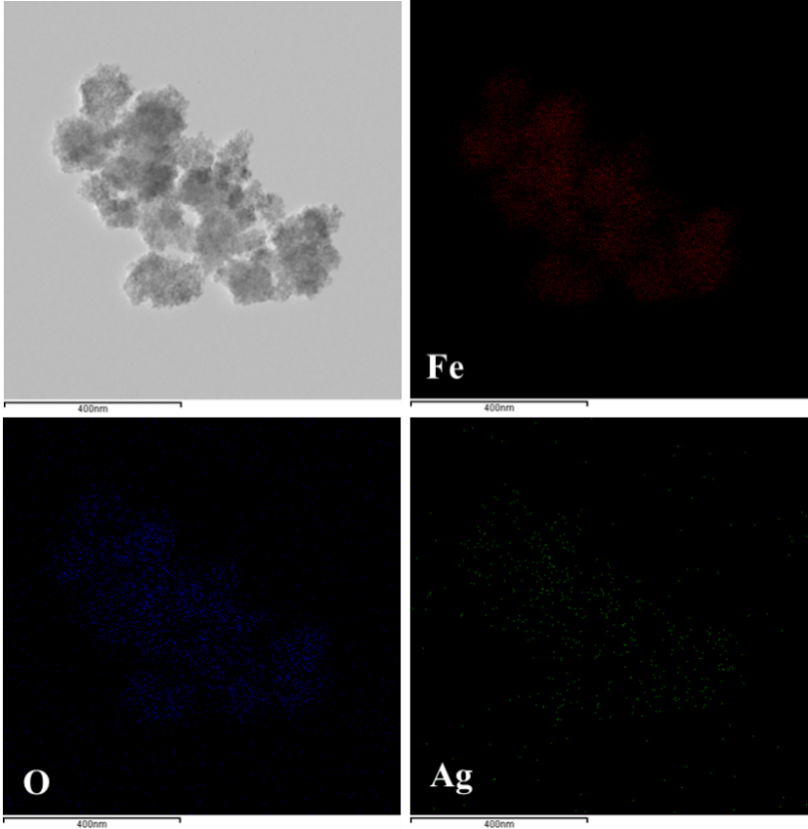
Figure S3. EDS map of element distribution of Fe₃O₄@Ag NPs.

Figure S4. Zeta potential measurements of Fe₃O₄@Ag NPs and Fe₃O₄@Ag NPs-apt.

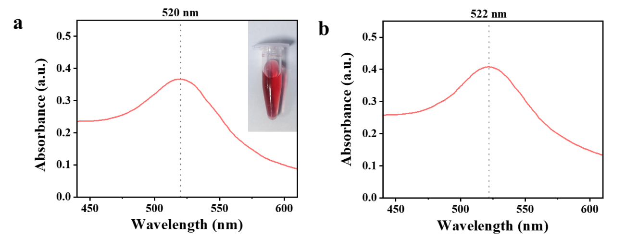
Figure S5. Characterization results of Ultraviolet absorption spectrum.(a)AuNPs. (b) AuNPs-IgY.

Figure S6. TEM image of Fe₃O₄@Ag NPs-apt, AuNPs-IgY and V. parahaemolyticus

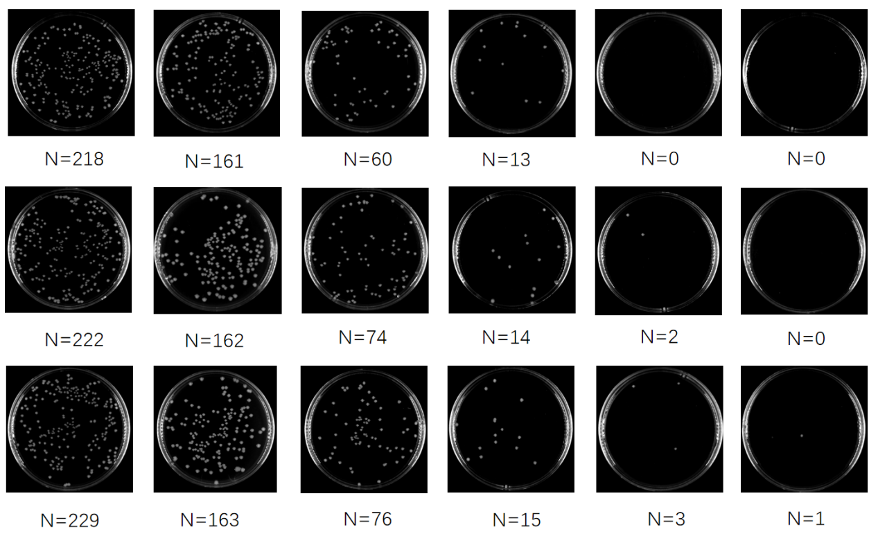
Figure S7. Photos of the plate count of V. parahemolyticus with different dosages of Fe₃O₄@Ag NPs-apt. (From left to right, they are positive control, 10 μL, 20 μL, 30 μL, 40 μL, 50 μL).

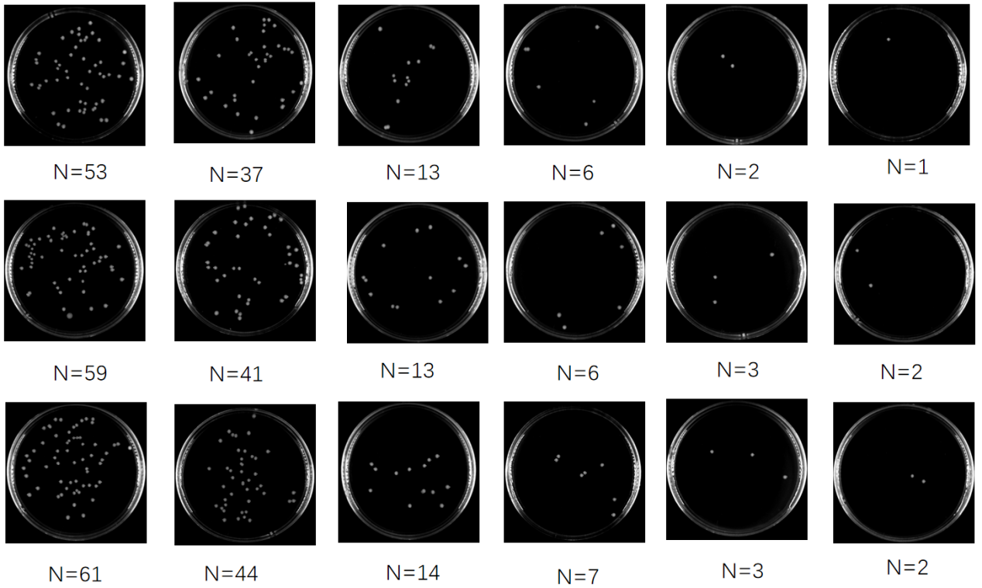
Figure S8. Photographs of the plate count of V. parahemolyticus with different enrichment time. (From left to right, they are positive control, 15 min, 30 min, 45 min, 60 min, 75 min).
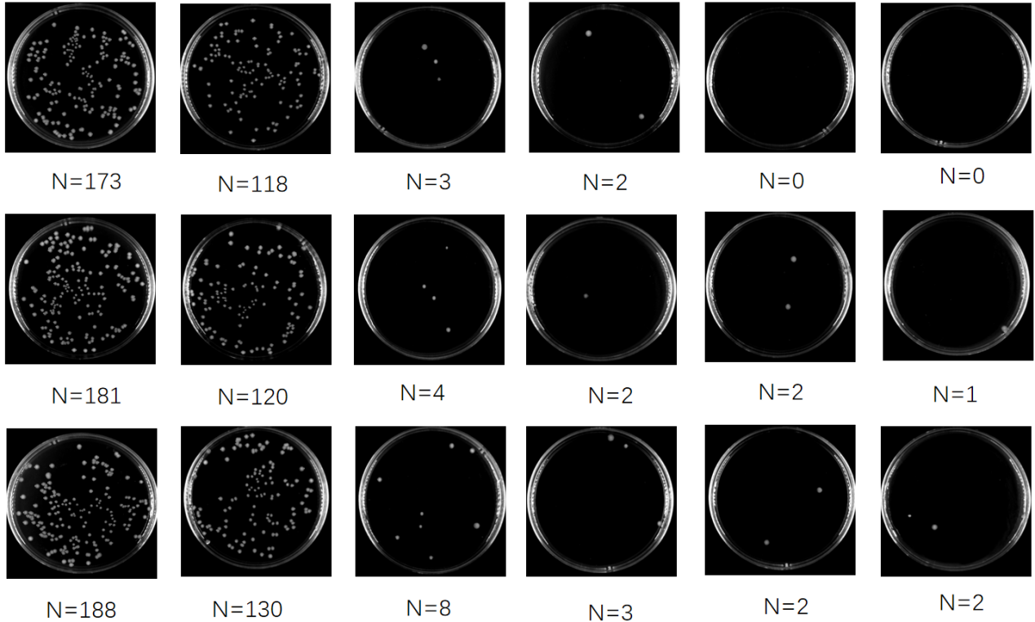
Figure S9. Photographs of the plate count of capturing different concentrations of V. parahemolyticus.(From left to right, they are positive control, 1.0×10⁸ CFU/mL、 1.0×10⁷ CFU/mL、1.0×10⁶ CFU/mL、1.0×10⁵ CFU/mL、1.0×10⁴ CFU/mL).

Figure S10. Optimization of pH for AuNPs solution.

Table S2. The comparison of the proposed method for the determination of V. parahaemolyticus with reported ones.
No. | Methods | Samples | LOD | Detection range | References
1 | Label-free colorimetric method | Shrimp | 6.1× 10² CFU/mL | - | (Chen et al., 2021)
2 | Colorimetric immunoassay | Marine | 15 CFU/mL | 20 - 10⁴ CFU/ml | (Liu et al., 2018)
3 | Multichromatic colorimetric detection method | Pure culture | 1.12 CFU/mL | 0 - 10⁴  CFU/ml | (Qiao et al., 2024)
4 | One-step label-free colorimetric strategy | Shrimp | 10³ CFU/mL | - | (Wang et al., 2023)
5 | LF-NMR/colorimetric dual-mode homogeneous immunosensor | East Sea seawater and fish | 100 CFU/mL | 10³ - 10⁸ CFU/mL | (Zhang et al., 2024)
6 | Colorimetric aptasensor | Water | 10 CFU/mL | 10 - 10⁶ CFU/mL | (Wu et al., 2015)
7 | Colorimetric-integrated PCR | Pure culture | 2.9×10⁴ CFU/mL | 2.2×10⁵ - 3.4 ×10⁵  CFU/mL | (Cheng et al., 2016)
8 | Colorimetric immunoassay | Pure culture | 10 CFU/mL | 10 - 10⁶ CFU/mL | (Fu et al., 2018)
9 | G-quadruplex-induced colorimetric method | Pure culture  /Oyster | 3.02 CFU/mL  /54.95 CFU/mL | 10 - 10⁷ CFU/mL | This study

References
Chen X, Wang L, He F, Chen G, Bai L, He K, Zhang F, Xu X (2021). Label-Free Colorimetric Method for Detection of Vibrio parahaemolyticus by Trimming the G-Quadruplex DNAzyme with CRISPR/Cas12a. Anal Chem [J], 93: 14300-14306.https://doi.org/10.1021/acs.analchem.1c03468
Liu P, Han L, Wang F, Li X, Petrenko V A, Liu A (2018b). Sensitive colorimetric immunoassay of Vibrio parahaemolyticus based on specific nonapeptide probe screening from a phage display library conjugated with MnO(2) nanosheets with peroxidase-like activity. Nanoscale [J], 10: 2825-2833.https://doi.org/10.1039/c7nr06633c
Qiao W, Wang L, Yang K, Liu Y, Liu Q, Yin F (2024). A multichromatic colorimetric detection method for Vibrio parahaemolyticus based on Fe(3)O(4)-Zn-Mn nanoenzyme and dual substrates. Microbiol Spectr [J], 12: e0318923.https://doi.org/10.1128/spectrum.03189-23
Wang P, Yu G, Wei J, Liao X, Zhang Y, Ren Y, Zhang C, Wang Y, Zhang D, Wang J, Wang Y (2023). A single thiolated-phage displayed nanobody-based biosensor for label-free detection of foodborne pathogen. J Hazard Mater [J], 443: 130157.https://doi.org/10.1016/j.jhazmat.2022.130157
Zhang D, Chen L, Lin H, Hao T, Wu Y, Xie J, Shi X, Jiang X, Guo Z (2024). Well plate-based LF-NMR/colorimetric dual-mode homogeneous immunosensor for Vibrio parahaemolyticus detection. Food Chem [J], 436: 137757.https://doi.org/10.1016/j.foodchem.2023.137757
Wu S, Wang Y, Duan N, Ma H, Wang Z (2015). Colorimetric Aptasensor Based on Enzyme for the Detection of Vibrio parahemolyticus. J Agric Food Chem [J], 63: 7849-7854.https://doi.org/10.1021/acs.jafc.5b03224
Cheng K, Pan D, Teng J, Yao L, Ye Y, Xue F, Xia F, Chen W (2016). Colorimetric Integrated PCR Protocol for Rapid Detection of Vibrio parahaemolyticus. Sensors (Basel) [J], 16.https://doi.org/10.3390/s16101600
Fu K, Zheng Y, Li J, Liu Y, Pang B, Song X, Xu K, Wang J, Zhao C (2018). Colorimetric Immunoassay for Rapid Detection of Vibrio parahemolyticus Based on Mn(2+) Mediates the Assembly of Gold Nanoparticles. J Agric Food Chem [J], 66: 9516-9521.https://doi.org/10.1021/acs.jafc.8b02494

