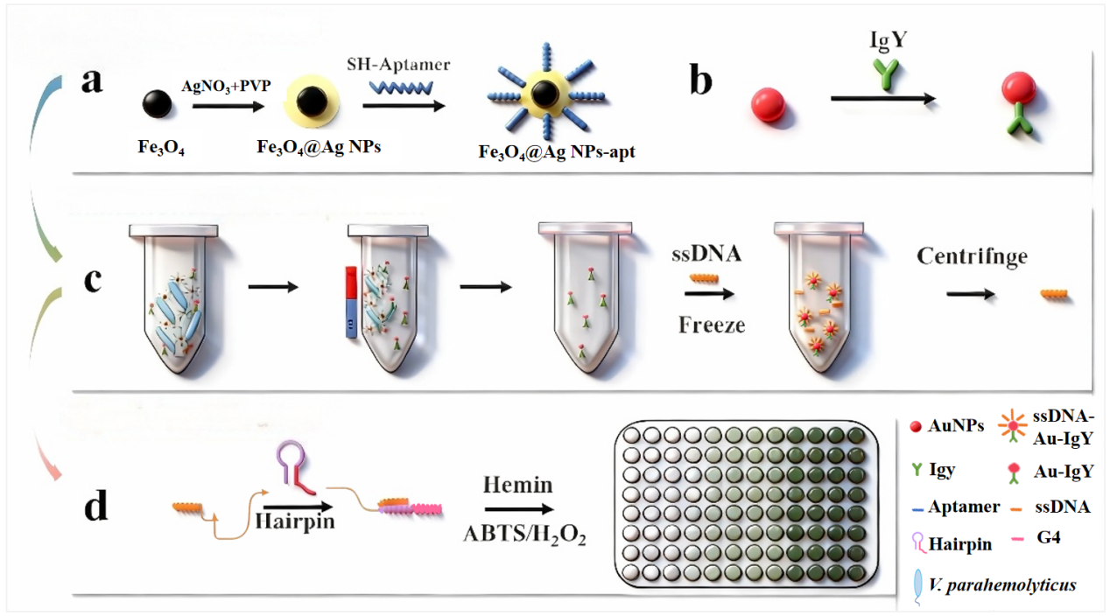
Scheme1. Schematic diagram of V. parahaemolyticus detection method in this study.

