Supplementary material

Error Analysis
Table S1 shows the converging evolution of the integral value with increasing the order of Taylor expansion. Most of the values converge within a relative error of 1‰ when the Taylor order is larger than 4. A relative error within 10⁻⁸ can reach when the Taylor order increases to 10. In order to avoid any possible errors, the 3D image (Figure 1a) of the integral function is established based on 200×200 calculation nodes, and each node is computed with a Taylor order of 20.

Table S1 The integral values of Boltzmann factor with varying Taylor order n
Taylor order n | E_{a}=2 J/mol |  | E_{a}=200 J/mol |  | E_{a}=20000 J/mol |  | E_{a}=200000 J/mol
Taylor order n | T=600 K | T=1200 K | T=600 K | T=1200 K | T=600 K | T=1200 K | T=600 K | T=1200 K
1 | 301.82115578 | 901.64929838 | 284.65221331 | 867.71805582 | 1.47187736 | 41.45574855 | 1.11339239E-17 | 6.64568260E-08
2 | 301.83262904 | 901.66613166 | 285.72844879 | 869.31399874 | 1.84315996 | 44.66857854 | 2.03501118E-17 | 9.66472837E-08
3 | 301.83160096 | 901.66487181 | 285.63545060 | 869.19891467 | 1.88712698 | 44.76038220 | 3.15684847E-17 | 1.05477139E-07
4 | 301.83170869 | 901.66499125 | 285.64482423 | 869.20938372 | 1.88871043 | 44.75981330 | 4.17892561E-17 | 1.07227989E-07
5 | 301.83169624 | 901.66497815 | 285.64378407 | 869.20828368 | 1.88857776 | 44.75969041 | 4.88644170E-17 | 1.07474026E-07
δ | 4.12482E-08 | 1.5E-08 | 3.6E-06 | 1.3E-06 | 7E-05 | 2.7E-06 | 0.144792 | 0.002289
6 | 301.83169778 | 901.66497973 | 285.64390756 | 869.20841067 | 1.88857039 | 44.75968614 | 5.27169484E-17 | 1.07498862E-07
7 | 301.83169758 | 901.66497953 | 285.64389214 | 869.20839504 | 1.88857151 | 44.75968706 | 5.44047391E-17 | 1.07500633E-07
8 | 301.83169761 | 901.66497955 | 285.64389414 | 869.20839705 | 1.88857153 | 44.75968709 | 5.50078992E-17 | 1.07500716E-07
9 | 301.83169761 | 901.66497955 | 285.64389388 | 869.20839679 | 1.88857152 | 44.75968708 | 5.51849690E-17 | 1.07500718E-07
10 | 301.83169761 | 901.66497955 | 285.64389391 | 869.20839682 | 1.88857152 | 44.75968708 | 5.52277114E-17 | 1.07500718E-07
δ | 0 | 0 | 1.05E-10 | 3.45E-11 | 0 | 0 | 0.000774 | 0
11 | 301.83169761 | 901.66497955 | 285.64389391 | 869.20839682 | 1.88857152 | 44.75968708 | 5.52361451E-17 | 1.07500718E-07
12 | 301.83169761 | 901.66497955 | 285.64389391 | 869.20839682 | 1.88857152 | 44.75968708 | 5.52374846E-17 | 1.07500718E-07
13 | 301.83169761 | 901.66497955 | 285.64389391 | 869.20839682 | 1.88857152 | 44.75968708 | 5.52376503E-17 | 1.07500718E-07
14 | 301.83169761 | 901.66497955 | 285.64389391 | 869.20839682 | 1.88857152 | 44.75968708 | 5.52376652E-17 | 1.07500718E-07
15 | 301.83169761 | 901.66497955 | 285.64389391 | 869.20839682 | 1.88857152 | 44.75968708 | 5.52376660E-17 | 1.07500718E-07
δ | 0 | 0 | 0 | 0 | 0 | 0 | 1.45E-08 | 0
16 | 301.83169761 | 901.66497955 | 285.64389391 | 869.20839682 | 1.88857152 | 44.75968708 | 5.52376660E-17 | 1.07500718E-07
17 | 301.83169761 | 901.66497955 | 285.64389391 | 869.20839682 | 1.88857152 | 44.75968708 | 5.52376660E-17 | 1.07500718E-07
18 | 301.83169761 | 901.66497955 | 285.64389391 | 869.20839682 | 1.88857152 | 44.75968708 | 5.52376660E-17 | 1.07500718E-07
19 | 301.83169761 | 901.66497955 | 285.64389391 | 869.20839682 | 1.88857152 | 44.75968708 | 5.52376660E-17 | 1.07500718E-07
20 | 301.83169761 | 901.66497955 | 285.64389391 | 869.20839682 | 1.88857152 | 44.75968708 | 5.52376660E-17 | 1.07500718E-07
δ | 0 | 0 | 0 | 0 | 0 | 0 | 0 | 0

As shown in Figures 1a, 1b, 1c and 1d, the integral values have differences in order of magnitude from each other with different temperatures and activation energies. In order to control computing error, the relative residual was defined as follows.
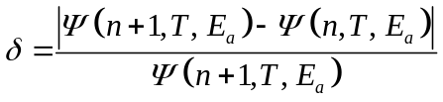 (1)
where Ψ(n, T, E_{a}) denotes the integral of Boltzmann factor with upper limit temperature of T, activation energy of E_{a}, and Taylor order of n; The relative residual δ denotes a tolerance when it is presupposed as a maximum limitation that should not be exceeded.
Figures S1a, S1b, S1c, and S1d demonstrate the minimum Taylor order required for calculating the temperature integral under error tolerances of 10⁻⁴, 10⁻⁸, 10⁻¹², and 10⁻¹⁶, respectively. According to Figures S1a and S1b, the relative residual errors in Figure 1a are no more than 10⁻⁴ under the domain of definition, and most of the values have a residual error of 10⁻⁸. The same trend is proved by these four figures that the minimum Taylor order required rises with decreasing the upper limit temperature and increasing the activation energy. These figures demonstrate the opposite trend in most series solutions previously studied[1]. Furthermore, the relationships between T, E_{a}, and Taylor order n are more complicated than monotonic and some singular points also exist in the plots. However, the maximum required Taylor order is no more than 45 under a tolerance of 10⁻¹⁶, which proves it is easier to approach convergence than the former methods.
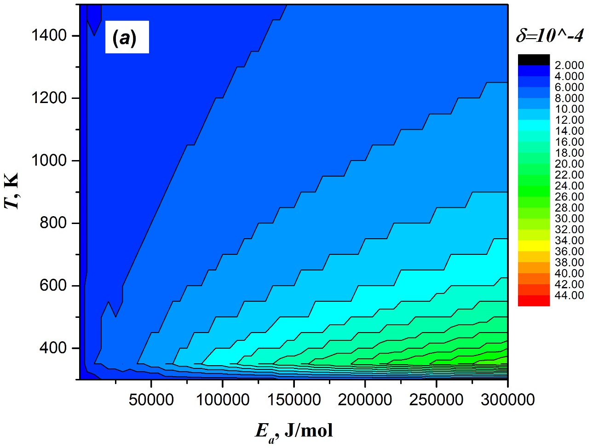
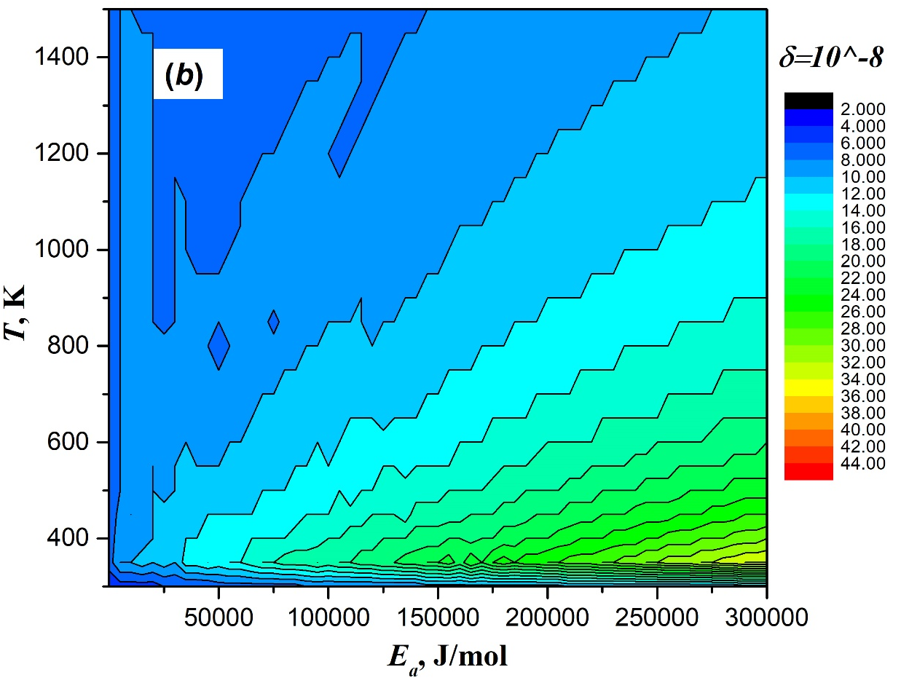
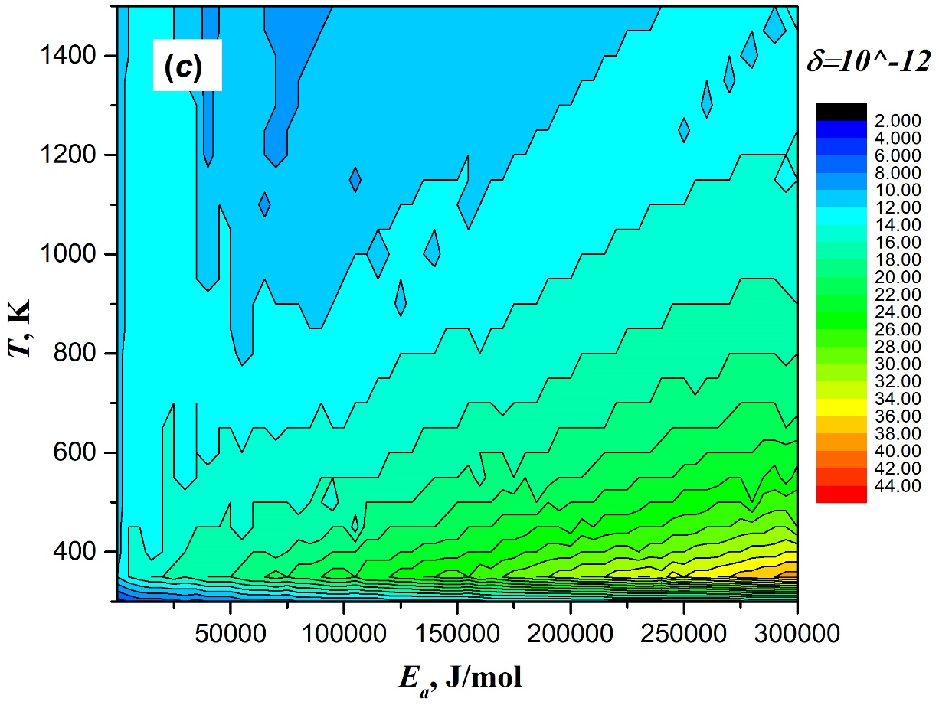
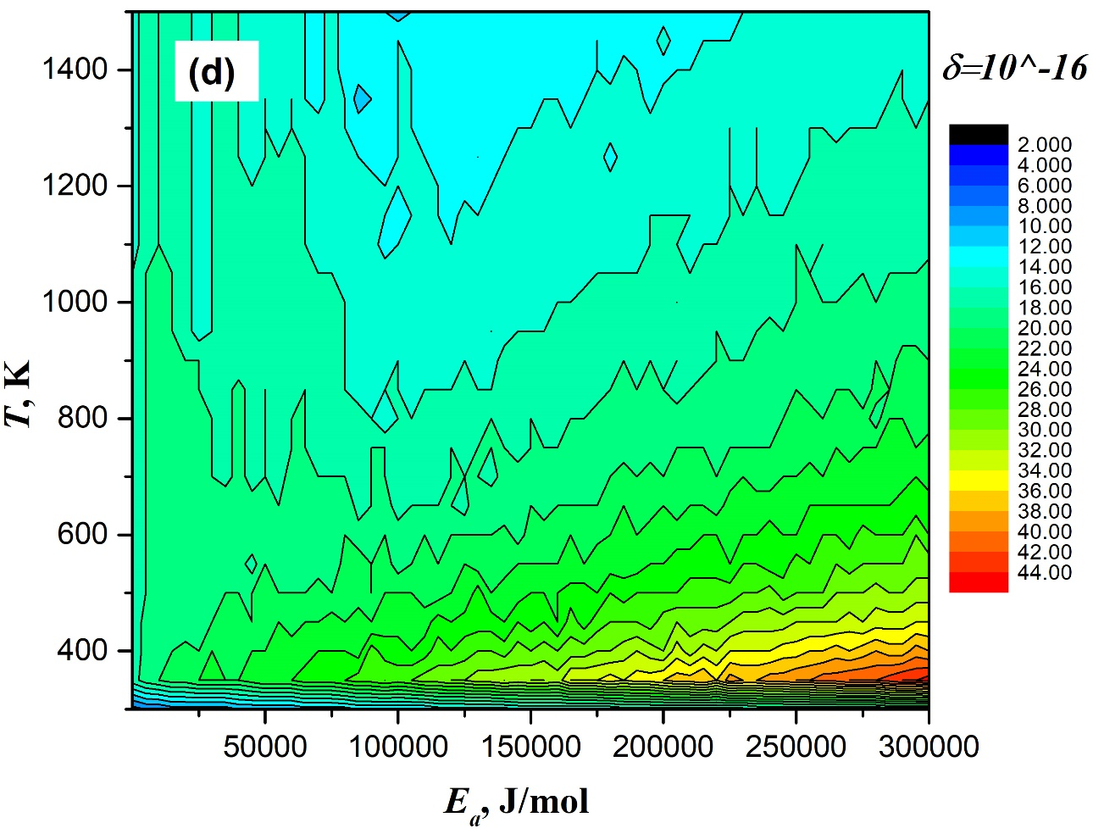
Figure S1 The minimum Taylor order required when using present method within the iterative tolerances of (a) 10⁻⁴, (b) 10⁻⁸, (c) 10⁻¹², and (d) 10⁻¹⁶
Another series solution is established to make a comparison. Using Newton-Leibniz quadrature method as an average idea to resolve it, we obtain:
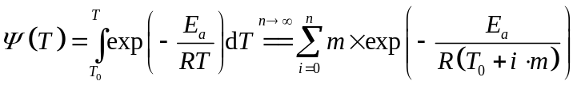 (2)
where
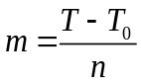 (3)
However, we find the Newton-Leibniz quadrature method was difficult to converge as shown in Table S2. Moreover, it is not realistic to adopt this method in the kinetic analysis because it always costs massive time to reach a high precision. As shown in Table S1, the results converge within 8 accurate digits after the decimal point when the Taylor order n is only larger than 15. It just takes less than a second for an ordinary computer (CPU: Intel I7) to reach such precision.
Table S3 gives the different temperature integral values calculated by different methods. Except the present solution, the other values are calculated based on a published article [2] where the original values are equivalent to Ψ/[T·exp(-E_{a}/(RT))]. It shows the approximation methods have bad agreements with present solution. Comparing Rao’s [2] results with present method, we find that the Newton-Leibniz numerical quadrature method even provides unreliable values particularly when the value of x tends to minor.

Table S2 Results of the Newton-Leibniz quadrature method
Quadr-ature node m | E_{a}=2 J/mol |  | E_{a}=200 J/mol |  | E_{a}=20000 J/mol |  | E_{a}=200000 J/mol
Quadr-ature node m | T=600 K | T=1200 K | T=600 K | T=1200 K | T=600 K | T=1200 K | T=600 K | T=1200 K
1E+02 | 304.84987233 | 910.68041913 | 288.48730649 | 877.78754503 | 1.91652897 | 45.37009283 | 6.12793756E-17 | 1.16596876E-07
1E+03 | 302.13351522 | 902.56652506 | 285.92824787 | 870.06645411 | 1.89135955 | 44.82059549 | 5.58241547E-17 | 1.08390284E-07
δ | -0.008990585 | -0.00899 | -0.00895 | -0.00887 | -0.01331 | -0.01226 | -0.09772 | -0.07571
1E+04 | 301.86187937 | 901.75513412 | 285.67232943 | 869.29420397 | 1.88885024 | 44.76577660 | 5.52961379E-17 | 1.07589474E-07
δ | -0.000899059 | -0.0009 | -0.0009 | -0.00089 | -0.00133 | -0.00122 | -0.00946 | -0.00739
1E+05 | 301.83471578 | 901.67399501 | 285.64673746 | 869.21697755 | 1.88859939 | 44.76029602 | 5.52435114E-17 | 1.07509592E-07
δ | -8.99949E-05 | -9E-05 | -9E-05 | -8.9E-05 | -0.00013 | -0.00012 | -0.00095 | -0.00074
1E+06 | 301.83199942 | 901.66588110 | 285.64417826 | 869.20925489 | 1.88857430 | 44.75974797 | 5.52382505E-17 | 1.07501606E-07
δ | -8.99949E-06 | -9E-06 | -9E-06 | -8.9E-06 | -1.3E-05 | -1.2E-05 | -9.5E-05 | -7.4E-05

Table S3 The temperature integral value calculated by the present method and the other approximation method
x (E_{a}/(RT),  T = 600 K | Present  solution(n=10) | Numerical quadrature [2] | Approximation Methods
x (E_{a}/(RT),  T = 600 K | Present  solution(n=10) | Numerical quadrature [2] | Rao [2] | Frank-Kamenetskii [3] | Coats-Redfern [4] | Gorbachev [5],  Doyle [6]
1 | 7.8106E+01 | 8.9108E+01 | 9.1425E+01 | 2.2073E+02 | -2.2073E+02 | 7.3569E+01
2 | 2.1597E+01 | 2.2517E+01 | 2.2801E+01 | 4.0601E+01 | 0.0000E+00 | 2.0300E+01
4 | 1.9093E+00 | 1.9187E+00 | 1.9275E+00 | 2.7473E+00 | 1.3737E+00 | 1.8319E+00
6 | 1.9083E-01 | 1.9096E-01 | 1.9141E-01 | 2.4792E-01 | 1.6523E-01 | 1.8591E-01
8 | 2.0481E-02 | 2.0490E-02 | 2.0510E-02 | 2.5160E-02 | 1.8870E-02 | 2.0128E-02
10 | 2.2981E-03 | 2.2982E-03 | 2.2999E-03 | 2.7240E-03 | 2.1792E-03 | 2.2699E-03
12 | 2.6575E-04 | 2.6576E-04 | 2.6587E-04 | 3.0720E-04 | 2.5599E-04 | 2.6333E-04
14 | 3.1404E-05 | 3.1402E-05 | 3.1417E-05 | 3.5638E-05 | 3.0544E-05 | 3.1182E-05
16 | 3.7724E-06 | 3.7724E-06 | 3.7731E-06 | 4.2201E-06 | 3.6927E-06 | 3.7515E-06
18 | 4.5901E-07 | 4.5900E-07 | 4.5909E-07 | 5.0771E-07 | 4.5123E-07 | 4.5690E-07
20 | 5.6429E-08 | 5.6430E-08 | 5.6443E-08 | 6.1835E-08 | 5.5651E-08 | 5.6208E-08

References
1. J.H. Flynn. The “temperature integral” - Its use and abuse. Thermochim Acta. 1997;300.
2. Rao VK, Bardon MF. Integral of the boltzmann factor-A new approximation. J Therm Anal. 1996;46:323–6.
3. D.A. Frankkamenetskii. Diffusion and heat exchange in chemical kinetics. USA; 1955.
4. Coats AW, Redfern JP. Kinetic parameters from thermogravimetric data. Nature. 1964;201:68–9.
5. V.M. Gorbachev. A solution of the exponential integral in the non-isothermal kinetics for linear heating. Therm Anal. 1975;8:349–50.
6. Doyle CD. Series approximation to the equation of thermogravimetric data. Nature. 1965;207:290–1.

