Supplementary Material
Nitrogen-metabolising microorganism analysis in rapid sand filters from drinking water treatment plant by culturing and metagenomics
Qihui Gu^{1,#}, Jun Ma^{2,#}, Jumei Zhang¹, Weipeng Guo¹, Huiqing Wu¹, Ming Sun¹, Wei Lei¹, Juan Wang³, Xianhu Wei¹, Youxiong Zhang¹ , Montong Chen¹, Liang Xue,Yu Ding^{4,}*, Qingping Wu^{1,}*
- Guangdong Provincial Key Laboratory of Microbial Safety and Health, State Key Laboratory of Applied Microbiology Southern China, Institute of Microbiology, Guangdong Academy of Sciences, Guangzhou 510070, China
2. School of Food and Biological Engineering, Shaanxi University of Science and Technology, Xi, an 710021, P.R. China
3. College of Food Science, South China Agricultural University, Guangzhou 510640, P.R. China
4. Department of Food Science & Technology, Institute of Food Safety and Nutrition, Jinan University, Huangpu Ave. 601, Guangzhou 510632, P.R. China

# These authors contributed equally.
* Corresponding author: Qingping Wu, Yu Ding
Tel./fax: 86-020-83911498
- mail address: wuqp203@163.com; dingyu @jnu.edu.cn
1.Supplementary Tables

Table.S1 Characteristics of the three SFs
 | SF1 | SF2 | SF3
Coordinate | 22.976N, 113.316E | 22.896 N,113.346 E | 22.896 N,113.345 E
HRT(min) | 9.6 | 12 | 11.5
Filter material (size; thickness) | quartz sand (0.8-0.9 mm, 1 m) | quartz sand (0.7-1.0 mm, 0.8 m) | quartz sand (0.8-1.1 mm, 1.2 m)
Backwash cycle(h) | 24 h | 36 h | 36h
Fliter area (m²) | 100 | 60 | 60
Hydraulic loading(m³/(m²·h)) | 8 | 8.3 | 7.6

Table.S2 AmoA genes sequences of AOA, AOB and comammox
Genes | Sequences
AOA | ctaatggtct ggcttagacg atgtactcac tacttgttca tagtagtggt tgcagtaaac  tctaccctgc taacaattaa cgcaggagac tacatcttct acactgactg ggcctggact  tcgtttgtaa tattctcaat atcacaatcg ttgatgttgg tagttggcgc atgctactat  ctcacattta cgggagtccc aggaacagca acgtattatg cgttgataat gaccgtctac  acatgggtag caaaaggtgc atggtttgca ctcggatacc catatgactt cattgtaaca  ccagtttggc taccgtcggc aatgttgctt gacctggcat actgggcgac aaagaagaac  aagcactcac tgattctatt cggtggtgtg atgtgtggaa tgtcattgcc gttgtttaac  atggtcaacc tcatcactgt ggctgatcca ttagagactg cattcaaata tccaagacca  acgctcgctc catatatgac accaatagaa cctgcggtag gcaagttcta taacagtcca  gtcgcattag gtgccggtgc aggtgctgta ttatcagtaa ccatggccgc gctaggatgt  aagctgaaca cgtggacata cagatggatg gccgc
AOB | tggggattct actggtggtc acactacccc atcaacttcg taacaccggg cattatgctt  ccgggtgcgc tgatgctgga cttcacgctg tatctgacac gcaactggct ggtgacggct  ctggttggag gtggattctt cggtctgctg ttctatccgg gtaactggcc gatttttgga  ccaacccatt tgccaatcgt tgtagaaggc acattgctgt cgatggctga ttacatggga  catctgtatg ttcgtacagg tacacccgag tatgttcgtc atattgagca aggttcactg  cgtacctttg gtggtcatac cacagttatt gcagcattct tctctgcgtt cgtatcaatg  ttgatgttca ccgtatggtg gtatcttgga aaagtttact gtacagcctt tttctacgtt  aaaggtaaaa gaggtcgtat cgtacatcgc aatgatgtta ccgcattcgg tgaagaaggc  tttccagagg gg
Comammox | cgagatcaatggtgctgtgaccgccgaaggtccgcagcgatcccacttcg  atcatccgaatgtactccggcgtcccggttcggacataggcaaagcccat  gtagtccgcccaggagagcaaggtcccatcgacgacgagcggcgtatggc  tatacgcgaagatggcccagttcgtcggatagaacagggcggcaaacatc  caggcgccgatcaccgccgtcagcgtccagttgcgggtcagcaacaggac  gatgtccaacaccagcgcgctgggcagcaacgtggccggcatgacgaagt  tatagggatagttcgaccaccaccaccacgcggcgacgatcgtgacccat  ttcccggcgagcagggccaaaatcgtgatcgtggcgccaaagggttgccg  atagttcacccaattgtagtactggagcgcggcacagaaggtaatggccg  taatcggcgtgacgatcggccaccactgccgatccttccagtccaaccaa  aagccccaagtcccca

Table S3. Gene information comparison of CNI, CNNf, CNNs, and ORFs of the non-redundant gene set from SF2 and SF3.
Species | SF2 |  | SF3
Species | ORF number | Covered genes | ORF number | Covered genes
CNI | 1160 | 75 | 1071 | 73
CNNs | 6075 | 1428 | 5505 | 1372
CNNf | 3405 | 1007 | 3114 | 977
Abbreviations:Candidatus Nitrospira inopinata:CNI, Candidatus Nitrospira nitrificans:CNNf,
Candidatus Nitrospira nitrosa:CNNs.

Table S4 Genomes characteristics of retrieved Nitrospira defluvii-like bins and the published Nitrospira defluvii
Characteristics | Nitrospira defluvii SF2.bin.188 | Nitrospira defluvii SF3.bin.113 | Nitrospira defluvii SF2.bin.132 | Nitrospira defluvii SF3.bin.25 | Nitrospira defluvii SF3.bin.52 | Nitrospira defluvii
Genome size (Mbp) | 7.244 | 7.596 | 4.090 | 3.914 | 1.243 | 3.11
Number of scaffold | 845 | 996 | 402 | 405 | 243 | 600
Mean length of scaffold(bp) | 8,573 | 7,626 | 10,175 | 9,663 | 5,114 | 5,180
Completeness(100%) | 81.58 | 79.12 | 92.21 | 78.23 | 29.82 | 62.63
Contamination(100%) | 73.68 | 54.39 | 39.73 | 27.19 | 7.02 | 0.91
GC content (100%) | 59.24 | 59.13 | 59.20 | 59.24 | 58.78 | 58.1

Table S5 General characteristics of MAGs recovered from SF2 metagenomes
MAG number | Classification | Completeness(%) | Contamination(%) | Length (Mb) | N50 | Number contigs | GC content (%)
bin.1 | g__Yersinia | 84.33 | 0 | 1.536474 | 54 | 196 | 47.685
bin.106 | g__Bradyrhizobium | 85.46 | 7.74 | 5.071304 | 140 | 611 | 69.428
bin.117 | g__Bradyrhizobium | 86.8 | 5.39 | 4.531574 | 139 | 562 | 69.525
bin.131 | g__Gemmata | 83.99 | 1.14 | 6.03501 | 231 | 836 | 56.77
bin.133 | s__Planctomycetes bacterium ETA_A1 | 89.01 | 0 | 6.654906 | 96 | 436 | 54.583
bin.134 | s__Planctomycetes bacterium MalM25 | 92.92 | 1.98 | 6.256907 | 189 | 749 | 66.012
bin.139 | g__Bradyrhizobium | 98.87 | 6.04 | 7.092222 | 131 | 615 | 69.318
bin.141 | g__Bradyrhizobium | 89.01 | 4.22 | 5.980654 | 80 | 428 | 66.172
bin.143 | g__Variovorax | 89.03 | 7.8 | 6.27199 | 141 | 617 | 69.946
bin.146 | g__Corallococcus | 88.1 | 5.66 | 3.147353 | 111 | 428 | 71.397
bin.147 | g__Methylobacterium | 81.62 | 2.2 | 3.158614 | 88 | 405 | 72.408
bin.148 | g__Rubrivivax| | 80.41 | 7.43 | 4.235468 | 151 | 602 | 69.764
bin.157 | g__Novosphingobium | 93 | 4.92 | 5.172163 | 118 | 507 | 64.47
bin.161 | g__Bradyrhizobium | 95.46 | 5.16 | 6.189374 | 122 | 559 | 58.952
bin.167 | g__Streptomyces | 97.84 | 2.59 | 4.066292 | 11 | 52 | 69.068
bin.17 | g__Rhizobium | 87.63 | 3.28 | 5.047224 | 187 | 691 | 56.311
bin.170 | g__Bradyrhizobium | 98.8 | 0.87 | 4.274047 | 12 | 68 | 66.16
bin.172 | g__Cupriavidus | 87.16 | 2.15 | 3.94499 | 134 | 528 | 68.614
bin.175 | g__Bradyrhizobium | 90.28 | 3.04 | 6.213036 | 142 | 700 | 67.669
bin.177 | g__Sorangium | 95.57 | 2.56 | 4.21179 | 27 | 157 | 70.173
bin.178 | g__Rhizobium | 92.74 | 7.86 | 3.949009 | 45 | 275 | 53.856
bin.181 | o__Burkholderiales | 93.89 | 2.42 | 3.718754 | 45 | 213 | 61.966
bin.19 | g__Burkholderia | 93.68 | 0.57 | 5.23091 | 44 | 217 | 66.129
bin.191 | g__Bradyrhizobium | 80.84 | 7.8 | 8.150195 | 455 | 1522 | 62.841
bin.194 | g__Burkholderia | 98.25 | 1.84 | 5.619771 | 29 | 161 | 66.833
bin.200 | g__Flavisolibacter | 99.01 | 0.54 | 4.569244 | 4 | 18 | 43.219
bin.201 | g__Pseudomonas | 95.45 | 5 | 5.923728 | 49 | 268 | 58.679
bin.202 | s__Planctomycetes bacterium ElP | 98.85 | 1.15 | 7.700091 | 27 | 168 | 63.787
bin.22 | g__Pseudomonas | 87.89 | 3.53 | 7.762518 | 99 | 500 | 52.789
bin.23 | g__Rubrivivax| | 96.03 | 8.78 | 5.112567 | 75 | 337 | 70.589
bin.36 | g__Variovorax | 92.76 | 3.74 | 5.570317 | 65 | 379 | 68.08
bin.38 | g__Pseudomonas | 89.06 | 5.68 | 4.389853 | 134 | 529 | 60.002
bin.41 | s__Planctomycetes bacterium Pla85_3_4 | 96.1 | 0 | 8.528745 | 56 | 291 | 56.407
bin.49 | g__Bradyrhizobium | 93.85 | 4.12 | 3.309814 | 67 | 318 | 68.914
bin.50 | g__Pseudomonas | 98.65 | 2.7 | 5.949148 | 33 | 155 | 63.489
bin.58 | s__Planctomycetes bacterium Pla175 | 93.36 | 1.78 | 8.739206 | 143 | 661 | 62.647
bin.62 | g__Nitrosomonas | 88.52 | 0 | 2.591121 | 24 | 101 | 42.976
bin.64 | g__Burkholderia | 90.72 | 7.69 | 4.538742 | 18 | 100 | 71.914
bin.66 | g__Pseudomonas | 89.78 | 3.53 | 4.339786 | 50 | 269 | 61.103
bin.75 | g__Variovorax | 94.63 | 6.6 | 5.435588 | 58 | 290 | 69.084
bin.78 | g__Methylobacterium | 90.22 | 5.98 | 4.644521 | 67 | 353 | 67.242
bin.8 | g__Pseudomonas | 95.73 | 4.7 | 6.86765 | 20 | 143 | 55.96
bin.80 | g__Bradyrhizobium | 93.33 | 1.45 | 5.771005 | 29 | 148 | 72.208
bin.85 | g__Immundisolibacter | 86.9 | 3.41 | 2.673171 | 74 | 316 | 69.65
bin.86 | g__Streptomyces | 93.89 | 1.49 | 8.433596 | 142 | 650 | 71.197
bin.88 | g__Anaeromyxobacter | 81.05 | 3.51 | 3.312464 | 44 | 204 | 70.053
bin.97 | g__Bradyrhizobium | 90.13 | 3.37 | 3.373391 | 26 | 132 | 68.604

Table S6 General characteristics of MAGs recovered from SF3 metagenomes
MAG number | Classification | Completeness(%) | Contamination(%) | Length (Mb) | N50 | Number contigs | GC content (%)
bin.101 | g__Burkholderia | 94.51 | 7.96 | 5.090491 | 99 | 468 | 66.187
bin.102 | g__Bradyrhizobium | 93.53 | 2.93 | 6.014791 | 86 | 465 | 66.181
bin.103 | g__Gemmata | 93.91 | 5.92 | 4.881722 | 141 | 631 | 59.897
bin.105 | g__Bradyrhizobium | 91.07 | 6.2 | 4.88021 | 78 | 451 | 67.244
bin.107 | p__Planctomycetes| | 94.04 | 4.08 | 8.430257 | 309 | 1289 | 62.687
bin.108 | g__Streptomyces | 88.18 | 9.65 | 6.118601 | 347 | 1375 | 69.123
bin.111 | g__Novosphingobium | 82.28 | 3.81 | 4.142613 | 181 | 704 | 64.665
bin.112 | g__Sorangium | 97.86 | 3.85 | 4.291619 | 29 | 172 | 70.115
bin.115 | g__Bradyrhizobium | 80.92 | 8.77 | 3.214284 | 225 | 859 | 71.272
bin.116 | g__Bradyrhizobium | 97.5 | 2.17 | 4.290234 | 12 | 68 | 66.195
bin.118 | g__Bradyrhizobium | 93.22 | 2.39 | 3.316866 | 77 | 365 | 68.973
bin.124 | g__Rhizobium | 94.73 | 5 | 6.034935 | 68 | 356 | 58.7
bin.128 | g__Bradyrhizobium | 93.26 | 2.33 | 3.299399 | 60 | 296 | 68.629
bin.130 | g__Gemmata | 97.69 | 1.98 | 8.21825 | 250 | 1151 | 71.169
bin.135 | g__Pseudomonas | 91.21 | 3.16 | 4.569518 | 52 | 357 | 61.05
bin.14 | g__Cupriavidus | 86.03 | 4.48 | 3.788466 | 239 | 890 | 68.576
bin.16 | g__Bradyrhizobium | 91.36 | 7.73 | 5.94077 | 256 | 1019 | 56.465
bin.2 | g__Bradyrhizobium | 80.59 | 8.28 | 4.721245 | 184 | 766 | 69.592
bin.26 | g__Panacibacter | 99.01 | 2.96 | 4.516864 | 3 | 17 | 43.261
bin.28 | g__Pseudomonas | 95.73 | 5.7 | 6.966152 | 20 | 160 | 56.044
bin.3 | g__Bradyrhizobium | 84.53 | 5.71 | 4.588698 | 156 | 626 | 69.554
bin.34 | g__Bradyrhizobium | 95.07 | 8.42 | 6.335851 | 169 | 779 | 58.958
bin.36 | g__Streptomyces | 96.98 | 3.02 | 4.038191 | 12 | 85 | 69.065
bin.44 | g__Burkholderia | 87.91 | 1.1 | 3.985592 | 70 | 391 | 70.855
bin.49 | g__Bradyrhizobium | 84.33 | 6.01 | 4.200281 | 43 | 190 | 71.986
bin.5 | g__Variovorax | 87.43 | 1.64 | 4.727879 | 57 | 362 | 68.196
bin.54 | g__Bradyrhizobium | 83.7 | 1.1 | 3.499944 | 138 | 657 | 72.531
bin.55 | g__Burkholderia | 93.21 | 0.97 | 5.068813 | 99 | 461 | 66.877
bin.64 | s__Planctomycetes bacterium Poly24 | 94.95 | 7.47 | 9.427467 | 107 | 629 | 56.746
bin.67 | s__Betaproteobacteria bacterium GR16-43 | 97.84 | 1.33 | 3.945772 | 48 | 247 | 61.982
bin.69 | g__Rubrivivax | 92.38 | 7.24 | 4.941193 | 58 | 291 | 70.601
bin.70 | g__Variovorax | 93.2 | 9.74 | 5.935986 | 63 | 342 | 68.972
bin.75 | g__Bradyrhizobium | 82.68 | 1.74 | 3.831755 | 78 | 440 | 63.058
bin.76 | g__Myxococcus | 84.6 | 3.74 | 3.1272 | 48 | 237 | 70.037
bin.77 | g__Cupriavidus | 86.84 | 3.91 | 5.101043 | 194 | 846 | 60.845
bin.80 | g__Bradyrhizobium | 98.99 | 3.21 | 6.227602 | 108 | 484 | 63.271
bin.81 | s__Planctomycetes bacterium ElP | 96.55 | 1.15 | 7.247835 | 41 | 228 | 63.936
bin.87 | g__Bradyrhizobium | 98.01 | 7.69 | 5.769465 | 29 | 179 | 70.17
bin.89 | g__Bradyrhizobium | 91.77 | 6.45 | 5.664978 | 87 | 441 | 72.294
bin.90 | g__Bradyrhizobium | 92.17 | 2.15 | 6.073453 | 153 | 775 | 67.859
bin.94 | s__Planctomycetes bacterium FF011L8 | 91.18 | 1.15 | 6.250174 | 218 | 864 | 54.604

- Supplementary Figures

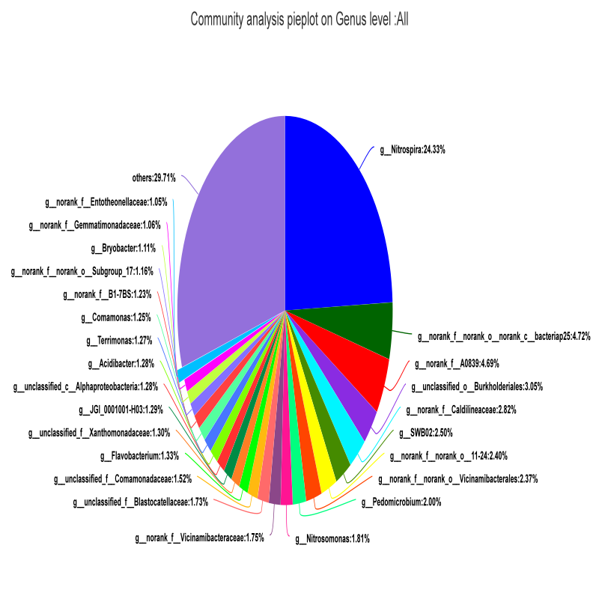Fig.S1 Relative abundances of bacterial community composition in three sand filters at the genus level

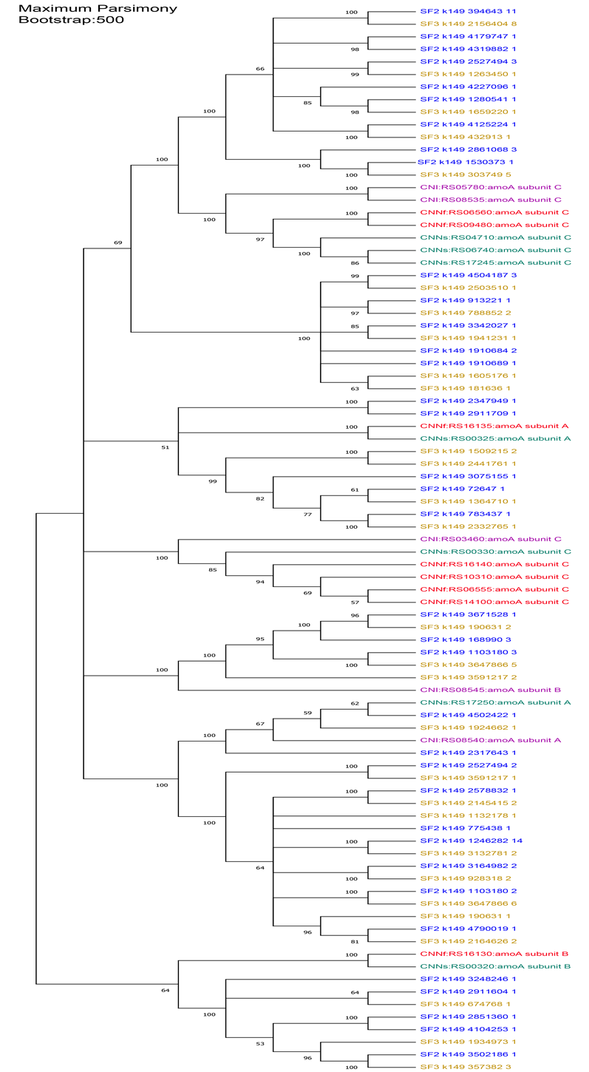
Fig.S2 Phylogenetic tree showing the affiliation of the comammox Nitrospira-like amoA, aligned amino acid sequences are used for tree construction. Cladogram of comammox related amoA sequence group, showing the ORFs of SF2 (blue) and SF3 (yellow) obtained in present study, published comammox bacteria such as Candidatus Nitrospira inopinata (CNI) (purple), Candidatus Nitrospira nitrificans (CNNf) (red) and Candidatus Nitrospira nitrosa (CNNs)(green).
Fig.S3 Nitrate nitrogen removal by different strains

Fig.S4 The neighbor-joining phylogenetic tree of 16S gene sequences was created by MEGA software 6.0

Fig.S5 Electrophoretic results of PCR amplification of napA gene obtained from DNA extracts of strain DW-5 using primers for NAP. The arrows denote amplicon fragment sizes.
Fig.S6 Nitrogen source removal by strain DW-5 inoculated in quartz sand columns under 1 mg/L ammonia-N (A) and 1 mg/L nitrate-N (B). Quartz sand columns without inoculated with strain DW-5 designed as control. The mean values from triplicate experiments and the standard errors of the means, indicated by error bars, are shown.

