Supplementary Table 1. Univariable and multivariable logistic regression for 12-month IPSS-QOL recovery.
 | Univariable OR (95% CI) | p | Multivariable OR (95% CI) | p
12-month IPSS-QOL ≤ 1 (n = 93; events = 36)
Age (per 10 years) | 0.69 (0.42–1.14) | 0.150 | — | —
Enucleated weight (per 10 g) | 1.37 (1.08–1.75) | 0.011 | — | —
MUL (per 1 mm) | 1.31 (1.10–1.55) | 0.002 | 1.24 (1.03–1.49) | 0.021
Multivariable model adjusted for age and enucleated weight (— = not entered). MUL-based model AUC 0.753 (base model 0.741). QOL recovery across MUL tertiles: 19.4%, 41.9%, and 54.8%. Postoperative urinary incontinence was assessed only at 6 months and was not available as a separate 12-month measure. MUL, membranous urethral length; QOL, quality of life; OR, odds ratio; CI, confidence interval; AUC, area under the curve.

Supplementary Figure 1. Time course of patient-reported quality-of-life outcomes after HoLEP.
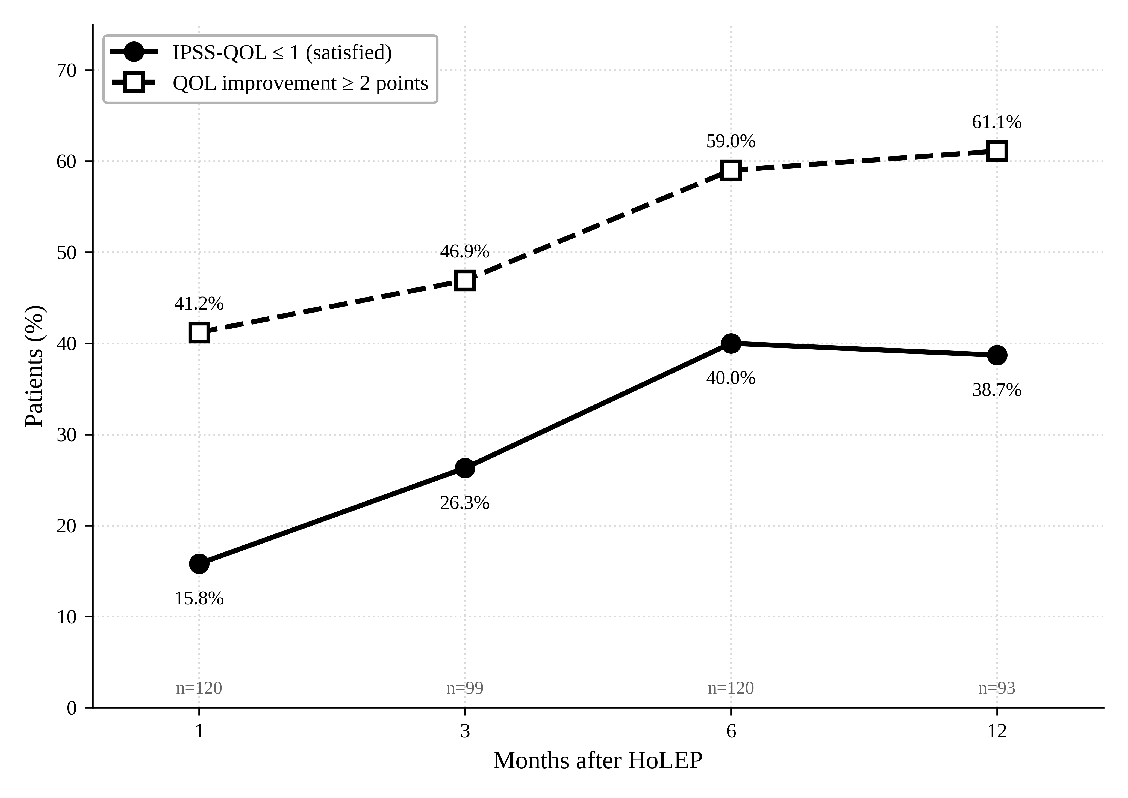
The proportion of patients reaching a satisfied state (IPSS-QOL ≤ 1) and the proportion with meaningful QOL improvement (≥ 2 points) are shown at 1, 3, 6, and 12 months. Both improved progressively, with the satisfied-state rate plateauing near 6 months and QOL improvement continuing to rise through 12 months. IPSS-QOL, International Prostate Symptom Score quality-of-life item.

