Supplementary Appendix

Table of contents:
- PRISMA checklist (e-Table1.)
- Included studies (e-Table 2.)
- Search strategies (e-Figures 1-4.)
- Study quality assessment (e-Tables 3-4.)
- Funnel Plot and Egger’s Test (e-Figures 5-6.)
- Forest plot sensitivity analysis (e-Figures 7-8.)
- Meta-regression figures (e-Figures 9-18.)
- Sensitivity analysis meta-regression table (e-Table 5.)

1. PRISMA checklist

e-Table 1. PRISMA checklist
Section/topic | # | Checklist item | Reported on page #
TITLE
Title | 1 | Identify the report as a systematic review, meta-analysis, or both. | 1
ABSTRACT
Structured summary | 2 | Provide a structured summary including, as applicable: background; objectives; data sources; study eligibility criteria, participants, and interventions; study appraisal and synthesis methods; results; limitations; conclusions and implications of key findings; systematic review registration number. | 2
INTRODUCTION
Rationale | 3 | Describe the rationale for the review in the context of what is already known. | 3
Objectives | 4 | Provide an explicit statement of questions being addressed with reference to participants, interventions, comparisons, outcomes, and study design (PICOS). | 4
METHODS
Protocol and registration | 5 | Indicate if a review protocol exists, if and where it can be accessed (e.g., Web address), and, if available, provide registration information including registration number. | 1
Eligibility criteria | 6 | Specify study characteristics (e.g., PICOS, length of follow-up) and report characteristics (e.g., years considered, language, publication status) used as criteria for eligibility, giving rationale. | 4
Information sources | 7 | Describe all information sources (e.g., databases with dates of coverage, contact with study authors to identify additional studies) in the search and date last searched. | 4
Search | 8 | Present full electronic search strategy for at least one database, including any limits used, such that it could be repeated. | E20-E23
Study selection | 9 | State the process for selecting studies (i.e., screening, eligibility, included in systematic review, and, if applicable, included in the meta-analysis). | 4
Data collection process | 10 | Describe method of data extraction from reports (e.g., piloted forms, independently, in duplicate) and any processes for obtaining and confirming data from investigators. | 4
Data items | 11 | List and define all variables for which data were sought (e.g., PICOS, funding sources) and any assumptions and simplifications made. | 5
Risk of bias in individual studies | 12 | Describe methods used for assessing risk of bias of individual studies (including specification of whether this was done at the study or outcome level), and how this information is to be used in any data synthesis. | 5
Summary measures | 13 | State the principal summary measures (e.g., risk ratio, difference in means). | 6
Synthesis of results | 14 | Describe the methods of handling data and combining results of studies, if done, including measures of consistency (e.g., I²) for each meta-analysis. | 6

Page 1 of 2
Section/topic | # | Checklist item | Reported on page #
Risk of bias across studies | 15 | Specify any assessment of risk of bias that may affect the cumulative evidence (e.g., publication bias, selective reporting within studies). | 6
Additional analyses | 16 | Describe methods of additional analyses (e.g., sensitivity or subgroup analyses, meta-regression), if done, indicating which were pre-specified. | 6
RESULTS
Study selection | 17 | Give numbers of studies screened, assessed for eligibility, and included in the review, with reasons for exclusions at each stage, ideally with a flow diagram. | 6
Study characteristics | 18 | For each study, present characteristics for which data were extracted (e.g., study size, PICOS, follow-up period) and provide the citations. | 7
Risk of bias within studies | 19 | Present data on risk of bias of each study and, if available, any outcome level assessment (see item 12). | E26-E28
Results of individual studies | 20 | For all outcomes considered (benefits or harms), present, for each study: (a) simple summary data for each intervention group (b) effect estimates and confidence intervals, ideally with a forest plot. | 7-8 Figure 2
Synthesis of results | 21 | Present results of each meta-analysis done, including confidence intervals and measures of consistency. | 7-8 Figure 2
Risk of bias across studies | 22 | Present results of any assessment of risk of bias across studies (see Item 15). | E30-E31
Additional analysis | 23 | Give results of additional analyses, if done (e.g., sensitivity or subgroup analyses, meta-regression [see Item 16]). | 8
DISCUSSION
Summary of evidence | 24 | Summarize the main findings including the strength of evidence for each main outcome; consider their relevance to key groups (e.g., healthcare providers, users, and policy makers). | 9
Limitations | 25 | Discuss limitations at study and outcome level (e.g., risk of bias), and at review-level (e.g., incomplete retrieval of identified research, reporting bias). | 11
Conclusions | 26 | Provide a general interpretation of the results in the context of other evidence, and implications for future research. | 12
FUNDING
Funding | 27 | Describe sources of funding for the systematic review and other support (e.g., supply of data); role of funders for the systematic review. | -

From: Moher D, Liberati A, Tetzlaff J, Altman DG, The PRISMA Group (2009). Preferred Reporting Items for Systematic Reviews and Meta-Analyses: The PRISMA Statement. PLoS Med 6(6): e1000097. doi:10.1371/journal.pmed1000097
For more information, visit: www.prisma-statement.org.
Page 2 of 2

2. Included studies table

e-Table 2. Included Studies
Author-Year | Journal | Title | Type | Study Duration | Patients | Country | Definition | Time of Data Collection | Mortality Reported | Variables Reported | Mortality (%)
Osman D et. al 2009 | Intensive Care Medicine | Incidence and prognostic value of right ventricular failure in acute respiratory distress syndrome | RCT | Jan-99 to Jun-01 | 145 | France | AECC | Baseline | 90 Day | TV  PEEP  Pplat | 98 (68)
Liao KM et. al 2009 | Journal of The Formosan Medical Association | Timing of Acute Respiratory Distress Syndrome Onset is Related to Patient Outcome | Observational | Dec-04 to May-06 | 172 | Taiwan | AECC | Baseline | Hospital |  | 121 (70)
Murphy CV et. al 2009 | Chest | The importance of fluid management in acute lung injury secondary to septic shock. | Observational | 1/2005 and 3/2004 to 12/2006 and 4/2007 | 212 | USA | AECC | Baseline | Hospital | TV  PEEP | 87 (41)
Taccone P et. al 2009 | JAMA | Prone Positioning in Patients With Moderate and Severe Acute Respiratory Distress Syndrome | RCT | Feb-04 to Jun-08 | 174 | Italy and Spain | AECC | Day 1 | ICU | TV  PEEP | 73 (42)
Raurich JM et. al 2010 | Respiratory Care | Prognostic Value of the Pulmonary Dead-Space Fraction During the Early and Intermediate Phases of Acute Respiratory Distress Syndrome | Observational | Oct-05 to May-08 | 80 | Spain | AECC | Within 1.5 days | Hospital | TV  PEEP  Pplat | 35 (44)
Mekontso Dessap A et. al 2010 | Critical Care Medicine | Prevalence and prognosis of shunting across patent foramen ovale during acute respiratory distress syndrome. | Observational | Jun-04 to May-09 | 203 | France | AECC | AT the time of TEE | Hospital | TV  PEEP  Pplat | 104 (51.2)
Guervilly C et. al 2011 | Critical Care | High levels of circulating leukocyte microparticles are associated with better outcome in acute respiratory distress syndrome | Observational | ? | 52 | France | AECC | Baseline | 28 Day | PEEP  Pplat | 21 (40.3)
Herasevich V et. al 2011 | Critical Care Medicine | Limiting ventilator-induced lung injury through individual electronic medical record surveillance | Observational | Feb-08 to Feb-09 | 490 | USA | AECC | Baseline and after alert implementation | Hospital | TV  Pplat | 194 (39.6)
Riscili BP et. al 2011 | PLoS One | An Assessment of H1N1 Influenza-Associated Acute Respiratory Distress Syndrome Severity after Adjustment for Treatment Characteristics | Observational | Oct-09 to Dec-09 | 60 | USA | AECC | Average over 6 days | Hospital |  | 23 (37.5)
Craig TR et. al 2011 | American Journal of Respiratory and Critical Care Medicine | A Randomized Clinical Trial of Hydroxymethylglutaryl–Coenzyme A Reductase Inhibition for Acute Lung Injury (The HARP Study) | RCT | Sep-06 to Mar-09 | 60 | Ireland | AECC | Baseline/Day 0 | Hospital | TV  Pplat | 22 (37)
NHLBI Matthay MA et. al 2011 | American Journal of Respiratory and Critical Care Medicine | Randomized, Placebo-controlled Clinical Trial of an Aerosolized b2-Agonist for Treatment of Acute Lung Injury | RCT | Aug-07 to Jul-08 | 282 | Multiinstitutional | AECC | Baseline/Day 0, also available are Day 2, and 4 | Hospital | TV  PEEP  Pplat | 58 (20.5)
Brun-Buisson C et. al 2011 | American Journal of Respiratory and Critical Care Medicine | Early Corticosteroids in Severe Influenza A/H1N1 Pneumonia and Acute Respiratory Distress Syndrome | Observational | Nov-09 to Mar-10 | 208 | France | AECC | Subject characteristics | Hospital |  | 49 (23.5)
Stapleton RD et. al 2011 | Critical Care Medicine | A phase II randomized placebo-controlled trial of omega-3 fatty acids for the treatment of acute lung injury | RCT | 2006 to 2008 | 90 | North American Centers | AECC | Baseline/Day 0, also available Day 4, and 8 | Hospital | TV  PEEP  Pplat | 19 (21.1)
Rice TW NHLBI et. al 2011 | JAMA | Enteral Omega-3 Fatty Acid, γ-Linolenic Acid, and Antioxidant Supplementation in Acute Lung Injury | RCT | Jan-08 to Feb-09 | 272 | Multiinstitutional | AECC | Baseline/Day 0 | 60 Day | TV  PEEP  Pplat | 59 (21.7)
Arnal JM et. al 2011 | Intensive Care Medicine | Optimal duration of a sustained inflation recruitment maneuver in ARDS patients | Observational | Jul-07 to Nov-08 | 50 | France | AECC | Baseline/Day 0 | ICU | TV  Pplat | 23/46 (50)*
de Matos GFJ et. al 2012 | Critical Care | How large is the lung recruitability in early acute respiratory distress syndrome: a prospective case series of patients monitored by computed tomography | Observational | Jan-03 to Jun-09 | 51 | Brazil | AECC | Baseline/Day 0 | Hospital | PEEP  Pplat | 17 (33)
NHLBI Rice TW et. al 2012 | JAMA | Initial Trophic vs Full Enteral Feeding in Patients With Acute Lung Injury The EDEN Randomized Trial | RCT | Jan-08 to Mar-11 | 1000 | Multicenter | AECC | Baseline/Day 0 | 60 Day | TV  PEEP  Pplat | 227 (22.7)
Hata JS et. al 2012 | Journal of Intensive Care Medicine | The Acute Effectiveness and Safety of the Constant-Flow, Pressure-Volume Curve to Improve Hypoxemia in Acute Lung Injury | Observational | 1999 to 2003 | 50 | USA | AECC | Baseline/Day 0 | 28 Day | TV  PEEP | 15 (30)
Mentzelopoulos SD et. al 2012 | European Respiratory Journal | Intermittent recruitment with high-frequency oscillation/tracheal gas insufflation in acute respiratory distress syndrome | RCT | 7/2006 and 9/2007 to 3/2008 and 5/2009 | 64 | Greece | AECC | Baseline data recorded, but day 1,5,10 available | Hospital | TV*  PEEP*  Pplat* | 41 (64.1)
Ichikado K et. al 2012 | BMJ Open | Fibroproliferative changes on high-resolution CT in the acute respiratory distress syndrome predict mortality and ventilator dependency: a prospective observational cohort study | Observational | Oct-04 to Jul-08 | 85 | Japan | AECC | Day 0 | 60 Day | TV  PEEP  Pplat | 31 (36.5)
Cordemans C et. al 2012 | Annals of Intensive Care | Aiming for a negative fluid balance in patients with acute lung injury and increased intra-abdominal pressure: a pilot study looking at the effects of PAL-treatment | Observational | 3/2004 (control) and 3/2008 (PAL) to 8/2007 and 2/2010 | 114 | Belgium | AECC | Baseline/Day 0 | 60 Day | TV  PEEP  Pplat | 44 (38.6)
Forel JM et. al 2012 | Critical Care | Ventilator-associated pneumonia and ICU mortality in severe ARDS patients ventilated according to a lung-protective strategy | RCT | Mar-06 to Mar-08 | 339 | France | AECC | Baseline/Day 0 | ICU | TV  PEEP  Pplat | 115 (33.9)
Chiumello D et. al 2013 | Critical Care Medicine | Visual anatomical lung CT scan assessment of lung recruitability | Observational | 6/2003 (for the retrospective from other study) and 11/2005 to 1/2005 (for the retrospective from other study) and 6/2011 | 129 | Itale and Germany | AECC | Baseline/Day 0 | ICU | TV  PEEP | 42 (32)
Jozwiak M et. al 2013 | Critical Care Medicine | Extravascular lung water is an independent prognostic factor in patients with acute respiratory distress syndrome | Observational | Sep-05 to Dec-10 | 200 | France | AECC | Subject characteristics | 28 Day | TV  PEEP | 108 (54)
Ferguson ND et. al 2013 | NEJM | High-Frequency Oscillation in Early Acute Respiratory Distress Syndrome | RCT | Jul-09 to Aug-12 | 273 | Canada, USA, Saudi Arabia, Chile, and India | Berlin | Day 0 | Hospital | TV  PEEP  Pplat | 96 (35)
Bein T et. al 2013 | Intensive Care Medicine | Lower tidal volume strategy (≈3 ml/kg) combined with extracorporeal CO2 removal versus ‘conventional’ protective ventilation (6 ml/kg) in severe ARDS | RCT | Sep-07 to Dec-10 | 79 | Austria and Germany | AECC | After 24 hours | Hospital | TV  PEEP  Pplat | 13 (16.5)
Salahuddin N et. al 2013 | Critical Care & Shock | High frequency oscillatory ventilation may not rescue ARDS patients: an observational study | Observational | 2010 to 2012 | 96 | Saudi Arabia | Berlin | Baseline | ICU |  | 51 (54)
Young D et. al 2013 | NEJM | High-Frequency Oscillation for Acute Respiratory Distress Syndrome | RCT | Dec-07 to Jul-12 | 397 | UK | AECC | Baseline data recorded, also day 1 for plateau pressure, NMB for these day 2 and 3 also available | Hospital | TV  PEEP  Pplat | 192 (48.4)
Guerin C et. al 2013 | NEJM | Prone Positioning in Severe Acute Respiratory Distress Syndrome | RCT | Jan-08 to Jul-11 | 229 | France and Spain | AECC | From Inclusion | 90 Day | TV  PEEP  Pplat | 94 (41)
Gates S et. al 2013 | Health Technology Assessment | Beta-Agonist Lung injury TrIal-2 (BALTI-2): a multicentre, randomised, double-blind, placebo-controlled trial and economic evaluation of intravenous infusion of salbutamol versus placebo in patients with acute respiratory distress syndrome | RCT | Dec-06 to Mar-10 | 326 | UK | AECC | Baseline/Day 0 | Hospital | TV | 115 (35.5) (missing 2)
Boissier F et. al 2013 | Intensive Care Medicine | Prevalence and prognosis of cor pulmonale during protective ventilation for acute respiratory distress syndrome | Observational | Jun-04 to Oct-09 | 226 | France | Berlin | Subject characteristics | Hospital | TV  PEEP  Pplat | 129 (57.1)
Lheritier G et. al 2013 | Intensive Care Medicine | Prevalence and prognostic value of acute cor pulmonale and patent foramen ovale in ventilated patients with early acute respiratory distress syndrome: a multicenter study | Observational | Nov-09 to Jun-12 | 200 | France | AECC | Baseline/Day 0 | 28 Day | TV  PEEP  Pplat | 46 (22.8)
Diehl JL et. al 2013 | Respiratory Care | Growth-Arrest-Specific 6 (GAS6) Protein in ARDS Patients: Determination of Plasma Levels and Influence of PEEP Setting | RCT | Sep-02 to Dec-05 | 52 | France | AECC and Berlin | Day 0 | 28 Day |  | 14 (26.9)
Liu X et. al 2013 | Current Therapeutic Research | Efficacy of Lung Recruitment Maneuver with High-Level Positive End-Expiratory Pressure in Patients with Influenza-Associated Acute Respiratory Distress: A Single-Center Prospective Study | Observational | Oct-09 to Feb-12 | 84 | China | AECC | Before recruitment maneuver | Hospital | PEEP | 25 (29.8)
Netzer G et. al 2013 | Annals of American Thoracic Society | Fever Is Associated with Delayed Ventilator Liberation in Acute Lung Injury | Observational | Oct-04 to Oct-07 | 450 | USA | AECC | Subject characteristics | Hospital |  | 150 (33.3)
Kangelaris KN et. al 2014 | Annals of Intensive Care | Is there still a role for the lung injury score in the era of the Berlin definition ARDS? | Observational | Jan-06 to Feb-11 | 550 | USA | Berlin | Baseline/Day 0 | Hospital | PEEP | 135 (25)
Morisawa K et. al 2014 | Journal of Intensive Care | Difference in pulmonary permeability between indirect and direct acute respiratory distress syndrome assessed by the transpulmonary thermodilution technique: a prospective, observational, multi-institutional study | Observational | Mar-09 to Aug-11 | 173 | Japan | Berlin | Initial measurement of thermodilution | 28 Day | PEEP | 69 (40)
Cornet AD et. al 2014 | PLOS one | Recombinant Human Activated Protein C in the Treatment of Acute Respiratory Distress Syndrome: A Randomized Clinical Trial | RCT | Jan-07 to May-11 | 71 | Netherlands | AECC and Berlin | Day 0 | Hospital | TV  PEEP | 19 (26.8)
Guirand DM et. al 2014 | The Journal of Trauma and Acute Care Surgery | Venovenous extracorporeal life support improves survival in adult trauma patients with acute hypoxemic respiratory failure: A multicenter retrospective cohort study | Observational | Jan-01 to Dec-09 | 76 | USA | Berlin |  | Hospital |  | 34 (45)
Truwit JD NHLBI ARDS et. al 2014 | NEJM | Rosuvastatin for Sepsis-Associated Acute Respiratory Distress Syndrome | RCT | Mar-10 to Sep-13 | 745 | Multinational | AECC | Baseline/Day 0 | 60 Day | TV  PEEP  Pplat | 199 (26.7)
Khandelwal N et. al 2014 | Critical Care Medicine | Long-term Survival in Patients with Severe Acute Respiratory Distress Syndrome and Rescue Therapies for Refractory Hypoxemia | Observational | Jan-08 to Dec-11 | 428 | USA | Berlin | Subject characteristics | Hospital | TV  PEEP | 148 (34.6)
McAuley DF et. al 2014 | NEJM | Simvastatin in the Acute Respiratory Distress Syndrome | RCT | Dec-10 to Mar-14 | 539 | UK and Ireland | AECC | Baseline/Day 0 | Hospital | TV  Pplat | 157 (29.1)
Kallet RH et. al 2014 | Respiratory Care | THE ASSOCIATION BETWEEN PHYSIOLOGIC DEAD-SPACE FRACTION AND MORTALITY IN PATIENTS WITH THE ACUTE RESPIRATORY DISTRESS SYNDROME ENROLLED INTO A PROSPECTIVE MULTI-CENTERED CLINICAL TRIAL | Observational | Aug-06 to Jul-08 | 115 | USA | AECC | Day 0 | 60 Day | PEEP  Pplat | 22 (19)
Chen YF et. al 2014 | Minerva Anestesiologica | Factors associated with adherence to low-tidal volume strategy for acute lung injury and acute respiratory distress syndrome and their impacts on outcomes: an observational study and propensity analysis | Observational | Mar-10 to Feb-11 | 111 | Taiwan | AECC | Day 2 | 28 Day | TV  PEEP  Pplat | 52 (47)
Forel JM et. al 2015 | Intensive Care Med | Type III procollagen is a reliable marker of ARDS-associated lung fibroproliferation | Observational | Jan-08 to Jun-12 | 51 | France | Berlin | Day 7 | 60 Day | TV  PEEP  Pplat | 17 (33)
Han F et. al 2015 | Am J Med Sci | Early Initiation of Continuous Renal Replacement Therapy Early Initiation of Continuous Renal Replacement Therapy Respiratory Distress Syndrome | RCT | Mar-09 to Mar-13 | 53 | China | AECC | Day 0 | 28 Day | TV  PEEP  Pplat | 15 (28.3)
Legras A et. al 2015 | Critical Care Medicine | Acute respiratory distress syndrome (ARDS)-associated acute cor pulmonale and patent foramen ovale: a multicenter noninvasive hemodynamic study | Observational | Nov-09 to Jun-12 | 195 | France | AECC and Berlin | . | 28 Day | TV  PEEP | 45 (23)
Kao KC et. al 2015 | Critical Care Medicine | Diffuse alveolar damage associated mortality in selected acute respiratory distress syndrome patients with open lung biopsy | Observational | Jan-99 to Jan-14 | 101 | Taiwan | Berlin | Day 0 | Hospital | TV  PEEP | 61 (60)
Villar J et. al 2015 | BMJ Open | Assessment of PaO2/FiO2 for stratification of patients with moderate and severe acute respiratory distress syndrome | Observational | 2004;2008 to 2005;2010 | 478 | Spain | AECC and Berlin | Day 0 | Hospital | TV  PEEP  Pplat | 202 (42.2)
Kacmarek RM et. al 2016 | Critical Care Medicine | Open Lung Approach for the Acute Respiratory Distress Syndrome: A Pilot, Randomized Controlled Trial* | RCT | Sep-07 to Aug-13 | 200 | Multinational | AECC | after 12-36 hour standard ventilation and 30 minutes standard setting | Hospital | TV  PEEP  Pplat | 64 (32)
Bellani G et. al 2016 | JAMA | Epidemiology, Patterns of Care, and Mortality for Patients With Acute Respiratory Distress Syndrome in Intensive Care Units in 50 Countries | Observational | Feb-14 to Mar-14 | 2377 | Multinational | Berlin | Day 0 | Hospital | TV*  PEEP  Pplat | 952 (40)
Mao Z et. al 2016 | Drug Design, Development and Therapy | Effects of Xuanbai Chengqi decoction on lung compliance for patients with exogenous pulmonary acute respiratory distress syndrome | RCT | Mar-09 to Feb-13 | 53 | China | Chin Crit Care Med | Day 0 Before treatment | 28 Day | TV  PEEP  Pplat | 17 (32.1)
Simon M et. al 2016 | Respiratory Care | Value of Computed Tomography of the Chest in Subjects With ARDS: A Retrospective Observational Study | Observational | Jan-07 to Jun-13 | 204 | Germany | Berlin | Day 0 | Hospital |  | 118 (57.8)
Lai CC et. al 2016 | Medicine | The Ratio of Partial Pressure Arterial Oxygen and Fraction of Inspired Oxygen 1 Day After Acute Respiratory Distress Syndrome Onset Can Predict the Outcomes of Involving Patients | Observational | Dec-12 to May-15 | 238 | China | Berlin | Day 0 | 28 Day | TV | 117 (49)
Sharma SK et. al 2016 | Indian Journal of Medical Research | Aetiology, outcomes & predictors of mortality in acute respiratory distress syndrome from a tertiary care centre in north India | Observational | Jul-10 to Jun-12 | 64 | India | AECC | Day 0 | 28 Day | TV  PEEP  Pplat | 36 (56)
Lim J et. al 2016 | Journal of Critical Care | Characteristics and outcomes of patients treated with airway pressure release ventilation for acute respiratory distress syndrome: A retrospective observational study | Observational | Oct-12 to Aug-14 | 50 | Australia | Berlin | Day 0 | Hospital |  | 19 (38)
Tongyoo S et. al 2016 | Critical Care | Hydrocortisone treatment in early sepsis-associated acute respiratory distress syndrome: results of a randomized controlled trial | RCT | Dec-10 to Dec-14 | 197 | Thailand | Berlin | Day 0 | 60 Day | TV  PEEP | 74 (38)
Cecchini J et. al 2016 | Shock | PULMONARY VASCULAR DYSFUNCTION AND COR PULMONALE DURING ACUTE RESPIRATORY DISTRESS SYNDROME IN SICKLERS | Observational | Jun-04 to Jun-14 | 362 | France | Berlin | Day 0 | ICU | TV  PEEP  Pplat | 188 (52)
Balzer et. al 2016 | BMC Anesthesiology | Predictors of survival in critically ill patients with acute respiratory distress syndrome (ARDS): an observational study | Observational | Jan-07 to Dec-13 | 442 | Germany | AECC and Berlin | Day 1 | Hospital |  | 202 (45.7)
Meng JB et. al 2016 | BioMed Research International | Effects of Early Continuous Venovenous Hemofiltration on E-Selectin, Hemodynamic Stability, and Ventilatory Function in Patients with Septic-Shock-Induced Acute Respiratory Distress Syndrome | RCT | Nov-14 to Mar-16 | 51 | China | Berlin | Day 0 | 28 Day | TV  PEEP  Pplat | 14 (27.5)
Bos LD et. al 2016 | Annals of Intensive Cre | External validation of the APPS, a new and simple outcome prediction score in patients with the acute respiratory distress syndrome | Observational | Jan-11 to 6/2018 (expected) | 439 | Netherland | Berlin | Day 0 | Hospital | TV  PEEP | 187 (43)
Gaudry S et. al 2017 | Annals of Intensive Care | Prone positioning in acute respiratory distress syndrome after abdominal surgery: a multicenter retrospective study | Observational | Mar-09 to Mar-14 | 62 | France | Berlin | Baseline | ICU | PEEP  Pplat | 28 (45)
Jabaudon M et. al 2017 | American Journal of Respiratory and Critical Care Medicine | Sevoflurane for Sedation in Acute Respiratory Distress Syndrome. A Randomized Controlled Pilot Study. | RCT | Apr-14 to Feb-16 | 50 | France | Berlin | Baseline | 30 Day | TV  PEEP  Pplat | 19 (38)
Chen Lu et. al 2017 | Critical Care | Implementing a bedside assessment of respiratory mechanics in patients with acute respiratory distress syndrome | Observational | Aug-14 to Aug-15 | 61 | Canada | Berlin | Baseline and pre measurement | Hospital | Pplat | 25 (41)
McAuley DF et. al 2017 | Lancet Respir Medicine | Keratinocyte growth factor for the treatment of the acute respiratory distress syndrome (KARE): a randomised, double-blind, placebo-controlled phase 2 trial. | RCT | Feb-11 to Feb-16 | 60 | UK | AECC | Baseline | Hospital | TV  PEEP  Pplat | 18 (30)
Raymondos K et. al 2017 | Critical Care | Outcome of acute respiratory distress syndrome in university and non-university hospitals in Germany. | Observational | May-04 to May-04 | 198 | Germany | AECC | During first week | Hospital | TV  PEEP  Pplat | 98 (49.5)
Rahmel T et. al 2017 | BMC Anesthesiology | Moxifloxacin monotherapy versus combination therapy in patients with severe community-acquired pneumonia evoked ARDS | Observational | 2001 to 2011 | 169 | Germany | AECC | Baseline | 30 Day |  | 52 (31)
Garcia-Montilla R | Echocardiography | Optimal right heart filling pressure in acute respiratory distress syndrome determined by strain echocardiography | Observational | 2009 to 2015 | 51 | USA | Berlin | Baseline | Hospital | TV  PEEP  Pplat | 17 (33)
Zhou Y et. al 2017 | Intensive Care Med | Early application of airway pressure release ventilation may reduce the duration of mechanical ventilation in acute respiratory distress syndrome | RCT | May-15 to Oct-16 | 138 | China | Berlin | Baseline | Hospital | TV  PEEP  Pplat | 42 (30)
Cavalcanti AB et. al 2017 | JAMA | Effect of lung recruitment and titrated Positive End-Expiratory Pressure (PEEP) vs low PEEP on mortality in patients with acute respiratory distress syndrome - A randomized clinical trial | RCT | Nov-11 to Apr-17 | 1010 | Multinational | AECC | Baseline | 28 Day | TV  PEEP  Pplat | 528 (52.3)
Muthu V et. al 2017 | Critical Care Medicine | Acute Respiratory Distress Syndrome Due To Tuberculosis in a Respiratory ICU Over a 16-Year Period. | Observational | Feb-01 to Oct-16 | 469 | India | Berlin | Baseline | Hospital | PEEP  Pplat | 132 (28.1)
See KC et. al 2017 | Annals of Intensive Care | Frequency and prognostic impact of basic critical care echocardiography abnormalities in patients with acute respiratory distress syndrome. | Observational | Sep-12 to May-14 | 234 | Singapore | Berlin | Patient characteristics | Hospital | TV  PEEP  Pplat | 75 (32.1)
Seong GM et. al 2018 | Journal of Intensive Care Medicine | Prognosis of Acute Respiratory Distress Syndrome in Patients With Hematological Malignancies. | Observational | Jan-08 to Dec-15 | 185 | South Korea | Berlin | Patient characteristics | ICU |  | 79 (42.7)
Zheng Y et. al 2018 | Annals of Intensive Care | Plasma microRNAs levels are different between pulmonary and extrapulmonary ARDS patients: a clinical observational study. | Observational | Jan-16 to Sep-16 | 57 | China | Berlin | General data comprasion | 28 Day |  | 18 (31.6)
Coombes A et. al 2018 | NEJM | Extracorporeal Membrane Oxygenation for Severe Acute Respiratory Distress Syndrome | RCT | Dec-11 to Sept-17 | 125 | Global | AECC | Baseline | Hospital | TV  PEEP  Pplat | 57 (46)
Kawamura K et. al 2018 | International Journal of Antimicrobial Agents | Adjunctive therapy with azithromycin for moderate and severe acute respiratory distress syndrome: a retrospective, propensity score-matching analysis of prospectively collected data at a single center | Observational | Oct-04 to Jun-17 | 191 | Japan | Berlin or AECC | Baseline | 90 Day |  | 75 (32.1)
Liu L et. al 2018 | Journal of Thoracic Disease | Practice of diagnosis and management of acute respiratory distress syndrome in mainland China: a cross-sectional study | Cross-sectional study | Aug-12 to Sep-12 | 135 | China | Berlin or AECC | Day 1 | Hospital |  | 50 (34)
Zhao Z et. al 2019 | Annals of Intensive Care | Positive end-expiratory pressure titration with electrical impedance tomography and pressure-volume curve in severe acute respiratory distress syndrome. | Observational | 2016 to ongoing | 55 | Taiwan | Berlin | Baseline | Hospital | TV  PEEP  Pplat | 24 (43.6)
Chan MC et. al 2019 | Journal of The Formosan Medical Association | First tidal volume greater than 8 mL/kg is associated with increased mortality in complicated influenza infection with acute respiratory distress syndrome | Observational | Jan-16 to Mar-16 | 263 | Taiwan | Berlin | Baseline | 30 Day | TV*  PEEP* | 61 (23.2)
Matthay MA et. al 2019 | Lancet Respir Medicine | Treatment with allogeneic mesenchymal stromal cells for moderate to severe acute respiratory distress syndrome (START study): a randomised phase 2a safety trial. | RCT | Mar-14 to Feb -17 | 60 | USA | Berlin | Baseline | 60 Day | TV  PEEP  Pplat | 20 (33.3)
Kamo T et. al 2019 | BMC Pulm Med | Prognostic values of the Berlin definition criteria, blood lactate level, and fibroproliferative changes on high-resolution computed tomography in ARDS patients | Observational | Jan-12 to Dec-15 | 153 | Japan | Berlin | Baseline | 60 Day | PEEP | 50 (32.7)
Kung SC et. al 2019 | J Clin Med | Effects of Stepwise Lung Recruitment Maneuvers in Patients with Early Acute Respiratory Distress Syndrome: A Prospective, Randomized, Controlled Trial | RCT | Mar-09 to Feb-12 | 120 | Taiwan | AECC | Day 1 | Hospital | TV  PEEP  Pplat | 44 (36.7)
Sinha P et. al 2019 | American Journal of Respiratory and Critical Care Medicine | Physiologic Analysis and Clinical Performance of the Ventilatory Ratio in Acute Respiratory Distress Syndrome. | Observational | Mar-10 to Apr-16 | 520 | USA | Berlin or AECC | Baseline | Hospital | TV  PEEP  Pplat | 203 (39)
Ni YN et. al 2019 | American Journal of Medical Sciences | High Visceral Adipose Tissue to Subcutaneous Adipose Tissue Ratio as a Predictor of Mortality in Acute Respiratory Distress Syndrome | Observational | Dec-14 to Nov-17 | 169 | China | Berlin | Baseline | Hospital | PEEP | 51 (30.2)
Obi AT et. al 2019 | Journal of Vascular Surgery: Venous and Lymphatic Disorders | Empirical systemic anticoagulation is associated with decreased venous thromboembolism in critically ill influenza A H1N1 acute respiratory distress syndrome patients | Observational | Feb-09 to Dec-10 | 71 | USA | AECC | Baseline | Hospital |  | 32 (45)
*Missing data

3. Search strategies

MEDLINE (Ovid):
e-Figure 1. MEDLINE search 2009-2017
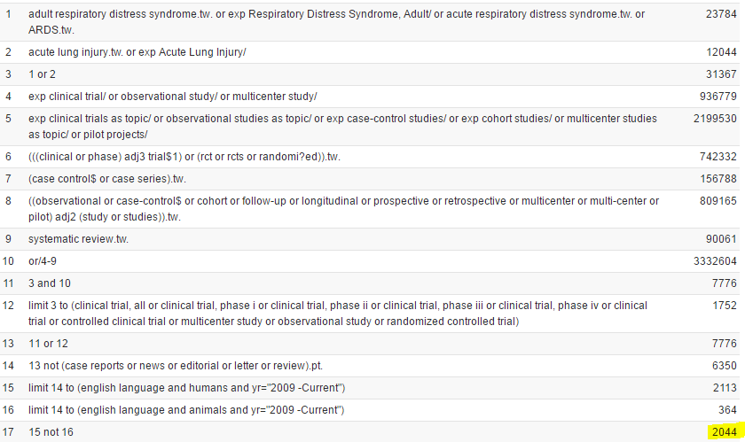

e-Figure 2. MEDLINE search 2017 – May 2019
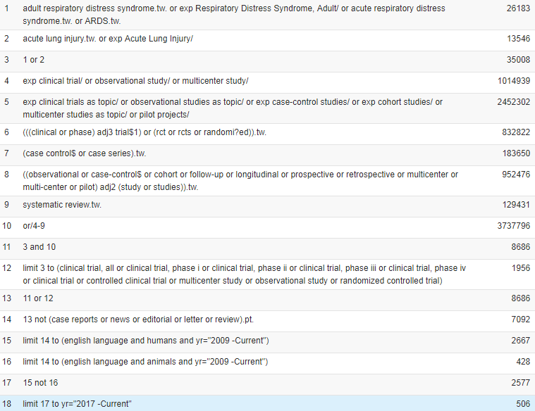

EMBASE (Ovid):
e-Figure 3. EMBASE search 2009-2017
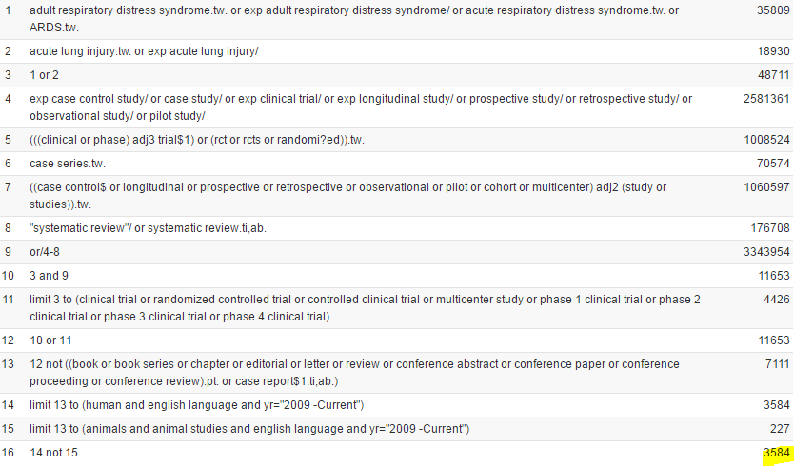

e-Figure 4. EMBASE search 2017 – May 2019
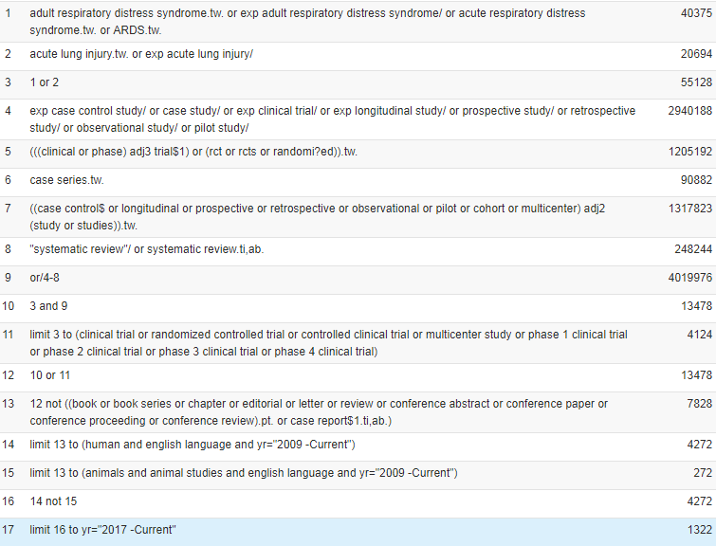
MEDLINE (Ovid) = 2,044 + 506
EMBASE (Ovid) = 3,584 + 1322
N = 7,456

Duplicates removed = 2,095

Final counts for the databases = 5,361

4. Study quality assessment

Year of Publication | First Author | Randomization Process | Deviation from Intended Intervention | Missing Outcome Data | Measurement of the Outcome | Selection of the Reported Results | Overall Risk of Bias
2009 | Osman et. al | Low | Low | Low | Low | Low | Low
2009 | Taccone et al | Low | Low | Low | Low | Low | Low
2011 | Craig TR | Low | Low | Low | Low | Low | Low
2011 | Matthay MA | Mod | Low | Low | Low | Mod | Mod
2011 | Stapleton | Low | Low | Low | Low | Low | Low
2011 | Rice | Low | Low | Low | Low | Low | Low
2012 | Rice TW (EDEN) | Low | Low | Low | Low | Low | Low
2012 | Mentzelopoulos | Low | Mod | Mod | Low | Mod | Mod
2012 | Forel JM | Low | Low | Low | Low | Low | Low
2013 | Ferguson | Low | Low | Low | Low | Low | Low
2013 | Bein | Low | Low | Mod | Mod | Mod | Mod
2013 | Young D (OSCAR) | Low | Low | Low | Low | Low | Low
2013 | Guerin C | Low | Low | low | Mod | Low | Mod
2013 | Gates S | Low | Low | Low | Low | Low | Low
2013 | Diehl | Low | Low | Low | Mod | Mod | Mod
2014 | Cornet AD | Low | Mod | Low | Low | Low | Mod
2014 | Truwit JD NHLBI ARDS | Low | Low | Low | Low | Low | Low
2014 | McAuley DF | Low | Mod | Low | Low | Low | Mod
2015 | Han F | Low | Low | Low | Mod | Low | Mod
2016 | Kacmarek RM | Low | Mod | Mod | Mod | Low | Mod
2016 | Mao Z | Mod | Mod | Low | Mod | Low | Mod
2016 | Tongyoo S | Low | Mod | Low | Mod | Low | Mod
2016 | Meng JB | Low | High | Low | High | Low | High
2017 | Jabaudon M | Low | Mod | Low | Low | Low | Mod
2017 | McAuley DF | Low | Low | Low | Mod | Low | Mod
2017 | Zhou Y | Mod | High | Low | Mod | Low | High
2017 | Cavalcanti AB | Low | High | Mod | Low | Low | High
2018 | Coombes A | Low | High | Low | Low | Low | High
2019 | Matthay MA | Low | Low | Low | Low | Low | Low
2019 | Kung SC | Low | Low | Low | Mod | Mod | Mod
e-Table 3. Risk of Bias for RCTs

e-Table 4. Risk of Bias for Observational studies

Year of Publication | First Author | Confounding | Selection of Participants | Classification of Interventions | Deviation from Intended Interventions | Missing data | Measurements of Outcomes | Selection of Reported Results | Overall Risk of Bias
2009 | Liao KM | Low | Low | Low | Low | Low | Low | Low | Low
2009 | Murphy CV | Low | Low | Mod | Low | Low | Low | Low | Mod
2010 | Raurich et al | Mod | Low | Low | Low | Mod | Mod | Low | Mod
2010 | Mekontso et al | Low | Low | Low | Low | Low | Mod | Low | Mod
2011 | Guervilly | Mod | Low | Low | Low | Low | Mod | Mod | Mod
2011 | Herasevich | Low | Low | Low | Mod | Low | Mod | Low | Mod
2011 | Riscili | Mod | Low | Low | Low | Low | Low | Low | Mod
2011 | Brun-Buisson | Mod | Low | Low | Low | Low | Mod | Mod | Mod
2011 | Arnal JM | Low | Low | Low | Mod | Low | Low | Low | Mod
2012 | De Matos | Mod | Mod | Mod | Low | Low | Low | Low | Mod
2012 | Hata | Low | Low | Low | Low | Mod | Low | Low | Mod
2012 | Ichikado | Low | Mod | Low | Low | Low | Mod | Low | Mod
2012 | Cordemans | Mod | Mod | Low | Low | Mod | low | Low | Mod
2013 | Chiumello | Mod | Low | Mod | Low | Low | Mod | Low | Mod
2013 | Jozwiak | Mod | Low | Mod | Low | Low | Mod | Low | Mod
2013 | Salahuddin | Low | Low | Mod | Mod | Low | Mod | Mod | Mod
2013 | Boisser | Low | Mod | Low | Mod | Mod | Mod | Low | Mod
2013 | Lheritier | Mod | Mod | Low | Low | Low | Mod | Mod | Mod
2013 | Liu | Mod | Low | Mod | Low | Low | Low | Low | Mod
2013 | Netzer | Low | Low | Low | Low | Low | Low | Low | Low
2014 | Kangelaris KN | Mod | Low | Mod | Low | Low | Low | Low | Mod
2014 | Morisawa K | Mod | Low | Low | Low | Low | High | Low | High
2014 | Guirand DM | High | Mod | Mod | Low | Low | Low | Low | High
2014 | Khandelwal N | Mod | Low | Low | Low | Mod | Low | Low | Mod
2014 | Kallet RH | High | Mod | Low | Low | Mod | Low | Low | High
2014 | Chen YF | Mod | Mod | Low | Low | Mod | Low | Low | Mod
2015 | Forel JM | Mod | Low | Low | Low | Low | Mod | Low | Mod
2015 | Legras A | Mod | Low | Low | Low | Low | Mod | Low | Mod
2015 | Kao KC | Mod | Mod | Low | Low | Low | Mod | Low | Mod
2015 | Villar J | Mod | Low | Low | Low | Low | Low | Low | Mod
2016 | Bellani G | Mod | Mod | Mod | Low | Mod | Mod | Low | Mod
2016 | Simon M | Mod | Mod | Mod | Mod | Low | Mod | Low | Mod
2016 | Lai CC | High | Mod | High | High | Mod | Mod | Low | High
2016 | Sharma SK | Mod | Low | Low | Low | Low | Mod | Low | Mod
2016 | Lim J | Mod | Low | Low | High | Low | Mod | Low | High
2016 | Cecchini J | Mod | Low | Low | Low | Low | Mod | Low | Mod
2016 | Balzer | Mod | Low | Mod | Low | Low | Low | Low | Mod
2016 | Bos LD | Mod | Low | Low | Low | Low | Low | Low | Mod
2017 | Gaudry S | Mod | Low | Mod | Mod | Low | Low | Low | Mod
2017 | Chen Lu | Mod | Mod | Mod | High | Low | High | Low | High
2017 | Raymondos K | Mod | Mod | Mod | Low | Low | Mod | Low | Mod
2017 | Rahmel T | High | Mod | Mod | Low | Low | Mod | Low | High
2017 | Garcia-Montilla R | Mod | Mod | Low | Low | Low | Mod | Low | Mod
2017 | Muthu V | Mod | Mod | Low | Low | Low | Mod | Low | Mod
2017 | See KC | High | Mod | High | Low | Low | Low | Mod | High
2018 | Seong GM | Mod | Low | High | Low | Low | Low | Mod | High
2018 | Zheng Y | High | Low | Low | Low | Low | Low | Low | High
2018 | Kawamura K | Low | Low | Low | Low | Mod | Mod | Mod | Mod
2018 | Liu L | Mod | Low | Low | Low | Mod | Mod | Mod | Mod
2019 | Zhao Z | Low | High | Low | Low | Mod | Mod | Mod | High
2019 | Chan MC | Low | Mod | Low | Low | Mod | Low | Low | Mod
2019 | Kamo T | High | Mod | Mod | Low | Mod | Low | Mod | High
2019 | Sinha P | Mod | Low | Low | Low | Low | Mod | Mod | Mod
2019 | Ni YN | Mod | Low | Mod | Low | Mod | Low | Mod | Mod
2019 | Obi AT | Mod | Low | Low | Low | Mod | Mod | Mod | Mod

5. Funnel Plot and Egger’s Test

e-Figure 5. Funnel Plot. Standard of error listed on y axis and mortality on x axis. Circles represent each individual study and dotted lines represents 95% CI.

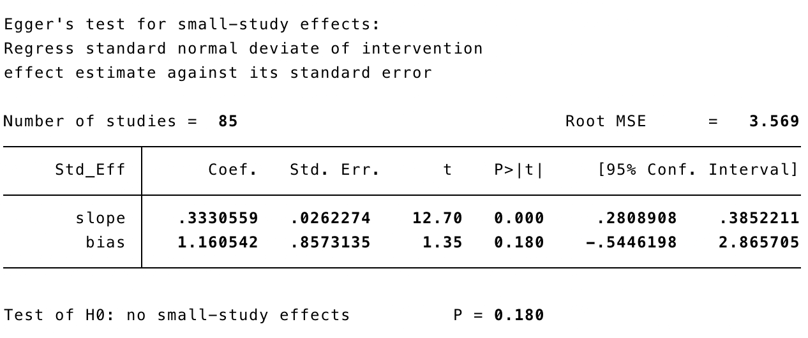

e-Figure 6. Egger’s test.

6. Forest plot sensitivity analysis

See e-Figure 7.
e-Figure 7. – Forest plot of mortality for all studies including interventional arm of studies evaluating an adjunctive therapy organized by RCT vs Observational study design. Listed in chronological order by year of publication (in parenthesis). 95% CI listed with point estimate of each individual study (vertical lines) and pooled estimate in observational studies, RCT, and in totality (vertical line and diamond).

See e-Figure 8.
e-Figure 8. – Forest plot of mortality for all studies reporting hospital mortality organized by RCT vs Observational study design. Listed in chronological order by year of publication (in parenthesis). 95% CI listed with point estimate of each individual study (vertical lines) and pooled estimate in observational studies, RCT, and in totality (vertical line and diamond).

7. Meta-regression figures

e-Figure 9. Meta-regression analysis of Positive end expiratory pressure (mmHg). Mortality listed on y axis and PEEP on x axis. Circles represent each individual study and vertical line represents meta-regression line. The p value is reported on bottom right.
e-Figure 10. Meta-regression analysis of Plateau Pressure (cmH₂O). Mortality listed on y axis and Pplat on x axis. Circles represent each individual study and vertical line represents meta-regression line. The p value is reported on bottom right.
e-Figure 11. Meta-regression analysis of Driving Pressure (cmH₂O). Mortality listed on y axis and Driving Pressure on x axis. Circles represent each individual study and vertical line represents meta-regression line. The p value is reported on bottom right.

e-Figure 12. Meta-regression analysis of Age. Mortality listed on y axis and age on x axis. Circles represent each individual study and vertical line represents meta-regression line. The p value is reported on bottom right.
e-Figure 13. Meta-regression analysis of APACHE II. Mortality listed on y axis and APACHE II on x axis. Circles represent each individual study and vertical line represents meta-regression line. The p value is reported on bottom right.
e-Figure 14. Meta-regression analysis of SOFA. Mortality listed on y axis and SOFA on x axis. Circles represent each individual study and vertical line represents meta-regression line. The p value is reported on bottom right.
e-Figure 15. Meta-regression analysis of Extracorporeal Membrane Oxygenation. Mortality listed on y axis and ECMO on x axis. Circles represent each individual study and vertical line represents meta-regression line. The p value is reported on bottom right.
e-Figure 16. Meta-regression analysis of Nitric Oxide. Mortality listed on y axis and Nitric Oxide axis. Circles represent each individual study and vertical line represents meta-regression line. The p value is reported on bottom right.
e-Figure 17. Meta-regression analysis of Neuromuscular Blockade. Mortality listed on y axis and NMBA on x axis. Circles represent each individual study and vertical line represents meta-regression line. The p value is reported on bottom right.
e-Figure 18. Meta-regression analysis of Prone Position. Mortality listed on y axis and PP on x axis. Circles represent each individual study and vertical line represents meta-regression line. The p value is reported on bottom right.

8. Sensitivity analysis meta-regression table

Variable | β₁ Co-efficient | 95% CI | p
PaO2/FiO2 | -0.0013 | -0.0025, -0.0001 | 0.033
Tidal Volume | 0.0203 | -0.0285, 0.0691 | 0.402
PEEP | -0.0027 | -0.0210, 0.0155 | 0.762
Plateau Pressure | 0.0041 | -0.0093, 0.0175 | 0.537
Driving Pressure | 0.0140 | -0.0064, 0.0345 | 0.168
Age | 0.0043 | -0.0008, 0.0093 | 0.095
APACHE II | 0.0108 | -0.0018, 0.0233 | 0.089
SOFA | 0.0278 | -0.0157, 0.0713 | 0.191
ECMO | 0.0027 | -0.0022, 0.0076 | 0.239
Nitric Oxide | 0.0005 | -0.0025, 0.0034 | 0.738
NMBA | 0.0018 | -0.0001, 0.0035 | 0.054
PP | 0.0024 | -0.0013, 0.0062 | 0.183
e-Table 5. Sensitivity analysis meta-regression

