Table 1 | State-level Data in the 2016 Election. The state mean indicates the mean difference between candidates in each state. A mean difference less than 0 favored Mr. Trump and a difference greater than zero favored Mrs. Clinton. The upper and lower confidence intervals were determined by parametric estimates. Shaded states have confidence intervals that overlap the method-specific uncertainty interval of ±3.5%.
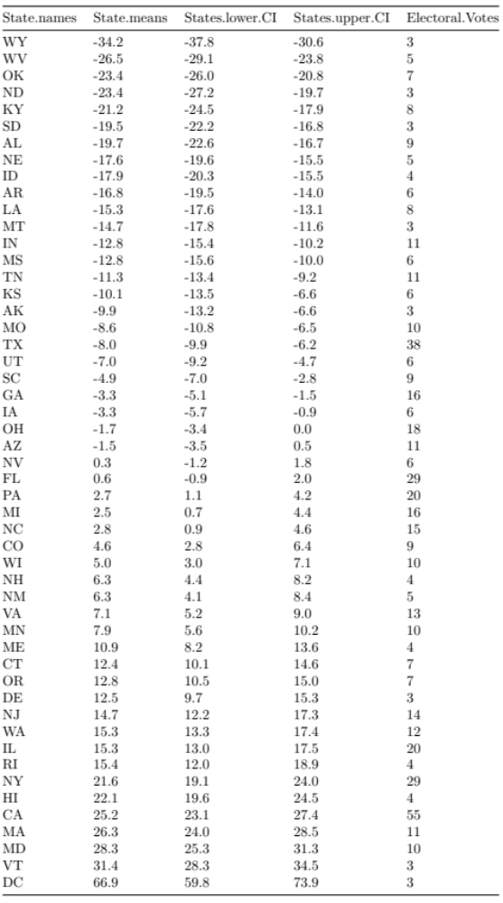

Table 2 | States Favoring Mr. Biden in the 2020 Election. The mean spread indicates the average difference between candidates in each state. A mean difference greater than zero was arbitrarily selected to favor Mr. Biden. The upper and lower confidence intervals were determined by parametric estimates.

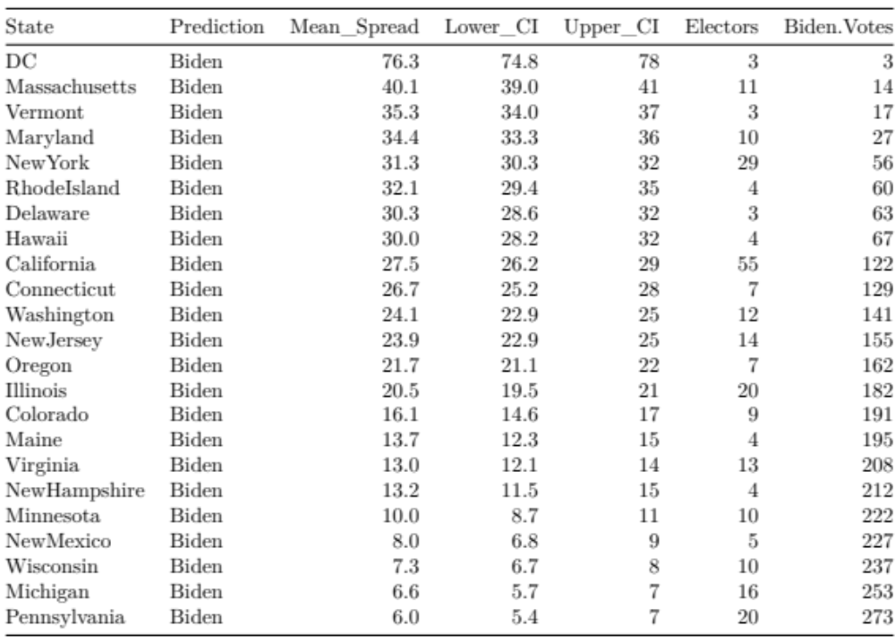

Table 3 | States Favoring Mr. Trump in the 2020 Election. The mean spread indicates the average difference between candidates in each state. A mean difference less than zero was arbitrarily selected to favor Mr. Trump. The upper and lower confidence intervals were determined by parametric estimates.

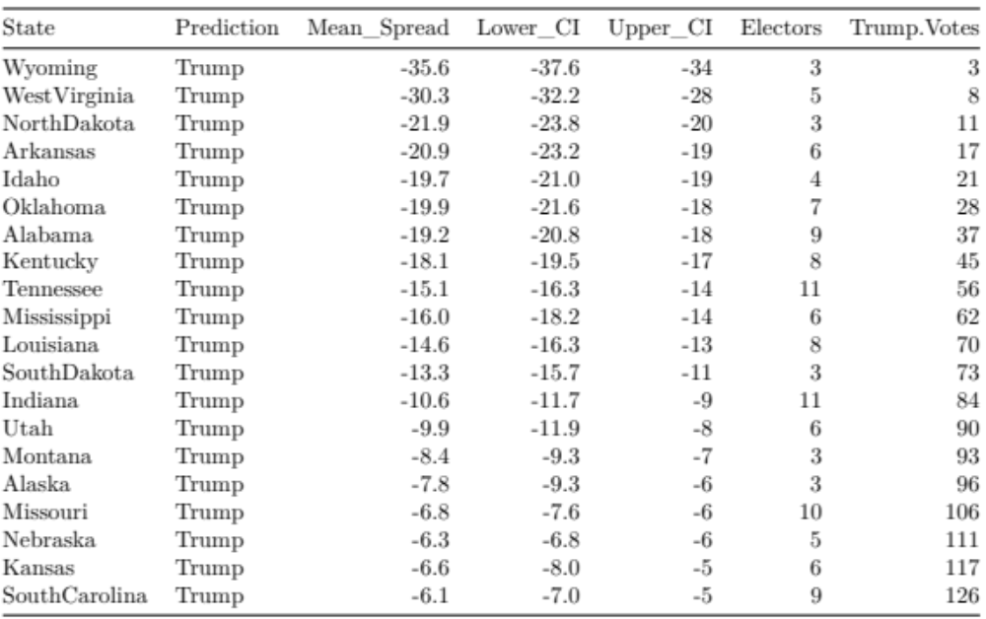

Table 4 | Uncertain States in the 2020 Election. The mean spread indicates the average difference between candidates in each state. A mean difference less than zero favors Mr. Trump and a mean difference greater than zero favors Mr. Biden. The upper and lower confidence intervals were determined by parametric estimates.

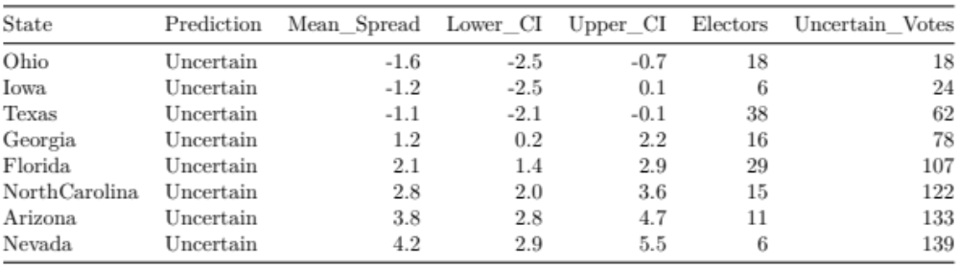

Table 5 | Uncertain States in the 2020 Election. The mean spread indicates the average difference between candidates in each state. A mean difference less than zero favors Mr. Trump and a mean difference greater than zero favors Mr. Biden. The upper and lower confidence intervals were determined by parametric estimates.

