Supplemental Material

Article title: Adipocytokine profile reveals a significant cytokine network in the acute phase of sepsis

Takeshi Ebihara, Hisatake Matsumoto*, Tsunehiro Matsubara, Hiroshi Matsuura, Tomoya Hirose, Kentaro Shimizu, Hiroshi Ogura, Sujin Kang, Toshio Tanaka and Takeshi Shimazu

*Corresponding Author Information
Hisatake Matsumoto, MD, PhD
Department of Traumatology and Acute Critical Medicine, Osaka University Graduate School of Medicine 2-15 Yamadaoka, Suita City, Osaka 565-0871, Japan
Tel: +81-6-6879-5707; Fax: +81-6-6879-5720
E-mail: h-matsumoto@hp-emerg.med.osaka-u.ac.jp

Figure S1 Levels of Vaspin, CXCL-12/SDF-1 and Angiotensinogen in septic shock vs. non-shock patients and survivors vs. non-survivors.

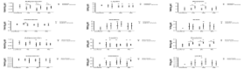
A
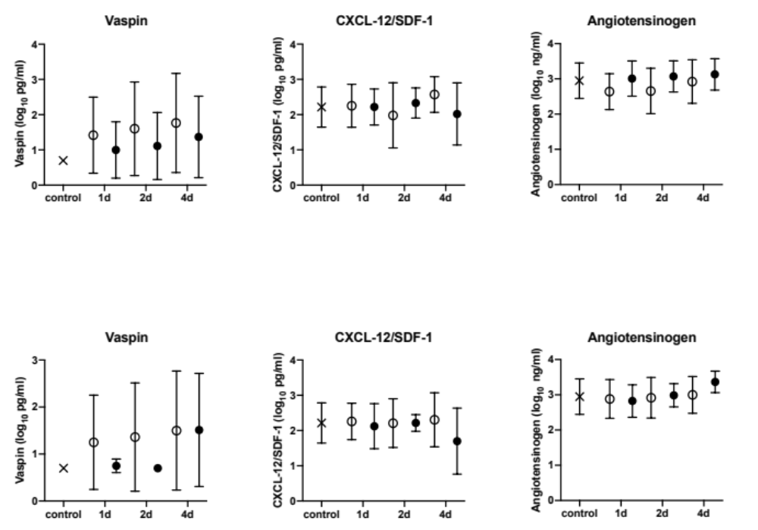

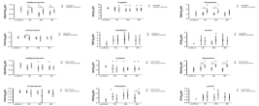
B

Fig S1. (A) Levels of mediators in septic shock and non-shock patients on Day 1 (septic shock patients, n=24; non-shock patients, n=12), Day 2 (n=22; n=10, respectively) and Day 4 (n=24; n=12, respectively). (B) Levels of mediators in 28-day survivors and non-survivors on Day 1 (n=24; n=12, respectively), Day 2 (n=26; n=6, respectively) and Day 4 (n=19; n=5, respectively). All data are expressed as the mean±SD. CXCL-12/SDF-1 C-X-C motif chemokine-12/stromal cell-derived factor-1

