 | Most significant |  | → | → | → | → | → | → | Least significant
Value | Vision | Central retina | Inner  Temporal | Inner  Superior | Inner  Nasal | Inner  Inferior | Outer  Temporal | Outer  Superior | Outer  Nasal | Outer  Inferior
State number | Normal  or  Reduced | Normal  or  Thick  or  Thin | Normal  or  Thick  or  Thin | Normal  or  Thick  or  Thin | Normal  or  Thick  or  Thin | Normal  or  Thick  or  Thin | Normal  or  Thick  or  Thin | Normal  or  Thick  or  Thin | Normal  or  Thick  or  Thin | Normal  or  Thick  or  Thin
Response  number | Same  or  Better  or  Worse | Same  or  Better  or  Worse | Same  or  Better  or  Worse | Same  or  Better  or  Worse | Same  or  Better  or  Worse | Same  or  Better  or  Worse | Same  or  Better  or  Worse | Same  or  Better  or  Worse | Same  or  Better  or  Worse | Same  or  Better  or  Worse
(Table 1- stacked values for weighted sum of response and state number)
 | Response number
 | Worse | Same | Better
State number
Thickened | Treat and reduce interval towards minimum. If at minimum interval already, consider treating with different agent | Treat and keep interval the same | Treat and extend treatment interval
Normal | Treat and reduce interval towards minimum | Treat and extend treatment interval | Treat and extend treatment interval
Thinned | Treat and reduce interval towards minimum | Treat and extend treatment interval | Treat and extend treatment interval  Give warning notice to user
(Table 2 – management recommendation based on state and response number)

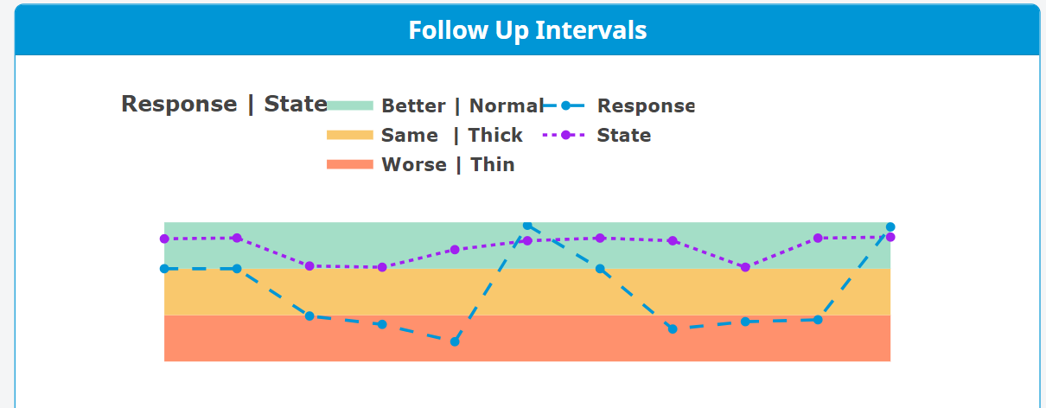
(Figure 1. state and response of individual patient over time)

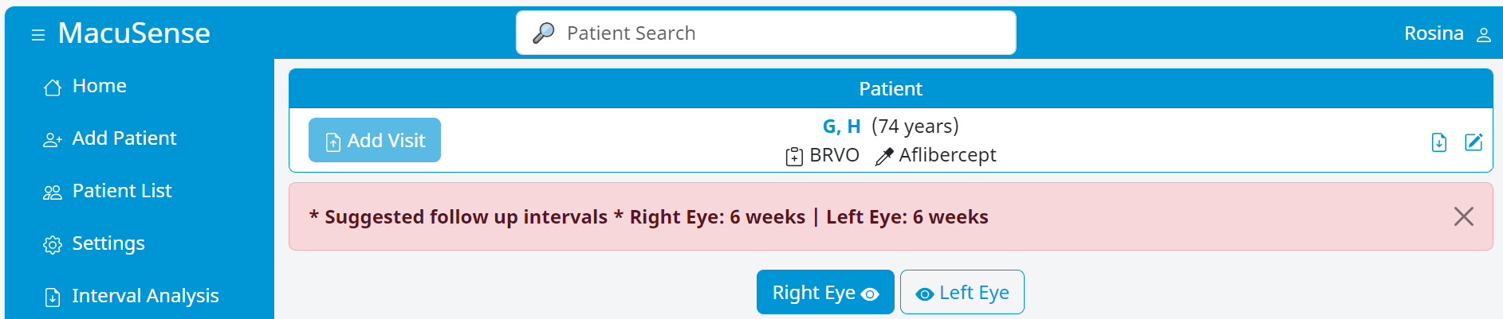

(figure 2. Graphical representation of algorithm output describing recommended interval change)

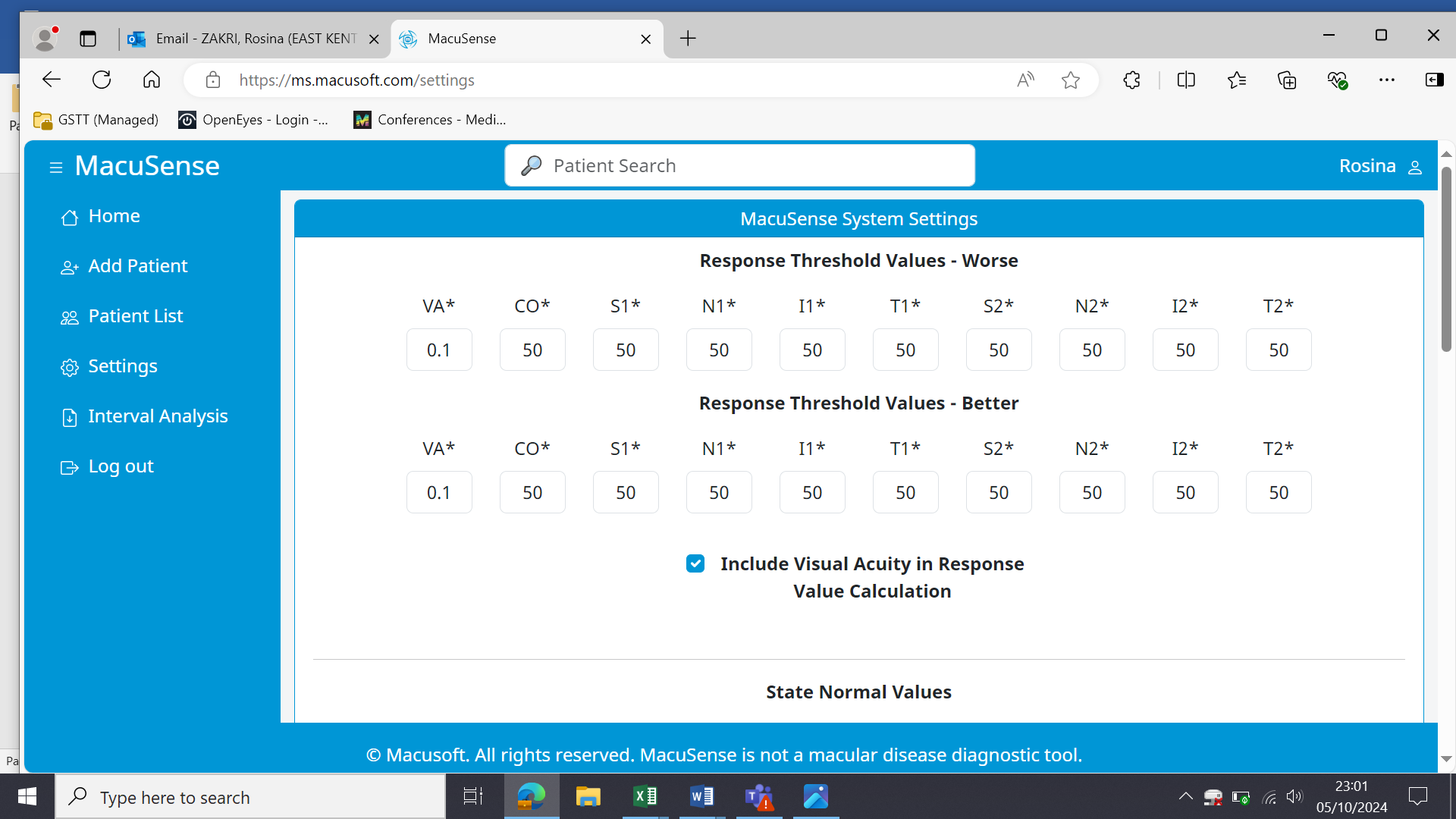
(Figure 3 Changing the macular thickness thresholds)

(Figure 4 showing total comparison of intervals by clinician and software)

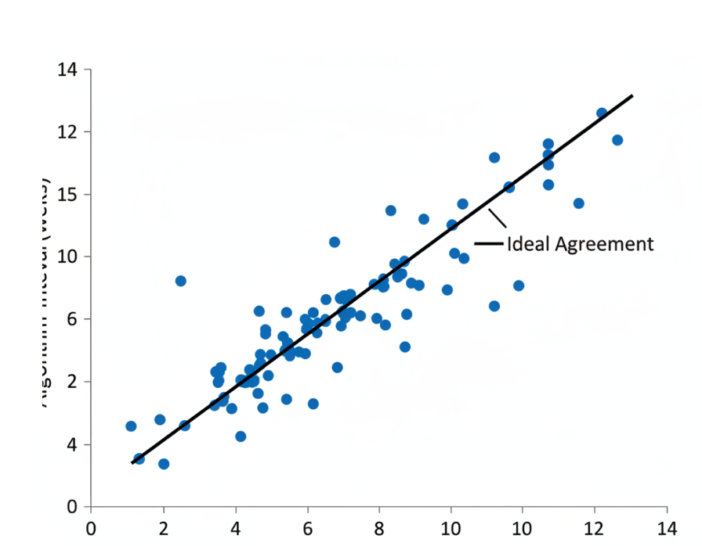
(Figure 5. Scatter graph to show the consensus between clinician and software in AMD patients)

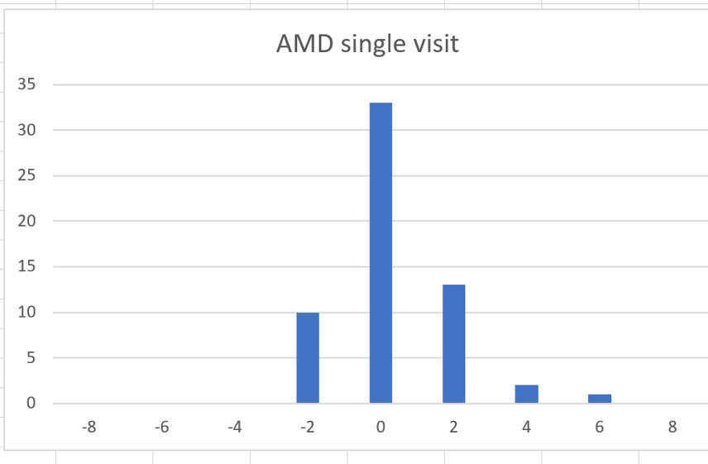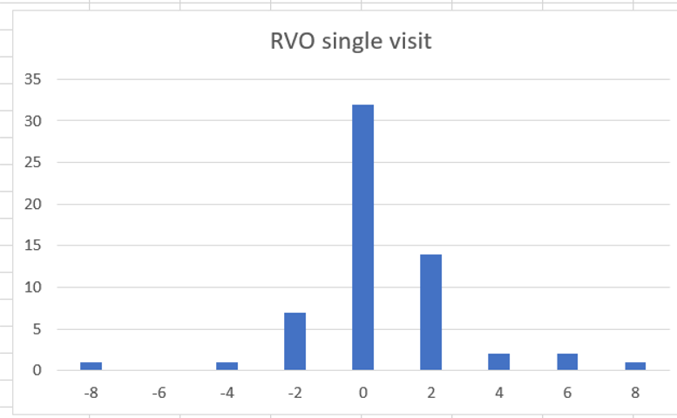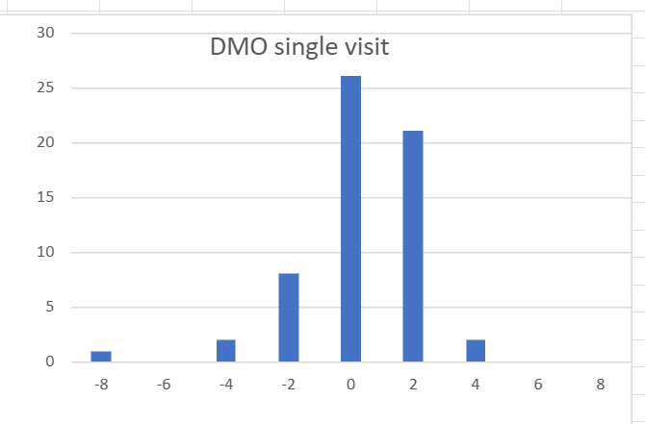
(Figure 6. Histograms of intervals in weeks suggested by the software compared to the clinician gold standard.

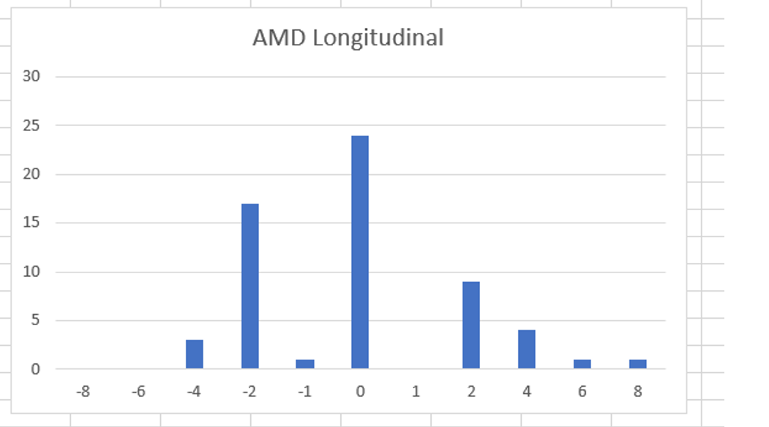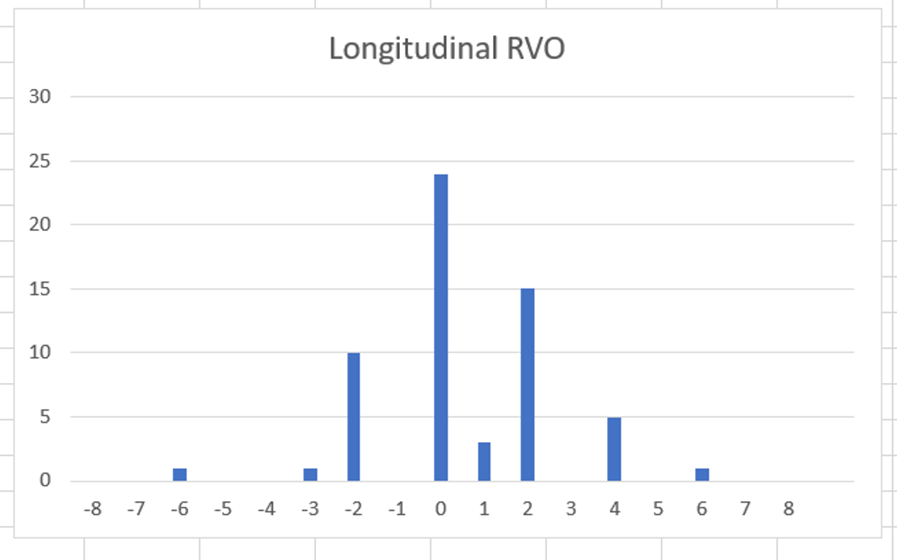
(Figure 7. Histogram of comparison between software to clinician over 3 visits)

2 4 6 8 10 12
2 0 0 1 0 0 0
4 0 2 2 2 4 1
6 0 1 3 2 5 0
8 0 0 3 4 5 3
10 0 0 3 2 4 0
12 0 1 1 0 4 9

(Figure 8. Matrix of confusion for DMO consensus between clinician and software)

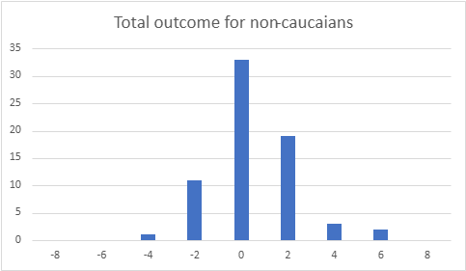
(Figure 9. Histogram for non-Caucasians)
Accuracy EKHUFT 86% Accuracy GSTT: 85%
(Figure 10. Histogram of difference to compare results from two different Trusts)

(Figure 11. Histogram of difference comparing NICE to clinician and software)
Clinician Accuracy: 94%, kappa: 0.8, skew 0.84, kurtosis: 3.41
Macusoft Accuracy:81% kappa:.0.9 Skew 0.95, Kurtosis: 3.42
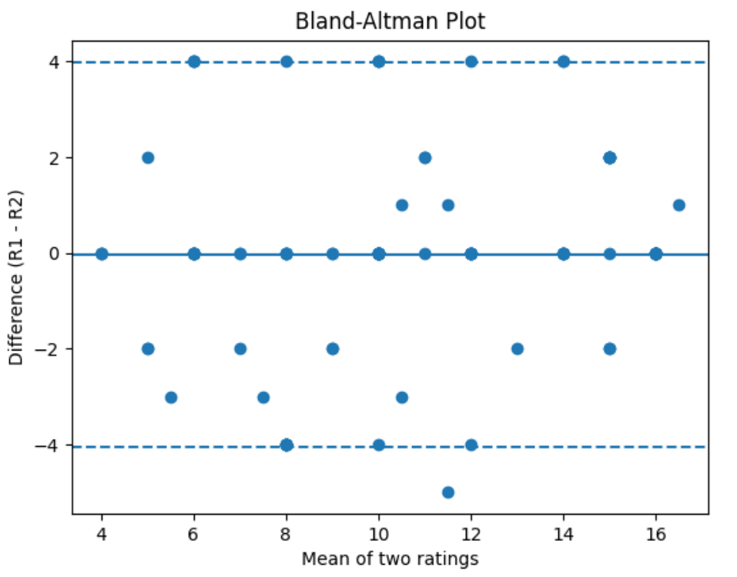
(Figure 12. Bald-Altman plot he bald-Alman plot confirming no overall bias)

