Supplementary Material

DXA-Measured Body Composition Effects of GLP-1 and Dual GIP/GLP-1 Receptor Agonists in Adults with Obesity or Type 2 Diabetes: A Systematic Review and Meta-Analysis of Phase 3 Randomized Trials
Birkan Alaycı, MD¹ · Öykü Zeynep Gerçek, MD²
¹ Department of Internal Medicine, Liv Hospital Vadi İstanbul, Istanbul, Turkey ² Department of Internal Medicine, Ministry of Health Muş State Hospital, Muş, Turkey
Corresponding author: Birkan Alaycı, MD (birkanalayci@gmail.com) PROSPERO: CRD420261323497

Contents
- Table S1. PRISMA 2020 Checklist
- Table S2. Risk of Bias 2 (RoB-2) detailed assessment
- Table S3. Database search strategies
  - S3a. PubMed
  - S3b. Cochrane CENTRAL
  - S3c. Scopus
- Table S4. Studies excluded at full-text screening with reasons
- Table S5. Pooled effects across analytic models — lean body mass and fat mass
- Table S6. Expanded inclusion sensitivity (k = 5 vs k = 6 vs k = 7)
- Figure S1. Leave-one-out sensitivity (lean and fat panels)
- Figure S2. Doi plot with LFK index (Panels A/B: lean and fat)
- Figure S3. Bayesian posterior distributions (Panels A/B: lean and fat)
- Supplementary Discussion. Estimand consistency and LEAD-2/LEAD-3 cluster justification

Table S1. PRISMA 2020 Checklist
Section / Topic | Item # | Checklist Item | Location
TITLE
Title | 1 | Identify the report as a systematic review. | Title page
ABSTRACT
Abstract | 2 | See the PRISMA 2020 for Abstracts checklist. | Abstract (structured, 247 words)
INTRODUCTION
Rationale | 3 | Describe the rationale for the review in the context of existing knowledge. | Introduction, paragraphs 1–3
Objectives | 4 | Provide an explicit statement of the objective(s). | Introduction, final paragraph
METHODS
Eligibility criteria | 5 | Specify the inclusion and exclusion criteria. | Methods 2.2
Information sources | 6 | Specify all databases, registers, and other sources searched; specify last search date. | Methods 2.3
Search strategy | 7 | Present the full search strategies. | Methods 2.3; Table S3
Selection process | 8 | Specify methods used to decide whether a study met the inclusion criteria. | Methods 2.4
Data collection process | 9 | Specify methods used to collect data from reports. | Methods 2.5
Data items | 10a | List and define all outcomes for which data were sought. | Methods 2.2 (Outcomes); 2.7.1
Data items | 10b | List and define all other variables for which data were sought. | Methods 2.5
Study risk of bias assessment | 11 | Specify methods used to assess risk of bias. | Methods 2.6
Effect measures | 12 | Specify effect measure(s) used in synthesis. | Methods 2.7.1
Synthesis methods | 13a | Describe processes used to decide which studies were eligible for each synthesis. | Methods 2.2; 2.7.4
Synthesis methods | 13b | Describe methods to prepare data for synthesis. | Methods 2.5
Synthesis methods | 13c | Describe methods used to tabulate or visually display results. | Methods 2.7.1, 2.7.2; Tables 1, 2A, 2B; Figures 3–6
Synthesis methods | 13d | Describe methods used to synthesize results; model(s), heterogeneity, software. | Methods 2.7.1, 2.7.2, 2.7.6, 2.7.8
Synthesis methods | 13e | Describe methods used to explore causes of heterogeneity. | Methods 2.7.2, 2.7.4
Synthesis methods | 13f | Describe sensitivity analyses. | Methods 2.7.3
Reporting bias assessment | 14 | Describe methods used to assess risk of bias due to missing results. | Methods 2.7.5
Certainty assessment | 15 | Describe methods used to assess certainty in the body of evidence. | Methods 2.7.7
RESULTS
Study selection | 16a | Describe results of the search and selection process. | Results 3.1; Figure 1 (PRISMA flow)
Study selection | 16b | Cite studies that might appear to meet criteria but were excluded, with reasons. | Results 3.1; Figure 1; Table S4
Study characteristics | 17 | Cite each included study and present its characteristics. | Results 3.2; Table 1
Risk of bias in studies | 18 | Present assessments of risk of bias for each included study. | Results 3.3; Figure 2; Table S2
Results of individual studies | 19 | Present individual-study summary statistics and effect estimates. | Table 1; Figures 3–6
Results of syntheses | 20a | Summarise characteristics and risk of bias among contributing studies. | Results 3.2, 3.3, 3.4, 3.5
Results of syntheses | 20b | Present results of all statistical syntheses. | Results 3.4–3.6, 3.8; Tables 2A, 2B
Results of syntheses | 20c | Present results of all investigations of possible causes of heterogeneity. | Results 3.6; Discussion 4.2
Results of syntheses | 20d | Present results of all sensitivity analyses. | Results 3.7; Tables S5, S6
Reporting biases | 21 | Present assessments of risk of bias due to missing results. | Results 3.10; Figure S2
Certainty of evidence | 22 | Present assessments of certainty for each outcome. | Results 3.11; Table 3
DISCUSSION
Discussion | 23a | Provide a general interpretation of the results. | Discussion 4.1, 4.4
Discussion | 23b | Discuss limitations of the evidence included in the review. | Discussion 4.6
Discussion | 23c | Discuss limitations of the review processes used. | Discussion 4.6
Discussion | 23d | Discuss implications for practice, policy, and future research. | Discussion 4.7
OTHER INFORMATION
Registration and protocol | 24a | Provide registration information. | Title page; Methods 2.1
Registration and protocol | 24b | Indicate where the protocol can be accessed. | Methods 2.1 (PROSPERO CRD420261323497); a separate full protocol document was not prepared — methodological details are fully specified in the PROSPERO record and the Methods section.
Registration and protocol | 24c | Describe and explain any amendments to the protocol. | No amendments were made to the registered protocol (PICO, search strategy, outcomes, or analytic plan).
Support | 25 | Describe sources of financial or non-financial support. | Funding statement (no external funding)
Competing interests | 26 | Declare any competing interests. | Conflict of Interest Statement
Availability of data, code, and other materials | 27 | Report availability of data, code, and other materials. | Data Availability Statement (Zenodo doi:10.5281/zenodo.19158245; GitHub)
Page MJ, McKenzie JE, Bossuyt PM, et al. The PRISMA 2020 statement: an updated guideline for reporting systematic reviews. BMJ. 2021;372:n71.

Table S2. Risk of Bias 2 (RoB-2) detailed assessment
Assessed for the effect of assignment to intervention (intention-to-treat). Outcome: change in DXA-measured lean body mass (kg). Domains: D1 randomization process; D2 deviations from intended interventions; D3 missing outcome data; D4 measurement of the outcome; D5 selection of the reported result.
Study | D1 | D2 | D3 | D4 | D5 | Overall | Key judgement
SURMOUNT-1 (Look 2025) | Low | Low | High | Low | Low | High | D3: 37% DXA attrition (95/255 lost); arm-level completion not reported; differential dropout plausible.
STEP-1 (Wilding 2021) | Low | Low | Low | Low | Some concerns | Some concerns | D5: DXA exploratory; no multiplicity adjustment; p-values not reported.
SUSTAIN-8 (McCrimmon 2020) | Low | Low | Low | Low | Low | Low | All domains low; double-blind, double-dummy; central IVRS; pre-specified DXA substudy.
LEAD-2 (Jendle 2009) | Some concerns | Low | Some concerns | Low | Low | Some concerns | D1: baseline LBM imbalance (53 vs 58–60 kg). D3: LOCF; no-imputation sensitivity consistent.
LEAD-3 (Jendle 2009) | Low | Low | Some concerns | Low | Low | Some concerns | D3: small DXA subset (n = 29); LOCF used; double-blind, double-dummy design.

Table S3. Database search strategies

S3a. PubMed (MEDLINE)
Date of search: 23 March 2026.
Search string:
("Glucagon-Like Peptides"[MeSH] OR "glucagon-like peptide-1"[All Fields]
OR "GLP-1 receptor agonist"[All Fields] OR "GLP-1 analogue"[All Fields]
OR "exendin"[All Fields] OR "incretin"[All Fields]
OR "tirzepatide"[All Fields] OR "semaglutide"[All Fields]
OR "liraglutide"[All Fields] OR "exenatide"[All Fields]
OR "dulaglutide"[All Fields])
AND
("Body Composition"[MeSH] OR "lean body mass"[All Fields]
OR "lean mass"[All Fields] OR "fat-free mass"[All Fields]
OR "Absorptiometry, Photon"[MeSH] OR "DXA"[All Fields]
OR "DEXA"[All Fields] OR "dual-energy X-ray"[All Fields])
AND
("Randomized Controlled Trial"[pt] OR "randomized"[All Fields]
OR "randomised"[All Fields])
Records retrieved: 290.

S3b. Cochrane CENTRAL
Date of search: 23 March 2026.
#1 [Title Abstract Keyword]
tirzepatide OR semaglutide OR liraglutide OR exenatide
OR dulaglutide OR incretin OR GLP-1
#2 [Title Abstract Keyword]
lean mass OR lean body mass OR fat-free mass OR body composition
OR DXA OR DEXA OR absorptiometry
#3 #1 AND #2
Records retrieved: 161.

S3c. Scopus
Date of search: 23 March 2026.
TITLE-ABS-KEY (semaglutide OR liraglutide OR tirzepatide OR dulaglutide
OR exenatide OR "GLP-1 receptor agonist"
OR "glucagon-like peptide-1")
AND TITLE-ABS-KEY ("lean mass" OR "lean body mass" OR "fat-free mass"
OR "muscle mass" OR "skeletal muscle"
OR "body composition" OR "lean soft tissue")
AND TITLE-ABS-KEY (DXA OR DEXA OR "dual-energy x-ray absorptiometry"
OR MRI OR "magnetic resonance imaging")
AND (LIMIT-TO (SRCTYPE, "j"))
AND (LIMIT-TO (DOCTYPE, "ar"))
Records retrieved: 265.

Table S4. Studies excluded at full-text screening with reasons (n = 8)
Study | Journal | DOI | Exclusion reason
Anyiam O, et al. 2024 | Clinical Nutrition | 10.1016/j.clnu.2024.06.034 | Open-label / no placebo (semaglutide + very-low-calorie diet combined intervention; no matched-placebo comparator).
Bunck MC, et al. 2010 | Diabetes Care | 10.2337/dc09-2361 | Not phase 3 / pilot (exenatide mechanistic substudy; body composition reported as secondary outcome).
Feng W, et al. 2019 | Journal of Diabetes Investigation | 10.1111/jdi.12888 | Not phase 3 / pilot (single-centre randomised trial in T2D + NAFLD; pilot scale).
Harder H, et al. 2004 | Diabetes Care | 10.2337/diacare.27.8.1915 | Subtherapeutic dose (liraglutide 1.25 mg, below the currently approved therapeutic dose range) and pilot design.
Nakaguchi H, et al. 2020 | Journal of Diabetes Investigation | 10.1111/jdi.13270 | Open-label / no placebo (liraglutide + empagliflozin add-on RCT without placebo arm).
Silver HJ, et al. 2023 | Diabetes, Obesity and Metabolism | 10.1111/dom.15113 | Open-label / no placebo (liraglutide vs caloric restriction as non-pharmacological active comparator).
Yang J, et al. 2025 | Metabolism | 10.1016/j.metabol.2025.156229 | Not phase 3 / pilot (mechanistic study of lipotoxicity and adipose tissue dysfunction; not a phase 3 efficacy trial).
Yin TT, et al. 2018 | Nutrition & Metabolism | 10.1186/s12986-018-0295-6 | Open-label / no placebo (exenatide vs insulin glargine in T2D; open-label design).
Per PRISMA 2020 item 16b. Distribution by reason: open-label / no placebo (n = 4); not phase 3 / pilot (n = 3); subtherapeutic dose (n = 1).

Table S5. Pooled effects across analytic models — lean body mass and fat mass (k = 5)

S5a. Lean body mass
Model | τ² | MD (kg) | 95% CI / CrI | p / P(μ<0)
HKSJ-REML (primary) | 1.52 | −1.96 | −3.64, −0.27 | p = 0.032
REML (Wald CI) | 1.52 | −1.96 | −3.12, −0.80 | p = 0.001
DerSimonian–Laird | 1.10 | −1.95 | −2.96, −0.93 | p = 0.0002
Paule–Mandel | 1.62 | −1.96 | −3.15, −0.77 | p = 0.001
Sidik–Jonkman | 1.61 | −1.96 | −3.14, −0.78 | p = 0.001
Empirical Bayes | 1.45 | −1.95 | −3.08, −0.83 | p = 0.001
Hedges | 1.50 | −1.96 | −3.10, −0.81 | p = 0.001
Profile likelihood (REML) | — | −1.95 | −2.97, −0.92 | —
Robust variance estimation (CR2, m = 4 clusters) | — | −1.96 | −4.01, +0.09 | p = 0.058 (conservative at m = 4)
Three-level model (ρ = 0 to 1) | 1.96–2.08 | −2.07 to −2.11 | excludes 0 across all ρ | —
brms Bayesian (HC(0,1)) | — | −1.95 | −3.40, −0.61 (CrI) | P(μ<0) = 99.4%
bayesmeta (HC(0,1)) | — | −1.94 | −3.38, −0.53 (CrI) | P(μ<0) = 99.2%

S5b. Fat mass
Model | τ² | MD (kg) | 95% CI / CrI | p / P(μ<0)
HKSJ-REML (primary) | 18.13 | −5.29 | −10.78, +0.21 | p = 0.056
REML (Wald CI) | 18.13 | −5.29 | −9.15, −1.42 | p = 0.007
DerSimonian–Laird | 15.07 | −5.27 | −8.81, −1.72 | p = 0.004
Paule–Mandel | 18.28 | −5.29 | −9.17, −1.41 | p = 0.008
Profile likelihood (REML) | — | −5.26 | −8.71, −1.81 | —
RVE (CR2, m = 4 clusters) | — | −5.27 | −10.73, +0.20 | p = 0.055 (conservative)
brms Bayesian (HC(0,1)) | — | −5.07 | −9.31, −0.77 (CrI) | P(μ<0) = 98.5%
bayesmeta (HC(0,1)) | — | −5.02 | −9.28, −0.75 (CrI) | P(μ<0) = 98.4%

S5c. Bayesian prior sensitivity (lean body mass)
Half-Cauchy scale on τ | Posterior mean (kg) | 95% CrI | P(μ<0)
0.5 | −1.95 | −3.32, −0.72 | 99.5%
1.0 (primary) | −1.96 | −3.38, −0.57 | 99.3%
2.0 | −1.94 | −3.54, −0.43 | 99.0%
Cross-engine convergence (brms vs bayesmeta) within 0.7% of posterior mean for both outcomes; pre-specified acceptance threshold was 5%.

Table S6. Expanded inclusion sensitivity analyses (k = 5 vs k = 6 vs k = 7)
Primary analysis restricted to phase 3 RCTs (k = 5). Sensitivity set A adds Lundgren 2021 (S-LiTE; investigator-initiated weight-maintenance design) at k = 6. Sensitivity set B further adds Mok 2023 (BARI-OPTIMISE; post-bariatric surgery population) at k = 7.

Lean body mass
Analysis | k | MD (kg) | 95% CI (HKSJ-REML) | HKSJ p | I² (DL)
Primary (phase 3) | 5 | −1.96 | −3.64, −0.27 | 0.032 | 87.8%
+ S-LiTE | 6 | −2.09 | −3.43, −0.74 | 0.010 | 84.4%
+ S-LiTE + BARI-OPTIMISE | 7 | −2.22 | −3.37, −1.06 | 0.003 | 82.5%

Fat mass
Analysis | k | MD (kg) | 95% CI (HKSJ-REML) | HKSJ p | I² (DL)
Primary (phase 3) | 5 | −5.29 | −10.78, +0.21 | 0.056 | 94.6%
+ S-LiTE | 6 | −5.15 | −9.32, −0.98 | 0.025 | 92.0%
+ S-LiTE + BARI-OPTIMISE | 7 | −5.09 | −8.45, −1.74 | 0.010 | 90.5%
The fat mass effect becomes statistically significant under HKSJ-REML at expanded inclusion sets at the conventional α = 0.05 threshold, supporting the interpretation that the marginal significance at k = 5 (p = 0.056) reflects sample-size–dependent confidence-interval inflation rather than absence of effect. The progressive decrease in I² with expanding k indicates that additional eligible studies reduce rather than amplify heterogeneity, supporting the generalisability of the primary estimate.

Figure S1. Leave-one-out sensitivity analysis
Forest plots showing pooled mean difference and 95% confidence interval after iterative omission of each primary trial, for lean body mass (panel A) and fat mass (panel B). All leave-one-out estimates retain statistical significance under DerSimonian–Laird and retain effect direction under HKSJ-REML.
Panel A (Lean body mass) — leave-one-out pooled MD (kg):
Omitted study | MD | 95% CI | I²
SURMOUNT-1 | −1.41 | −1.88, −0.95 | 17.6%
STEP-1 | −2.01 | −3.42, −0.60 | 87.2%
SUSTAIN-8 | −2.25 | −3.40, −1.11 | 81.7%
LEAD-2 | −2.06 | −3.36, −0.77 | 89.4%
LEAD-3 | −2.06 | −3.32, −0.81 | 88.5%
Panel B (Fat mass) — leave-one-out pooled MD (kg):
Omitted study | MD | 95% CI | I²
SURMOUNT-1 | −3.47 | −5.84, −1.09 | 83.7%
STEP-1 | −4.87 | −8.94, −0.80 | 94.6%
SUSTAIN-8 | −6.46 | −10.34, −2.58 | 90.9%
LEAD-2 | −5.77 | −10.77, −0.77 | 95.2%
LEAD-3 | −5.77 | −10.22, −1.32 | 95.2%
Numeric values are provided in the tables above; visual forest plots can be regenerated from the deposited analytic code (Zenodo doi:10.5281/zenodo.19158245).

Figure S2. Doi plot with LFK index — publication bias assessment
Doi plots with Luis Furuya-Kanamori (LFK) index for the primary analyses (k = 5) and for the expanded inclusion set (k = 7). LFK indices were |+0.19| for lean body mass and |+0.34| for fat mass, both below the asymmetry threshold of |1.0| recommended by Furuya-Kanamori et al. 2018. Doi plots are the recommended graphical diagnostic for small-k meta-analyses and were preferred to funnel plots, which require k ≥ 10 for reliable visual interpretation. Egger’s regression, Begg’s rank correlation, and Peters’ test were not formally interpreted at k = 5 owing to their well-documented low power and inflated type-I error at small k.
Panel A — Lean body mass:
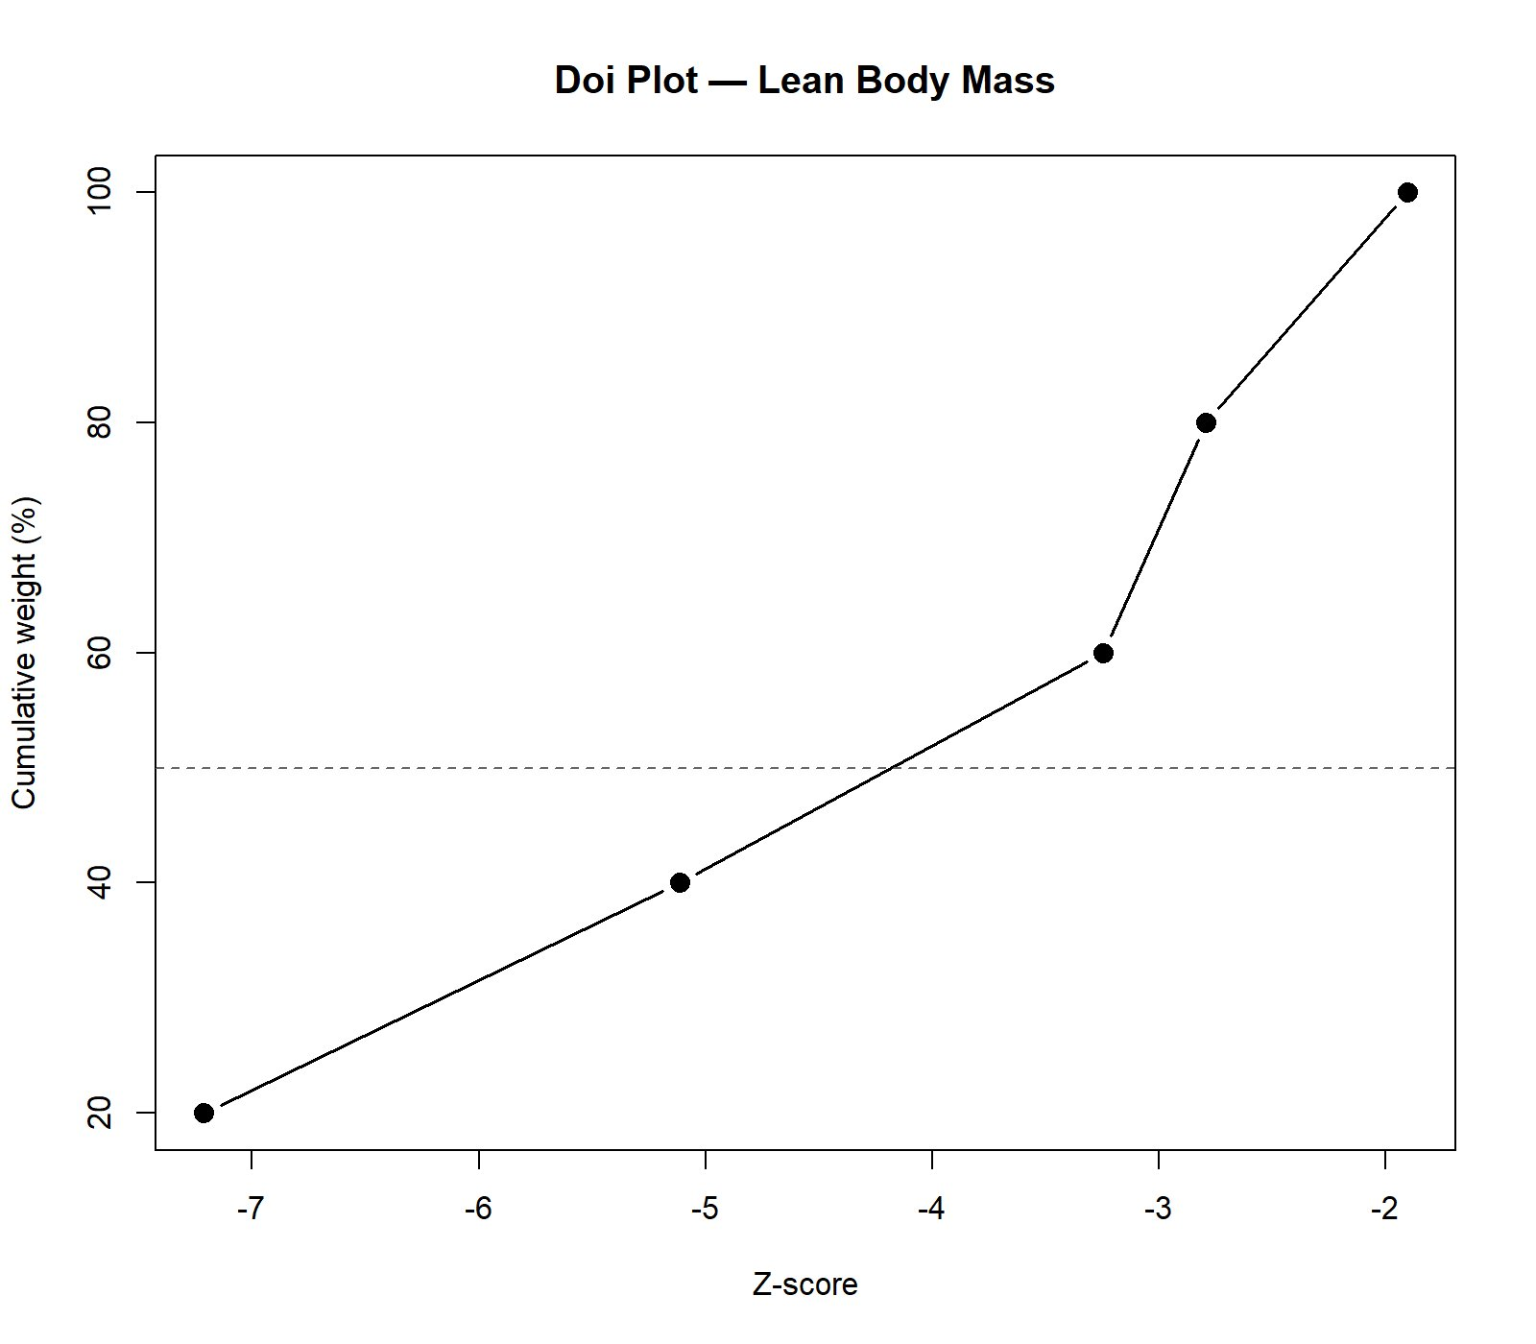
Doi plot for lean body mass
Panel B — Fat mass:
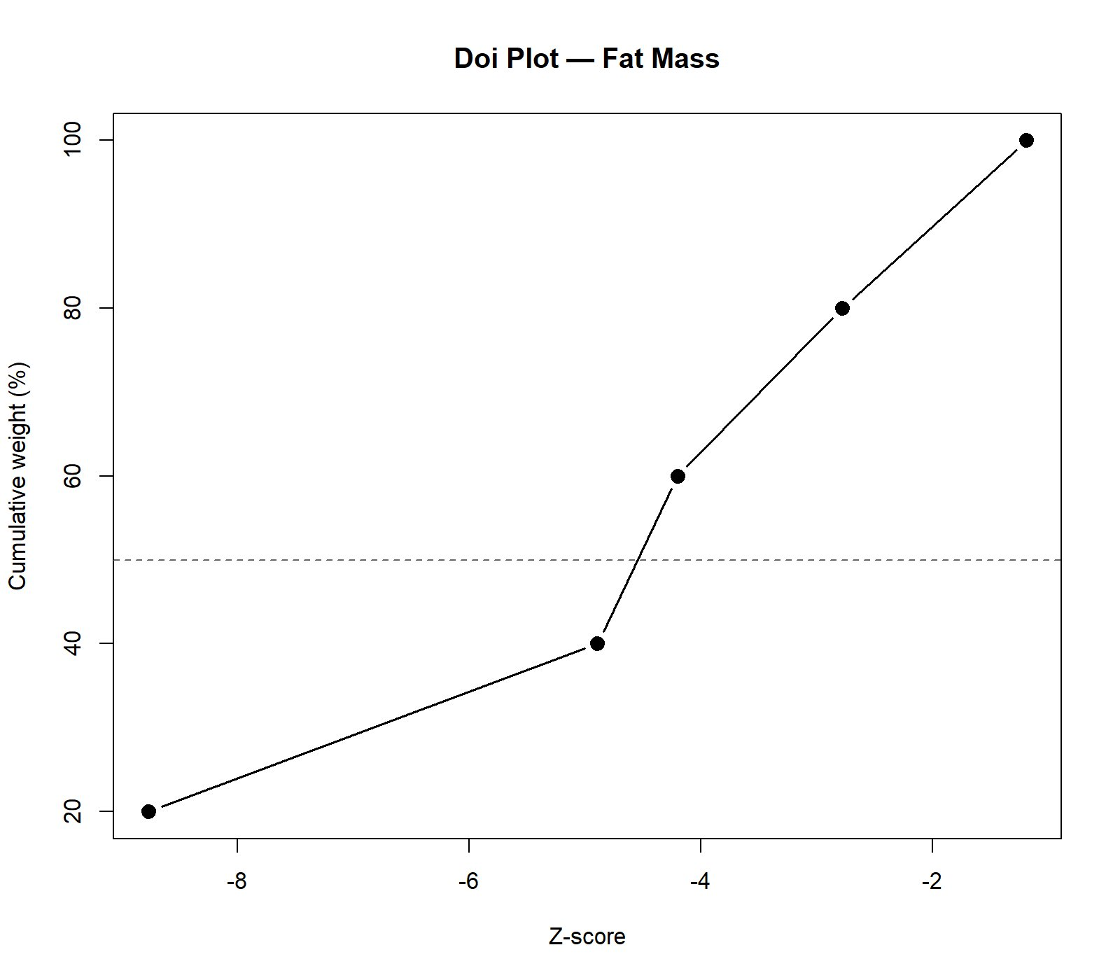
Doi plot for fat mass

Figure S3. Bayesian posterior distributions and prior sensitivity
Posterior distributions of the pooled mean effect (μ) and the between-trial standard deviation (τ) under three half-Cauchy prior scales (0.5, 1.0, 2.0), generated from brms (Hamiltonian Monte Carlo via Stan) and cross-validated against bayesmeta (closed-form posterior under conjugate-prior approximation).
Panel A — Lean body mass posterior:
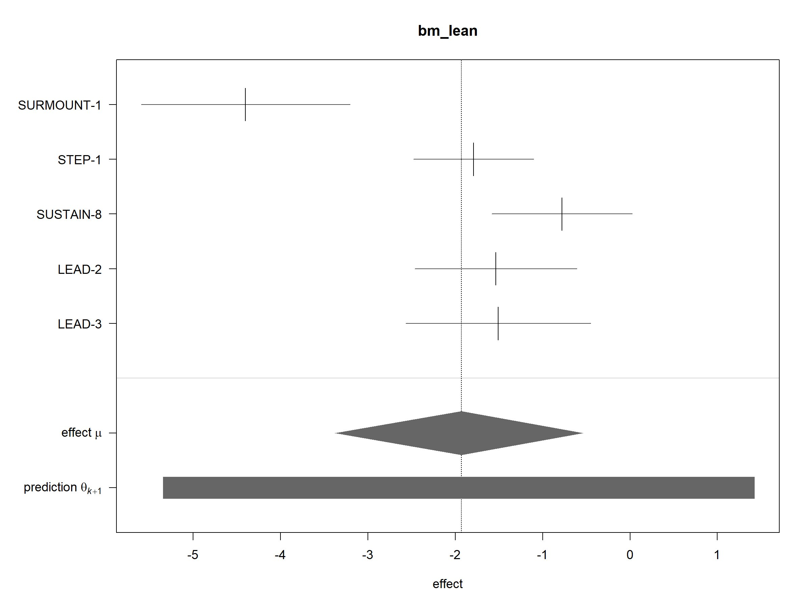
Bayesian posterior distribution, lean body mass
Panel B — Fat mass posterior:
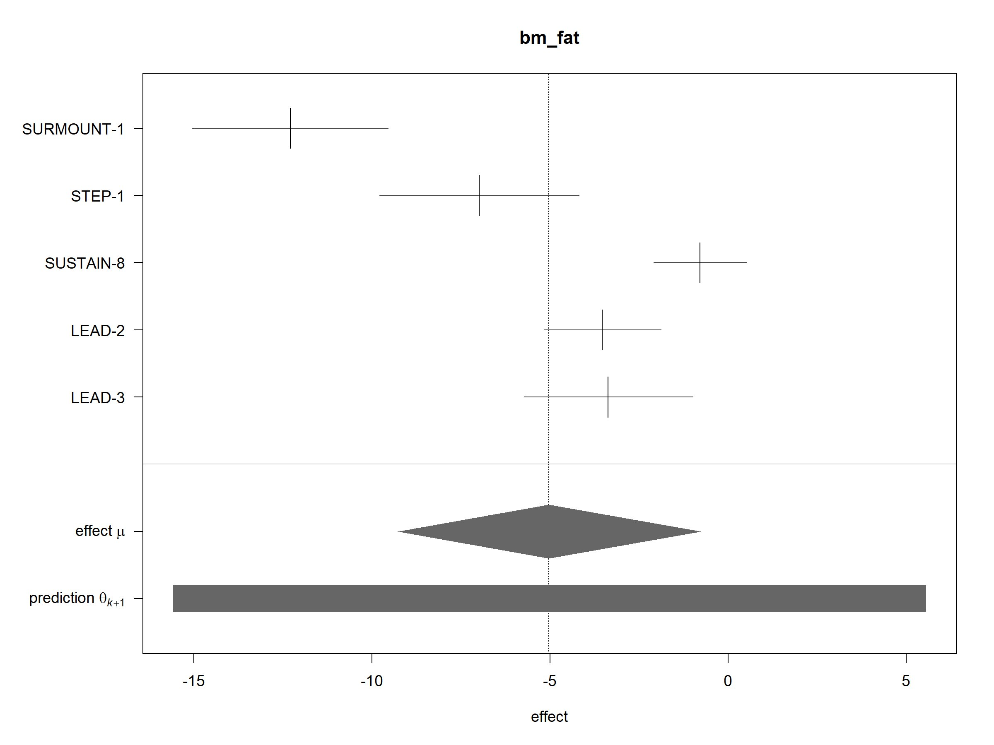
Bayesian posterior distribution, fat mass

Figure S4. Forest plot — Lean body mass by population subgroup
Random-effects meta-analysis (HKSJ-REML) of lean body mass changes stratified by underlying population (T2D vs obesity), with k=3 in the T2D subgroup (SUSTAIN-8, LEAD-2, LEAD-3) and k=2 in the obesity subgroup (SURMOUNT-1, STEP-1). The T2D subgroup yielded MD −1.21 kg (95% CI −2.33, −0.09; p=0.04) with negligible heterogeneity (I²=5.3%), while the obesity subgroup yielded MD −3.05 kg (95% CI −19.62, +13.52) with very high heterogeneity (I²=92.7%), illustrating that the heterogeneity observed in the overall pooled analysis arises predominantly from the obesity-versus-T2D contrast rather than within-population inconsistency.
[See FigS4.jpg in the figure files.]

Figure S5. Forest plot — Fat mass by population subgroup
Random-effects meta-analysis (HKSJ-REML) of fat mass changes stratified by underlying population. The T2D subgroup yielded MD −2.43 kg (95% CI −6.39, +1.52; p=0.12; I²=71.8%); the obesity subgroup yielded MD −9.65 kg (95% CI −43.39, +24.08; p=0.17; I²=85.8%). The wide intervals in the obesity subgroup reflect pooling at k=2 across two pharmacologically distinct interventions (tirzepatide vs semaglutide 2.4 mg) with substantially different absolute weight loss magnitudes.
[See FigS5.jpg in the figure files.]

Supplementary Discussion

Estimand consistency across included trials
All five primary study comparisons used the treatment-policy estimand (intention-to-treat, ANCOVA-adjusted), which estimates the effect of treatment assignment regardless of post-randomisation adherence. SURMOUNT-1 (Look 2025) reported body-composition outcomes pooling tirzepatide doses under the treatment-policy estimand. STEP-1 (Wilding 2021) DXA outcomes were reported under the treatment-policy estimand (Wilding 2021 Supplementary Table S5); kilogram values were derived by applying the reported percentage-point estimated treatment difference and its 95% confidence interval to the pooled baseline lean mass. SUSTAIN-8 (McCrimmon 2020) reported DXA outcomes as between-group differences adjusted for baseline values. LEAD-2 and LEAD-3 (Jendle 2009) DXA outcomes from the Novo Nordisk clinical trial reports were reported as ANCOVA-adjusted least-squares mean differences with baseline value and treatment as covariates. The consistency of the estimand framework across all five comparisons supports the validity of pooling.

LEAD-2 and LEAD-3: cluster justification
LEAD-2 (NN2211-1572) and LEAD-3 (NN2211-1573) were independent randomised trials with non-overlapping participants, different comparator regimens (glimepiride plus metformin vs glimepiride monotherapy), and separate clinical trial reports. Their DXA outcomes were reported jointly in a single substudy publication (Jendle 2009) with overlapping investigator authorship and shared methodological infrastructure. The primary meta-analytic model treats them as independent comparisons. To assess robustness to potential within-publication correlation, two complementary approaches were applied: (i) robust variance estimation with CR2 bias-reduced linearisation treating LEAD-2 and LEAD-3 as a single cluster, and (ii) a three-level random-effects model in which level 1 corresponds to participants within trial, level 2 to trials within cluster, and level 3 to between-cluster variance. Three-level model estimates were stable across all assumed within-study correlation values (ρ = 0 to 1.0), with confidence intervals excluding zero throughout. The RVE marginal non-significance (p = 0.058, Satterthwaite df = 2.6) reflects the extreme conservatism of small-sample corrections at m = 4 clusters (Pustejovsky & Tipton, 2018), not genuine uncertainty about effect direction.

Nutritional and exercise countermeasures
The lean mass reductions observed in this meta-analysis are relevant to clinical practice for incretin-based weight management. General principles of weight-loss-associated lean mass preservation support dietary protein intakes in the range of approximately 1.0–1.5 g/kg/day and the incorporation of resistance exercise during pharmacological weight loss. None of the included primary trials systematically prescribed resistance exercise or controlled dietary protein intake in the DXA subpopulations, which limits the ability to assess whether such interventions modify the lean-to-fat mass ratio during incretin-based therapy. Future trials incorporating body-composition endpoints should consider standardised exercise and dietary co-interventions to address this gap.

