- Input Data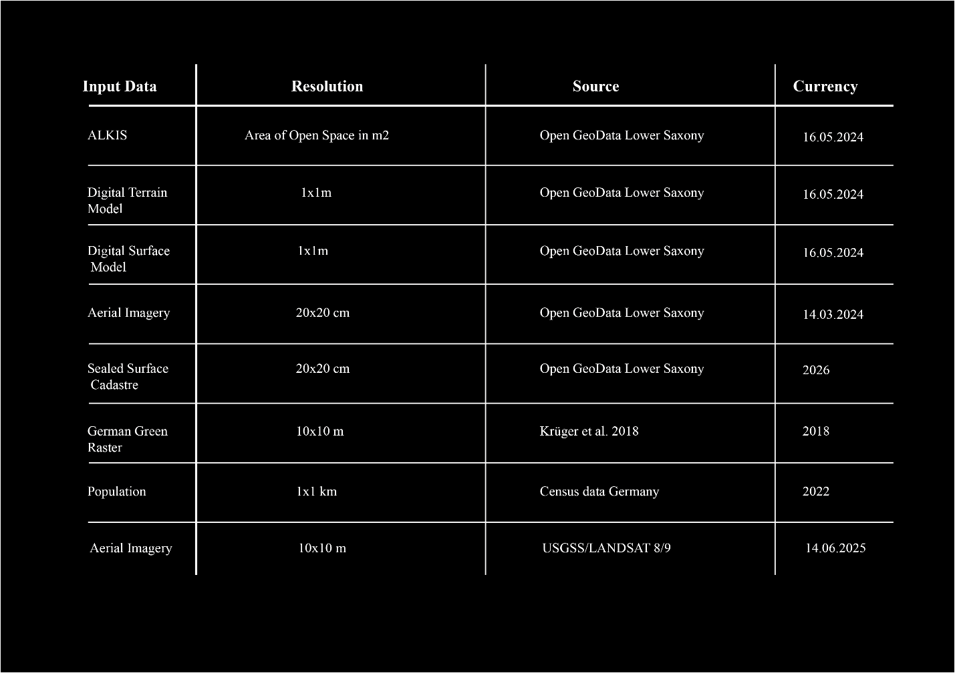
Caption: List of data considered to calculate Climpact attributes
- Climpact Attributes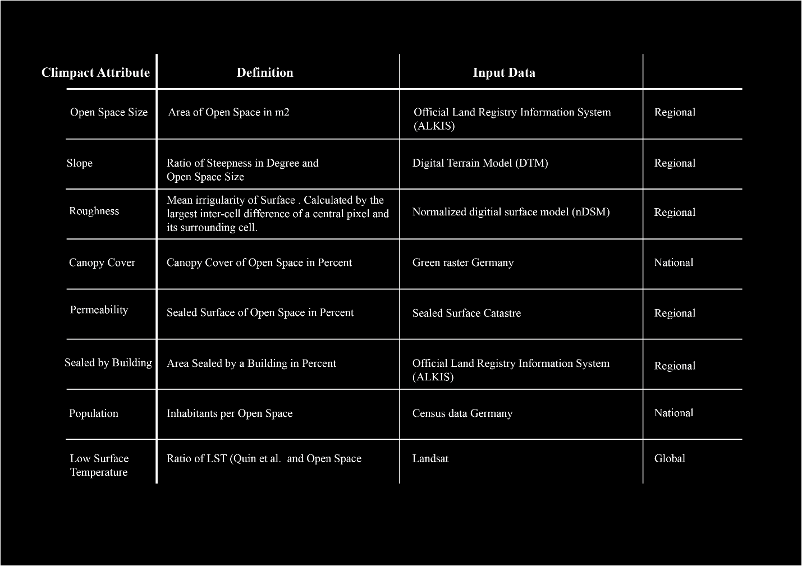
Caption: Overview of Climpact attributes and correspondence to input Dataset
- Climpact Type Median Performance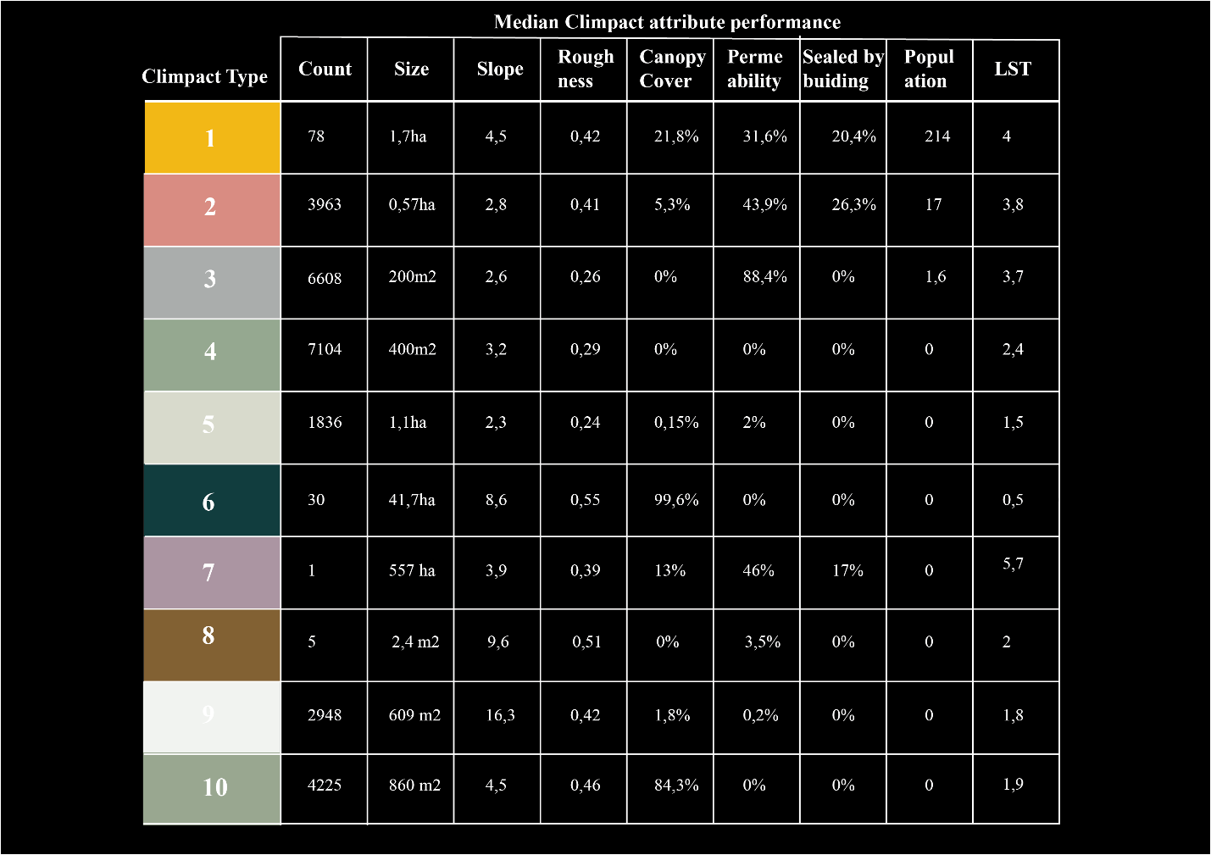
Caption: Median Climpact attribute performance per Climpact type

