Supplementary Files
Supplementary Data

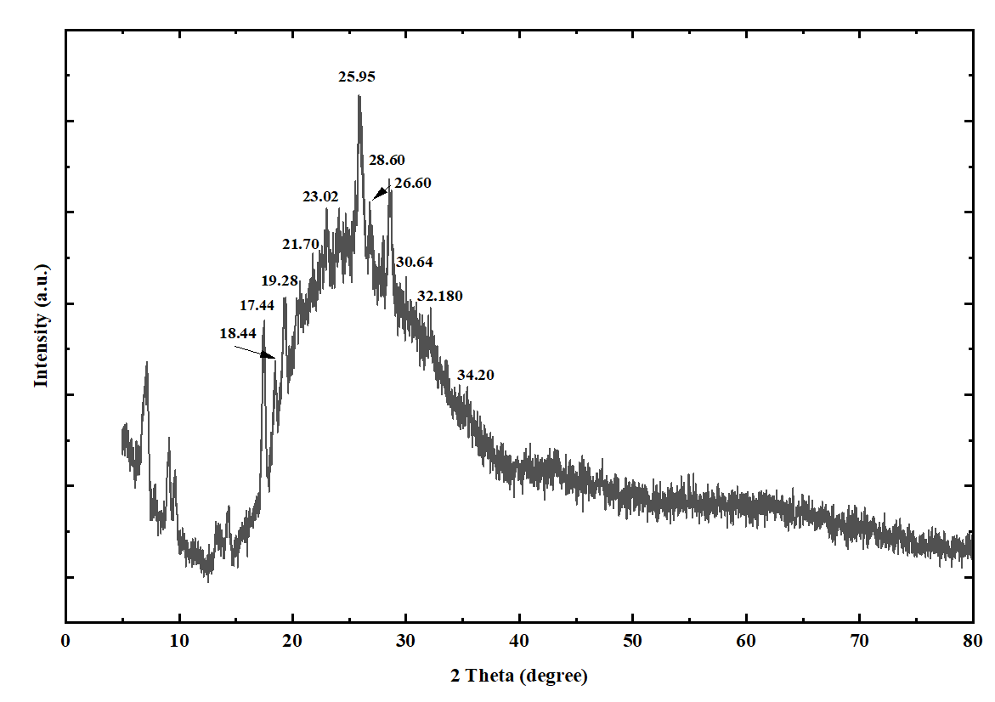
Fig. S1. Structural characterization of the BBR powder by X-ray diffraction (XRD).

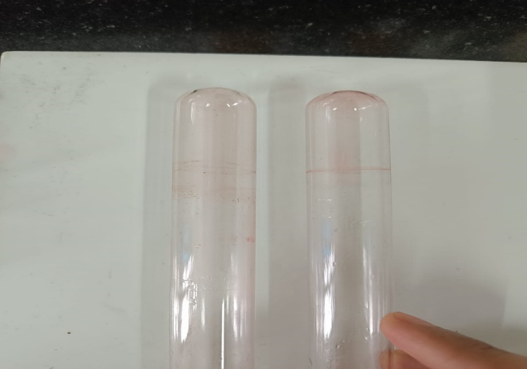
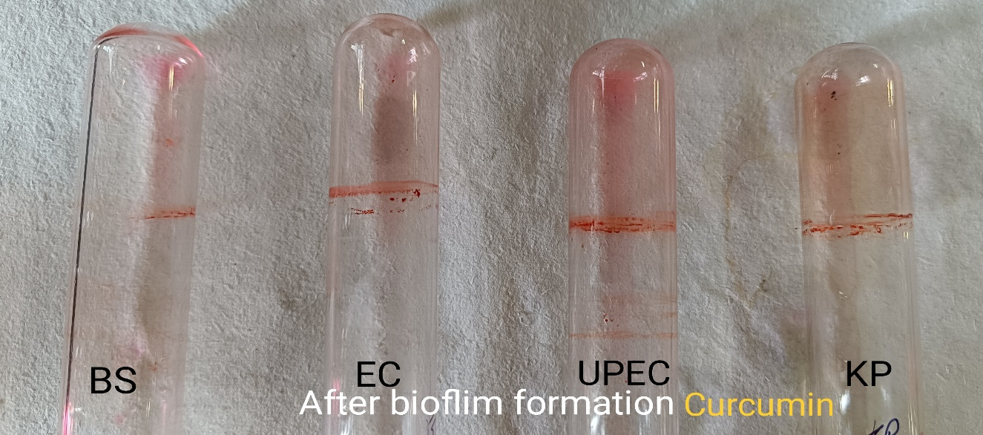
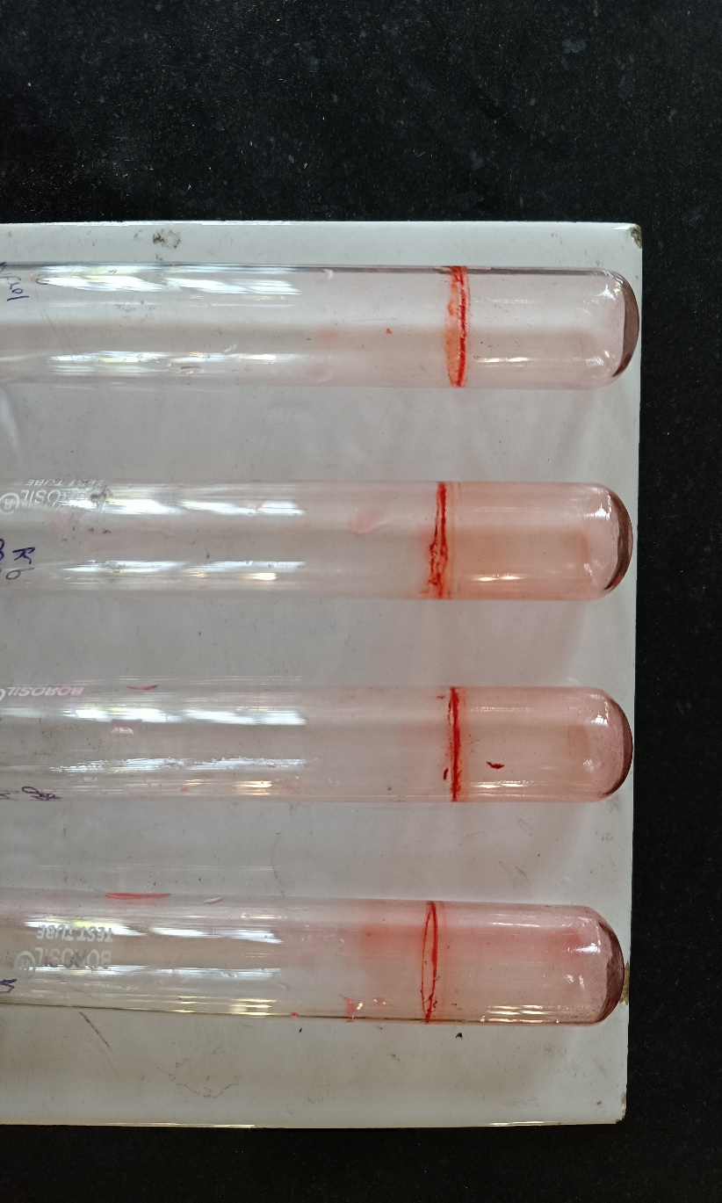
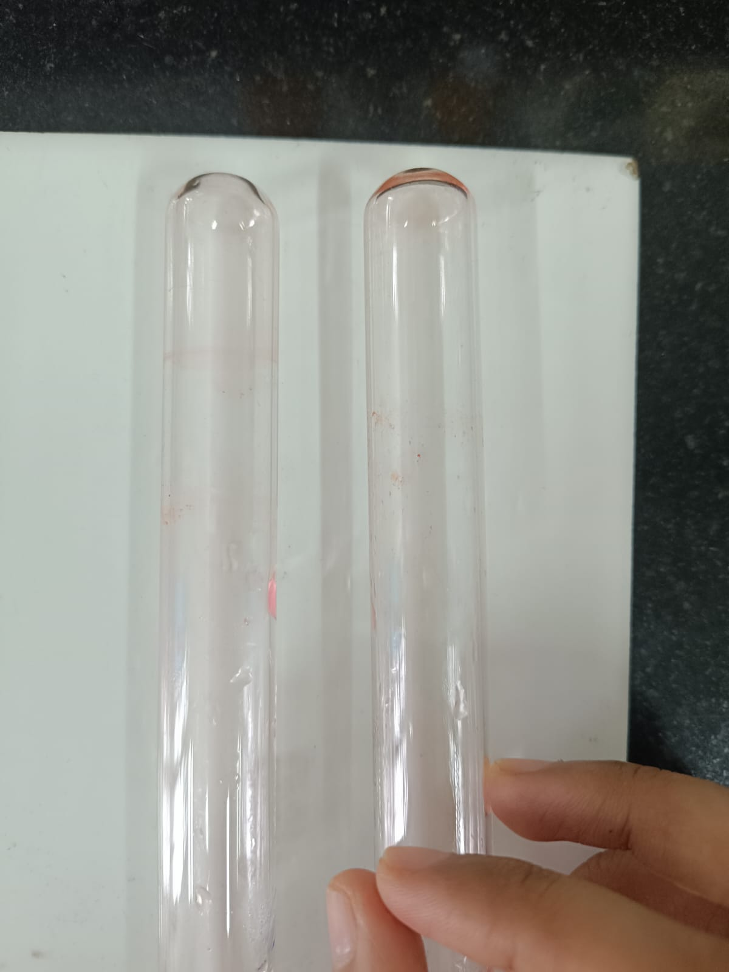
A
C
B
D

Fig. S2. Tube assay showing disruption of preformed biofilm in Uropathogenic Enterobacter hormaechei following treatment with different formulations. (A) Untreated control exhibiting dense biofilm adherence along the tube walls, (B) BBR-treated group showing partial disruption of established biofilm, (C) Mp-AgNPs-treated group demonstrating enhanced biofilm reduction, and (D) Mp-AgNP@BBR nanocomplex-treated group displaying maximum disruption of mature biofilm with minimal residual biomass.

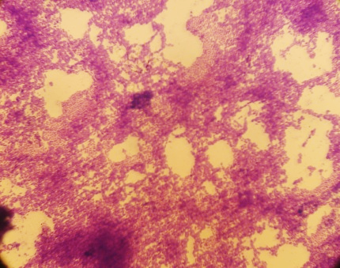
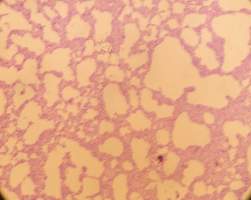
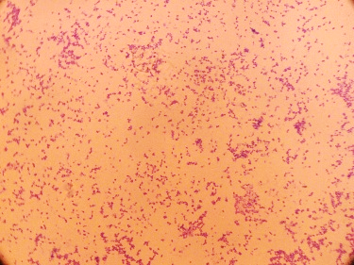
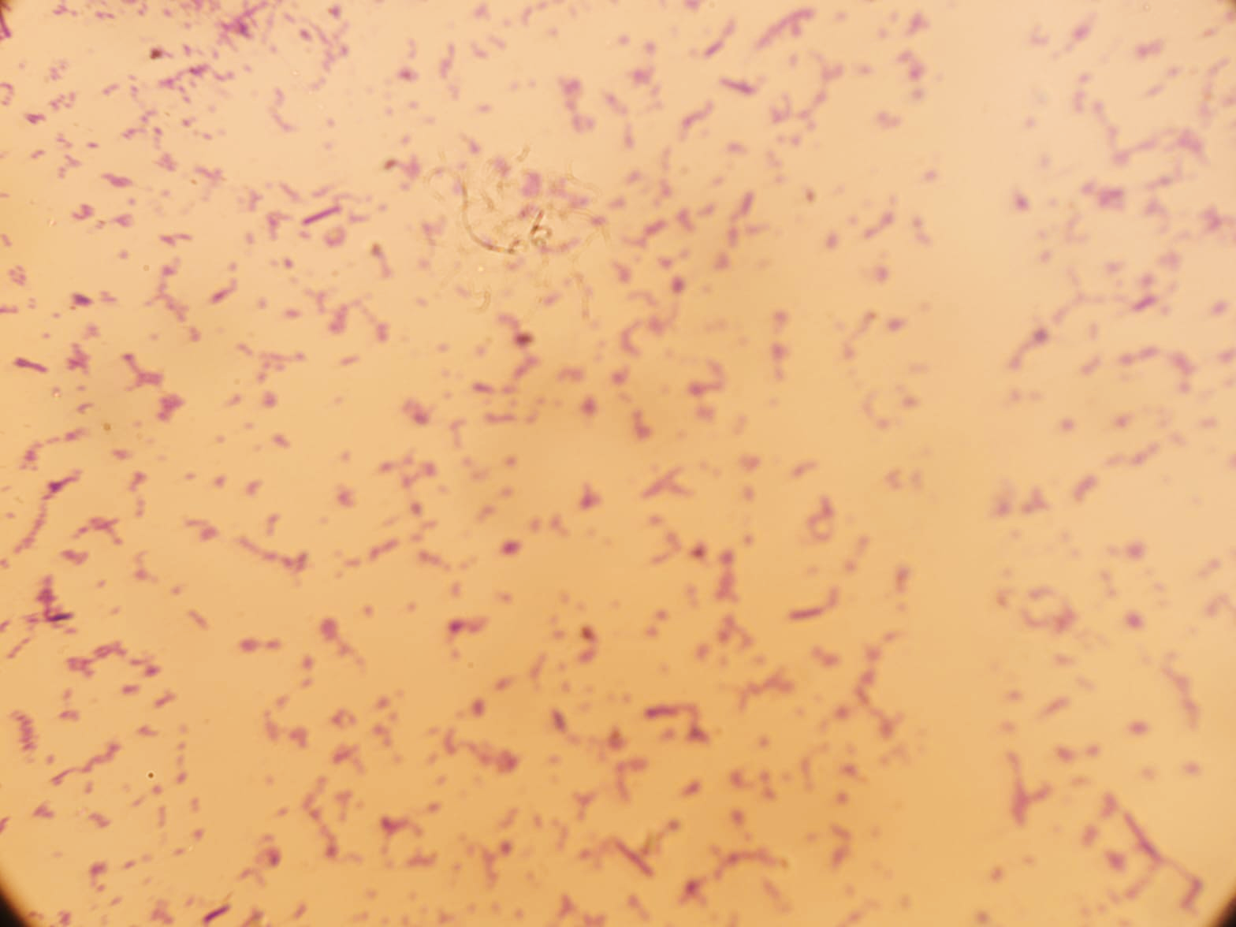
D
C
B
A

Fig. S3. Microscopic observation of preformed biofilm disruption in uropathogenic Enterobacter hormaechei following treatment with different formulations. (A) Untreated control showing dense biofilm formation, (B) BBR-treated group showing partial biofilm disruption, (C) Mp-AgNPs-treated group demonstrating reduced biofilm biomass, and (D) Mp-AgNP@BBR nanocomplex-treated group exhibiting maximum disruption of mature biofilm architecture.

Table S1. Checkerboard microdilution layout for evaluating the interaction between berberine and Mp-AgNPs.

Mp-AgNPs (µg/mL) → / Berberine (µg/mL) ↓ | 128 | 64 | 32 | 16 | 8 | 4 | 2
128 | 0.05 | 0.7 | 0.07 | 0.9 | 0.15 | 0.6 | 0.98
64 | 0.06 | 0.7 | 0.09 | 0.12 | 0.18 | 0.32 | 1.01
32 | 0.08 | 0.12 | 0.12 | 0.2 | 0.35 | 0.5 | 0.92
16 | 0.11 | 0.16 | 0.2 | 0.35 | 0.48 | 0.6 | 0.96
8 | 0.12 | 0.18 | 0.4 | 0.48 | 0.09 | 0.65 | 0.91
4 | 0.2 | 0.35 | 0.5 | 0.6 | 0.65 | 0.7 | 0.89
2 | 0.4 | 0.5 | 0.6 | 0.68 | 0.72 | 0.71 | 0.88

