Supplementary
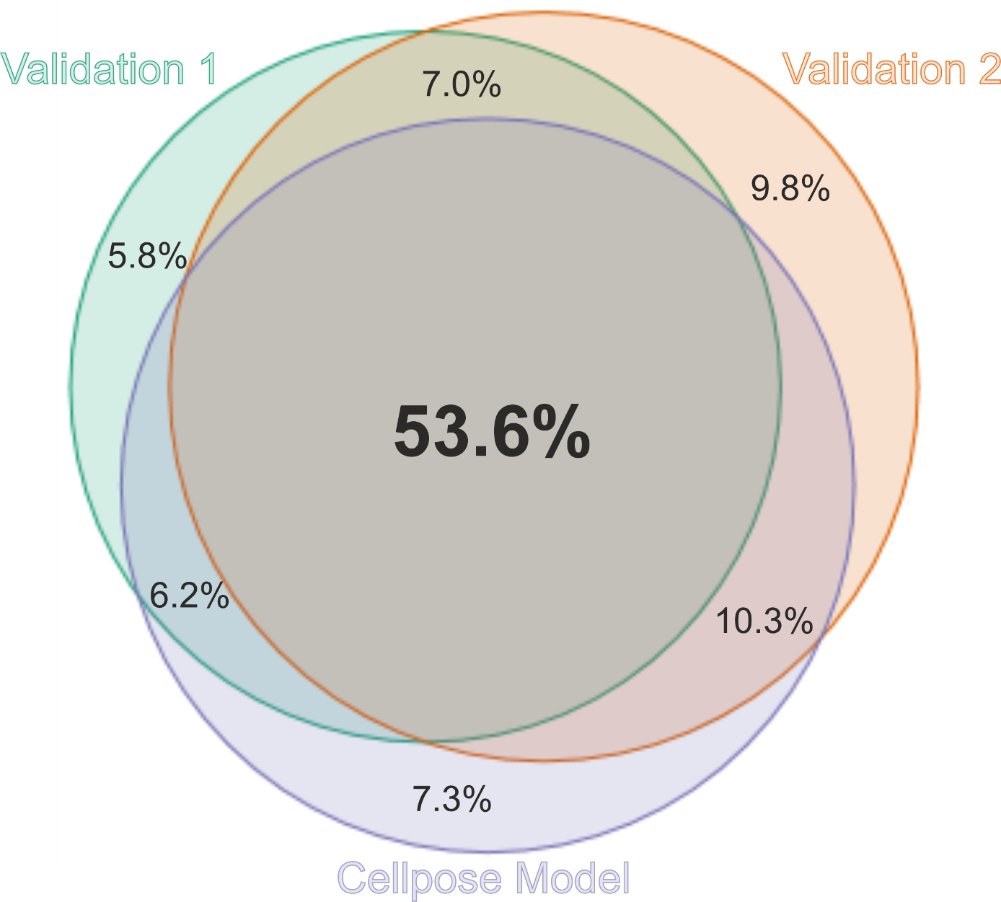
Figure S1: Venn diagram of pixel-wise agreement between Cellpose segmentation and two manual validations. The diagram shows the proportion of pixels shared between the automated Cellpose model and two manual validations (Validation 1 and Validation 2). The central overlap represents pixels consistently segmented across all three approaches, while pairwise overlaps indicate partial agreement between methods.
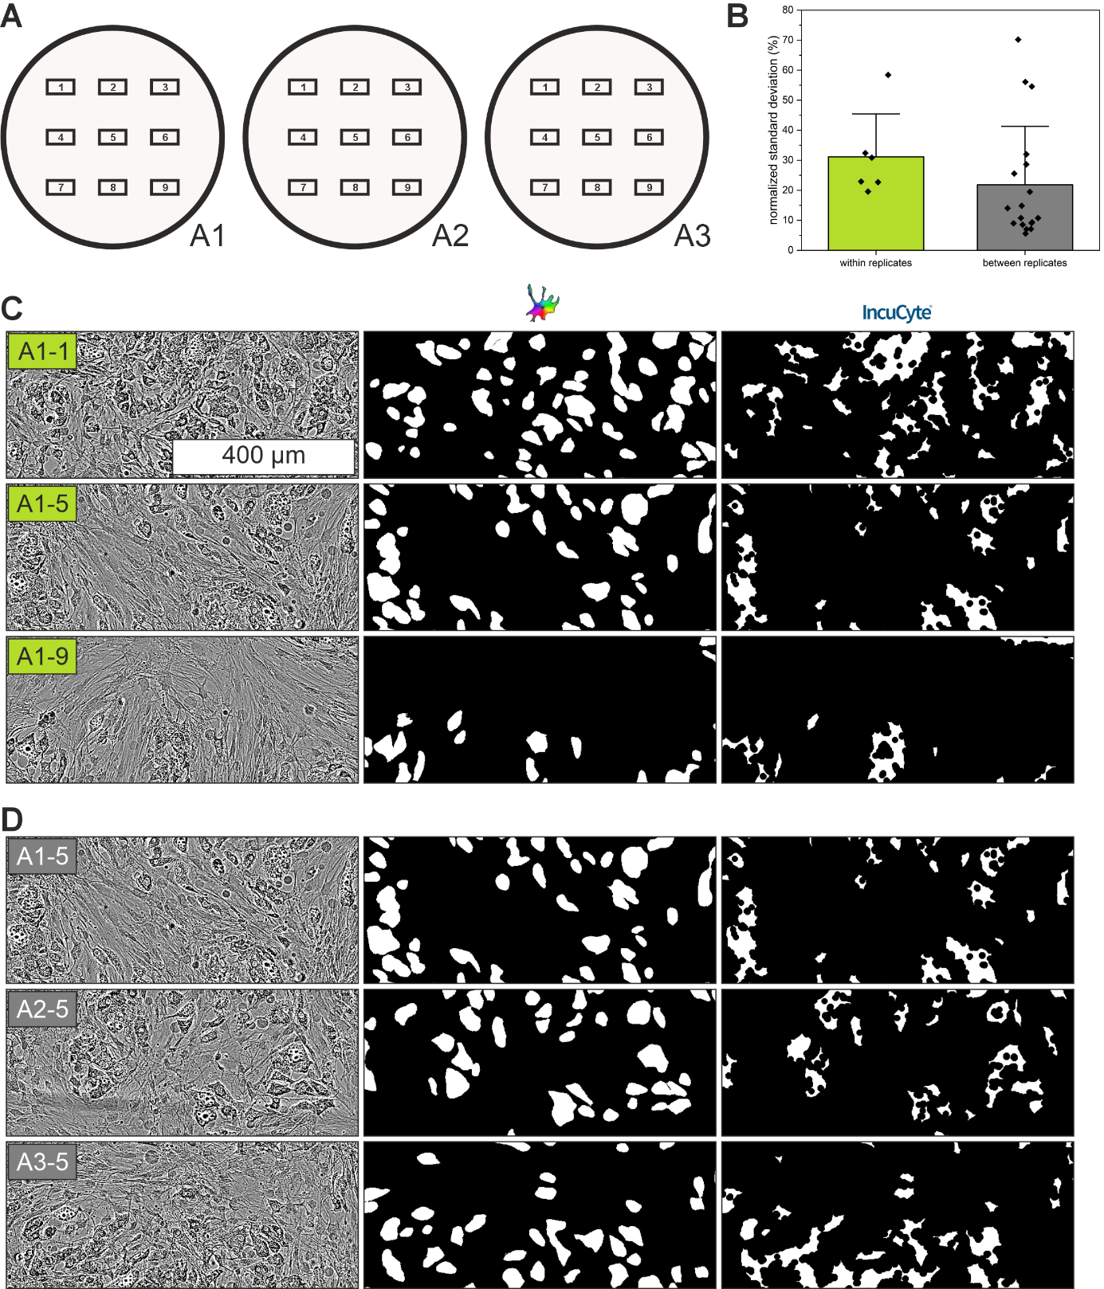
Figure S2: Spatial heterogeneity within replicates. A Graphical representation of the acquired microscopic images (n = 9) from replicates (n = 3) of one condition. B Average standard deviation normalized to the average in per cent of the nine images within the same well of one replicate (n = 6 replicates, green) and the same imaging location between three different replicates of the same condition (n = 9 imaging locations, m = 2 conditions, gray) C+D Exemplary images of differentiated porcine AD-MSCs of the same replicate (C) and of the same imaging position of different replicates of the same condition (D). From left to right: Sections of original images acquired by high-throughput Incucyte imaging; Overlay of the mask of the Cellpose model for adipocyte quantification; Overlay of the Incucyte analysis mask for adipocyte quantification
Table S1: Quantitative Validation parameters of the Cellpose-based adipocyte segmentation model compared to two independent manual annotations. Dice coefficient (F1-score), Intersection over Union (IoU), precision, and recall were calculated based on pixel-wise overlap between segmentation masks.
 | Dice Coefficient | IoU | Precision | Recall
Cellpose Model  vs Manual Annotation 1 | 0.809 | 0.679 | 0.826 | 0.792
Cellpose Model  vs Manual Annotation 2 | 0.797 | 0.663 | 0.773 | 0.824
Manual Annotation 1  vs Manual Annotation 2 | 0.790 | 0.654 | - | -

