Graphical Abstract
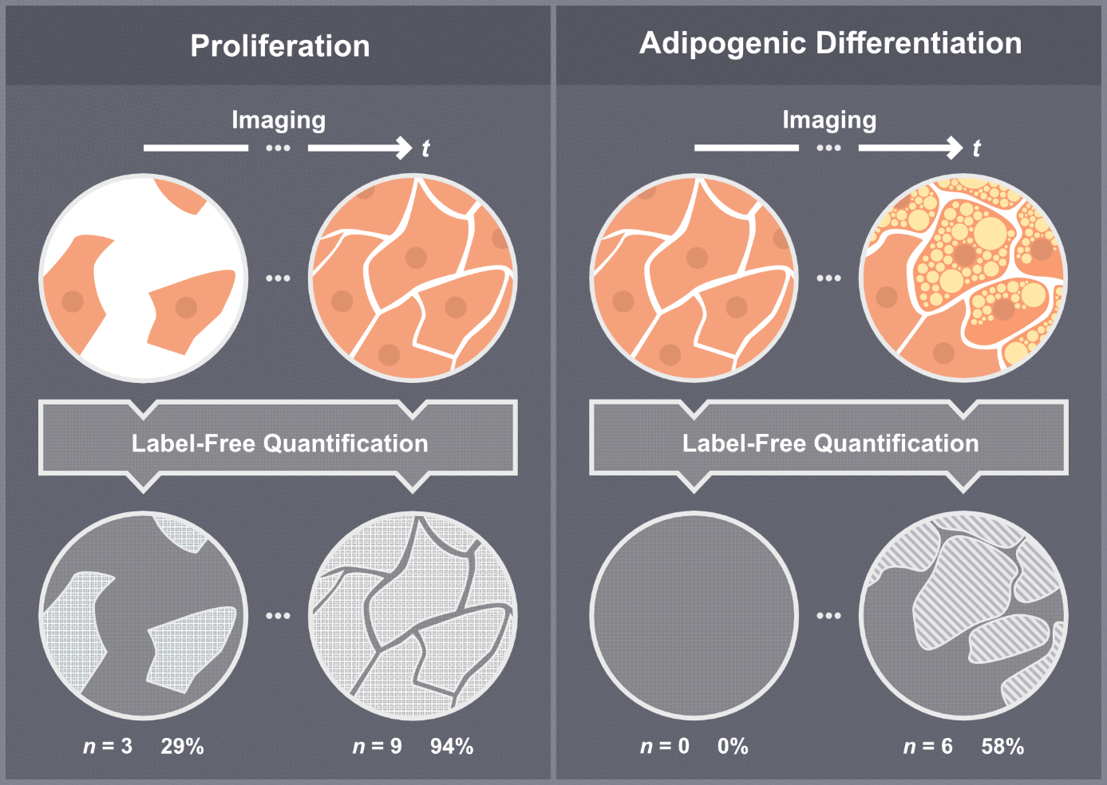
Label-free, high-throughput live-cell imaging was used to monitor proliferation and adipogenic differentiation of human and porcine adipose-derived mesenchymal stem cells. Customized platform-integrated analyses and custom-trained Cellpose models enabled quantitative assessment of cell number, confluence, adipocyte number, and adipocyte area across species and imaging modalities.

