Electronic Supplementary Material (ESI)
Virtual screening of PEBP1 inhibitors by combining 2D/3D-QSAR analysis, Hologram QSAR, Homology modeling, molecular docking analysis and molecular dynamic simulations
Mourad Stitou, Hamid Toufik*, Taoufik Akabli and Fatima Lamchouri
Laboratory of Natural Substances, Pharmacology, Environment, Modeling, Health & Quality of Life (SNAMOPEQ). Polydisciplinary Faculty of Taza, Sidi Mohamed Ben Abdellah University of Fez – Morocco B.P 1223, Taza Gare – Taza – Morocco
* Corresponding Author:
Prof. Hamid TOUFIK,
Laboratory of Natural Substances, Pharmacology, Environment, Modeling, Health & Quality of Life (SNAMOPEQ), Polydisciplinary Faculty of Taza, Sidi Mohamed Ben Abdellah University of Fez B.P.: 1223, Taza-Gare. Taza, Morocco.
Email: hamid.toufik@usmba.ac.ma
Mobile: +212 6 61 05 45 67

Table of contents
List of Tables
Table A1: Data Set of 38 descriptors obtained by the two studied quantum methods and topological methods. 2
Table A2: Correlation matrix of calculated descriptors using AM1-based method and topological methods. 3
Table A4. Selected descriptors in 2D- QSAR models 4
Table A5: Predicted and observed values with their residuals from 2D-QSAR models 5
Table A6: Predicted and observed values with their residuals from 3D-QSAR and HQSAR models. 6
Table A7. Ramachandran plot statistics of generated PEBP1 model. 7

List of Figures

Figure A1. 2D and 3D representations of the molecular docking interactions between compound M29 against modeled PEBP1 protein 9
Figure A2. 2D and 3D representations of the molecular docking interactions between compound M26 against modeled PEBP1 protein. 10
Figure A3. 2D and 3D representations of the molecular docking interactions between predicted compound X1 against modeled PEBP1 protein. 10
Figure A4. 2D and 3D representations of the molecular docking interactions between predicted compound X2 against modeled PEBP1 protein 11
Figure A5. 2D and 3D representations of the molecular docking interactions between predicted compound X3 against modeled PEBP1 protein. 12

Table A1: Data Set of 38 descriptors obtained by the two studied quantum methods and topological methods.
Symbol | Description | 2D or 3D | Level of theory
E_{HOMO (eV)} | Highest Occupied Molecular Orbital | 3D | AM1 | DFT (B3LYP/6-31G)
E_{LUMO (eV)} | Lowest Unoccupied Molecular Orbital | 3D | AM1 | DFT (B3LYP/6-31G)
Egap _{(eV)} | Egap energies = E_{LUMO}-E_{HOMO} | 3D | AM1 | DFT (B3LYP/6-31G)
µ | Chemical potential | 3D | AM1 | DFT (B3LYP/6-31G)
DM | Dipole Moment | 3D | AM1 | DFT (B3LYP/6-31G)
χ | Electronegativity; χ = - (E_{LUMO}+E_{HOMO})/2 | 3D | AM1 | DFT (B3LYP/6-31G)
η | Absolute hardness; η = (E_{LUMO}-E_{HOMO})/2 | 3D | AM1 | DFT (B3LYP/6-31G)
ω | Electrophilicity index ; ω = χ²/2η | 3D | AM1 | DFT (B3LYP/6-31G)
ΔE act _{(eV)} | Activation energy | 3D | AM1 | DFT (B3LYP/6-31G)
λmax | Maximum absorption wavelengths | 3D | AM1 | DFT (B3LYP/6-31G)
f | Oscillator strength | 3D | AM1 | DFT (B3LYP/6-31G)
E (ZINDO) _{(eV)} | Calculated energy at ZINDO level | 3D | AM1 | -
E (TD-DFT) _{(eV)} | Calculated Energy at TD-DFT level | 3D | - | DFT (B3LYP/6-31G)
HBA | Hydrogen Bond Acceptor | 2D | MM2 Force field
HBD | Hydrogen Bond Donor | 2D
Ovality | Ovality | 2D
MR | Molar refractivity | 2D
Log P | Log of the octanol/water partition coefficient. | 2D
Log S | Log of the aqueous solubility | 2D
balabanJ | Balaban's connectivity topological index | 2D
W | Wiener's connectivity topological index | 2D
TPSA | Polar surface area | 2D
b_1rotN | Number of rotatable bonds | 2D
Tconn | Total connectivity | 2D
Tvconn | Total Valence Connectivity | 2D
(C1, C2, C3) | Mulliken atomic charges | 2D
MW | Molecular Weight | 2D

Table A2: Correlation matrix of calculated descriptors using AM1-based method and topological methods.
Variables | E_{HOMO} | E_{LUMO} | Egap | µ | X | ŋ | ω | f | λmax | EZindo | H accep | Ovality | C2 | C3 | PIC50
E_{HOMO} | 1.00
E_{LUMO} | 0.21 | 1.00
Egap | -0.40 | 0.81 | 1.00
µ | 0.66 | 0.88 | 0.42 | 1.00
X | -0.66 | -0.88 | -0.42 | -1.00 | 1.00
ŋ | -0.40 | 0.81 | 1.00 | 0.42 | -0.42 | 1.00
ω | -0.91 | -0.61 | -0.02 | -0.92 | 0.92 | -0.02 | 1.00
f | 0.16 | -0.05 | -0.15 | 0.04 | -0.04 | -0.15 | -0.13 | 1.00
λmax | -0.25 | -0.71 | -0.51 | -0.67 | 0.67 | -0.51 | 0.52 | -0.29 | 1.00
EZindo | 0.20 | -0.69 | -0.77 | -0.43 | 0.43 | -0.77 | 0.13 | 0.34 | 0.25 | 1.00
HBA | -0.13 | -0.84 | -0.71 | -0.71 | 0.71 | -0.71 | 0.47 | 0.18 | 0.63 | 0.76 | 1.00
Ovality | 0.41 | -0.59 | -0.80 | -0.25 | 0.25 | -0.80 | -0.08 | 0.33 | 0.39 | 0.60 | 0.67 | 1.00
C2 | -0.28 | -0.06 | 0.11 | -0.18 | 0.18 | 0.11 | 0.26 | -0.11 | 0.17 | -0.20 | -0.08 | -0.22 | 1.00
C3 | -0.40 | -0.19 | 0.07 | -0.34 | 0.34 | 0.07 | 0.42 | -0.37 | 0.43 | -0.27 | 0.04 | -0.19 | 0.89 | 1.00
PIC50 | 0.41 | -0.46 | -0.67 | -0.15 | 0.15 | -0.67 | -0.13 | 0.27 | 0.40 | 0.58 | 0.64 | 0.63 | -0.28 | -0.24 | 1.00

Table A3: Correlation matrix of calculated descriptors using DFT-based method and topological methods.
Variables | E_{HOMO} | E_{LUMO} | Egap | µ | X | ŋ | ω | f | λmax | E _{TD-DFT} | HBA | ovality | C3 | C2 | PIC50
E_{HOMO} | 1.00
E_{LUMO} | 0.21 | 1.00
Egap | -0.10 | 0.95 | 1.00
µ | 0.48 | 0.96 | 0.83 | 1.00
X | -0.48 | -0.96 | -0.83 | -1.00 | 1.00
ŋ | -0.10 | 0.95 | 1.00 | 0.83 | -0.83 | 1.00
ω | -0.28 | -0.99 | -0.91 | -0.97 | 0.97 | -0.91 | 1.00
f | 0.65 | 0.16 | -0.05 | 0.33 | -0.33 | -0.05 | -0.13 | 1.00
λmax | 0.11 | -0.84 | -0.89 | -0.73 | 0.73 | -0.89 | 0.81 | 0.00 | 1.00
E_{TD-DFT} | 0.26 | 0.70 | 0.63 | 0.71 | -0.71 | 0.63 | -0.71 | -0.02 | -0.56 | 1.00
HBA | -0.23 | -0.85 | -0.80 | -0.83 | 0.83 | -0.80 | 0.90 | -0.02 | 0.72 | -0.75 | 1.00
ovality | 0.11 | -0.60 | -0.64 | -0.51 | 0.51 | -0.64 | 0.60 | 0.30 | 0.56 | -0.82 | 0.66 | 1.00
C3 | 0.08 | -0.17 | -0.20 | -0.13 | 0.13 | -0.20 | 0.14 | -0.13 | 0.33 | 0.11 | 0.03 | -0.21 | 1.00
C2 | 0.10 | -0.06 | -0.09 | -0.03 | 0.03 | -0.09 | 0.04 | -0.07 | 0.14 | 0.23 | -0.09 | -0.22 | 0.89 | 1.00
PIC50 | 0.30 | -0.55 | -0.66 | -0.41 | 0.41 | -0.66 | 0.58 | 0.40 | 0.57 | -0.40 | 0.66 | 0.64 | -0.23 | -0.28 | 1.00

Table A4. Selected descriptors in 2D- QSAR models.

cpds ID | AM1-Based method |  |  |  | DFT-Based method
cpds ID | Egap (ev) | TVConn | C3 | HBA | Egap (ev) | E_{TD-DFT} (eV) | f | HBA
1 | 10.36 | 6E-07 | 0.036 | 2 | 6.28 | -38035 | 0.0207 | 2
2 | 10.43 | 1.1E-07 | 0.039 | 2 | 6.38 | -42189 | 0.0034 | 2
3 | 9.92 | 3.2E-08 | 0.038 | 3 | 5.88 | -44203 | 0.0002 | 3
4 | 10.37 | 4.8E-07 | 0.238 | 2 | 5.92 | -38003 | 0.0002 | 2
6 | 9.81 | 1E-07 | 0.29 | 3 | 4.97 | -41085 | 0.0002 | 3
8 | 9.21 | 2.3E-08 | 0.28 | 4 | 4.50 | -44169 | 0.0001 | 4
9 | 9.80 | 7.9E-08 | 0.29 | 3 | 4.97 | -42155 | 0.0002 | 3
10 | 9.41 | 9.7E-09 | 0.04 | 3 | 4.98 | -46265 | 0.0005 | 3
11 | 9.12 | 8.4E-09 | 0.039 | 3 | 5.22 | -47334 | 0.01 | 3
12 | 9.12 | 7.5E-09 | 0.04 | 4 | 5.70 | -46701 | 0.0002 | 4
13 | 9.31 | 2.8E-09 | 0.037 | 4 | 4.86 | -48278 | 0.0002 | 4
14 | 8.94 | 2.4E-09 | 0.038 | 4 | 4.84 | -49348 | 0.0002 | 4
15 | 9.51 | 2.2E-09 | 0.037 | 5 | 4.62 | -48714 | 0.0003 | 5
16 | 9.33 | 4.1E-08 | 0.24 | 3 | 4.96 | -42078 | 0.0001 | 3
17 | 9.18 | 3.6E-08 | 0.24 | 3 | 5.05 | -43148 | 0.0001 | 3
18 | 9.11 | 3.2E-08 | 0.24 | 3 | 5.04 | -42514 | 0.0002 | 3
19 | 9.31 | 1.2E-08 | 0.23 | 4 | 4.60 | -44092 | 0.0002 | 4
20 | 8.94 | 1E-08 | 0.23 | 4 | 4.63 | -45162 | 0.0002 | 4
21 | 9.43 | 9.2E-09 | 0.23 | 4 | 4.26 | -44528 | 0 | 4
22 | 8.80 | 6.4E-10 | 0.28 | 5 | 4.40 | -49237 | 0.0036 | 5
24 | 9.03 | 3.9E-10 | 0.28 | 7 | 4.40 | -50109 | 0.0004 | 7
25 | 8.76 | 2E-09 | 0.28 | 5 | 4.22 | -46198 | 0.0056 | 5
26 | 8.47 | 1.7E-09 | 0.26 | 4 | 3.94 | -44268 | 0.0051 | 4
28 | 8.80 | 6.8E-09 | 0.28 | 4 | 4.42 | -44184 | 0.0043 | 4
30 | 8.81 | 5.3E-09 | 0.28 | 5 | 4.22 | -44620 | 0.0004 | 5
5 | 9.80 | 1.4E-07 | 0.23 | 3 | 5.66 | -40017 | 0.0002 | 3
7 | 10.43 | 5.5E-07 | 0.039 | 2 | 5.79 | -39105 | 0.002 | 2
23 | 9.76 | 4.8E-10 | 0.26 | 5 | 4.35 | -51377 | 0.0084 | 5
27 | 9.26 | 1.5E-09 | 0.28 | 5 | 4.39 | -46634 | 0.0011 | 5
29 | 8.48 | 5.9E-09 | 0.27 | 4 | 4.11 | -45253 | 0.0201 | 4

Table A5: Predicted and observed values with their residuals from 2D-QSAR models.
Cpd ID | Status | AM1-Based method |  |  | DFT-Based method |  |  | Observed pIC50
Cpd ID | Status | Predicted pIC50 | Residual | HAT i/i (h*=0.6000) | Predicted pIC50 | Residual | HAT i/i (h*=0.6000) | Observed pIC50
1 | Training | 4.74 | -0.15 | 0.69 | 4.90 | 0.01 | 0.80 | 4.89
2 | Training | 4.16 | 0.01 | 0.33 | 4.20 | 0.05 | 0.25 | 4.14
3 | Training | 4.43 | -0.04 | 0.19 | 4.41 | -0.05 | 0.18 | 4.47
4 | Training | 4.82 | 0.21 | 0.40 | 4.52 | -0.08 | 0.30 | 4.61
6 | Training | 4.83 | -0.03 | 0.19 | 4.95 | 0.07 | 0.12 | 4.87
8 | Training | 5.13 | 0.09 | 0.07 | 5.17 | 0.13 | 0.07 | 5.04
9 | Training | 4.81 | -0.32 | 0.20 | 4.89 | -0.24 | 0.09 | 5.14
10 | Training | 4.62 | -0.20 | 0.14 | 4.68 | -0.12 | 0.17 | 4.81
11 | Training | 4.73 | 0.04 | 0.19 | 4.78 | 0.09 | 0.38 | 4.69
12 | Training | 4.88 | 0.25 | 0.14 | 4.55 | -0.07 | 0.23 | 4.63
13 | Training | 4.79 | -0.06 | 0.13 | 4.82 | -0.03 | 0.13 | 4.85
14 | Training | 4.95 | 0.13 | 0.18 | 4.77 | -0.03 | 0.20 | 4.81
15 | Training | 4.86 | -0.12 | 0.27 | 5.09 | 0.10 | 0.12 | 4.99
16 | Training | 4.91 | 0.09 | 0.09 | 4.90 | 0.08 | 0.09 | 4.81
17 | Training | 4.96 | 0.25 | 0.11 | 4.81 | 0.10 | 0.07 | 4.70
18 | Training | 4.98 | 0.26 | 0.12 | 4.84 | 0.13 | 0.08 | 4.71
19 | Training | 5.02 | 0.09 | 0.06 | 5.14 | 0.21 | 0.06 | 4.93
20 | Training | 5.17 | -0.11 | 0.07 | 5.07 | -0.21 | 0.05 | 5.29
21 | Training | 4.97 | -0.03 | 0.08 | 5.25 | 0.25 | 0.10 | 5.005
22 | Training | 5.42 | 0.13 | 0.11 | 5.25 | -0.04 | 0.15 | 5.29
24 | Training | 5.63 | 0.22 | 0.54 | 5.50 | 0.09 | 0.58 | 5.40
25 | Training | 5.44 | -0.19 | 0.12 | 5.52 | -0.11 | 0.16 | 5.63
26 | Training | 5.39 | -0.28 | 0.23 | 5.53 | -0.14 | 0.25 | 5.67
28 | Training | 5.28 | 0.04 | 0.11 | 5.32 | 0.08 | 0.10 | 5.23
30 | Training | 5.42 | -0.29 | 0.11 | 5.47 | -0.25 | 0.17 | 5.72
5 | Test | 4.81 | 0.55 | 0.11 | 4.72 | 0.46 | 0.25 | 4.26
7 | Test | 4.66 | -0.09 | 0.55 | 4.56 | -0.18 | 0.19 | 4.75
23 | Test | 5.13 | 0.18 | 0.22 | 5.28 | 0.33 | 0.42 | 4.94
27 | Test | 5.23 | 0.14 | 0.16 | 5.32 | 0.22 | 0.09 | 5.09
29 | Test | 5.40 | -0.27 | 0.24 | 5.80 | 0.13 | 1.00 | 5.67

Table A6: Predicted and observed values with their residuals from 3D-QSAR and HQSAR models.

Cpd ID | Status | Observed pIC50 | CoMFA DFT-Based method |  | CoMFA AM1-Based method |  | CoMSIA DFT-Based method |  | CoMSIA AM1-Based method |  | HQSAR
Cpd ID | Status | Observed pIC50 | Predicted pIC50 | Res | Predicted pIC50 | Res | Predicted pIC50 | Res | Predicted pIC50 | Res | Predicted pIC50 | Res
1 | Training | 4.90 | 4.86 | -0.04 | 4.82 | -0.08 | 4.92 | 0.02 | 4.75 | -0.15 | 4.60 | -0.30
2 | Training | 4.15 | 4.31 | 0.17 | 4.32 | 0.17 | 4.37 | 0.22 | 4.40 | 0.25 | 4.37 | 0.23
3 | Training | 4.48 | 4.50 | 0.03 | 4.51 | 0.03 | 4.48 | 0.00 | 4.46 | -0.02 | 4.57 | 0.10
4 | Training | 4.61 | 4.52 | -0.09 | 4.71 | 0.10 | 4.52 | -0.09 | 4.49 | -0.12 | 4.54 | -0.07
6 | Training | 4.87 | 4.86 | -0.01 | 4.85 | -0.02 | 4.71 | -0.16 | 4.83 | -0.04 | 4.92 | 0.04
8 | Training | 5.05 | 5.00 | -0.04 | 5.15 | 0.11 | 5.18 | 0.14 | 5.24 | 0.19 | 5.05 | 0.01
9 | Training | 5.14 | 5.05 | -0.09 | 4.97 | -0.17 | 5.19 | 0.04 | 5.26 | 0.11 | 4.89 | -0.25
10 | Training | 4.82 | 4.66 | -0.16 | 4.55 | -0.26 | 4.73 | -0.09 | 4.68 | -0.14 | 4.68 | -0.14
11 | Training | 4.69 | 4.75 | 0.06 | 4.84 | 0.15 | 4.85 | 0.16 | 4.78 | 0.08 | 4.74 | 0.05
12 | Training | 4.63 | 4.57 | -0.06 | 4.52 | -0.11 | 4.59 | -0.05 | 4.67 | 0.03 | 4.65 | 0.01
13 | Training | 4.86 | 4.89 | 0.04 | 4.90 | 0.05 | 4.91 | 0.05 | 4.82 | -0.03 | 4.87 | 0.01
14 | Training | 4.82 | 4.91 | 0.10 | 4.67 | -0.15 | 4.83 | 0.01 | 4.73 | -0.09 | 4.94 | 0.12
15 | Training | 4.99 | 4.95 | -0.05 | 4.97 | -0.03 | 4.88 | -0.11 | 4.81 | -0.18 | 4.84 | -0.15
16 | Training | 4.82 | 4.83 | 0.01 | 4.82 | 0.00 | 4.86 | 0.04 | 4.77 | -0.04 | 4.84 | 0.02
17 | Training | 4.71 | 4.94 | 0.24 | 4.80 | 0.10 | 4.86 | 0.16 | 4.78 | 0.07 | 4.91 | 0.20
18 | Training | 4.72 | 4.75 | 0.04 | 4.79 | 0.08 | 4.73 | 0.02 | 4.78 | 0.07 | 4.81 | 0.10
19 | Training | 4.93 | 4.99 | 0.05 | 5.10 | 0.16 | 4.98 | 0.04 | 5.21 | 0.28 | 5.04 | 0.11
20 | Training | 5.29 | 5.09 | -0.20 | 5.09 | -0.20 | 4.98 | -0.31 | 5.20 | -0.09 | 5.10 | -0.19
21 | Training | 5.00 | 4.92 | -0.08 | 5.06 | 0.06 | 5.03 | 0.02 | 5.21 | 0.20 | 5.01 | 0.00
22 | Training | 5.29 | 5.35 | 0.06 | 5.42 | 0.13 | 5.14 | -0.15 | 5.29 | 0.00 | 5.39 | 0.10
24 | Training | 5.41 | 5.43 | 0.02 | 5.45 | 0.04 | 5.42 | 0.02 | 5.36 | -0.05 | 5.43 | 0.02
25 | Training | 5.64 | 5.55 | -0.09 | 5.53 | -0.11 | 5.53 | -0.11 | 5.53 | -0.11 | 5.62 | -0.02
26 | Training | 5.68 | 5.82 | 0.15 | 5.63 | -0.05 | 5.51 | -0.17 | 5.42 | -0.26 | 5.64 | -0.03
28 | Training | 5.24 | 5.35 | 0.11 | 5.42 | 0.18 | 5.42 | 0.18 | 5.46 | 0.22 | 5.46 | 0.23
30 | Training | 5.72 | 5.59 | -0.14 | 5.54 | -0.18 | 5.84 | 0.12 | 5.54 | -0.18 | 5.53 | -0.19
5 | Test | 4.26 | 4.69 | 0.43 | 4.56 | 0.30 | 4.63 | 0.36 | 4.74 | 0.48 | 4.73 | 0.11
7 | Test | 4.75 | 4.72 | -0.03 | 4.83 | 0.08 | 5.06 | 0.31 | 5.20 | 0.45 | 4.57 | -0.18
23 | Test | 4.95 | 5.35 | 0.40 | 4.96 | 0.01 | 5.09 | 0.15 | 4.96 | 0.01 | 5.38 | 0.44
27 | Test | 5.09 | 5.50 | 0.41 | 5.60 | 0.51 | 5.60 | 0.51 | 5.40 | 0.31 | 5.50 | 0.41
29 | Test | 5.68 | 5.38 | -0.30 | 5.26 | -0.42 | 5.40 | -0.28 | 5.36 | -0.32 | 5.48 | -0.19

Table A7. Ramachandran plot statistics of generated PEBP1 model.
Ramachandran plot statistics | Amino-acid residues | Residues (%)
Favored regions [A, B, L] | 135 | 87.70
Additional allowed regions [a, b, l, p] | 19 | 12.30
No. of non-glycine and non-proline residues | 154 | 100
No. of end residues (exclusive of Gly and Pro) | 1 | -
No. of glycine residues | 15 | -
No. of proline residues | 14 | -
Total No. of residues | 184 | -

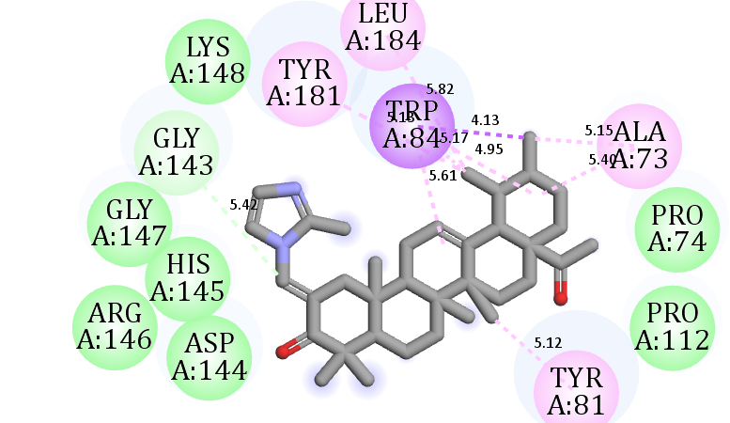
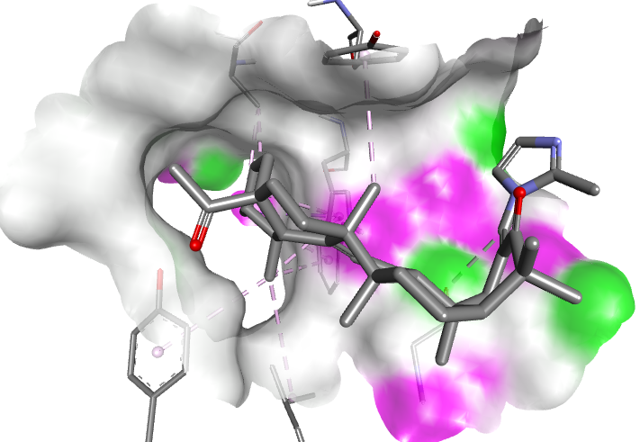
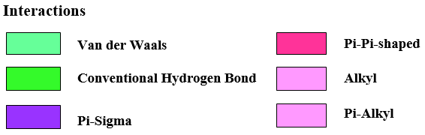
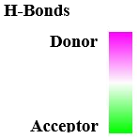
Figure A1. 2D and 3D representations of the molecular docking interactions between compound M29 against modeled PEBP1 protein.

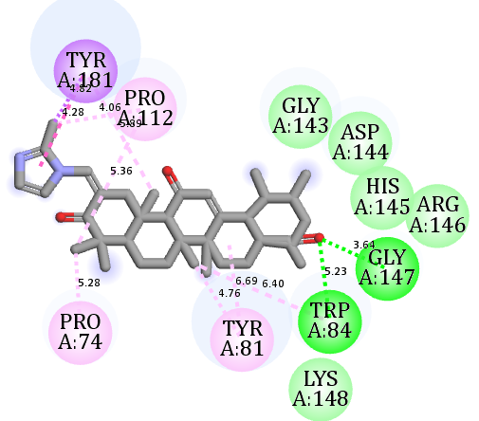
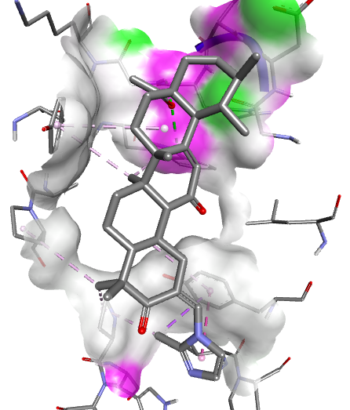
Figure A2. 2D and 3D representations of the molecular docking interactions between compound M26 against modeled PEBP1 protein.

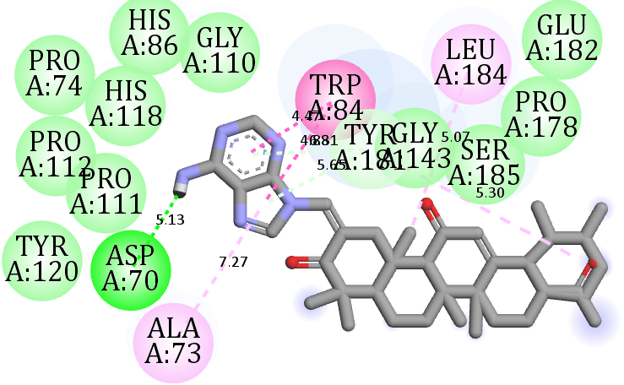
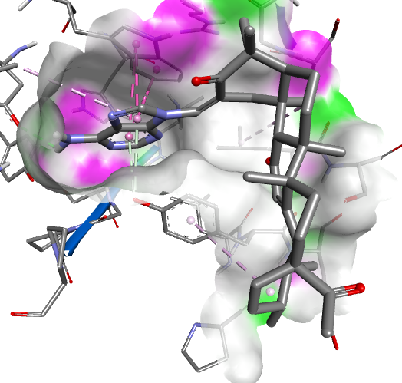
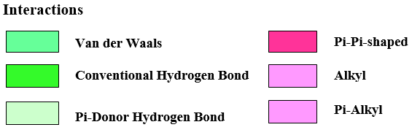
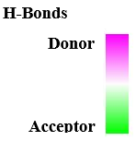
Figure A3. 2D and 3D representations of the molecular docking interactions between predicted compound X1 against modeled PEBP1 protein.

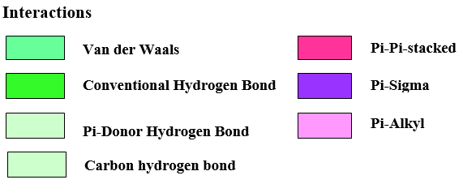
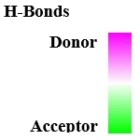
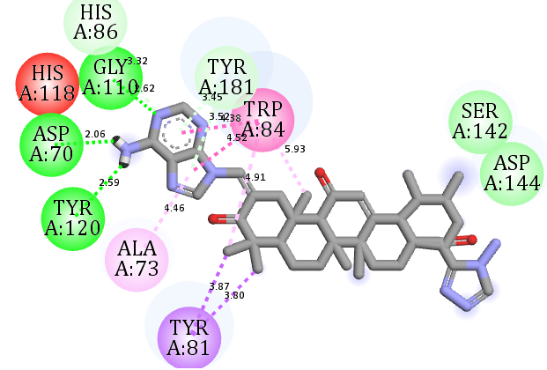
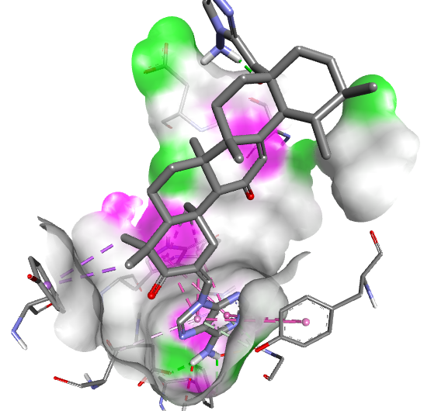
Figure A4. 2D and 3D representations of the molecular docking interactions between predicted compound X2 against modeled PEBP1 protein.

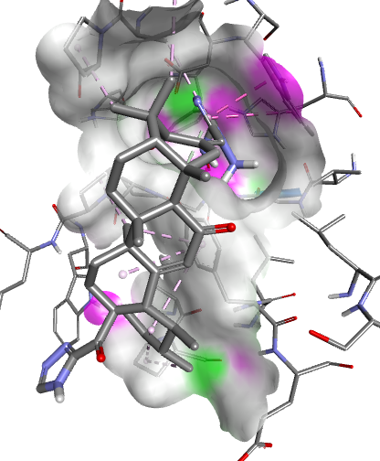
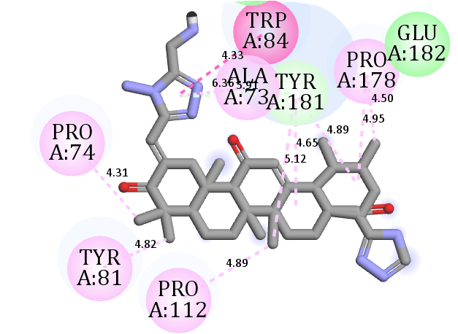
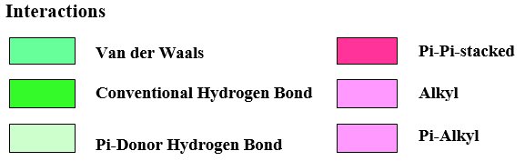
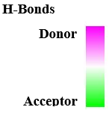
Figure A5. 2D and 3D representations of the molecular docking interactions between predicted compound X3 against modeled PEBP1 protein.

