Supplementary materials
- Supplementary material 1: Food list (preliminary and final);
- Supplementary material 2: Study card deck;
- Supplementary material 3: Similarity matrix.

Supplementary Material 1
Table A1. List of 50 food items arranged according to the GloboDiet food groups and their conceptual categories (33), compiled after step 1 of phase 1.
Food groups and items | Conceptual category
Potatoes and other tubers | Specific food item
- Boiled potato
- Fries
Vegetables | Taxonomic-professional
- Carrot
- White onion
- Cucumber
- Leek
- Garlic
- Red bell peper
- Tomato
Legumes | Taxonomic-professional
Fruits, nuts and seeds, olives | Taxonomic-professional + specific food item
- Mandarin
- Apple sauce
- Apple
- Banana
- Peanut butter
Dairy products and substitutes | Taxonomic-professional
- Cow milk
- Gouda cheese
- Chocolate milk
- Yogurt
- Yogurt drink
- Cream cheese
- Custard
- Popsicle
Cereals and cereal products | Taxonomic-professional
- Whole grain bread
- White roll
- White bread
- Pasta
- Rice
- Muesli
Meat, meat products, and substitutes | Taxonomic professional
- Grilled sausage
- Ham
- Chicken filet (bread topping)
- Salami
- Minced meat
- Chicken filet
Fish, shellfish and amphibians | Taxonomic-professional
Eggs and egg products | Taxonomic-professional
- Egg
Fats and oils | Taxonomic-professional
N/A
Sugar and confectionery | Nutrient composition + taxonomic-professional
- Chocolate sprinkles
- Chocolate paste
- Chocolate flakes
- Jam
- Winegum
- Milk chocolate
- Gingerbread paste
Cakes and sweet biscuits | Specific food item + food characteristics
Non-alcoholic beverages | Nutrient composition + taxonomic-professional
- Lemonade
- Soft drink (fruit)
- Water
- Tea
Alcoholic beverages | Nutrient composition + taxonomic-professional
N/A
Sauces and seasonings | Taxonomic-professional
- Ketchup
- Mayonnaise
- Warm tomato sauce
Stocks | Taxonomic-professional
N/A
Miscellaneous | Other
N/A
Savory snacks | Food characteristics + script scheme
- Plain chips
N/A: not applicable
Table A2. List of 63 food items arranged according to the GloboDiet food groups and their conceptual categories (33), compiled after step 2 of phase 1.
Food groups and items | Conceptual category
Potatoes and other tubers | Specific food item
- Roasted potato
- Boiled potato
- Fries
Vegetables | Taxonomic-professional
- Carrot
- Cauliflower
- Cucumber
- Broccoli
- Red bell peper
- Tomato
Legumes | Taxonomic-professional
- Brown beans
- Kidney beans
Fruits, nuts and seeds, olives | Taxonomic-professional + specific food item
- Apple
- Banana
- Mandarin
- Peanut butter
Dairy products and substitutes | Taxonomic-professional
- Cow milk
- Cream cheese
- Custard
- Gouda cheese
- Quark
- Yogurt
- Yogurt drink
- Popsicle
Cereals and cereal products | Taxonomic-professional
- Crackers
- Muesli
- Oatmeal
- Pasta
- Rice
- White bread
- White roll
- Whole grain bread
Meat, meat products and substitutes | Taxonomic-professional
- Chicken filet
- Chicken filet (for bread)
- Grilled sausage
- Ham
- Meatball
- Minced meat
- Salami
- Vegetarian minced meat
Fish, shellfish and amphibians | Taxonomic-professional
- Fish stick
- Fried fish nuggets
- Salmon
Eggs and egg products | Specific food item
- Boiled egg
- Fried egg
Fats and oils | Taxonomic-professional
N/A
Sugar and confectionery | Nutrient composition + taxonomic-professional
- Candy
- Chocolate flakes
- Chocolate spread
- Chocolate sprinkles
- Jam
- Milk chocolate
Cakes and sweet biscuits | Specific food item + food characteristics
- Biscuit
- Gingerbread
Non-alcoholic beverages | Nutrient composition + taxonomic-professional
- Lemonade
- Orange juice
- Soft drink (fruit)
- Tea
- Water
Alcoholic beverages | Nutrient composition + taxonomic-professional
- N/A
Sauces and seasonings | Taxonomic-professional
- Curry
- Ketchup
- Mayonnaise
- Warm tomato sauce
Savory snacks | Food characteristics + script-scheme
- Paprika chips
- Plain chips
N/A: not applicable

Supplementary Material 2
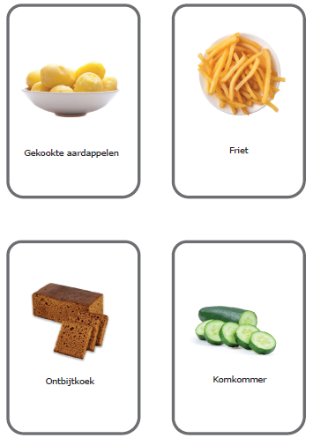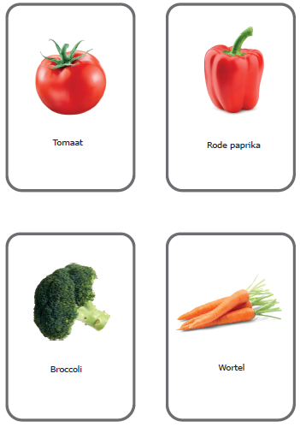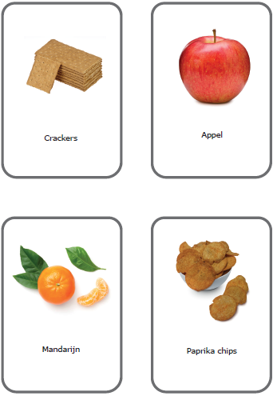
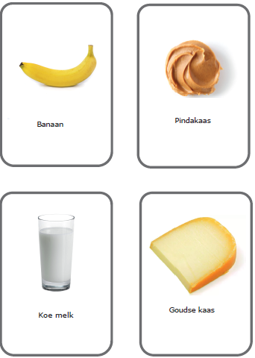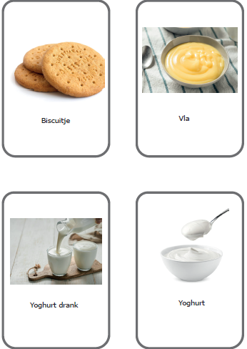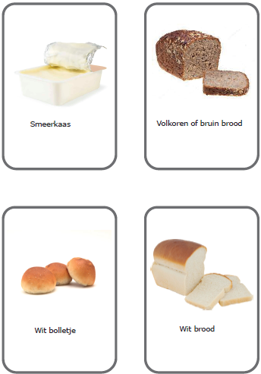
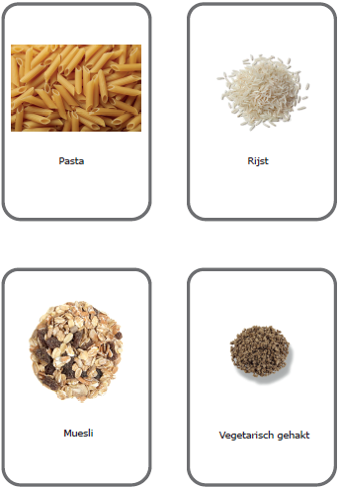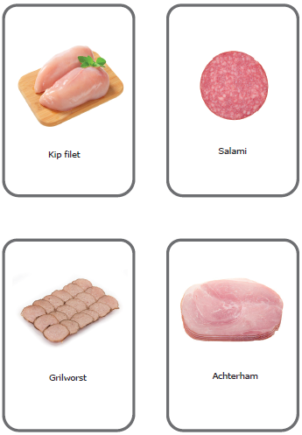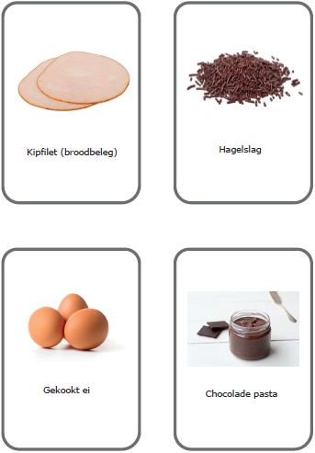
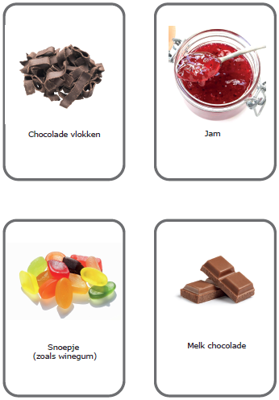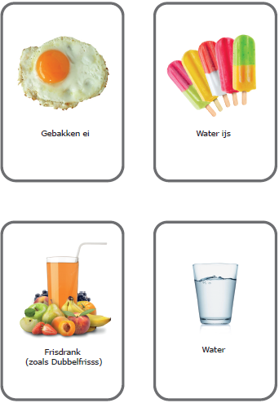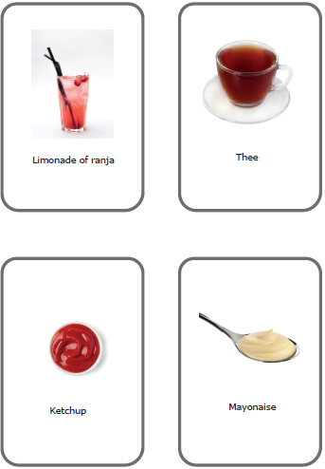
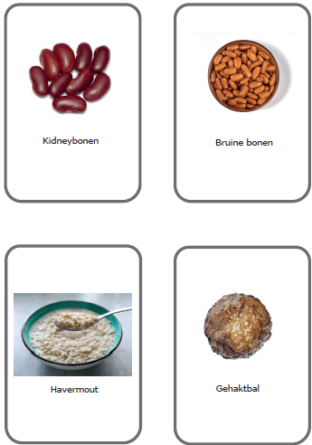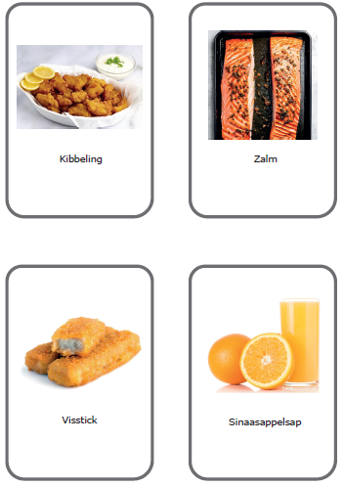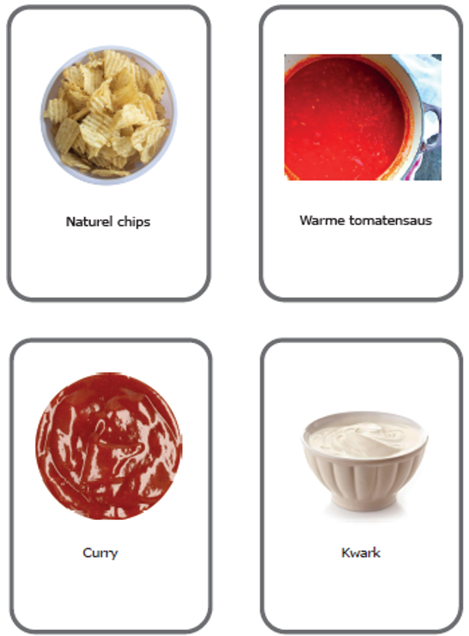
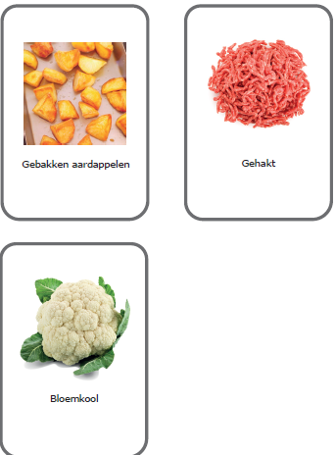
Figure A1. Card deck used for the card sorting task, consisting of 63 food items with names (in Dutch) and supporting images.
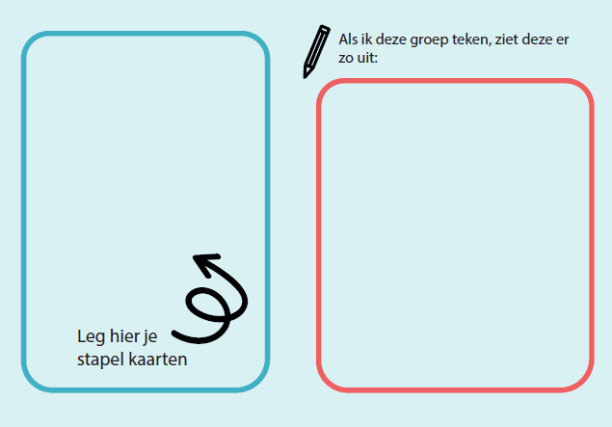
Figure A2. Stencil used for the illustration task. The left panel reads “Put your pile of cards here” and the right panel reads “When I draw this food group, it looks like this”.

Supplementary Material 3
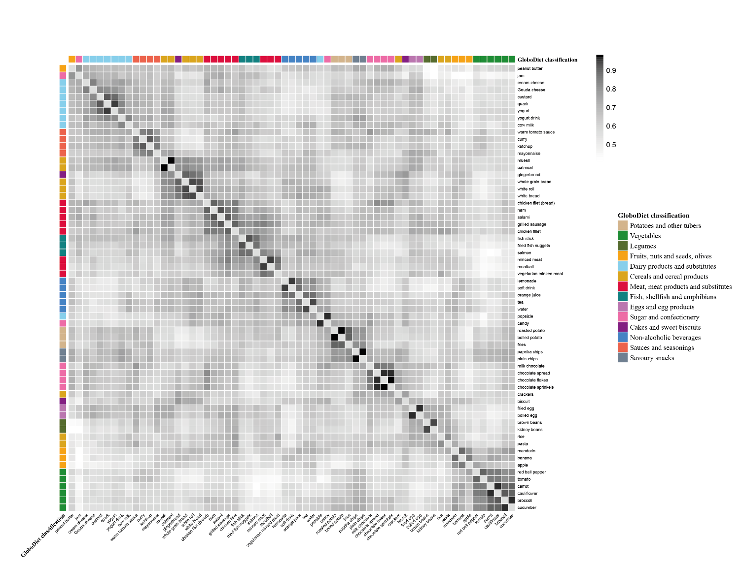
Figure A3. Similarity matrix of card sorting data (N = 42; one participant excluded due to incomplete data). The matrix visualizes how often pairs of food items were grouped together across participants. An overlay of the original GloboDiet food group classification is included for comparison.

