Title: Exploratory machine learning analysis of factors associated with positive circumferential resection margins following transanal total mesorectal excision: a multicenter registry study

Supplementary Materials – Index
Supplementary Figures and Tables
Figure S1. Data missingness for each variable.  Figure S2. Figures of the k-nearest neighbors model. (a) Combined ROC, (b) Cross-validation results.  Figure S3. Figures of the LightGBM model. (a) Combined ROC, (b) Cross-validation results. (c) Variable importance.  Figure S4. Figures of the logistic regression model. (a) Combined ROC.  Figure S5. Figures of the radial support vector machine model. (a) Combined ROC, (b) Cross-validation results.  Figure S6. Figures of the XGBoost model. (a) Combined ROC, (b) Cross-validation results. (c) Variable importance.  Figure S7. Figures of the decision tree model. (a) Combined ROC, (b) Cross-validation results. (c) model structure..  Figure S8. Figures of the elastic net model. (a) Combined ROC, (b) Cross-validation results.  Figure S9. Figures of the random forest model. (a) Combined ROC, (b) Cross-validation results. (c) model structure..  Figure S10. Figures of the multilayer perceptron model. (a) Combined ROC.  Table S1. Baseline characteristics and balance assessment between training and validation groups  Note: In all images, the variables correspond to the following: (a) gender, (b) anterior tumor, (c) clinical T-stage, (d) clinical N-stage, (e) MRF, (f) EMVI, (g) neoadjuvant radiotherapy, (h) previous pelvic therapies, (i) presence of expert supervision, (j) simultaneous abdominal/perineal surgery, (k) surgical approach, (l) conversion to open surgery during the abdominal phase, (m) intraoperative difficulties during the abdominal phase, (n) ISR, (o) conversion to open surgery during the perineal phase, (p) intraoperative difficulties during the perineal phase, (q) pathological T-stage, (r) pathological N-stage, (s) age, (t) BMI (kg/m²), (u) distance from the lower edge of the tumor to the anal verge (mm). | pag. 3  pag. 4  pag. 5  pag. 6  pag. 7  pag. 8  pag. 9  pag. 10  pag. 11  pag. 12  pag. 13-14

Supplementary Figures and Tables

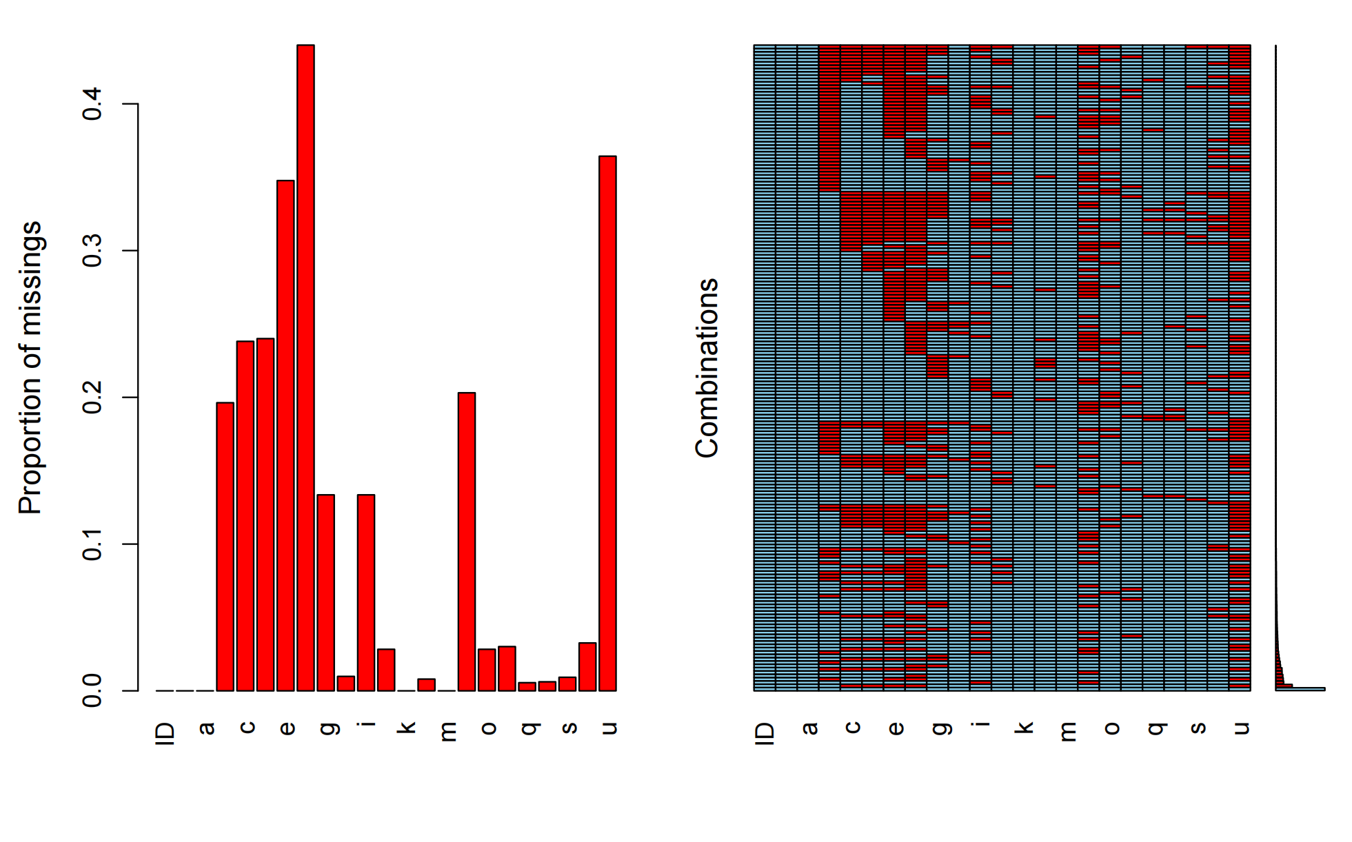 Figure S1. Data missingness for each variable.
(a) gender, (b) anterior tumor, (c) clinical T-stage, (d) clinical N-stage, (e) MRF, (f) EMVI, (g) neoadjuvant radiotherapy, (h) previous pelvic therapies, (i) presence of expert supervision, (j) simultaneous abdominal/perineal surgery, (k) surgical approach, (l) conversion to open surgery during the abdominal phase, (m) intraoperative difficulties during the abdominal phase, (n) ISR, (o) conversion to open surgery during the perineal phase, (p) intraoperative difficulties during the perineal phase, (q) pathological T-stage, (r) pathological N-stage, (s) age, (t) BMI (kg/m²), (u) distance from the lower edge of the tumor to the anal verge (mm).

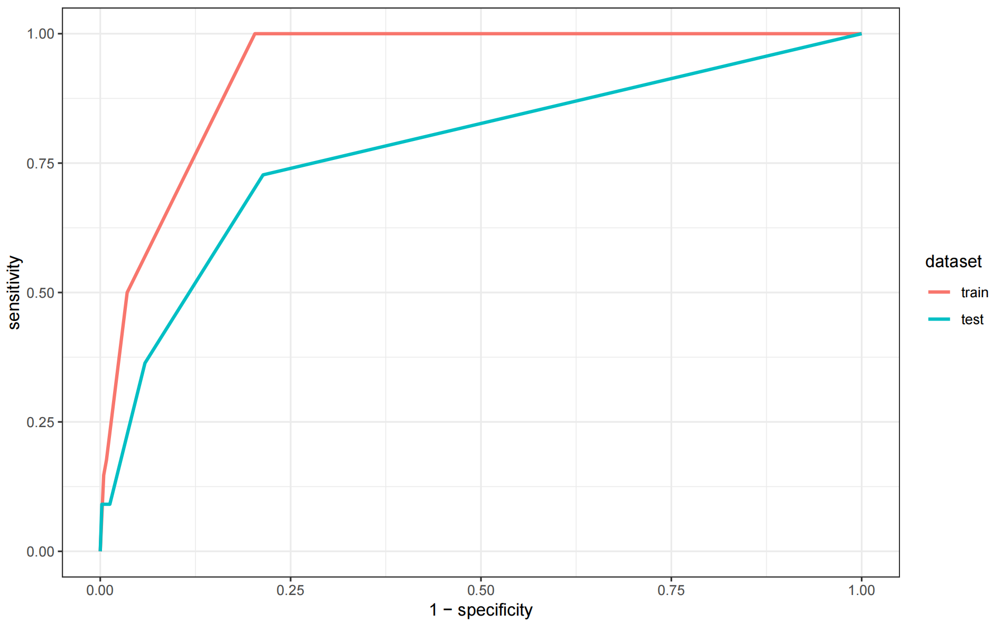a
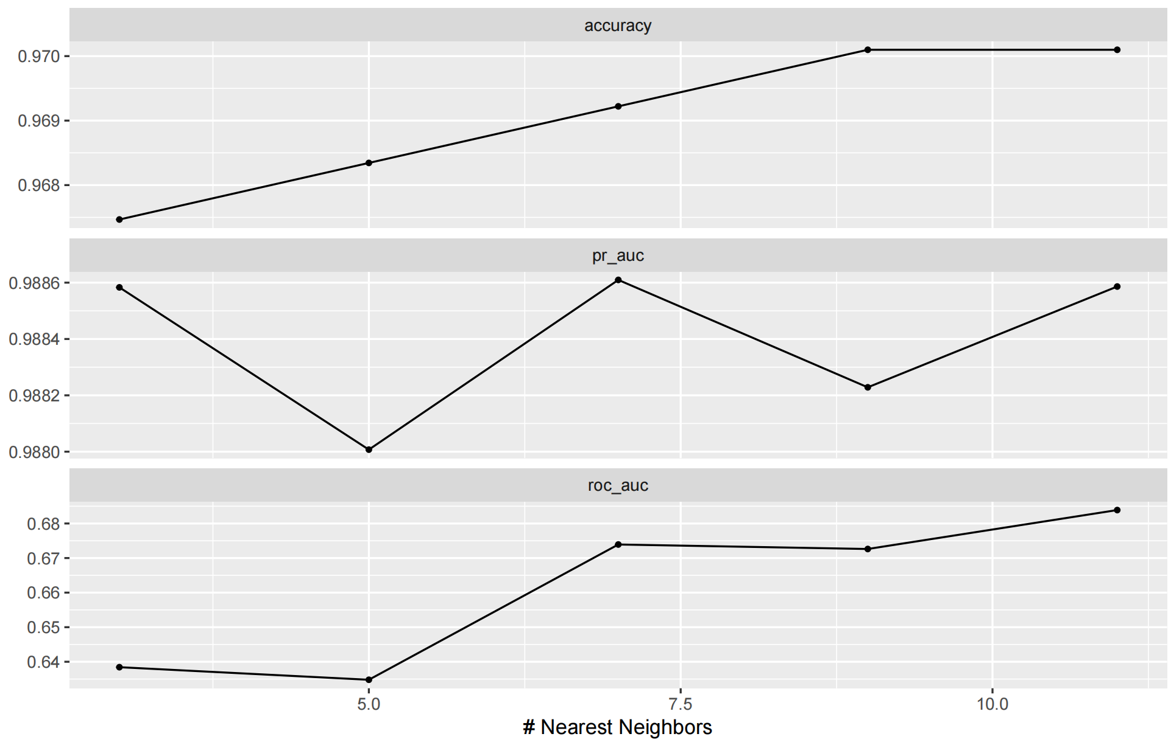b
Figure S2. Figures of the k-nearest neighbors model. (a) Combined ROC, (b) Cross-validation results.

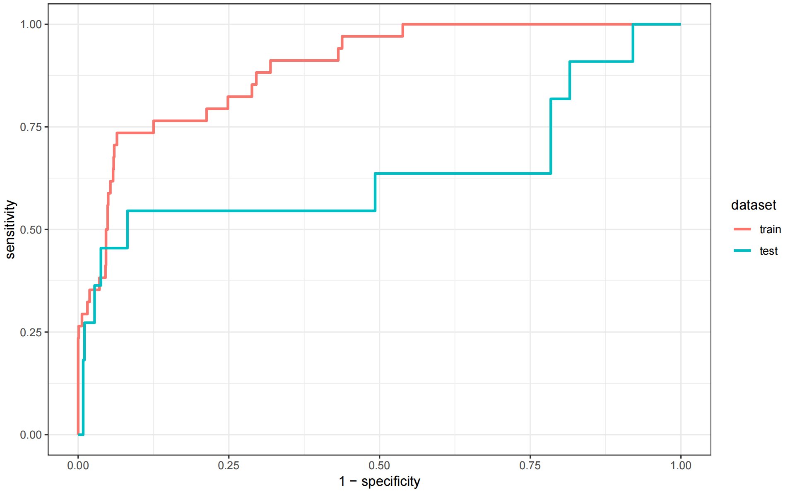a 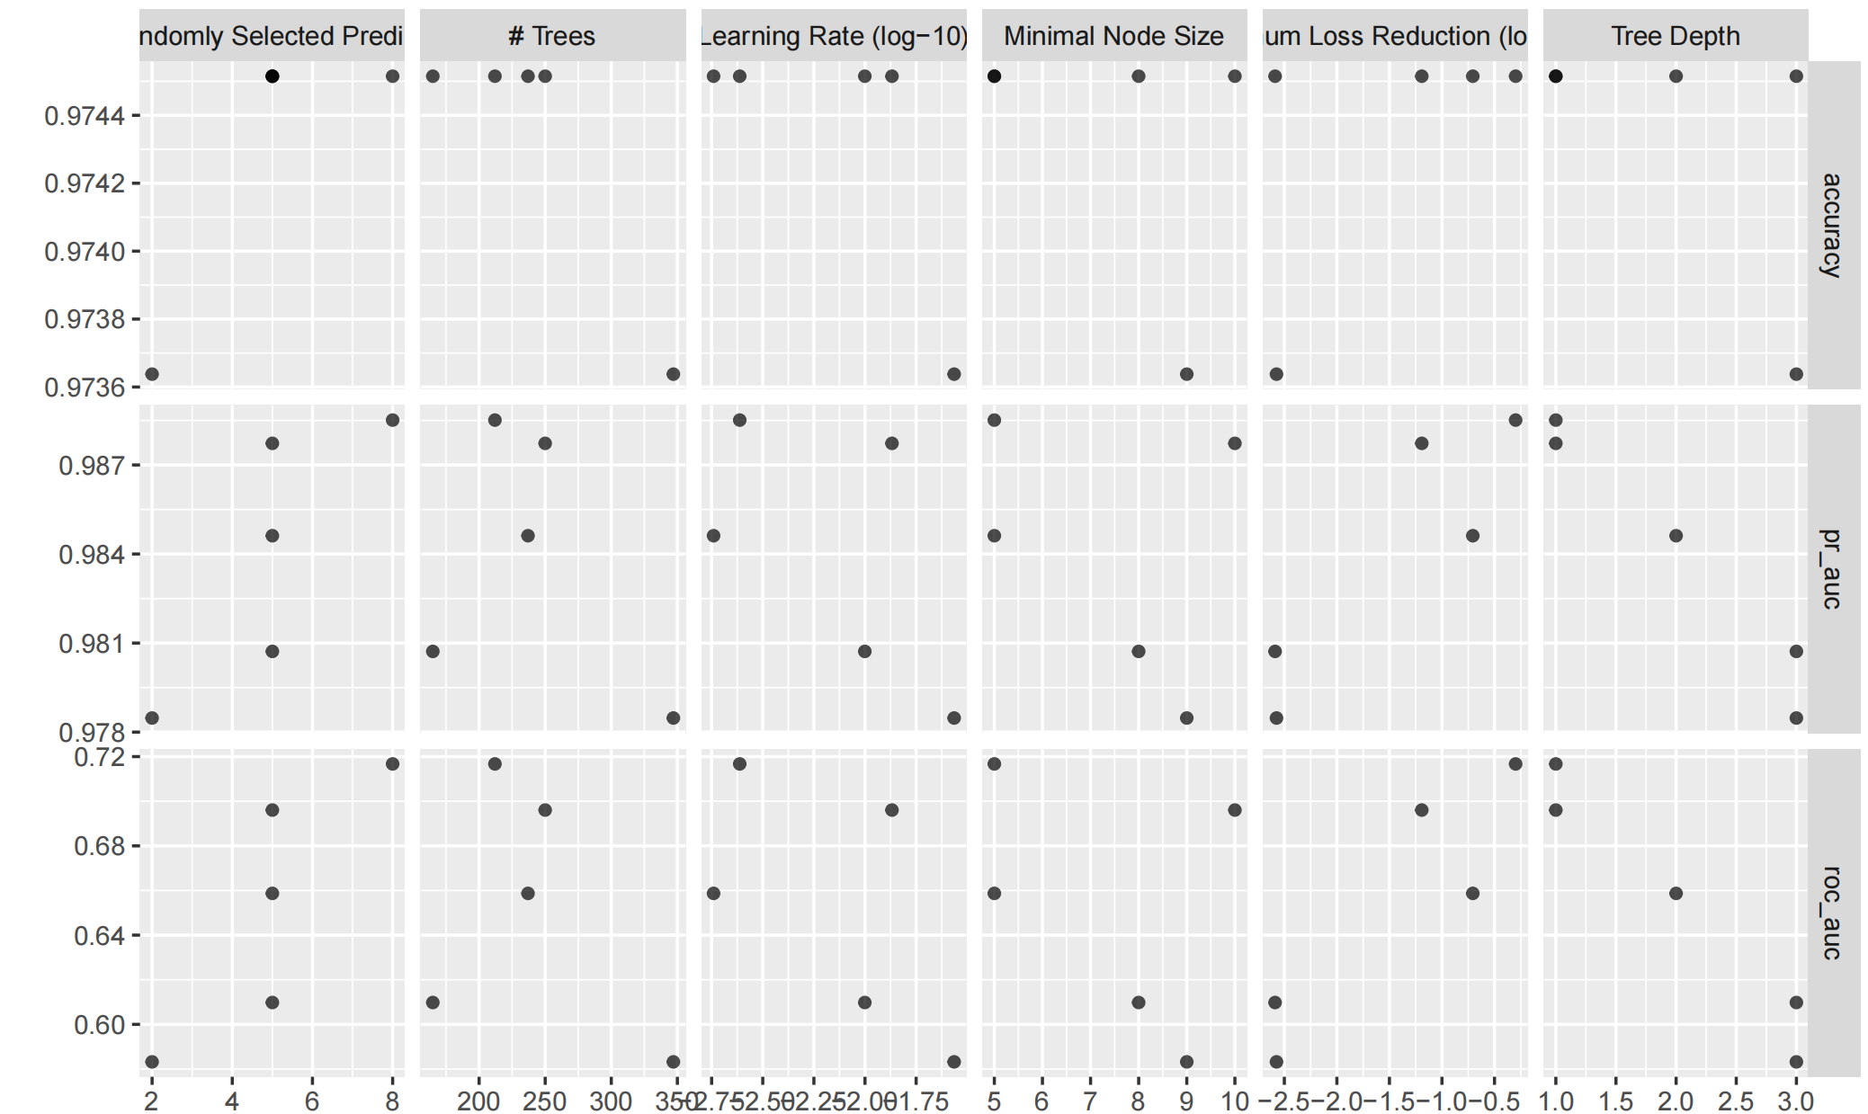b
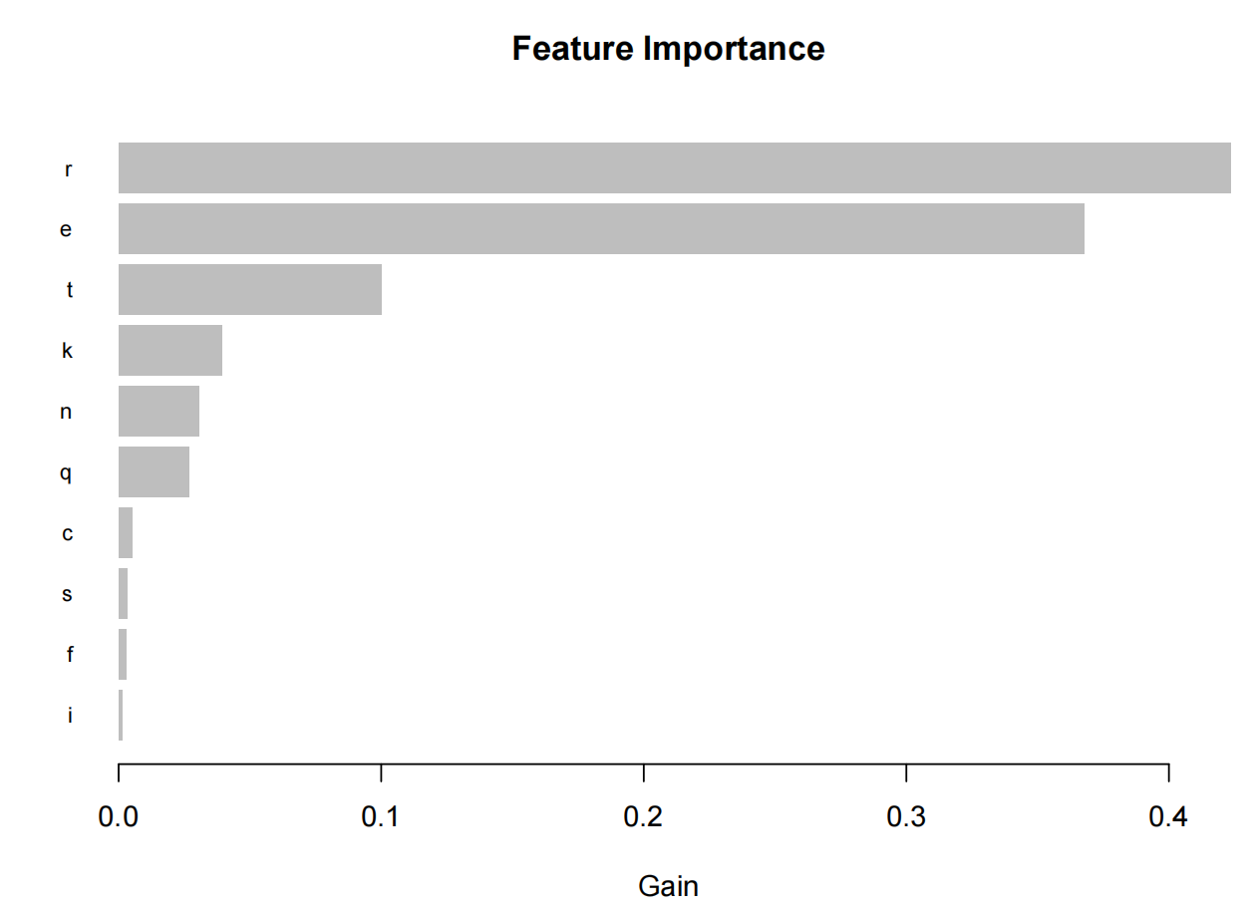c
Figure S3. Figures of the LightGBM model. (a) Combined ROC, (b) cross-validation results, and (c) variable importance.
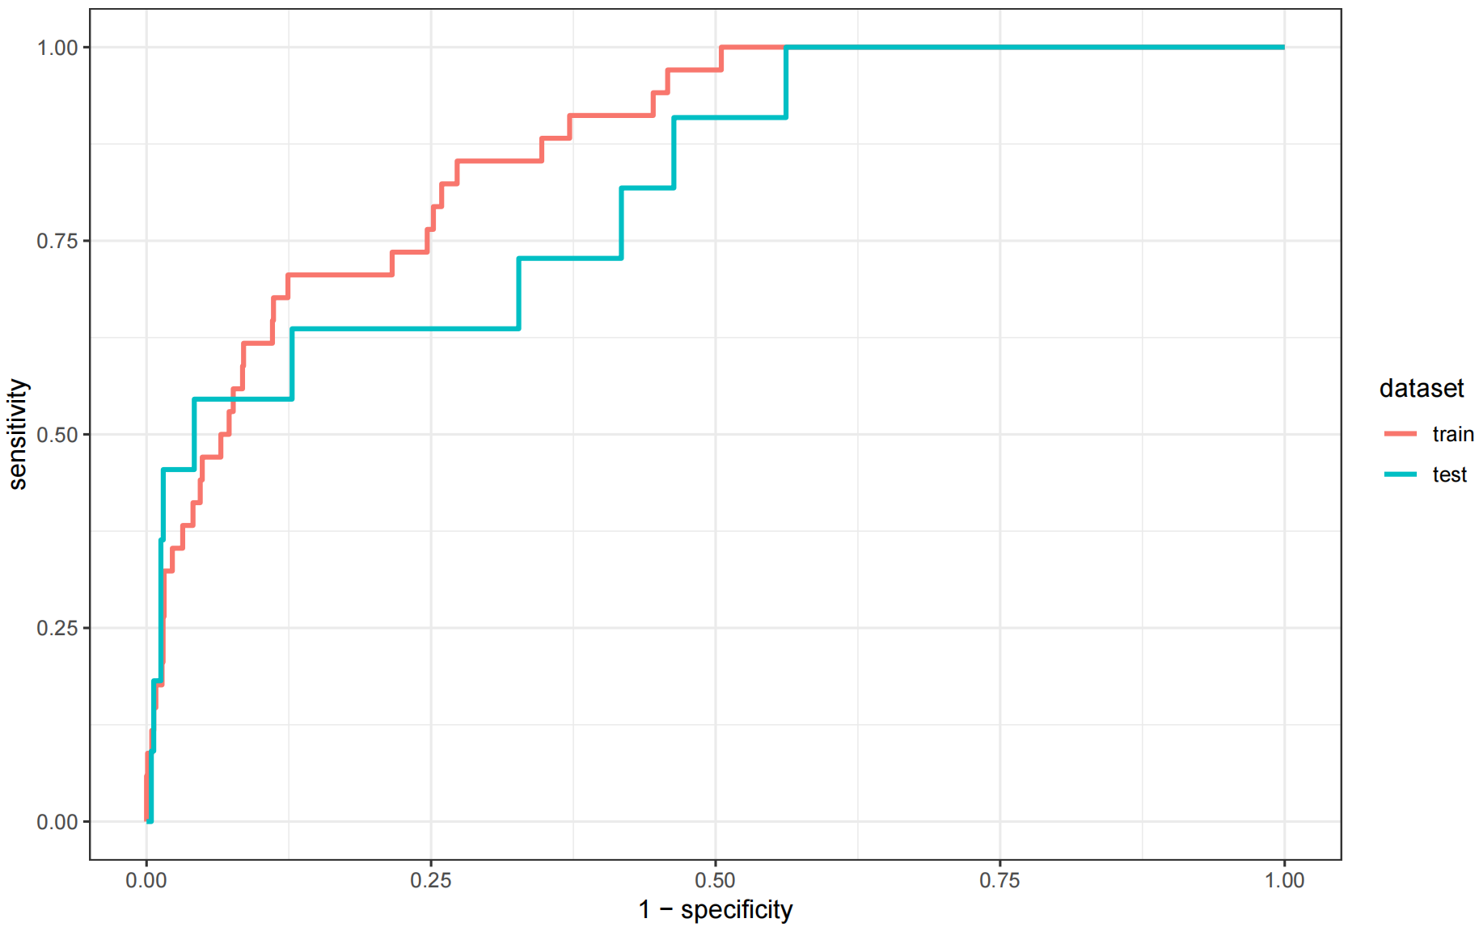a
Figure S4. (a) Combined ROC.

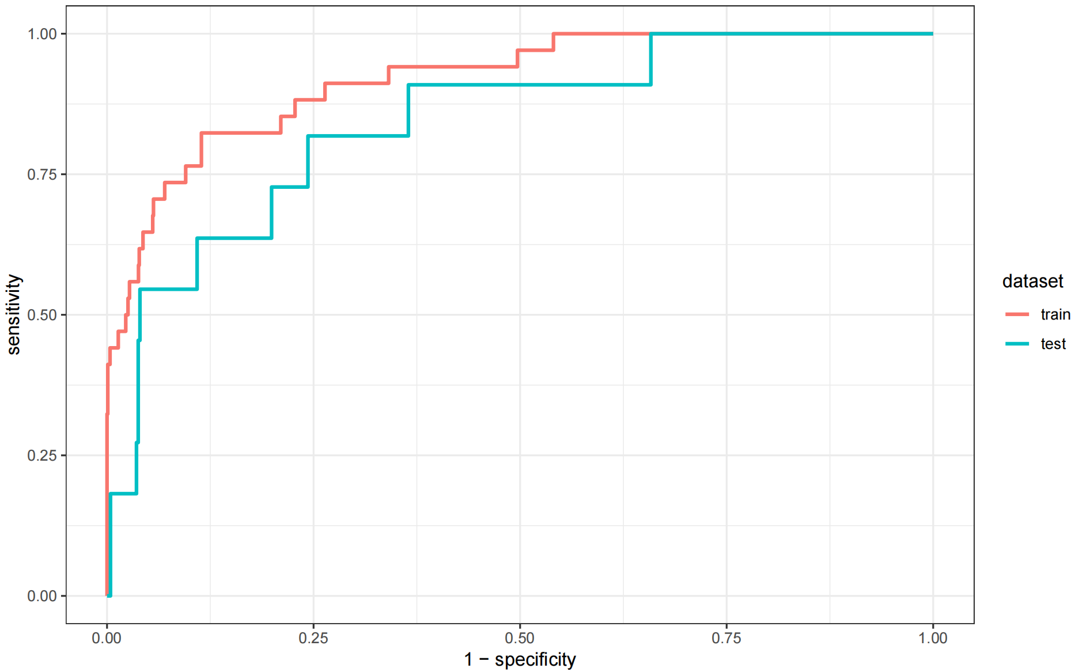a 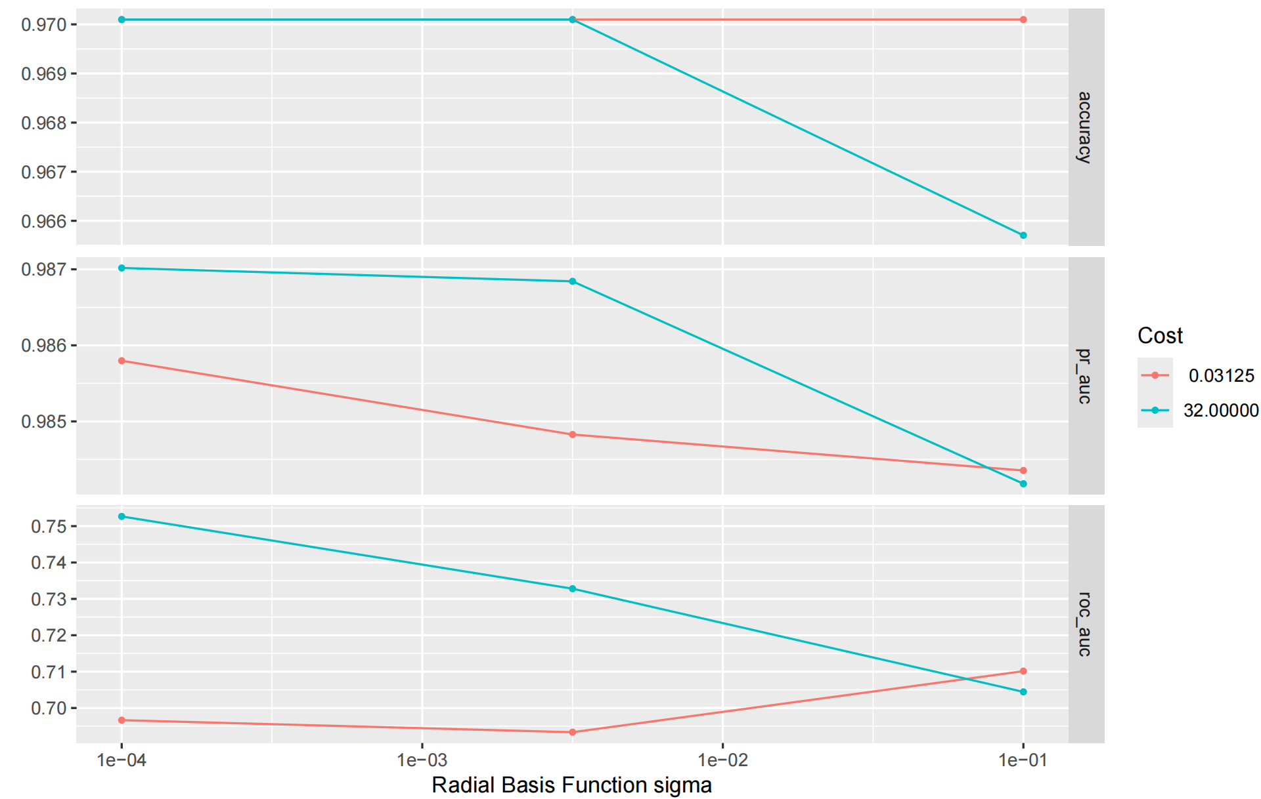b
Figure S5. Figures of the radial support vector machine model. (a) Combined ROC, (b) Cross-validation results.

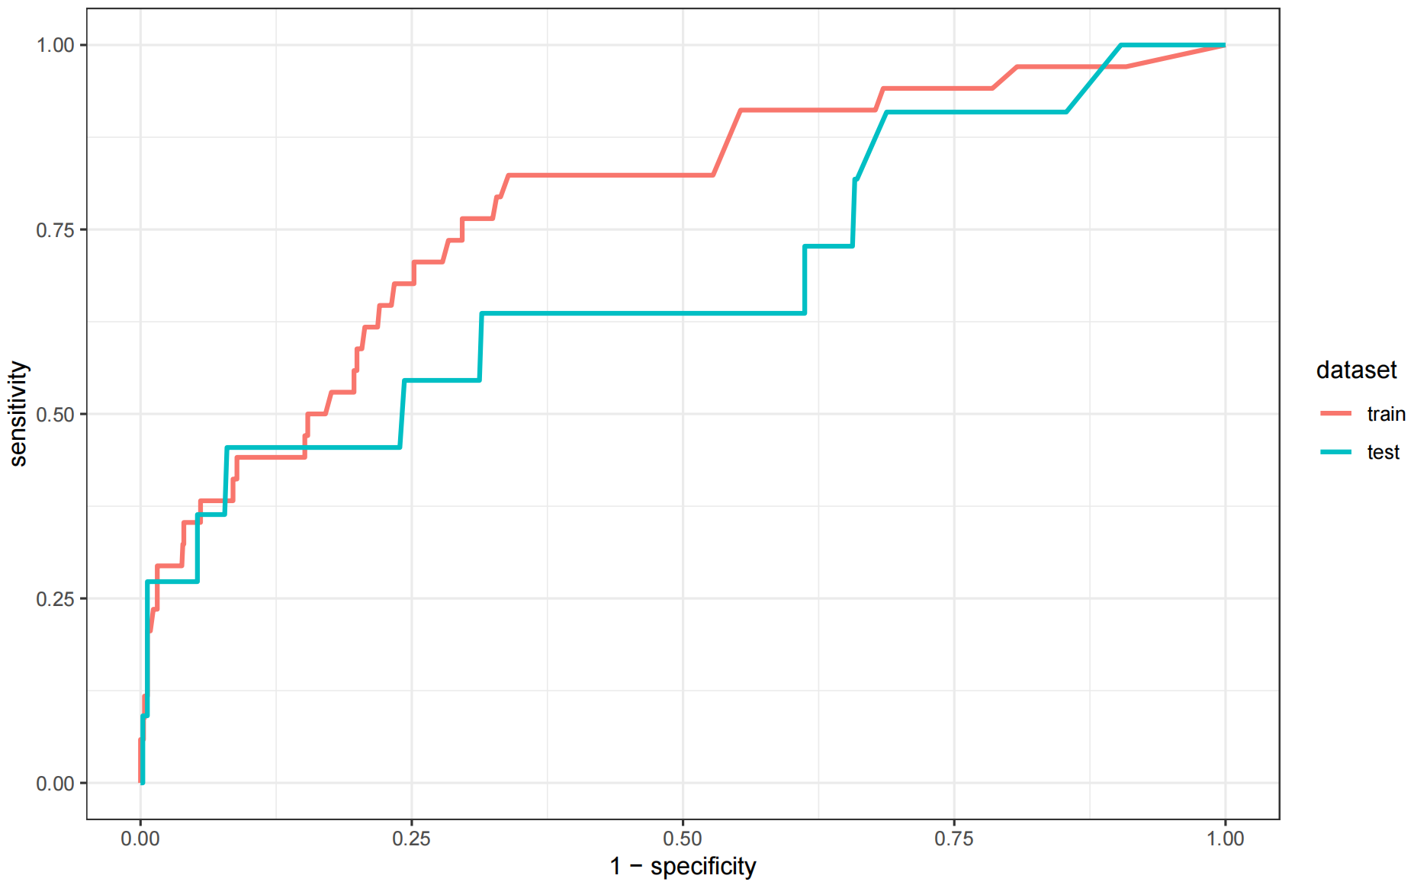a 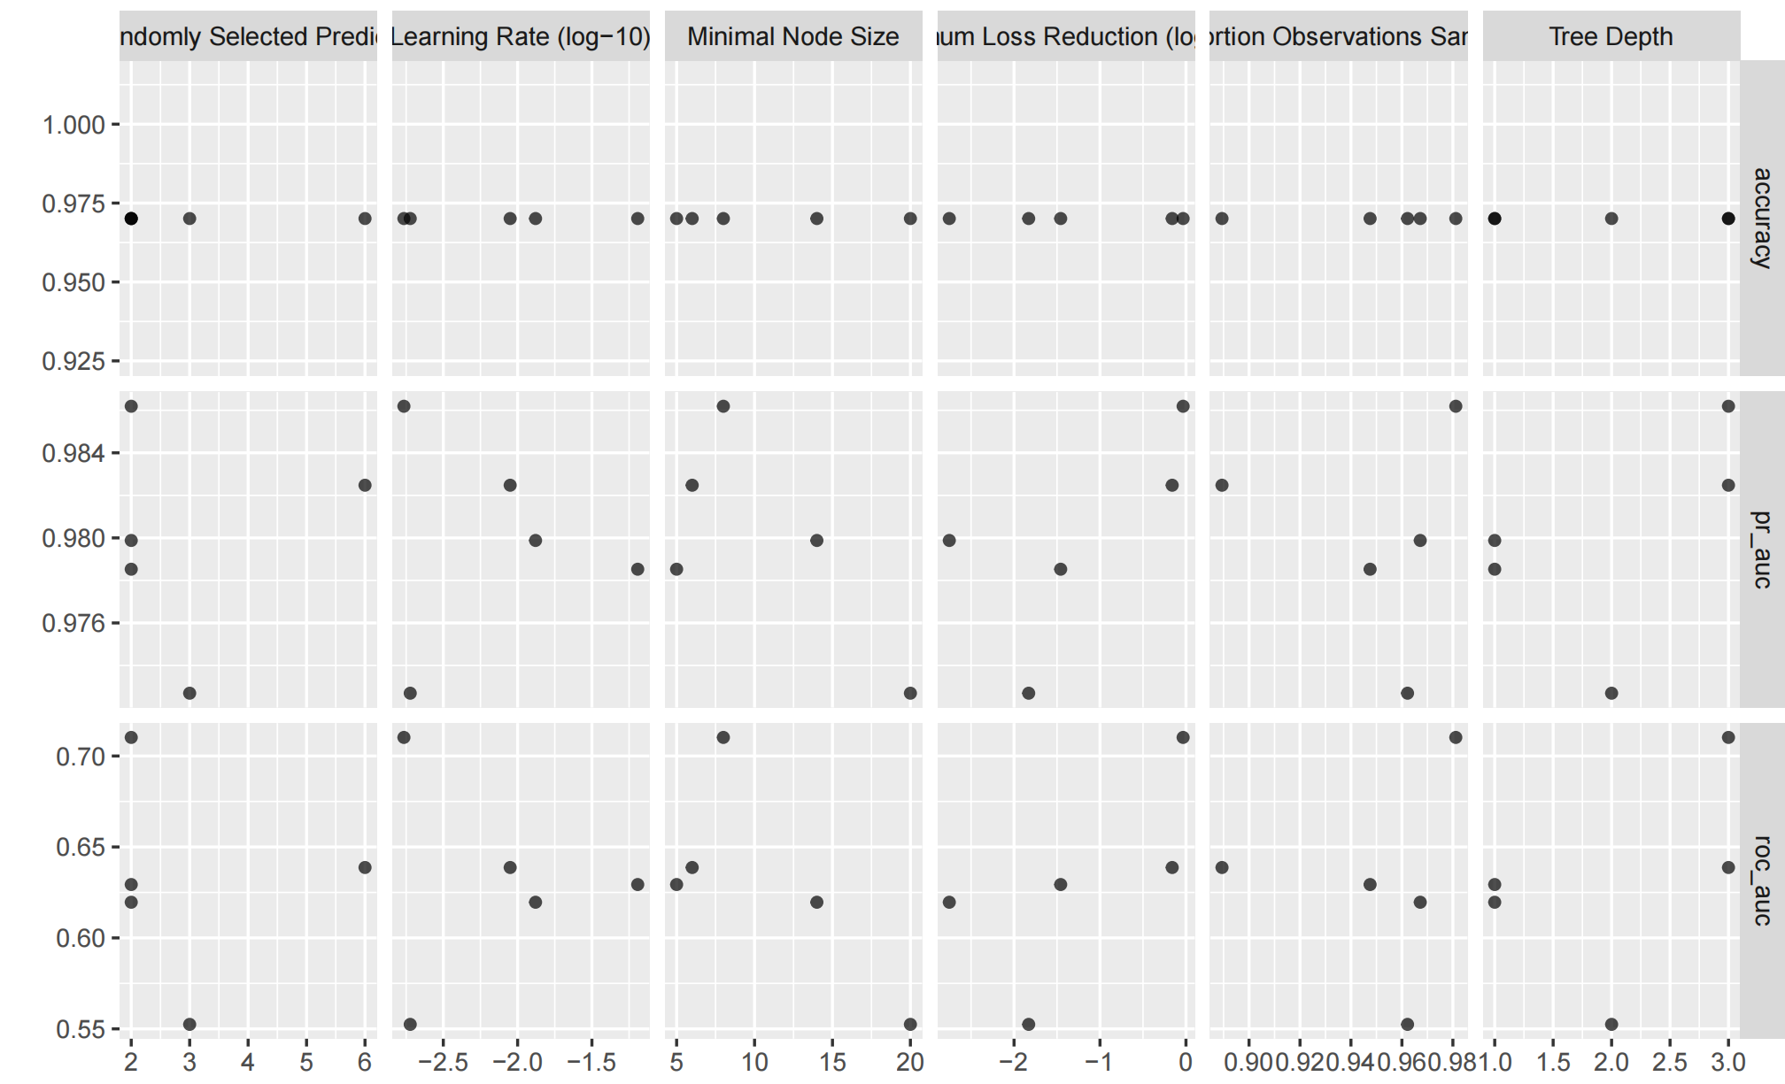b 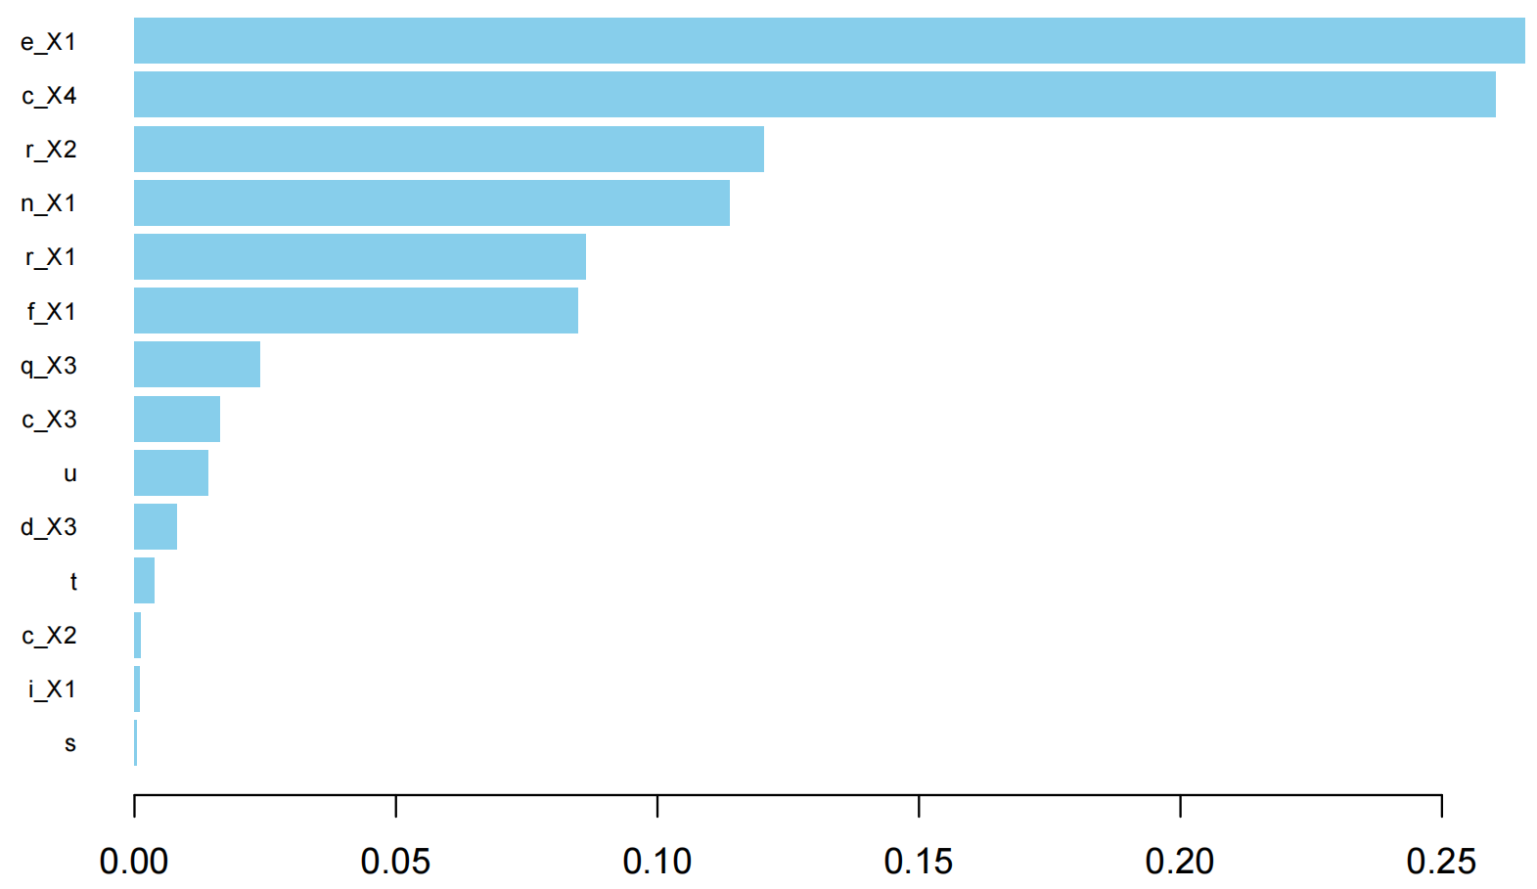c
Figure S6. Figures of the XGBoost model. (a) Combined ROC, (b) Cross-validation results. (c) Variable importance.

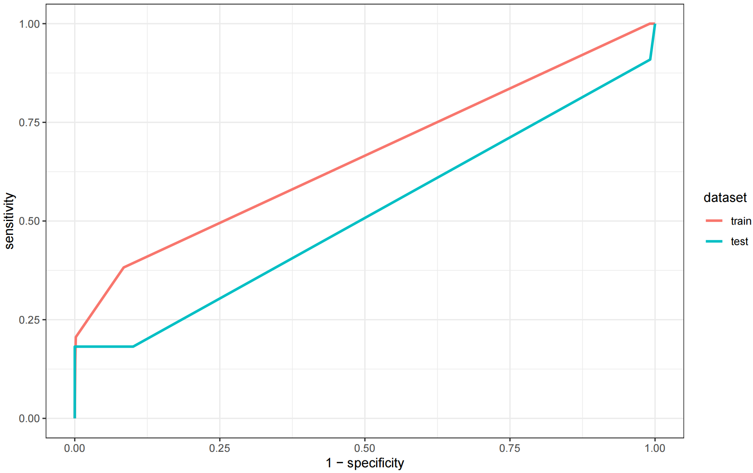a 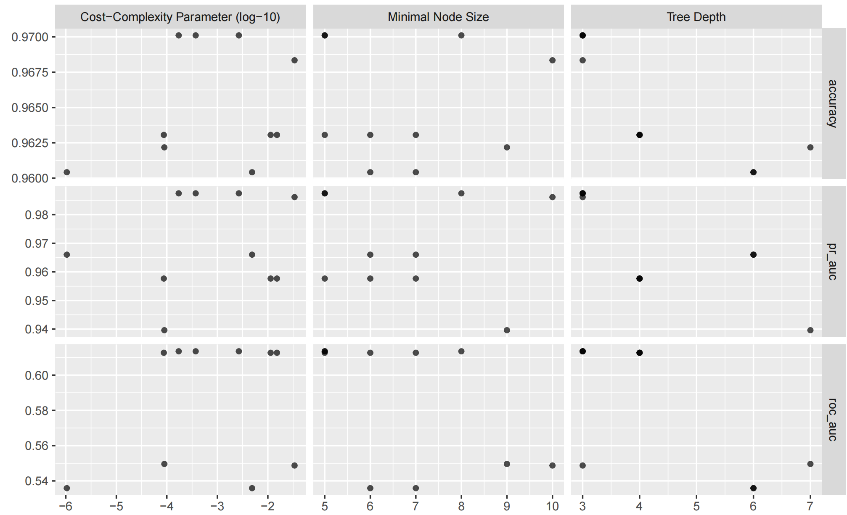b 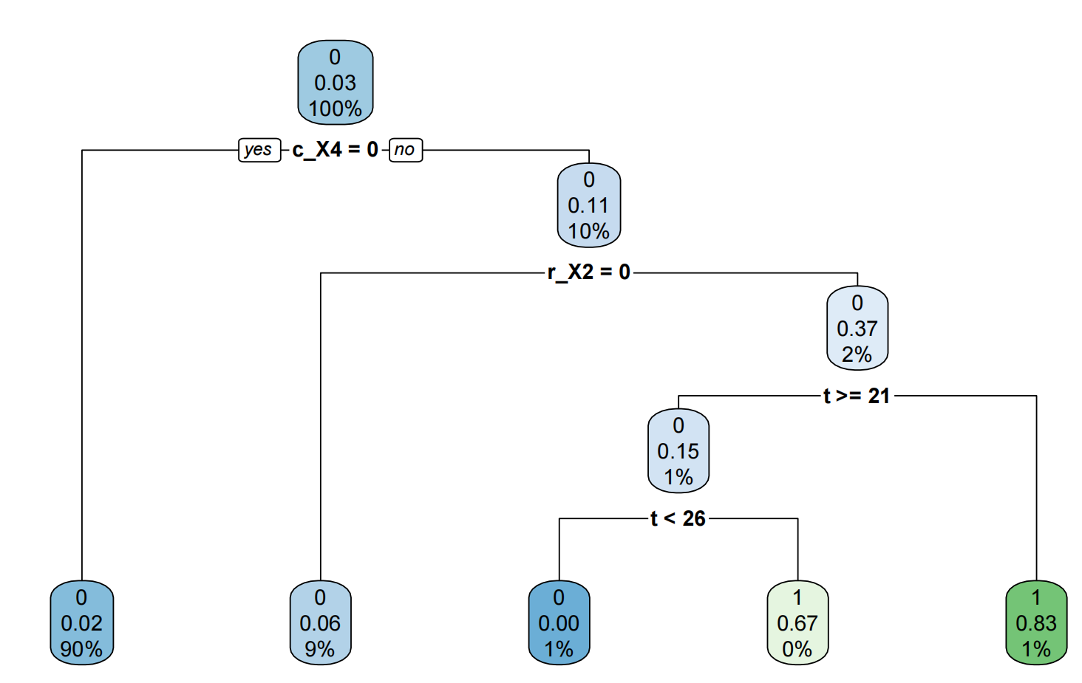c
Figure S7. Figures of the decision tree model. (a) Combined ROC, (b) Cross-validation results. (c) algorithm model.

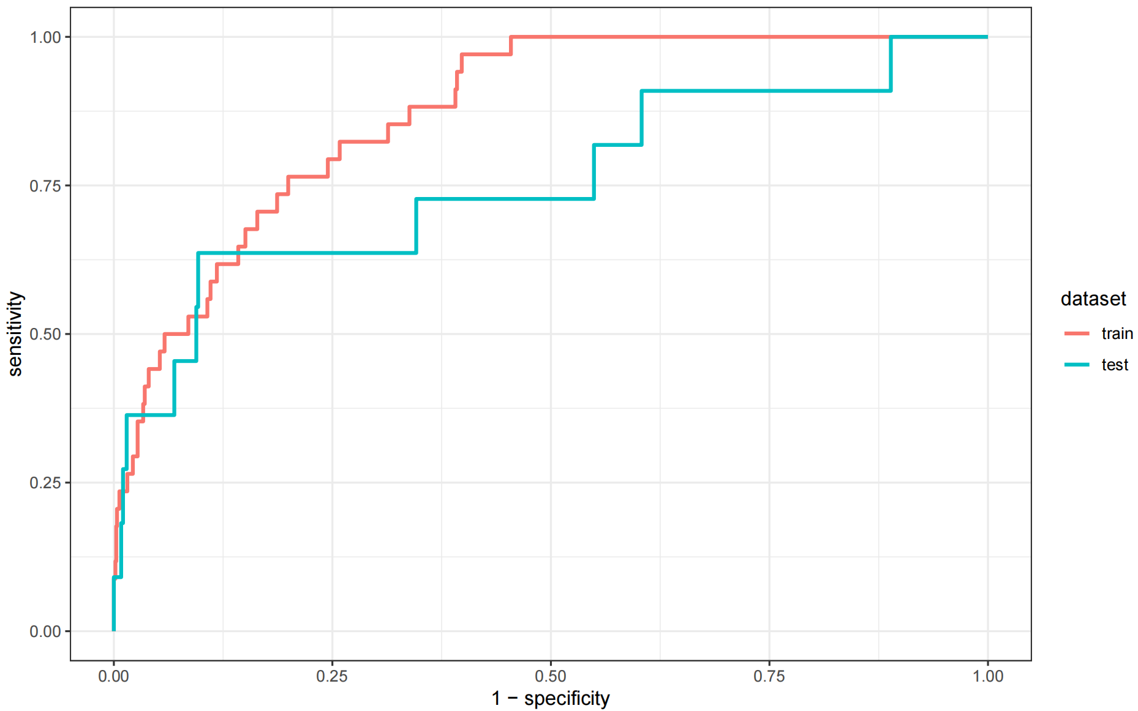a 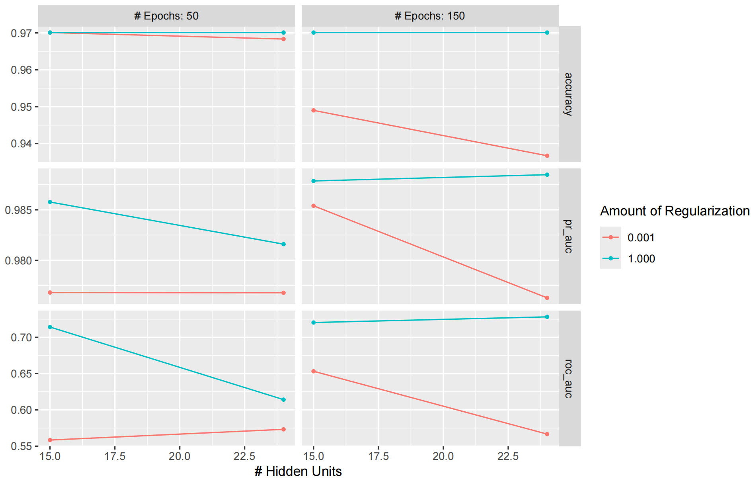b
Figure S8. Figures of the elastic net model. (a) Combined ROC, (b) Cross-validation results.

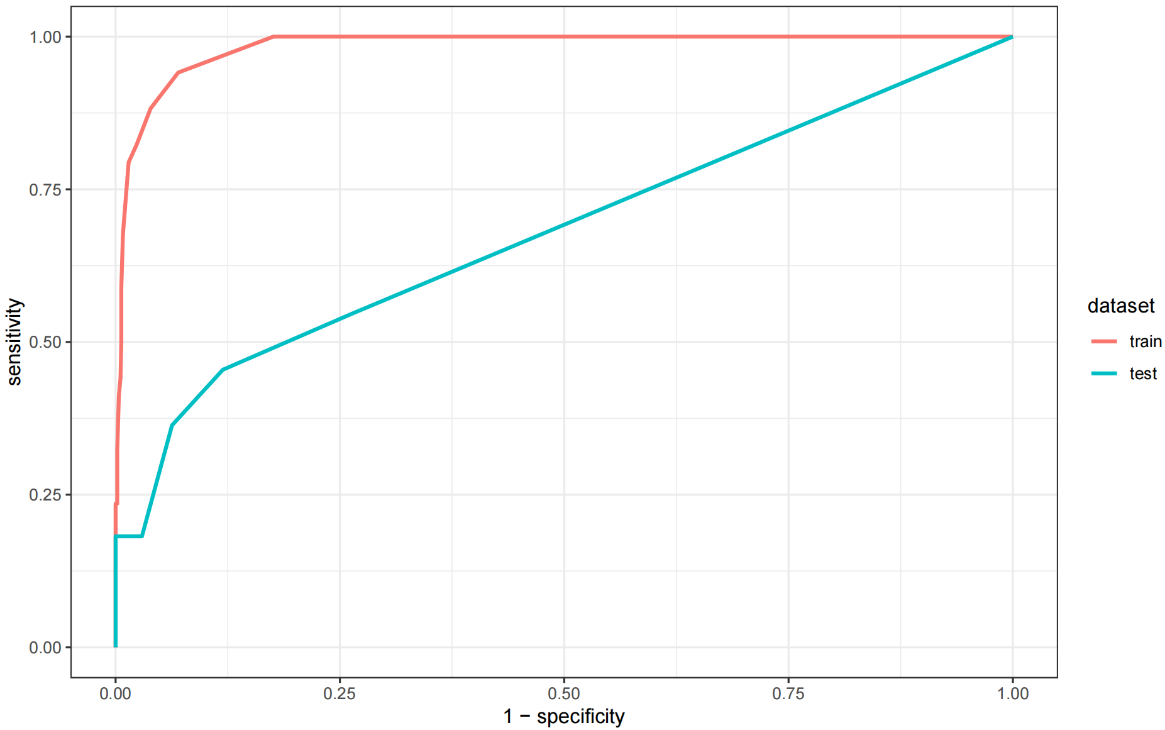a 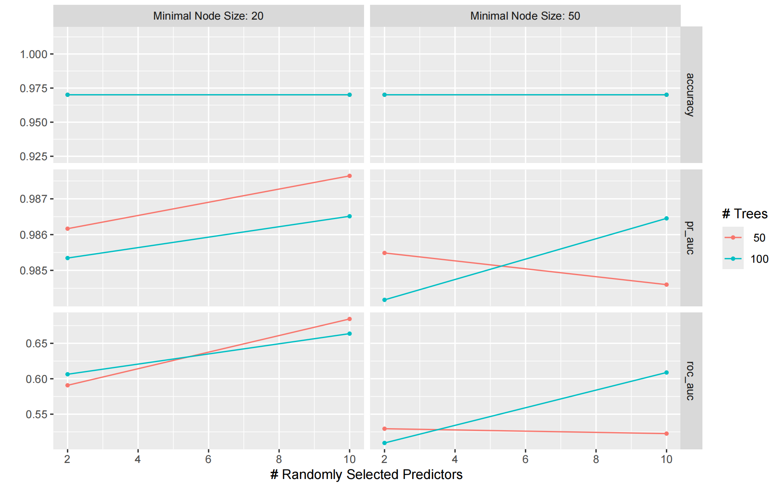b 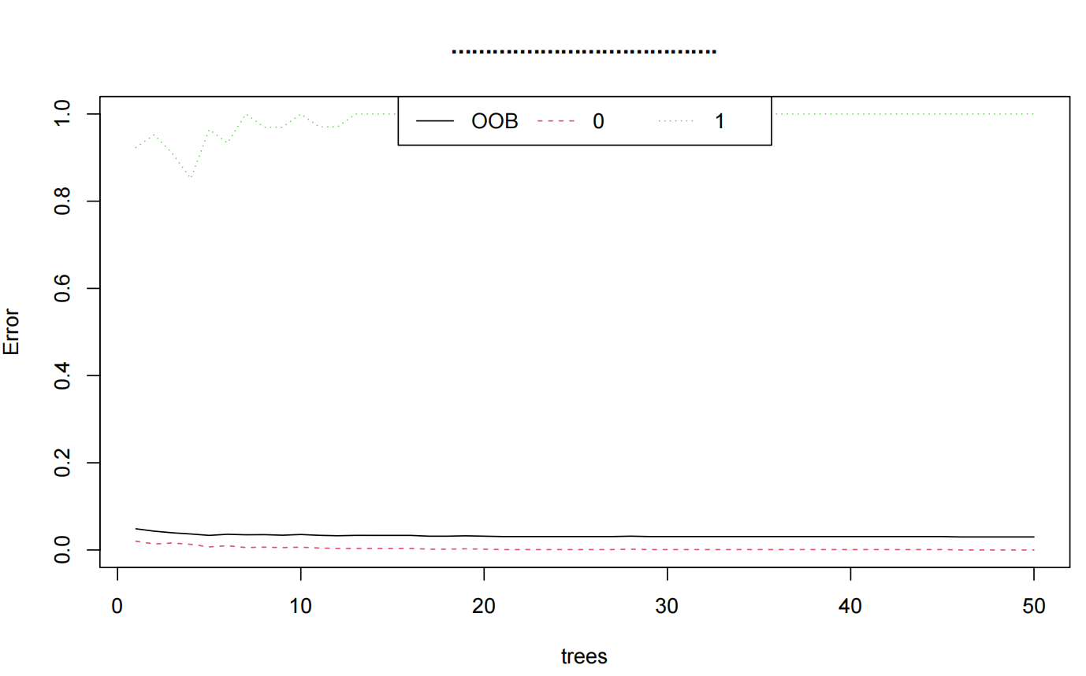c
Figure S9. Figures of the random forest model. (a) Combined ROC, (b) Cross-validation results. (c) algorithm model.

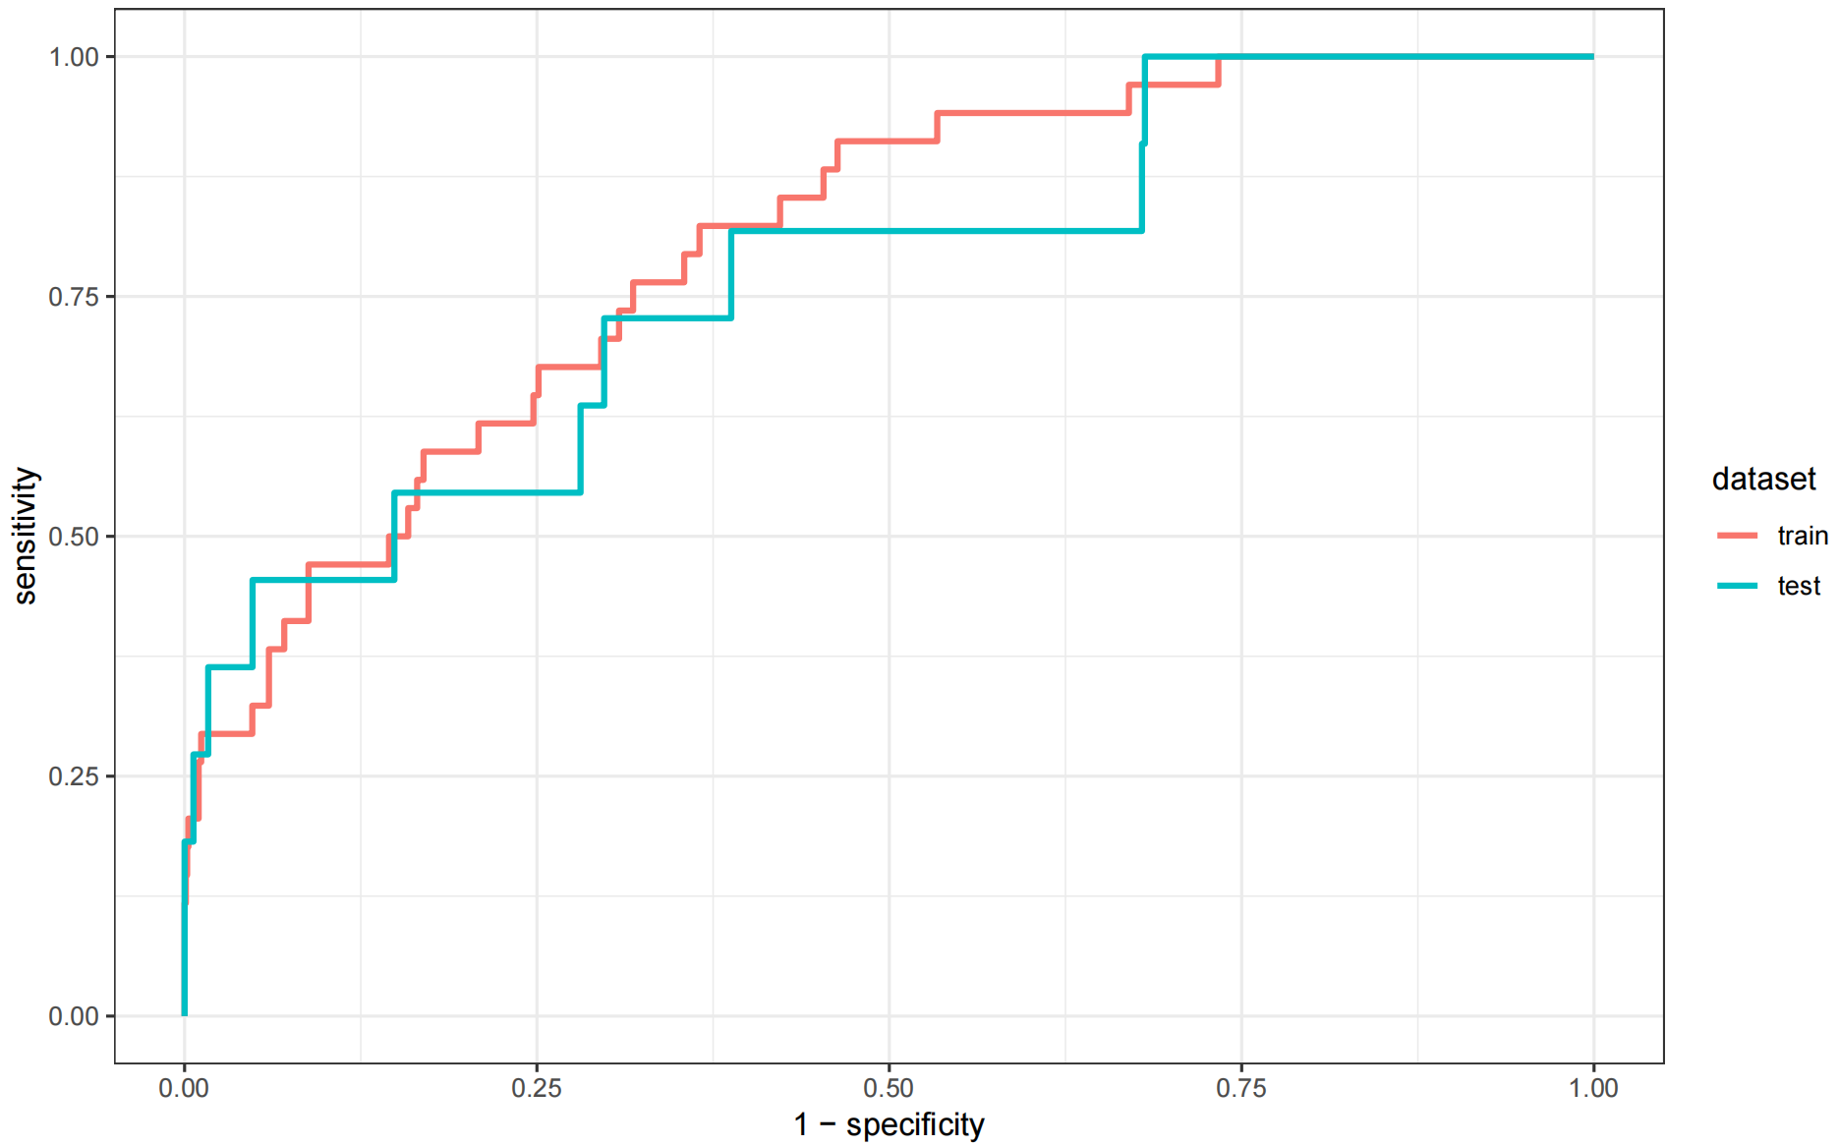a
Figure S10. Figures of the multilayer perceptron model. (a) Combined ROC.

 | level | Overall | Train | Test | p-value
n |  | 1625 | 1138 | 487
CRM | Negative | 1580 (97.2) | 1106 (97.2) | 474 (97.3) | 0.873
 | Positive | 45 (2.8) | 32 (2.8) | 13 (2.7)
Gender (%) | Female | 500 (30.77) | 346 (30.4) | 154 (31.6) | 0.668
 | Male | 1125 (69.23) | 792 (69.6) | 333 (68.4)
Anterior tumor (%) | No | 1062 (65.35) | 751 (66.0) | 311 (63.9) | 0.441
 | Yes | 563 (34.65) | 387 (34.0) | 176 (36.1)
Clinical T-stage (%) | cT0 | 7 (0.43) | 4 ( 0.4) | 3 ( 0.6) | 0.949
 | cT1 | 42 (2.58) | 30 ( 2.6) | 12 ( 2.5)
 | cT2 | 321 (19.75) | 221 (19.4) | 100 (20.5)
 | cT3 | 1075 (66.15) | 754 (66.3) | 321 (65.9)
 | cT4 | 171 (10.52) | 123 (10.8) | 48 ( 9.9)
 | cTx | 9 (0.55) | 6 ( 0.5) | 3 ( 0.6)
Clinical N-stage (%) | cN0 | 639 (39.32) | 466 (40.9) | 173 (35.5) | 0.052
 | cN1 | 485 (29.85) | 317 (27.9) | 168 (34.5)
 | cN2 | 410 (25.23) | 292 (25.7) | 118 (24.2)
 | cNx | 91 (5.60) | 63 ( 5.5) | 28 ( 5.7)
MRF (%) | Negative | 1423 (87.57) | 999 (87.8) | 424 (87.1) | 0.747
 | Positive | 202 (12.43) | 139 (12.2) | 63 (12.9)
EMVI (%) | Negative | 1229 (75.63) | 858 (75.4) | 371 (76.2) | 0.784
 | Positive | 396 (24.37) | 280 (24.6) | 116 (23.8)
Neoadjuvant radiotherapy (%) | No | 1146 (70.52) | 799 (70.2) | 347 (71.3) | 0.717
 | Yes | 479 (29.48) | 339 (29.8) | 140 (28.7)
Previous pelvic therapies (%) | No | 1531 (94.22) | 1078 (94.7) | 453 (93.0) | 0.216
 | Yes | 94 (5.78) | 60 ( 5.3) | 34 ( 7.0)
Presence of expert supervision (%) | No | 992 (61.05) | 695 (61.1) | 297 (61.0) | 1.000
 | Yes | 633 (38.95) | 443 (38.9) | 190 (39.0)
Abdominal/perineal surgery was performed simultaneously (%) | No | 933 (57.42) | 661 (58.1) | 272 (55.9) | 0.436
 | Yes | 692 (42.58) | 477 (41.9) | 215 (44.1)
Surgical approach (%) | Laparoscopic | 1570 (96.62) | 1101 (96.7) | 469 (96.3) | 0.729
 | robotic surgery | 50 (3.08) | 33 ( 2.9) | 17 ( 3.5)
 | single-incision laparoscopic | 5 (0.31) | 4 ( 0.4) | 1 ( 0.2)
Conversion to open (abdominal phase) (%) | No | 1607 (98.89) | 1129 (99.2) | 478 (98.2) | 0.108
 | Yes | 18 (1.11) | 9 ( 0.8) | 9 ( 1.8)
Intraoperative difficulties (abdominal phase) (%) | No | 1569 (96.55) | 1104 (97.0) | 465 (95.5) | 0.161
 | Yes | 56 (3.45) | 34 ( 3.0) | 22 ( 4.5)
ISR (%) | No | 1322 (81.35) | 920 (80.8) | 402 (82.5) | 0.461
 | Yes | 303 (18.65) | 218 (19.2) | 85 (17.5)
Conversion to open (perineal phase) (%) | No | 1593 (98.03) | 1112 (97.7) | 481 (98.8) | 0.228
 | Yes | 32 (1.97) | 26 ( 2.3) | 6 ( 1.2)
Intraoperative difficulties (perineal phase) (%) | No | 1124 (69.17) | 780 (68.5) | 344 (70.6) | 0.436
 | Yes | 501 (30.83) | 358 (31.5) | 143 (29.4)
Pathological T-stage (%) | pT0 | 118 (7.26) | 86 ( 7.6) | 32 ( 6.6) | 0.393
 | pT1 | 149 (9.17) | 109 ( 9.6) | 40 ( 8.2)
 | pT2 | 490 (30.15) | 338 (29.7) | 152 (31.2)
 | pT3 | 652 (40.12) | 464 (40.8) | 188 (38.6)
 | pT4 | 177 (10.89) | 113 ( 9.9) | 64 (13.1)
 | pTis | 31 (1.91) | 21 ( 1.8) | 10 ( 2.1)
 | pTx | 8 (0.49) | 7 ( 0.6) | 1 ( 0.2)
Pathological N-stage (%) | pN0 | 1097 (67.51) | 772 (67.8) | 325 (66.7) | 0.086
 | pN1 | 377 (23.20) | 251 (22.1) | 126 (25.9)
 | pN2 | 151 (9.29) | 115 (10.1) | 36 ( 7.4)
Age (mean (SD)) |  | 60.95 (11.15) | 62.00 (10.23) | 61.63 (11.25) | 0.325
BMI (kg/m2) (mean (SD)) |  | 23.82 (3.42) | 23.60 (3.41) | 23.93 (3.28) | 0.925
Distance from the lower edge of the tumor to the anal verge (mm) (mean (SD)) |  | 49.40 (18.25) | 50.00 (18.24) | 49.68 (17.86) | 0.847
Table S1. Baseline characteristics and balance assessment between training and validation groups
Abbreviations: CRM, Circumferential Resection Margin; MRF, Mesorectal Fascia; EMVI, Extramural Vascular Invasion; ISR, Inter-sphincteric Resection; BMI, Body Mass Index

