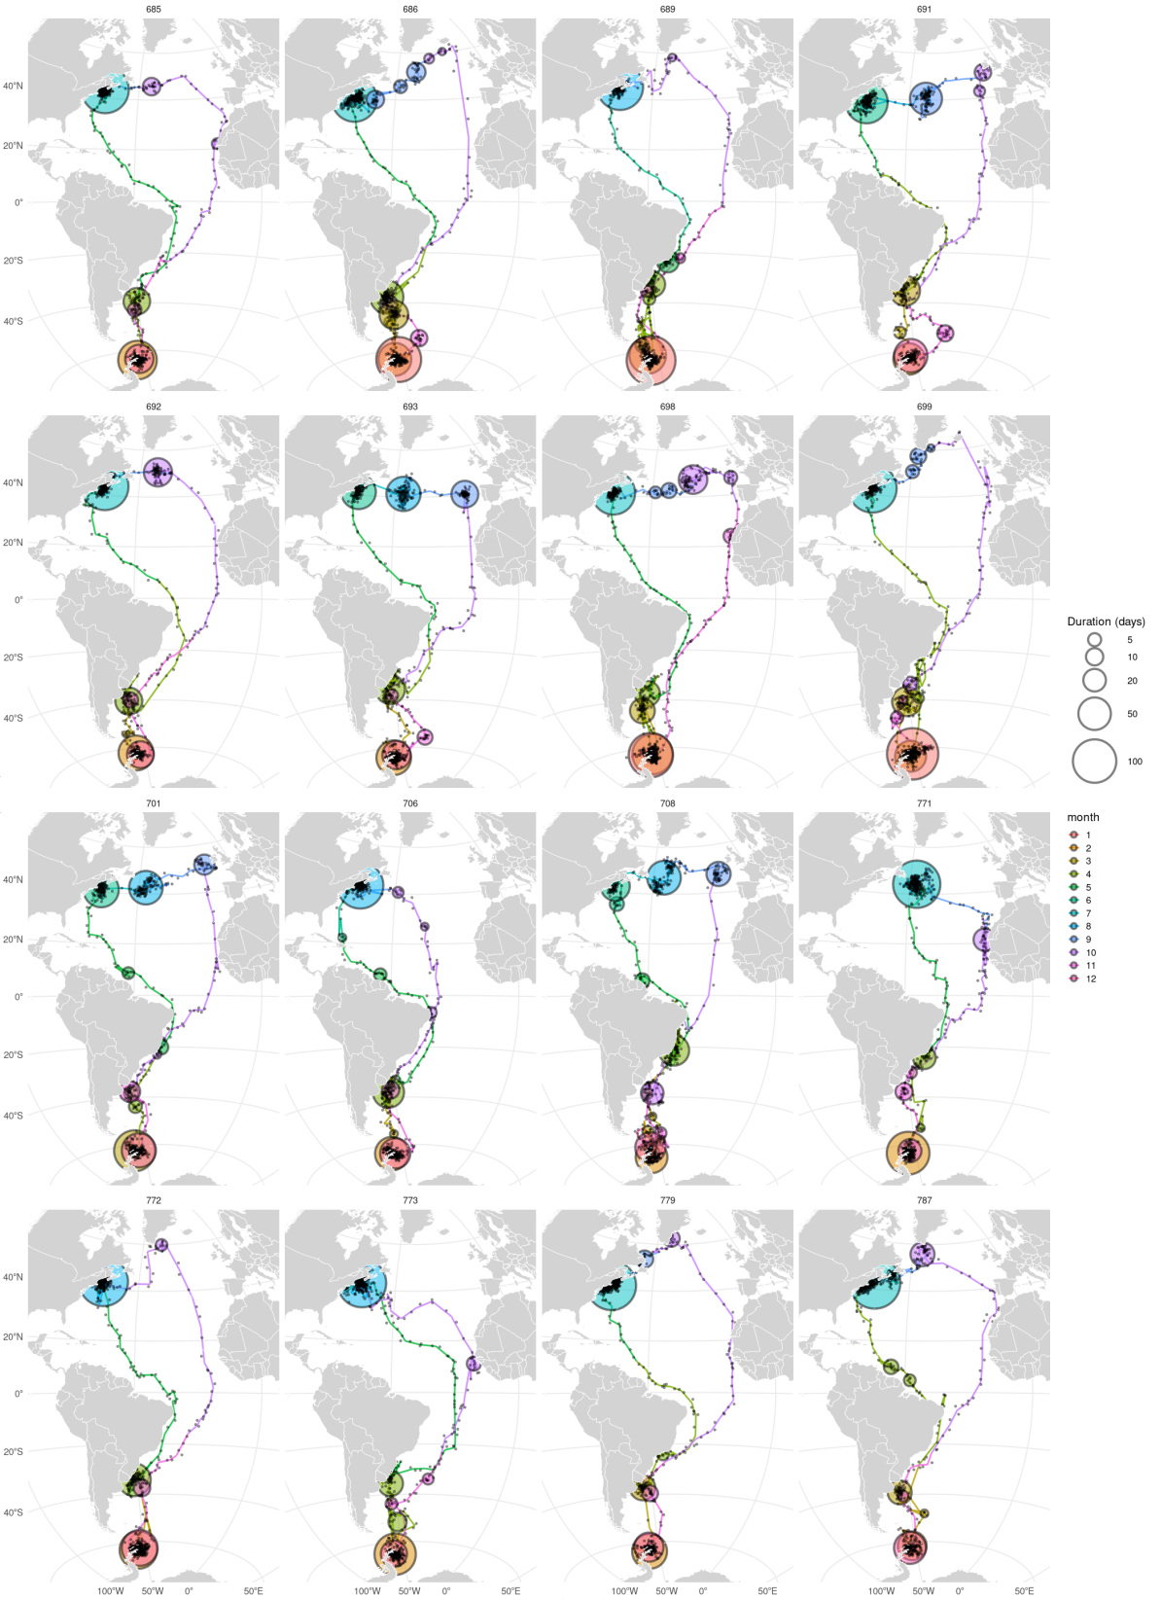
Figure S1. Individual migration routes and stopover sites identified by spatiotemporal clustering (ST-DBSCAN). Each panel shows one individual's complete track with stopover sites marked as circles (size indicates duration in days; colour indicates month). Tracks are based on daily mean locations; small black dots show raw estimated positions for reference.
Figure S2. Temporal changes in latitude (top) and longitude (bottom) of 16 Wilson's Storm-Petrels over one annual cycle. Colours indicate migration phases classified by ST-DBSCAN: Antarctic breeding (yellow), stopover (green), North Atlantic non-breeding (navy), and transit migration (grey). Orange dashed lines indicate the equinoxes.

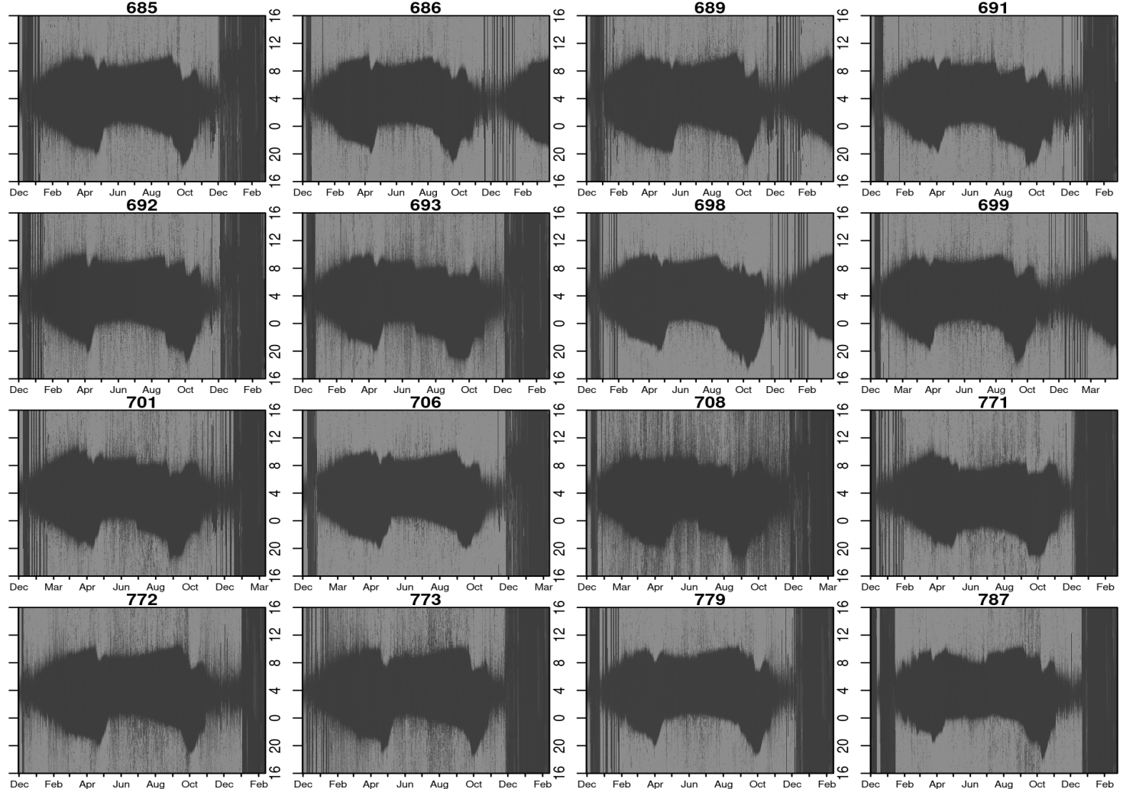
Figure S3. Raw light-level plots for each individual over the tracking period. The y-axis represents the hour of the day, and the x-axis represents the date. Individuals 685, 689, 692, 698, 701, 771, 773, and 779 were classified as breeders; the remaining eight were classified as non-breeders or uncertain in the first breeding season.

Table S1. Tag-effect and sampling-bias tests for tagged versus control birds. Body mass change, initial body mass and brood-patch score were tested with two-sided Welch's t-tests and recapture rate with Fisher's exact test. Values are reported as mean ± s.d.
Test | Tagged | Control | t | df | p | Hedges’ g | Wilcoxon p
Body-mass change (g) | −0.36 ± 2.53 (n = 21) | −0.42 ± 3.22 (n = 50) | −0.08 | 47.5 | 0.937 | −0.02 | 0.743
Initial body mass (g) | 37.82 ± 3.11 (n = 50) | 37.26 ± 2.74 (n = 205) | −1.18 | 68.8 | 0.244 | −0.20 | 0.268
Initial Brood-patch score (0–3) | 1.90 ± 0.71 (n = 49) | 1.87 ± 0.86 (n = 126) | −0.26 | 104.8 | 0.797 | −0.04 | 0.740
Recapture rate | 0.314 (22/70) | 0.183 (41/224) | — | — | 0.029 | OR 2.04 [1.05, 3.90] | —

Table S2. Sex differences in migration phenology and movement metrics (females vs males), tested with two-sided Welch's t-tests. Values are reported as mean ± s.d., with ranges.
Variable | Female  (n = 6) | Male  (n = 10) | t | df | raw p | p_{BH} | Hedges’ g | Wilcoxonp
Departure from breeding (Julian) | 75.8 ± 15.0  (61–97) | 79.8 ± 15.6  (59–104) | −0.50 | 11.0 | 0.624 | 0.873 | −0.24 | 0.625
Arrival at non-breeding (Julian) | 135.5 ± 13.4  (117–151) | 143.2 ± 13.2  (125–167) | −1.12 | 10.5 | 0.288 | 0.866 | −0.55 | 0.302
Departure from non-breeding (Julian) | 281.3 ± 12.6  (262–293) | 281.7 ± 7.2  (272–297) | −0.07 | 7.0 | 0.950 | 0.993 | −0.04 | 0.957
Arrival at breeding (Julian) | 320.5 ± 3.6  (316–324) | 320.8 ± 5.6  (314–334) | −0.13 | 13.8 | 0.898 | 0.993 | −0.06 | 0.703
Northward trip duration (days) | 59.8 ± 10.9  (43–77) | 63.4 ± 13.0  (41–77) | −0.60 | 12.2 | 0.556 | 0.866 | −0.28 | 0.625
Southward trip duration (days) | 39.2 ± 12.4  (28–61) | 39.1 ± 4.2  (34–47) | 0.01 | 5.7 | 0.993 | 0.993 | 0.01 | 0.551
Northward stopover (days) | 33.1 ± 10.9  (20–51) | 37.0 ± 12.9  (12–53) | −0.66 | 12.2 | 0.523 | 0.866 | −0.31 | 0.357
Southward stopover (days) | 6.0 ± 11.6  (0–29) | 10.2 ± 6.5  (0–21) | −0.80 | 6.9 | 0.449 | 0.866 | −0.45 | 0.110
Total annual distance (km) | 37,116 ± 3,739  (31,779–41,669) | 35,672 ± 2,077  (32,225–40,024) | 0.87 | 6.9 | 0.414 | 0.866 | 0.49 | 0.416
Northward distance (km) | 16,900 ± 2,052  (14,430–20,598) | 15,416 ± 1,341  (14,031–18,804) | 1.58 | 7.6 | 0.155 | 0.722 | 0.86 | 0.074
Southward distance (km) | 18,257 ± 2,941  (15,234–23,047) | 16,838 ± 1,792  (14,945–21,220) | 1.07 | 7.3 | 0.320 | 0.866 | 0.59 | 0.357
Mean transit speed (km/h) | 21.59 ± 1.13  (20.4–23.4) | 20.36 ± 1.36  (17.1–21.8) | 1.96 | 12.3 | 0.074 | 0.515 | 0.91 | 0.093
Mean speed, northward (km/h) | 22.09 ± 1.55  (20.7–24.1) | 20.11 ± 2.26  (16.1–22.5) | 2.08 | 13.6 | 0.057 | 0.515 | 0.92 | 0.212
Mean speed, southward (km/h) | 21.55 ± 1.85  (19.9–23.9) | 21.87 ± 4.19  (17.4–32.4) | −0.21 | 13.3 | 0.838 | 0.993 | −0.09 | 0.625
Table S3. Breeder vs non-breeder differences across the migration phenology and movement variables, tested with two-sided Welch's t-tests. Values are reported as mean ± s.d., with ranges.
Variable | Breeders  (n = 8) | Non-breeders  (n = 8) | t | df | raw p | p_{BH} | Hedges’ g | Wilcoxon p
Departure from breeding (Julian) | 89.8 ± 11.3  (73–104) | 66.9 ± 7.5  (59–78) | 4.78 | 12.1 | <0.001 | 0.006* | 2.26 | 0.004
Arrival at non-breeding (Julian) | 144.8 ± 12.4  (126–167) | 135.9 ± 13.7  (117–155) | 1.36 | 13.9 | 0.195 | 0.545 | 0.64 | 0.293
Departure from non-breeding (Julian) | 282.9 ± 10.4  (262–297) | 280.2 ± 8.2  (271–293) | 0.56 | 13.3 | 0.586 | 0.813 | 0.26 | 0.528
Arrival at breeding (Julian) | 322.9 ± 5.0  (318–334) | 318.5 ± 3.7  (314–323) | 1.99 | 12.8 | 0.068 | 0.240 | 0.94 | 0.081
Northward trip duration (days) | 55.0 ± 11.4  (41–77) | 69.1 ± 8.1  (55–77) | -2.85 | 12.7 | 0.014 | 0.065 | -1.35 | 0.031
Southward trip duration (days) | 39.9 ± 9.0  (31–61) | 38.4 ± 7.0  (28–47) | 0.37 | 13.2 | 0.718 | 0.813 | 0.17 | 0.875
Northward stopover (days) | 28.4 ± 11.4  (12–52) | 42.7 ± 7.6  (30–53) | -2.97 | 12.2 | 0.012 | 0.065 | -1.40 | 0.018
Southward stopover (days) | 8.0 ± 10.0  (0–29) | 9.2 ± 7.7  (0–21) | -0.27 | 13.1 | 0.794 | 0.813 | -0.13 | 0.488
Total annual distance (km) | 36,014 ± 3,119  (31,779–41,142) | 36,413 ± 2,615 (32,225–41,669) | -0.28 | 13.6 | 0.786 | 0.813 | -0.13 | 0.372
Northward distance (km) | 16,354 ± 2,273  (14,031–20,598) | 15,591 ± 1,001 (14,335–17,107) | 0.87 | 9.6 | 0.406 | 0.812 | 0.41 | 0.793
Southward distance (km) | 17,629 ± 2,082  (15,785–21,220) | 17,111 ± 2,627 (14,945–23,047) | 0.44 | 13.3 | 0.669 | 0.813 | 0.21 | 0.495
Mean transit speed (km/h) | 20.72 ± 0.85  (19.2–21.8) | 20.92 ± 1.83  (17.1–23.4) | -0.28 | 9.9 | 0.782 | 0.813 | -0.13 | 0.564
Mean speed, northward (km/h) | 20.99 ± 1.11  (19.2–22.3) | 20.71 ± 3.01  (16.1–24.1) | 0.24 | 8.9 | 0.813 | 0.813 | 0.11 | 0.958
Mean speed, southward (km/h) | 20.91 ± 1.51  (18.4–23.2) | 22.59 ± 4.60  (17.4–32.4) | -0.98 | 8.5 | 0.352 | 0.812 | -0.47 | 0.637

