Supplementary files
Table S1. Station-blocked validation performance of the conditional diffusion model explained by DREA. Although the raw diffusion intervals undercovered the nominal 90% level, post-hoc uncertainty calibration restored coverage to approximately nominal levels, indicating that the predictive distribution was suitable for calibrated probabilistic interpretation.
Metric | Value
MAE | 0.37
RMSE | 0.53
CRPS | 0.28
Pearson r | 0.97
NSE | 0.94
Raw 90% coverage | 0.66
Calibrated 90% coverage | 0.90
Calibration factor | 2.21

Table S2. Performance of Random-Forest SHAP and permutation importance in recovering known drivers from the synthetic data.
Synthetic variable | Known role | Random-Forest SHAP | Scaled Random-Forest SHAP | Permutation mean | Permutation standard deviation
Mean variable | Mean/location driver | 0.853 | 1.000 | 0.524 | 0.019
Uncertainty variable | Variance/uncertainty driver | 0.077 | 0.090 | -0.004 | 0.003
Tail variable | Upper-tail driver | 0.438 | 0.513 | 0.072 | 0.007
Noise variable | Irrelevant noise | 0.071 | 0.083 | 0.002 | 0.003
Mean-proxy variable | Correlated proxy for mean | 0.433 | 0.508 | 0.078 | 0.008
Note: Scaled Random-Forest SHAP values were computed by dividing each SHAP value by the maximum SHAP value in the synthetic benchmark. These scaled values are used in Figure 3.
Table S3. Comparison of the top selected hydrological predictors under DREA and SHAP. DREA values are empirical probabilities ranging from 0 to 1. SHAP importance values are raw mean absolute SHAP values from the Random Forest point-prediction baseline. The corresponding normalized RF-SHAP values are shown in Figure 4.
Predictor | Wasserstein-DREA | Width-DREA | Variance-DREA | Tail-DREA | CRPS-DREA | SHAP importance | Interpretation
Basin area | 1.00 | 0.20 | 0.30 | 1.00 | 1.00 | 0.91 | High point and distributional influence
Basin perimeter | 1.00 | 1.00 | 1.00 | 1.00 | 1.00 | 0.82 | Stable distributional influence across all metrics
30-day maximum temperature | 1.00 | 1.00 | 0.90 | 1.00 | 1.00 | 0.11 | Strong distributional effect despite low SHAP
30-day minimum temperature | 1.00 | 0.60 | 0.50 | 1.00 | 1.00 | 0.15 | Tail and skill influence beyond point attribution
30-day precipitation | 0.70 | 0.00 | 0.00 | 0.90 | 0.80 | 0.11 | Tail and skill influence with limited width effect
3-day precipitation | 0.60 | 1.00 | 0.90 | 0.00 | 0.90 | 0.14 | Uncertainty/variance influence more than tail influence

Table S4. Experimental Settings for the Diffusion model
Component | Synthetic benchmark | Hydrology application
Model | Conditional diffusion | Conditional diffusion
DREA realizations | 30 | 10
Diffusion samples | 50 | 30
Diffusion steps | 60 | 40
Diffusion epochs | 35 | 25
Batch size | 512 | 512
Learning rate | 0.001 | 0.001
Hidden dimension | 128 | 128
Test sample cap | 1200 | 1200
Primary global perturbation | Marginal shuffle | Marginal shuffle
Local perturbation | N/A | ±1 SD
Material threshold | 60th percentile | 60th percentile
SHAP baseline model | Random Forest | Random Forest
RF trees | 300 | 250
RF minimum leaf size | 3 | 3
RF max features | sqrt | sqrt

Table S5. Sensitivity of synthetic DREA probabilities to the material-change threshold.
DREA probabilities were recomputed using empirical material-change thresholds $q=0.50$, $0.60$, $0.70$, and $0.80$. The table reports the top-ranked variable for each DREA component at each threshold. Mean/location attribution was stable across thresholds for Wasserstein-DREA and CRPS-DREA, while uncertainty attribution was stable across thresholds for Width-DREA and Variance-DREA. Tail-DREA identified the Tail variable under moderate thresholds, whereas stricter thresholds increasingly emphasized the Mean variable, consistent with the fact that fixed-threshold exceedance probability can be affected by both tail-specific jumps and large location shifts.
DREA component | q = 0.50 | q = 0.60 | q = 0.70 | q = 0.80 | Interpretation
Wasserstein-DREA | Mean variable, 1.000 | Mean variable, 1.000 | Mean variable, 1.000 | Mean variable, 1.000 | Stable recovery of mean/location driver
Width-DREA | Uncertainty variable, 1.000 | Uncertainty variable, 1.000 | Uncertainty variable, 0.967 | Uncertainty variable, 0.767 | Stable recovery of uncertainty-width driver
Variance-DREA | Uncertainty variable, 1.000 | Uncertainty variable, 0.967 | Uncertainty variable, 0.933 | Uncertainty variable, 0.667 | Stable recovery of variance driver
Tail-DREA | Tail variable, 0.867 | Tail variable, 0.733 | Mean variable, 0.600 | Mean variable, 0.500 | Tail driver recovered at moderate thresholds; stricter thresholds emphasize location shifts
CRPS-DREA | Mean variable, 1.000 | Mean variable, 1.000 | Mean variable, 1.000 | Mean variable, 1.000 | Stable recovery of probabilistic-skill/location driver

Table S6. Same-architecture SHAP applied to the diffusion predictive mean in the synthetic benchmark. A conditional diffusion model with the same synthetic architecture used for DREA was converted to a point-output model by averaging generated samples. Exact interventional SHAP was then applied to this diffusion predictive mean using 60 evaluation rows and 25 background rows. Permutation importance was computed as the increase in mean absolute error after feature permutation. DREA values are the primary $q=0.60$ probabilities. The results show that diffusion-mean SHAP primarily emphasizes the Mean variable as the dominant point-output driver, whereas DREA decomposes predictor influence by distributional role: the Uncertainty variable is identified through Width-DREA and Variance-DREA, and the Tail variable is identified through Tail-DREA.
Synthetic variable | Known role | Diffusion-mean SHAP | Scaled diffusion-mean SHAP | Diffusion-mean permutation ΔMAE | Wasserstein-DREA | Width-DREA | Variance-DREA | Tail-DREA | CRPS-DREA
Mean variable | Mean/location driver | 0.751 | 1.000 | 0.715 | 1.000 | 0.633 | 0.733 | 0.700 | 1.000
Tail variable | Upper-tail driver | 0.247 | 0.329 | 0.033 | 0.400 | 0.367 | 0.300 | 0.733 | 0.700
Uncertainty variable | Variance/uncertainty driver | 0.053 | 0.071 | 0.009 | 0.600 | 1.000 | 0.967 | 0.400 | 0.167
Noise variable | Irrelevant noise | 0.045 | 0.060 | 0.002 | 0.000 | 0.000 | 0.000 | 0.100 | 0.000
Mean-proxy variable | Correlated proxy for mean | 0.038 | 0.051 | -0.013 | 0.000 | 0.000 | 0.000 | 0.067 | 0.133

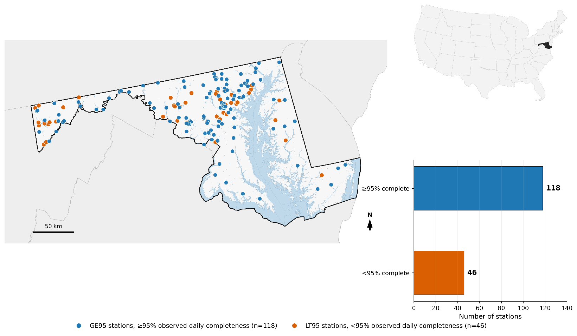
Figure S1. Selected stations for hydrological modelling. Only stations with daily data coverage from 2010 to 2024 exceeding 95% completeness were retained

