Supplementary File
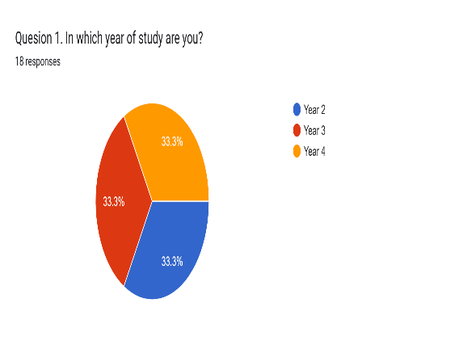
Fig. 1: Levels of trainees who participated.
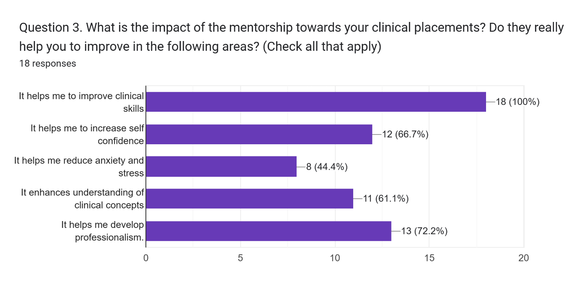
Fig. 2: The chart illustrates trainees’ insights on the impact of mentorship on their clinical practice. 18 trainees reported that mentorship provided to the during clinical placement helps them to improve their clinical skills while 8 of them reported that mentorship has helped them to reduce anxiety and stress that they were having during their clinical placement.

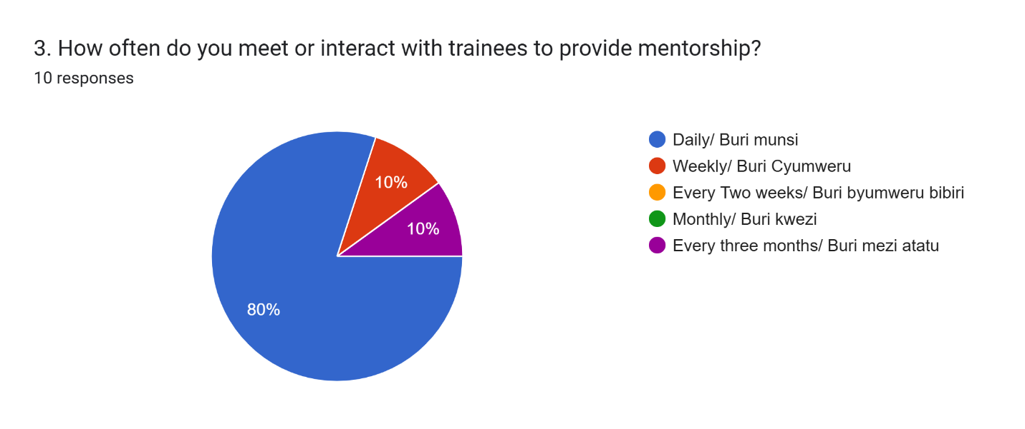
Fig 3: A figure showing the duration that a mentor is in contact with Clinical Officer Trainee. Among 10 participants, 8 are together with trainees daily, 1 trainee once a week, and one for every three months

