Supplementary Material
Table S1: Number of digested dried bloodspots collected from laboratory-raised Culex quinquefasciatus. Split by host and timepoint.
Blood Type | Timepoint (hours after feeding) | Number of Individual DBS
Horse | 6 | 120
Horse | 12 | 102
Horse | 24 | 105
Horse | 30 | 97
Chicken | 6 | 121
Chicken | 12 | 128
Chicken | 24 | 131
Chicken | 30 | 8
Pig | 6 | 53
Pig | 12 | 147
Pig | 24 | 101
Pig | 30 | 87
Cow | 6 | 82
Cow | 12 | 123
Cow | 24 | 120
Cow | 30 | 131
Dog | 6 | 86
Dog | 12 | 106
Dog | 24 | 96
Dog | 30 | 53
Human | 6 | 131
Human | 12 | 120
Human | 24 | 153
Human | 30 | 160
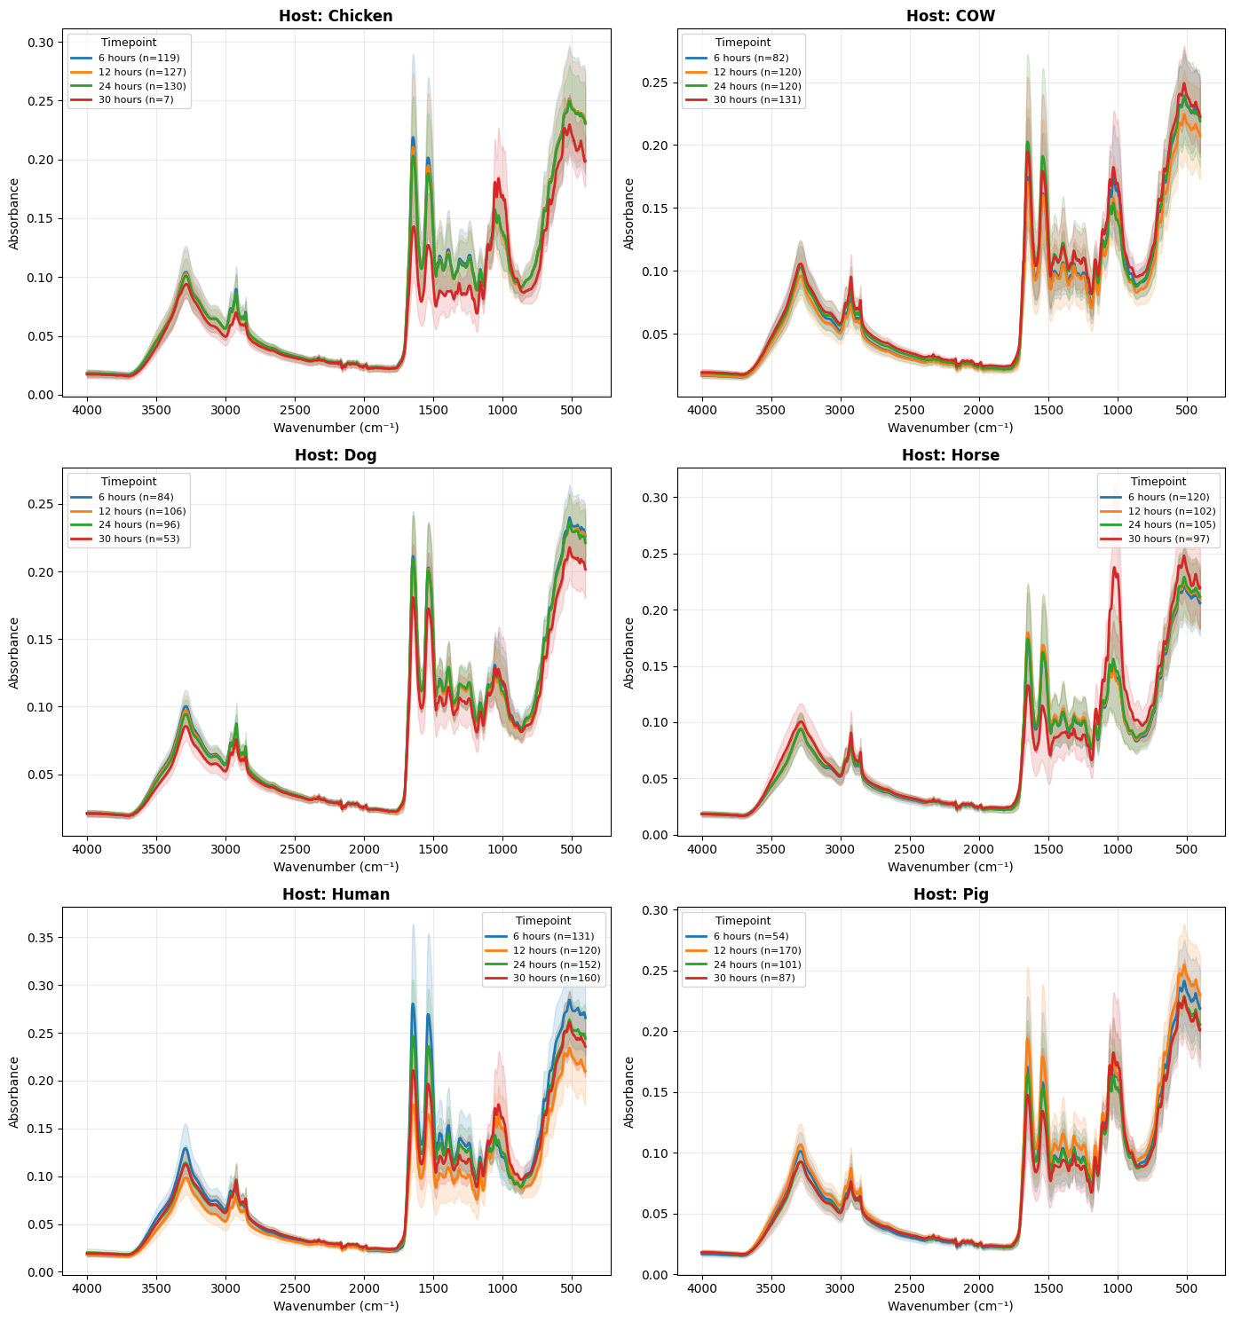
Figure S1: Spectra from mid-infrared spectroscopy obtained from laboratory-reared Cx. quinquefasciatus dried bloodspots, averaged across the six host species and each of the four timepoints.

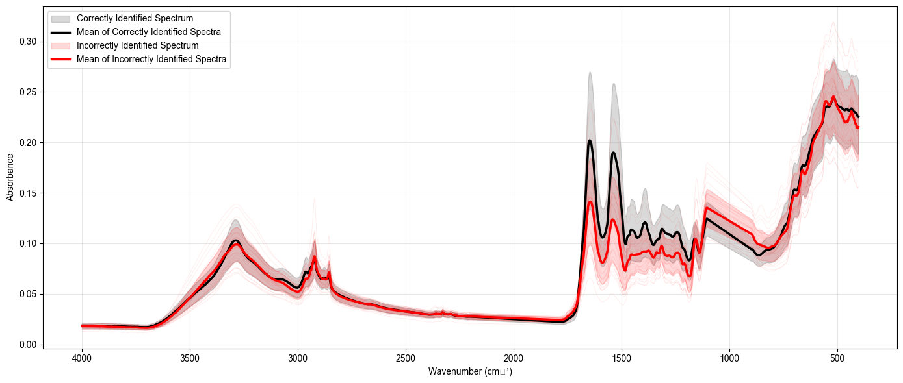
Figure S2: Mean and individual spectra of incorrect and correctly labelled host species from each dried bloodspot from laboratory-reared Cx. quinquefasciatus.

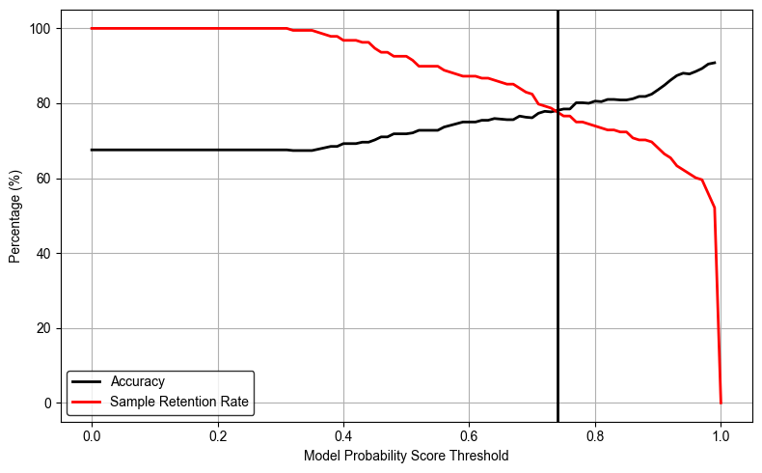
Figure S3: Overall multi-layer perceptron model accuracy and sample retention rate after applying model probability score thresholds for dried blood spots collected from field-collected mosquitoes in the Philippines (n = 187). The vertical line indicates the optimal threshold (0.73).

