Supplementary Information

Long-term biodegradation of thiamethoxam by sodium alginate/biochar-immobilized Bacillus subtilis

Huyen Nguyen¹, Anh Hang¹, Nhi Cao¹, Anh Nguyen¹, Thao Vo², and Khang Huynh¹*

¹Faculty of Biological Sciences, Nong Lam University, Ho Chi Minh City, Vietnam
²Biotechnology Center of Ho Chi Minh City, Ho Chi Minh City, Vietnam

*Address correspondence to Khang Huynh:
Address: Room BIO315, Building A1, Nong Lam University Ho Chi Minh City
Linh Xuan ward, Ho Chi Minh city, Vietnam
Tel: +84 82-255-1844
E-mail: khanghv@hcmuaf.edu.vn

Fig. S1 Growth of B. thuringiensis (A), B. megaterium (B), and B. subtilis (C) in mineral salts medium (MSM) with or without thiamethoxam (THI; 6 mg/L) over 20 days. Error bars represent the standard error of the mean (n = 3).

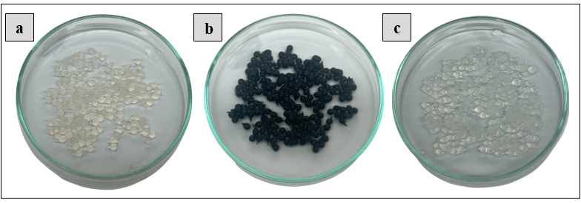
Fig. S2 Three bead formulations: (a) sodium alginate/bacterial cell beads, SA/CS; (b) sodium alginate/bacterial cell/biochar beads, SA/CS/BC; and (c) sodium alginate beads, SA.

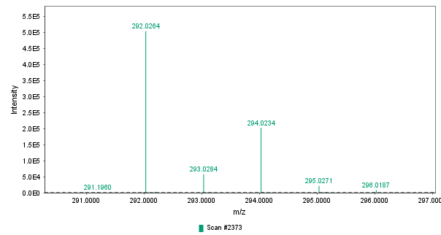
0 eV
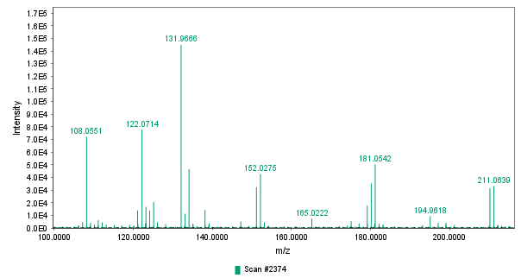
10–40 eV ramp
Fig. S3 Mass spectra of THI standard 1 µg/mL (m/z 292.0264) on the UPLC-QTOF-MS^{E}.

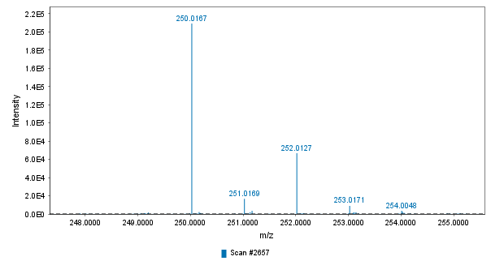
0 eV
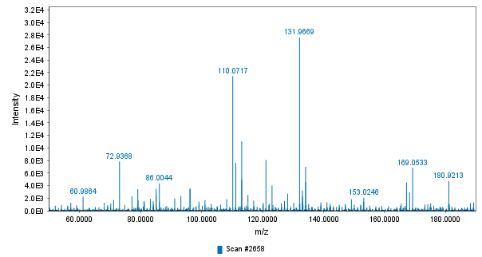
10–40 eV ramp
Fig. S4 Mass spectra of CLO standard 1 µg/mL (m/z 250.0167) on the UPLC-QTOF-MS^{E}.

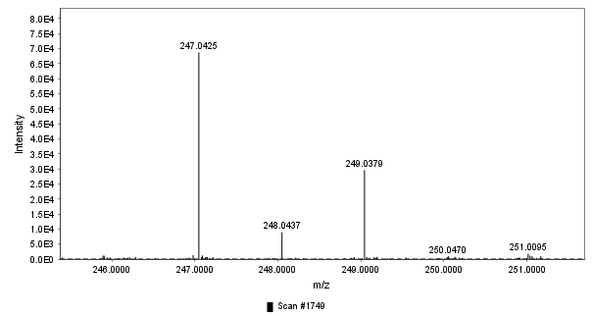
0 eV
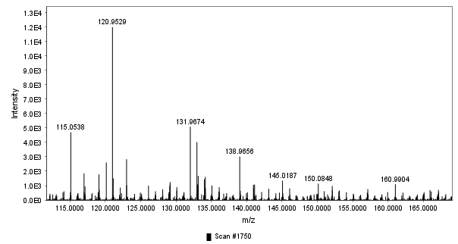
10–40 eV ramp
Fig S5 Mass spectra of TP1 (m/z 247.0409) on the UPLC-QTOF-MS^{E}.

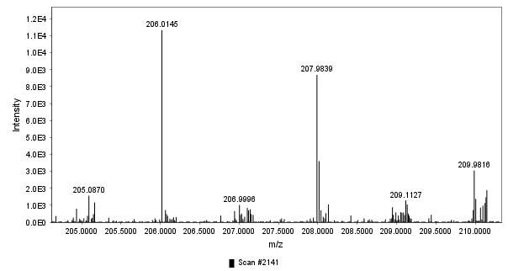
0 eV
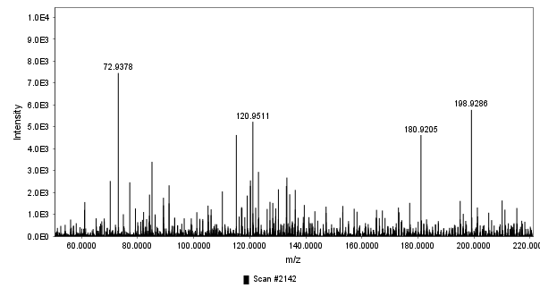
10–40 eV ramp
Fig S6 Mass spectra of TP2 (m/z 206.0145) on the UPLC-QTOF-MS^{E}.

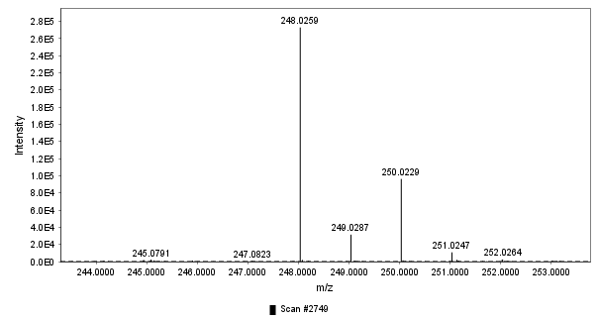
0 eV
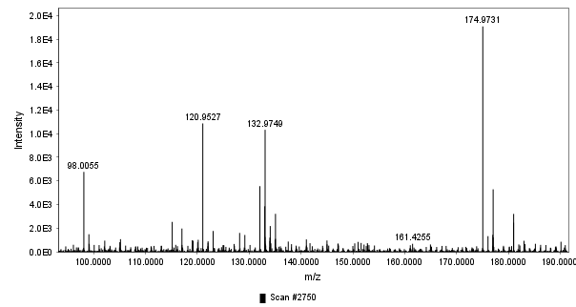
10–40 eV ramp
Fig S7 Mass spectra of TP3 (m/z 248.0259) on the UPLC-QTOF-MS^{E}.

