Three-dimensional motion capture discriminates extremely mild cerebellar ataxia from parkinsonism in the upper limbs

Supplementary materials
Supplementary Fig. 1
Comparison of FNT-forward parameters among mild SCD, mild PD and NCs in the experimental cohort.
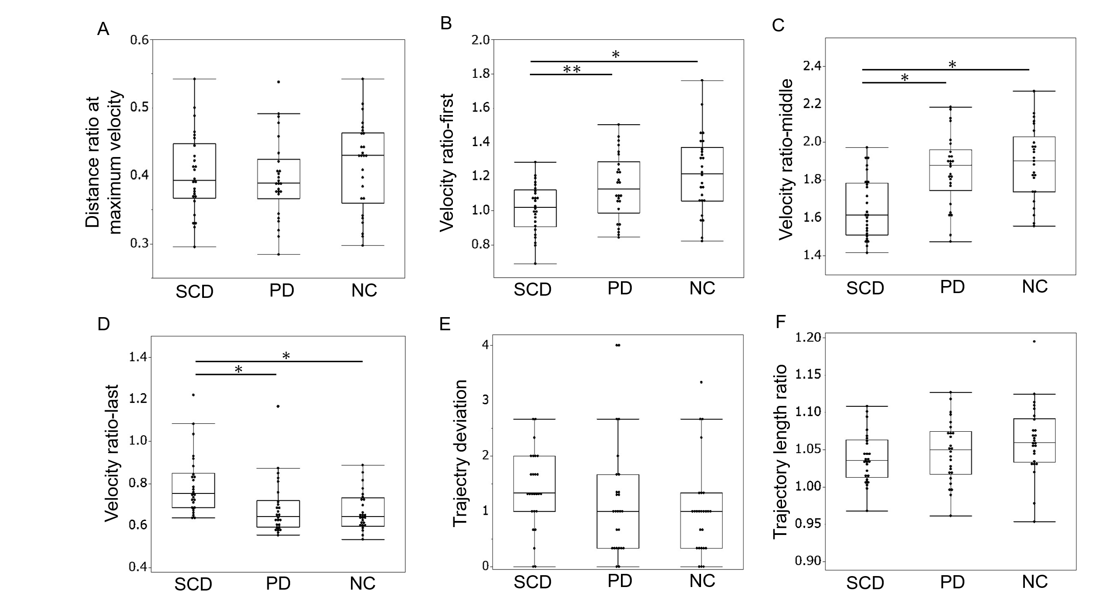

Supplementary Fig. 2
Comparison of FNT-backward parameters among mild SCD, mild PD and NCs in the experimental cohort.

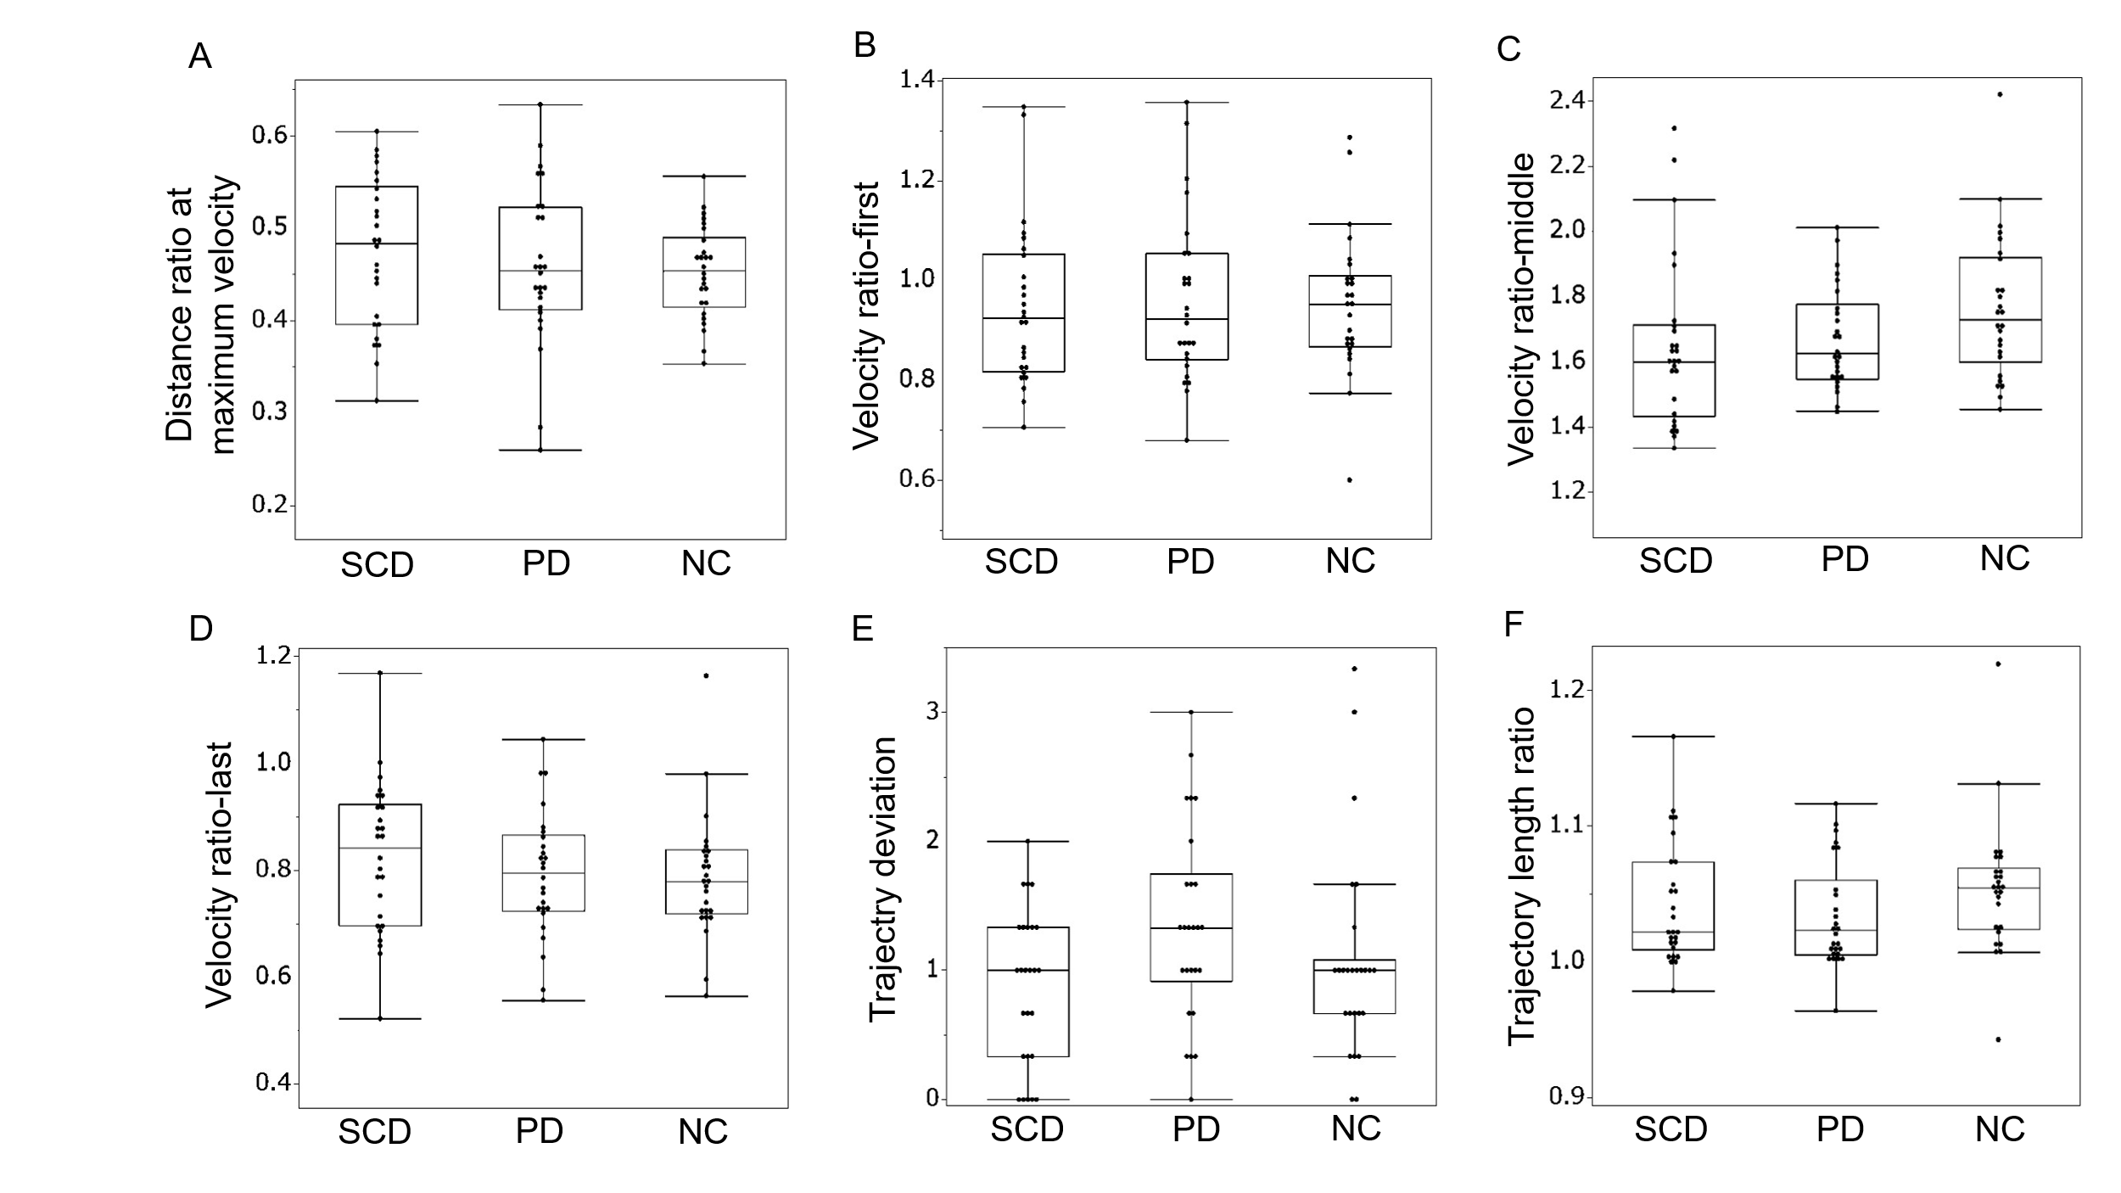

Supplementary Fig. 3
Comparison of DDKT parameters among mild SCD, mild PD and NCs in the experimental cohort.
