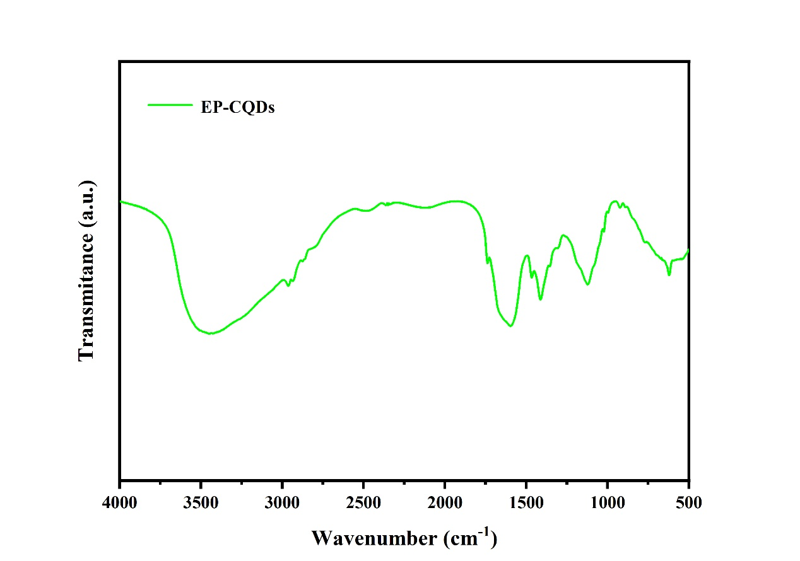
Figure S1. FTIR spectra of EP-CQDs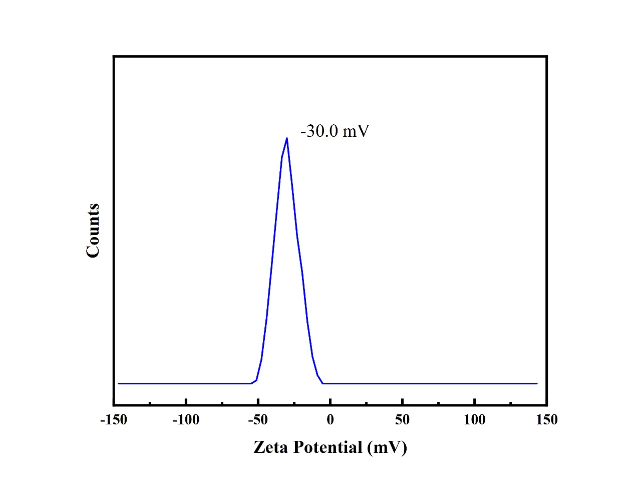
Figure S2. Zeta potential of EP-CQDs
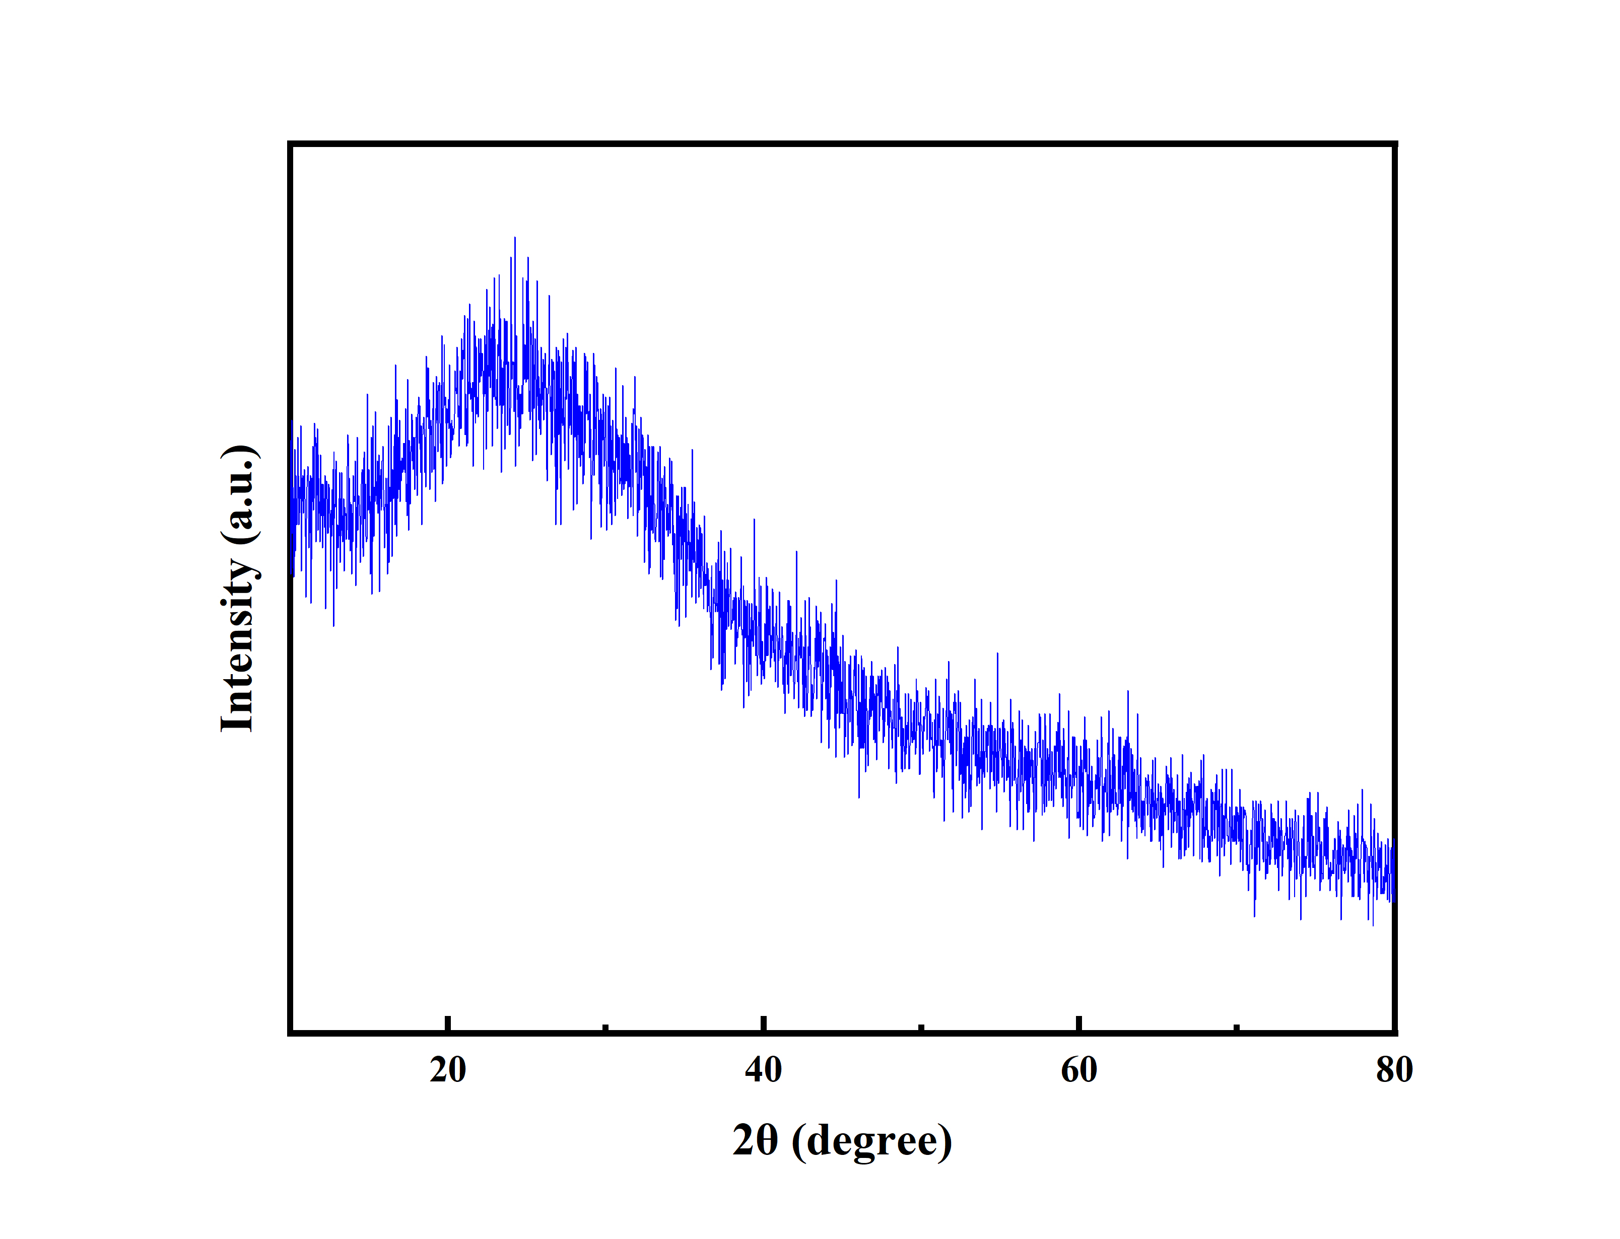 Figure S3. XRD spectrum of EP-CQDs
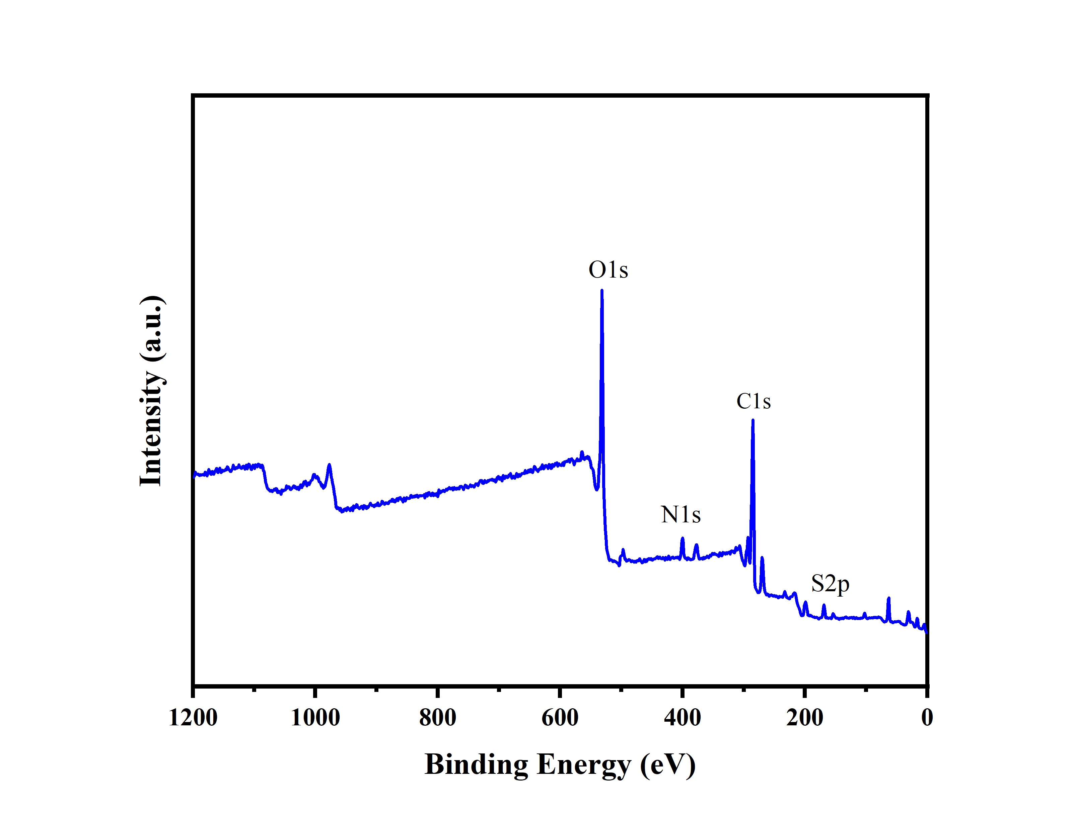
Figure S4. XPS survey spectrum of EP-CQDs
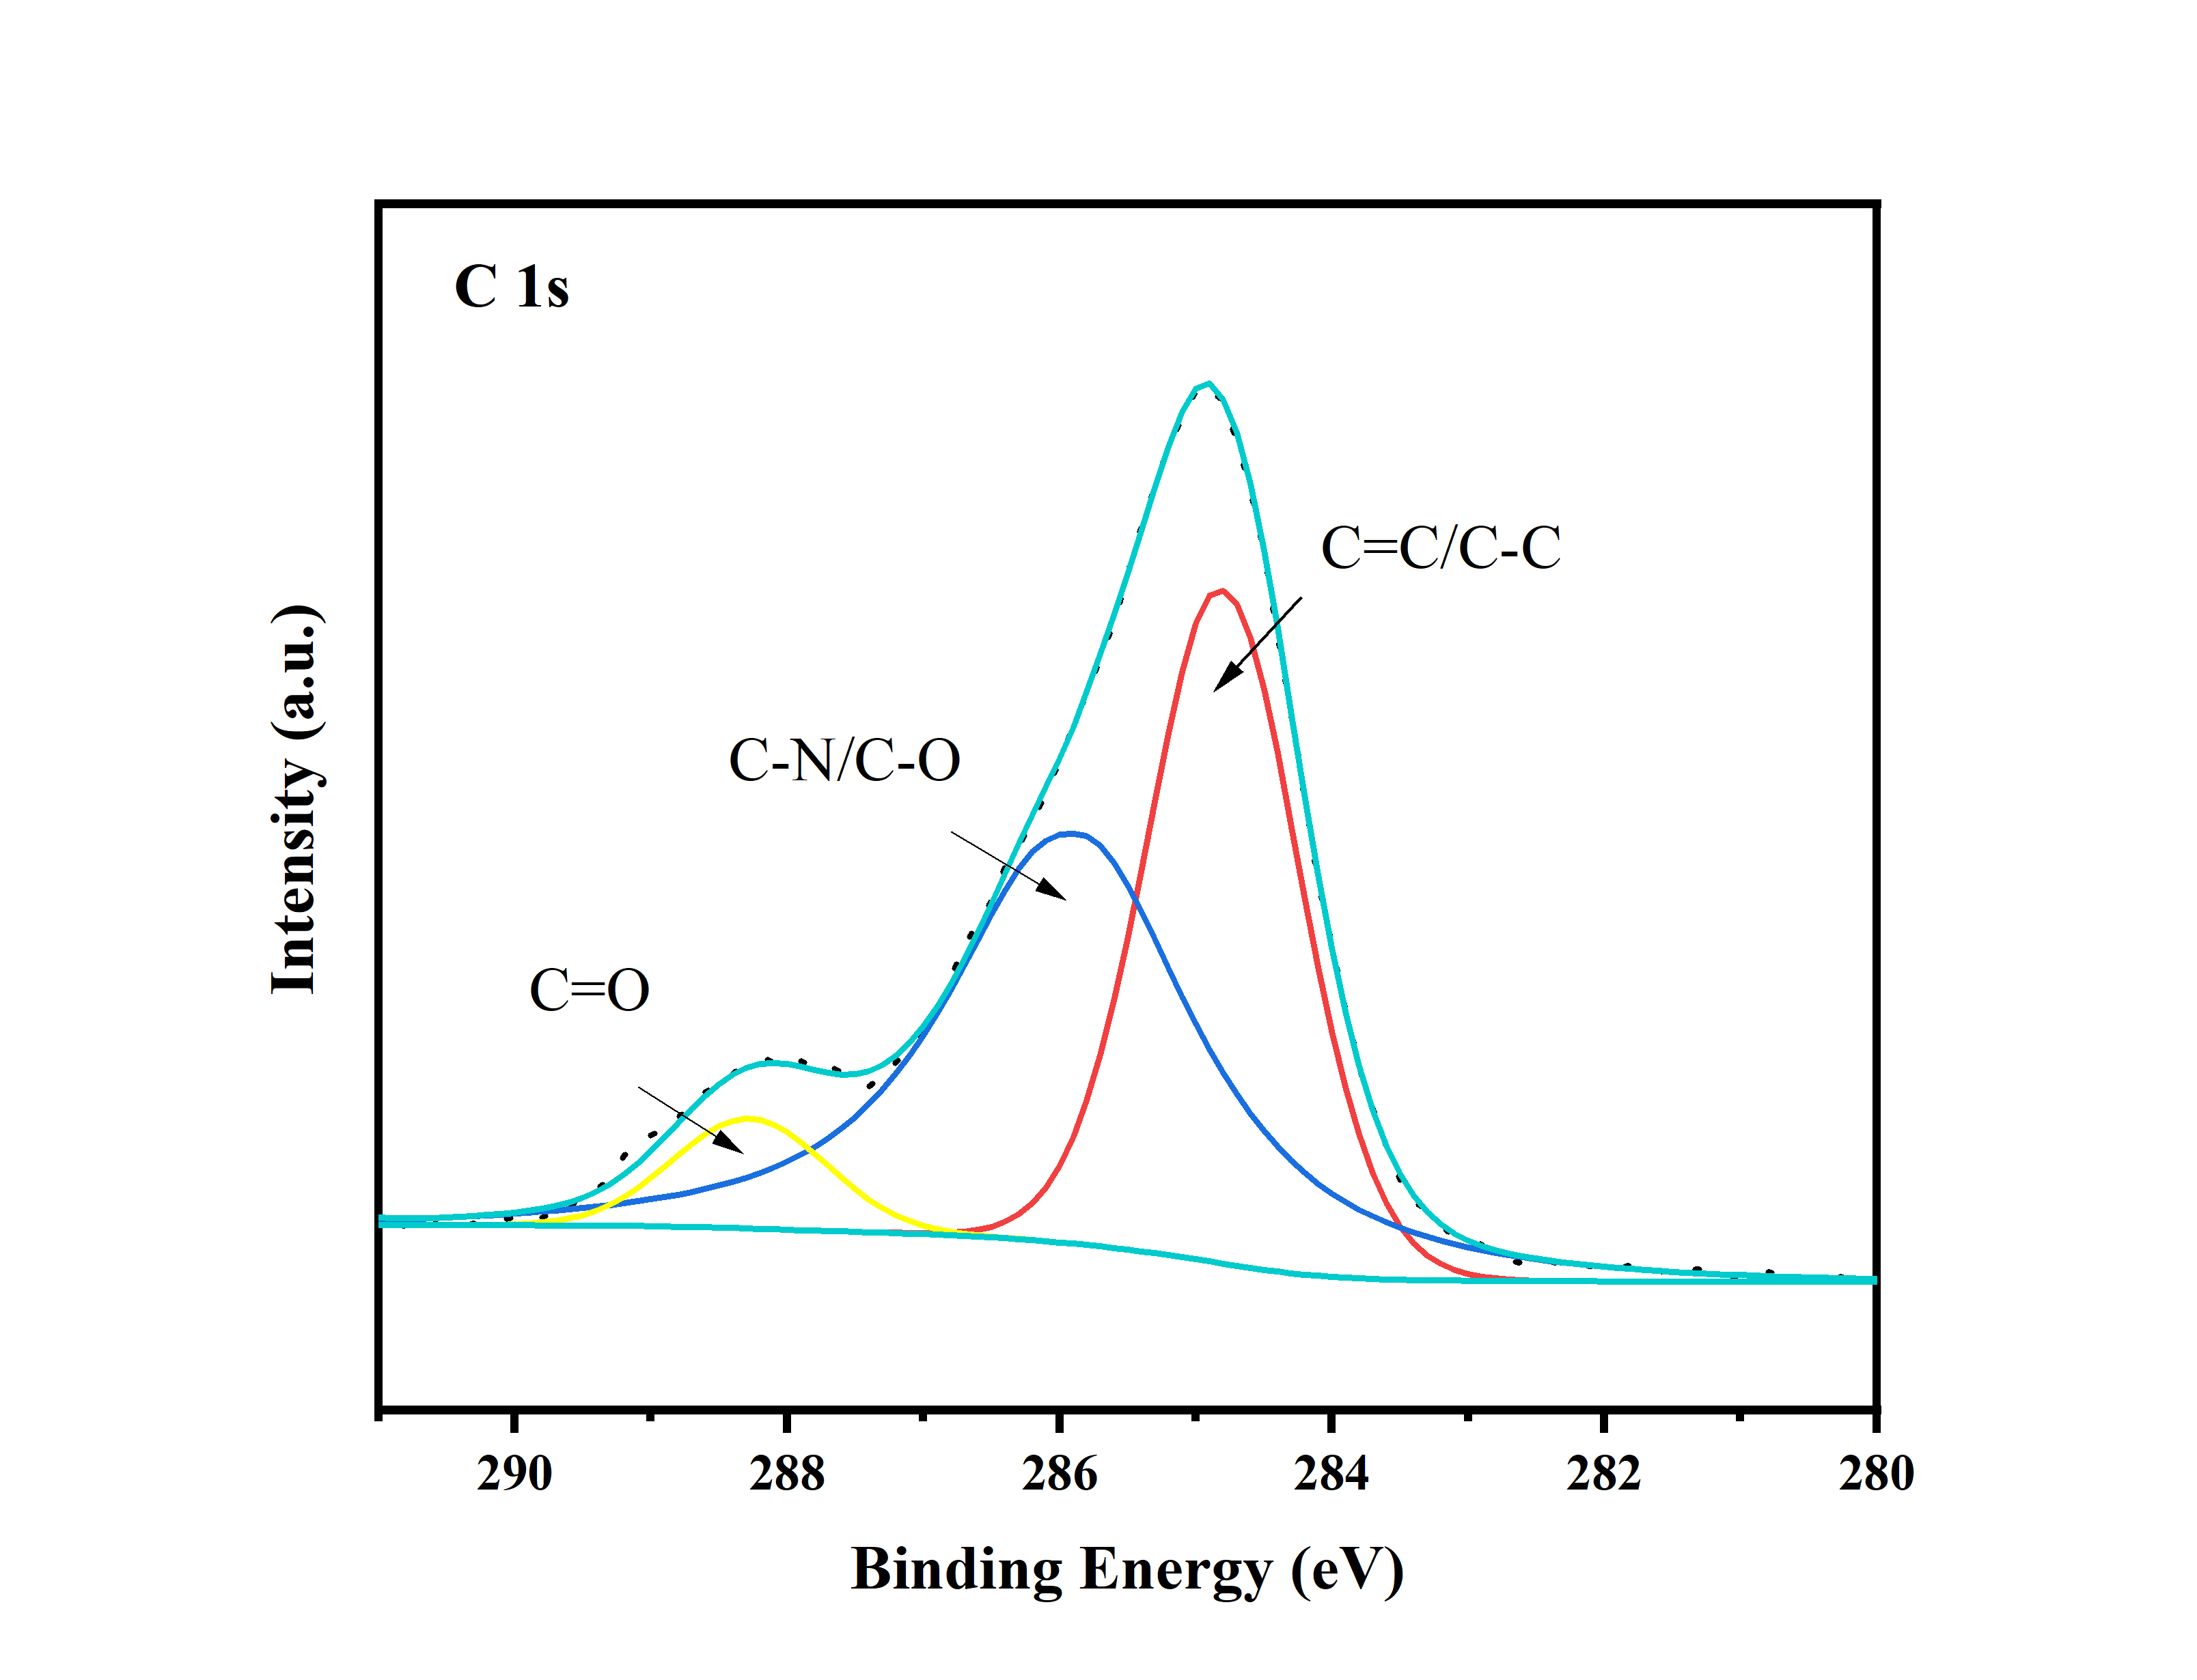
Figure S5. C1s XPS spectrum of EP-CQDs

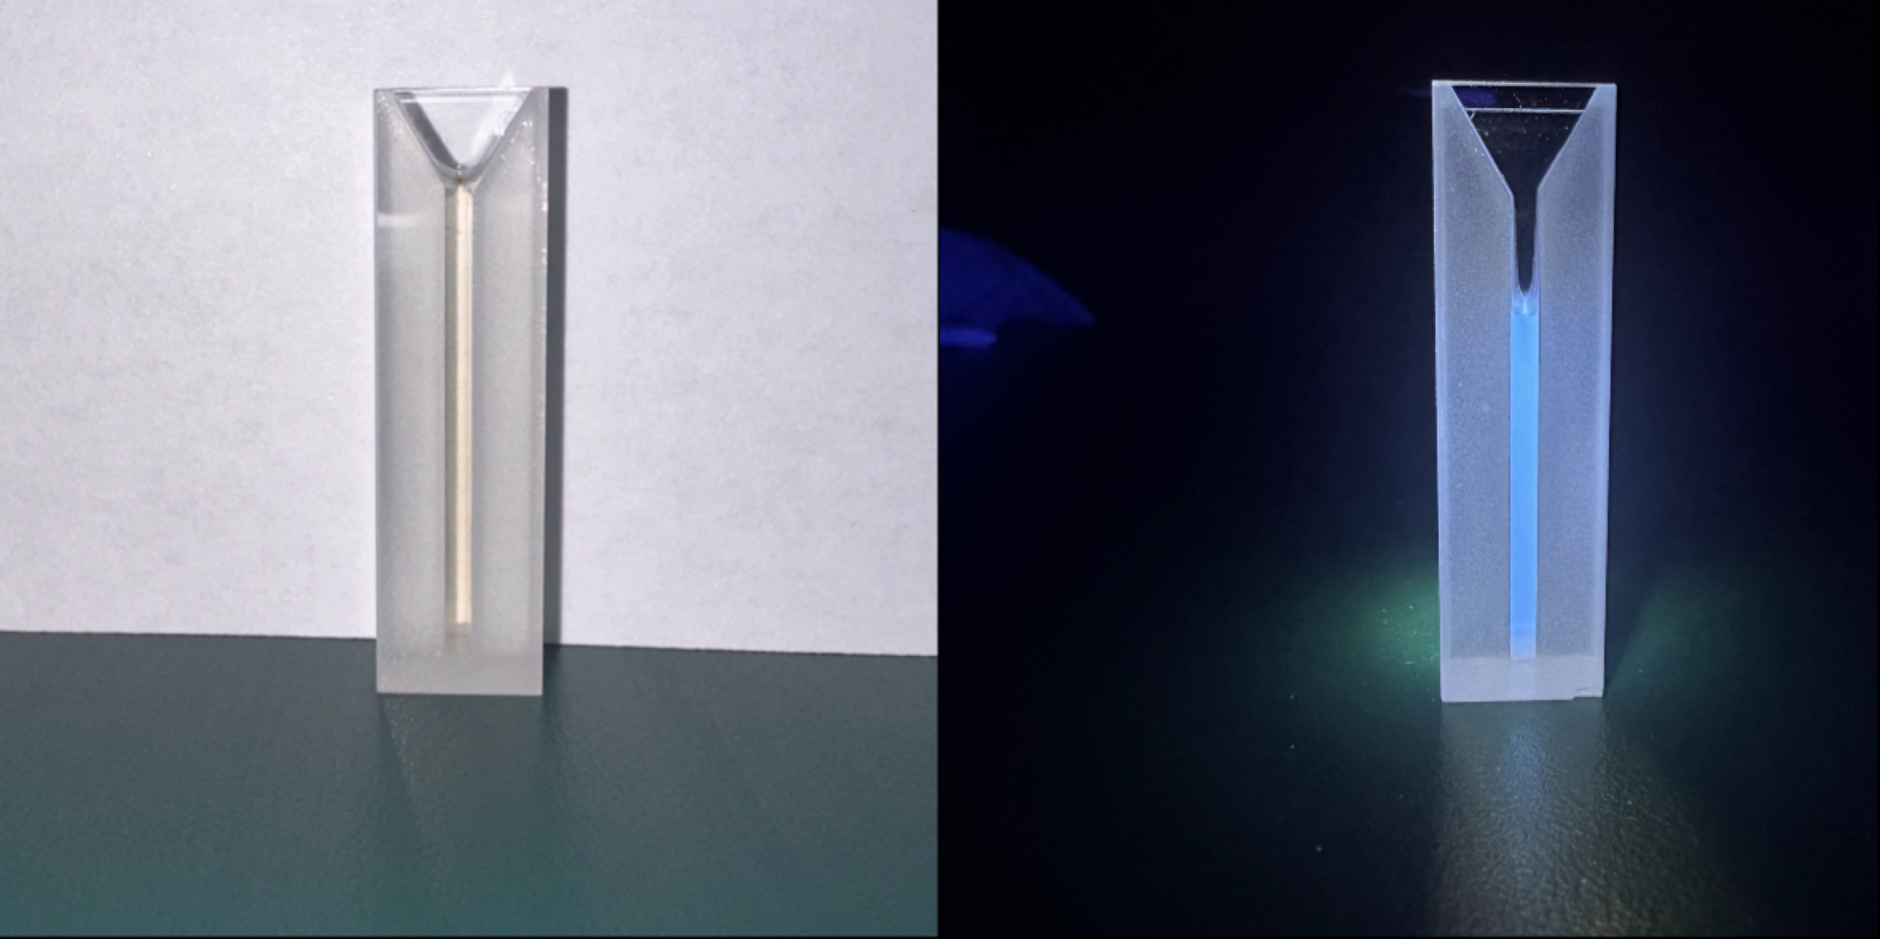
Figure S6. EP-CQDs in daylight (left) and in 365 nm light (right)
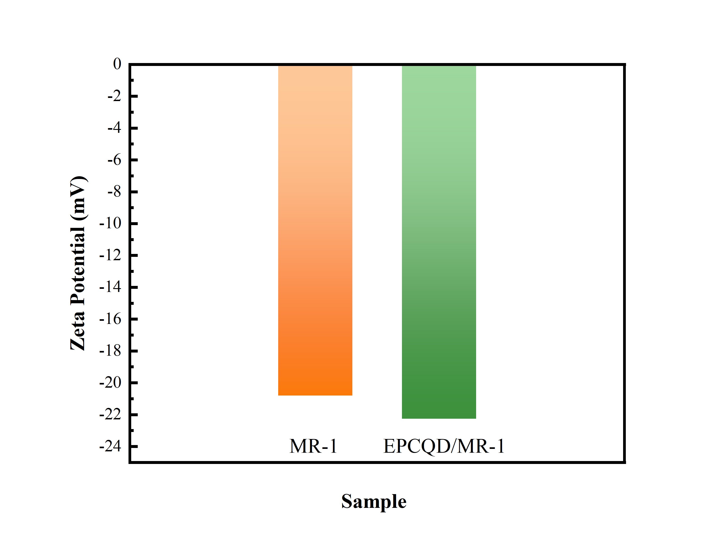
Figure S7. Zeta potential of MR-1 and EPCQDs/MR-1

