Appendix for manuscript:

Distributional impacts of decarbonizing the Swiss residential sector on key societal actors

Authors: Alexandre Torné¹*, Evelina Trutnevyte¹

¹ Renewable Energy Systems, Institute for Environmental Sciences (ISE), Section of Earth and Environmental Sciences, University of Geneva, Switzerland

* corresponding author (Uni Carl Vogt, Boulevard Carl Vogt 66, CH-1211 Geneva 4, Switzerland; +41 22 379 06 03; alexandre.torne@unige.ch)

Appendix

A. The household sample 2
A1. Examples of household data and sources 2
A2. Descriptive statistics 4
A3. Representativeness of the household sample 5
B. Microsimulation model 7
B1. Assumptions for energy investment options 7
B2. Definition of policy instruments 21
B3. Techno-economic calculations at the household level 22
C. Other results 33
C1. Supporting figures 33
C2. Sensitivity analysis 38
References 47

A. The household sample

A1. Examples of household data and sources
Table A1. Example of key household final data and corresponding sources. The household-level information displayed is only to illustrate data handling and organization and does not represent real specific households in our sample.
 |  | Cross-sectional weight |  | Household  structure |  | Setting |  | Dwelling tenure |  | At risk of poverty |  | Flat (in multi-family building) / House (single-family house) | Size of dwelling  (m²) | Year construction of dwelling | Envelope efficiency label | Electricity consumption (kWh/year) | Heating consumption (kWh/year) | Year renovation of roof
Household_1 |  | 230.55 |  | Couple w/o children, under 65 |  | Urban |  | Tenant |  | Yes |  | Flat | 86 | 1983 | G | 3871 | 12449 | 2023
Household_2 |  | 120.67 |  | Couple with children |  | Urban |  | Owner |  | No |  | Flat | 137 | 2019 | A | 5083 | 15453 | 2019
Household_3 |  | 56.80 |  | One-person, woman,  over 65 |  | Periurban |  | Owner |  | No |  | House | 55 | 1999 | D | 2809 | 8820 | 1999
Household_4 |  | 27.93 |  | One-person, man, under 65 |  | Rural |  | Tenant |  | No |  | House | 68 | 1956 | C | 2700 | 8536 | 1996
 |  |  |  |  | …
Household_n |  | 199.45 |  | Couple with children |  | Rural |  | Tenant |  | Yes |  | House | 112 | 1970 | D | 3903 | 12283 | 2010
Source |  | From the Swiss Household Budget Survey (HBS) (BFS, 2015) and the Swiss Household Energy Demand Survey (SHEDS) (Weber et al., 2017), processed as in Torné and Trutnevyte (2026) |  |  |  |  |  |  |  | Imputed from the equivalized disposable income of the household from the HBS (BFS, 2015), processed as in Torné and Trutnevyte (2026) |  | From SHEDS (Weber et al., 2017), processed as in Torné and Trutnevyte (2026) |  |  |  |  | From Streicher and Patel (2020), imputed as explained in Appendix B3 | Imputed as explained in Appendix B2

Table A1. Example of household final data and corresponding sources (continued).

 | Heating system type | Having solar thermal collectors | Having PV | Having batteries | Year installation of heating system | Year installation of solar thermal collectors | Year installation of PV and batteries | Postal code of residence
Household_1 | Oil | No | No | No | 2005 | N/A | N/A | 1211
Household_2 | Heat pump | No | Yes | Yes | 2019 | N/A | 2013 | 3001
Household_3 | Gas | Yes | No | No | 1999 | 2014 | N/A | 8000
Household_4 | Electric | No | No | No | 2009 | N/A | N/A | 6003
 |  | … |  |  | … |  |  | 1001
Household_n | Gas | No | No | No | 2011 | N/A | N/A | …
Source | From SHEDS (Weber et al., 2017), processed as in Torné and Trutnevyte (2026) |  |  | Imputed as explained in Appendix B1 | From SHEDS (Weber et al., 2017), processed as in Torné and Trutnevyte (2026) Missing values imputed from Streicher and Patel (2020), as explained in Appendix B1 | Imputed as explained in Appendix B1 |  | From SHEDS (Weber et al., 2017), processed as in Torné and Trutnevyte (2026).  From this information, we link each household with electricity prices for H1 to H8 consumer profiles (Elcom, 2024), with the capacity factors for PV (Renewables.ninja, 2023), PV feed-in tariffs (Vese, 2022), and with the annual yield of solar thermal collectors in kWh_{t}/m² (Opendata.swiss, 2023). We also use this information for the location-based constraints that we include in the model for district heating and heat pumps, as explained in the main text, Section 2.3.

A2. Descriptive statistics
Table A2. Descriptive statistics for relevant variables of the household sample, cross-tabulated with household descriptives.
 | households within descriptive  (%) | Size of dwelling  (m²) |  | Year construction of dwelling |  | Electricity consumption (kWh/year) |  | Heating consumption (kWh/year) |  | Enveloppe efficiency label (%) |  |  |  |  |  | At risk of poverty (%)
 | households within descriptive  (%) | Mean | Std. dev | Mean | Std. dev | Mean | Std. dev | Mean | Std. dev | A | B | C | D | E | F | No | Yes
Owners in Flats | 12.9 | 123.7 | 49.0 | 1989 | 37 | 4’866 | 5’637 | 10’203 | 5’519 | 31.6 | 8.8 | 13.6 | 22.3 | 10.1 | 13.7 | 83.4 | 16.6
Owners in Houses | 23.5 | 172.6 | 79.2 | 1969 | 64 | 10’215 | 8’692 | 18’152 | 10’535 | 18.9 | 7.0 | 8.3 | 12.0 | 13.5 | 40.4 | 83.8 | 16.2
Tenants in Flats | 59.6 | 87.3 | 38.3 | 1973 | 46 | 3’514 | 3’443 | 8’103 | 4’244 | 19.2 | 10.3 | 5.3 | 14.2 | 11.0 | 40.0 | 79.7 | 20.3
Tenants in Houses | 4.0 | 140.8 | 62.9 | 1962 | 61 | 8’170 | 8’381 | 15’616 | 7’540 | 14.0 | 7.5 | 6.0 | 11.2 | 9.5 | 51.8 | 82.0 | 18.0
TOTAL | 100 | 114.2 | 63.9 | 1974 | 51 | 5’449 | 6’295 | 11’035 | 7’807 | 20.5 | 9.2 | 7.1 | 14.6 | 11.4 | 37.2 | 81.2 | 18.8

Table A2. Descriptive statistics for relevant variables of the household sample, cross-tabulated with household descriptives (continued).
 | Year installation heating system |  | Heating system type (%)
 | Mean | Std. dev | District heating | Electric boiler | Gas boiler | Air-source heat pump | Ground-source heat pump | Water-source heat pump | Oil boiler | Wood boiler
Owners in Flats | 2009 | 10 | 13.5 | 4.7 | 28.7 | 16.2 | 6.1 | 0.7 | 24.3 | 5.7
Owners in Houses | 2009 | 13 | 4.0 | 6.4 | 16.7 | 26.7 | 10.3 | 0.6 | 26.3 | 8.8
Tenants in Flats | 2007 | 12 | 13.2 | 7.2 | 22.1 | 9.6 | 4.1 | 0.1 | 39.6 | 4.0
Tenants in Houses | 2005 | 14 | 3.9 | 10.2 | 17.6 | 17.4 | 3.0 | 0.0 | 40.1 | 7.9
TOTAL | 2008 | 12 | 10.7 | 6.8 | 21.5 | 14.8 | 5.8 | 0.3 | 34.5 | 5.5

Table A2. Descriptive statistics for relevant variables of the household sample, cross-tabulated with household descriptives (continued).
 | Having solar thermal collectors (%) |  | Having PV (%) |  | Having batteries (%) |  | Year installation of solar thermal collectors |  | Year installation of PV and batteries |  | Year renovation roof
 | No | Yes | No | Yes | No | Yes | Mean | Std. dev | Mean | Std. dev | Mean | Std. dev
Owners in Flats | 88.5 | 11.5 | 91.0 | 9.0 | 98.4 | 1.6 | 2014 | 4 | 2017 | 3 | 2010 | 9
Owners in Houses | 83.1 | 16.9 | 79.8 | 20.2 | 95.6 | 4.4 | 2014 | 4 | 2017 | 3 | 2008 | 10
Tenants in Flats | 93.2 | 6.8 | 93.1 | 6.9 | 98.4 | 1.6 | 2015 | 4 | 2018 | 3 | 2008 | 10
Tenants in Houses | 88.7 | 11.3 | 89.9 | 10.1 | 98.7 | 1.3 | 2014 | 5 | 2015 | 2 | 2007 | 11
TOTAL | 90.1 | 9.9 | 89.6 | 10.4 | 97.7 | 2.3 | 2015 | 4 | 2017 | 3 | 2008 | 10

A3. Representativeness of the household sample

This study’s household sample was previously built by Torné and Trutnevyte (2026) and is based on data from the Swiss Household Energy Demand Survey from 2018 to 2023 (SHEDS) (Weber et al., 2017) weighted with data from the Swiss Household Budget Survey from 2015 to 2017 (HBS) (BFS, 2015), and complemented by data from other sources, as shown in Appendix Table A1. As shown in the supplementary information of Torné and Trutnevyte (2026), this sample is representative of 81.5% of the diversity of the HBS sample, which has cross-sectional weights and is representative of Switzerland. Among other factors, this study’s sample is not 100% representative of Switzerland, as the underlying SHEDS sample does not include respondents from the Swiss canton (state) of Ticino. However, there are no substantial differences between the sociodemographics of this study sample, the weighted HBS sample, and official Swiss statistics (Torné and Trutnevyte, 2026).

The technical characteristics of this study’s sample also closely align with those of the whole Swiss dwelling stock published in official Swiss statistics. In our sample, the average electricity demand per household is 5’450 kWh/year, while the Swiss Federal Office of Energy reports around 5’000 kWh/year for 2019 (SuisseEnergie and SFOE, 2021). If scaled up proportionally to the total of Switzerland, the total final heating demand of our sample is 43.7 TWh/year , whereas according to the Swiss Statistical Office in 2022 it was 43.5 TWh/year (FSO, 2025a). The shares of dwellings per heating system type in our sample also closely align with officially published Swiss statistics for 2023 (FSO, 2024) (see Table A3 below). Total installed capacities of solar PV systems, batteries, and solar thermal collectors in our sample also largely fit the totals for the Swiss residential sector in recent years (Swisssolar, 2024). While in 2023 there were around 2’400 MW of PV systems below 30kW, 325 MWh to 600 MWh of Li-ion PV batteries between 2022 and 2023, and around 1’600’000 m² of solar thermal collectors in 2022 (Swisssolar, 2024), our sample yields 2’390 MW of PV systems, 479 MWh of Li-ion batteries, and 1’722’021 m² of solar thermal collectors.

Table A3. Share of heating system types in this study’s household sample and in officially published Swiss statistics for 2023 (FSO, 2024)
Heating system type | % in sample | % in official published statistics for 2023 (FSO, 2024) | % of difference
Oil boiler | 34.5 | 39.0 | -4.4
Gas boiler | 21.5 | 23.9 | -2.4
Heat pump | 20.9 | 17.5 | 3.4
District heating | 10.7 | 8.3 | 2.4
Electric boiler | 6.8 | 4.2 | 2.6
Wood boiler | 5.5 | 7.1 | -1.6

B. Microsimulation model
As the previous static version of the microsimulation model (Torné and Trutnevyte, 2026), the current dynamic version considers various energy investment options per household that can be combined: (1) to retrofit the envelope of the dwelling, with or without mechanical ventilation with heat recovery; (2) to replace the heating system; (3) to install solar thermal collectors as a complement to the heating system; and (4) to install solar PV with or without batteries. In section B1, we detail the assumptions of size, cost, emissions, efficiencies, and lifetimes of each of the options and how these evolve from 2025 to 2050. We also detail the assumptions on the equipment’s installation and expiration dates. In section B2, we give further details on the modeling of policy instruments, and in section B3, we present the formulation that describes the techno-economic calculations at the household level.
Beyond the temporal dimension for the simulations, the main differences between the previous static version of the microsimulation and the current dynamic version are the use of an implicit discount rate for investment decisions, and the consideration of longer and empirically based lifetimes for heating systems. These changes respond to a different study aim, better replicating dwelling owner investment behavior and the natural replacement cycle of equipment.

B1. Assumptions for energy investment options

Envelope retrofits

Dwelling owners can invest in retrofitting the envelope up to three different depths defined by the target thermal transmittance (U-value) for the ceiling, exterior walls, windows, and floor (Table B1). The low depth of retrofit is the minimum proposed in the model regulatory prescriptions for the Swiss cantons (the MuKEn 2025) (EnDK, 2024), while the high depth of retrofit represents a deep envelope retrofit, specifically the standard Sys1 solution proposed by the Minergie association (Minergie, 2018). We also include a medium depth of retrofit between the two:

Table B1. Target U-values for the three dwelling retrofit depths considered
Retrofit depth | Floor U-value (W/(m²K)) | Ceiling U-value (W/(m²K)) | Walls U-value (W/(m²K)) | Windows U-value (W/(m²K))
Low | 0.5 | 0.4 | 0.5 | 2
Mid | 0.4 | 0.3 | 0.4 | 1
High | 0.25 | 0.17 | 0.25 | 1

Depending on current U-values, dwelling owners can invest in retrofitting some or all the envelope elements to reach the target (lower) U-values. Current U-values for each of the dwellings in our sample are obtained from Streicher and Patel (2020) and depend on the archetype of dwelling defined by its age, whether it is a single-family house or part of a multi-family building, and whether it is located in a rural, urban, or periurban area.

We calculate annual heating savings resulting from the envelope retrofit $h_{retrofit}$in kWh as in Streicher et al., 2020, and as detailed in Eq. B1:

$h_{retrofit}=\sum_{element=0}^{n}{{(U}_{element}-U_{target, element})*A_{ element}*{HDD}_{municipality}*24h/day, }$ $∀ element ∈\left\{Floor, Ceiling, Wall,Window\right\} \text{| }{ U}_{element}>U_{target, element}$ (B1)

where $U_{element}$ is the current U-value of the envelope element in W/(m²K), $U_{target, element}$ is the target U-value of the envelope element in W/(m²K), and ${HDD}_{municipality}$ are the average annual heating degree days between 2000 and 2019 of the Swiss municipality in which the dwelling is located. $A_{ element}$ is the area of the retrofitted envelope element and is calculated by multiplying the area of the dwelling in m² by the specific surface of that element per m² of dwelling area from Streicher and Patel (2020), which, as current U-values, is specific to the dwelling archetype.

We then caculate the retrofit investment costs ${Upfront_INV}_{retrofit}$ in CHF, also as in Streicher et al., 2020, and as detailed in Eq. B2-4:

${Upfront_INV}_{retrofit}=\sum_{element=0}^{n}{({thickness}_{element}*{{INV}_{variable}}_{element}+{{INV}_{fixed}}_{element})*A_{element}},$
$∀ element ∈\left\{Floor, Ceiling, Wall,Window\right\} \text{| }{ U}_{element}>U_{target, element}$ (B2)

${thickness}_{element}=0.035*\left(\frac{1}{U_{element}}+\frac{1}{U_{target, element}}\right),$ $∀ element ∈\left\{Ground, Roof,Wall\right\}$ (B3)

${thickness}_{window}=0$ (B4)

where ${thickness}_{element}$ is the thickness of the envelope element in m calculated as in Eq. B3-4, assuming an equivalent insulating capacity of 0.035 W/(mK), as for standard mineral wool insulation (Streicher and Patel, 2020). ${{INV}_{variable}}_{element}$ are the variable investment costs for each element in CHF per m of thickness and m² of element surface, and ${{INV}_{fixed}}_{element}$ the fixed investment costs for each element in CHF per m² of element surface from Streicher et al. (2020).

To annualize the investment costs, as in Streicher and Patel, 2020, we assume lifetimes of 50 years for floors, 40 years for ceilings, 50 years for exterior walls, and 30 years for windows. To calculate annual embodied emissions, we multiply the surface area of the envelope elements by their respective emission factors in kg CO_{2eq}/m²/year from the standard renovation scenario of Galimshina et al. (2021).

In parallel to the envelope retrofit, dwelling owners can invest in mechanical ventilation with heat recovery, reducing the specific ventilation rate and therefore reducing the losses through the ventilation system. Resulting heat savings $h_{ventilation}$ in kWh and investment costs ${Upfront_INV}_{ventilation}$ in CHF are calculated as by Streicher and Patel (2020), and as detailed in Eq. B5 and B6, respectively:

$h_{ventilation}={(v}_{original}-v_{heat recovery})*A_{dwelling}*c_{air}*ρ_{air}*{HDD}_{municipality}*24 h/day$,
${∀ v}_{original}$> $v_{heat recovery}$ (B5)

where $v_{original}$ is the original ventilation rate specific to the archetype of dwelling in m³/h/m², $v_{heat recovery}$ is the target ventilation rate with heat recovery of 0.35 m³/h/m² (Streicher and Patel, 2020), $c_{air}$is the heat capacity of air in kWh/kg/K , and $ρ_{air}$ the density of air in kg/ m³ .

$Upfront_{INV}_{ventilation}={{INV}_{fixed}}_{ventilaton}*A_{dwelling}$ (B6)

where ${{INV}_{fixed}}_{ventilaton}$ is the fixed investment costs of the mechanical ventilation system with heat recovery in CHF/m² from Streicher and Patel, 2020.

To annualize the investment costs, we assume a lifetime of the new ventilation system of 25 years (Streicher and Patel, 2020).

Heating system replacements

Subject to the technical and location-based constraints detailed in the main text, dwelling owners can replace heating systems with air-source, water-source, and ground-source heat pumps, wood boilers, or district heating. This can happen when heating systems arrive at the end of their lifetime, when the ban on the use of fossil fuel boilers is enforced, or when dwelling owners must make other energy-related investments and it is economically appealing to do the replacement.

We obtain the expiration year of the heating systems reported in our sample by adding their empirical lifetimes to the installation year. Installation years are self-reported by SHEDS respondents (Weber et al., 2017), and if missing (around 30% of observations), are imputed from Streicher and Patel (2020) depending on the dwelling archetype (defined by its age, whether it is a single-family house or part of a multi-family building, and whether it is located in a rural, urban, or periurban area). Empirical lifetimes for heating boilers are obtained by random sampling from historical survival curves for heating systems (SFOE, 2019a), built from SHEDS data (Weber et al., 2017). For district heating, we assume 40 years of lifetime, and for heat pumps, 20 years (SFOE, 2019a), except for water and ground-source heat pumps in single-family houses, for which we assume 27 years (Hubbuch and Vecsei, 2019). If the resulting expiration year is before 2025, we use a uniform probability distribution to randomly set it to any year between 2025 and 2035. The resulting distribution of expiration years for heating systems is the following (Fig. B1):

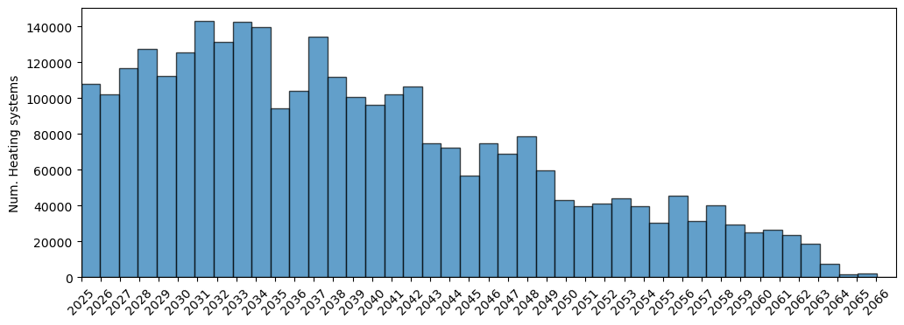
Fig. B1. Expiration years of existing heating systems

While empirical lifetimes for heating boilers are used to determine their expiration years, annualize investment costs, and annualize embodied emissions, we use economic lifetimes (reported in Table B2) in the economic calculations that are considered in the investment decision. More precisely, we use economic lifetimes in the calculations of the annualized investment costs of each heating system replacement option. This mimics a business case approach where experts, e.g., an energy service company (ESCO), would use reference values to evaluate the profitability of various investment options, and then present these results to dwelling owners for them to make an informed investment choice.

We assume the following values for cost, economic lifetime, efficiencies, and emissions of each of the heating system options and sizes (Table B2):

Table B2. Input data for investments in heating systems. Data sources and units for each value are reported by default in the first column of the table, unless reported below the value.

Variable | Size | Oil boiler | Gas boiler | Electric boiler | Wood (pellets) boiler | Air-source heat pump | Water-source heat pump | Ground-source heat pump | District heating
CAPEX  (CHF/kW)  (without VAT)  (HSLU, 2022) | 0-2.5 kW | 12580 | 10900 | 5450 | 15820 | 16660 | 25300 | 18540 | 7660
CAPEX  (CHF/kW)  (without VAT)  (HSLU, 2022) | 2.5-7.5 kW | 6290 | 5450 | 2725 | 7910 | 8330 | 12650 | 9270 | 3830
CAPEX  (CHF/kW)  (without VAT)  (HSLU, 2022) | 7.5-15 kW | 3290 | 2900 | 1450 | 4630 | 4800 | 7120 | 6200 | 2430
CAPEX  (CHF/kW)  (without VAT)  (HSLU, 2022) | 15-40 kW | 1995 | 1645 | 822.5 | 2745 | 3435 | 4430 | 4660 | 1775
CAPEX  (CHF/kW)  (without VAT)  (HSLU, 2022) | 40-200 kW | 760 | 665 | 333 | 1108 | 2529 | 2252 | 3587 | 1431
Fixed OPEX  (CHF/kW/  year)  (without VAT)  (HSLU, 2022) | 0-2.5 kW | 212 | 284.4 | 284.4 | 264 | 196 | 292 | 292 | 100
Fixed OPEX  (CHF/kW/  year)  (without VAT)  (HSLU, 2022) | 2.5-7.5 kW | 106 | 142.2 | 142.2 | 132 | 98 | 146 | 146 | 50
Fixed OPEX  (CHF/kW/  year)  (without VAT)  (HSLU, 2022) | 7.5-15 kW | 53 | 72.2 | 72.2 | 66 | 49 | 73 | 73 | 25
Fixed OPEX  (CHF/kW/  year)  (without VAT)  (HSLU, 2022) | 15-40 kW | 34 | 37.2 | 37.2 | 33 | 27.5 | 42.5 | 42.5 | 12.5
Fixed OPEX  (CHF/kW/  year)  (without VAT)  (HSLU, 2022) | 40-200 kW | 8.6 | 13.3 | 13.3 | 9.5 | 14.0 | 12.2 | 12.2 | 2.5
Variable OPEX/ Heating fuel and elelctricity prices (CHF/kWh)  (FSO, 2025b) | Flat | 0.1006 | 0.159 | Electricity supplier specific  (Elcom, 2023) | 0.1024 | Electricity supplier specific  (Elcom, 2023) |  |  | 0.1447  (Michel et al., 2023)
 | House | 0.1006 | 0.159 | Electricity supplier specific  (Elcom, 2023) | 0.1024 |  |  |  | 0.1526  (Michel et al., 2023)
Economic lifetime  (Year)  (SFOE, 2019a) | House | 20 | 20 | 20 | 20  (Zuberi et al., 2021) | 20 (Hubbuch and Vecsei, 2019) | 27 (Hubbuch and Vecsei, 2019) | 27 (Hubbuch and Vecsei, 2019) | 40  (Suisse énergie, 2017)
Economic lifetime  (Year)  (SFOE, 2019a) | Flat | 20 | 20 | 20 | 25  (Zuberi et al., 2021) | 20  (Zuberi et al., 2021) | 20  (Zuberi et al., 2021) | 20  (Zuberi et al., 2021) | 40  (Suisse énergie, 2017)
Efficiency  (COP for heat pumps)  (p.u)  (Nägeli et al., 2020) | N/A | 0.85 | 0.85 | 0.95 | 0.75 | 3.05 | 3.97 | 3.46 | 1
Embodied emissions  (tCO_{2eq}/unit) (Carbotech, 2021) | Flat | 0.108 | 0.108 | 0.385 | 0.86 | 1.957 | 1.541 | 6.083 | 0.000004212 tCO2eq/kWht
Embodied emissions  (tCO_{2eq}/unit) (Carbotech, 2021) | House | 0.406 | 0.406 | 0.385 | 2.67 | 3.06 | 2.408 | 7.8 | 0.000004212 tCO2eq/kWht
Operation emissions  (tCO_{2eq}/  kWh)  (KBOB, 2023) | N/A | 0.000324 | 0.00023 | 0.0000455  (Rüdisüli et al., 2022) | 0.000028 | Attributed to electricity (0.0000455/kWhe)  (Rüdisüli et al., 2022) |  |  | 0.0000666

As there is no distinction between types of heat pumps in the underlying SHEDS data (Weber et al., 2017), we randomly assign heat pump typology to observations in our sample. We do so such that the final distribution of heat pump types matches the current one (76.6% are air-source, 26.6% ground-source, and 1.6% water-source (SFOE, 2024)), and respecting location-based constraints, i.e., without assigning a type of heat pump to postal codes where there are no heat pumps of that type yet (before 2024) (Swiss Federal Statistical Office (FSO), 2023).

Solar thermal collectors

Solar thermal collectors can be installed as a complement to the heating system, sometimes replacing old collectors that have expired. In this study’s sample, 9.9% of the households report having solar thermal collectors. Their expiration dates are calculated by adding an assumed lifetime of 21 years (Swiss Federal Office for Energy (SFOE), 2019) to their installation year. We assume that solar thermal collectors were installed when the dwelling was built for dwellings built after 2007, as it was then when a ramp-up of solar thermal capacity started nationwide (SwissSolar and FSO, 2024). For the rest of the dwellings, we assume a uniform random distribution of solar thermal installation years from 2007 to 2023. The resulting distribution of expiration years for solar thermal collectors is the following (Fig. B2):
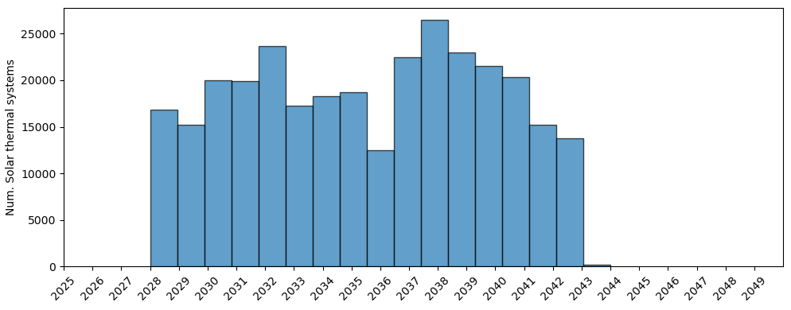
Fig. B2. Expiration years of solar thermal collectors

The surface of collectors depends on the area of the dwelling and whether it is a single-family house or part of a multi-family building (see Table B3). We also consider different sizes for collectors already installed in 2025 and for new installations, as statistics show bigger systems being installed in recent years (SwissSolar and FSO, 2024). Overall, we assume the following values for solar thermal collectors’ cost, economic lifetime, efficiency, emissions, and sizes (Table B3):
Table B3. Input data for solar thermal collectors.
Variable | Size | Value
CAPEX (CHF/ m²)  (without VAT)  (HSLU, 2022) | 0-10 m² | 1950
CAPEX (CHF/ m²)  (without VAT)  (HSLU, 2022) | 10-32 m² | 1812
Fixed OPEX (CHF/ m²/year)  (without VAT)  (HSLU, 2022) | 0-10 m² | 0
Fixed OPEX (CHF/ m²/year)  (without VAT)  (HSLU, 2022) | 10-32 m² | 0
Variable OPEX (CHF/kWh) | N/A | 0
Economic lifetime (Year)  (Swiss Federal Office for Energy (SFOE), 2019) | N/A | 21
Efficiency (p.u.)  (Nägeli et al., 2020) | N/A | 0.9
Embodied emissions (tCO_{2eq}/m²)  (Carbotech, 2021) | Flat | 0.168
Embodied emissions (tCO_{2eq}/m²)  (Carbotech, 2021) | House | 0.204
Operation emissions (tCO2eq/kWh) | N/A | 0
Size – already installed  (m² collectors / m² dwelling)  (SwissSolar and FSO, 2024) | Flat | 0.03
 | House | 0.04
Size – new  (m² collectors / m² dwelling)  (SwissSolar and FSO, 2024) | Flat | 0.03
 | House | 0.045
Size to power ratio  (kW/ m² collectors)  (IEA SHC, 2004) | N/A | 0.7

As in (Torné and Trutnevyte, 2026), to calculate the heat production of the solar thermal collectors, we use annual municipality-specific yields in kWh_{t}/m² from (Opendata.swiss, 2023).

PV and battery systems

PV systems can be installed with or without electric batteries, sometimes replacing PV panels and batteries that have expired. In this study’s sample, 10.4% of the households report having PV panels. Since SHEDS households do not self-report having batteries or not, we impute this information. We assign a higher probability of having batteries to PV owners who are richer and consume less electricity (Lagomarsino et al., 2023). As a result, we get that 22% of dwellings that have PV in our sample also have batteries, which is close to official published statistics (26% between 2017 and 2023) (SwissSolar and FSO, 2024).

The expiration years of PV panels and batteries are calculated by adding their respective assumed lifetimes of 30 and 15 years (SFOE, 2019a) to their installation year. We assume PV panels and batteries were installed at the same time, when the dwelling was built for dwellings built after 2012, which is the year from which the ramp-up of PV capacity started nationwide (SwissSolar and FSO, 2024). For the rest of the dwellings, we assume a uniform random distribution of PV and battery installation years from 2012 to 2023. The resulting distribution of expiration years for PV panels and electric batteries is shown in Fig. B3 and Fig. B4:
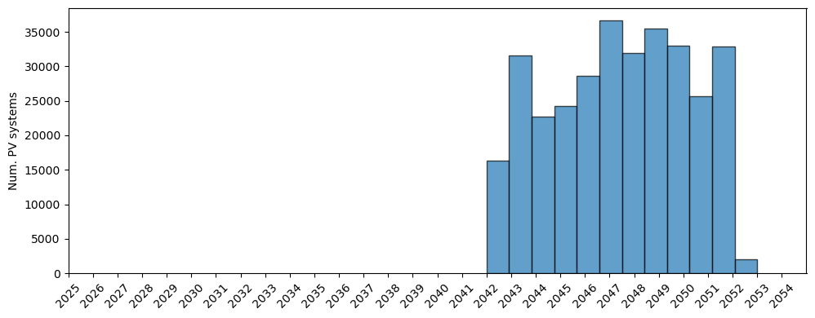
Fig. B3. Expiration years of PV panels

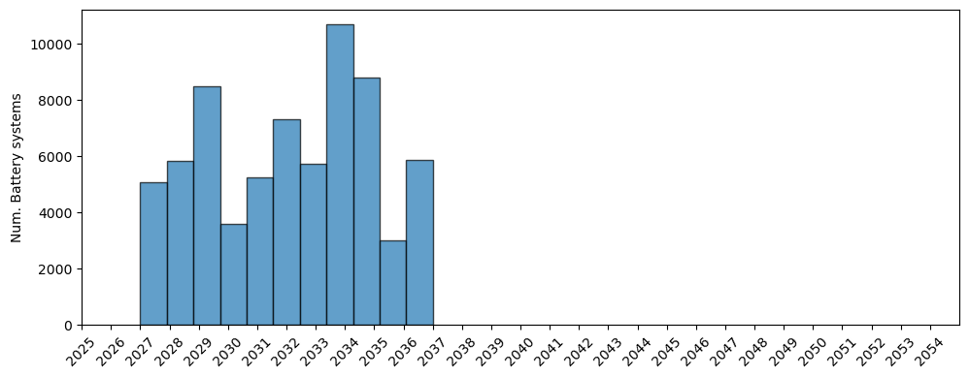
Fig. B4. Expiration years of electric batteries

The size of the PV installations depends on the area of the dwelling, whether it is a single-family house or part of a multi-family building, and whether it is an existing system or a new installation, as statistics show bigger systems being installed in recent years (SwissSolar and FSO, 2024) (see Table B4). When households in multi-family buildings are not affected by a PV requirement, we assume that there are additional administrative costs of agreeing to a common project. We account for these additional costs with higher CAPEX values (in CHF/kW_{p}), equivalent to those faced by households if they installed PV systems individually without profiting from economies of scale. However, when renovating the building roof and thus collectively affected by a PV requirement, we assume that installing a common PV system is easier and thus that they can profit from economies of scale and lower CAPEX values. We assume that electric batteries are Li-ion, as it has been by far the most used type of battery for PV systems in Switzerland (Swiss Federal Office of Energy (SFOE), 2023). Its size depends on the size of the PV installation (see Table B5). Overall, we assume the following values for PV panels and batteries’ cost, economic lifetime, efficiency, emissions, and sizes (Table B4 and B5):

Table B4. Input data for PV panels
Variable | Size | Value
CAPEX (CHF/ kW_{p})  (without VAT)  (HSLU, 2022) | 0-10 kW_{p} | 3000
CAPEX (CHF/ kW_{p})  (without VAT)  (HSLU, 2022) | 10-30 kW_{p} | 2200
CAPEX (CHF/ kW_{p})  (without VAT)  (HSLU, 2022) | 30-100 kW_{p} | 1600
Fixed OPEX (CHF/kWh/year)  (without VAT)  (HSLU, 2022) | 0-10 kW_{p} | 0.03
Fixed OPEX (CHF/kWh/year)  (without VAT)  (HSLU, 2022) | 10-30 kW_{p} | 0.03
Fixed OPEX (CHF/kWh/year)  (without VAT)  (HSLU, 2022) | 30-100 kW_{p} | 0.025
Variable OPEX  (CHF/kWh) | N/A | 0
Economic lifetime  (Year)  (SFOE, 2019a) | N/A | 30
Efficiency  (p.u.) | N/A | 1
Embodied emissions  (tCO_{2eq}/kW_{p})  (Carbotech, 2021) | Flat | 1.227
Embodied emissions  (tCO_{2eq}/kW_{p})  (Carbotech, 2021) | House | 1.2046
Operation emissions  (tCO_{2eq}/kWh) | N/A | 0
Size – already installed  (W_{p} / m² dwelling)  (SwissSolar and FSO, 2024) | Flat | 35
 | House | 50
Size – new  (W_{p} / m² dwelling)  (SwissSolar and FSO, 2024) | Flat | 40
 | House | 70

Table B5. Input data for electric batteries. To choose a value that depends on size, we select the one for the closest reference size reported here. Note: CAPEX values reported here and used in our study are on the high end of the spectrum (see latest costs developments reported by SuisseEnergie (2025) and SwissSolar (2026)).
Variable | Size | Value
CAPEX  (CHF/kWh)  (Schmidt et al., 2023) | 2.5 kWh | 2099
CAPEX  (CHF/kWh)  (Schmidt et al., 2023) | 5 kWh | 1564
CAPEX  (CHF/kWh)  (Schmidt et al., 2023) | 7.5 kWh | 1317
CAPEX  (CHF/kWh)  (Schmidt et al., 2023) | 10 kWh | 1166
CAPEX  (CHF/kWh)  (Schmidt et al., 2023) | 12.5 kWh | 1061
CAPEX  (CHF/kWh)  (Schmidt et al., 2023) | 15 kWh | 982
Fixed OPEX (CHF/kWh/year)  (Schmidt et al., 2023) | N/A | 4
Economic lifetime  (Year) | N/A | 15
Efficiency  (p.u.) | N/A | 1
Embodied emissions  (tCO_{2eq}/kWh)  (Carbotech, 2021) | N/A | 0.25
Operation emissions  (tCO_{2eq}/kWh) | N/A | 0
Size – already installed  (kWh/kW_{p} PV)  (SwissSolar and FSO, 2024) | Flat | 0.66
 | House | 1.05
Size – new  (kWh/kW_{p} PV)  (SwissSolar and FSO, 2024) | Flat | 0.66
Size – new  (kWh/kW_{p} PV)  (SwissSolar and FSO, 2024) | House | 1.05

We calculate the PV electricity production from municipality-specific hourly capacity factors for one year (Renewables.ninja, 2023). We calculate hourly production for one year and not just an annual value to be able to more accurately calculate PV self-consumption shares that are specific to each household, as explained in Appendix B2.

Evolution of input values
The model’s input values for the costs, emissions, and efficiency of heating and PV systems evolve from 2025 to 2050 (Fig. B5). The CAPEX and fixed OPEX costs of heating systems evolve as described by the JRC (2017) and of PV systems as described by NREL (2024). Variable OPEX cost, i.e., heating fuel and electricity consumer prices (without heating fuel taxes), evolve in line with the wholesale prices of the PE2050+ Scenario from the Swiss Federal Office of Energy (2022), with 2025 as the reference value. The part of the consumer price that corresponds to the cost of energy evolves as the estimated future wholesale prices, while the rest remains constant. For electricity, wholesale prices assumed raise strongly after 2040 due to the winter gap and the still reliance in this season of costly backup generation abroad, mainly gas-fired plants that set market prices due to the merit order effect. For district heating, consumer prices evolve as in Nägeli et al. (2020).

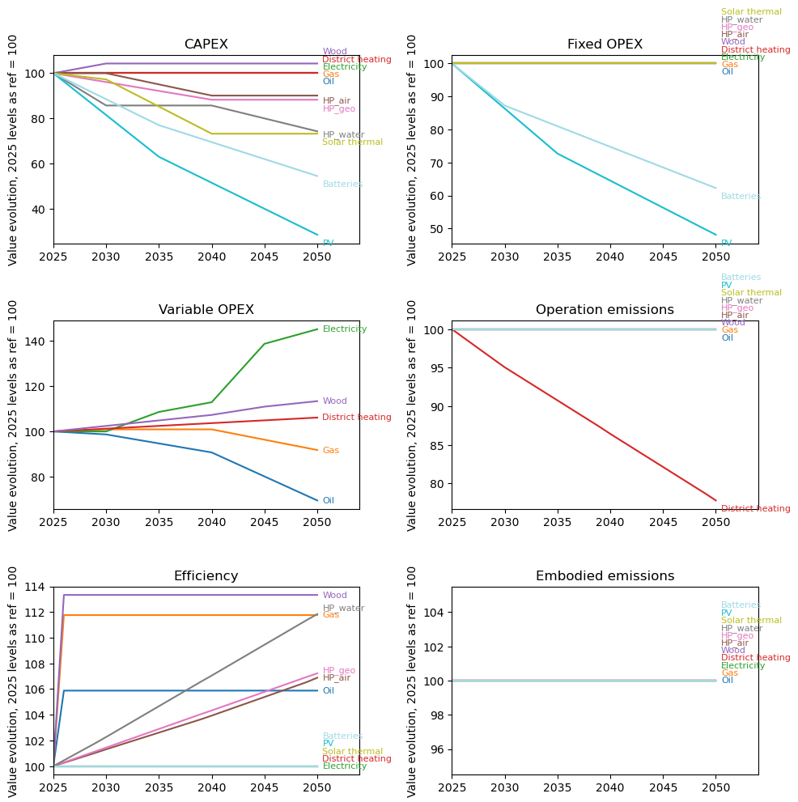
Fig. B5. Evolution of the model’s input values for the costs, emissions, and efficiency of heating and PV systems from 2025 to 2050

In addition, we make the evolution of the emission factor of Swiss electricity as an endogeneous calculation of our model. We assume that additional residential PV generation decarbonizes the grid by reducing demand and by excess generation that is fed to the grid. On an hourly basis, this reduces the need for imports, which are, on average, far more emission-intensive than Swiss electricity generation (Romano et al., 2024). For each policy mix and year, once PV investments are simulated, we compute hourly import reductions and the associated avoided emissions, and then update the emissions factor for electricity consumed in Switzerland (Fig. B6). This approach has limitations: we do not model the parallel decarbonization of grid electricity from other renewable generation technologies, storage, or sector coupling within Switzerland; we ignore the likely decarbonization of imports in line with the power sector transition in neighbouring countries; and we do not consider new demands of the future, such as for electric vehicles or air-conditioning. Despite the limitations, given the sectoral scope of the model, and that emissions from household electricity use are small relative to emissions from heating-fuel combustion, this stylized approach is appropriate for our purpose. Moreover, we comment on the implications that this approach has on the mitigation effectiveness of PV obligations in the main text.
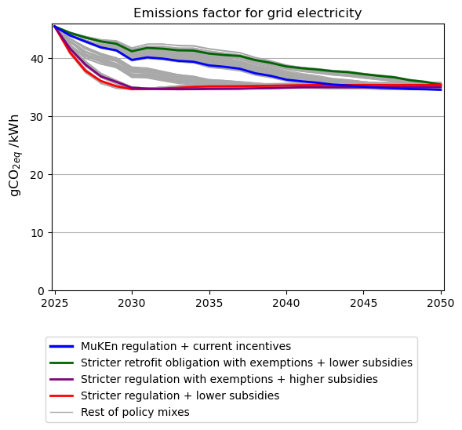
Fig. B6. Evolution of the emissions factor for grid electricity under all simulated policy mixes from 2025 to 2050

B2. Definition of policy instruments

Enforcement waves of regulation

Retrofit obligations, as well as the strict level of the fossil heating ban and PV obligations, force investments in waves from 2026 to 2035 (e.g., as the retrofit obligations in Geneva (EBP, 2024)). The enforcement is gradual, with dwellings with older boilers, older roofs, and worst-performing dwelling envelopes targeted first. To operationalize this, we divide the enforcement period (2026-2035) of each regulation into ten bins of equal size. For retrofit obligations, these bins are based on the specific heating demand of the dwelling (in kWh/m²), and higher values are targeted first. For the heating ban, they are based on the heating system age, and for the PV obligation, on the roof’s age, inferred from the dwelling’s construction year and assuming roof renovations every 40 years (Streicher and Patel, 2020). When several regulations apply to the same dwelling, all mandatory investments are made simultaneously in a random year between the earliest and latest enforcement year.

Subsidies

We include subsidies for low-carbon heating, renewable generation, and envelope retrofits, including one-time investment subsidies for all technologies and feed-in tariffs for PV. These remain constant for the period 2025 to 2050. Despite cantonal (Swiss state) variability, we define spatially homogeneous but technology-specific investment subsidies. For the current level, they are the averages across cantons for the period 2017-2022 (EBP and SFOE, 2023) (Table B6). PV feed-in tariffs for the current level are municipality-specific from 2022 (VESE, 2022). Lower and higher subsidy levels are simply 50% lower or higher than the current level, except for batteries (see Table B6).

Table B6. Investment subsidy amounts for the “Current” subsidies level
Technology | Subsidy amount
Wood boilers | 391 CHF/kW
Air-source  heat pumps | 481 CHF/kW
Water-source  heat pumps | 658 CHF/kW
Ground-source  heat pumps | 658 CHF/kW
District heating | 233 CHF/kW
Solar thermal collectors | 943 CHF/kW
Envelope retrofits | 57 CHF/m²
Mechnical ventilation with heat recovery | 3255 CHF
PV panels | 25% of CAPEX and feed-in tariff as in 2022
Batteries | 0 for current and decreased subsidy levels,  25% of CAPEX for increased subsidy level

B3. Techno-economic calculations at the household level
For each of the 6’355 households in our representative Swiss sample, when equipment expires (Appendix B1) or when regulation is enforced (Appendix B2), we perform techno-economic calculations for the different investment options presented in Appendix B1 (Fig. B7). Investment decisions are then based on these calculations. First, we filter the set of nested energy investment options listed in Appendix B1 that can be considered, given the bans and obligations in place, the current equipment, and additional constraints, as explained in the main manuscript, section 2.2. We then calculate the annualized heating and electricity cost of each combination of options and select the one with the minimum cost, using an implicit discount rate of 15% (and 3% and 27% for sensitivity analysis). Next, for the selected combination of options (e.g. keeping the heating system, deeply retrofitting the envelope of the dwelling, and installing a new PV system without batteries), we calculate and update the household’s resulting yearly CO_{2eq} emissions, its annualized heating and electricity costs, the heating fuel and value-added taxes paid by the household, and the subsidies received. Yearly CO_{2eq} emissions include annualized embodied emissions and emissions from heating fuel and electricity use, and annualized heating and electricity costs consider a real discount rate of 3% and are broken down into investment, operation and maintenance, and heating fuel and electricity cost components. Using these household-level outcomes across the entire sample, we then evaluate each policy mix in terms of its effectiveness and cost impacts on the different actors involved.
Fig. B7. Schematic of the dynamic microsimulation approach, including energy investments, household and policy mix level outcomes.

For a given year, as in the previous static version of the microsimulation model (Torné and Trutnevyte, 2026), the annualized heating and electricity cost of each combination of options that is considered in the investment decision $C_{elec \& heat}$ in CHF/year is calculated using Eq. B7:
$C_{elec \& heat}=C_{elec }+C_{heat}$ (B7)
where $C_{elec }$is the annualized cost of electricity in CHF/year, and $C_{heat }$ is the annualized cost of heating in CHF/year.

Electricity cost
$C_{elec }$is the sum of the costs of electricity bought from the grid $C_{elec,grid}$, the PV system $C_{PV}$, and the batteries $C_{Batteries}$, as depicted in Eq. B8-11:
$C_{elec }=C_{elec,grid}+C_{PV}+C_{Batteries}$ (B8)
$C_{elec,grid}=e_{grid} p_{elec}$ (B9)
$C_{PV}={α_{PV} (INV}_{PV}+P_{PV} {OPEX}_{fixed, PV}-FiT e_{PV, excess})$ (B10)
$C_{Batteries}=α_{batteries} ({INV}_{batteries}+P_{batteries} {OPEX}_{fixed, batteries})$ (B11)
where $e_{grid}$ is the demand of grid electricity in kWh_{e}/year as calculated in Eq. B12, and $p_{elec}$ the consumer price of electricity in CHF/kWh_{e} that is specific to the retailer of the household and to its consumption level (Elcom, 2023) and evolves as shown in Fig. B6. $α_{PV}$ , and $α_{batteries}$ are binary variables that take the value 1 when the dwelling already has PV or batteries, or if the combination of investments evaluated includes a new PV system and new batteries, respectively. ${INV}_{PV}$ is the annualized investment cost of the PV system in CHF/year calculated as in Eq. B13, $P_{PV}$ is the power of the PV system in kW_{p} as defined in Table B4, and ${OPEX}_{fixed, PV}$ is the fixed operational costs of the PV system in CHF/kW_{p}/year (see Table B4 for the assumed values and Fig. B6 for its assumed evolution). $FiT$ is the municipality-specific PV feed-in tariff of the policy mix (VESE, 2022), and $e_{PV, excess}$ is the annual excess PV generation that is fed to the grid, calculated on an hourly basis as the difference between the PV generation and self-consumption that is defined in Eq. B12. ${INV}_{batteries}$ is the annualized investment cost of the batteries in CHF/year calculated as in Eq. B14, $P_{batteries}$ is the capacity of the batteries in kWh as defined in Table B5, and ${OPEX}_{fixed, batteries}$ is the fixed operational costs of the batteries in CHF/kWh/year (see Table B5 for the assumed values and Fig. B6 for its assumed evolution).
The demand for grid electricity $e_{grid}$ is the sum of electricity demand for appliances, lighting, and even for charging EVs at home $e_{appliances }$ , and the electricity demand for heating with an electric boiler or heat pump $e_{heating}$, minus the self-consumed electricity from the PV and battery system $e_{PV,self-consumption }$, all in kWh_{e}/year:
$e_{grid}$=$e_{appliances}+e_{heating}-e_{PV,self-consumption }$ (B12)
The self-consumed electricity from the PV and battery system $e_{PV,self-consumption }$ can reduce the need for grid electricity in a given hour by covering part, or even all, of the household’s electricity demand, with any excess electricity fed back into the grid. It is calculated from the hourly balances of the electricity produced by the PV system, stored and extracted from the batteries, and required by the household for a whole year. It is the sum of the hourly overlaps of the electricity demand for appliances, lighting, heating, and even for charging EVs at home, with the PV system electricity generation, plus the electricity that is stored in the batteries when there is excess generation and consumed later on when PV generation is not enough to cover demand. For the electricity demand for appliances, lighting, and even for charging EVs at home, we assume hourly profiles that are specific to the household structure (Pflugrad, 2020), which we scale to match the yearly electricity demand of the household, heating excluded. If the heating system considered is an electric boiler or heat pump, we assume an hourly profile for the electricity demand for heating that is specific to the dwelling age, whether it is a single-family house or an apartment in a multi-family building, and whether it has already been retrofitted (Murray et al., 2020), which we scale to match the yearly demand. The hourly production of the PV system is obtained by multiplying the power of the PV system $P_{PV}$ in kW_{p}, as defined in Table B4, by hourly capacity factors in kWh/kW_{p} that are specific to the household’s municipality (Renewables.ninja, 2023). Last, if the PV system includes batteries, we assume the capacities defined in Table B5 and maximum charge and discharge power from reference Li-ion battery models (ABB, 2024; GSL Energy, 2024). If PV generation is not enough to satisfy electricity demand in a given hour, we assume that the battery is discharged with a basic control strategy to maximize the self-consumption of the PV generation (Energycodeace, 2019). With these assumptions, we obtain the following distributions of theoretical solar PV self-consumption shares, for systems with and without batteries, and with and without heat pumps and electric boilers (Fig. B8):
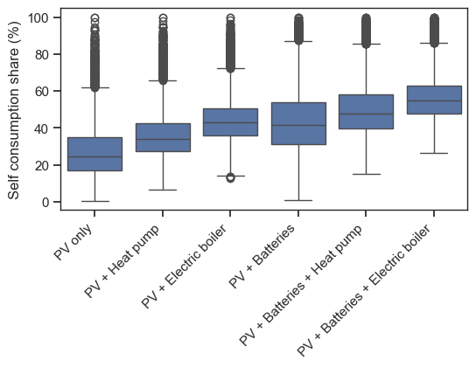
Fig. B8. Distributions of theoretical solar PV self-consumption shares across the entire household sample, assuming systems with and without batteries, and with and without heat pumps and electric boilers
The annualized investments for the PV ${INV}_{PV}$ and battery system ${INV}_{batteries}$, or its equivalent annual costs, are calculated by dividing the upfront investment net of subsidies by the annuity factor (Investopedia, 2024):
${INV}_{PV}=\left({Upfront_INV}_{ PV }-Subidy_{INV}_{ PV }\right){/ AF}_{ PV }=$
$P_{PV} {CAPEX}_{PV} (1- s_{PV}) \frac{r}{{1-\left(1+r\right)}^{-l_{PV}}}$ (B13)
$${INV}_{batteries}=\left({Upfront_INV}_{batteries }-Subidy_{INV}_{ batteries }\right){/ AF}_{ batteries }=$$
${ P}_{batteries} {CAPEX}_{batteries} (1- s_{batteries}) \frac{r}{{1-\left(1+r\right)}^{-l_{batteries}}}$ (B14)
They take into account the capital expenditures ${CAPEX}_{PV}$ and ${CAPEX}_{batteries}$ at the time of installation in CHF/kW_{p} and CHF/kWh respectively (see Table B4 and B5 for the assumed values and Fig. B6 for its assumed evolution), the one-time subsidies in place $s_{PV}$ and $s_{batteries}$ given as a share of the investment costs as reported in Table B6, the assumed implicit discount rate $r$, and the economic lifetimes of both PV and batteries $l_{PV}$ and $l_{batteries}$ reported in Tables B4 and B5.

Heating cost
$C_{heat }$is the sum of the costs of the heating system $C_{heating sytem}$, the costs of the solar thermal collectors $C_{solar thermal}$, and the costs of the envelope retrofit and the mechanical ventilation system with heat recovery $C_{retrofit \& ventilation}$, as depicted in Eq. B15-18:
$C_{heat }=C_{heating sytem}+C_{solar thermal}+C_{retrofit \& ventilation}$ (B15)
$$C_{heating sytem}=α_{heating system,new} ({INV}_{ heating system, new }+{INV}_{ residual, heating system,old })$$
$+$ $\left(1-α_{heating system,new}\right){ INV}_{ heating system,old }$
$+ P_{ heating sytem} {OPEX}_{fixed, heating system}+\frac{h_{fuel }}{{eff}_{heating system }} {(p}_{fuel}+i_{fuel} p_{carbon})$ (B16)
$C_{solar thermal}=α_{solar thermal} {(INV}_{solar thermal}+A_{solar thermal} {OPEX}_{fixed, solar thermal })$ (B17)
$C_{retrofit \& ventilation}=α_{retrofit} {INV}_{retrofit }+α_{ventilation} {INV}_{ventilation}$ (B18)

where $α_{heating system,new}$ is a binary variable that takes the value 1 when the combination of investments evaluated includes a new heating system that replaces the existing one. ${INV}_{ heating system, new}$ and ${INV}_{ heating system, old}$ are the annualized investments on the new and existing heating systems respectively in CHF/year, as calculated in Eq. B21. ${INV}_{ residual, heating system,old }$ is the annualized residual value of the existing heating system in CHF/year as calculated in Eq. B25. $P_{heating system}$ is the power of either the new or already existing heating system in kW calculated as in Eq. B19. ${OPEX}_{fixed, heating system }$ is its fixed operational costs in CHF/kW/year (see Table B2), ${eff}_{heating system }$ is its efficiency as reported in Table B2, $p_{fuel}$ is its heating fuel consumer price in CHF/kWh (the variable OPEX in Table B2), and $i_{fuel}$ the carbon intensity of its fuel in tCO_{2eq}/kWh (the operation emissions in Table B2). These values evolve over time as shown in Fig.B6. $h_{fuel}$ is final heat demand to be supplied by a fuel-based heating system in kWh/year calculated as in Eq. B20 and $p_{carbon}$ is the carbon tax for heating fuels of the policy mix in CHF/tCO_{2eq}. $α_{solar thermal}$ , $α_{retrofit}$ , and $α_{ventilation}$ are binary variables that take the value 1 when solar thermal collectors have already been installed, the envelope of the dwelling has already been retrofitted, and a mechanical ventilation system with heat recovery has already been installed, respectively, or if the combination of investments evaluated includes these investments. ${INV}_{solar thermal}$ is the annualized investment cost of solar thermal collectors in CHF/year calculated as in Eq. B22, $A_{solar thermal}$ is the surface of the new and existing solar thermal collectors in m² as defined in Table B3, and ${OPEX}_{fixed, solar thermal }$ is the fixed operational costs of the solar thermal collectors in CHF/m²/year (see Table B3). ${INV}_{retrofit }$ and ${INV}_{ventilation }$ are the annualized investments of the dwelling envelope retrofit and the mechanical ventilation with heat recovery in CHF/year as calculated in Eq. B23 and B24.

The power of the heating system $P_{heating system}$ is calculated at the time of installation of the heating system and is the total final heat demand after considering the energy savings from the dwelling envelope retrofit and the mechanical ventilation system with heat recovery, divided by assumed hours of full charge of the heating system $t_{full charge}$ (2000h/year (Minergie, 2023)):
$P_{heating system}=\frac{h_{total }{-α_{retrofit} h}_{retrofit}{-α_{ventilation} h}_{ventilation}}{t_{full charge}}$ (B19)
where $h_{total }$ is the total final heat demand of the household for space heating and domestic hot water, obtained from multiplying the demand for space heating and domestic hot water in kWh/m² specific to the dwelling archetype from Streicher and Patel (2020) by the dwelling area. $h_{retrofit}$ and $h_{ventilation}$ are the energy savings in final heat consumption resulting from the envelope retrofit and the new mechanical ventilation system with heat recovery, calculated as described in Appendix B1 and in Eq. B1 and B5.
The final heat demand to be supplied by a fuel-based heating system $h_{fuel}$ is the part of the total final heat demand of the household for space heating and domestic hot water $h_{total }$ after subtracting the heating savings from the dwelling envelope retrofit and new ventilation system $h_{retrofit}$ and $h_{ventilation}$ , that is not covered by the heat provided by an electric boiler or heat pump (its electricity demand $e_{heating}$ multiplied by its efficiency or COP ${eff}_{elec,heating}$, as reported in Table B2), nor by the heat provided by the solar thermal collectors $h_{solar thermal}$:

$$h_{fuel}=h_{total }{-{α_{solar thermal} h}_{solar thermal}-α_{retrofit} h}_{retrofit}$$
${-α_{ventilation} h}_{ventilation}-e_{heating} {eff}_{elec,heating}$ (B20)

The contribution to the heat demand of the solar thermal collectors $h_{solar thermal}$ is calculated by multiplying the size of the solar thermal collectors $A_{solar thermal}$ as defined in Table B3 by the annual municipality-specific heat production in kWh/m² (Opendata.swiss, 2023). In this case, we assume that heat production is stored in a hot water tank with negligible losses and thus that the self-consumption share is 100%. We also limit the size of the solar thermal collectors to not exceed the heating demand.

The annualized investments for the new heating system, solar thermal collectors, envelope retrofit, and new ventilation system, or its equivalent annual costs, are calculated by dividing the upfront investment net of subsidies by the annuity factor (Investopedia, 2024):
${INV}_{ heating system }=\left({Upfront_INV}_{ heating system }-Subidy_{INV}_{ heating system }\right){/ AF}_{ heating system }=P_{heating system}{(CAPEX}_{heating system}-s_{heating system}) \frac{r}{{1-\left(1+r\right)}^{-l_{heating system}}}$ (B21)

${INV}_{ solar thermal }=\left({Upfront_INV}_{ solar thermal }-Subidy_{INV}_{ solar thermal }\right){/ AF}_{ solar thermal }={ A}_{solar thermal} {(CAPEX}_{solar thermal}- {b_{solar thermal} s}_{solar thermal}) \frac{r}{{1-\left(1+r\right)}^{-l_{solar thermal}}}$ (B22)

$${INV}_{retrofit }=\left({Upfront_INV}_{ retrofit }-Subidy_{INV}_{ retrofit }\right){/ AF}_{ retrofit }=$$
$\left({Upfront_INV}_{ retrofit }-\sum_{element}^{n}{A_{element} s_{retrofit}}\right) \frac{r}{{1-\left(1+r\right)}^{-l_{retrofit}}}$,
$∀ element ∈\left\{Floor, Ceiling, Wall,Window\right\}$ (B23)

$${INV}_{ventilation}=\left({Upfront_INV}_{ ventilation }-Subidy_{INV}_{ ventilation }\right){/ AF}_{ ventilation }=$$
$\left({ Upfront_INV}_{ ventilation }- s_{ventilation}\right) \frac{r}{{1-\left(1+r\right)}^{-l_{ventilation}}}$ (B24)

They take into account the capital expenditures ${CAPEX}_{heating system}$ and ${CAPEX}_{solar thermal}$ at the time of installation in CHF/kW and CHF/m² respectively (see Table B2 and B3 and Fig. B6), the total upfront investments of the envelope retrofit and mechanical ventilation system with heat recovery ${Upfront_INV}_{ retrofit }$and ${ Upfront_INV}_{ ventilation }$ as calculated in Eq. B2 and B6, the one-time subsidies in place $s_{heating system}$ , $s_{solar thermal}$ , $s_{retrofit}$, and $s_{ventilation},$ given as reported in Table B6 for the current subsidy level, the assumed implicit discount rate $r$, and the respective economic lifetimes $l_{heating system}$, $l_{solar thermal}$, $l_{retrofit}$, and $l_{ventilation}$, reported in Tables B2 and B3 and in Appendix B1. $b_{solar thermal}$ is the size-to-power ratio of solar thermal collectors as reported in Table B3. $A_{ element}$ is the area of the retrofitted envelope element calculated as explained in Appendix B1.
If substituting the old heating system with a new one, we also consider its annualized residual value. To calculate this value, we consider the same annuity factor as for the annualized investment of the new heating system, and as in Streicher and Patel (2020) we assume a Vogel’s asset depreciation pattern based on the empirical observation of real state value:
$\left\{\begin{aligned}{INV}_{residual, heating system, old }=α_{heating system,new} P_{heating system, old}{CAPEX}_{heating system, old} \\ (1- \left(\left(-0.4\right){\left(\frac{{ age}_{heating system, old}}{l_{heating system, old}} \right)}^{2}+1.2 \left(\frac{{ age}_{heating system, old}}{l_{heating system, old}}\right)\right) \frac{r}{{1-\left(1+r\right)}^{-l_{heating system, new}}} ; \\ if { age}_{heating system, old}<l_{heating system, old} \\ {INV}_{residual, heating system, old }=0; if { age}_{heating system, old}≥l_{heating system, old}\end{aligned}\right.$
(B25)
where ${CAPEX}_{heating system, old}$ is the capital expenditures of the replaced heating system at the time of installation in CHF/kW, ${ age}_{heating system,old}$ is the age of the old heating system at the year in which the decision to replace it is evaluated, and $l_{heating system,old}$ its lifetime, as reported in Table B2.

Household-level outputs
For each household and under each policy mix, we select the combination of investment options with minimum annual electricity and heating costs and update:

- The resulting CO_{2eq} emissions of the household ${emissions }_{hh}$ in tCO_{2eq}/year, which include annualized embodied emissions and emissions from heating fuel and electricity use, as depicted in Eq. 26:
$${emissions }_{hh}=e_{grid} i_{elec}+\frac{h_{fuel}}{{eff}_{heating system}} i_{fuel}+$$
$$\frac{{emb}_{heating system}}{l_{heating system}}+α_{early heating system replacement} \frac{{emb}_{heating system, old}}{l_{heating system,old}}+$$
$$α_{PV} \frac{{{emb}_{PV}P}_{PV}}{l_{PV}}+ α_{batteries} \frac{{{emb}_{batteries}P}_{batteries}}{l_{batteries}}+$$
$α_{solar thermal} \frac{{{emb}_{solar thermal}A}_{solar thermal}}{l_{solar thermal}}+α_{retrofit} \sum_{element}^{n}{\frac{A_{element} {emb}_{element}}{l_{element}}}$,
$∀ element ∈\left\{Floor, Ceiling, Wall,Window\right\}$ (B26)

where $e_{grid}$, $i_{elec}$, $h_{fuel}$, ${eff}_{heating system}$, and $i_{fuel}$ are the demand of grid electricity, the endogenously calculated average carbon intensity of the Swiss grid electricity, the final heat demand to be supplied by a fuel-based heating system, the efficiency of the heating system, and the carbon intensity of the heating fuel, as defined above. $α_{PV}$ , $α_{batteries}$ , $α_{solar thermal}$ , and $α_{retrofit}$ are binary variables that take the value 1 when the dwelling has PV systems, batteries, solar thermal collectors, or has been retrofitted, respectively. $α_{early heating sytem replacement}$ is a binary variable that takes the value 1 when the previous heating system would still be operative but was replaced. It serves to keep accounting for the annual embodied emissions of the previous heating system once replaced before the end of its lifetime. ${emb}_{heating system}$, ${emb}_{heating system,old}$, ${emb}_{PV}$, ${emb}_{batteries}$, ${emb}_{solar thermal}$, and ${emb}_{element}$ are the embodied emissions of the operative and previous heating system, the PV system, batteries, solar thermal collectors, and retrofitted dwelling envelope elements, as reported in Appendix B1.

- The household annualized heating and electricity costs $C_{hh}$ (Eq. B27):
$C_{hh}={INV}_{hh}+{OM}_{hh}+E_{hh}+T_{hh}-S_{hh}$ (B27)
where $C_{hh}$ can be broken down into annualized investment costs ${INV}_{hh}$ (Eq. B28), operation and maintenance costs ${OM}_{hh}$ (Eq. B29), the costs for heating fuel and electricity $E_{hh}$ (Eq. B30), taxes $T_{hh}$ (Eq. B31), and $S_{hh}$subsidies (B32).

${INV}_{hh}$ is the sum, net of subsidies, of annualized investments in the operative heating system (see Eq. B21), solar thermal collectors (see Eq. B22), the retrofit of the dwelling (Eq. B23), a mechanical ventilation system with heat recovery (see Eq. B24), a PV system (see Eq. B13), batteries (see Eq. B14), and the annualized residual value of the previous heating system if replaced before expired (see Eq. B25), depending on whether these investments have been made, which is definied by the $α$ binary variables (see above). However, different than with the annualization of investments in the investment decision process where an implicit discount rate is considered (Eq. B13-14 and B21-25), for the calculation of the actual annual heating and electricity costs of households in a given year, investments are annualized considering a real discount rate r of 3%.
${INV}_{hh}={INV}_{ heating system}+α_{early heating sytem replacement} {INV}_{ residual, heating system,old }+$
$${ α_{solar thermal} INV}_{ solar thermal }+α_{retrofit} {INV}_{retrofit }+α_{ventilation} {INV}_{ventilation}+$$
${α_{PV} INV}_{PV}+α_{batteries} {INV}_{batteries}$ (B28)

${OM}_{hh}$ are the operation and maintenance costs of the heating system (see Eq. B16), solar thermal collectors (see Eq. B17), the PV system (see Eq. B10), and the batteries (see Eq. B11), without VAT. These costs, plus investements and subsidies, represent revenues for the construction industry.

$${OM}_{hh}= P_{ heating sytem} {OPEX}_{fixed, heating system}+$$
$$α_{solar thermal} A_{solar thermal} {OPEX}_{fixed, solar thermal }+$$
${α_{PV} P}_{PV} {OPEX}_{fixed, PV}+α_{batteries} P_{batteries} {OPEX}_{fixed, batteries}$ (B29)

$E_{hh}$ are the costs of grid electricity (see Eq. B9) and heating fuels (see Eq. B16), without VAT. They represent revenues for utilities.
$E_{hh}=e_{grid} p_{elec}+ \frac{h_{fuel }}{{eff}_{heating system }} p_{fuel}$ (B30)
$T_{hh}$ are the sum of heating fuel taxes and the VAT that applies to heating fuel and electricity costs (see Eq. B30), operation and maintenance costs (see Eq. B29), and total upfront investments (see Eq. B13, B14, B21-24), which are revenues for the construction industry. These taxes are the revenues considered when calculating net public spending under each policy mix.
$$T_{hh}=\frac{h_{fuel }}{{eff}_{heating system }} i_{fuel} p_{carbon}+$$
$VAT ({E_{hh}+OM}_{hh}+{ Upfront_INV}_{ heating system }+{{ Upfront_INV}_{ solar thermal }+Upfront_INV}_{ retrofit }+{ Upfront_INV}_{ ventilation }+{ Upfront_INV}_{ PV }+ { Upfront_INV}_{ batteries })$ (B31)
$S_{hh}$ are the sum of investment subsidies and the PV feed-in tariff (see Eq. B10, B13, B14, B21-24). They are the expenditures considered when calculating net public spending under each policy mix.
$$S_{hh}=α_{heating system} Subidy_{INV}_{ heating sytem }+α_{solar thermal} {Subsidy_INV}_{solar thermal}+$$
$$α_{retrofit} Subidy_{INV}_{ retrofit }+ {α_{ventilation} Subsidy_INV}_{ventilation}+$$
$α_{PV} (Subidy_{INV}_{ PV }+ FiT e_{PV, excess})+$ $α_{batteries} Subidy_{INV}_{ batteries }$ (B32)

C. Other results

C1. Supporting figures
Fig. C1. Decomposition of total annual residential GHG emissions into annual operation emissions (from heating fuel and electricity use) and annualized embodied emissions (of heating systems, PV systems, and envelope retrofits) assuming A) an implicit discount rate of 3%, B) of 15% as in the baseline (for which results are presented in the main text), and C) of 27%. Black crosses represent the Swiss residential sector target of 0.89 MtCO_{₂eq} for household heating fuel and electricity use in 2050 in the (net) ZERO base scenario of the Swiss Federal Office of Energy (2022). This value is the sum of the target for direct fuel combustion of households (emissions category 1A4b) and the emissions of the energy industry (refineries, electricity and heat production mainly in waste incineration plants, combustion activities for district heating, emissions category 1A1) that we assign to households proportional to their share of total future electricity consumption in the same ZERO base scenario.

Fig. C2. Pearson correlation coefficients between policy mix outcomes

Fig. C3. Effects of pairwise interactions between policy instruments on key cumulative policy mix outcomes. They can be interpreted as a measure of the joint effect minus the sum of single effects, and are estimated from OLS regressions that include the main effects of all policy instruments and all pairwise interactions. Main effects are presented separately in Fig. 4. The shading uses a diverging scale centered at 0 (with outcome-specific ranges): darker green indicates a stronger desirable effect, and darker pink indicates a stronger undesirable effect. Parentheses show 95% confidence intervals based on robust standard errors. Significant interaction effects are highlighted in bold. Significance: *** p < 0.001, ** p < 0.01, * p < 0.05.

Fig. C4. Average marginal main effects (AMEs) of policy instruments on total, operation, and embodied greenhouse gas emissions. Each cell reports the AME of moving from a reference level that is more similar to the status quo to the indicated alternative level. AMEs are estimated from OLS regressions that include the main effects of all policy instruments and all pairwise interactions. The shading uses a diverging scale centered at 0 (with outcome-specific ranges): darker green indicates a stronger desirable effect, and darker pink indicates a stronger undesirable effect. Parentheses show 95% confidence intervals based on robust standard errors. Significance: *** p < 0.001, ** p < 0.01, * p < 0.05.

Fig. C5. Distribution of total heating system capacities and quantities of other energy investments in 2050 across policy instrument levels

C2. Sensitivity analysis

Here, we present our sensitivity analysis results when varying the 15% implicit discount rate (IDR) assumption to two alternative values, 3% and 27%. We also complement the explanations given in the main text.

As explained in the main text, our results prove robust to the IDR assumption with a few nuances. The lower the IDR, the faster and the deeper decarbonization would be (Appendix Fig. C1, C6), which would make it more likely to achieve the Swiss residential sector targets of emissions (Swiss Federal Office of Energy, 2022), energy efficiency, and self-generation of electricity (EnDK, 2022). However, this would come at the cost of increasing the temporal peaks of required public spending and construction industry revenues (Fig. 3, Appendix C11-12). In addition, for the same mix of policy instruments, a lower IDR of 3% would lead to lower utility revenue, but higher construction industry revenue (Appendix Fig. C6). Lower IDR would also lead to a lower range of long-run heating and electricity costs for households and of net public spending (Fig. 2, Appendix Fig. C9-10). However, the effect of the IDR on these outcomes ultimately depends on the policy mix (Appendix Fig. C6). For instance, while lower IDR leads to lower net public spending in mixes with current or decreased subsidies as expenditures in subsidies due to additional investments grow less than revenues from the VAT, the opposite happens with higher subsidies.

There are a few findings regarding outcome trade-offs and instrument effects that also change with a different IDR assumption. Regarding trade-offs, we find that with a lower IDR of 3%, the construction industry does not necessarily benefit from more owner-occupier investments, as their Pearson correlation is negative instead of positive (Appendix Fig. C2, C13, C14). With lower IDR, more and deeper retrofits are implemented (Fig. 5 and Appendix Fig. C7-8), especially in owner-occupied dwellings. Although more investment in retrofits provides additional revenues for the construction industry, as retrofits lead to the installation of smaller heating systems, the increase in revenues from retrofits is offset by the decrease in revenues from heating system investments and their operation and maintenance. Regarding instrument effects, we see that regulation and investment subsidies become even more important for mitigation effectiveness with a higher IDR of 27%, i.e., less cost-rational dwelling owners who care more about immediate costs (Fig. 4 and Appendix Fig. C16). Conversely, heating fuel taxes are more influential for the mitigation effectiveness of the policy mix with lower IDR of 3%, i.e., with dwelling owners who have a wider foresight when investing (Fig. 4 and Appendix Fig. C15). In addition, with a lower IDR of 3%, tightening the PV obligation on average slightly alleviates public budget pressure and requires less landlord investment, instead of the opposite; tightening the fossil fuel heating ban adversely affects construction industry revenue and requires slightly less landlord investments; and exemptions especially protect tenants and owners of houses, instead of tenants in flats and owners of houses (Fig. 4 and Appendix Fig. C15). With a higher IDR of 27%, exemptions increase the long-run cost of tenants in houses, instead of decreasing their costs (Fig. 4 and Appendix Fig. C16).

Fig. C6. Ceteris paribus sensitivity of policy mix outcomes to implicit discount rate assumptions. Each dot represents the percent difference in an outcome for a same policy mix when varying the implicit discount rate from the baseline of 15% to either 3% (in blue) or 27% (in red).

Fig. C7. With an implicit discount rate of 3%, the temporal evolution of (a) heating system capacities and (b) quantities of other energy-related investments from 2025 to 2050 under all simulated policy mixes

Fig. C8. With an implicit discount rate of 27%, the temporal evolution of (a) heating system capacities and (b) quantities of other energy-related investments from 2025 to 2050 under all simulated policy mixes

Fig. C9. With an implicit discount rate of 3%, a) Decarbonization pathways and b) key cumulative outcomes from 2025 to 2050 of all simulated policy mixes

Fig. C10. With an implicit discount rate of 27%, a) Decarbonization pathways and b) key cumulative outcomes from 2025 to 2050 of all simulated policy mixes

Fig. C11. With an implicit discount rate of 3%, the temporal evolution of cost impacts across key actors from 2025 to 2050

Fig. C12. With an implicit discount rate of 27%, the temporal evolution of cost impacts across key actors from 2025 to 2050

Fig. C13. With an implicit discount rate of 3%, Pearson correlation coefficients between policy mix outcomes

Fig. C14. With an implicit discount rate of 27%, Pearson correlation coefficients between policy mix outcomes

Fig. C15. With an implicit discount rate of 3%, average marginal main effects (AMEs) of policy instruments on policy mix outcomes (cumulative, from 2025 to 2050). Each cell reports the AME of moving from a reference level that is more similar to the status quo to the indicated alternative level. AMEs are estimated from OLS regressions that include the main effects of all policy instruments and all pairwise interactions. The shading uses a diverging scale centered at 0 (with outcome-specific ranges): darker green indicates a stronger desirable effect, and darker pink indicates a stronger undesirable effect. Parentheses show 95% confidence intervals based on robust standard errors. Significance: *** p < 0.001, ** p < 0.01, * p < 0.05.

Fig. C16. With an implicit discount rate of 27%, average marginal main effects (AMEs) of policy instruments on policy mix outcomes (cumulative, from 2025 to 2050). Each cell reports the AME of moving from a reference level that is more similar to the status quo to the indicated alternative level. AMEs are estimated from OLS regressions that include the main effects of all policy instruments and all pairwise interactions. The shading uses a diverging scale centered at 0 (with outcome-specific ranges): darker green indicates a stronger desirable effect, and darker pink indicates a stronger undesirable effect. Parentheses show 95% confidence intervals based on robust standard errors. Significance: *** p < 0.001, ** p < 0.01, * p < 0.05.

References

ABB, 2024. Technical datasheet for REACT2-BATT Li-ion Battery 3P729900000A [WWW Document]. URL https://new.abb.com/products/6AGC069531/3p729900000a?CH (accessed 4.15.24).
BFS, 2015. Household Budget Survey [WWW Document]. URL https://www.bfs.admin.ch/bfs/en/home/statistics/economic-social-situation-population/surveys/hbs.html (accessed 1.31.23).
Carbotech, 2021. Life cycle inventories of heating systems.
EBP, 2024. Évaluation de la politique climatique et énergétique cantonale Groupe d’accompagnement.
EBP, SFOE, 2023. Bases d’élaboration du programme d’impulsion pour le remplacement des installations de production de chaleur et l’efficacité énergétique (LCI) et pour le développement du Programme Bâtiments selon l’art. 34 de la loi sur le CO2.
Elcom, 2023. Prix de l’électricité en Suisse [WWW Document]. URL https://www.prix-electricite.elcom.admin.ch/?period=2023 (accessed 11.9.23).
EnDK, 2024. Révision complète du Modèle de prescriptions énergétiques (MoPEC) [WWW Document]. URL https://hubenergiebatiment.ch/gros-plan/ouverture-de-la-consultation-relative-a-la-revision-complete-du-modele-de-prescriptions-energetiques-mopec/ (accessed 3.18.24).
EnDK, 2022. Politique du bâtiment 2050+.
EnDK, 2014. Modèle de prescriptions énergétiques des cantons 2014 [WWW Document]. URL https://hubenergiebatiment.ch/politique-energetique-des-cantons/#modele-de-prescriptions (accessed 3.18.24).
Energycodeace, 2019. Battery Control Strategies [WWW Document]. URL https://energycodeace.com/site/custom/public/reference-ace-2019/index.html#!Documents/batterycontrolstrategies.htm (accessed 4.15.24).
FSO, 2025a. Comptes de l’utilisation d’énergie des ménages et de l’économie - 2000-2023 [WWW Document]. URL https://www.bfs.admin.ch/bfs/fr/home/statistiques/espace-environnement/comptabilite-environnementale/energie.assetdetail.36179320.html (accessed 11.24.25).
FSO, 2025b. IPC, prix moyens de l’énergie et des carburants, valeurs mensuelles (depuis 1993) et annuelles (depuis 1966) [WWW Document]. URL https://www.bfs.admin.ch/bfs/fr/home/statistiques/catalogues-banques-donnees.assetdetail.34367916.html (accessed 11.11.25).
FSO, 2024. Logements selon le système de chauffage et la source d’énergie du chauffage [WWW Document]. URL https://www.bfs.admin.ch/bfs/en/home/statistics/construction-housing/buildings/energy-sector.assetdetail.36158382.html (accessed 11.24.25).
Galimshina, A., Moustapha, M., Hollberg, A., Padey, P., Lasvaux, S., Sudret, B., Habert, G., 2021. What is the optimal robust environmental and cost-effective solution for building renovation? Not the usual one. Energy Build. 251, 111329. https://doi.org/10.1016/J.ENBUILD.2021.111329
GSL Energy, 2024. Technical datasheet for HESS6K10-EU Li-ion Battery.
HSLU, 2022. Heating Cost Calculator Tool [WWW Document]. URL https://www.hslu.ch/en/lucerne-school-of-engineering-architecture/about-us/organization/competence-centres-and-research-groups/building-and-construction/building-technology-and-energy/software-tools/ (accessed 8.26.25).
Hubbuch, M., Vecsei, P.M., 2019. Life cycle costs of heat pumps.
IEA SHC, 2004. Converting solar thermal collector area into installed capacity (m 2 to kW th ).
Investopedia, 2024. Equivalent Annual Cost (EAC): What It Is, How It Works, Examples [WWW Document]. URL https://www.investopedia.com/terms/e/eac.asp (accessed 4.15.24).
JRC, 2017. 2017 Techno-economics for smaller heating and cooling technologies [WWW Document]. URL https://data.europa.eu/data/datasets/jrc-etri-techno-economics-smaller-heating-cooling-technologies-2017?locale=en (accessed 8.26.25).
KBOB, 2023. Données écobilans dans la construction [WWW Document]. URL https://www.kbob.admin.ch/kbob/fr/home/themen-leistungen/nachhaltiges-bauen/oekobilanzdaten_baubereich.html (accessed 11.9.23).
Lagomarsino, M., van der Kam, M., Rahmani Azad, Z., Parra, D., Hahnel, U.J.J., 2023. Co-adoption pathways toward a low-carbon energy system. iScience 26, 107815. https://doi.org/10.1016/J.ISCI.2023.107815
Michel, J., Rüfenacht, Z., Pannatier, V., 2023. Observation du marché des tarifs de chauffage à distance en Suisse Rapport du Surveillant des prix.
Minergie, 2023. Calcul de la puissance de chauffe: Informations générales.
Minergie, 2018. Modèles de rénovation.
Murray, P., Marquant, J., Niffeler, M., Mavromatidis, G., Orehounig, K., 2020. Optimal transformation strategies for buildings, neighbourhoods and districts to reach CO2 emission reduction targets. Energy Build. 207, 109569. https://doi.org/10.1016/J.ENBUILD.2019.109569
Nägeli, C., Jakob, M., Catenazzi, G., Ostermeyer, Y., 2020. Policies to decarbonize the Swiss residential building stock: An agent-based building stock modeling assessment. Energy Policy 146, 111814. https://doi.org/10.1016/J.ENPOL.2020.111814
NREL, 2024. 2024 Electricity Annual Technology Baseline (ATB) [WWW Document]. URL https://atb.nrel.gov/electricity/2024/technologies (accessed 8.26.25).
Opendata.swiss, 2023. Suitability of house roofs for the use of solar energy [WWW Document]. URL https://opendata.swiss/de/dataset/eignung-von-hausdachern-fur-die-nutzung-von-sonnenenergie (accessed 4.10.24).
Pflugrad, N., 2020. LoadProfileGenerator [WWW Document]. URL https://www.loadprofilegenerator.de/ (accessed 4.15.24).
Renewables.ninja, 2023. Hourly capacity factors for PV [WWW Document]. URL https://www.renewables.ninja/ (accessed 4.10.24).
Romano, E., Patel, M.K., Hollmuller, P., 2024. Applying trade mechanisms to quantify dynamic GHG emissions of electricity consumption in an open economy - The case of Switzerland. Energy 311, 133398. https://doi.org/10.1016/j.energy.2024.133398
Rüdisüli, M., Romano, E., Eggimann, S., Patel, M.K., 2022. Decarbonization strategies for Switzerland considering embedded greenhouse gas emissions in electricity imports. Energy Policy 162, 112794. https://doi.org/10.1016/J.ENPOL.2022.112794
Schmidt, T., Stadelmann-Steffen, I., Dukan, M., Giger, D., Schmid, N., Schneuwly, V., 2023. Quantifying the degree of fragmentation of policies targeting household solar PV in Switzerland. https://doi.org/10.3929/ETHZ-B-000596612
SFOE, 2024. Schweizerische Statistik der erneuerbaren Energien Ausgabe 2024 [Swiss statistics on renewable energies, 2024 edition].
SFOE, 2023. Statistics solar energy 2022.
SFOE, 2019a. DUREE Project Analysis of lifetimes of building elements in the literature and in renovation practices and sensitivity analyses on building LCA & LCC.
SFOE, 2019b. DUREE Project – Analysis of lifetimes of building elements in the literature and in renovation practices and sensitivity analyses on building LCA & LCC.
Streicher, K.N., Mennel, S., Chambers, J., Parra, D., Patel, M.K., 2020. Cost-effectiveness of large-scale deep energy retrofit packages for residential buildings under different economic assessment approaches. Energy Build. 215, 109870. https://doi.org/10.1016/j.enbuild.2020.109870
Streicher, K.N., Patel, M., 2020. Cost-effective energy retrofit at national building stock level: Data-driven archetype modelling of the techno-economic energy efficiency potential in the Swiss residential sector. https://doi.org/10.13097/ARCHIVE-OUVERTE/UNIGE:148611
Suisse énergie, 2017. Programme réseaux thermiques – Économie et fondements de la rentabilité.
SuisseEnergie, 2025. Observation des prix de marché photovoltaïque 2024.
SuisseEnergie, SFOE, 2021. Consommation électrique d’un ménage.
Swiss Federal Office of Energy, 2022. Energy Perspectives 2050+ [WWW Document]. URL https://www.bfe.admin.ch/bfe/en/home/policy/energy-perspectives-2050-plus.html/ (accessed 6.5.24).
Swiss Federal Statistical Office (FSO), 2023. Federal register of Buildings and Dwellings: energy/heat source heating [WWW Document]. URL https://www.geocat.ch/geonetwork/srv/eng/catalog.search#/metadata/44598622-14ca-4937-a65b-3d3c2207f8a5 (accessed 3.18.24).
SwissSolar, 2026. Batterie-monitor Schweiz 2026 .
Swisssolar, 2024. Statistique de l’énergie solaire [WWW Document]. URL https://www.swissolar.ch/fr/services/actualites-et-medias/faits-et-chiffres/statistique-de-l-energie-solaire (accessed 11.11.25).
SwissSolar, FSO, 2024. Statistique de l’énergie solaire [WWW Document]. URL https://www.swissolar.ch/fr/services/actualites-et-medias/faits-et-chiffres/statistique-de-l-energie-solaire (accessed 8.26.25).
Torné, A., Trutnevyte, E., 2026. Policy mixes for a just, effective, and public budget-conscious household energy transition in Switzerland. Energy Policy 208, 114872. https://doi.org/10.1016/j.enpol.2025.114872
VESE, 2022. PVTARIF expert mode – La référence pour le tarif de rachat photovoltaique suisse [WWW Document]. URL https://www.vese.ch/wp-content/uploads/pvtarif/pvtarif2/appPvMapExpert/pvtarif-map-expert-fr.html (accessed 10.22.25).
Weber, S., Burger, P., Farsi, M., Martinez‐Cruz, A.L., Puntiroli, M.;, Schubert, I.,, Volland, B., 2017. Swiss Household Energy Demand Survey (SHEDS): Objectives, design, and implementation, Competence Center for Research in Energy, Society, and Transition .
Zuberi, M.J.S., Chambers, J., Patel, M.K., 2021. Techno-economic comparison of technology options for deep decarbonization and electrification of residential heating. Energy Effic. 14, 1–18. https://doi.org/10.1007/S12053-021-09984-7/FIGURES/4

