Environmental Science and Pollution Research
Supplementary Information for:
Health effects of PM_{2.5} constituents and source contributions in major metropolitan cities, South Korea

Sangcheol Kim^{1,2}, Juyeon Yang², Jieun Park³, Inho Song⁴, Dae-Gon Kim⁴, Kwonho Jeon⁵, Ho Kim⁶, Seung-Muk Yi^{6,*}
¹ Sejong Institute of Health and Environment, Sejong, Republic of Korea
² Graduate School of Public Health, Seoul National University, Republic of Korea
³ Institute of Health and Environment, Seoul National University, Seoul, South Korea
⁴ Climate and Air Quality Research Department Air Quality Research Division, National Institute of Environmental Research, Incheon, Republic of Korea
⁵ Climate and Air Quality Research Department Global Environment Research Division, National Institute of Environmental Research, Incheon, Republic of Korea
⁶ Graduate School of Public Health & Institute of Health and Environment, Seoul National University, Republic of Korea

*corresponding author:
Seung-Muk Yi, Ph.D.
E-mail address: yiseung@snu.ac.kr
Address: 1, Gwanak-ro, Gwanak-gu, 08826, Seoul, Korea
Phone: +82-2-880-2736, Fax: +82-2-745-9104

CONTENTS
Supplementary material captions

Table S1 The highest RR and 95% CI with its lag days of cause-specific mortality associated with the IQR increase in the concentration of PM_{2.5} constituents 3
Table S2 The highest RR and 95% CI of cause-specific mortality associated with the IQR increase in source contributions 5
Fig. S1 Source profiles of PM_{2.5} in SL during 2014-2018. 6
Fig. S2 Source profiles of PM_{2.5} in DJ during 2014-2018. 7
Fig. S3 Source profiles of PM_{2.5} in GJ during 2014-2018. 8
Fig. S4 Source profiles of PM_{2.5} in US during 2014-2018. 9

Table S1 The Highest RR and 95% CI with its lag days of cause-specific mortality associated with the IQR increase in the concentration of PM_{2.5} constituents
Constituent | Cause | SL | DJ | GJ | US | Constituent | Cause | SL | DJ | GJ | US
SO₄²⁻  (㎍/㎥) | NA | 1.011 (2)  (0.999, 1.023) | 1.018 (2)  (0.984, 1.051) | 1.004 (1)  (0.977, 1.032) | 1.047* (4)  (1.004, 1.091) | NO₃⁻  (㎍/㎥) | NA | 1.005 (1)  (0.992, 1.018) | 1.026 (1)  (0.990, 1.062) | 1.014 (6)  (0.989, 1.038) | 1.024 (5)  (0.988, 1.060)
SO₄²⁻  (㎍/㎥) | CVD | 1.015 (2)  (0.991, 1.039) | 1.049 (1)  (0.977, 1.123) | 1.029 (7)  (0.981, 1.077) | 1.049 (5)  (0.958, 1.142) | NO₃⁻  (㎍/㎥) | CVD | 1.008 (2)  (0.982, 1.034) | 1.041 (1)  (0.963, 1.119) | 1.072 (0)  (0.989, 1.156) | 1.04 (4)  (0.968, 1.114)
SO₄²⁻  (㎍/㎥) | RD | 1.024 (4)  (0.987, 1.059) | 1.059 (5)  (0.954, 1.165) | 1.085* (1)  (1.009, 1.163) | 1.077 (7)  (0.968, 1.190) | NO₃⁻  (㎍/㎥) | RD | 1.025 (0)  (0.942, 1.110) | 1.070 (1)  (0.965, 1.177) | 1.047 (1)  (0.980, 1.114) | 1.074 (0)  (0.937, 1.218)
NH₄⁺  (㎍/㎥) | NA | 1.008 (2)  (0.995, 1.020) | 1.016 (1)  (0.980, 1.053) | 1.011 (1)  (0.986, 1.037) | 1.050 (0)  (0.960, 1.145) | K⁺  (㎍/㎥) | NA | 1.016* (7)  (1.002, 1.031) | 1.015 (4)  (0.981, 1.059) | 1.008 (7)  (0.990, 1.027) | 1.008 (0)  (0.995, 1.024)
NH₄⁺  (㎍/㎥) | CVD | 1.012 (2)  (0.987, 1.036) | 1.054 (1)  (0.975, 1.134) | 1.030 (2)  (0.977, 1.085) | 1.100 (0)  (0.914, 1.303) | K⁺  (㎍/㎥) | CVD | 1.017 (7)  (0.989, 1.049) | 1.049 (1)  (0.973, 1.184) | 1.023 (7)  (0.986, 1.068) | 1.028 (4)  (0.997, 1.071)
NH₄⁺  (㎍/㎥) | RD | 1.022 (4)  (0.984, 1.058) | 1.093 (0)  (0.834, 1.372) | 1.071* (1)  (1.000, 1.143) | 1.065 (4)  (0.936, 1.202) | K⁺  (㎍/㎥) | RD | 1.044 (0)  (0.992, 1.112) | 1.123 (5)  (0.981, 1.443) | 1.047 (5)  (0.983, 1.138) | 1.028 (7)  (0.99, 1.087)
OC  (㎍/㎥) | NA | 1.012 (2)  (0.997, 1.027) | 1.024 (4)  (0.983, 1.066) | 1.018 (2)  (0.990, 1.045) | 1.056* (4)  (1.001, 1.113) | EC  (㎍/㎥) | NA | 1.015* (2)  (1.000, 1.031) | 1.051* (2)  (1.004, 1.100) | 1.012 (6)  (0.985, 1.039) | 1.029 (4)  (0.981, 1.081)
OC  (㎍/㎥) | CVD | 1.023 (2)  (0.994, 1.053) | 1.146* (4)  (1.057, 1.239) | 1.035 (5)  (0.978, 1.092) | 1.126* (4)  (1.009, 1.248) | EC  (㎍/㎥) | CVD | 1.021 (7)  (0.992, 1.050) | 1.060 (4)  (0.955, 1.177) | 1.057 (0)  (0.970, 1.157) | 1.066 (0)  (0.911, 1.279)
OC  (㎍/㎥) | RD | 1.030 (6)  (0.986, 1.074) | 1.219* (5)  (1.091, 1.354) | 1.056 (2)  (0.979, 1.134) | 1.121 (0)  (0.878, 1.391) | EC  (㎍/㎥) | RD | 1.032 (7)  (0.990, 1.076) | 1.189 (0)  (0.978, 1.447) | 1.048 (7)  (0.983, 1.120) | 1.105 (4)  (0.964, 1.289)
Ti  (ng/㎥) | NA | 1.011* (7)  (1.003, 1.019) | 1.022 (2)  (0.999, 1.045) | 1.015* (3)  (1.001, 1.029) | 1.017 (6)  (0.987, 1.047) | V  (ng/㎥) | NA | 1.008 (1)  (0.995, 1.021) | 1.025 (3)  (0.991, 1.060) | 1.015 (7)  (0.992, 1.038) | 1.027 (5)  (0.999, 1.055)
Ti  (ng/㎥) | CVD | 1.016* (7)  (1.001, 1.032) | 1.026 (0)  (0.975, 1.079) | 1.018 (0)  (0.991, 1.044) | 1.039 (4)  (0.980, 1.099) | V  (ng/㎥) | CVD | 1.008 (1)  (0.983, 1.034) | 1.080* (1)  (1.007, 1.154) | 1.034 (4)  (0.981, 1.087) | 1.046 (0)  (0.982, 1.110)
Ti  (ng/㎥) | RD | 1.017 (7)  (0.993, 1.041) | 1.056 (2)  (0.994, 1.118) | 1.048* (5)  (1.009, 1.088) | 1.056 (2)  (0.968, 1.144) | V  (ng/㎥) | RD | 1.033 (0)  (0.990, 1.077) | 1.080 (2)  (0.976, 1.186) | 1.109* (1)  (1.040, 1.179) | 1.043 (7)  (0.976, 1.110)
* significant at 95% confidence interval
Table S1 (continued)

Constituent | Cause | SL | DJ | GJ | US | Constituent | Cause | SL | DJ | GJ | US
Mn  (ng/㎥) | NA | 1.004 (3)  (0.991, 1.016) | 1.027 (1)  (0.995, 1.059) | 1.012 (5)  (0.989, 1.035) | 1.060* (0)  (1.018, 1.103) | Fe  (ng/㎥) | NA | 1.010 (7)  (1.000, 1.021) | 1.039* (2)  (1.009, 1.069) | 1.017 (5)  (0.997, 1.038) | 1.036 (0)  (0.989, 1.083)
Mn  (ng/㎥) | CVD | 1.017 (7)  (0.994, 1.040) | 1.097* (1)  (1.027, 1.167) | 1.022 (0)  (0.961, 1.084) | 1.062 (0)  (0.973, 1.151) | Fe  (ng/㎥) | CVD | 1.023* (7)  (1.003, 1.044) | 1.026 (1)  (0.957, 1.095) | 1.037 (0)  (0.992, 1.081) | 1.065 (0)  (0.970, 1.161)
Mn  (ng/㎥) | RD | 1.034 (0)  (0.985, 1.082) | 1.075 (2)  (0.981, 1.171) | 1.036 (1)  (0.970, 1.102) | 1.101 (2)  (0.996, 1.207) | Fe  (ng/㎥) | RD | 1.022 (0)  (0.982, 1.063) | 1.070 (2)  (0.984, 1.156) | 1.061* (5)  (1.001, 1.120) | 1.073 (7)  (0.970, 1.177)
Ni  (ng/㎥) | NA | 1.004 (1)  (0.991, 1.017) | 1.018 (2)  (0.999, 1.038) | 1.011 (7)  (0.990, 1.032) | 1.027 (5)  (0.996, 1.059) | Cu  (ng/㎥) | NA | 1.009 (2)  (0.996, 1.021) | 1.038 (1)  (0.999, 1.076) | 1.008 (2)  (0.988, 1.029) | 1.020 (1)  (0.983, 1.056)
Ni  (ng/㎥) | CVD | 1.008 (7)  (0.985, 1.032) | 1.042* (1)  (1.005, 1.080) | 1.034 (2)  (0.986, 1.084) | 1.046 (0)  (0.973, 1.122) | Cu  (ng/㎥) | CVD | 1.021 (1)  (0.995, 1.048) | 1.064 (1)  (0.978, 1.151) | 1.033 (0)  (0.983, 1.083) | 1.037 (4)  (0.964, 1.111)
Ni  (ng/㎥) | RD | 1.024 (4)  (0.987, 1.062) | 1.039 (2)  (0.984, 1.097) | 1.100* (1)  (1.033, 1.170) | 1.048 (7)  (0.972, 1.125) | Cu  (ng/㎥) | RD | 1.023 (0)  (0.973, 1.073) | 1.098 (5)  (0.979, 1.219) | 1.032 (1)  (0.973, 1.091) | 1.086 (7)  (0.990, 1.184)
Zn  (ng/㎥) | NA | 1.008 (2)  (0.995, 1.020) | 1.021 (1)  (0.989, 1.053) | 1.016 (1)  (0.992, 1.04) | 1.040 (0)  (0.99, 1.091) | As  (ng/㎥) | NA | 1.004 (2)  (0.990, 1.018) | 1.040 (1)  (0.995, 1.086) | 1.015 (1)  (0.993, 1.039) | 1.015 (1)  (0.991, 1.038)
Zn  (ng/㎥) | CVD | 1.015 (2)  (0.990, 1.040) | 1.076* (1)  (1.005, 1.148) | 1.030 (6)  (0.980, 1.080) | 1.099 (0)  (0.995, 1.203) | As  (ng/㎥) | CVD | 1.030* (1)  (1.003, 1.058) | 1.091 (1)  (0.992, 1.194) | 1.026 (5)  (0.979, 1.074) | 1.017 (3)  (0.969, 1.067)
Zn  (ng/㎥) | RD | 1.038 (0)  (0.979, 1.098) | 1.079 (5)  (0.979, 1.179) | 1.078* (1)  (1.010, 1.146) | 1.090 (6)  (0.975, 1.207) | As  (ng/㎥) | RD | 1.027 (6)  (0.985, 1.069) | 1.190* (0)  (1.007, 1.384) | 1.058 (1)  (0.994, 1.124) | 1.048 (7)  (0.986, 1.111)
Pb  (ng/㎥) | NA | 1.009 (2)  (0.997, 1.022) | 1.033 (1)  (0.995, 1.071) | 1.015 (0)  (0.986, 1.043) | 1.026 (4)  (0.992, 1.060)
Pb  (ng/㎥) | CVD | 1.017 (7)  (0.993, 1.041) | 1.091* (1)  (1.006, 1.177) | 1.019 (0)  (0.960, 1.079) | 1.039 (4)  (0.969, 1.110)
Pb  (ng/㎥) | RD | 1.071* (0)  (1.014, 1.128) | 1.146 (0)  (0.955, 1.339) | 1.069 (1)  (0.999, 1.140) | 1.044 (6)  (0.949, 1.140)
* significant at 95% confidence interval
Table S2 The highest RR and 95% CI of cause-specific mortality associated with the IQR increase in source contributions
 | Sources | NA | CVD |  | RD |  | Sources | NA | CVD | RD
SL | Secondary sulfate | 1.009 (0.998, 1.020) | 1.012 (0.992, 1.033) |  | 1.024 (0.992, 1.057) | DJ | Secondary sulfate | 1.019 (0.986, 1.052) | 1.040 (0.967, 1.114) | 1.104* (1.005, 1.204)
SL | Secondary nitrate | 1.005 (0.992, 1.017) | 1.004 (0.979, 1.030) |  | 1.024 (0.986, 1.061) | DJ | Secondary nitrate | 1.034* (1.003, 1.065) | 1.060 (0.991, 1.130) | 1.126* (1.040, 1.214)
SL | District heating | 1.009 (0.996, 1.021) | 1.032* (1.007, 1.057) |  | 1.016 (0.980, 1.052) | DJ | District heating | 1.037 (1.000, 1.074) | 1.129* (1.049, 1.212) | 1.092 (0.984, 1.204)
SL | Coal combustion | 1.009 (0.993, 1.026) | 1.034* (1.003, 1.065) |  | 1.043 (0.995, 1.092) | DJ | Coal combustion | 1.020 (0.974, 1.067) | 1.061 (0.960, 1.164) | 1.078 (0.941, 1.219)
SL | Mobile | 1.009 (0.996, 1.022) | 1.018 (0.993, 1.044) |  | 1.012 (0.975, 1.050) | DJ | Mobile | 1.030 (0.991, 1.070) | 1.125* (1.038, 1.214) | 1.102 (0.980, 1.227)
SL | Biomass burning | 1.012 (0.998, 1.026) | 1.012 (0.981, 1.044) |  | 1.039 (0.989, 1.091) | DJ | Biomass burning | 1.018 (0.991, 1.046) | 1.044 (0.994, 1.098) | 1.068 (0.998, 1.158)
SL | Industry | 1.005 (0.993, 1.017) | 1.014 (0.990, 1.039) |  | 1.008 (0.972, 1.044) | DJ | Industry | 1.032 (0.998, 1.067) | 1.095* (1.016, 1.176) | 1.078 (0.979, 1.181)
SL | Oil combustion | 1.008 (0.996, 1.020) | 1.007 (0.984, 1.030) |  | 1.025 (0.986, 1.063) | DJ | Oil combustion | 1.031* (1.002, 1.061) | 1.038 (0.975, 1.103) | 1.086 (0.999, 1.176)
SL | Soil | 1.010* (1.002, 1.018) | 1.016* (1.000, 1.032) |  | 1.024 (0.998, 1.052) | DJ | Soil | 1.034 (0.990, 1.079) | 1.029 (0.933, 1.133) | 1.127 (0.989, 1.276)
SL | Aged sea salt | 1.007 (0.996, 1.018) | 1.020 (0.998, 1.043) |  | 1.029 (0.996, 1.064) | DJ | - | - | - | -
GJ | Secondary sulfate | 1.008 (0.977, 1.040) | 1.036 (0.980, 1.091) |  | 1.085 (0.995, 1.176) | US | Secondary sulfate | 1.053* (1.007, 1.099) | 1.051 (0.956, 1.148) | 1.093 (0.977, 1.211)
GJ | Secondary nitrate | 1.016 (0.990, 1.041) | 1.076 (0.996, 1.157) |  | 1.041 (0.970, 1.112) | US | Secondary nitrate | 1.022 (0.988, 1.057) | 1.036 (0.946, 1.128) | 1.045 (0.924, 1.170)
GJ | District heating | 1.017 (0.989, 1.045) | 1.044 (0.986, 1.103) |  | 1.047 (0.979, 1.115) | US | District heating | 1.026 (0.990, 1.064) | 1.030 (0.952, 1.117) | 1.089 (0.988, 1.204)
GJ | Coal combustion | 1.012 (0.991, 1.034) | 1.020 (0.977, 1.065) |  | 1.063* (1.003, 1.125) | US | Coal combustion | 1.016 (0.994, 1.039) | 1.009 (0.965, 1.057) | 1.036 (0.979, 1.099)
GJ | Mobile | 1.016 (0.985, 1.048) | 1.034 (0.969, 1.100) |  | 1.114* (1.026, 1.204) | US | Mobile | 1.054* (1.009, 1.099) | 1.056 (0.963, 1.150) | 1.042 (0.911, 1.176)
GJ | Biomass burning | 1.007 (0.988, 1.025) | 1.022 (0.985, 1.060) |  | 1.035 (0.985, 1.087) | US | Biomass burning | 1.006 (0.995, 1.017) | 1.019 (0.996, 1.043) | 1.021 (0.991, 1.052)
GJ | Industry | 1.014 (0.992, 1.037) | 1.018 (0.976, 1.062) |  | 1.033 (0.969, 1.100) | US | Industry | 1.059* (1.016, 1.102) | 1.049 (0.962, 1.140) | 1.116* (1.007, 1.231)
GJ | Oil combustion | 1.013 (0.988, 1.038) | 1.031 (0.979, 1.087) |  | 1.108* (1.036, 1.188) | US | Oil combustion | 1.029 (0.999, 1.061) | 1.048 (0.985, 1.115) | 1.043 (0.972, 1.120)
GJ | Soil | 1.013* (1.001, 1.025) | 1.019 (0.996, 1.042) |  | 1.040* (1.006, 1.074) | US | Soil | 1.015 (0.992, 1.038) | 1.029 (0.982, 1.079) | 1.048 (0.992, 1.107)
GJ | Aged sea salt | 1.030 (0.997, 1.064) | 1.055 (0.987, 1.129) | 1.085* (1.007, 1.171) |  | US | Sea salt | 1.023 (0.981, 1.067) | 1.047 (0.960, 1.147) | 1.098 (0.990, 1.223)
* significant at 95% confidence interval
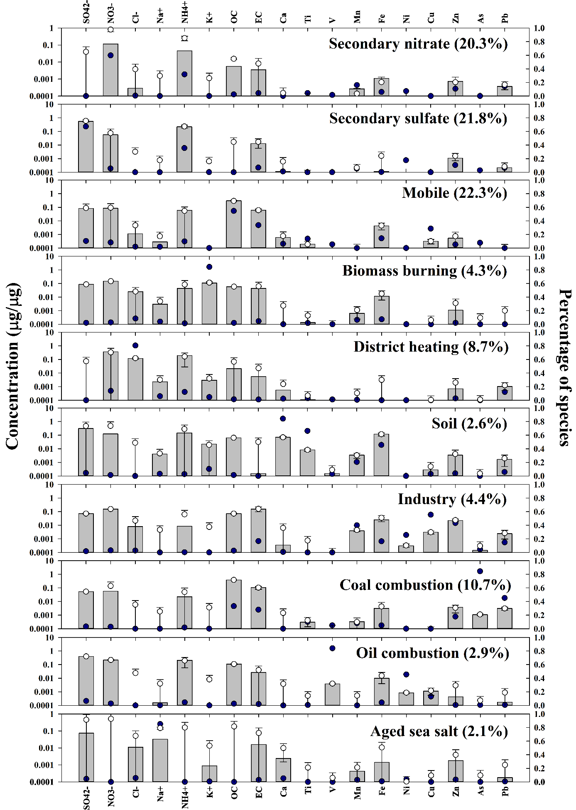
Fig. S1 Source profiles of PM_{2.5} in SL during 2014-2018.

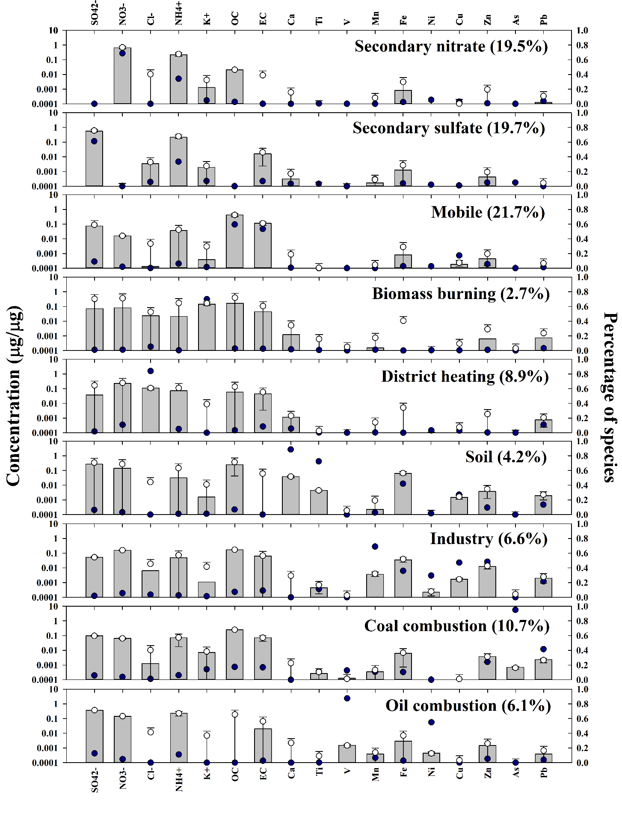
Fig. S2 Source profiles of PM_{2.5} in DJ during 2014-2018.
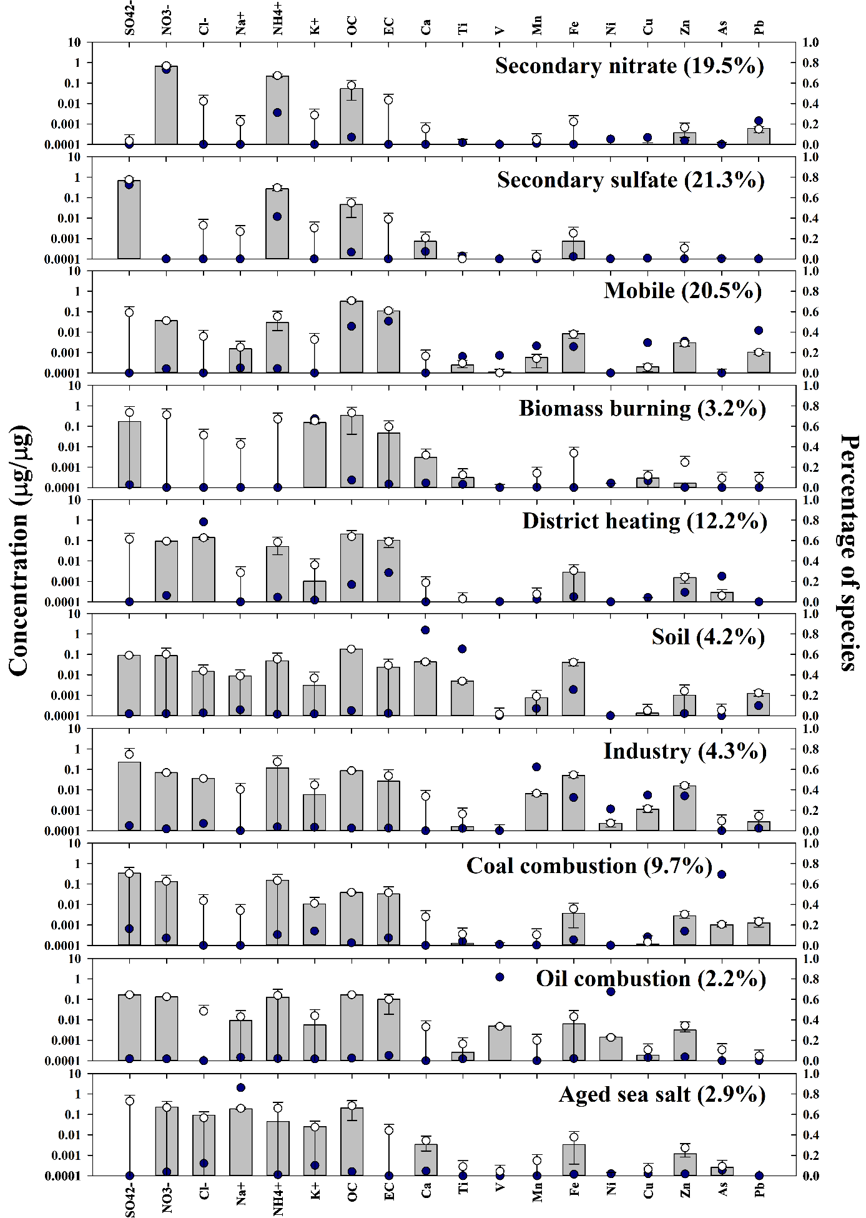
Fig. S3 Source profiles of PM_{2.5} in GJ during 2014-2018.

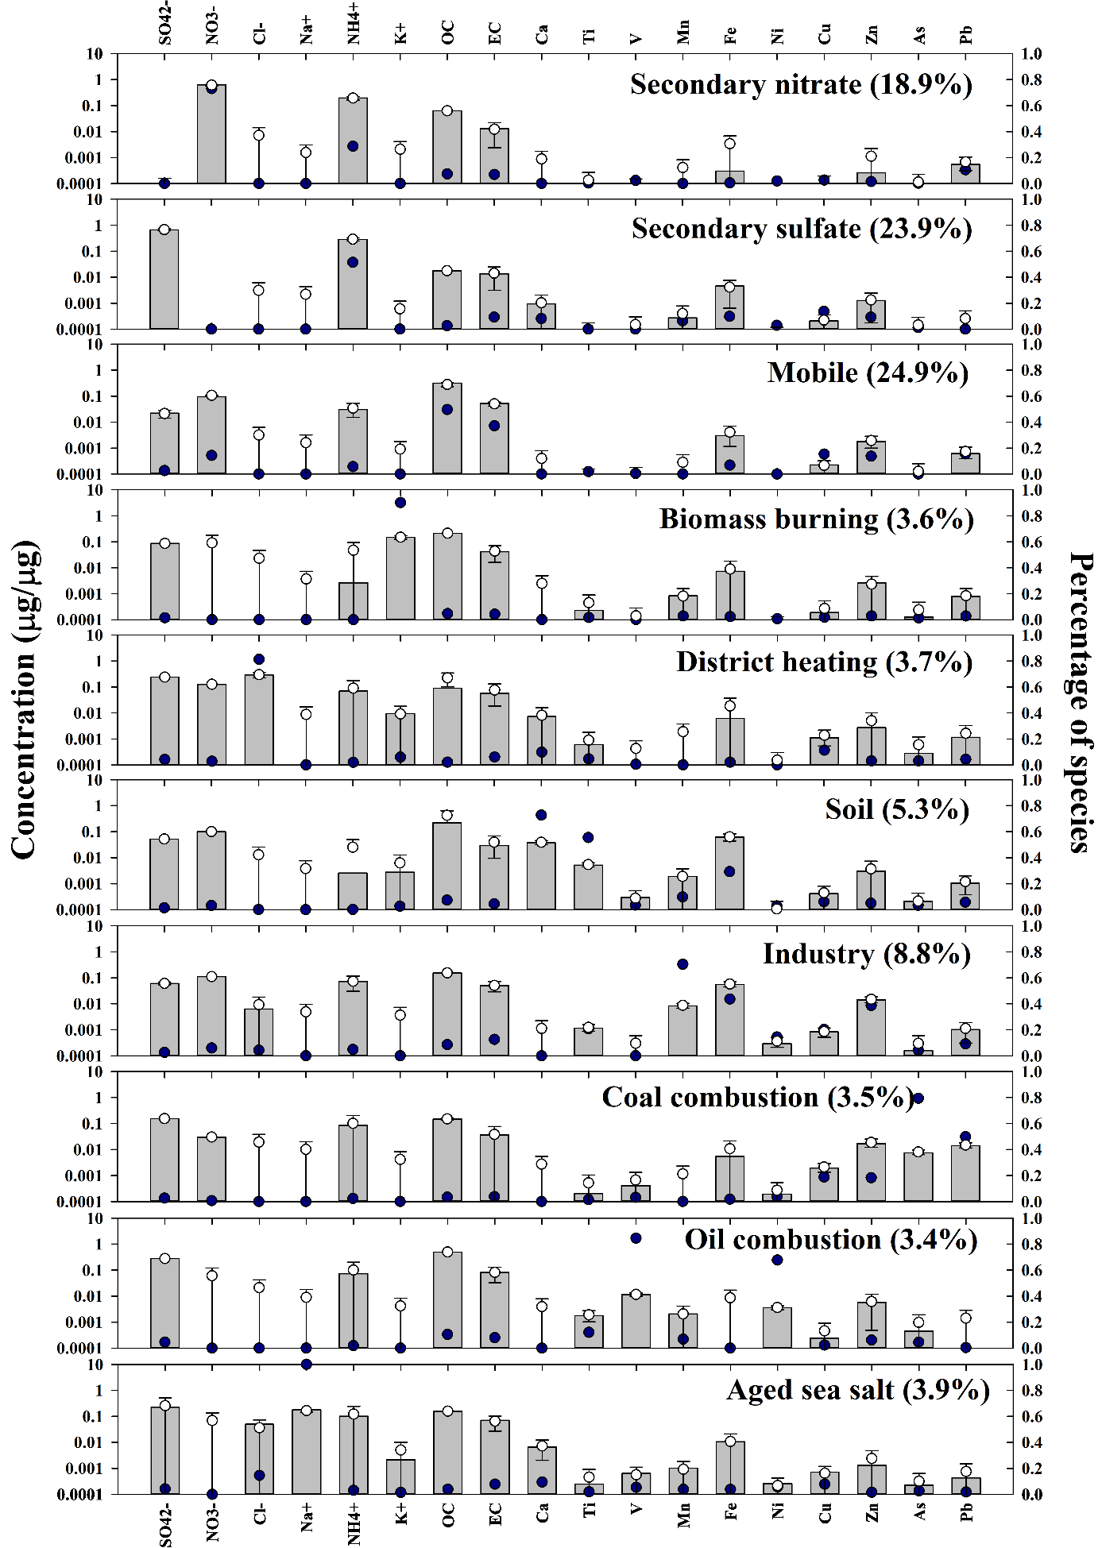
Fig. S4 Source profiles of PM_{2.5} in US during 2014-2018.

