Supporting Figures
Paenibacillus spp., a novel potato endophyte, adapts its physiology in planta to establish mutualistic symbiosis with potato
Karmen Pogačar, Tim Godec, Juliane Albrecht, Polonca Štefanič, Maja Križnik, Barbara Kraigher, Tjaša Lukan, Valentina Levak, Katja Stare, Marko Petek, Sarah Lebeis, Peter Dolničar, Ines Mandić Mulec, Kristina Gruden

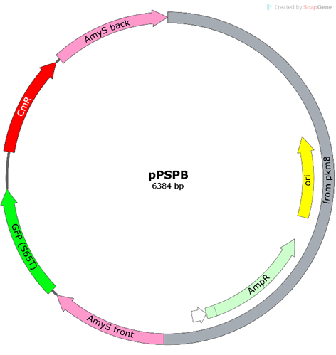
Figure S1: Schematic representation of plasmid pPSPB showing successful integration of the gfp gene, driven by the upp promoter, and a chloramphenicol resistance cassette at the amyS locus.

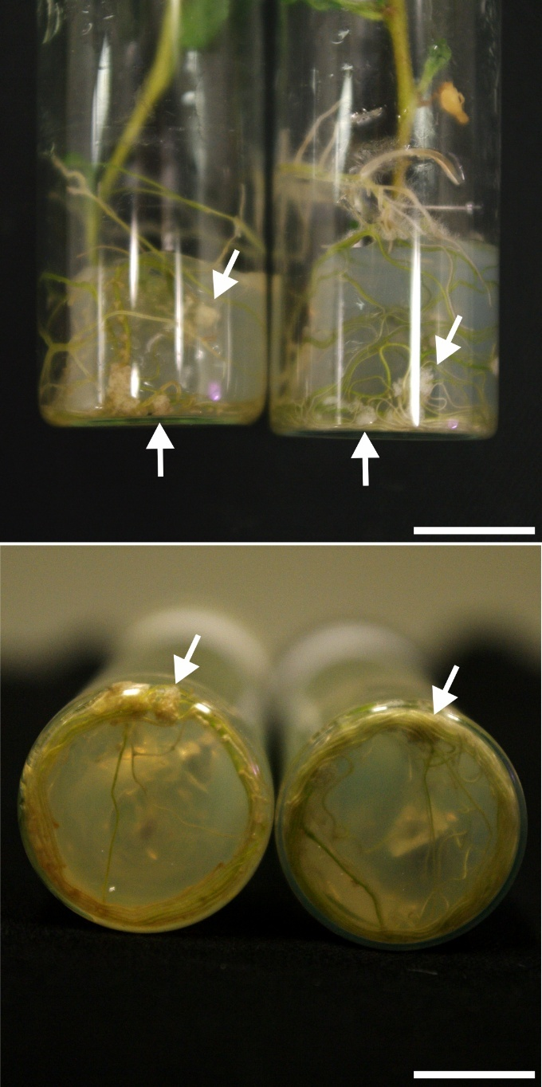
Figure S2: Image of Paenibacillus sp. ST1 emerging from the roots of potato cultivar Désirée. Scale bar = 1 cm.

Figure S3: Paenibacillus sp. strain ST1 exhibiting multiple plant growth–promoting traits. a) Comparison in biofilm formation between biofilm forming Bacillius subtilis PS-216 and strain ST1 in MsGG medium. Scale bar: 1 cm. b) Indole-acetic acid (IAA) production by strain ST1 in TBS medium. Scale bar: 6 mm. c) Xylanase activity by strain ST1. Scale bar: 5 mm. d) Cellulase activity by strain ST1. Scale bar = 5 mm. e) Pectinase activity by strain ST1. Scale bar = 5 mm. c) Amylase activity by strain ST1. Scale bar = 5 mm. g) Phosphate solubilization by strain ST1. Scale bar = 4 mm. h) Nitrogen fixation by strain ST1. Scale bar = 5 mm. i) Surfactant production by strain ST1. Scale bar = 5 mm. j) Protease activity by strain ST1. Scale bar = 7 mm. k) Summary of all plant growth–promoting traits tested in this study, including their intensity and representative images. Enzymatic activities are indicated semi-quantitatively: ++ strong activity; + moderate activity; +/− weak or variable activity; − no detectable activity.

Figure S4: Representative root images of three potato genotypes after 3 h of incubation with bacterial strain ST1 or control medium. The tagged strain ST1 was visualized in the GFP channel and is shown in green. Scale bar: 100 µm.
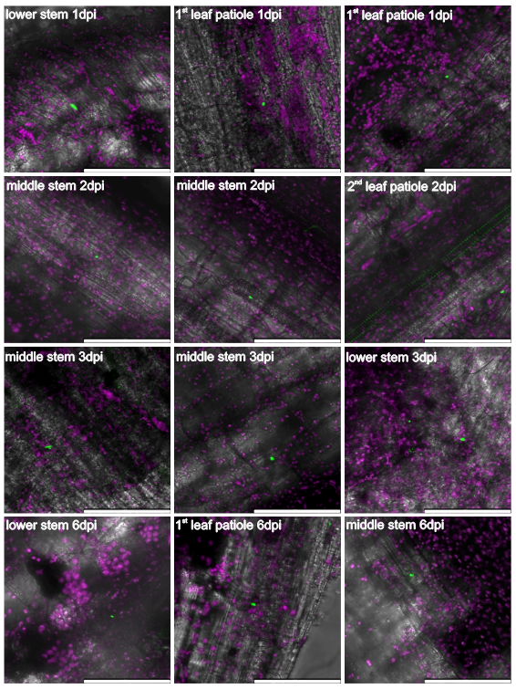
Figure S5: Strain ST1 colonisation pattern and movement in the upper plant tissues of Rywal from 1 to 6 days post root inoculation. The GFP-tagged strain ST1 is shown in green (GFP channel). Chlorophyll autofluorescence is shown in purple (RFP channel). Scale bar: 100 µm.
Figure S6: Strain ST1 presence, localization and morphology in leaf tissue of Rywal from 1 to 10 days post leaf infiltration. The GFP-tagged strain ST1 is shown in green (GFP channel). Chlorophyll autofluorescence is shown in purple (RFP channel). Scale bar: 100 µm.
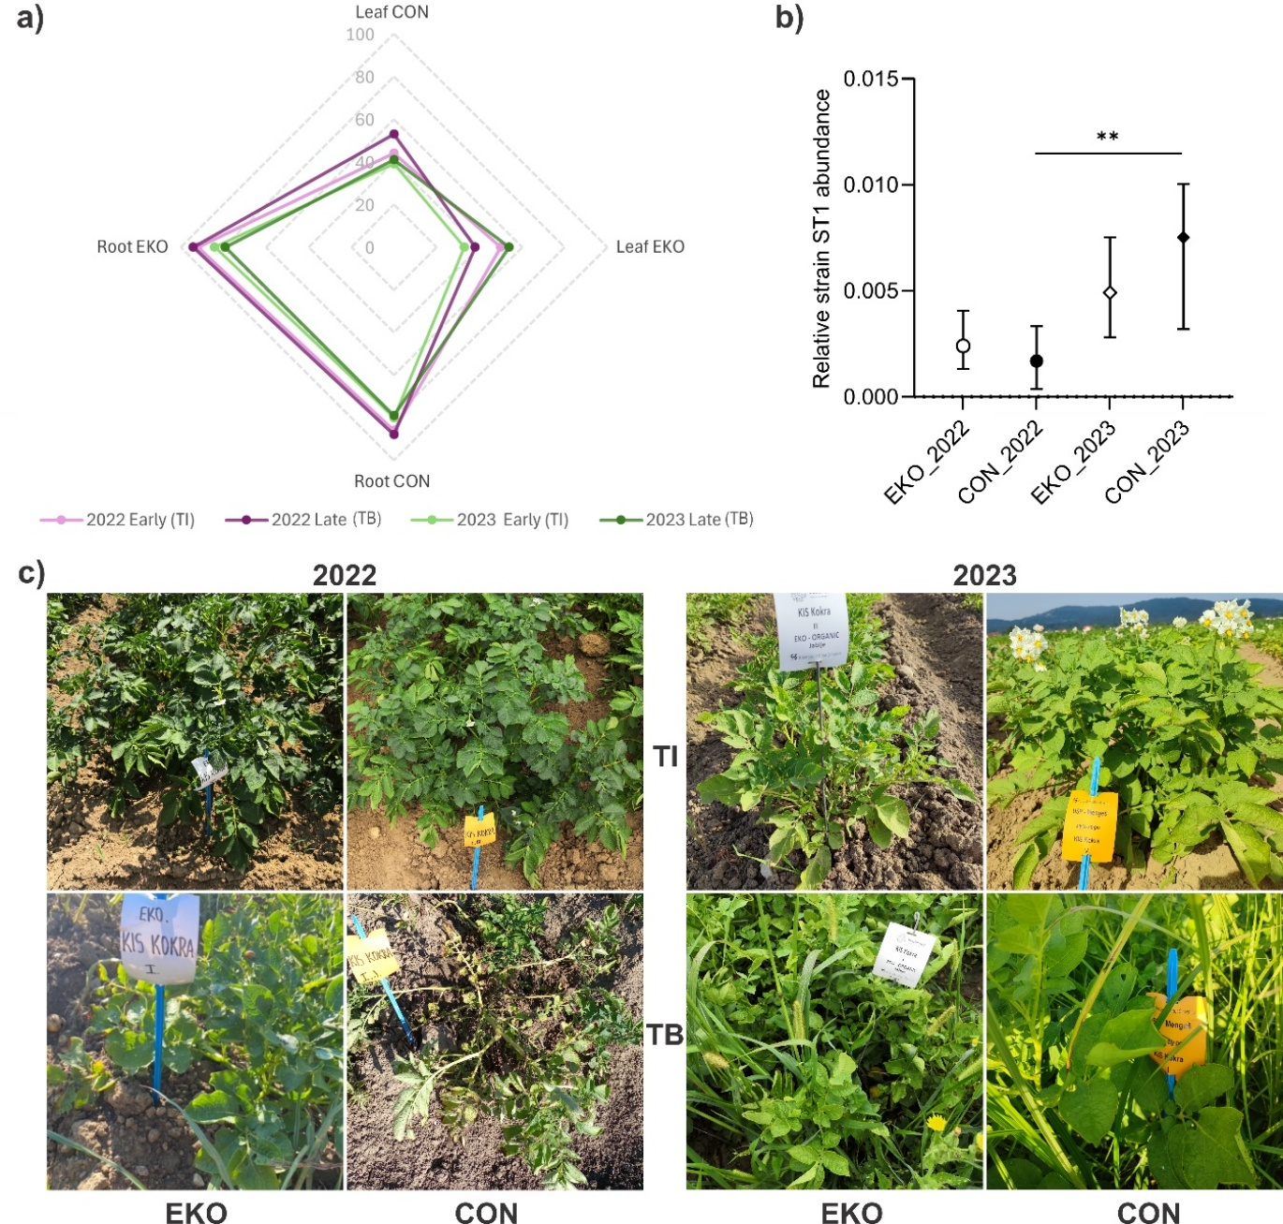
Figure S7: In field colonization dynamics of strain ST1 in potato plants under different cultivation systems across two years. a) Percentage of potato leaf and root samples positive for strain ST1 under different field treatments and sampling periods across two years; n = 53-64 per group. b) Comparison of relative bacterial abundance between cultivation types in 2022 and 2023 in leaf and root samples. Data are presented as median with 0–95% confidence interval and were analyzed using the Kruskal–Wallis test with Dunn’s multiple comparisons correction; ** p < 0.01; n = 74-109. c) Phenotypic comparison of potato plant Kokra genotype between two years, cultivation types and developmental stages.

Figure S8: Relative Paenibacillus sp. strain ST1 abundance in field grown potato plants. a) Comparison of bacterial abundance across cultivation types, potato developmental stages, and sterilised versus non-sterilised tissues in 2022 and 2023. Sample sizes varied between n = 2-30. b) Comparison of bacterial abundance across tissue types, potato developmental stages, and sterilized versus non-sterilized tissues in 2022 and 2023. Sample sizes varied between n = 3–28 for sterilized samples and n = 5–56 for non-sterilized samples. Data are presented as median with interquartile range and were analyzed using the Kruskal–Wallis test with Dunn’s multiple comparisons correction; * p < 0.05, ** p < 0.01, *** p < 0.001, **** p < 0.0001.

Figure S9: Protective role against potato virus Y (PVY) and root architecture effect of Paenibacillus sp strain ST1. a) Average root length per plant (cm) grown in media with viable bacteria or control conditions. Each data point represents the mean root length of one plant. Boxplots indicate the median and interquartile range; whiskers extend from minimum to maximum values. Roots were measured after 14 days of growth; n = 24 plants per group. Statistical significance was determined by unpaired t test; **** p < 0.0001. b) Number of roots per plant grown in media with viable bacteria or control conditions. Each data point represents the number of roots of one plant. Boxplots indicate the median and interquartile range; whiskers extend from minimum to maximum values. Roots were counted after 14 days of growth; n = 24 plants per group. Statistical significance was determined by unpaired t test; *** p < 0.001. c) Average root length per plant (cm) grown in media with viable bacteria, bacteria applied in spots on the bottom (spotted) or control conditions. Each data point represents the mean root length of one plant. Boxplots indicate the median and interquartile range; whiskers extend from minimum to maximum values. Roots were measured after 14 days of growth; n = 6 plants per group. Statistical significance was determined by one-way ANOVA followed by Šídák's multiple comparisons test; * p < 0.05, ns - not significant. d) Comparison of lesion number per infected leaf between ST1-treated plants and control at 5 dpi. Each data point represents one infected leaf. Boxplots indicate the median and interquartile range; whiskers extend from minimum to maximum values. Statistical significance was determined by Mann Whitney test; ** p < 0.01; n = 39 leaves per group. e) Comparison of mean total fluorescence intensity (a.u.) between ST1-treated plants and control. Data represents mean total intensity per plant per day, calculated from 6 measurements. Data are presented as mean ± SEM. Statistical analysis was performed using a mixed-effects model (REML), with treatment and time as fixed effects and plant as a random effect (n = 6 plants per group); * p < 0.05, ns - not significant.

Figure S10: Dynamics of plant volume growth over a 34-day period for Rywal shRbohD plant lines 13 and 14 under control and strain ST1 inoculated conditions. Data are presented as natural logarithm (ln) transformed values of plant volume (mm³). Individual data points are shown overlaid on box-and-whisker plots. Statistical analysis was done using a mixed-effects model (REML), with treatment and time as fixed effects and plant as a random effect (n =5-6 plants per group) and revealed no statistically significant differences (p > 0.05) between the treatment and control at any time point.

Figure S11: Dynamics of plant volume growth over a 34-day period for NahG-Rywal plants under control and strain ST1 inoculated conditions. Data are presented as natural logarithm (ln) transformed values of plant volume (mm³). Individual data points are shown overlaid on box-and-whisker plots. Statistical analysis was done using a mixed-effects model (REML), with treatment and time as fixed effects and plant as a random effect (n = 4-6 plants per group) and revealed no statistically significant differences (p > 0.05) between the treatment and control at any time point.

Figure S12: Differentially expressed genes of Galactose pathway in strain ST1 in planta. KEGG pathway maps show significantly regulated genes (|log2FC| ≥ 1, adjusted p ≤ 0.05) in galactose metabolism (Table S6). Red boxes indicate upregulated genes and blue boxes indicate downregulated genes relative to the control condition. Color intensity reflects the magnitude of log2 fold change.

Figure S13: Differentially regulated genes of fructose and mannose metabolism in strain ST1 in planta. KEGG pathway maps show significantly regulated genes (|log2FC| ≥ 1, adjusted p ≤ 0.05) in fructose and mannose metabolism (Table S6). Red boxes indicate upregulated genes and blue boxes indicate downregulated genes relative to the control condition. Color intensity reflects the magnitude of log2 fold change.

Figure S14: Differentially expressed TCA cycle genes in strain ST1 in planta. KEGG pathway maps show significantly regulated genes (|log2FC| ≥ 1, adjusted p ≤ 0.05) in citrate cycle (Table S6). Red boxes indicate upregulated genes and blue boxes indicate downregulated genes relative to the control condition. Color intensity reflects the magnitude of log2 fold change.

Figure S15: Differentially expressed genes of pentose phosphate pathway in strain ST1 in planta. KEGG pathway maps show significantly regulated genes (|log2FC| ≥ 1, adjusted p ≤ 0.05) in pentose phosphate pathway (Table S6). Red boxes indicate upregulated genes and blue boxes indicate downregulated genes relative to the control condition. Color intensity reflects the magnitude of log2 fold change.

