Supplementery file (SI)
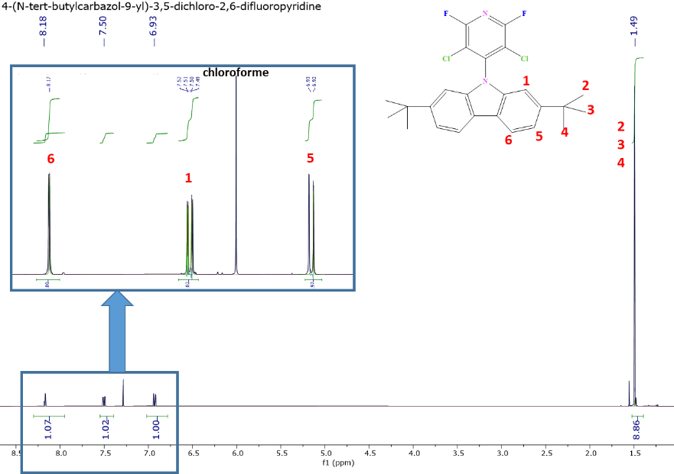
The ¹H NMR characterization of the pyridine derivative displays a distinctive spectral signature, featuring: (i) a multiplet centered at 8.18 ppm assigned to the H6/H7 aromatic protons of the pyridine ring, (ii) a complex system at 7.50 ppm, resolved as overlapping doublet of doublets, corresponding to H1/H12 protons, and (iii) a multiplet at 6.93 ppm associated with H5/H8 protons. The tert-butyl groups are characterized by an intense singlet at 1.49 ppm, integrating for 9 methyl protons. Definitive structural confirmation is provided by ¹⁹F NMR spectroscopy, where the observation of a singlet at -68.83 ppm indicates a single fluorine environment in the molecular architecture. Collectively, these spectral data conclusively corroborate the formation of the target substituted pyridine derivative structure.

Figure S1: ¹H NMR spectrum of 4-(N-tert-butylcarbazol-9-yl)-3,5-dichloro-2,6-difluoropyridine (in chloroform, 25°C).
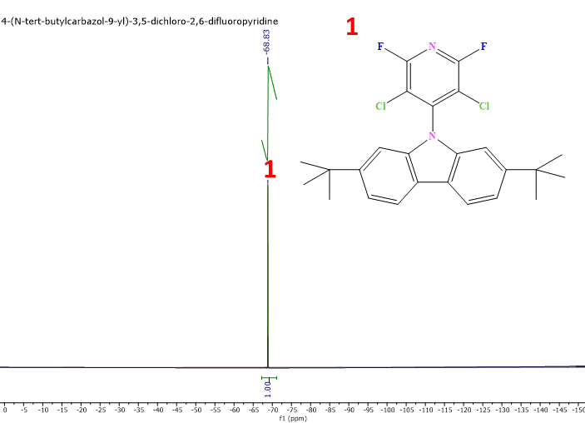

Figure S2: 19F NMR spectrum of 4-(N-tert-butylcarbazol-9-yl)-3,5-dichloro-2,6-difluoropyridine (in chloroform, 25°C).
The assignment of the ¹³C NMR and DEPT-135 spectra reveals characteristic signals for the different structural groups. The carbon atoms of the tert-butyl groups are observed at 34.86 ppm (C4/C15) and 34.36 ppm (C5/C6/C7/C16/C17/C18). The carbazole moiety carbons display distinct chemical shifts at 109.26 ppm (C2/C19), 117.18 ppm (C8/C13), 124.45 ppm (C9/C12), 136.88 ppm (C10/C11), 144.58 ppm (C1/C20), and 148.21 ppm (C3/C14). Integration analysis indicates the presence of approximately 10-15% excess N-tert-butylcarbazole residue in the sample.
The carbon atoms of the substituted pyridine ring are identified at 115.16 ppm (C21), 154.49 ppm (C22/C25), and 156.95 ppm (C23/C24). This complete assignment is in perfect agreement with the expected molecular structure and confirms the formation of the target product.
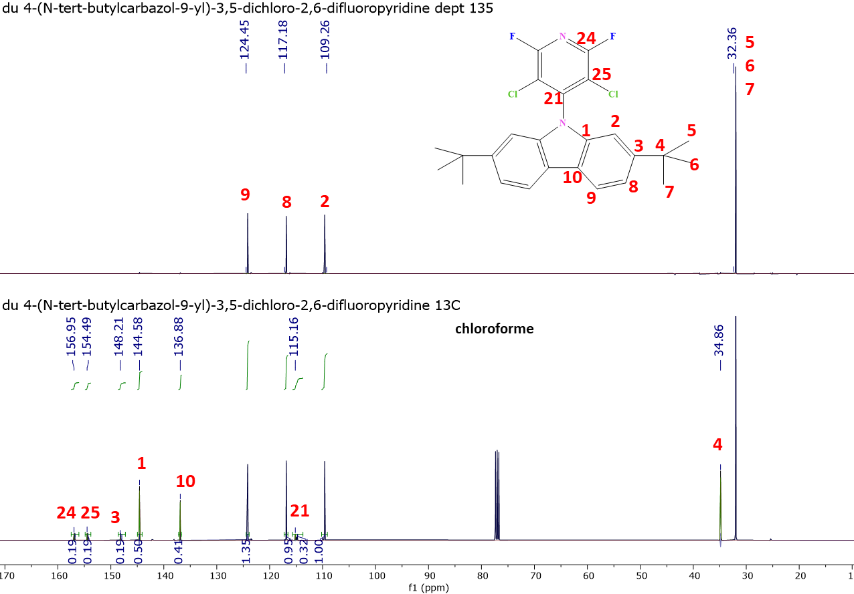

Figure S3: 13C NMR and DEPT-135 spectra of 4-(N-tert-butylcarbazol-9-yl)-3,5-dichloro-2,6-difluoropyridine (in chloroform, 25°C).

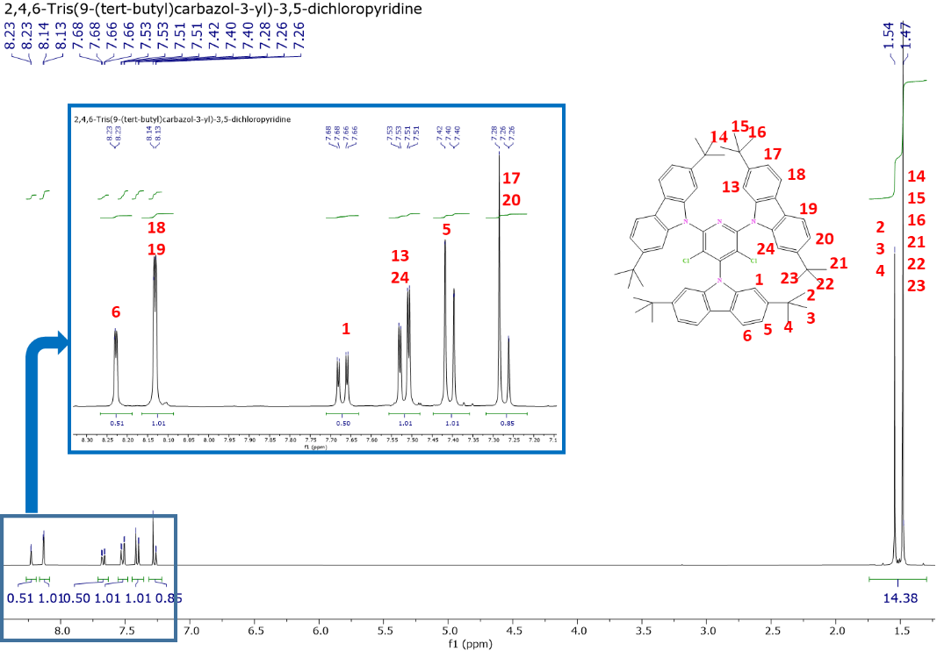

Figure S4: 1H NMR spectrum of 2,4,6-Tris(9-(tert-butyl)carbazol-3-yl)-3,5-dichloropyridine (in chloroform, 25°C).
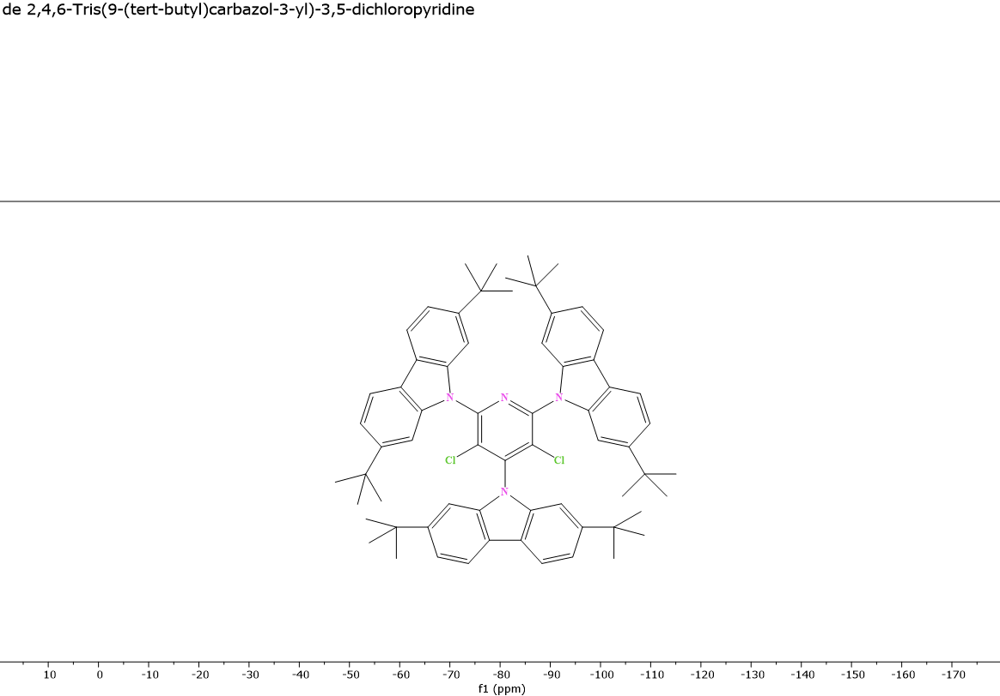

Figure S5: 19F NMR spectrum of 2,4,6-Tris(9-(tert-butyl)carbazol-3-yl)-3,5-dichloropyridine (in chloroform, 25°C).

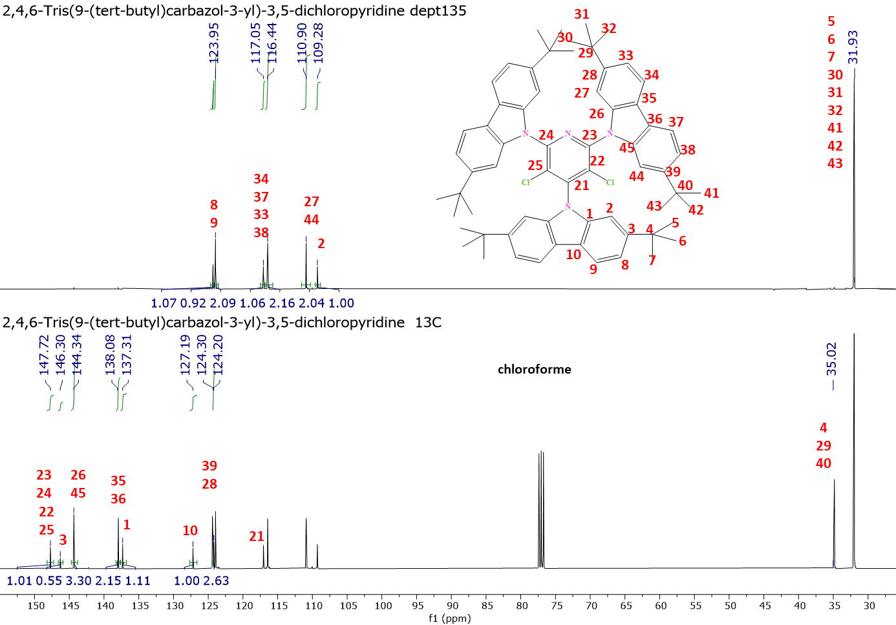

Figure S6: 13C NMR and DEPT-135 spectra of 2,4,6-Tris(9-(tert-butyl)carbazol-3-yl)-3,5-dichloropyridine (in chloroform, 25°C).

