Table. 1 The introduction of the measured instruments

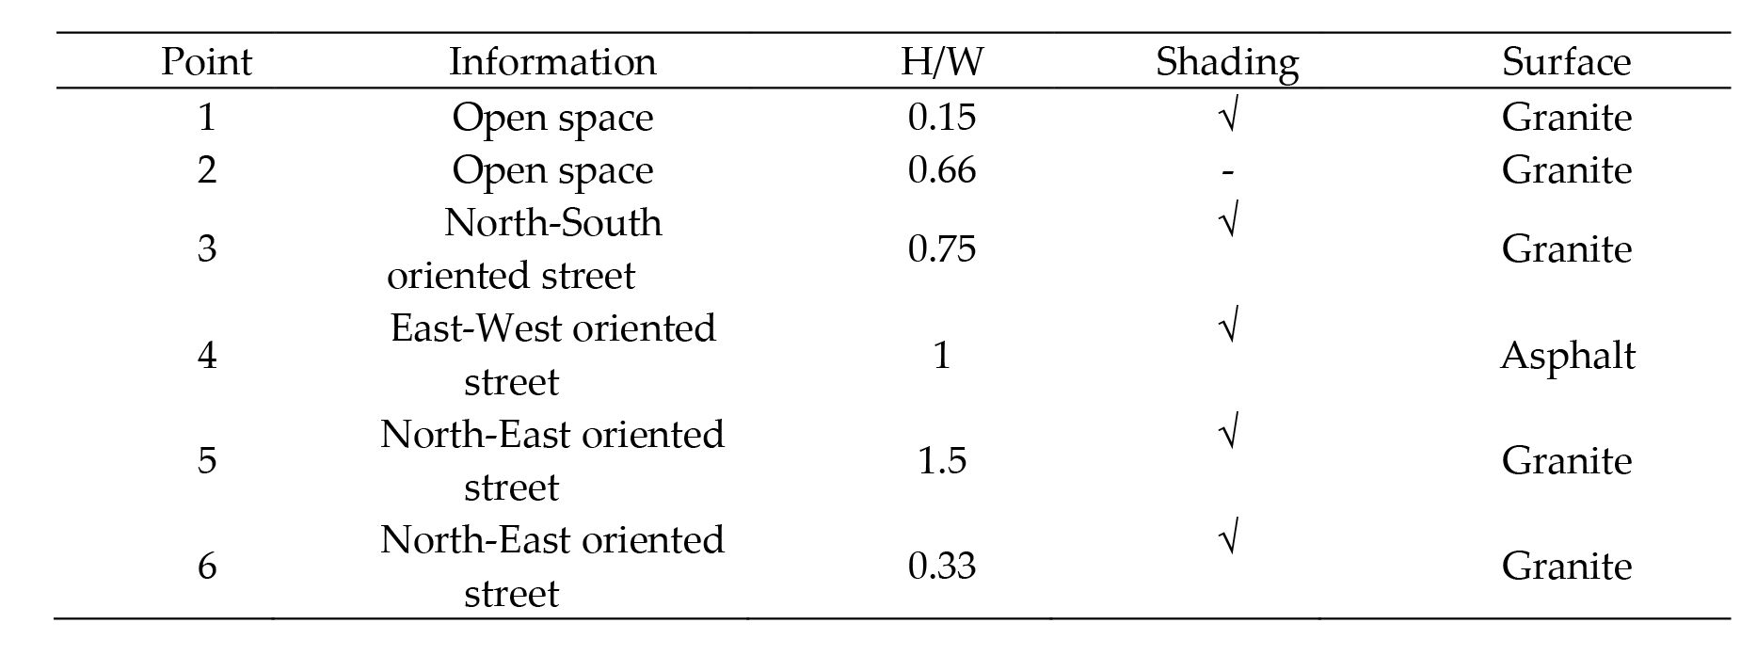
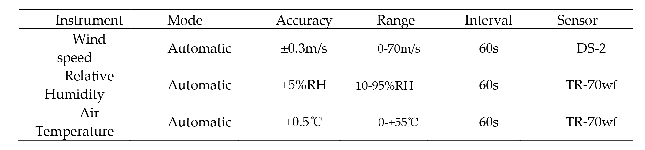
Table. 2 Introduction about the selected six points [43]

Table. 3 The weather conditions during the measured days [43]
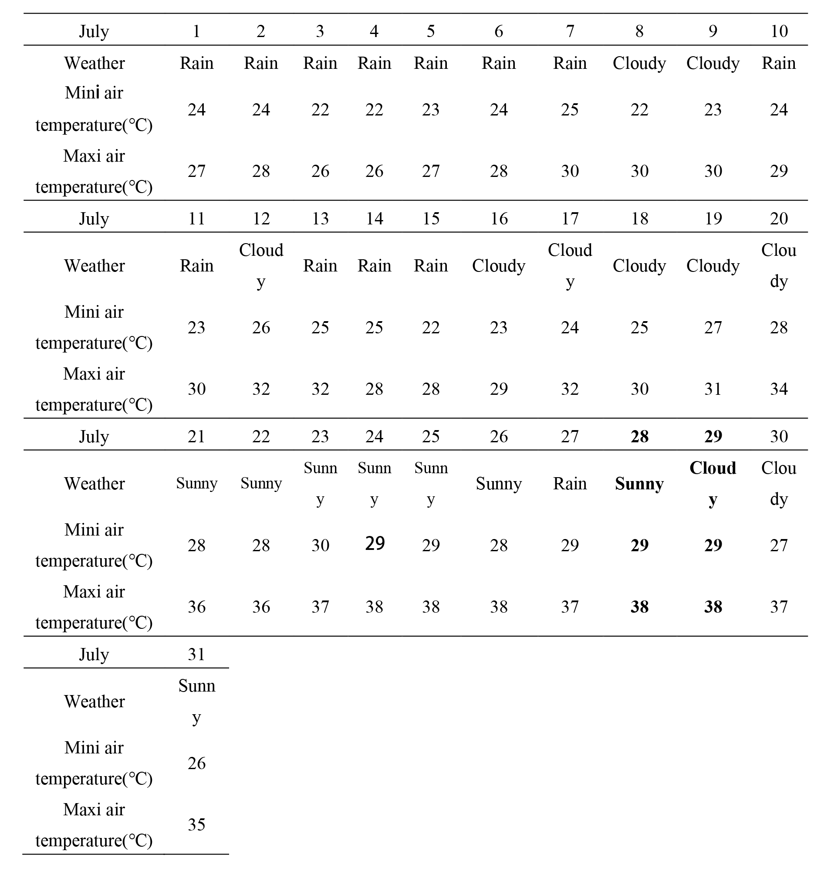

Table. 4 LAD distribution of the selected border tree

Table. 5 Initial data for numerical simulation
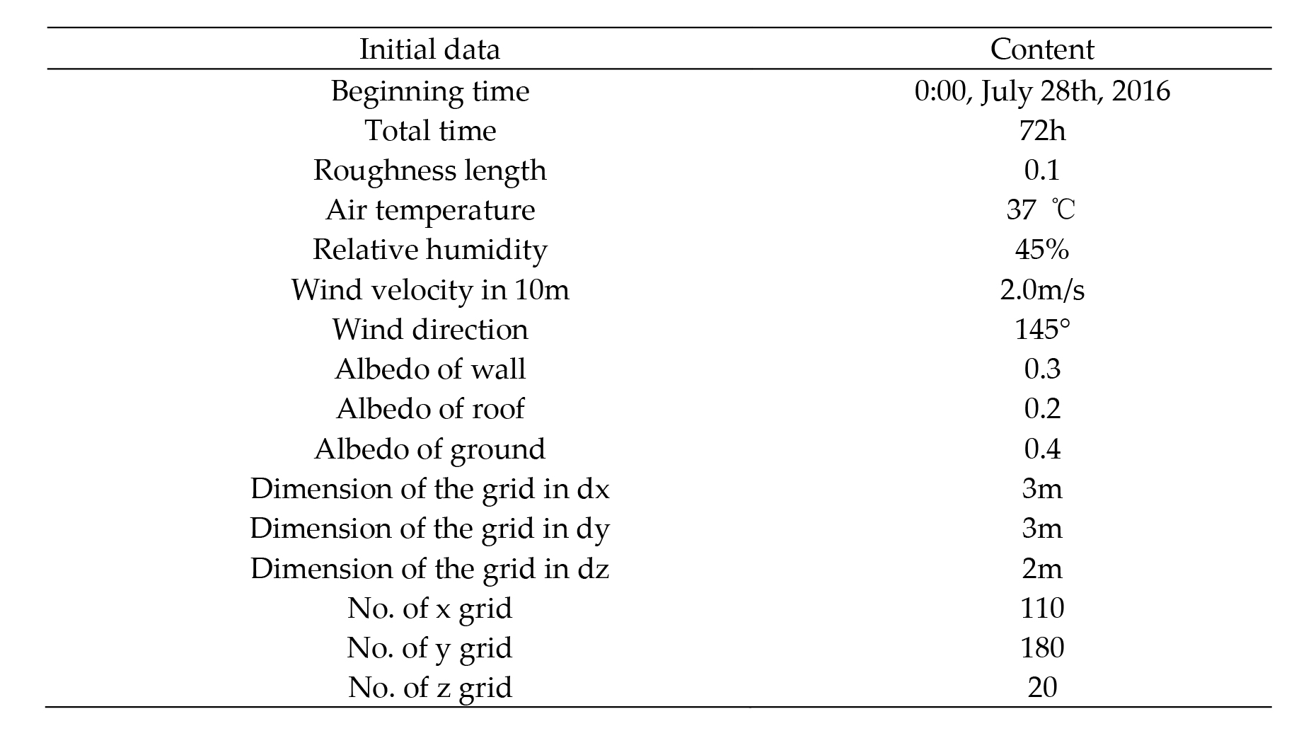

Table. 6 The PET values and humans’ thermal perceptions [59]
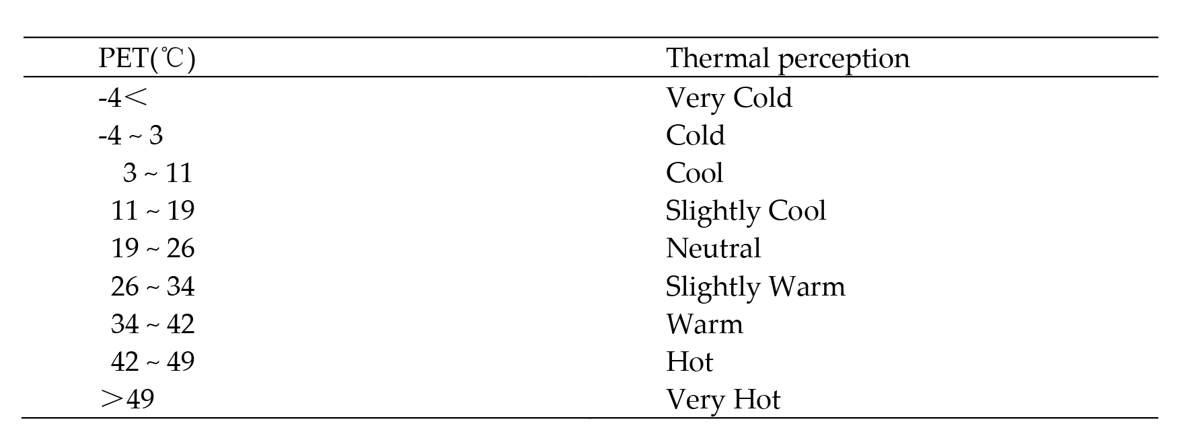
Table. 7 The introduction of new strategies
