This supplements to:
Subnational Inequities in Measles Vaccination Coverage in Kenya: A Bayesian Geostatistical Modelling Analysis
Brian Njuguna^{1#}, Nyamai Mutono^{1,2}, Rose Jalang’o³, Stanley Sayianka¹, Emmanuel Okunga⁴, George P. Omondi¹, Helen Kiarie⁵, Teresia N. Kimani¹, Marybeth C. Maritim^{1,6} Claudio Fronterre^{7,8}, Loice Ombajo^{1,6}, SM Thumbi^{1,2}
¹ Centre for Epidemiological Modelling and Analysis, University of Nairobi, Nairobi, Kenya
² Paul G Allen School for Global Health, Washington State University, Pullman, USA
³ National Vaccines Immunization Program, Ministry of Health, Nairobi, Kenya
⁴ Kenya National Public Health Institute, Nairobi, Kenya
⁵ Division of Monitoring and Evaluation, Ministry of Health, Nairobi, Kenya
⁶ Department of Medicine and Therapeutics, Faculty of Health Sciences, University of Nairobi, Nairobi, Kenya
⁷Department of Applied Health Sciences, University of Birmingham, United Kingdom
⁸CHICAS, Lancaster Medical School, Lancaster University, United Kingdom
# Corresponding author; brian.njuguna@cema.africa

Table S1: Covariates and Data sources
 | Covariate | Timeline | Time extent | units | Resolution | Source
 | Population density | Static | 2020 | - | 100M | WordlPop [1]
 | Population age structures | Static | 2020 | counts | 100M | WorldPop [2]
 | Land Surface Temperature in the Day | Temporal | 2019-2024 | K | 5KM | MODIS [3]
 | Night light | Static | 2016 | nanoWatts/cm2/sr | 100M | WorldPOP [4]
 | Travel time to cities (20,000 - 50,000) | Static | 2015 | minutes | 1KM | CGIR [5]
 | Motorized Travel time to health facilities | Static | 2020 | Minutes | 1KM | Malaria Atlas [6]
 | Precipitation | Temporal | 2019-2024 | mm/d | 5KM | CHIRPS [7]
 | Percentage of women age 15−49 who are literate | Static | 2022 | % | 5KM | DHS Modelled surfaces [8]
 | Percentage of men age 15−49 who are literate | Static | 2022 | % | 5KM | DHS Modelled surfaces [9]
 | Percentage of population practicing open defecation | Static | 2022 | % | 5KM | DHS Modelled surfaces [10]
 | Percentage of live births in a health facility | Static | 2022 | % | 5KM | DHS Modelled surfaces [11]
 | Percentage of children 12−23 months who had received Pneumococcal 3 vaccination | Static | 2022 | % | 5KM | DHS Modelled surfaces [12]
 | Percentage of children 12−23 months who had received a third dose of DPT | Static | 2022 | % | 5KM | DHS Modelled surfaces [13]
 | Percentage of children 12−23 months who had received first dose of DPT | Static | 2022 | % | 5KM | DHS Modelled surfaces [14]
 | Percentage of children 12−23 months with a vaccination card | Static | 2022 | % | 5KM | DHS Modelled surfaces [15]
 | Proportion of population in the lowest wealth quantile | Static | 2022 | - | 5KM | Bayesian geostatistical model[16]
 | Facility density | Static | 2023 | - | 5KM | Kenya Health Facility Census 2023[17]
 | Nurse density | Static | 2023 | - | 5KM | Kenya Health Facility Census 2023[17]

Table S2: Covariates selected using the backward-stepwise algorithm
 | MCV1 | MCV2
 | Percentage of children 12−23 months who had received first dose of DPT | Percentage of children 12−23 months who had received first dose of DPT
 | Percentage of women aged 15−49 who are literate | Percentage of women aged 15−49 who are literate
 | Proportion of population in the lowest wealth quintile | Proportion of population in the lowest wealth quintile
 | Population density | Percentage of children 12−23 months who had received Pneumococcal 3 vaccination
 | Motorized travel time to health facilities | Facility density
 | Urbanicity | Population density
 |  | Motorized Travel time to health facilities
 |  | Urbanicity

Model Validation
We assessed model calibration by comparing population-weighted estimates from the two models against design-adjusted estimates (Figures S1c and d in the main paper). We also examined potential violations of the assumed spatial correlation structure using the approach described in Peter J. Diggle and Emanuele Giorgi, in their book Model-based Geostatistics for Global Public Health¹⁸. Figure S1c and d shows the empirical variogram diagnostic plots to check the compatibility of the data and the model assumed, specifically the spatial autocorrelation function. These plots compare the observed spatial correlation structure in the residuals (black points) against the expected variogram behavior under the fitted model. The blue shaded envelope represents the range of variogram values obtained from 1000 posterior predictive samples, while the dashed lines indicate the 2.5% and 97.5% quantiles of this posterior distribution. When the observed empirical variogram points fall within this posterior envelope, it indicates that the assumed correlation function adequately captures the true spatial correlation structure in the data. Both panels demonstrate good model compatibility, with the observed variogram points lying well within the credible intervals.
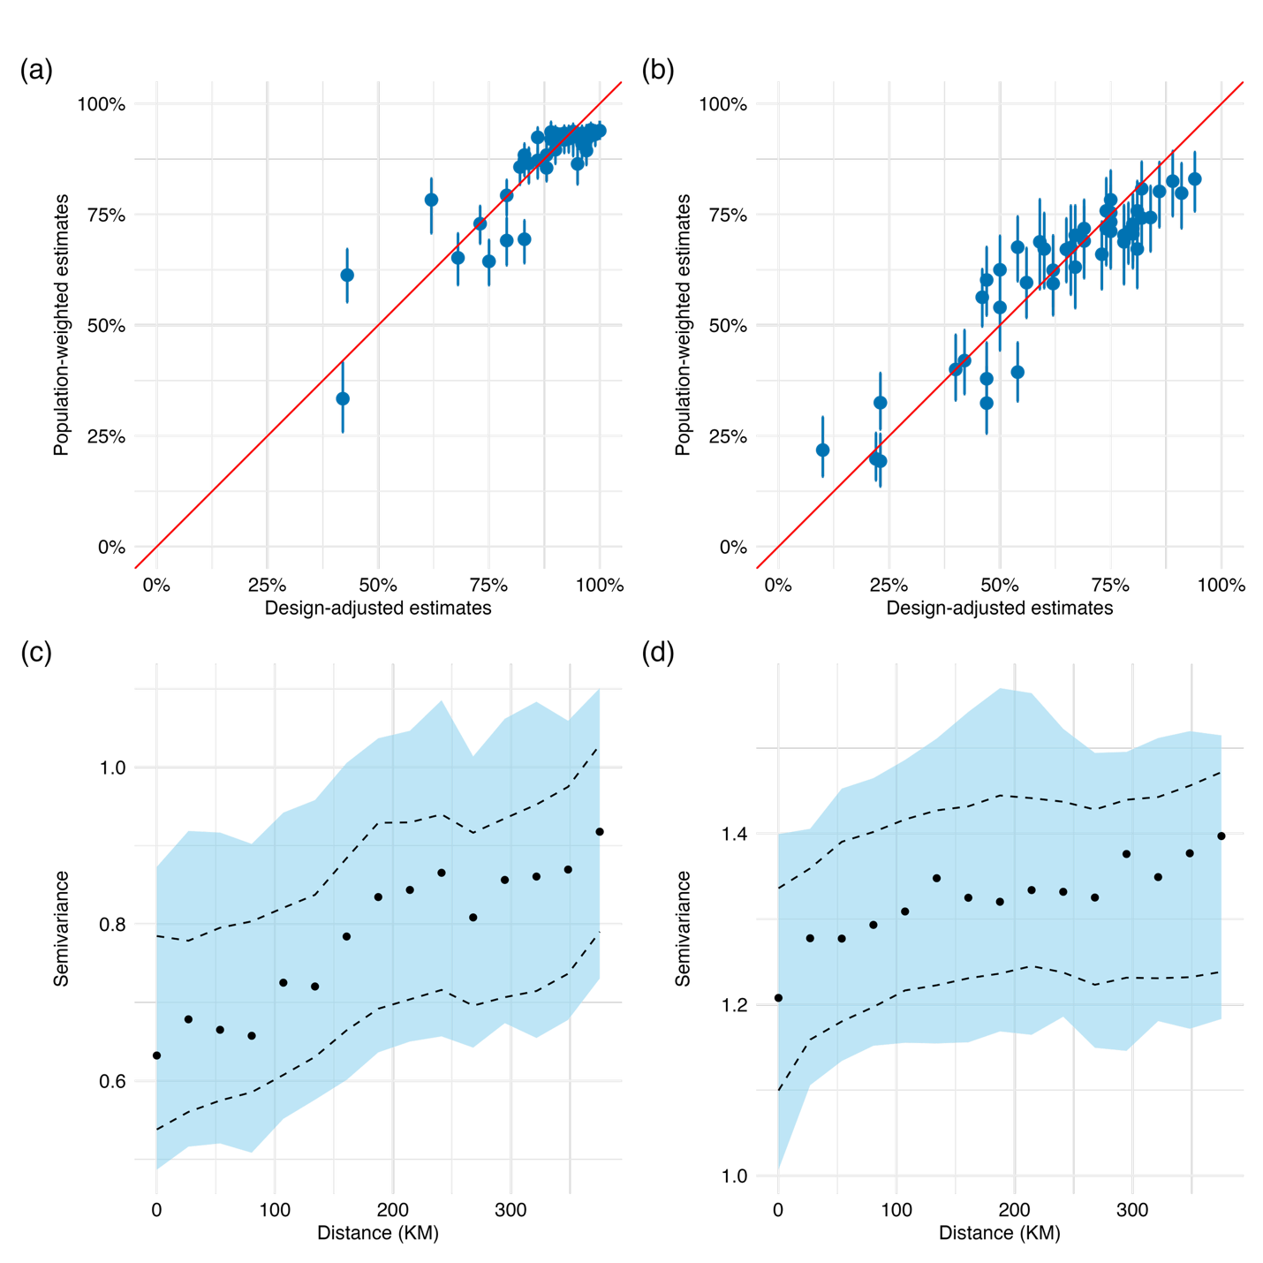
Figure S1: Figures 1a and S1b show model calibration assessment comparing population-weighted estimates against design-adjusted estimates for MCV1 (panel a) and MCV2 (panel b) vaccination coverage. Figures S1c and d represents the empirical variogram for MCV1 (panel c) and MCV2 (panel d)

Table S3: Model validation metrics
Vaccine |  | RMSE | MAE | MSE
MCV1 |  | 0.247 | 0.164 | 0.061
MCV1 |  | 0.218 | 0.145 | 0.047
MCV1 |  | 0.231 | 0.155 | 0.053
MCV1 |  | 0.224 | 0.154 | 0.050
MCV1 | Average | 0.230 | 0.154 | 0.053
MCV2 |  | 0.355 | 0.294 | 0.126
MCV2 |  | 0.328 | 0.279 | 0.108
MCV2 |  | 0.348 | 0.290 | 0.121
MCV2 |  | 0.335 | 0.281 | 0.112
MCV2 | Average | 0.342 | 0.286 | 0.117

Model Calibration Assessment
We assessed the calibration of the fitted geostatistical model using the average non-randomized Probability Integral Transform (AnPIT), originally proposed by Czado et al. (2009) and adapted to binomial geostatistical models by Giorgi et al. (2021)^{19,20}. The AnPIT evaluates whether the predictive distribution of the fitted model adequately reflects the observed data. For a well-calibrated model, the AnPIT curve follows the 45-degree identity line when plotted against $u∈[0,1]$.
We randomly held out 30% of survey clusters as a test set, refitting the model on the remaining 70%, and repeated this procedure 10 times with different random seeds. The AnPIT reported is the mean across the 10 replicates. A 95% predictive envelope was constructed under the null hypothesis of a well-calibrated model by simulating 1,000 datasets from the fitted predictive distribution at each replicate, with the reported envelope being the mean lower and upper bounds across replicates.
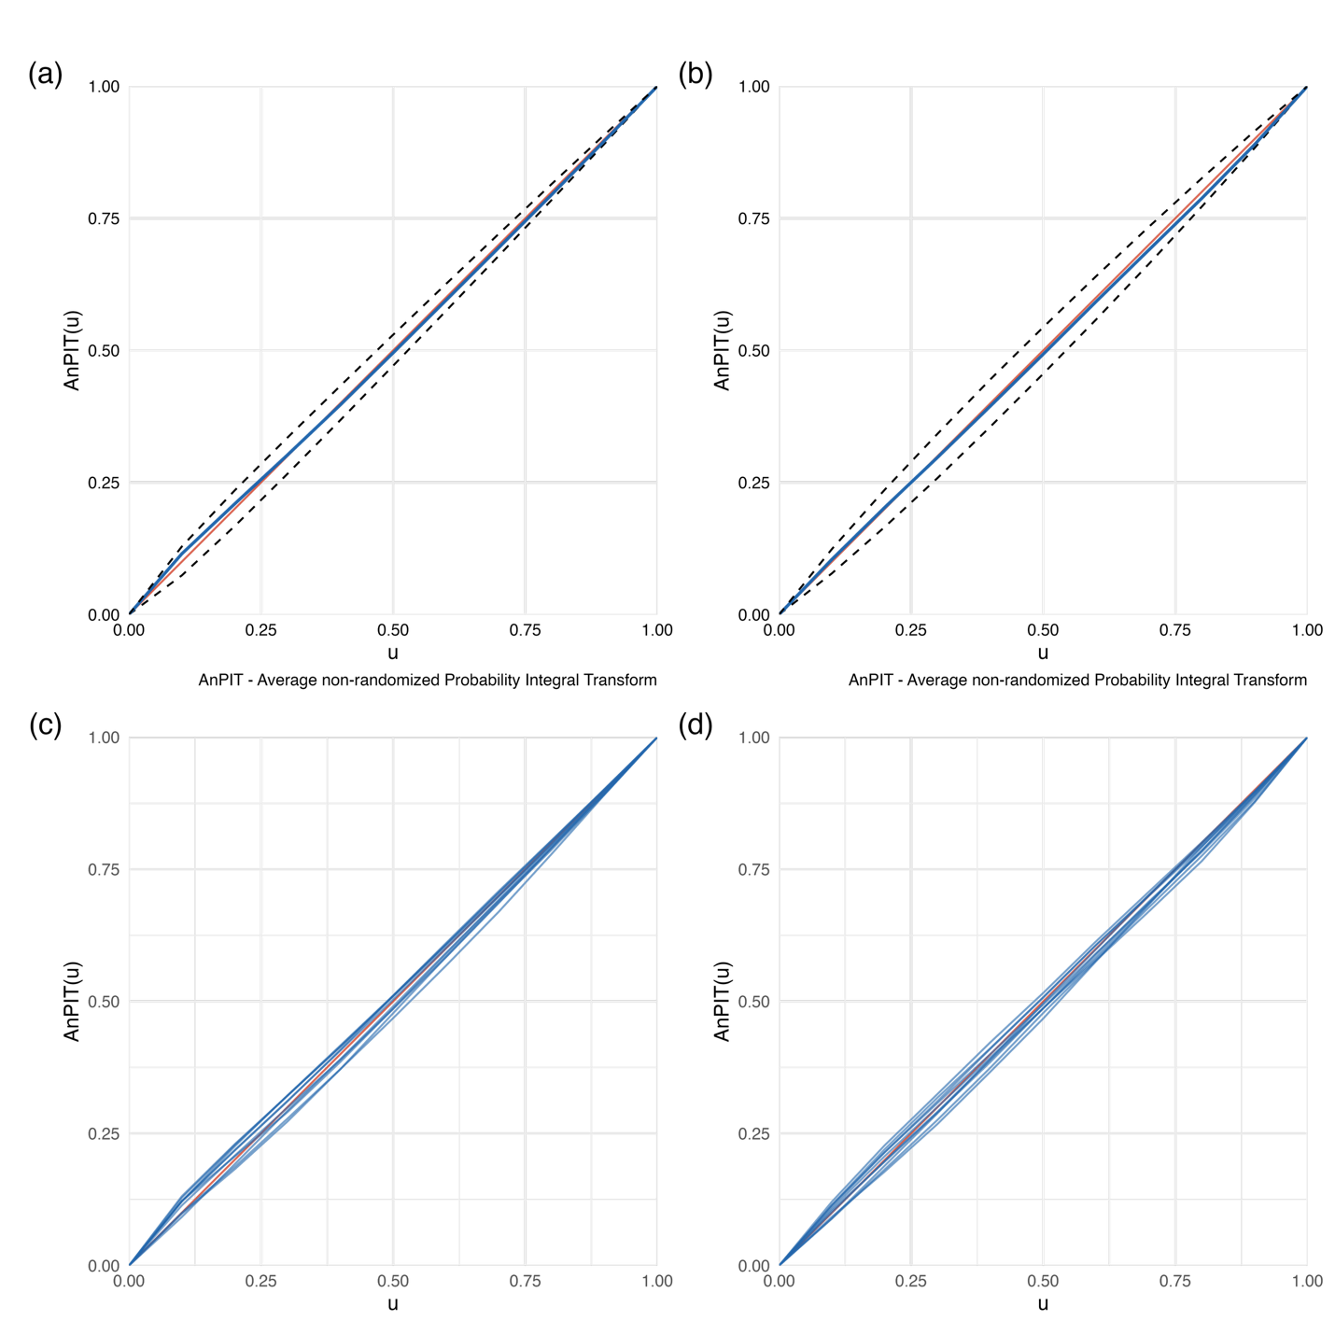
Figure S2: Average non-randomized Probability Integral Transform (AnPIT) for MCV1 and MCV2 geostatistical models. Upper panels show the mean AnPIT curve (blue) averaged across 10 replicates with the 95% predictive envelope (dashed lines) for MCV1 (a) and MCV2 (b). Lower panels show the individual AnPIT curves from each of the 10 replicates for MCV1 (c) and MCV2 (d). The red diagonal line represents the identity line, corresponding to a perfectly calibrated model. AnPIT curves lying within the predictive envelope and close to the identity line indicate good model calibration.

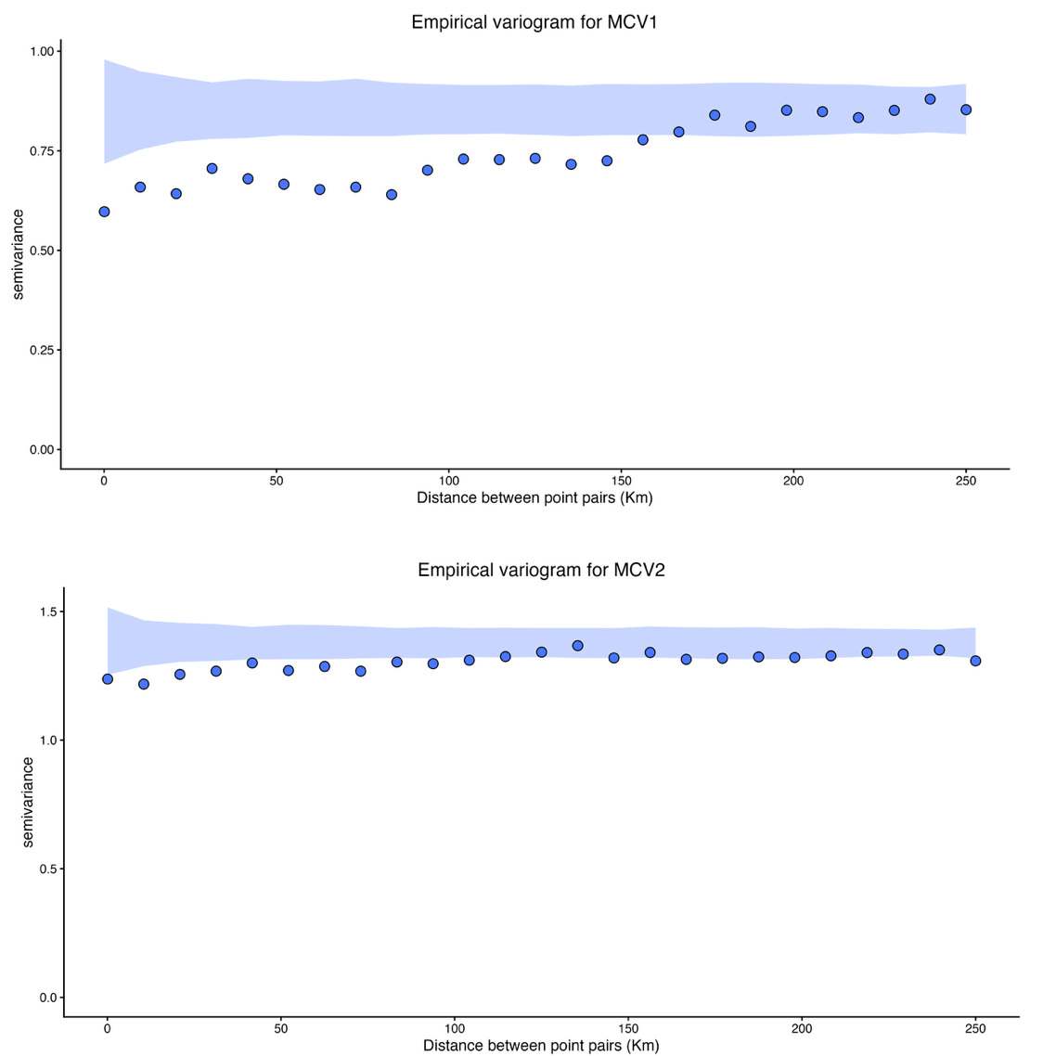
Figure S3: Empirical variograms for MCV1 and MCV2
Model hyperparameters
Table S4: MCV1 model hyperparameters
 | Posterior mean | Lower credible interval | Upper credible interval
Spatial range | 165.97 | 25.87 | 662.5
Spatial variance | 0.06 | 0 | 0.5
Nugget | 0.74 | 0.43 | 1.2

Table S5: MCV2 model hyperparameters
 | Posterior mean | Lower credible interval | Upper credible interval
Spatial range | 97.48 | 38.92 | 197.99
Spatial variance | 0.35 | 0.19 | 0.58
Nugget | 0.16 | 0.04 | 0.38
Within county heterogenity
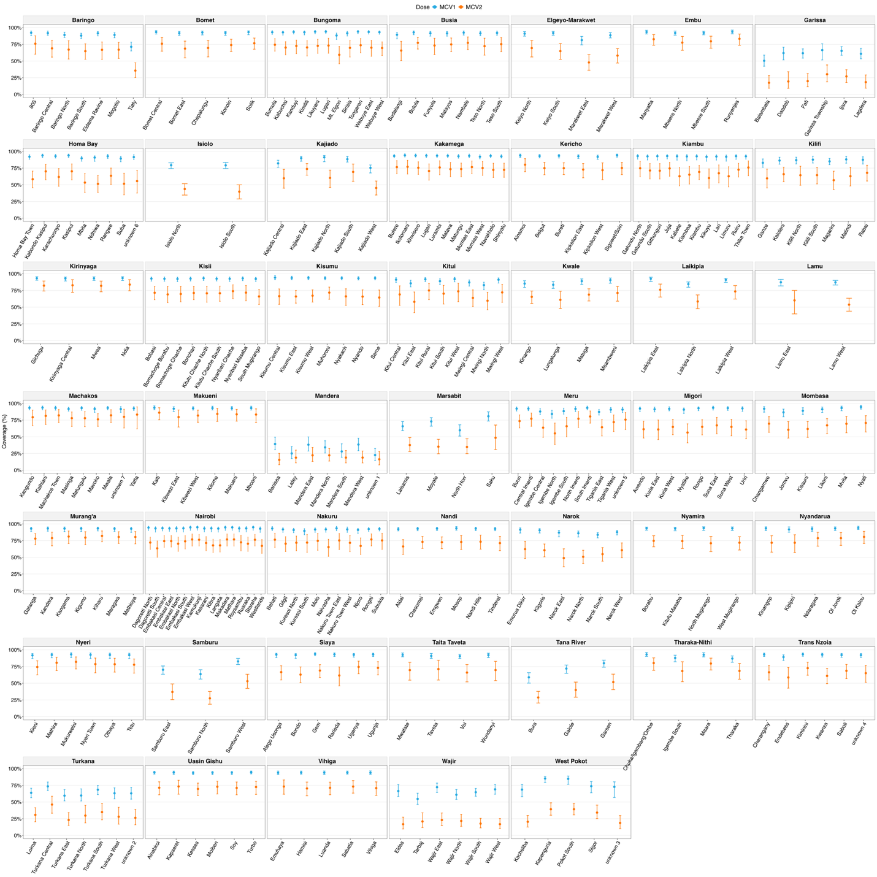
Figure S4: Sub-county level model-based MCV1 and MCV2 coverage estimates with 95% credible intervals, by county. Each panel represents one of the 47 counties. Points indicate posterior mean estimates and error bars represent 95% credible intervals.

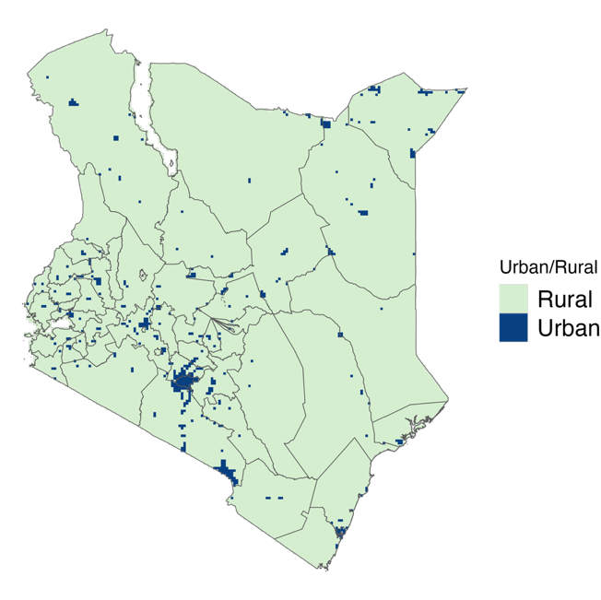
Figure S5:Rural urban classification raster file

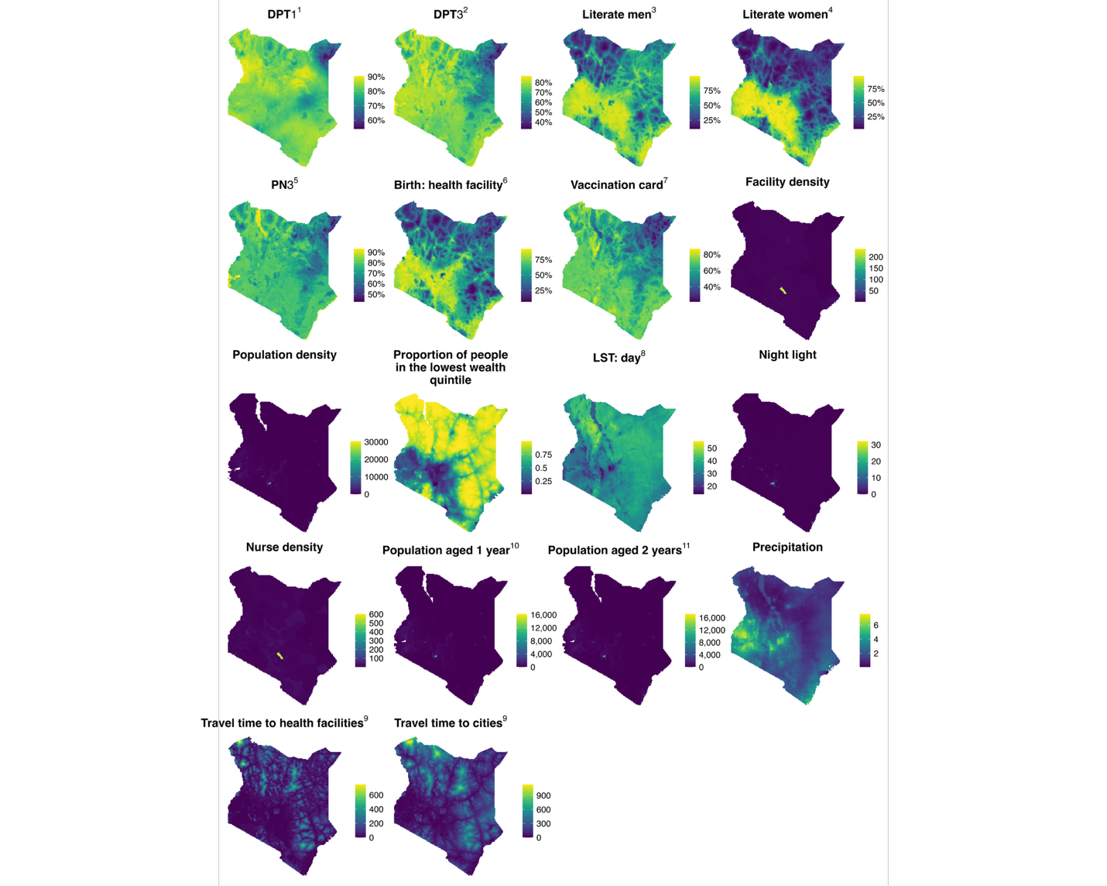
Figure S6: Covariates used in the models

Number of unvaccinated children
Table S6: Number of children aged 12-23 who have not received MCV1 at county level
County | Number of unvaccinated children | Lower 95% CI | Upper 95% CI
Baringo | 3338 | 2667 | 4018
Bomet | 2278 | 1715 | 3086
Bungoma | 4076 | 3138 | 5596
Busia | 2158 | 1640 | 2926
Elgeyo-Marakwet | 1694 | 1287 | 2163
Embu | 894 | 622 | 1224
Garissa | 14612 | 12410 | 16937
Homa Bay | 2745 | 2143 | 3668
Isiolo | 1030 | 854 | 1255
Kajiado | 3636 | 2943 | 4655
Kakamega | 4282 | 3206 | 5467
Kericho | 1967 | 1506 | 2691
Kiambu | 3016 | 2088 | 4834
Kilifi | 5402 | 3887 | 7219
Kirinyaga | 843 | 603 | 1231
Kisii | 2966 | 2143 | 4254
Kisumu | 2008 | 1434 | 2576
Kitui | 4048 | 3132 | 5335
Kwale | 3533 | 2595 | 4693
Laikipia | 1334 | 1046 | 1745
Lamu | 373 | 288 | 490
Machakos | 2239 | 1684 | 3032
Makueni | 1928 | 1338 | 2469
Mandera | 40742 | 35660 | 45338
Marsabit | 2821 | 2345 | 3327
Meru | 4437 | 3259 | 5775
Migori | 2938 | 2195 | 4077
Mombasa | 1678 | 1072 | 2473
Murang'a | 1627 | 1169 | 2426
Nairobi | 6361 | 4108 | 10622
Nakuru | 4925 | 3801 | 6694
Nandi | 2338 | 1761 | 3048
Narok | 5560 | 4614 | 7177
Nyamira | 1379 | 1017 | 1970
Nyandarua | 1211 | 857 | 1662
Nyeri | 1166 | 821 | 1769
Samburu | 2895 | 2465 | 3372
Siaya | 2119 | 1620 | 2991
Taita Taveta | 723 | 521 | 944
Tana River | 3973 | 3421 | 4677
Tharaka-Nithi | 910 | 636 | 1241
Trans Nzoia | 2683 | 2025 | 3659
Turkana | 9412 | 7916 | 11063
Uasin Gishu | 2018 | 1491 | 2802
Vihiga | 1159 | 734 | 1561
Wajir | 14631 | 12636 | 16835
West Pokot | 5362 | 4174 | 7224

Table S7: Number of children aged 24:35 who have not received MCV2 at county level
County | Number of unvaccinated children | Lower 95% CI | Upper 95% CI
Baringo | 9891 | 8186 | 11627
Bomet | 8862 | 6599 | 11577
Bungoma | 17488 | 13539 | 22064
Busia | 7205 | 5212 | 9367
Elgeyo-Marakwet | 6277 | 5095 | 7514
Embu | 2534 | 1727 | 3579
Garissa | 31351 | 28354 | 33751
Homa Bay | 14564 | 11844 | 17505
Isiolo | 3055 | 2691 | 3451
Kajiado | 10097 | 8037 | 12232
Kakamega | 17576 | 13384 | 21852
Kericho | 7690 | 5738 | 9880
Kiambu | 13463 | 10022 | 17092
Kilifi | 15530 | 12045 | 19404
Kirinyaga | 2304 | 1405 | 3339
Kisii | 12607 | 9156 | 15962
Kisumu | 11019 | 8689 | 13490
Kitui | 12130 | 9113 | 15379
Kwale | 9399 | 7366 | 11596
Laikipia | 4051 | 3126 | 5078
Lamu | 1417 | 1129 | 1717
Machakos | 6520 | 4327 | 9164
Makueni | 4828 | 3138 | 6890
Mandera | 52349 | 48352 | 56052
Marsabit | 6005 | 5217 | 6720
Meru | 13807 | 10300 | 18046
Migori | 14760 | 11671 | 18039
Mombasa | 7048 | 4991 | 9350
Murang'a | 4953 | 3286 | 6883
Nairobi | 29892 | 22565 | 38727
Nakuru | 18013 | 14089 | 22813
Nandi | 9845 | 7634 | 12318
Narok | 20336 | 17394 | 23421
Nyamira | 5796 | 4136 | 7745
Nyandarua | 4480 | 3230 | 5886
Nyeri | 3514 | 2443 | 4807
Samburu | 6796 | 5905 | 7581
Siaya | 10393 | 8166 | 12862
Taita Taveta | 2799 | 1936 | 3756
Tana River | 8355 | 7429 | 9259
Tharaka-Nithi | 2557 | 1779 | 3459
Trans Nzoia | 12374 | 9397 | 15729
Turkana | 19374 | 16979 | 21346
Uasin Gishu | 10291 | 7916 | 13158
Vihiga | 5818 | 4217 | 7530
Wajir | 34935 | 32396 | 37060
West Pokot | 17681 | 15923 | 19256

References
1. WorldPop :: Population Counts.
2. WorldPop :: Age and sex structures.
3. LP DAAC - MOD11A2.
4. WorldPop :: Geospatial covariate data layers.
5. Weiss, D. J. et al. A global map of travel time to cities to assess inequalities in accessibility in 2015. Nature 553, 333–336 (2018).
6. Weiss, D. J. et al. Global maps of travel time to healthcare facilities. Nat. Med. 26, 1835–1838 (2020).
7. Funk, C. et al. The climate hazards infrared precipitation with stations - A new environmental record for monitoring extremes. Sci. Data 2, (2015).
8. Spatial Data Repository, The Demographic and Health Surveys Program. Modeled Surfaces. KE2022DHS_EDLITRWLIT_MS_v01. https://spatialdata.dhsprogram.com.
9. Spatial Data Repository, The Demographic and Health Surveys Program. Modeled Surfaces. KE2022DHS_EDLITRMLIT_MS_v01. https://spatialdata.dhsprogram.com.
10. Spatial Data Repository, The Demographic and Health Surveys Program. Modeled Surfaces. KE2022DHS_WSTLETPNFC_MS_v01. https://spatialdata.dhsprogram.com.
11. Spatial Data Repository, The Demographic and Health Surveys Program. Modeled Surfaces. KE2022DHS_RHDELPCDHF_MS_v01. https://spatialdata.dhsprogram.com.
12. Spatial Data Repository, The Demographic and Health Surveys Program. Modeled Surfaces.KE2022DHS_CHVACCCPN3_MS_v01. https://spatialdata.dhsprogram.com.
13. Spatial Data Repository, The Demographic and Health Surveys Program. Modeled Surfaces.KE2022DHS_CHVACCCDP3_MS_v01. https://spatialdata.dhsprogram.com.
14. Spatial Data Repository, The Demographic and Health Surveys Program. Modeled Surfaces.KE2022DHS_CHVACCCDP1_MS_v01. https://spatialdata.dhsprogram.com.
15. Spatial Data Repository, The Demographic and Health Surveys Program. Modeled Surfaces.KE2022DHS_CHVAC1CVCD_MS_v01. https://spatialdata.dhsprogram.com.
16. Sub-national estimates of incidence of visceral leishmaniasis and optimisation of geographical accessibility to treatment centres in Kenya | Research Square. https://www.researchsquare.com/article/rs-8967363/v1.
17. MINISTRY OF HEALTH. KENYA HEALTH FACILITY CENSUS REPORT REPORT. https://www.health.go.ke/sites/default/files/2024-01/Kenya%20Health%20Facility%20Census%20Report%20September%202023.pdf (2023).
18. Diggle, P. J. & Giorgi, E. Model-Based Geostatistics for Global Public Health: Methods and Applications. (Chapman and Hall/CRC, New York, 2019). doi:10.1201/9781315188492.
19. Czado, C., Gneiting, T. & Held, L. Predictive Model Assessment for Count Data. Biometrics 65, 1254–1261 (2009).
20. Giorgi, E. et al. Model building and assessment of the impact of covariates for disease prevalence mapping in low-resource settings: to explain and to predict. J. R. Soc. Interface 18, 20210104 (2021).

