Highly efficient biosorbent produced from Syagrus romanzoffiana to be applied in water treatment

Gabriel André Tochetto^{a,b*}, Tainá Cristini da Silva^{b}, Josiane Bampi^{b}, Regina de Fátima Peralta Muniz Moreiraª, Cleuzir da Luz^{c}, Gean Delise Leal Pasquali^{b}, Adriana Dervanoski^{b*}

ª Department of Chemical and Food Engineering (EQA), Federal University of Santa Catarina (UFSC), 88040-900, Florianópolis, Santa Catarina, Brazil.

^{b} Laboratory of Effluent and Waste (LAER), Environmental and Sanitary Engineering (EAS), Federal University of Fronteira Sul (UFFS), 99700-970, Erechim, Rio Grande do Sul, Brazil.

^{c} Post-Graduation Program in Food Science and Technology (PPGCTA), University of Santa Catarina State (UDESC), 89870-000, Pinhalzinho, Santa Catarina, Brazil.

* Corresponding authors: Gabriel A. Tochetto (tochettogabriel@gmail.com +55 (54) 99664-0195)

Table SM1. Plackett & Burman experimental design matrix with real and coded values used to investigate the effect of the variables on the process and the percentage of methylene blue dye removal.
Assay | Mass (g) ± 0.005 | pH ± 0.3 | Shaking (rpm) ± 0.5 | Temperature (°C) ± 0.5 | Concentration (mg L⁻¹) ± 2.79 | Removal (%)
1 | +1 (2.0) | -1 (2) | +1 (250) | -1 (25) | -1 (5) | 98.60
2 | +1 (2.0) | +1 (10) | -1 (50) | +1 (55) | -1 (5) | 85.94
3 | -1(0.2) | +1 (10) | +1 (250) | -1 (25) | +1 (60) | 97.58
4 | +1 (2.0) | -1 (2) | +1 (250) | +1 (55) | -1 (5) | 98.61
5 | +1 (2.0) | +1 (10) | -1 (50) | +1 (55) | +1 (60) | 52.74
6 | +1 (2.0) | +1 (10) | +1 (250) | -1 (25) | +1 (60) | 99.89
7 | -1(0.2) | +1 (10) | +1 (250) | +1 (55) | -1 (5) | 99.39
8 | -1(0.2) | -1 (2) | +1 (250) | +1 (55) | +1 (60) | 98.07
9 | -1(0.2) | -1 (2) | -1 (50) | +1 (55) | +1 (60) | 20.33
10 | +1 (2.0) | -1 (2) | -1 (50) | -1 (25) | +1 (60) | 62.08
11 | -1(0.2) | +1 (10) | -1 (50) | -1 (25) | -1 (5) | 46.13
12 | -1(0.2) | -1 (2) | -1 (50) | -1 (25) | -1 (5) | 33.62
13 | 0 (1.1) | 0 (6) | 0 (150) | 0 (40) | 0 (32.2) | 99.78
14 | 0 (1.1) | 0 (6) | 0 (150) | 0 (40) | 0 (32.2) | 99.83
15 | 0 (1.1) | 0 (6) | 0 (150) | 0 (40) | 0 (32.2) | 99.86
16 | 0 (1.1) | 0 (6) | 0 (150) | 0 (40) | 0 (32.2) | 99.74

Table SM2. Equations used to estimate the kinetic and thermodynamic parameters of the sorption of MB on ACJC and the error functions used
Model | Equations | n°
Mass balance | $$q_{e}=\frac{\left(C_{0}-C_{e}\right)V}{m}$$ | (1)
Avrami-fractional-order | $$q_{t}=q_{e}(1-\exp\left(-k_{1}C_{e}^{n}\right))$$ | (2)
Elovich | $$q_{t}=\frac{1}{β}+ln⁡(αβt)$$ | (3)
Pseudo-first order | $$q_{t}=q_{e}(1-\exp\left(-k_{1}t\right))$$ | (4)
Pseudo-second order | $$q_{t}=\frac{q_{e}^{2}{ k}_{2} t}{(1+{ q}_{e}{ k}_{2} t )}$$ | (5)
Intraparticle Diffusion | $$q_{t}=k_{id}\sqrt{t}+C$$ | (6)
BET | $$q_{e}=\frac{q_{m} K_{S} C_{e}}{(1-K_{S}C_{e})(1+\left(K_{S}-K_{L}\right)C_{e})}$$ | (7)
Langmuir | $$q_{e}=\frac{q_{m} K_{L} C_{e}}{1+K_{L} C_{e}}$$ | (8)
Freundlich | $$q_{e}=K_{F} C_{e}^{1/n_{F}}$$ | (9)
Sips | $$q_{e}=\frac{q_{m}K_{S}{C_{e}}^{1/ns}}{{1+K_{S}{ C}_{e}}^{1/ns}}$$ | (10)
Thermodynamics | $$∆G^{o}=∆H^{o}-T∆S^{o}$$ | (11)
 | $$\ln\left(\frac{q_{e}}{C_{e}}\right)=\frac{∆S^{o}}{R}-\frac{∆H^{o}}{RT}$$ | (12)
Hybrid fractional error | $$HYBRID= \frac{100}{p-n}\sum_{i=1}^{p}{{\left(\frac{q_{e}-q_{cal}}{q_{e}}\right)}^{2}}$$ | (13)
Sum of square errors | $$SSE= \sqrt{\sum_{i=1}^{p}{\frac{{(q_{e}-q_{cal})}^{2}}{n}}}$$ | (14)
Correlation coefficient | $$R^{2}=1-\frac{{RSS}_{mod}}{{SS}_{exp}}$$ | (15)
Adjusted correlation coefficient | $$R_{adj}^{2}=1-\left(\frac{n-1}{n-p}\right)\frac{{RSS}_{mod}}{{SS}_{exp}}$$ | (16)
Notes: Co - initial concentration of dye (mg L⁻¹); Ce - concentration at equilibrium (mg L⁻¹); V - volume of the adsorbate solution (L); W - mass of adsorbent (g); qt - amount of adsorbate adsorbed (mg g⁻¹) at time t; qe - amount of adsorbate adsorbed (mg g⁻¹) at the equilibrium time; t - time (min); k₁ - constant rate for the Avrami and pseudo-first order kinetics (min⁻¹); α - initial rate adsorption (mg g⁻¹ min⁻¹); β - related to the activation energy and surface coverage (g mg⁻¹); k₂ - constant rate for the pseudo-second order kinetic (g mg⁻¹ min⁻¹); k_{id} - Intraparticle diffusion constant (mg g⁻¹ min^{-0.5}); C - Constantly connected to the boundary layer (mg g⁻¹); qm - maximum amount of adsorption (mg g⁻¹); K_{L} – BET constant of multilayer adsorption (L mg⁻¹); K_{F} - Freundlich adsorption constant (mg g⁻¹(mg L⁻¹)^{-1/n}); n_{F} - constant depicting adsorption intensity (dimensionless); K_{S} – BET, Langmuir and Sips constant of monolayer adsorption (L mg⁻¹); ΔG° - Gibbs free energy (kJ mol⁻¹); ΔH° - enthalpy change (kJ mol⁻¹); ΔS° - entropy change (kJ mol⁻¹ K⁻¹); R - gas constant (8314 kJ mol⁻¹ K⁻¹); T - temperature (K); q_{cal} - sorption capacity estimated by the models (mg g⁻¹); RSSmod - sum of squares of the residual between the model and the data experimental; SSexp - total sum of squares od deviations from the experimental mean; n - number of experiments carried out; p - number of model parameters.

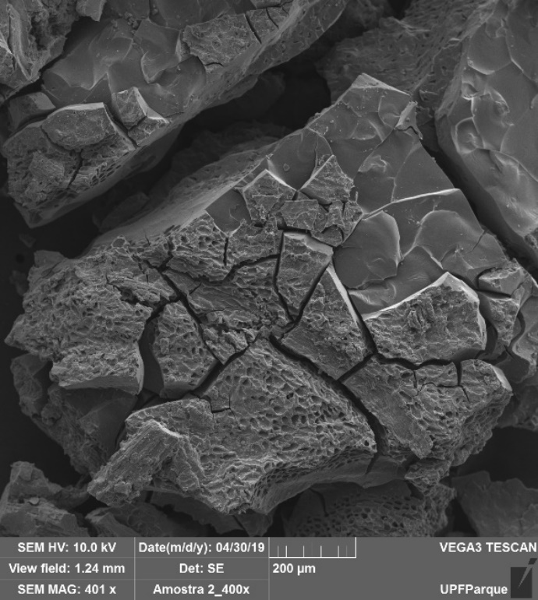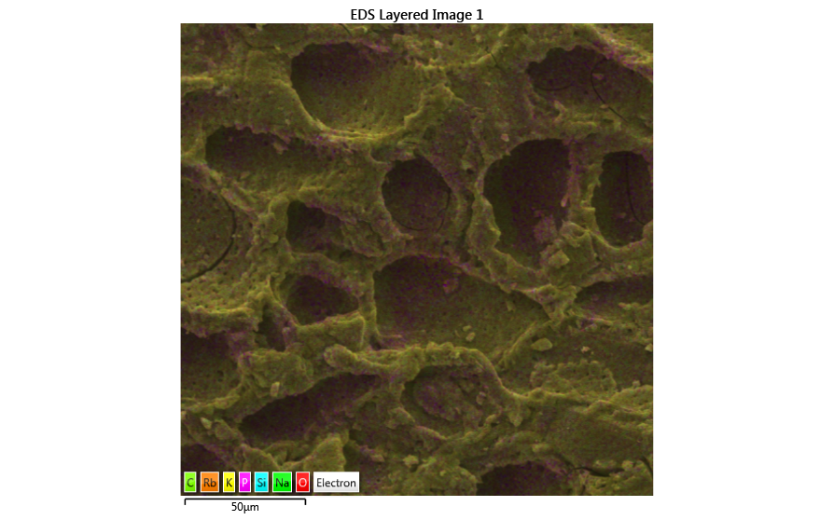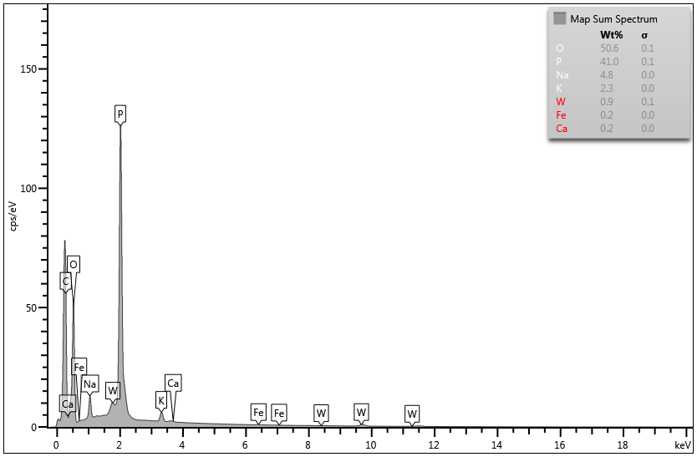
Fig. SM1. Isolated SEM micrographs of ACJC at magnification of 400 times (a), punctual chemical map of ACJC (b) and spectrum of the identified chemical elements (c).

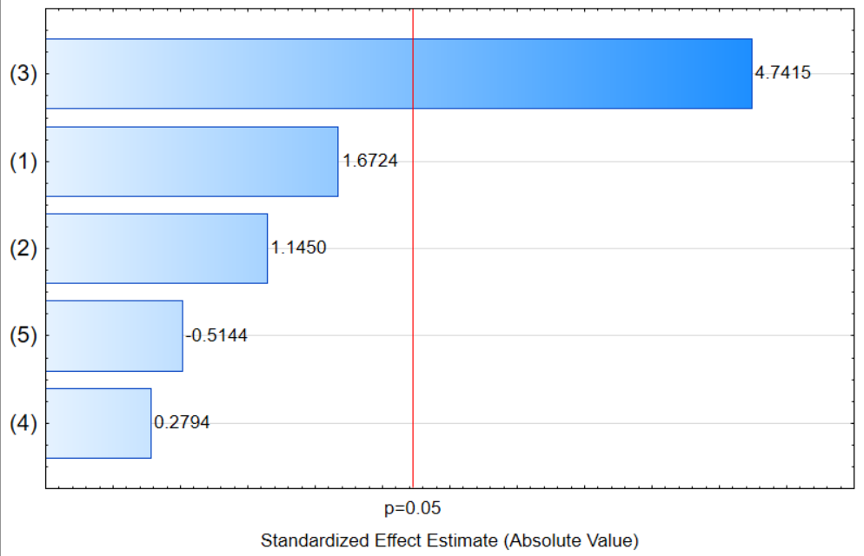
Fig. SM2. Pareto chart for the effects of the variables studied in terms of removal of methylene blue considering 95% confidence (p=0.05) (1) mass, (2) pH, (3) shaking, (4) temperature, (5) concentration.

Table SM3. Equations used to estimate the kinetic and thermodynamic parameters of the sorption of MB on ACJC and the error functions used
Kinetics models | Concentration (mg L⁻¹)
Kinetics models | 51.4 | 77.1 | 103.5
1st zone
k_{id} (mg g⁻¹ min^{-0.5}) | 1.5419 | 2.8544 | 3.1042
C (mg g⁻¹) | 2.0448 | 3.7317 | 6.5468
R² | 0.9659 | 0.9943 | 0.9825
R²_{adj} | 0.9546 | 0.9923 | 0.9766
SSE | 0.2128 | 0.1614 | 0.3071
HYBRID | 1.5136 | 0.4513 | 1.2409
2nd zone
k_{id} (mg g⁻¹ min^{-0.5}) | 0.7790 | 0.6298 | 0.9096
C (mg g⁻¹) | 5.2341 | 11.4235 | 14.1883
R² | 0.9792 | 0.9366 | 0.9504
R²_{adj} | 0.9687 | 0.9049 | 0.9256
SSE | 0.1060 | 0.1538 | 0.1950
HYBRID | 0.2419 | 0.3326 | 0.4129
3rd zone
k_{id} (mg g⁻¹ min^{-0.5}) | 0.0151 | 0.0082 | 0.0414
C (mg g⁻¹) | 10.0633 | 15.2959 | 20.5623
R² | 0.9686 | 0.9668 | 0.9750
R²_{adj} | 0.9528 | 0.9502 | 0.9625
SSE | 0.0058 | 0.0032 | 0.0041
HYBRID | 0.0007 | 0.0001 | 0.0002

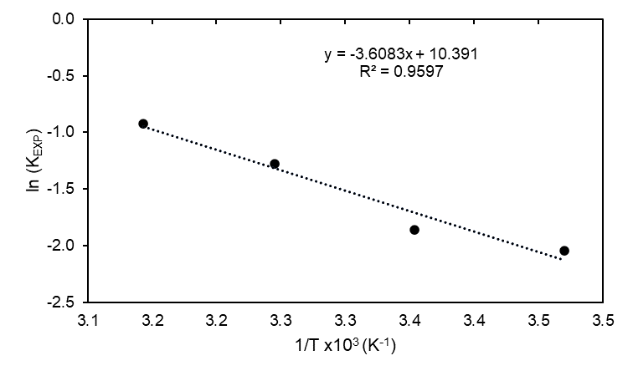
Fig. SM3. Van’t Hoff graph of thermodynamic parameters.

