Novel Benzo[b][1,5] naphthyridine–Arylhydrazone Hybrids as EGFR-Targeted Anticancer Agents: Synthesis, DFT, and MCF-7 Antiproliferative Evaluation
Jay B. Mahetaª, Darshna K. Lakhnotraª, Yogesh O. Bholaª*
ª Department of Chemistry, Shri M.P. Pandya Science College-Lunawada, Mahisagar, Shri Govind Guru University-Godhra, Gujarat, India.
Corresponding author: dryobhola@gmail.com, yogeshbhola90@gmail.com
Supporting Information
Contain
Fig. S1: ¹H NMR spectra of final compound 2
Fig. S2: ¹H NMR spectra of final compound 3a
Fig. S3: ¹H NMR spectra of final compound 3b
Fig. S4: ¹H NMR spectra of final compound 3c
Fig. S5: ¹H NMR spectra of final compound 3d
Fig. S6: ¹H NMR spectra of final compound 3e
Fig. S7: ¹H NMR spectra of final compound 3f
Fig. S8: IR spectra of final compound 2
Fig. S9: IR spectra of final compound 3a
Fig. S19: IR spectra of final compound 3b
Fig. S11: IR spectra of final compound 3c
Fig. S12: IR spectra of final compound 3d
Fig. S13: IR spectra of final compound 3e
Fig. S14: IR spectra of final compound 3f
Fig. S15: ¹³C NMR spectra of final compound 2
Fig. S16: ¹³C NMR spectra of final compound 3a
Fig. S17: ¹³C NMR spectra of final compound 3b
Fig. S18: ¹³C NMR spectra of final compound 3c
Fig. S19: ¹³C NMR spectra of final compound 3d
Fig. S20: ¹³C NMR spectra of final compound 3e
Fig. S21: ¹³C NMR spectra of final compound 3f
Fig. S22: Mass spectra of final compound 2
Fig. S23: Mass spectra of final compound 3a
Fig. S24: Mass spectra of final compound 3b
Fig. S25: Mass spectra of final compound 3c
Fig. S26: Mass spectra of final compound 3d
Fig. S27: Mass spectra of final compound 3e
Fig. S28: Mass spectra of final compound 3f
In Vitro Cytotoxicity Assay Against MCF-7 Cells
Figure S29: In vitro antiproliferative activity of compounds 3a–f against the MCF-7 human breast cancer cell line.
Table S1. Molecular docking results of compounds 3a–f and reference ellipticine against EGFR kinase (PDB: 3EQM).
Figure S30: Three-dimensional (3D) binding poses (left panel) and two-dimensional (2D) ligand interaction diagrams (right panel) of compounds 3a–f docked into the ATP-binding site of EGFR kinase (PDB: 3EQM).

Fig. S1: ¹H NMR spectra of final compound 2
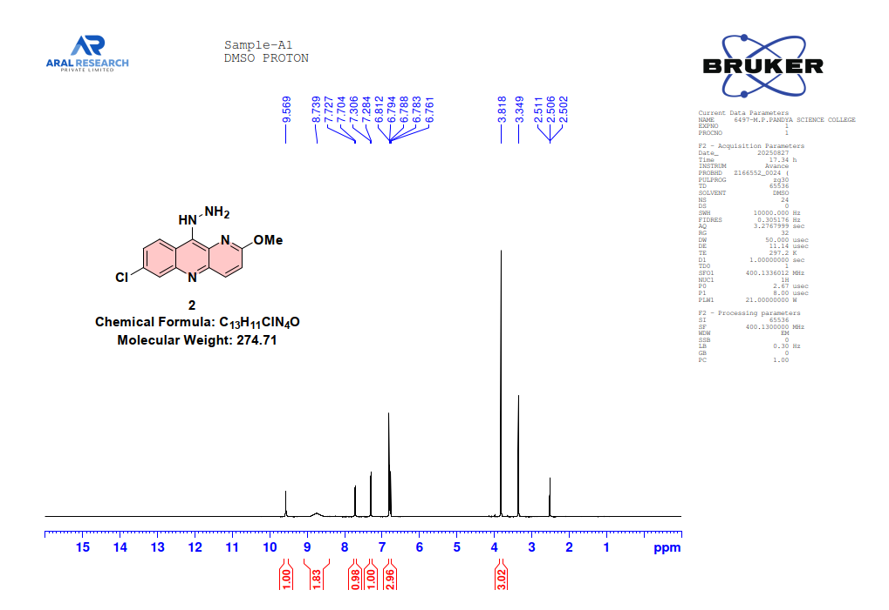
Fig. S2: ¹H NMR spectra of final compound 3a
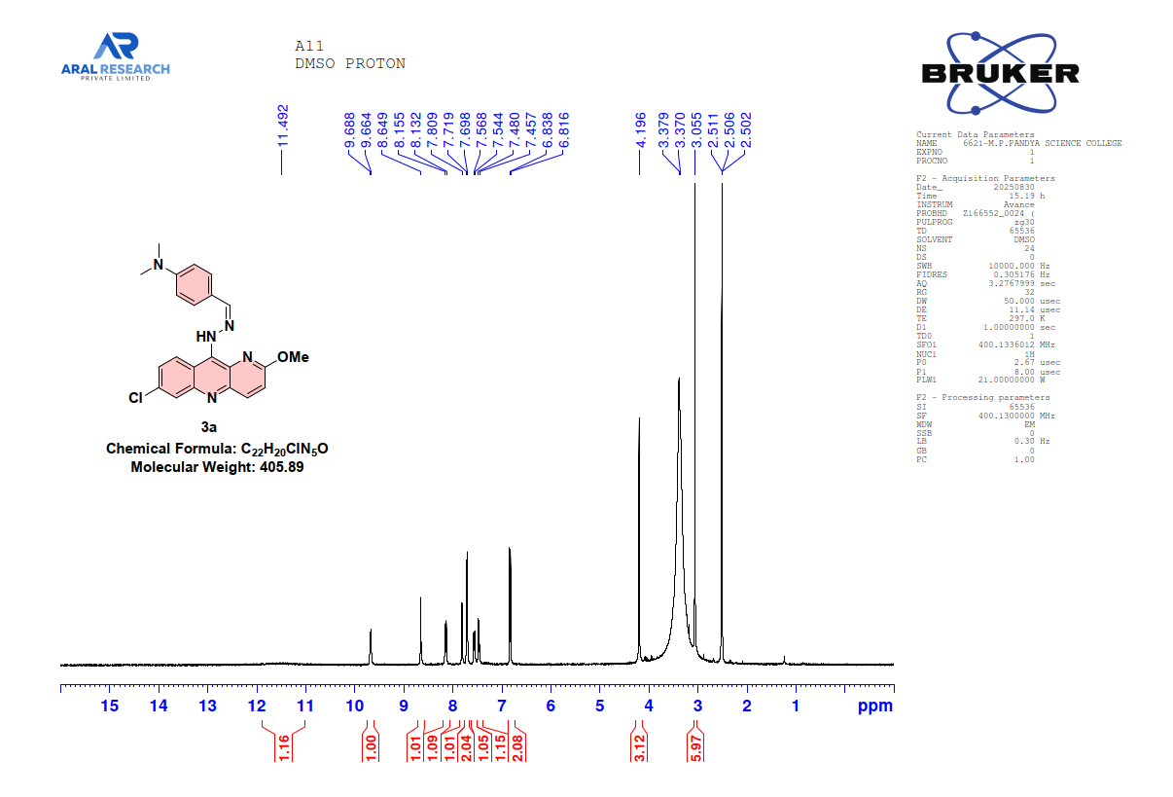
Fig. S3: ¹H NMR spectra of final compound 3b
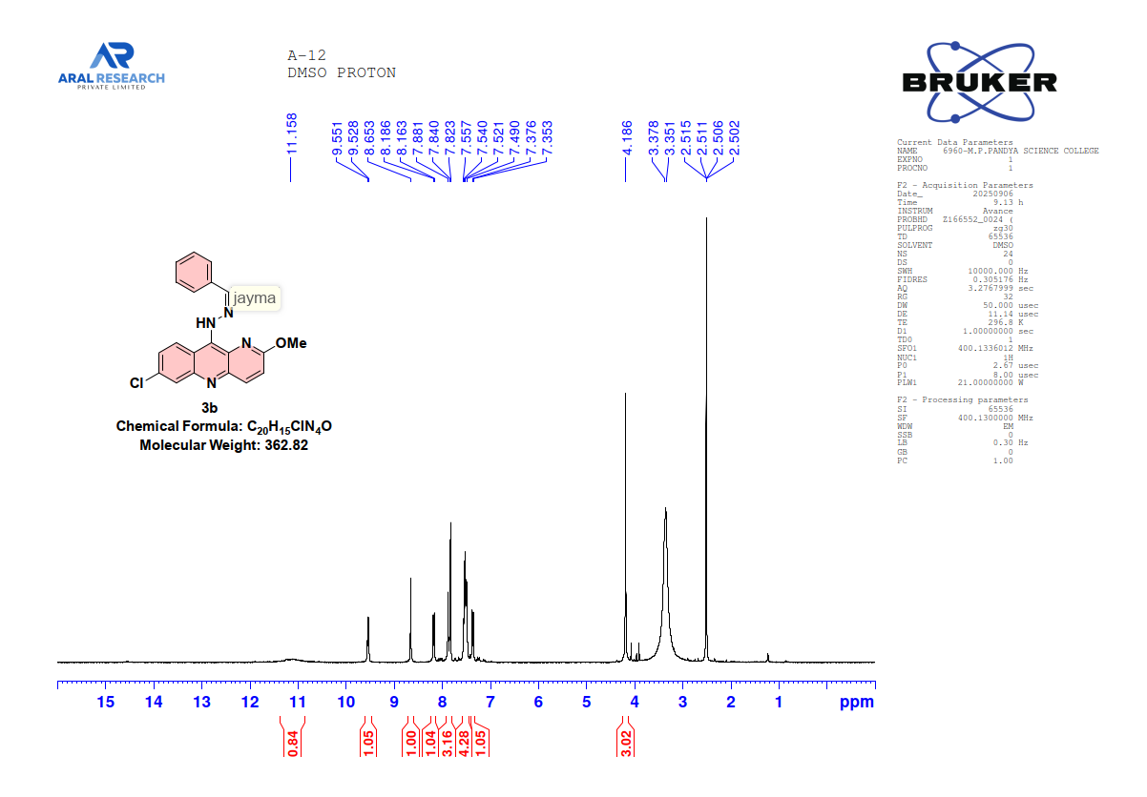
Fig. S4: ¹H NMR spectra of final compound 3c
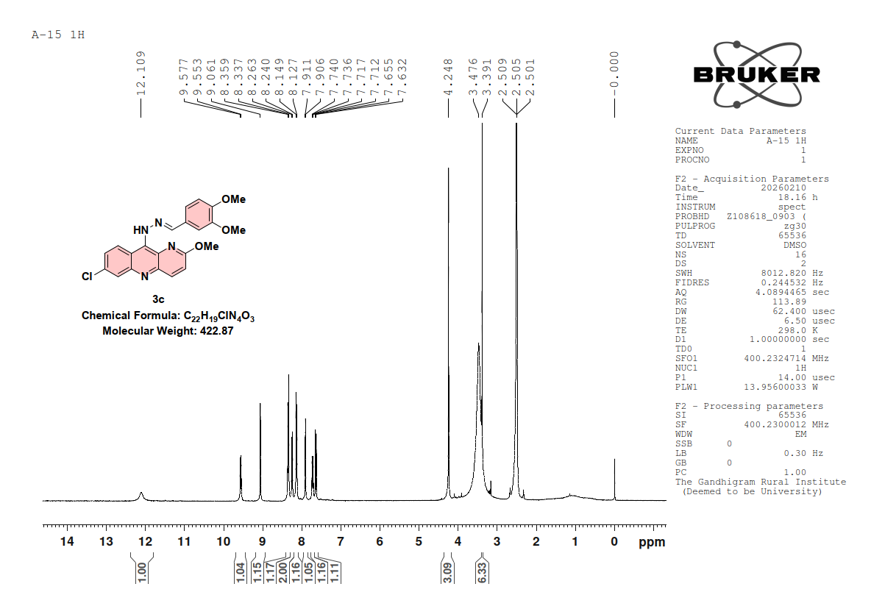
Fig. S5: ¹H NMR spectra of final compound 3d
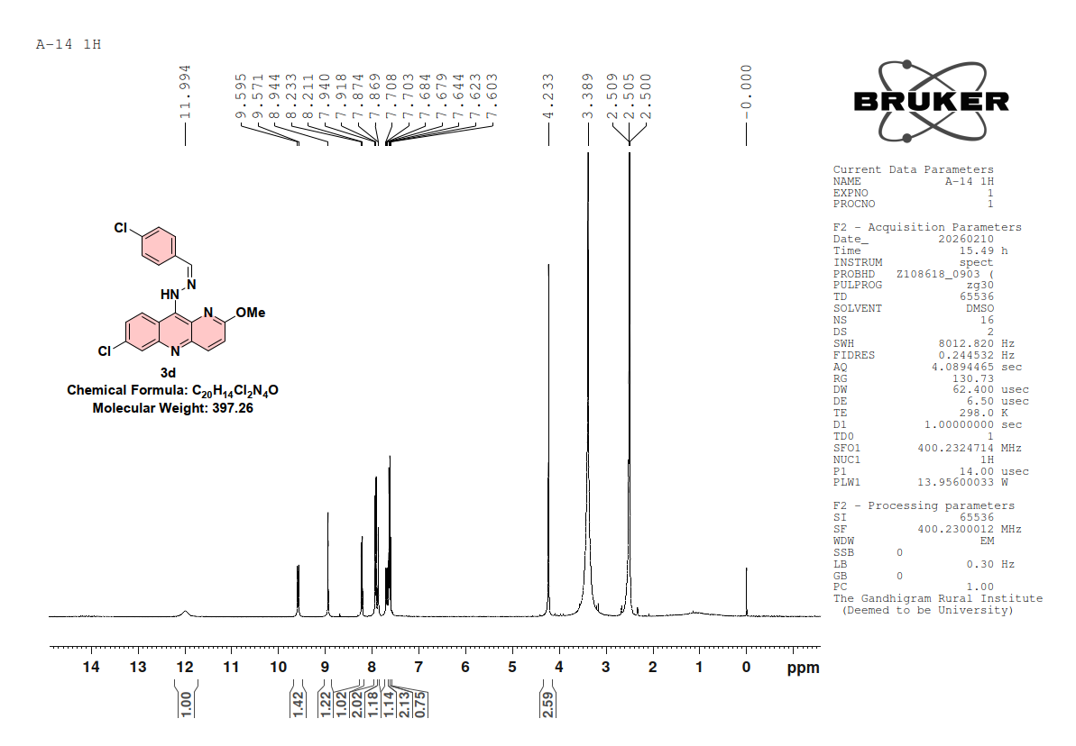
Fig. S6: ¹H NMR spectra of final compound 3e
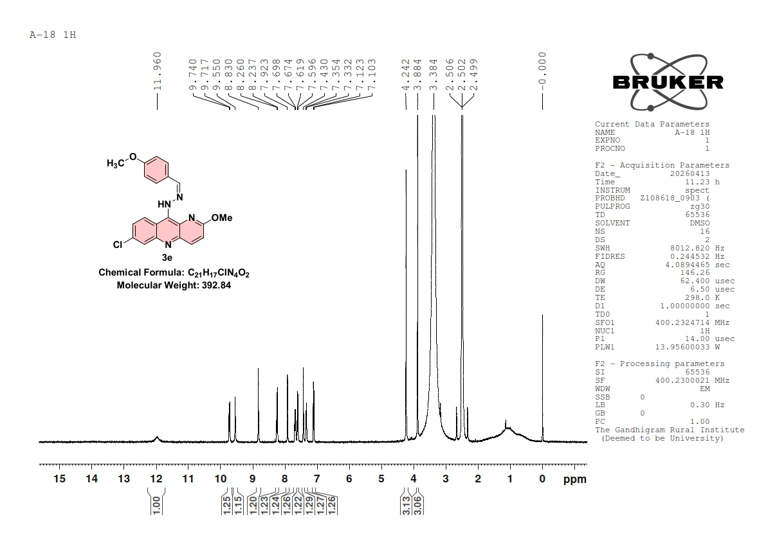
Fig. S7: ¹H NMR spectra of final compound 3f
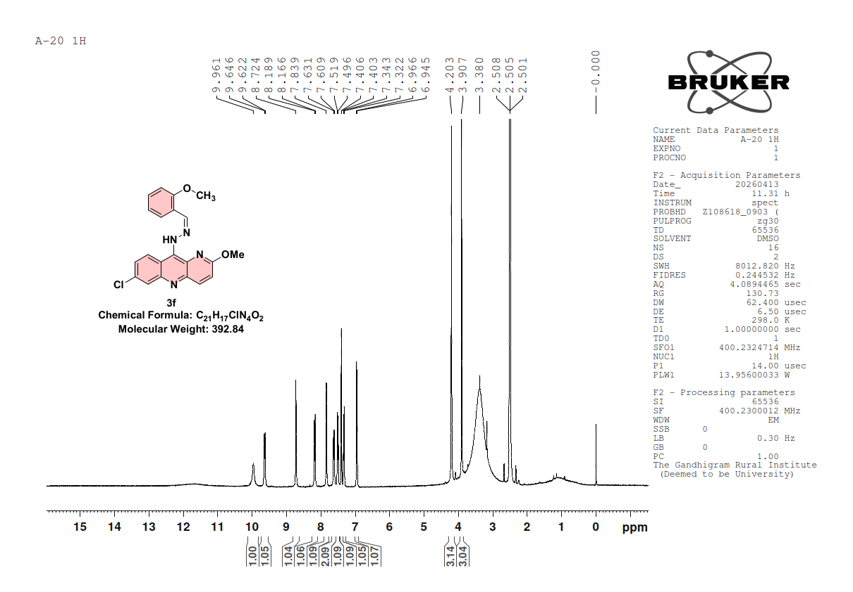
Fig. S8: IR spectra of final compound 2
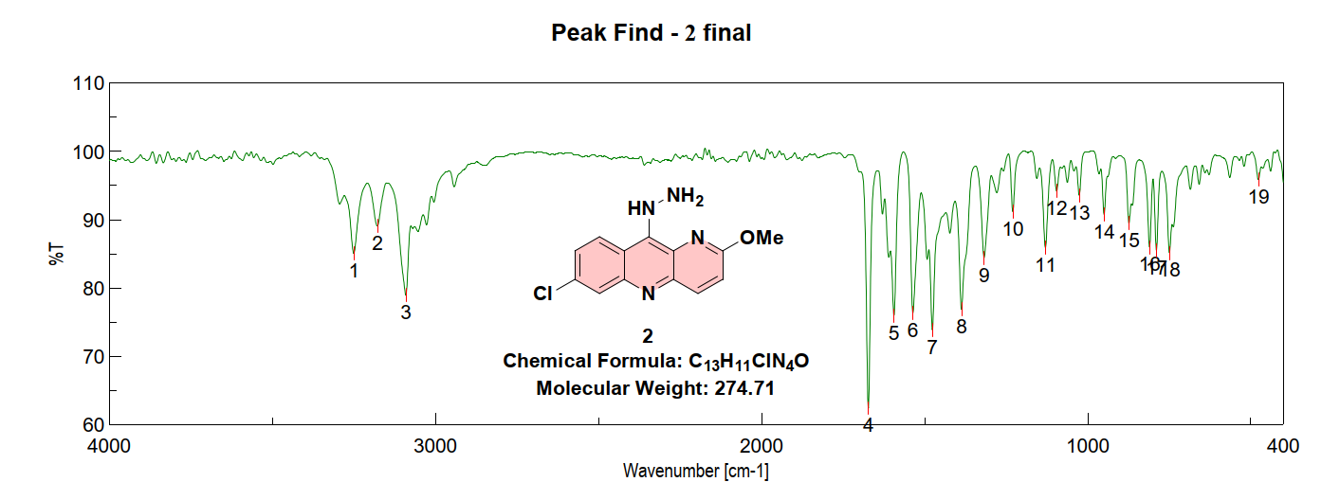

Fig. S9: IR spectra of final compound 3a
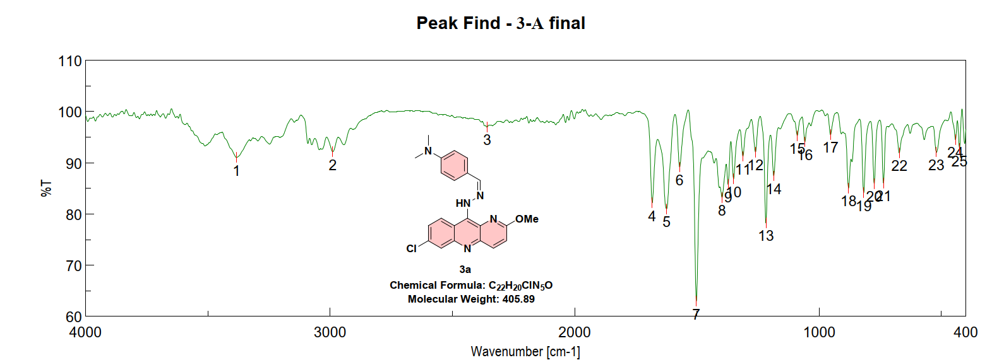
Fig. S10: IR spectra of final compound 3b
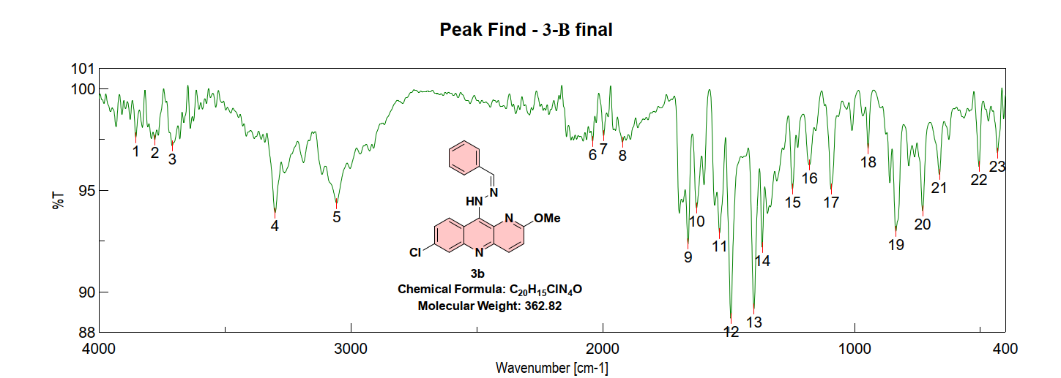
Fig. S11: IR spectra of final compound 3c
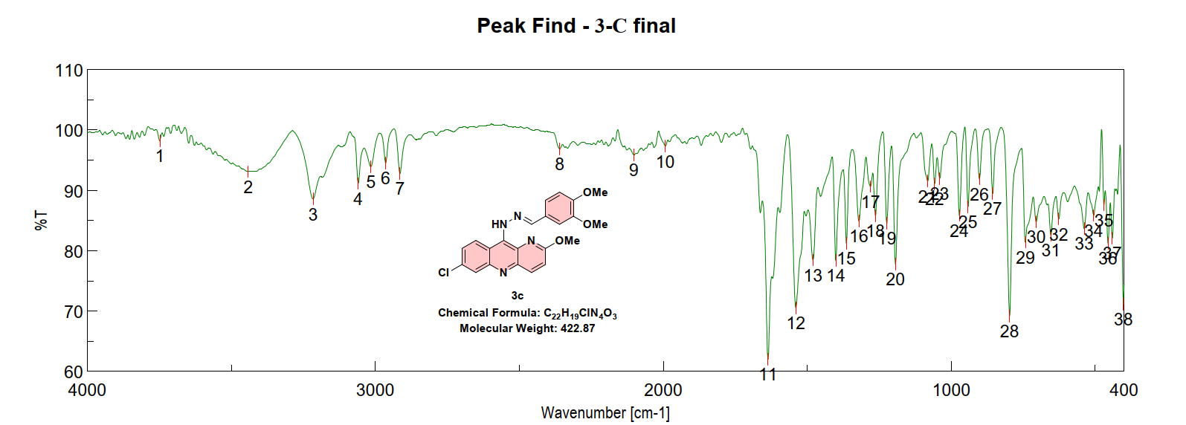

Fig. S12: IR spectra of final compound 3d
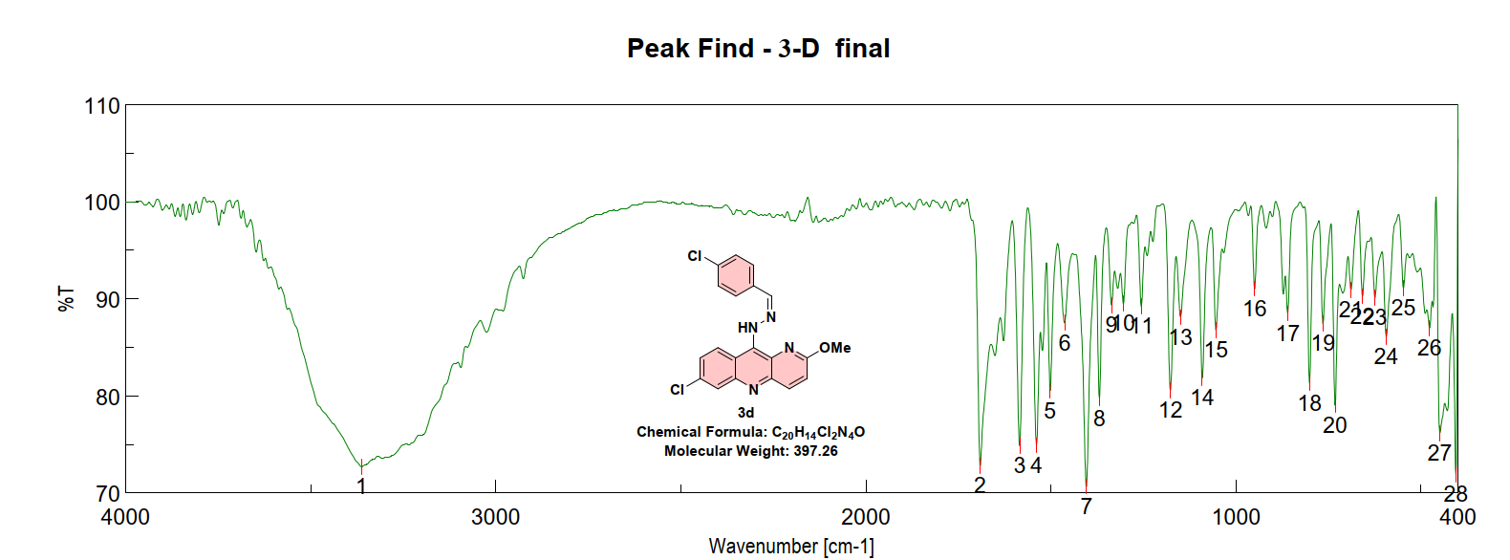
Fig. S13: IR spectra of final compound 3e
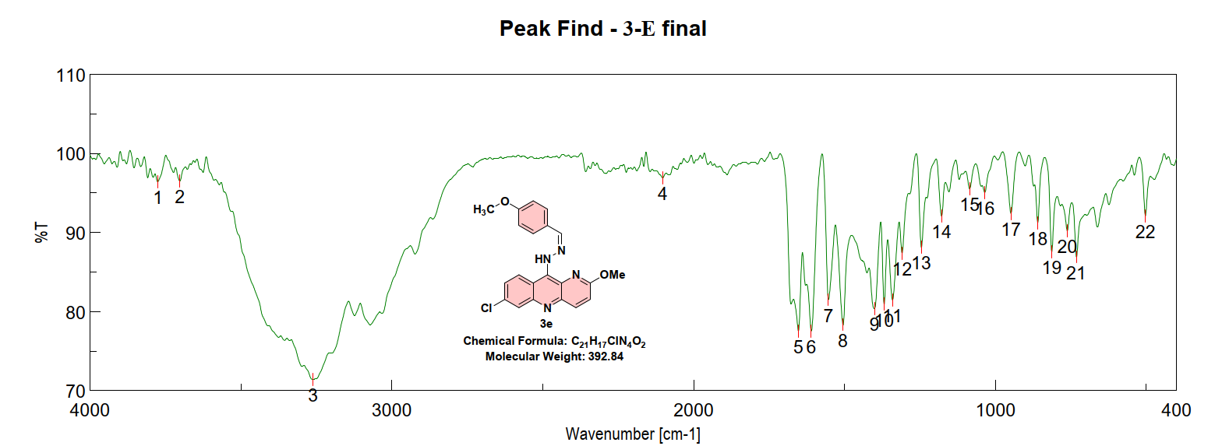
Fig. S14: IR spectra of final compound 3f
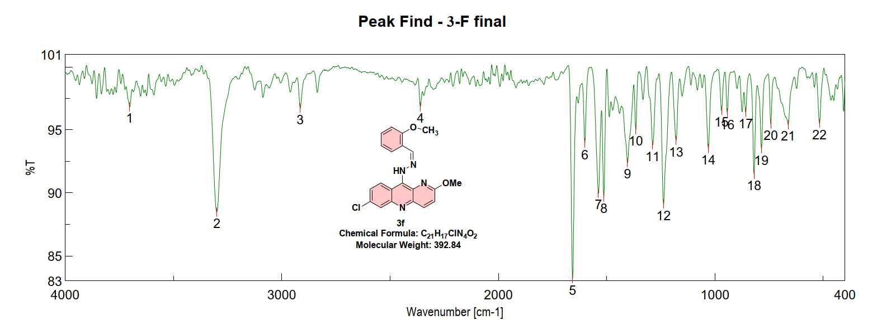

Fig. S15: ¹³C NMR spectra of final compound 2
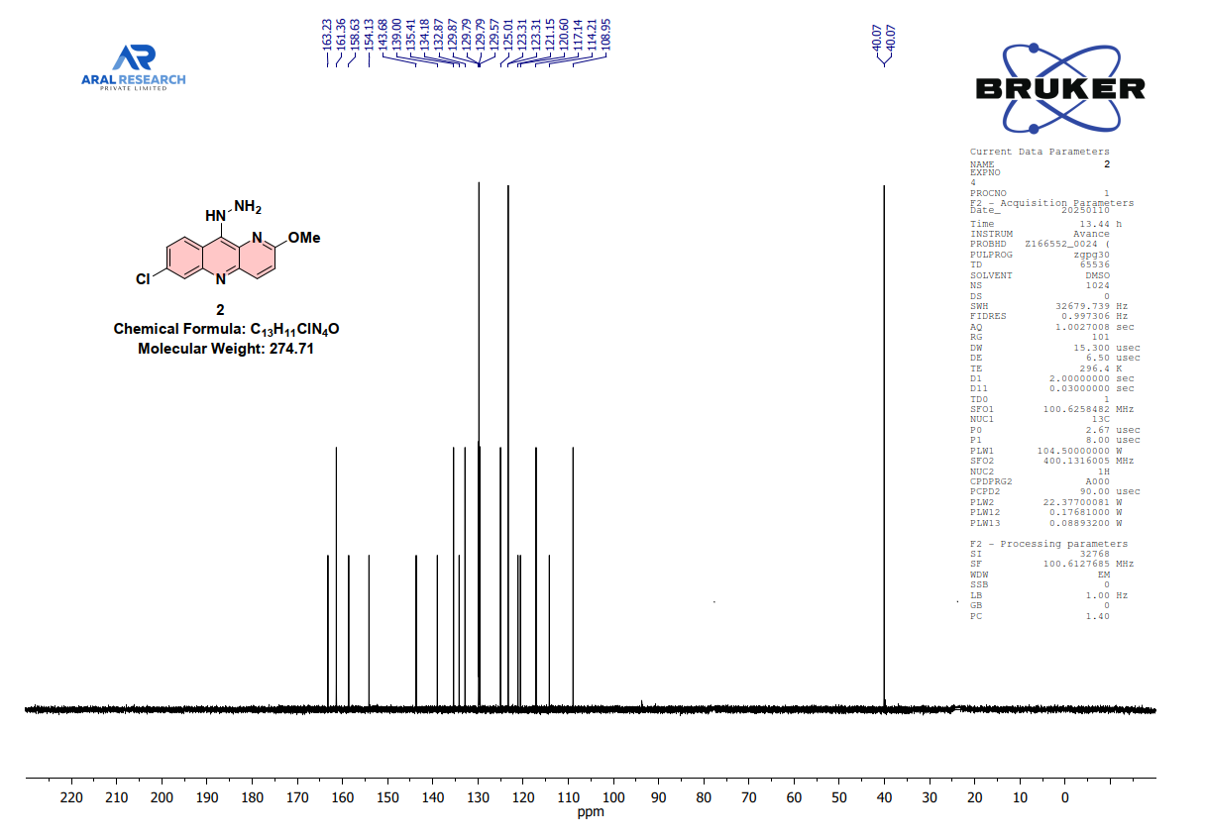
Fig. S16: ¹³C NMR spectra of final compound 3a
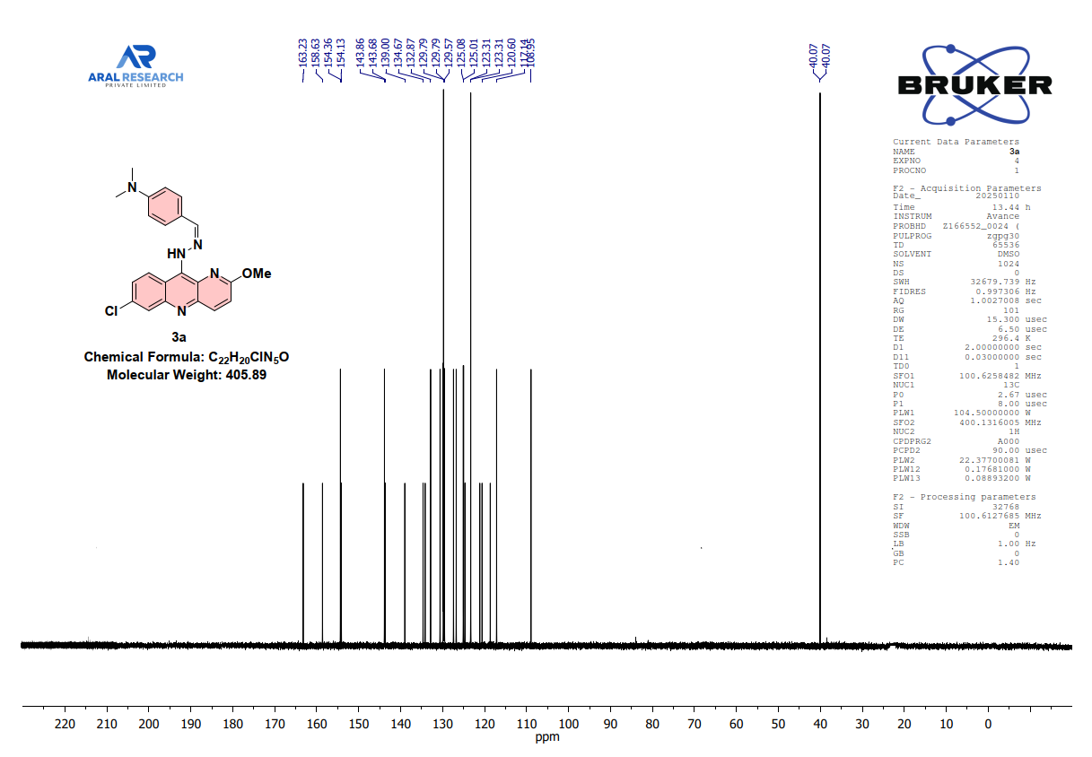
Fig. S17: ¹³C NMR spectra of final compound 3b
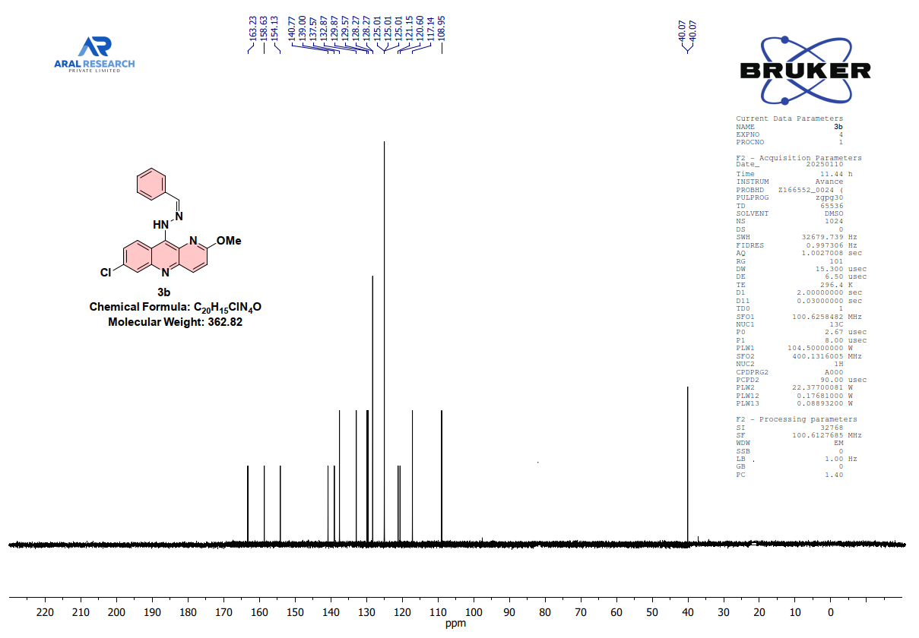
Fig. S18: ¹³C NMR spectra of final compound 3c
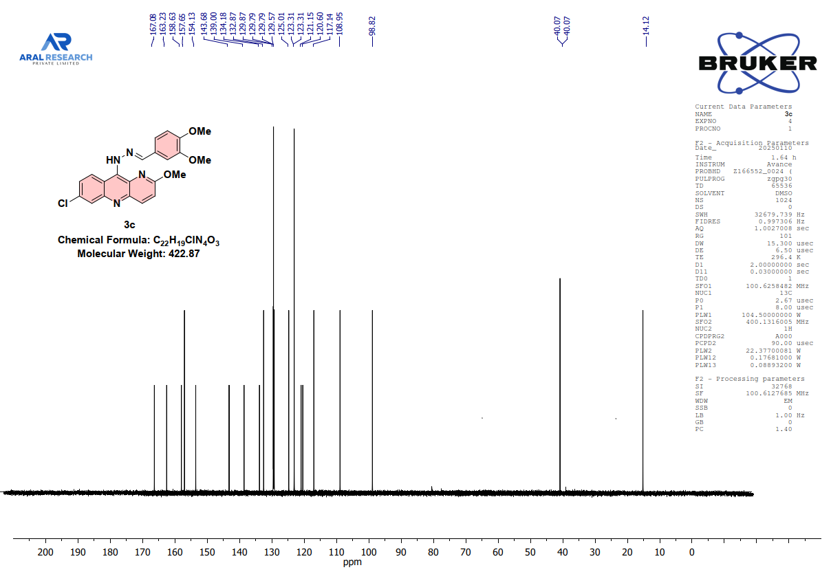
Fig. S19: ¹³C NMR spectra of final compound 3d
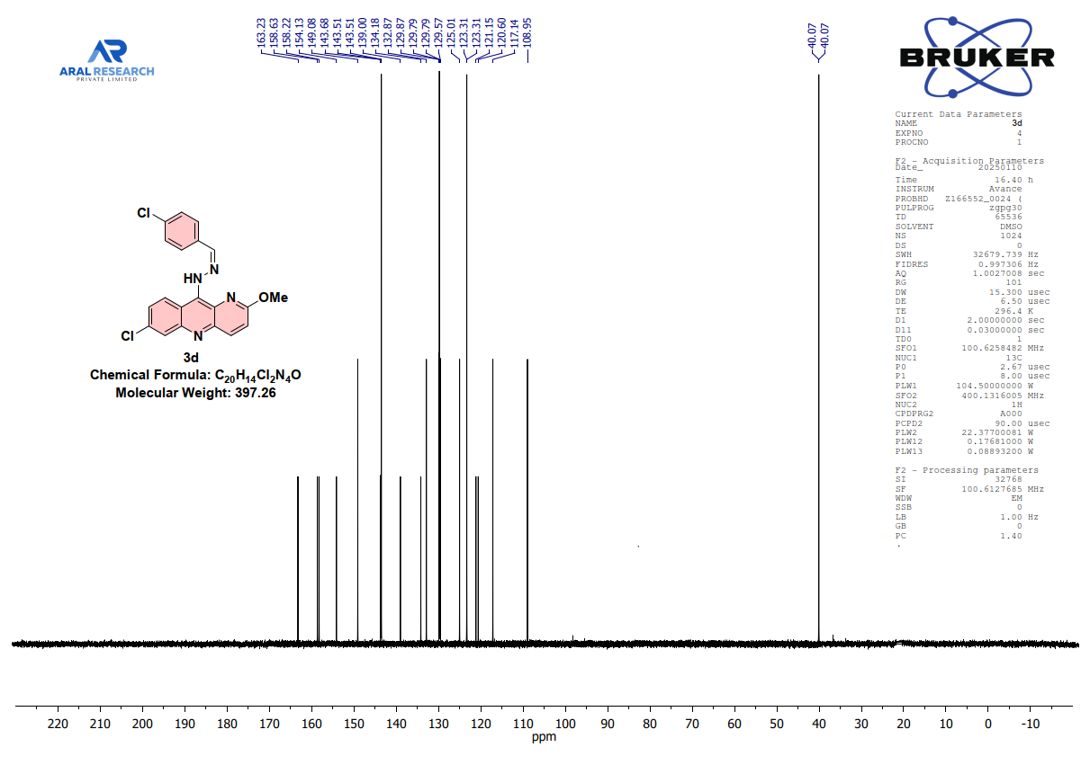
Fig. S20: ¹³C NMR spectra of final compound 3e
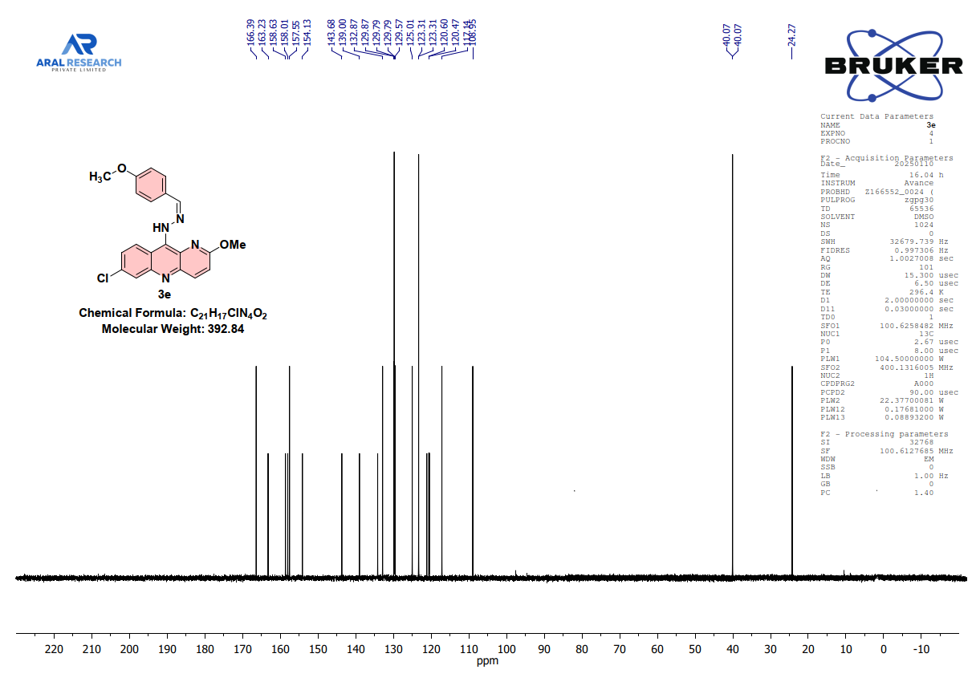
Fig. S21: ¹³C NMR spectra of final compound 3f
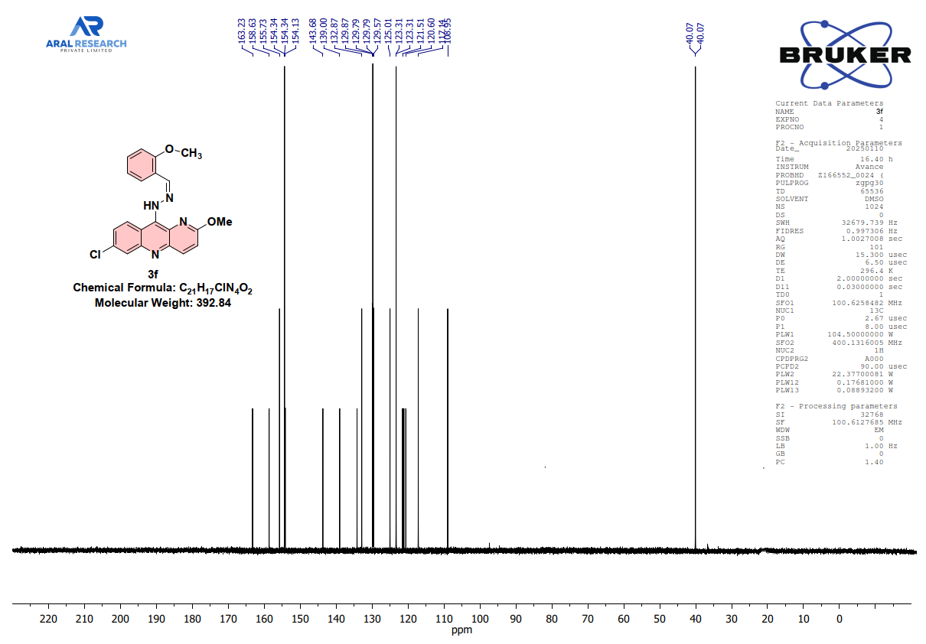

Fig. S22: Mass spectra of final compound 2
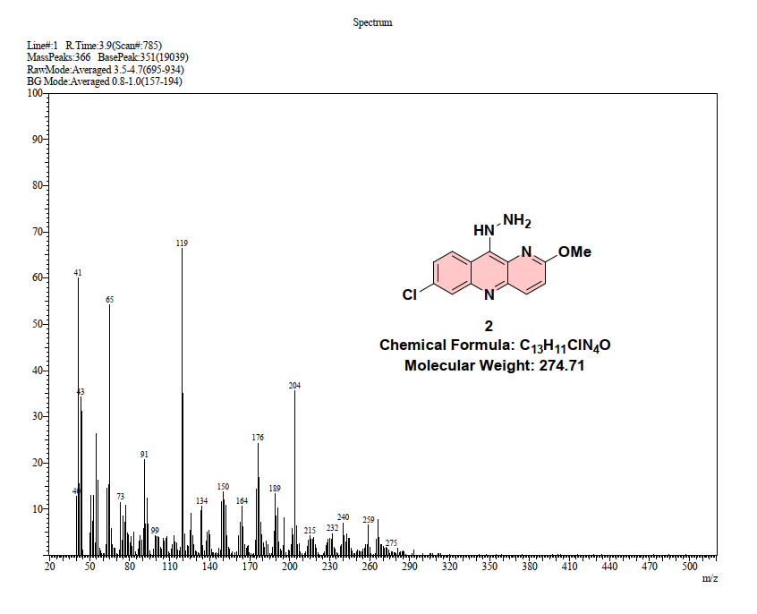
Fig. S23: Mass spectra of final compound 3a
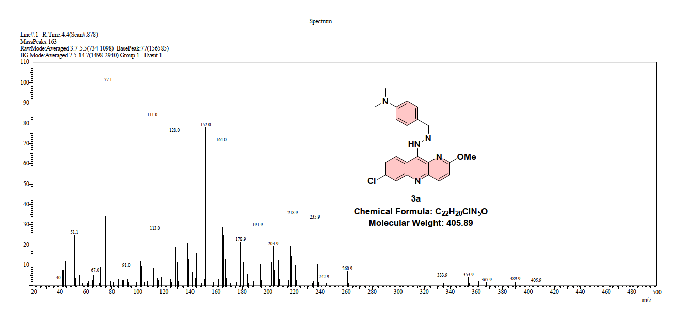

Fig. S24: Mass spectra of final compound 3b
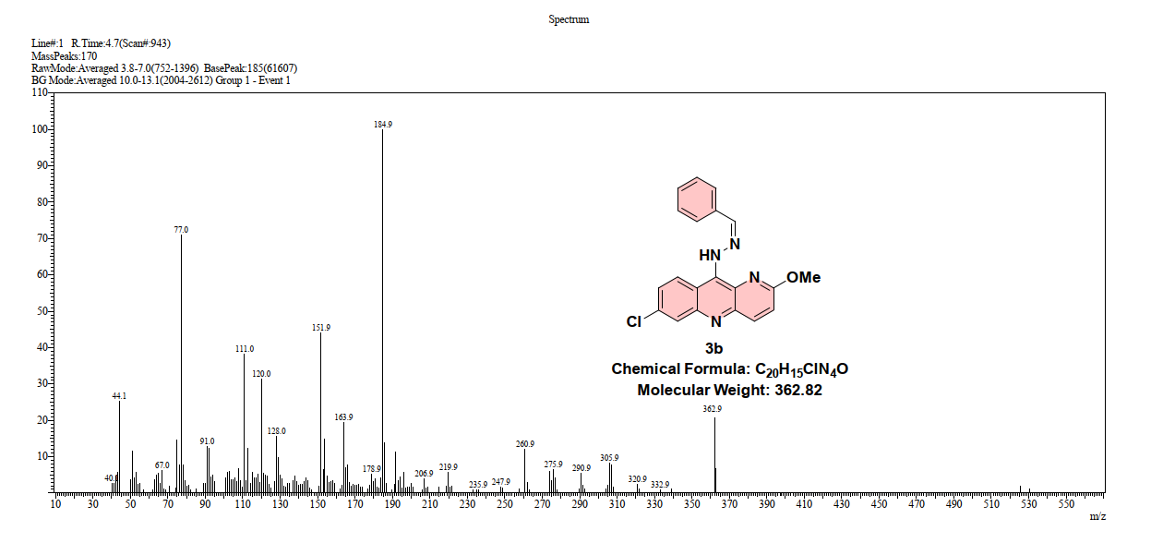
Fig. S25: Mass spectra of final compound 3c
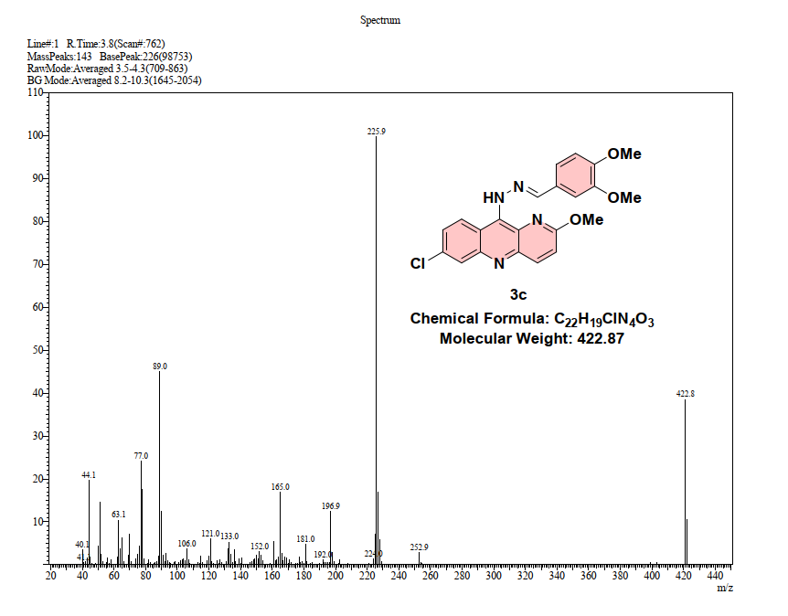

Fig. S26: Mass spectra of final compound 3d
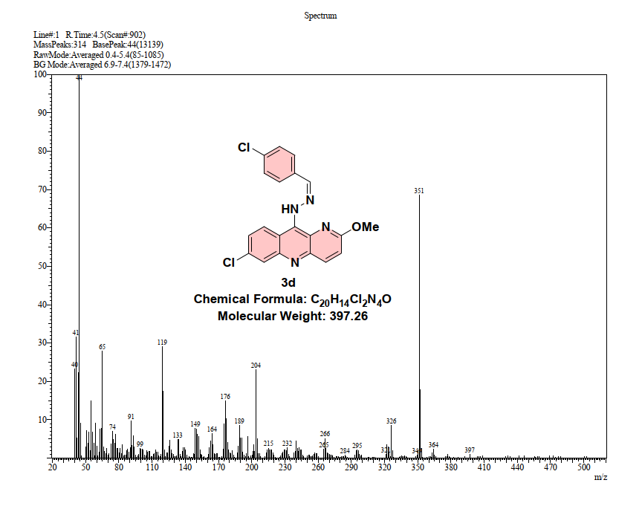
Fig. S27: Mass spectra of final compound 3e
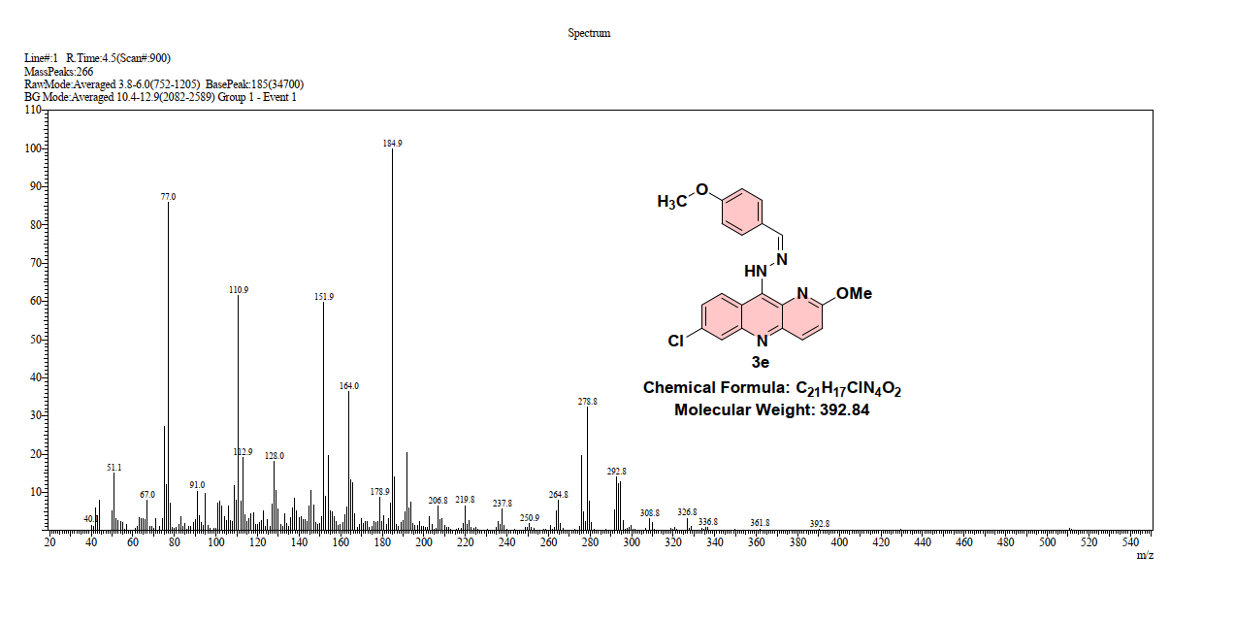

Fig. S28: Mass spectra of final compound 3f
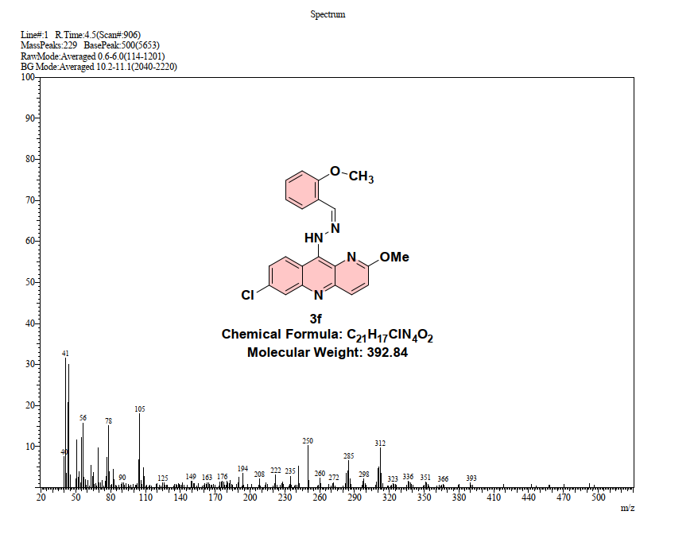

In Vitro Cytotoxicity Assay Against MCF-7 Cells
The cytotoxic activity of the synthesized compounds was evaluated against the human breast cancer cell line MCF-7 using the sulforhodamine B (SRB) colorimetric assay, following the protocol established by the U.S. National Cancer Institute (NCI) with minor modifications. ^{[1,2]} This method determines total cellular protein content as an indirect measurement of cell proliferation and viability.
MCF-7 cells were harvested by trypsinization and counted using a hemocytometer. Cells were seeded into 96-well plates at a density of 1.0 × 10⁴ cells per well (190 μL per well) in complete culture medium supplemented with 5% fetal bovine serum (FBS) and incubated for 8–20 h at 37 °C in a humidified 5% CO₂ atmosphere to allow cell attachment and stabilization prior to treatment.
Test compounds were dissolved in 100% DMSO to prepare stock solutions (20 mM for pure compounds or 20 mg mL⁻¹ for extracts) and subsequently diluted with serum-free culture medium to generate four serial concentrations. A volume of 10 μL of each diluted sample was added to the wells containing adherent cells (final volume 200 μL per well). Wells containing cells treated with 1% DMSO (v/v) served as the negative control, while wells fixed immediately after treatment (time zero) were used as the day-0 reference control to account for cell density at the start of drug exposure.
After 48 h of incubation, cells were fixed in situ by the addition of cold 20% (w/v) trichloroacetic acid (TCA) directly to the medium and incubated at 4 °C for 1 h. Plates were gently washed four times with distilled water and air-dried at room temperature. Fixed cells were stained with 0.4% (w/v) sulforhodamine B (SRB) dissolved in 1% acetic acid for 30 min at 37 °C, followed by three washes with 1% acetic acid to remove unbound dye. After complete drying, the protein-bound dye was solubilized with 200 μL of 10 mM unbuffered Tris base (pH 10.5), and absorbance was measured at 540 nm using a BioTek microplate reader (BioTek Instruments, Winooski, VT, USA).
Cell growth inhibition was calculated according to Equation S1:
$$\%\text{ Inhibition}=\left(\frac{{\text{OD}}_{\text{sample}}-{\text{OD}}_{\text{day-0}}}{{\text{OD}}_{\text{control}}-{\text{OD}}_{\text{day-0}}}\right)×100$$
where OD~sample~ is the absorbance of compound-treated wells, OD~day-0~ is the absorbance of wells fixed at time zero (before drug addition), and OD~control~ is the absorbance of vehicle-treated (1% DMSO) control wells after 48 h. The IC₅₀ value (concentration required to inhibit cell growth by 50%) was determined from the dose–response curve by nonlinear regression analysis using GraphPad Prism 9.0 (GraphPad Software, San Diego, CA, USA). All experiments were performed in triplicate, and results are expressed as mean ± standard deviation (SD).
References:
- Skehan, P., Storeng, R., Scudiero, D., Monks, A., McMahon, J., Vistica, D., Warren, J. T., Bokesch, H., Kenney, S., & Boyd, M. R. (1990). New colorimetric cytotoxicity assay for Anticancer-Drug Screening. JNCI Journal of the National Cancer Institute, 82(13), 1107–1112. https://doi.org/10.1093/jnci/82.13.1107
- Vichai, V., & Kirtikara, K. (2006). Sulforhodamine B colorimetric assay for cytotoxicity screening. Nature Protocols, 1(3), 1112–1116. https://doi.org/10.1038/nprot.2006.179

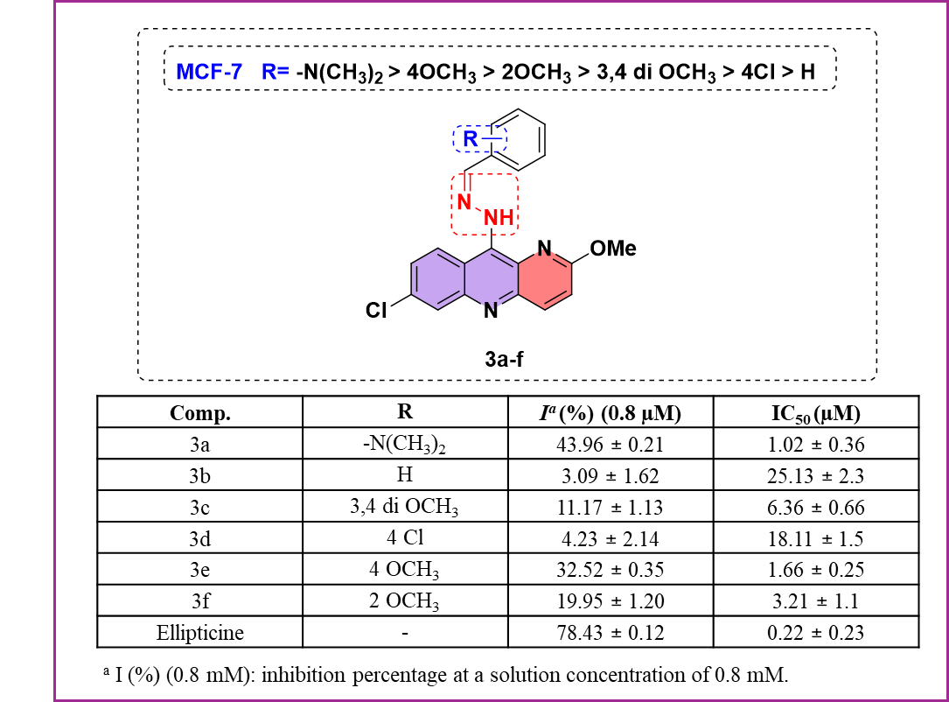
Figure S29: In vitro antiproliferative activity of compounds 3a–f against the MCF-7 human breast cancer cell line.
Table S1. Molecular docking results of compounds 3a–f and reference ellipticine against EGFR kinase (PDB: 3EQM).
Compound | Docking Score (kcal/mol) | Hydrophobic / Polar Interactions | H-bond Interactions | Others (Pi–Pi / Pi–cation / Charged / Polar)
3a | −8.166 | TRP 224, PHE 221, PHE 430, MET 364, LEU 477, VAL 370, LEU 372, MET 303 | — | Pi–Pi: PHE 221, TRP 224; Pi–cation: —; ARG 115 (charged+); GLU 302, ASP 309 (charged−); THR 310, SER 478 (polar)
3b | −7.875 | PHE 430, MET 311, MET 446, MET 447, MET 364, ALA 306, ALA 307, ALA 443, VAL 369, VAL 370 | ARG 115 (sidechain) with OMe-O | Pi–Pi: PHE 430; Salt bridge: ARG 115; THR 310, SER 314 (polar); ILE 132, GLY 439, CYS 437, LEU 152
3c | −6.733 | PHE 430, PHE 134, LEU 372, VAL 370, VAL 373, MET 374, LEU 477, TRP 224, ILE 133 | — | Pi–cation: ARG 115; ARG 115 (charged+); THR 310 (polar); MET 364, MET 311, ALA 306, GLY 431, GLY 439, PRO 429
3d | −5.698 | PHE 430, MET 311, MET 446, MET 447, ALA 306, ALA 307, ALA 443, VAL 369, VAL 370, MET 303 | ARG 115 (sidechain) with OMe-O | Pi–Pi: PHE 430; Salt bridge: ARG 115; THR 310, SER 314 (polar); ILE 132, ILE 133, GLY 439, CYS 437, LEU 152
3e | −7.888 | PHE 430, MET 311, MET 447, MET 446, MET 364, ALA 306, ALA 307, ALA 443, VAL 369, VAL 370, PRO 429 | THR 310 (sidechain) with hydrazone N–H | Pi–Pi: PHE 430; ARG 115 (charged+); THR 310, SER 314, SER 199 (polar); ILE 133, GLY 439, CYS 437, LEU 152, MET 160, MET 303
3f | −6.575 | PHE 430, MET 311, MET 446, MET 447, MET 364, ALA 306, ALA 307, ALA 443, VAL 369, VAL 370 | — | Pi–Pi: PHE 430; ARG 115 (charged+); THR 310, SER 314 (polar); ILE 132, ILE 133, GLY 439, CYS 437, ALA 438, LEU 152, MET 303
Ellipticine | −6.698 | PHE 430, VAL 370, MET 447, MET 446, MET 311, MET 364, ALA 306, ALA 307, ALA 443, ILE 442, LEU 152 | — | THR 310 (polar); ILE 132, ILE 133, GLY 439, CYS 437, ALA 438, PHE 148, MET 303
Pi–Pi: pi–pi stacking interaction; Pi–cat: pi–cation interaction; H-bond: hydrogen bond. Hydrophobic residues (green), polar residues (cyan), charged positive (blue), charged negative (orange).

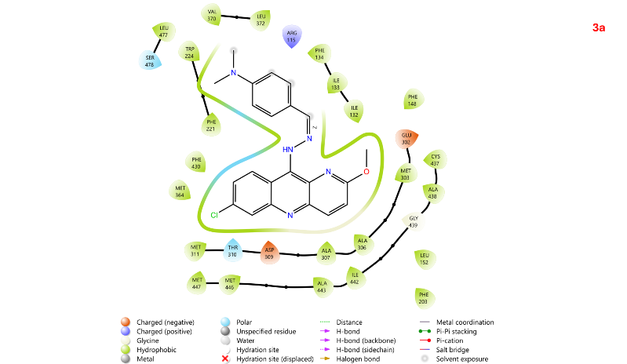 | 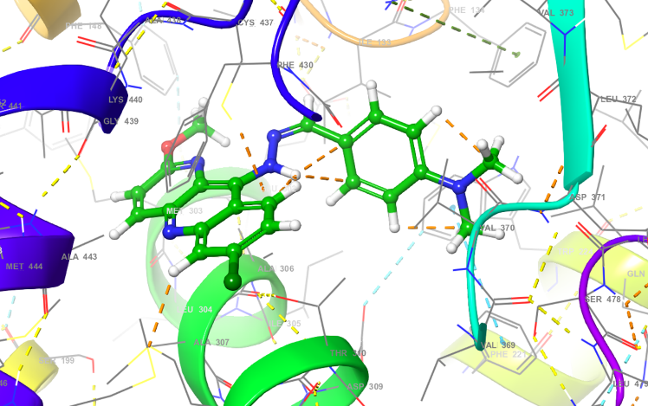
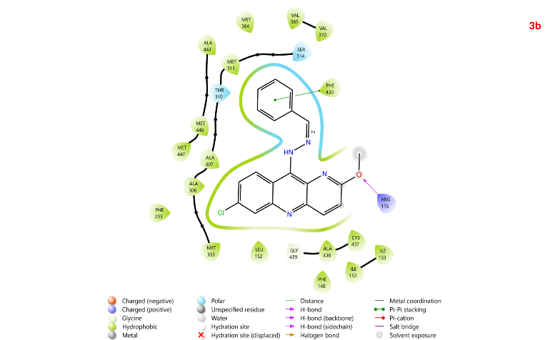 | 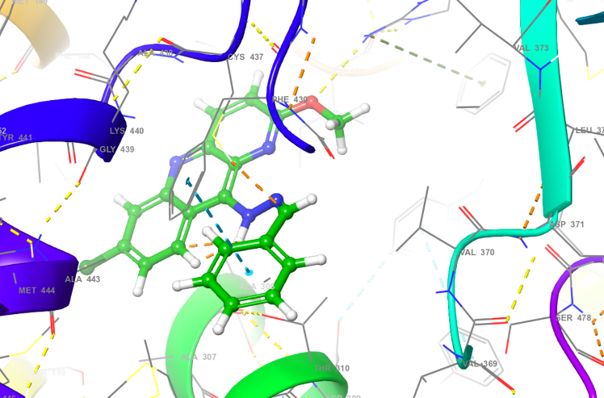
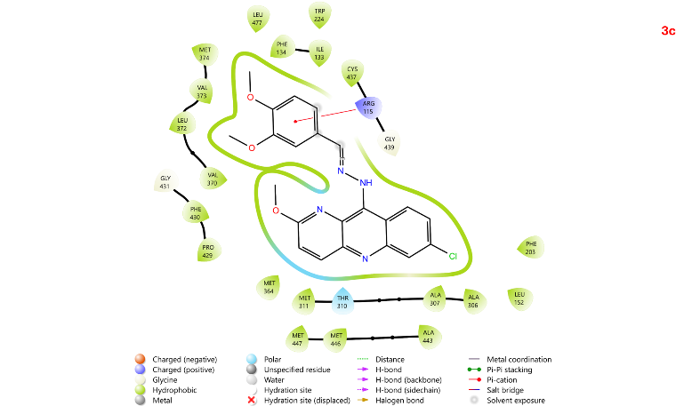 | 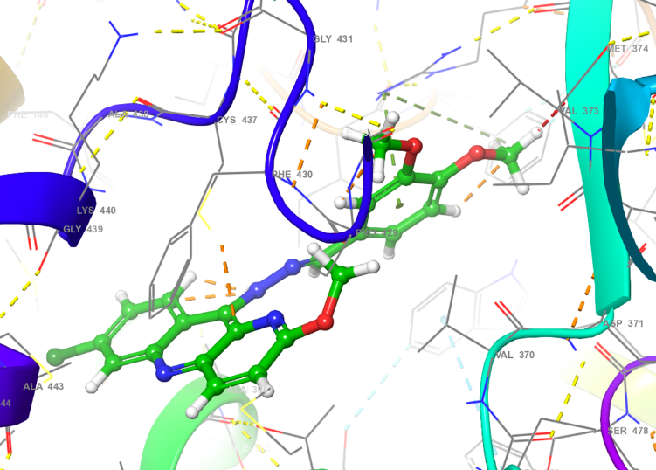
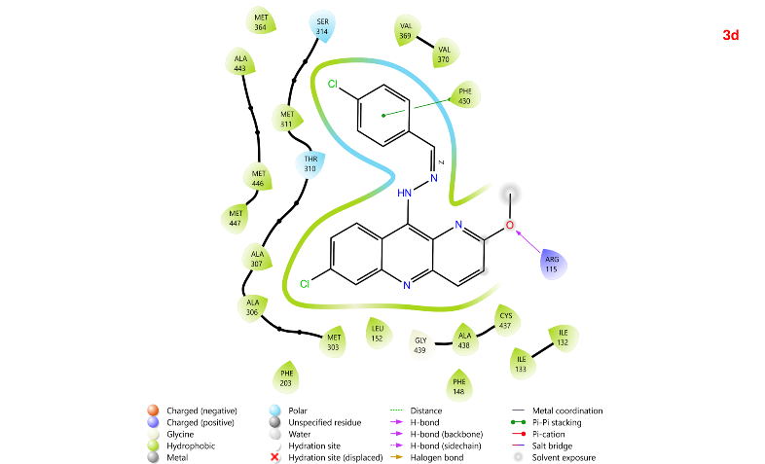 | 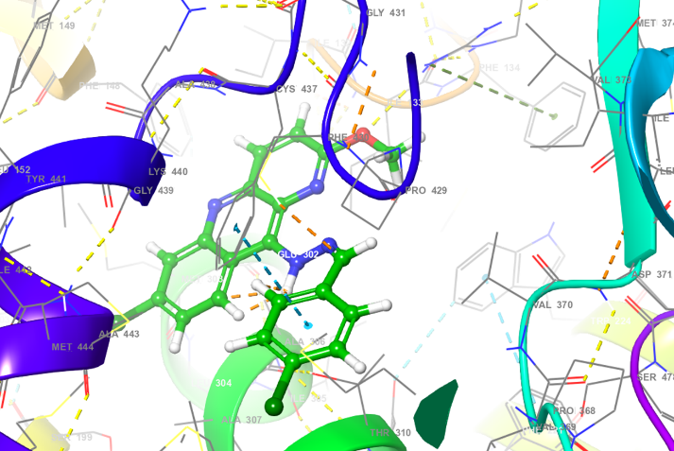
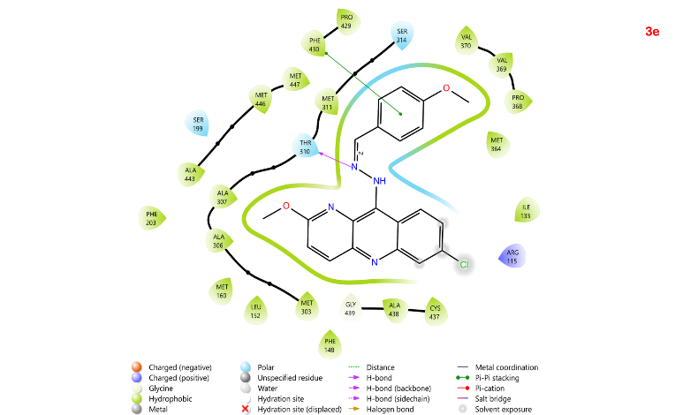 | 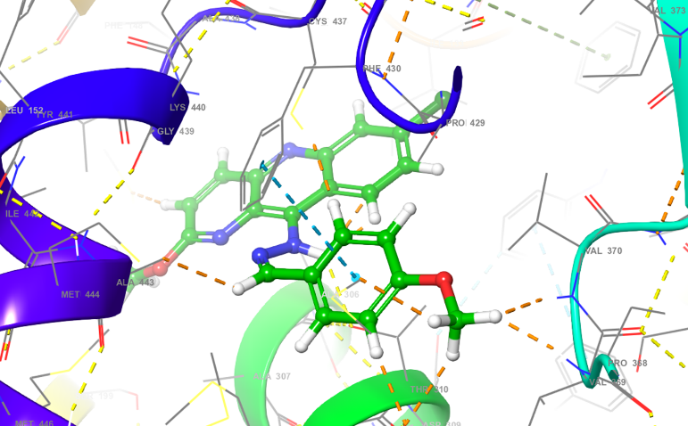
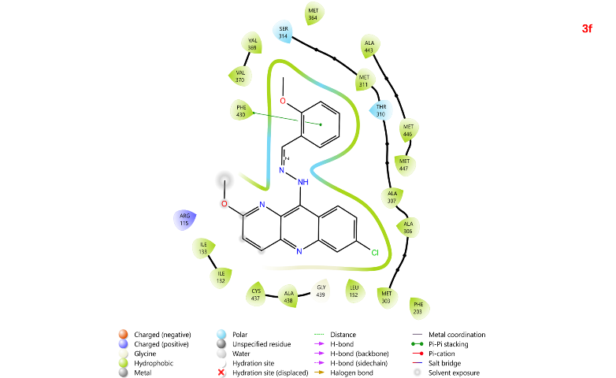 | 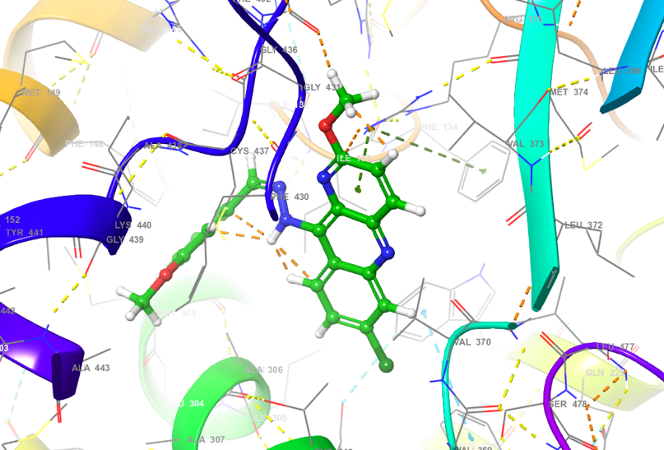
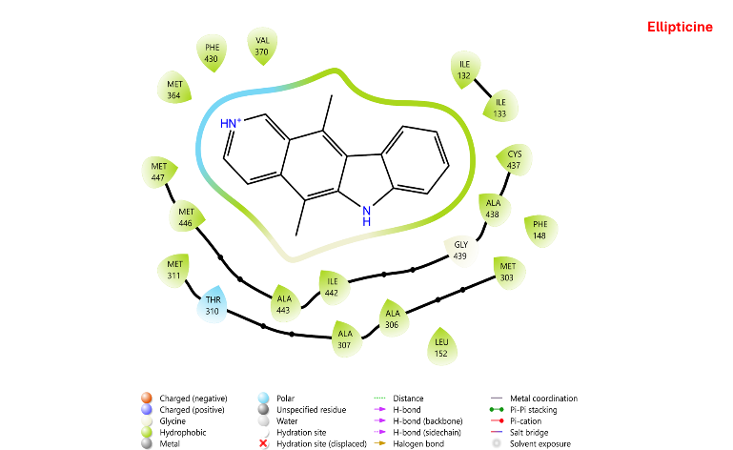 | 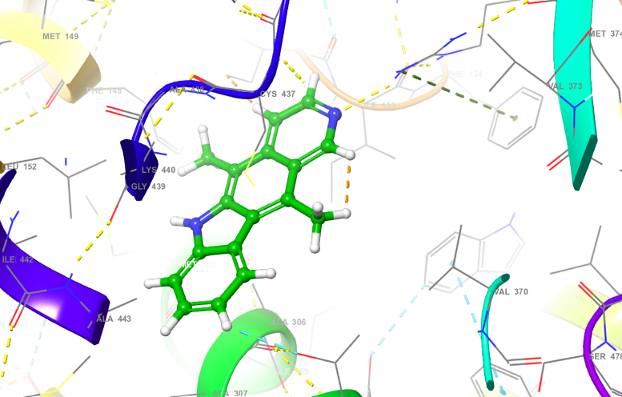
Figure S30: Three-dimensional (3D) binding poses (left panel) and two-dimensional (2D) ligand interaction diagrams (right panel) of compounds 3a–f docked into the ATP-binding site of EGFR kinase (PDB: 3EQM).

