Supplementary Materials
Prokaryotic communities in particle-associated and free-living environments in Osaka Bay are possibly mediated by the microalga, Heterosigma akashiwo
Shuhe Chen¹ Yoshinari Imaura¹, Keigo Yamamoto², Ryoma Kamikawa¹, Takashi Yoshida¹*
¹Graduate School of Agriculture, Kyoto University, Kyoto, Japan
²Research Institute of Environment, Agriculture and Fisheries, Osaka Prefecture, Osaka, Japan
*Corresponding author: yoshida.takashi.7a@kyoto-u.ac.jp

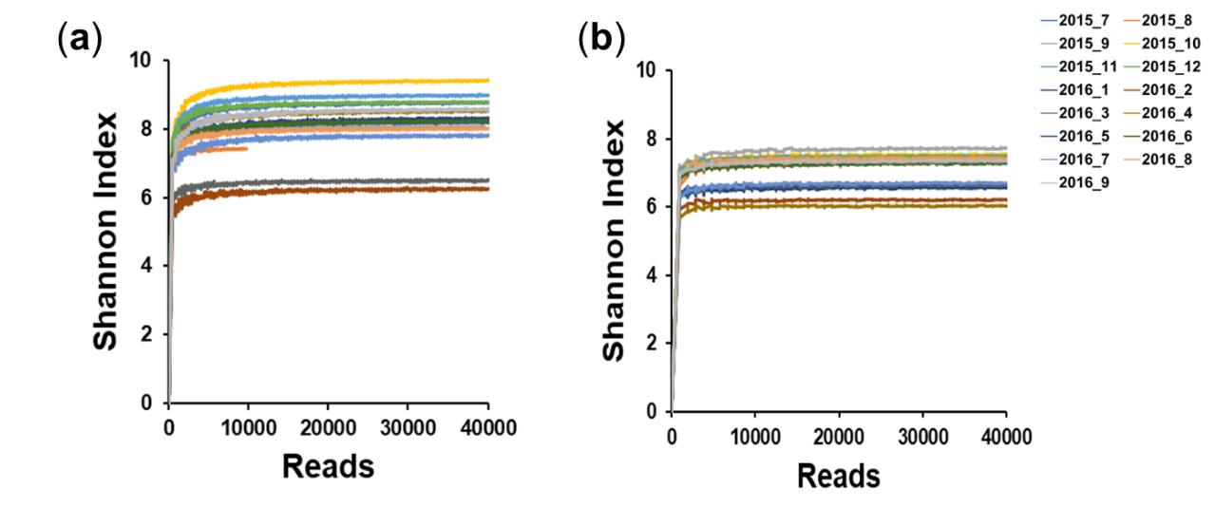
Fig. S1. Rarefaction curve of 16S amplicon
(a): particle-associated fraction; (b): free-living fraction.
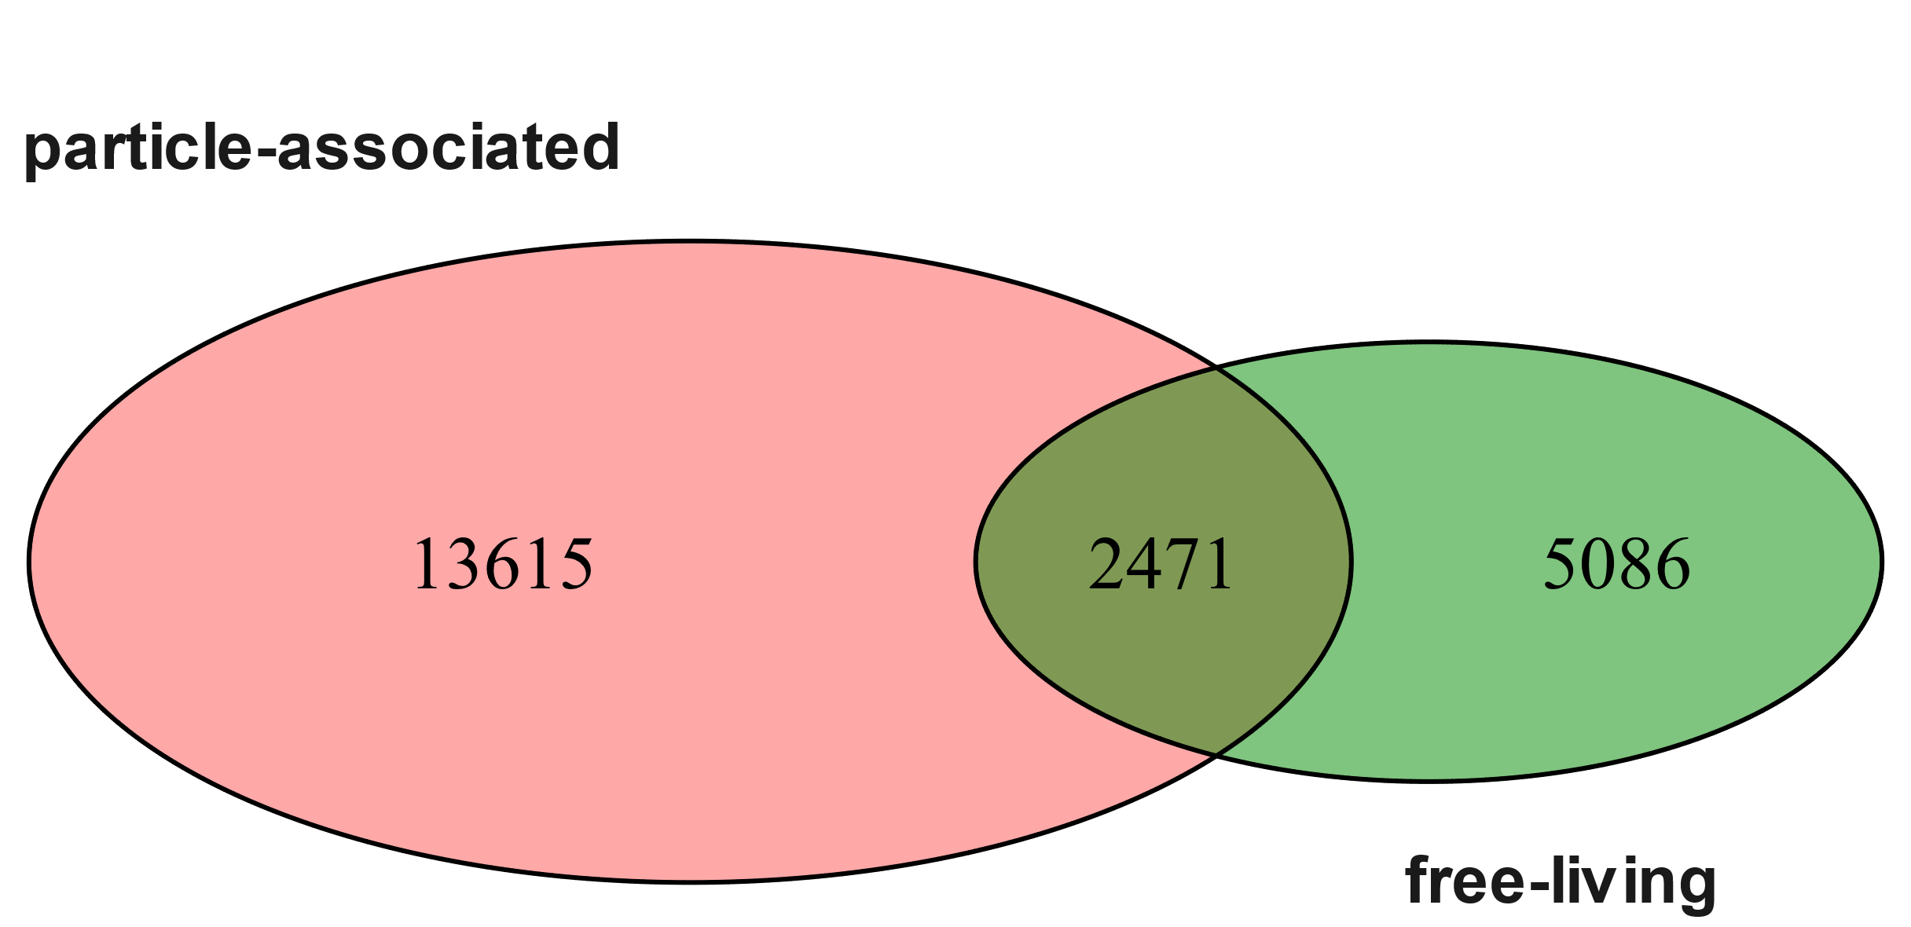
Fig. S2. Venn diagram based on ASVs

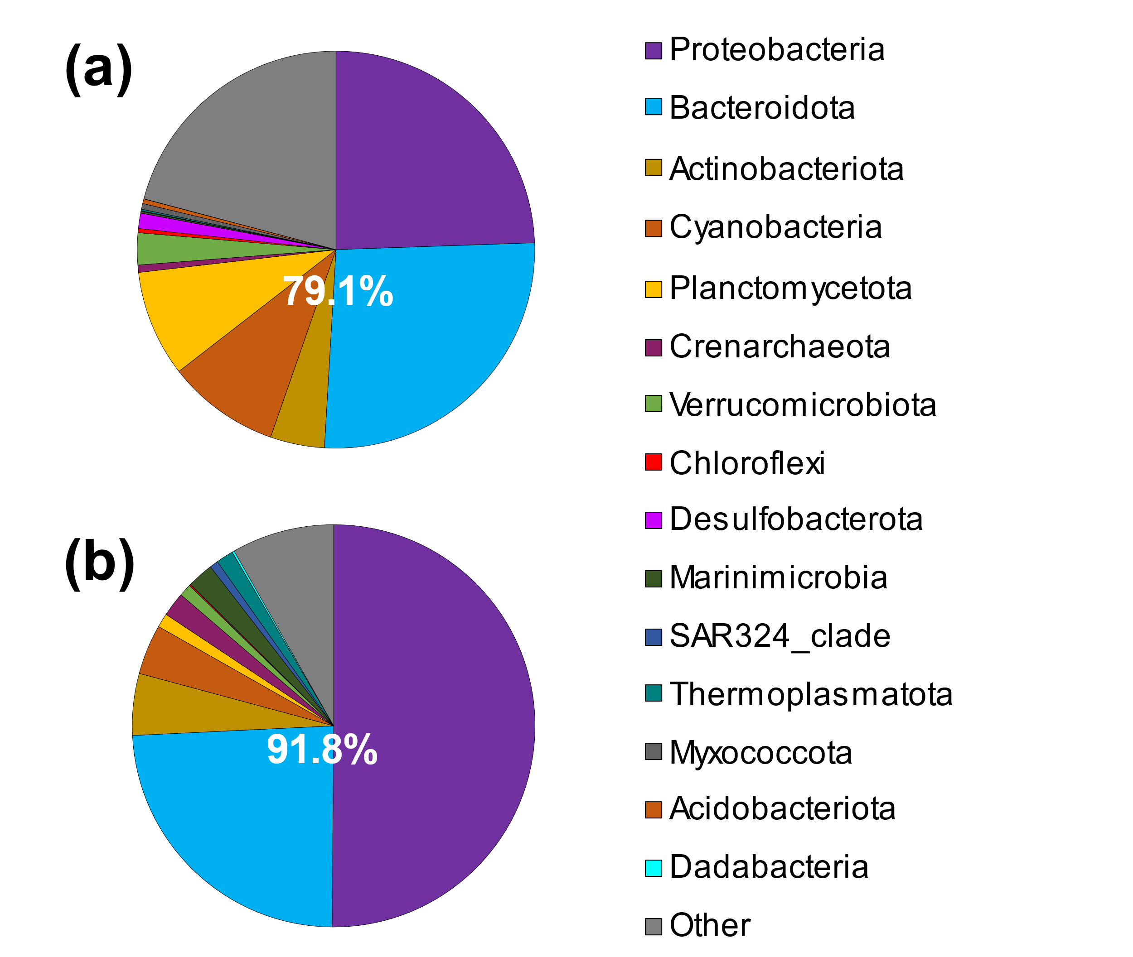
Fig. S3. Main ASVs in phylum (relative content is over 0.1 %)
(a): particle-associated; (b): free-living
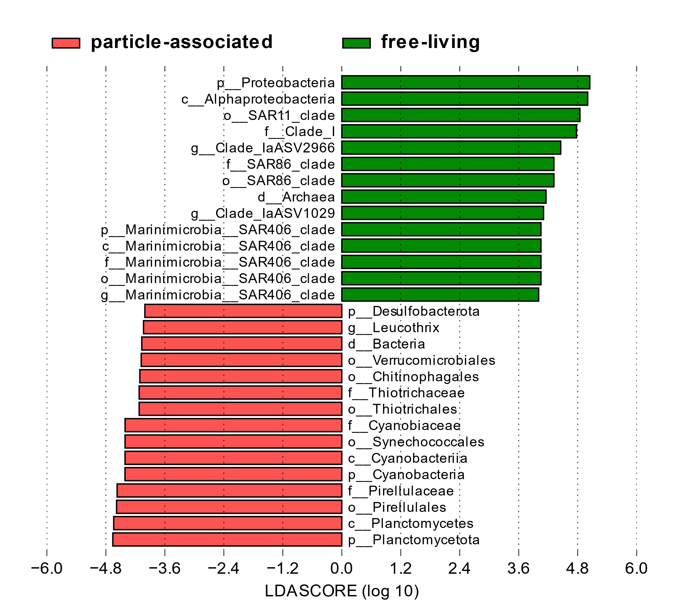
Fig. S4. LDA Score Distribution Histogram based on LEfSe (Linear discriminant analysis effect size) result

Fig. S5. Heat map showing the relative abundances of the top 30 most abundant ASVs from particle-associated (a) and free-living (b) prokaryotes.

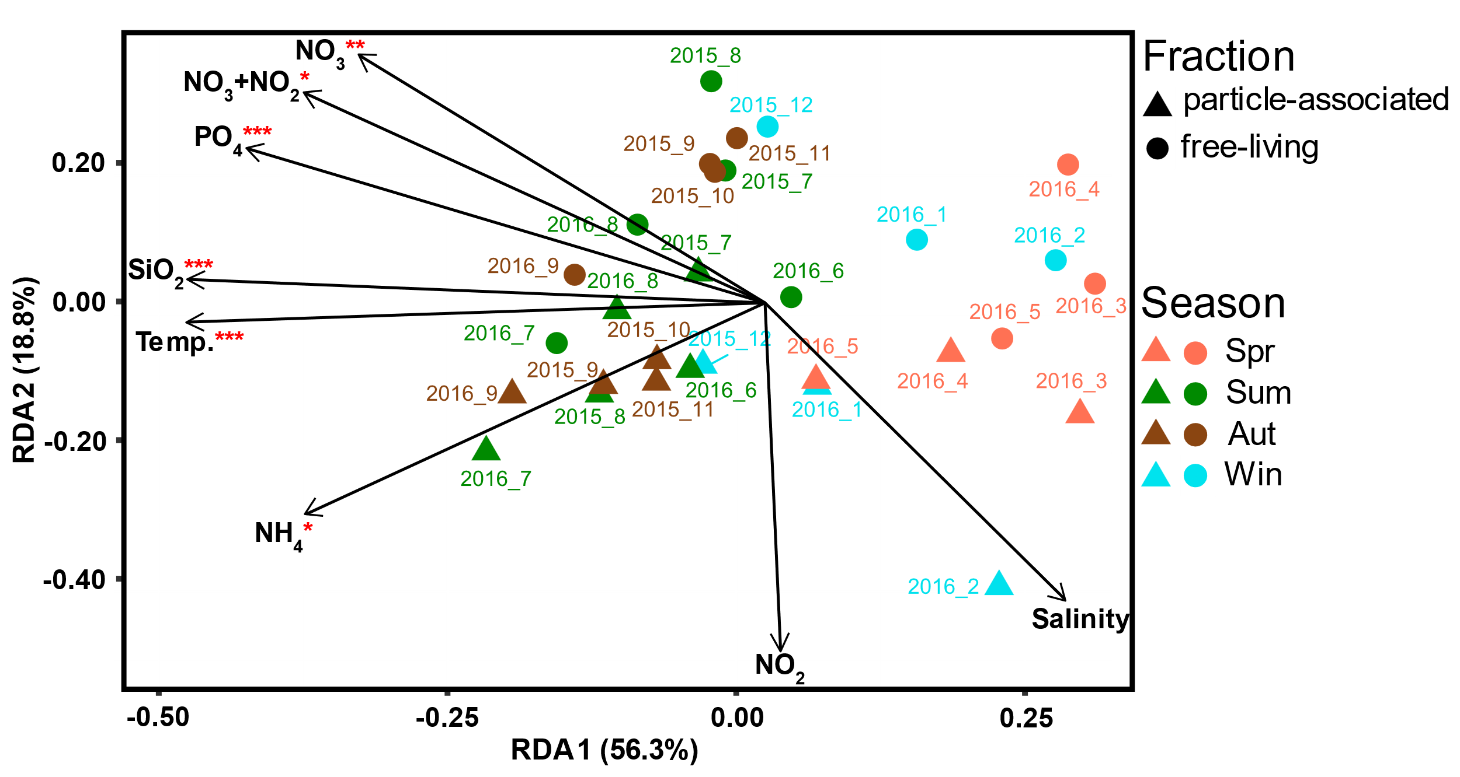
Fig. S6. RDA biplots showing the microbial community composition in relation to significant environment variables. The distance of each variable to the origin was reduced to 50% of its original value. Asterisk “*”, “**” and “***” indicate that environmental parameters have a significant impact on the prokaryotic community.

Table S1. Composition of 1 L of f/2-Si medium
Component | Stock solution | Quantity used
NaNO₃ | 75 g/L | 1 mL
NaHPO₄・H₂O | 5 g/L | 1 mL
Trace Metal Solution | (see Table S2) | 1 mL
Vitamins Solution | (see Table S3) | 0.5 mL
Artificial seawater |  | up to 1 L

Table S2. Composition of Trace Metal Solution
Component | Stock solution | Quantity used
FeCl₃・6H₂O | - | 3.15 g
Na₂EDTA・2H₂O | - | 4.36 g
MnCl₂・4H₂O | 180.0 g/L | 1 mL
ZnSO₄・7H₂O | 22.0 g/L | 1 mL
CoCl₂・6H₂O | 10.0 g/L | 1 mL
CuSO₄・5H₂O | 9.8 g/L | 1 mL
Na₂MoO₄・2H₂O | 6.3 g/L | 1 mL
Artificial seawater |  | Up to 1 L

Table S3. Composition of Trace Metal Solution
Component | Stock solution | Quantity used
Thiamine HCl (vitamin B1) | - | 200 mg
Biotin (vitamin H) | 1 | 1 ml
Cyanocobalamin (Vitamin B₁₂) | 1 | 1 ml
Artificial seawater |  | Up to 1 L
-: No addition

Table S4. Species identification of 14 isolated algicidal strains.
Number of  algicidal bacteria | Phylum | Class | Order | Family | The closest species (Accession) | Identity (%)
1 | Proteobacteria | γ-proteobacteria | Vibrionales | Vibrionaceae | Vibrio pelagius strain NBRC 15639 (NR_113789.1) | 99.9
18 | Proteobacteria | γ-proteobacteria | Pseudomonadales | Marinobacteraceae | Marinobacter adhaerens strain HP15 (NR_074765.1) | 100.0
19 | Proteobacteria | γ-proteobacteria | Vibrionales | Vibrionaceae | Vibrio pelagius (NR_042043.1) | 99.9
21 | Proteobacteria | γ-proteobacteria | Vibrionales | Vibrionaceae | Vibrio pelagius (NR_042043.1) | 99.9
24 | Proteobacteria | γ-proteobacteria | Vibrionales | Vibrionaceae | Vibrio pelagius (NR_042043.1) | 99.9
27 | Proteobacteria | γ-proteobacteria | Vibrionales | Vibrionaceae | Vibrio pelagius (NR_042043.1) | 99.9
36 | Proteobacteria | γ-proteobacteria | Vibrionales | Vibrionaceae | Vibrio pelagius (NR_042043.1) | 99.9
40 | Proteobacteria | γ-proteobacteria | Vibrionales | Vibrionaceae | Vibrio pelagius (NR_042043.1) | 99.9
43 | Proteobacteria | γ-proteobacteria | Vibrionales | Vibrionaceae | Vibrio pelagius (NR_042043.1) | 99.9
47 | Proteobacteria | γ-proteobacteria | Alteromonadales | Alteromonadaceae | Alteromonas confluentis (NR_137375.1) | 99.3
59 | Proteobacteria | γ-proteobacteria | Alteromonadales | Alteromonadaceae | Alteromonas tagae (NR_043977.2) | 99.0
74 | Proteobacteria | γ-proteobacteria | Alteromonadales | Alteromonadaceae | Alteromonas tagae (NR_043977.2) | 99.0
78 | Proteobacteria | γ-proteobacteria | Alteromonadales | Alteromonadaceae | Alteromonas tagae (NR_043977.2) | 98.7
81 | Proteobacteria | γ-proteobacteria | Alteromonadales | Pseudoalteromona  -daceae | Pseudoalteromonas carrageenovora (NR_113605.1) | 99.4

Table S5. Construction blast database of the algicidal and algae-utilizing bacteria.
 | phylum | number | Target or Substrate | In total
Algicdal bacteria | From NCBI Database |  |  | 281
Algicdal bacteria | Proteobacteria | 141 | Raphidophyta (Kristyanto et al., 2017) | 281
Algicdal bacteria | Bacteroidota | 36 | Bacillariophyta (Li et al., 2013) | 281
Algicdal bacteria | Bacillota | 36 | Prymnesiophyta (Tan et al., 2016) | 281
Algicdal bacteria | Actinomycetota | 23 | Dinoflagellata (Bai et al., 2011) | 281
Algicdal bacteria | Unknown | 45 |  | 281
Algicdal bacteria | Identified by this Lab |  |  | 281
Algicdal bacteria | Proteobacteria | 14 | Heterosigma akashiwo, Raphidophyta (In this study) | 281
Algae-utilizing bacteria | From NCBI Database |  |  | 106
Algae-utilizing bacteria | Proteobacteria | 93 | Oil, Hydrocarbon, and other substances  (Retrieved from NCBI without published references) | 106
Algae-utilizing bacteria | Actinomycetota | 5 |  | 106
Algae-utilizing bacteria | Bacteroidota | 8 |  | 106
Algae-utilizing bacteria | Identified by this Lab |  |  | 106
Algae-utilizing bacteria | Proteobacteria | 7 | Dissolved Intracellular Substance from H. akashiwo (Takebe et al., 2024) | 106
Algae-utilizing bacteria | Bacteroidota | 1 |  | 106

Table S6. Identification of algicidal and algae-utilizing bacteria among the 27 ASVs co-occurring with H. akashiwo.
 | ASV id | Taxonomy |  |  | Species with the highest identity (Accession) | Identity percentage (%)
 | ASV id | Phylum | Class | Order | Species with the highest identity (Accession) | Identity percentage (%)
Algicidal bacteria | ASV_FL276 | Proteobacteria | α-roteobacteria | Rhodobacterales | Phaeobacter sp. (AB180391.1) | 97.0
Algicidal bacteria | ASV_FL517 | Bacteroidota | Bacteroidia | Flavobacteriales | Flavobacterium sp. (AB017597.1) | 98.6
Algicidal bacteria | ASV_FL705 | Bacteroidota | Bacteroidia | Flavobacteriales | Flavobacterium sp. (AB017597.1) | 97.0
Algicidal bacteria | ASV_PA705 | Bacteroidota | Bacteroidia | Flavobacteriales | Flavobacterium sp. (AB017597.1) | 97.0
Algae-utilizing bacteria | ASV_FL692 | Proteobacteria | α-roteobacteria | Rhodobacterales | Sulfitobacter sp. (EU052732.1) | 98.4

Reference
Bai, S. J., Huang, L. P., Su, J. Q., Tian, Y., & Zheng, T. L. (2011). Algicidal effects of a novel marine actinomycete on the toxic dinoflagellate Alexandrium tamarense. Current Microbiology, 62, 1774–1781. https://doi.org/10.1007/s00284-011-9927-z
Kristyanto, S., Chaudhary, D. K., Lee, S.-S., & Kim, J. (2017). Characterization of Marinomonas algicida sp. nov., a novel algicidal marine bacterium isolated from seawater. International Journal of Systematic and Evolutionary Microbiology, 67(11), 4777–4784. https://doi.org/10.1099/ijsem.0.002374
Li, Y., Wei, J., Yang, C., Lai, Q., Chen, Z., Li, D., Zhang, H., Tian, Y., Zheng, W., & Zheng, T. (2013). Tenacibaculum xiamenense sp. nov., an algicidal bacterium isolated from coastal seawater. International Journal of Systematic and Evolutionary Microbiology, 63(Pt_9), 3481–3486. https://doi.org/10.1099/ijs.0.050765-0
Takebe, H., Tominaga, K., Isozaki, T., Watanabe, T., Yamamoto, K., Kamikawa, R., & Yoshida, T. (2024). Taxonomic difference in marine bloom-forming phytoplanktonic species affects the dynamics of both bloom-responding prokaryotes and prokaryotic viruses. Msystems, 9(4), e00949-23. https://doi.org/https://doi.org/10.1128/msystems.00949-23
Tan, S., Hu, X., Yin, P., & Zhao, L. (2016). Photosynthetic inhibition and oxidative stress to the toxic Phaeocystis globosa caused by a diketopiperazine isolated from products of algicidal bacterium metabolism. Journal of Microbiology, 54, 364–375. https://doi.org/10.1007/s12275-016-6012-0

